Docker rmi image_id --------to remove the image

Docker rmi image_id -f--------to remove the image to force fully

Dokcer export –output=”lastest.tar” image _id------to export certain image as a tar file

Docker history image_id ----it will give the layers of specified imgae

To run an images (centos) : docker run -t -i 300e315adb2f /bin/bash

docker run -it --rm --name my_running_app my-apache2 -----------to run as container for apache

accessing a afirefox:

docker pull jlesage/firefox

docker run -d \

--name=firefox \

-p 5800:5800 \

-v /docker/appdata/firefox:/config:rw \

--shm-size 2g \

jlesage/firefox

if we want what are the network present I the docker is docker network ls

and we want create new netowk we can use docker network create simple-network by default it is form bridge network

docker network inspect simple-network

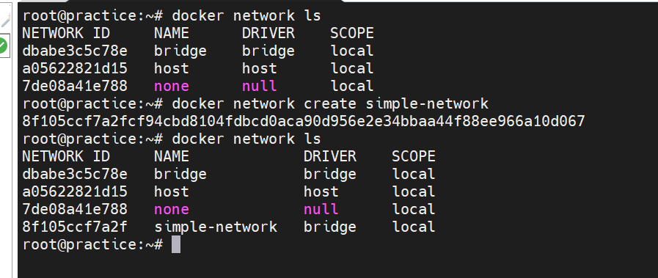

If we want remove a network we use docker network rm simple-netwpork