**ASSIGNEMNT NEXUS**

1. What is SAST?

Answer: Static Application Security Testing is performed by SonarQube to analyze the security.

1. What is mvn sonar: sonar?

Answer: mvn sonar: sonar is a goal and which performs static code analysis. It is mainly used in pipeline script.

1. What is quality gate and quality profile?

Answer: Quality gate is a set of conditions that need to be fulfilled in order to make our project error free and production ready.

1. How would you configure quality gates?

Answer:

* 1. First of all, we need to download plugin name called ”quality gate sonar”
  2. After that go to that configure system in Jenkins and add sonar instance
  3. Open administration page in SonarQube
  4. Generate the token it is one time valid
  5. In configurations click on web hook.
  6. Create a new web hook.
  7. Enter name and copy the url of Jenkins
  8. Enter the key and save it
  9. write a pipeline project and run the pipeline script then we can view the project quality in SonarQube

**STPES TO INSTALL NEXUS**

**Step:1 Create instance run a docker and create a volume as a name of nexus**

docker run -d --name nexus-data sonatype/nexus echo "data-only container for nexus"



Run a command which give port number 8081 and name of nexcus1:

docker run -d -p 8081:8081 --name nexus1 --volumes-from nexus-data sonatype/nexus

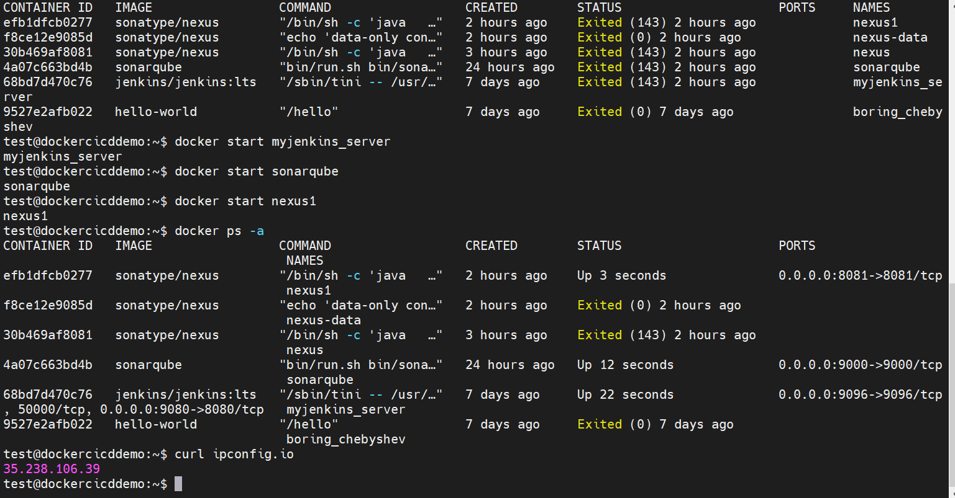

Then go to your browser and hit on [**http://35.238.106.39:8081/nexus**](http://35.238.106.39:8081/nexus) **then you redirect to below page.**

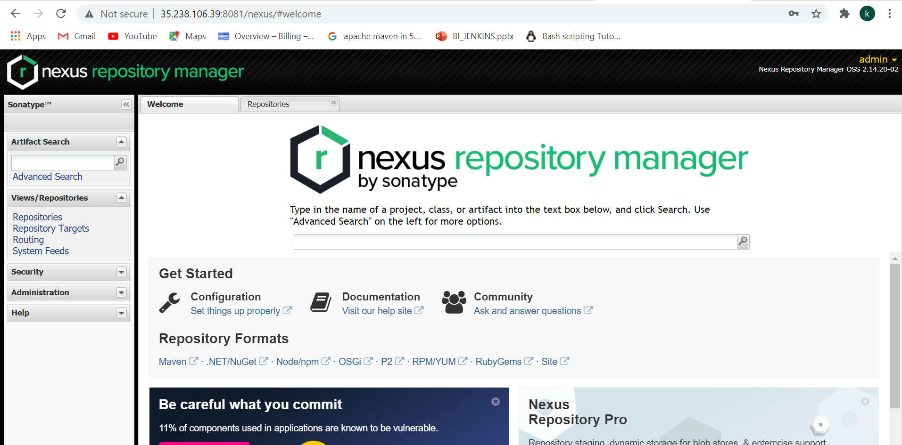

**Then your nexus is working now.**

**Then we need to build a pipeline go to Jenkins create simple pipeline job as name of demo_mvn_sonar_nexus**

**Go to pipeline script in configure write the below pipeline script**

**pipeline {**

**agent any**

**stages {**

**stage('SCM Checkout') {**

**steps {**

**git 'https://github.com/Gkasiraju/mvn_sonar.git'**

**}**

**}**

**stage ('Build') {**

**steps {**

**sh '/opt/maven/bin/mvn clean sonar:sonar -Dmaven.test.skip=true'**

**}**

**}**

**stage ('Artifact-Deployment') {**

**steps {**

**sh '/opt/maven/bin/mvn clean deploy -Dmaven.test.skip=true'**

**}**

**}**

**stage ('Release') {**

**steps {**

**sh 'export JENKINS_NODE_COOKIE=dontkillme ;nohup java -jar $WORKSPACE/target/*.jar &'**

**}**

**}**

**}**

**}**

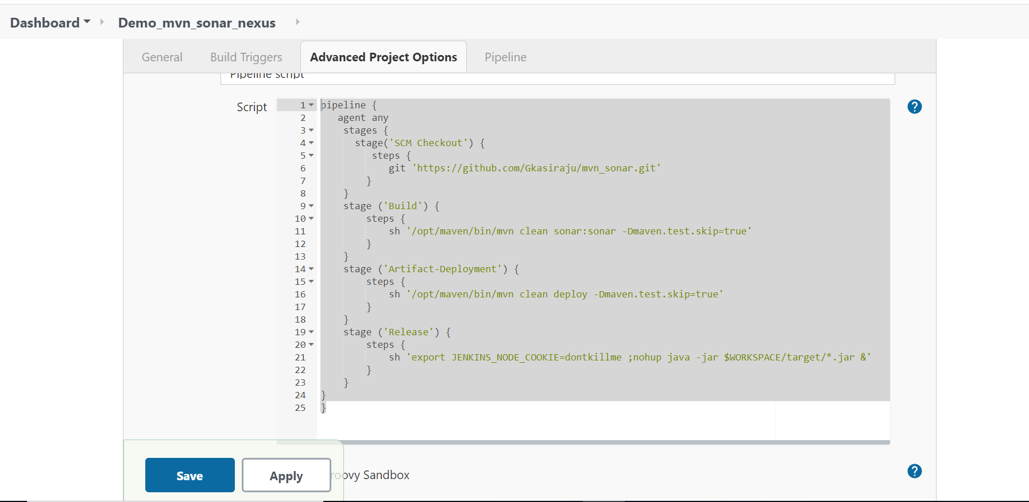

**Then go to git hub repository open your pom.xml add the properties and snapshot repository**

|  |
| --- |
| <properties> |
|  | <project.build.sourceEncoding>UTF-8</project.build.sourceEncoding> |
|  | <sonar.host.url>http://35.238.106.39:9000</sonar.host.url> |
|  | <sonar.login>admin</sonar.login> |
|  | <sonar.password>admin123</sonar.password> |
|  | </properties>   |  | | --- | | <snapshotRepository> | |  | <id>nexus</id> | |  | <url>http://35.238.106.39:8081/nexus/content/repositories/snapshots</url> | |  | </snapshotRepository> | |

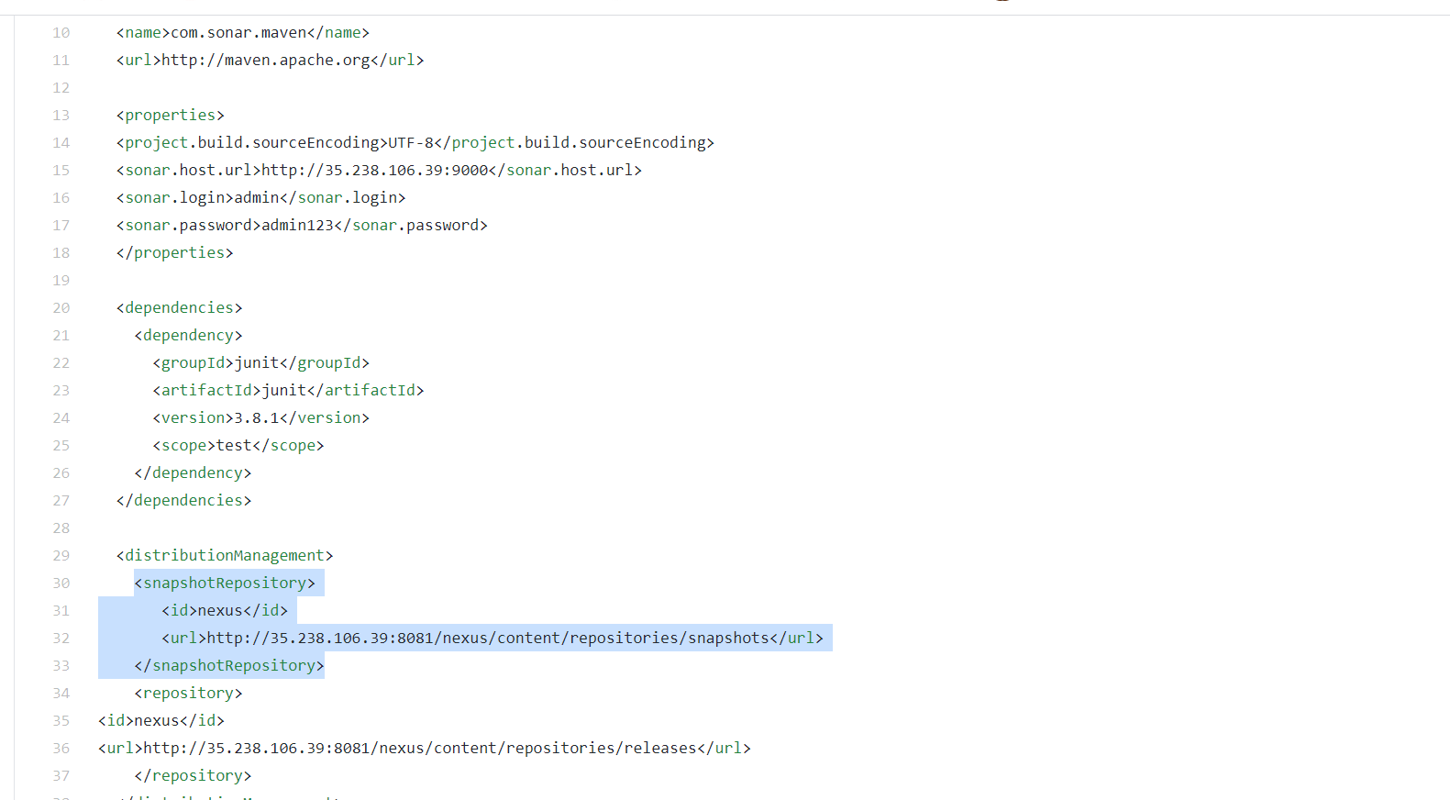

**Open mobaXterm then go to maven config folder**

**Cd /opt/maven/conf/ vi settings.xml**

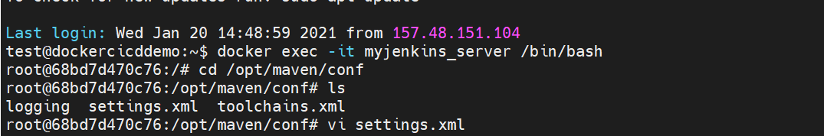

**In the servers tage write the server details of nexus shown below**

**<server>**

**<id>nexus</id>**

**<username>admin</username>**

**<password>admin123</password>**

**</server>**

**</servers>**

**Then your configuration part is completed then go to Jenkins build the job**

**Click on build now:**

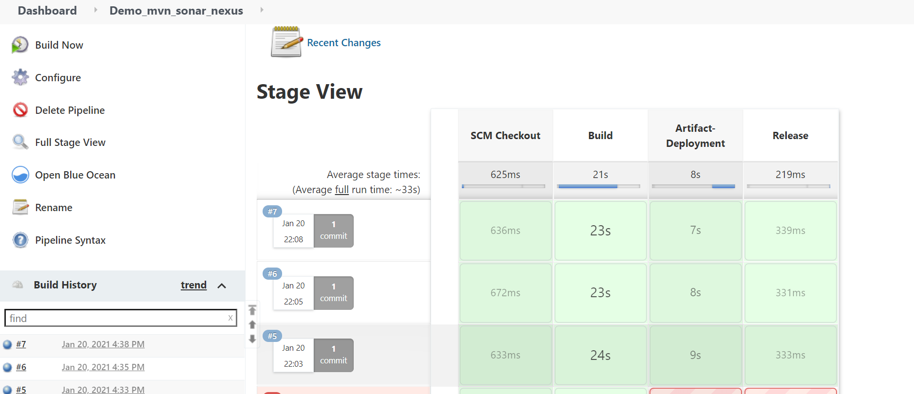

**After successfully build go to your sonaQube server check if there is any code smell is there..**

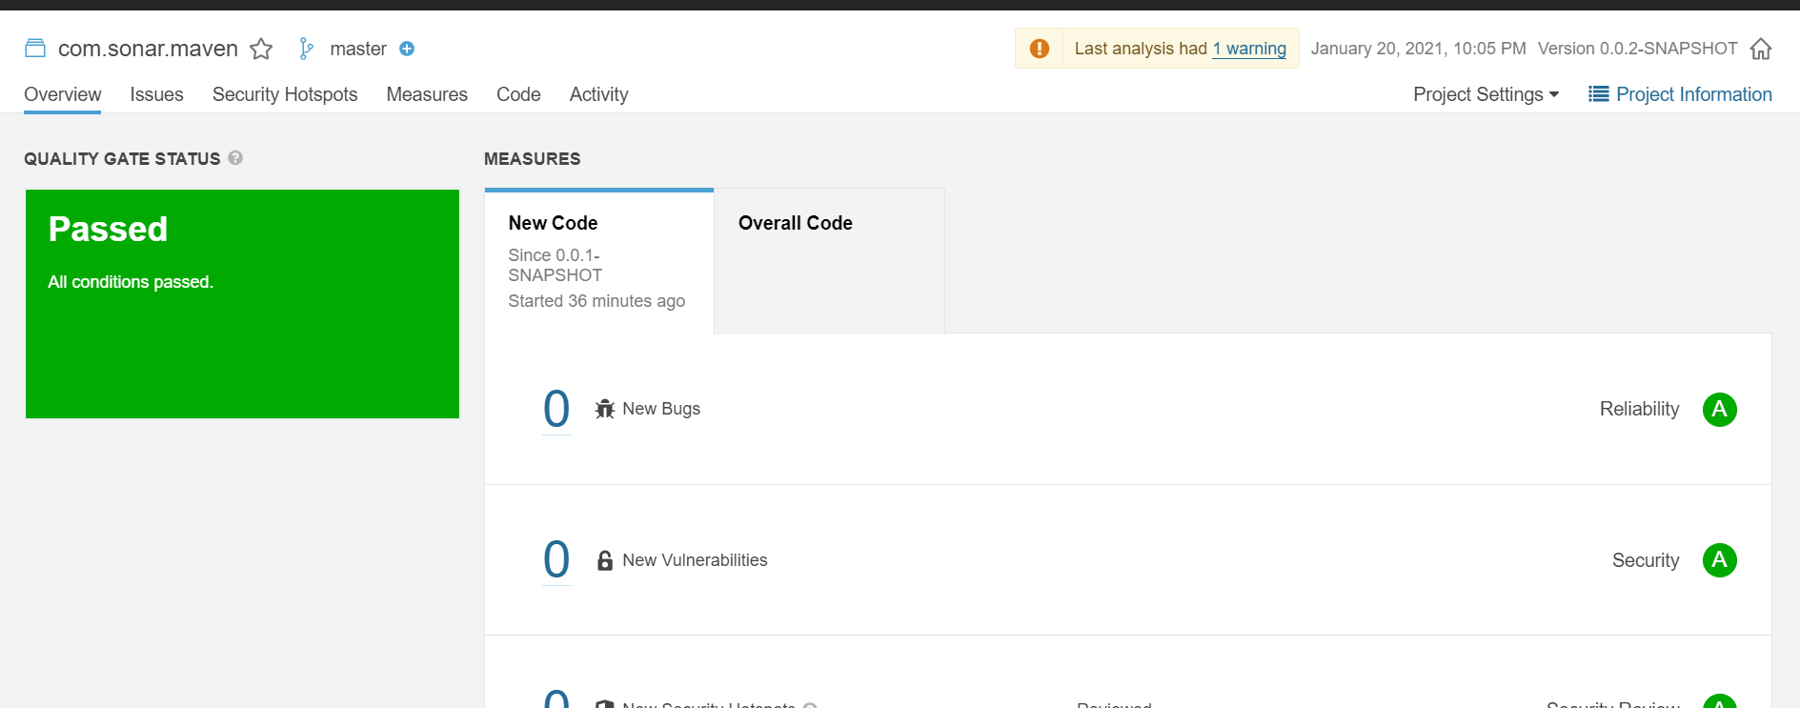

After that got your nexus then where you need to go for snapshot 0.0.1 snapshot.

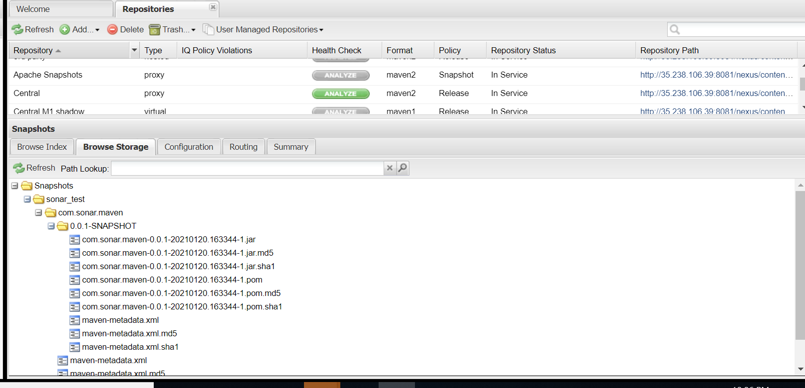

Again I am changing in pom.xml the snapshot version0.0.1 to 0.0.2 snapshot again build now

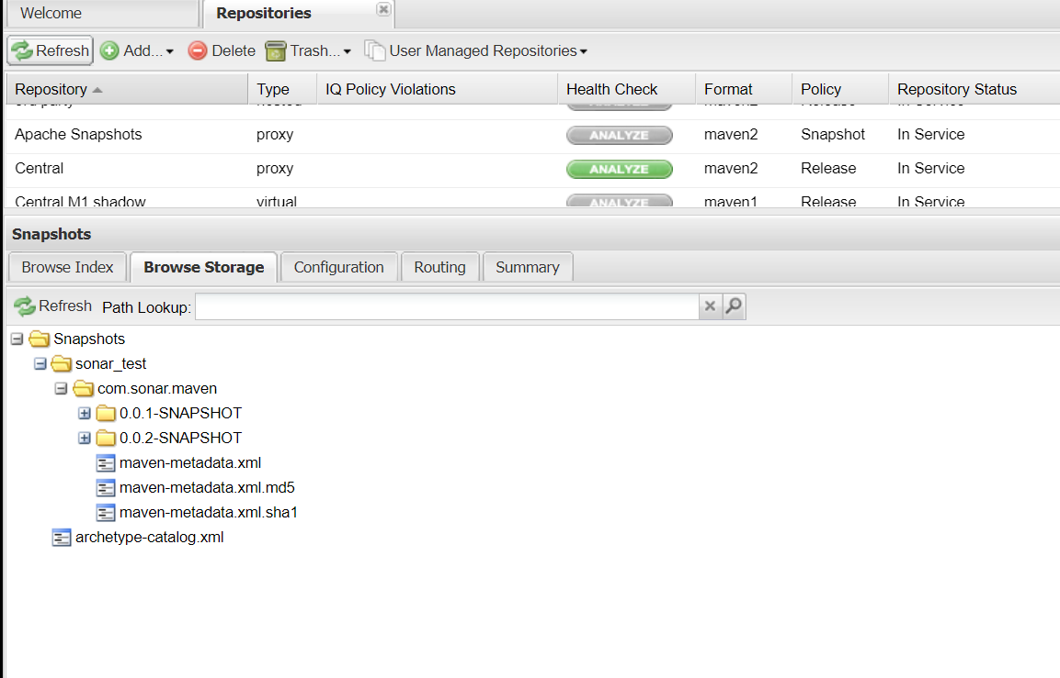

Until snapshot is ready then now I am going to release the artifact now I am going to change the pom.xml remove the snapshot and under the distributed repository add release repository as shown below

|  |
| --- |
| <repository> |
|  | <id>nexus</id> |
|  | <url>http://35.238.106.39:8081/nexus/content/repositories/releases</url> |
|  | </repository> |

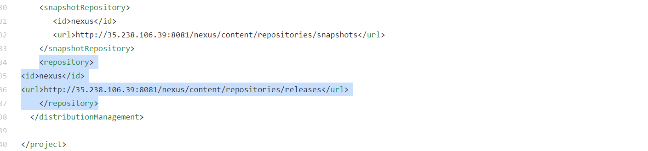

Then commit the changes go to Jenkins build now then back to nexus here we can see the release 1.0

