**SONAR INSTALLATION STEPS**

**Step:1**

**Install the sonar in instance**

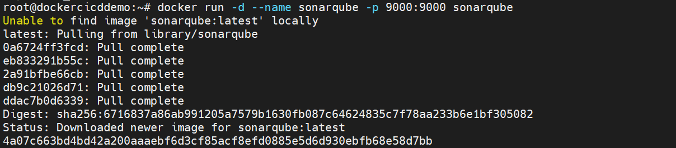

**To show what running**

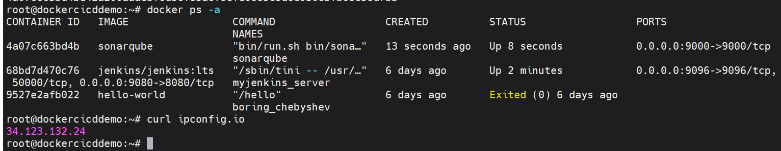

**Sonarqube is running at port :9000**

**After Successfully installed we will redirect to this page**

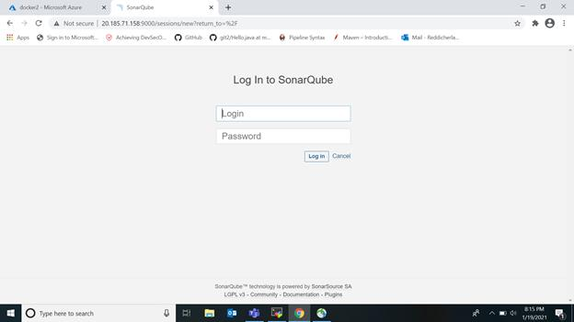

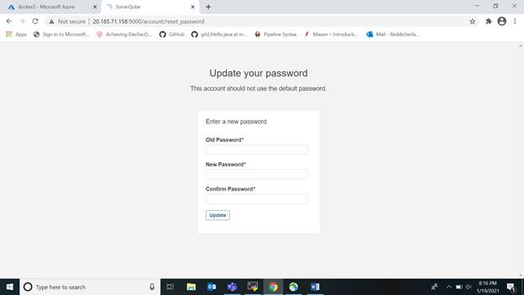

**After successfully given the credentials then updtate the password. You will redirect to that default home page.**

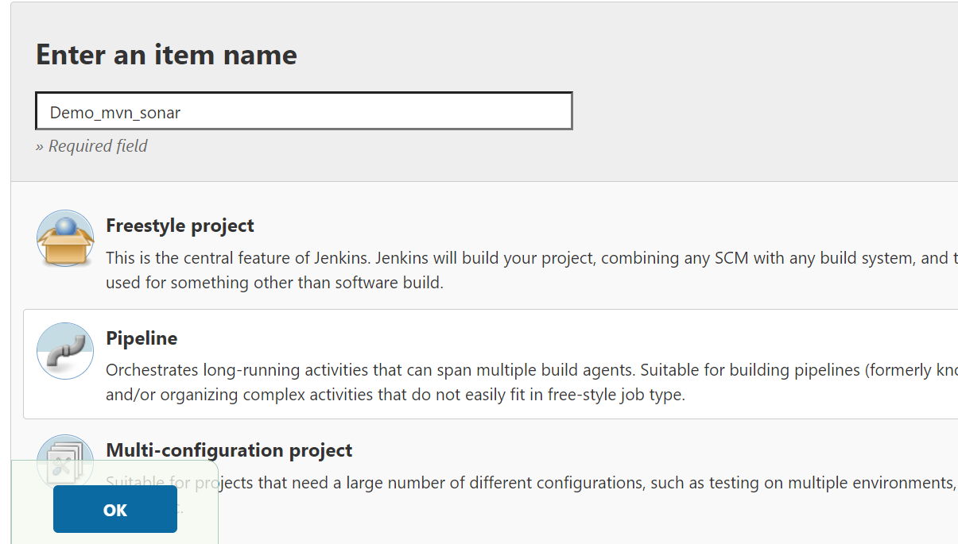

**We are adding pipeline script**

**pipeline {**

**agent any**

**stages {**

**stage('SCM Checkout') {**

**steps {**

**git 'https://github.com/Gkasiraju/mvn_sonar.git'**

**}**

**}**

**stage ('Build') {**

**steps {**

**sh '/opt/maven/bin/mvn clean sonar:sonar -Dmaven.test.skip=true'**

**}**

**}**

**stage ('Release') {**

**steps {**

**sh 'export JENKINS_NODE_COOKIE=dontkillme ;nohup java -jar $WORKSPACE/target/*.jar &'**

**}**

**}**

**}**

**}**

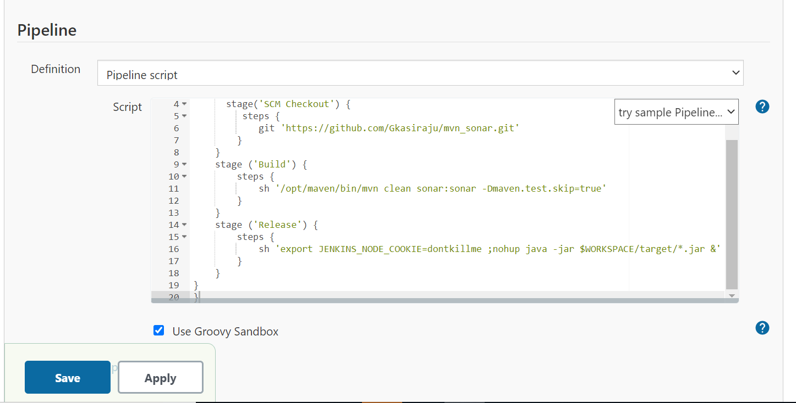

**I am pull the code from github here I am add properties in pom.xml**

|  |
| --- |
| <properties> |
|  | <project.build.sourceEncoding>UTF-8</project.build.sourceEncoding> |
|  | <sonar.host.url>http://34.123.132.24:9000</sonar.host.url> |
|  | <sonar.login>admin</sonar.login> |
|  | <sonar.password>admin123</sonar.password> |
|  | </properties> |

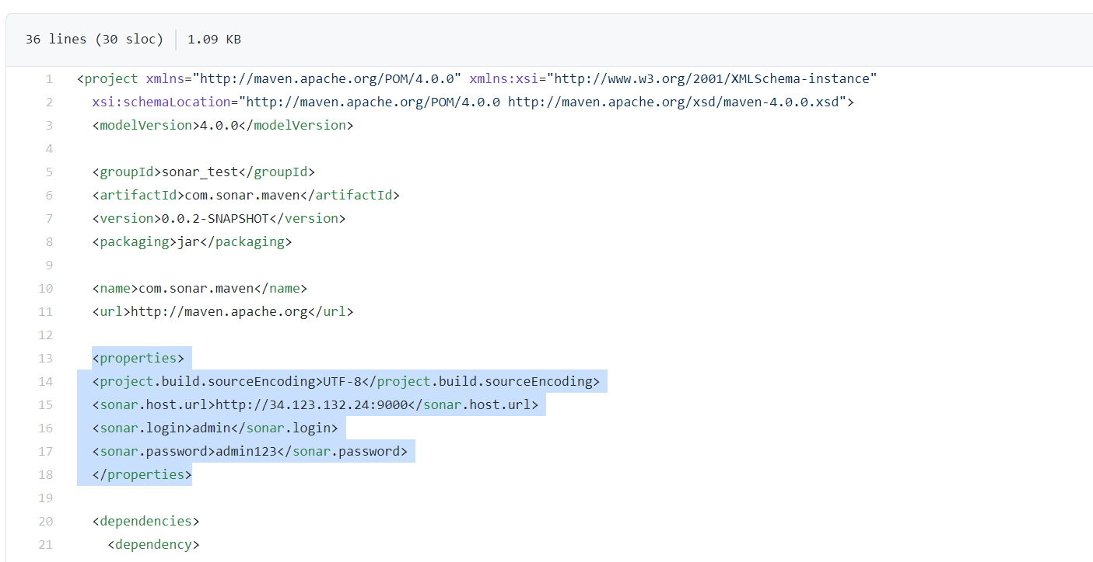

**Console output:**

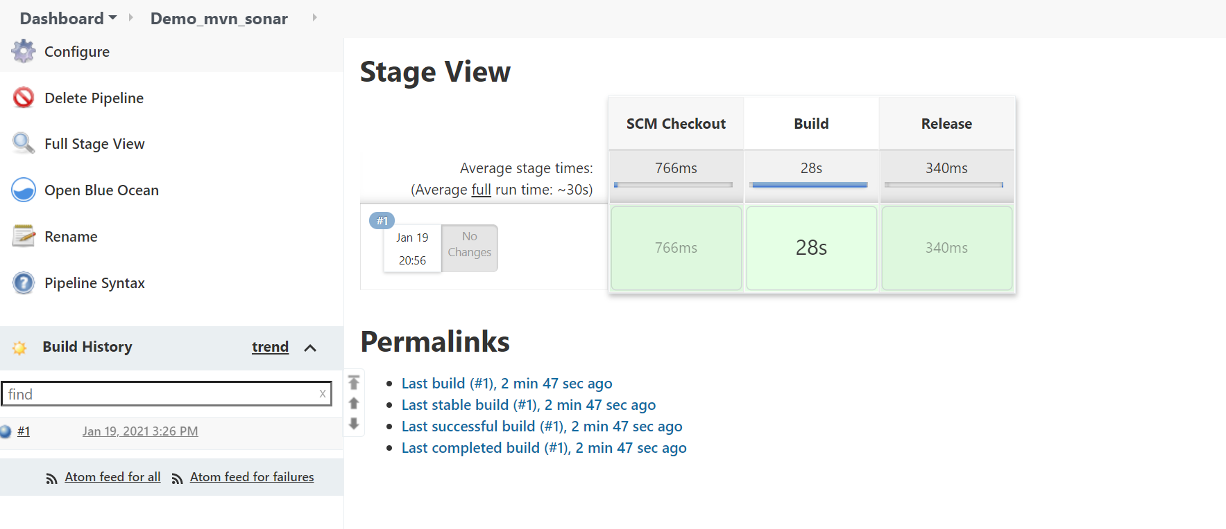

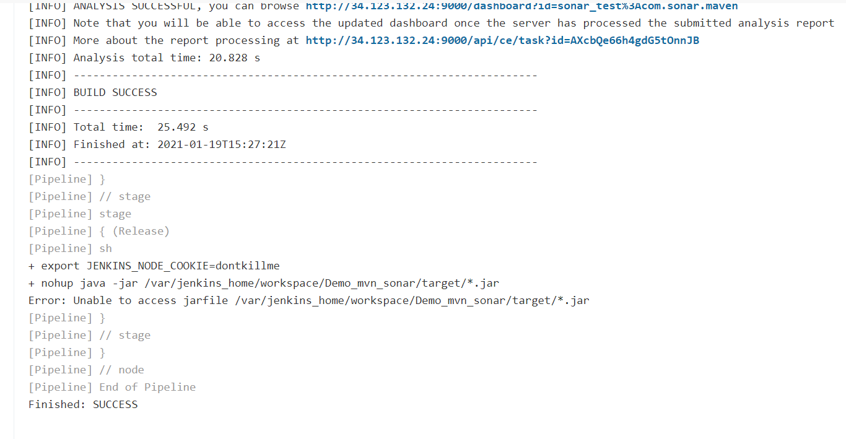

**Sonarqube:**

