MAVEN INSTALLATON STEPS

* validate - validate the project is correct and all necessary information is available
* compile - compile the source code of the project
* test - test the compiled source code using a suitable unit testing framework. These tests should not require the code be packaged or deployed
* package - take the compiled code and package it in its distributable format, such as a JAR.
* verify - run any checks on results of integration tests to ensure quality criteria are met
* install - install the package into the local repository, for use as a dependency in other projects locally
* deploy - done in the build environment, copies the final package to the remote repository for sharing with other developers and projects.

apt -get install wget

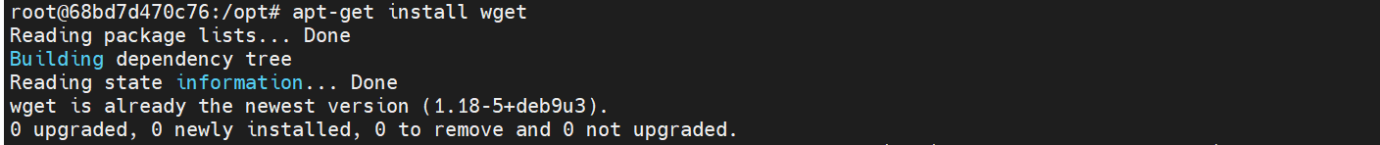

wget https://apache.claz.org/maven/maven-3/3.6.3/binaries/apache-maven-3.6.3-bin.tar.gz

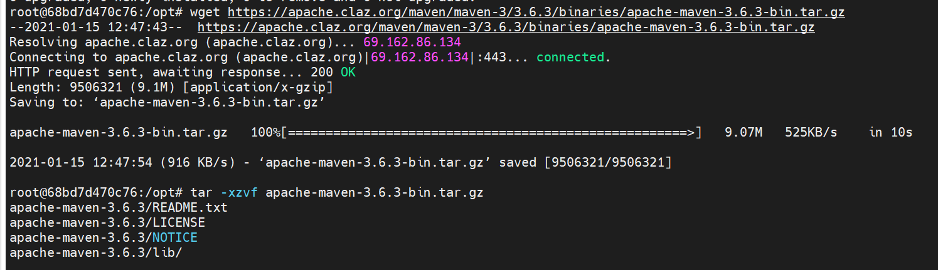

tar -xzvf apache-maven-3.6.3-bin.tar.gz

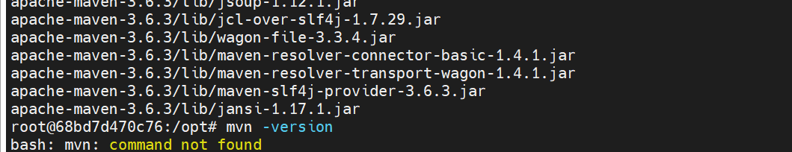

Apt-get update

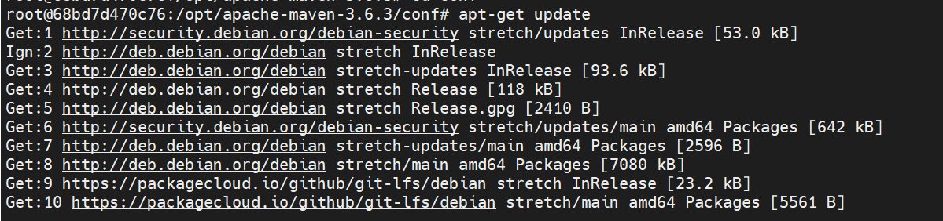

conf# apt-get install vim

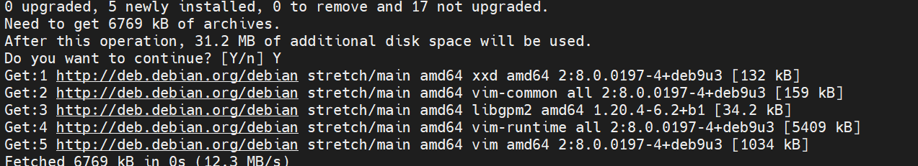

tar -zxvf apache-maven-3.6.3-bin.tar.gz -C /opt/maven --strip-components=1

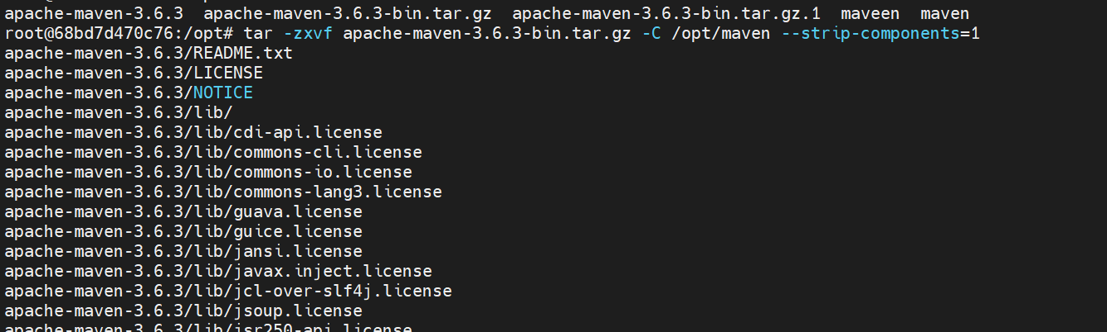

vi /etc/profile

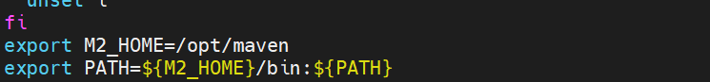

Ls



Source /etc/profile



mvn –version

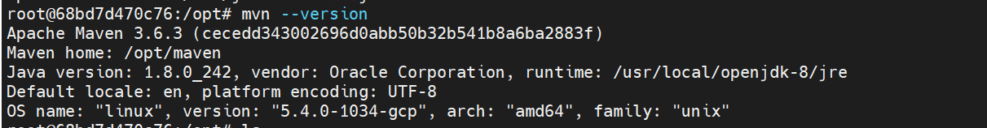

**Assignment:**

**First of all create one pipelie project with name of Demo_Maven**

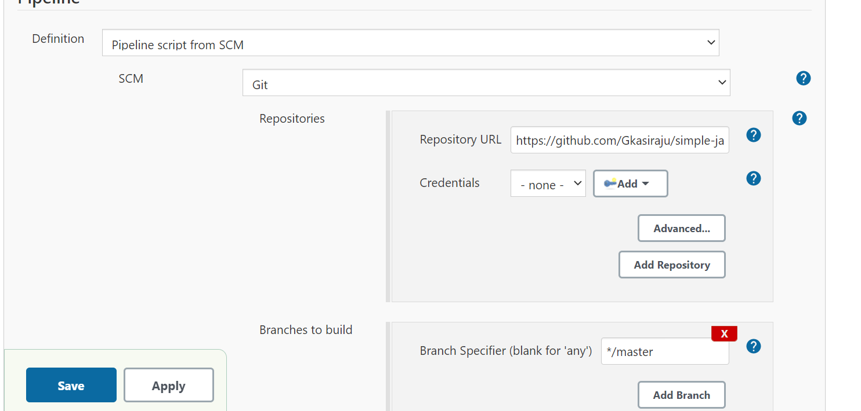

* **Then apply and save**
* **Fork the Code**
* **Create Jenkinsfile in the git hub account**

**Content of file:**

|  |
| --- |
| pipeline { |
|  | agent any |
|  | stages { |
|  | stage('SCM Checkout') { |
|  | steps { |
|  | git 'https://github.com/Gkasiraju/simple-java-maven-app.git' |
|  | } |
|  | } |
|  | stage ('Build') { |
|  | steps { |
|  |  |
|  | sh '/opt/maven/bin/mvn clean verify -Dmaven.test.skip=true' |
|  | } |
|  | } |
|  | } |
|  | } |

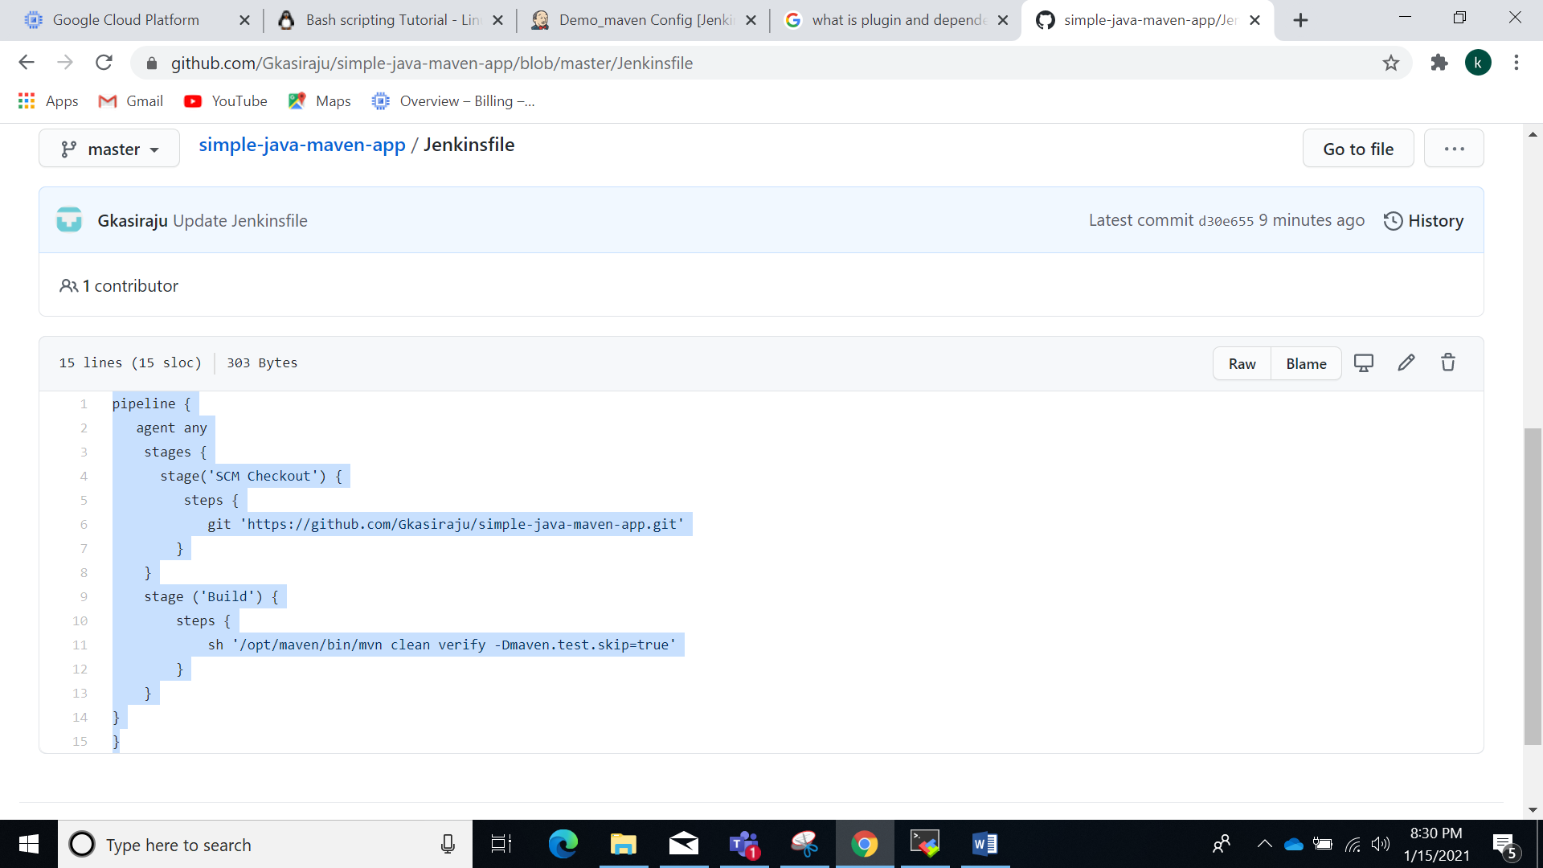

**Then click on build now**

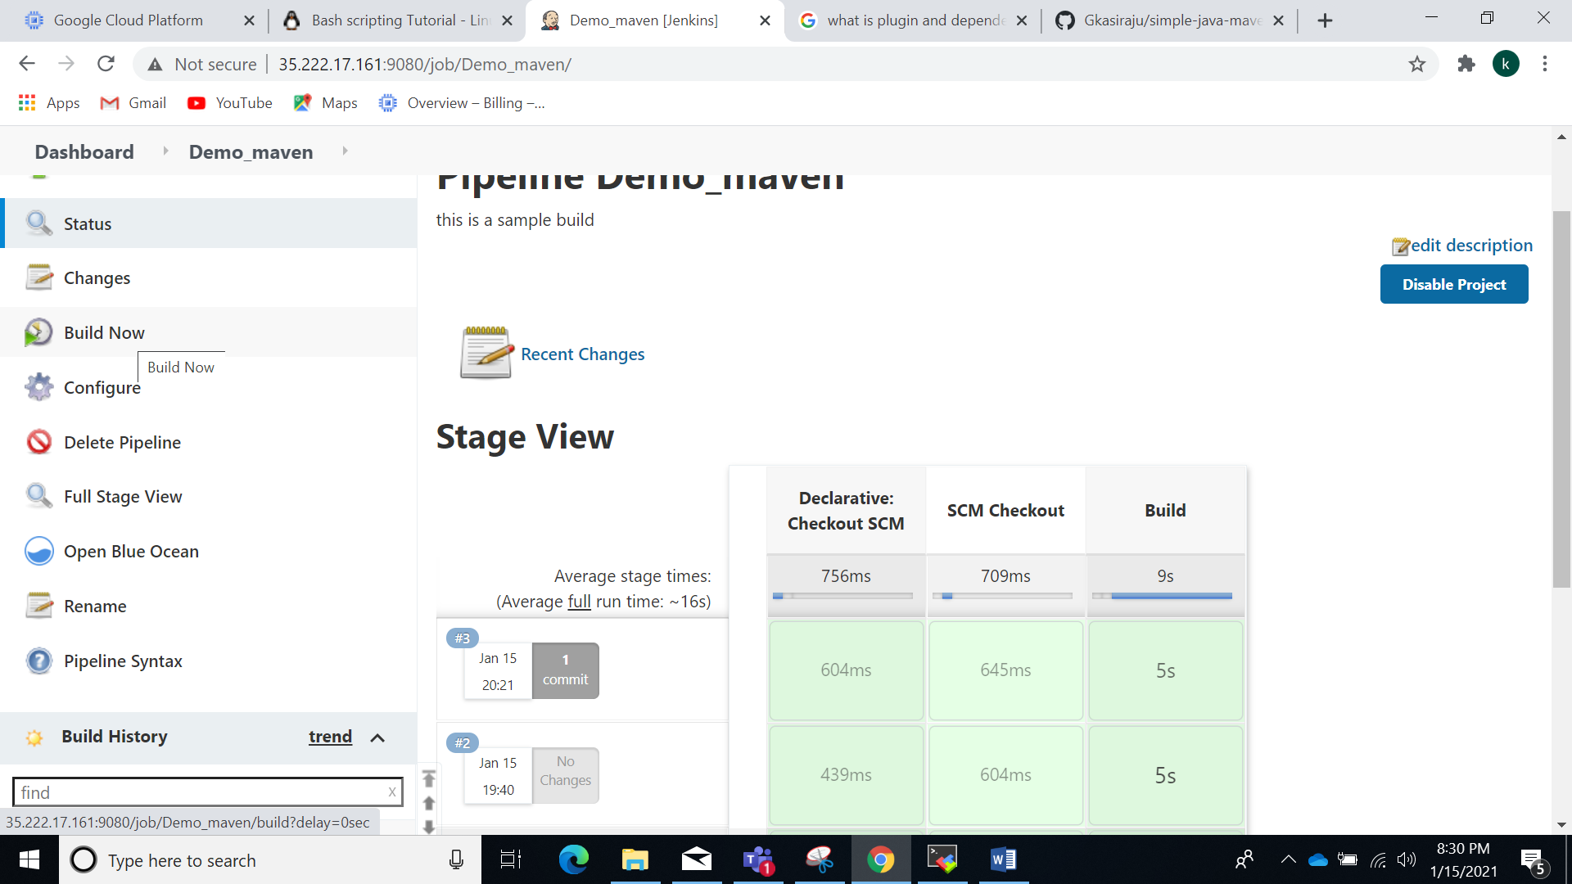

**Console Output:**

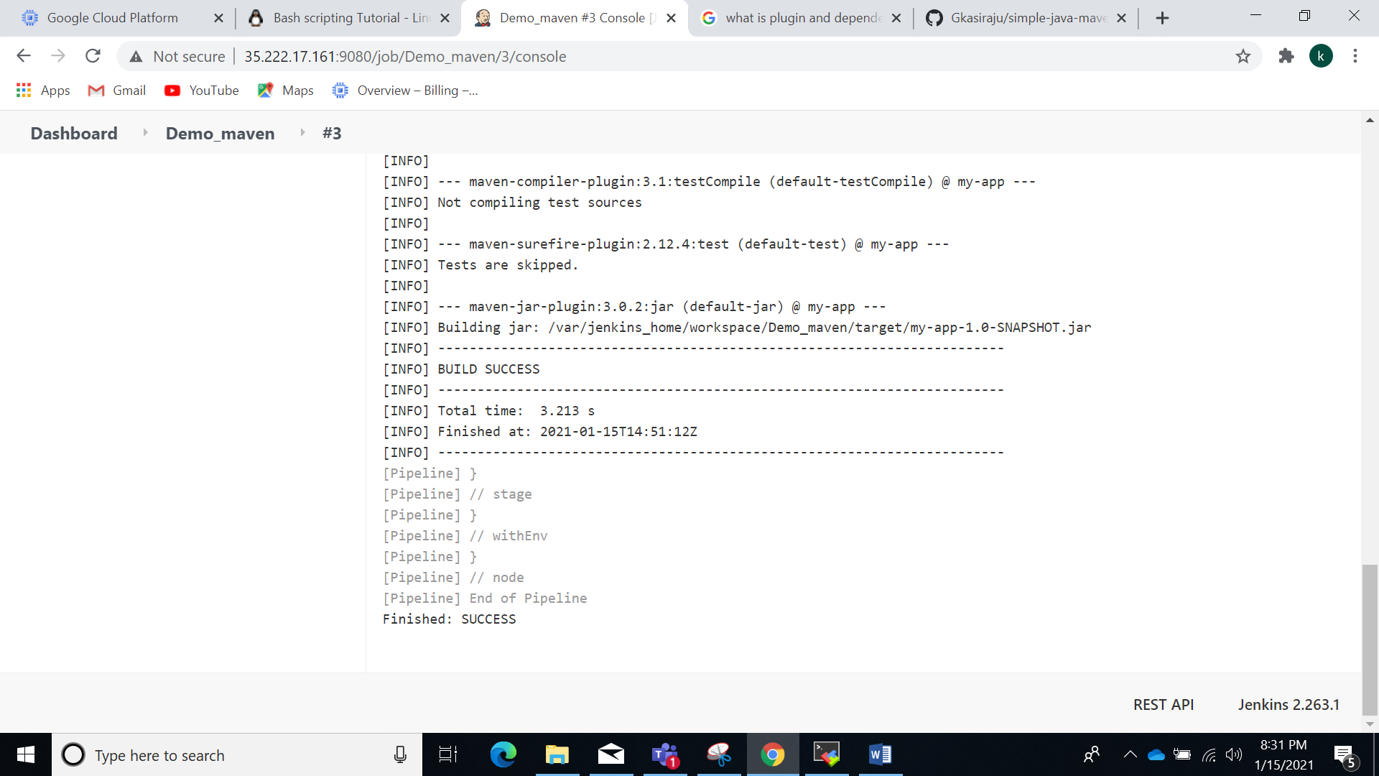

**In blue Ocean:**

