TOMCAT INSTALLATION ON DOCKER

Here I am installing tomcat on centos in docker instance.

<https://dzone.com/articles/deploying-machine-learning-workflows-on-lke-with-k>

docker pull centos //pulling a docker images from docker hub.

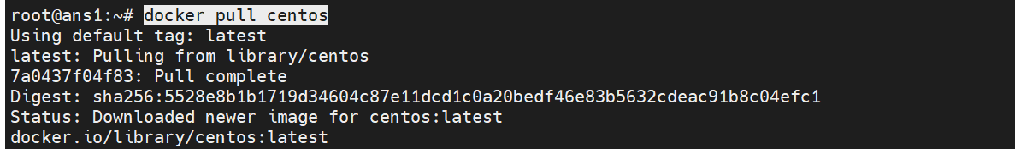

docker run -dit --name tomcat_container -p 8088:8080 centos



docker exec -it 4ea83c2f2a5c /bin/bash

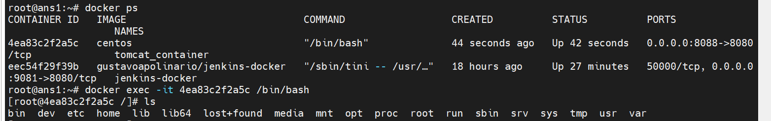

Cd opt

yum install wget

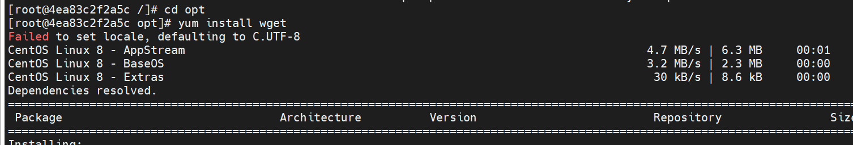

wget <https://apache.inspire.net.nz/tomcat/tomcat-8/v8.5.63/bin/apache-tomcat-8.5.63.tar.gz>

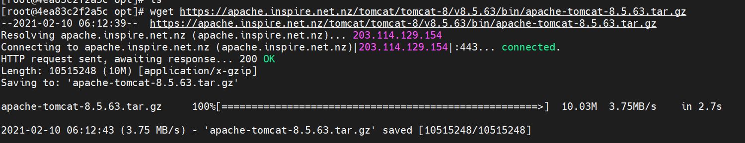

tar -xvzf apache-tomcat-8.5.63.tar.gz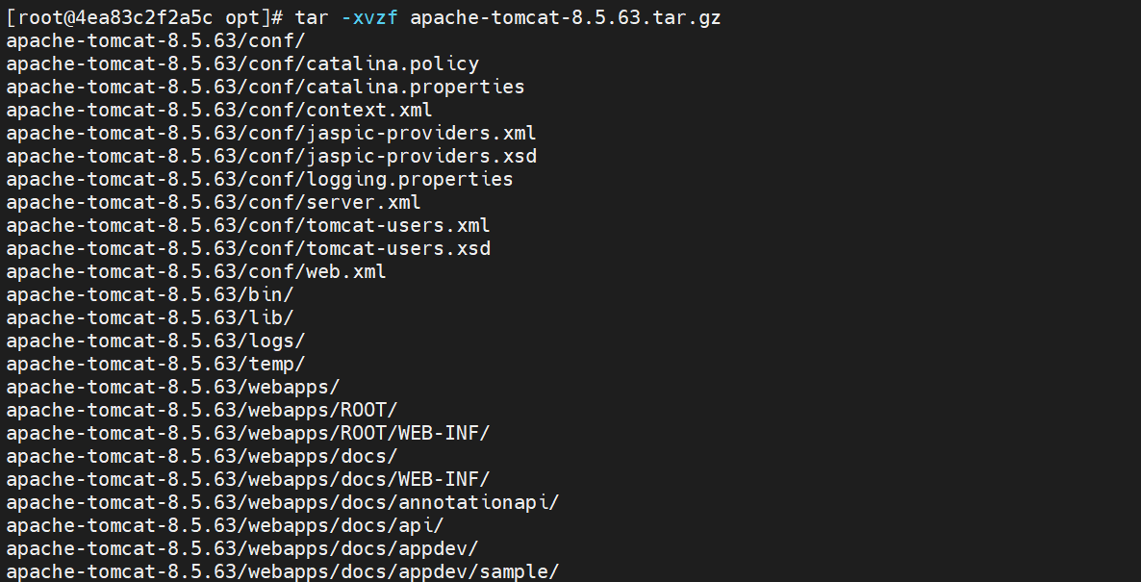

yum install java-1.8.0-openjdk-devel

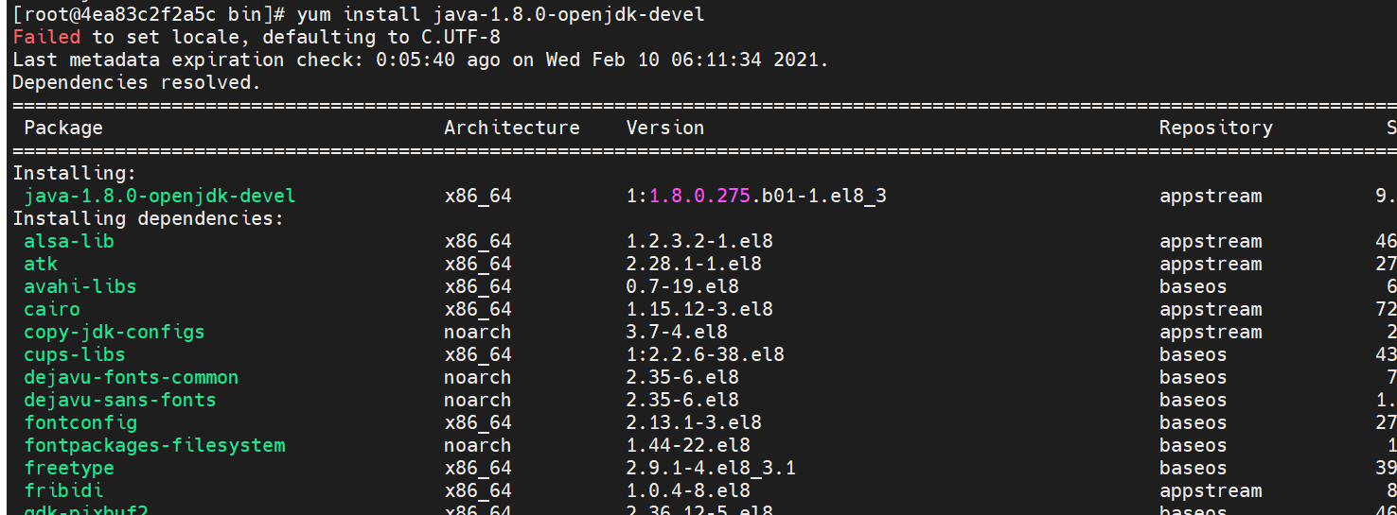

./startup.sh

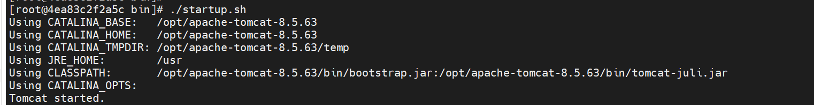

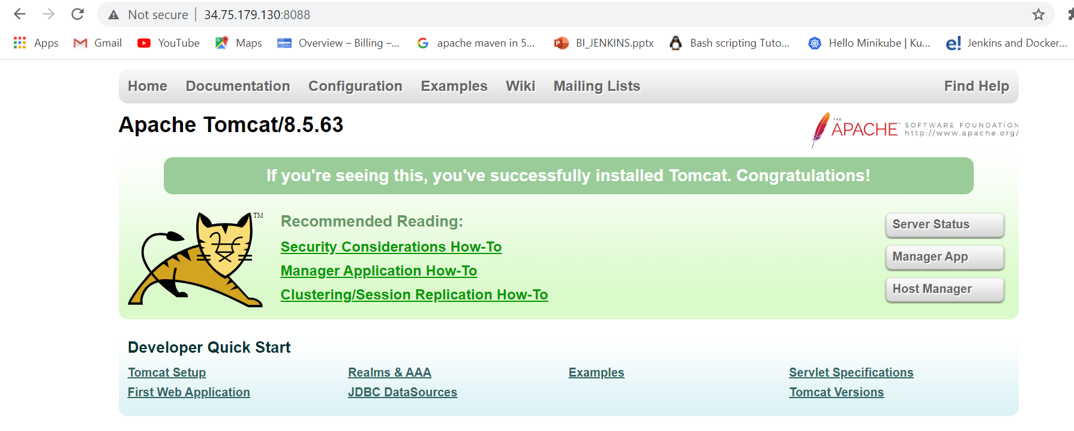

./shutdown.sh

docker exec -it tomcat_container /bin/bash

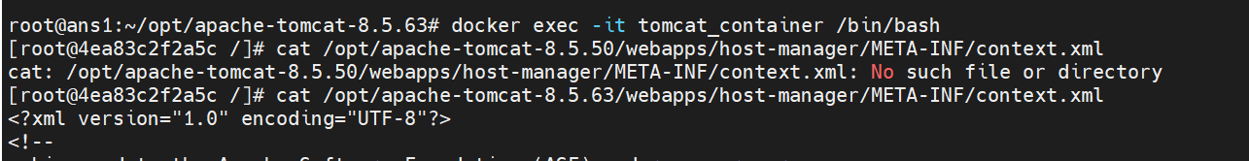

<!-- <Valve className="org.apache.catalina.valves.RemoteAddrValve"

3

        allow="127\.\d+\.\d+\.\d+|::1|0:0:0:0:0:0:0:1" /> -->

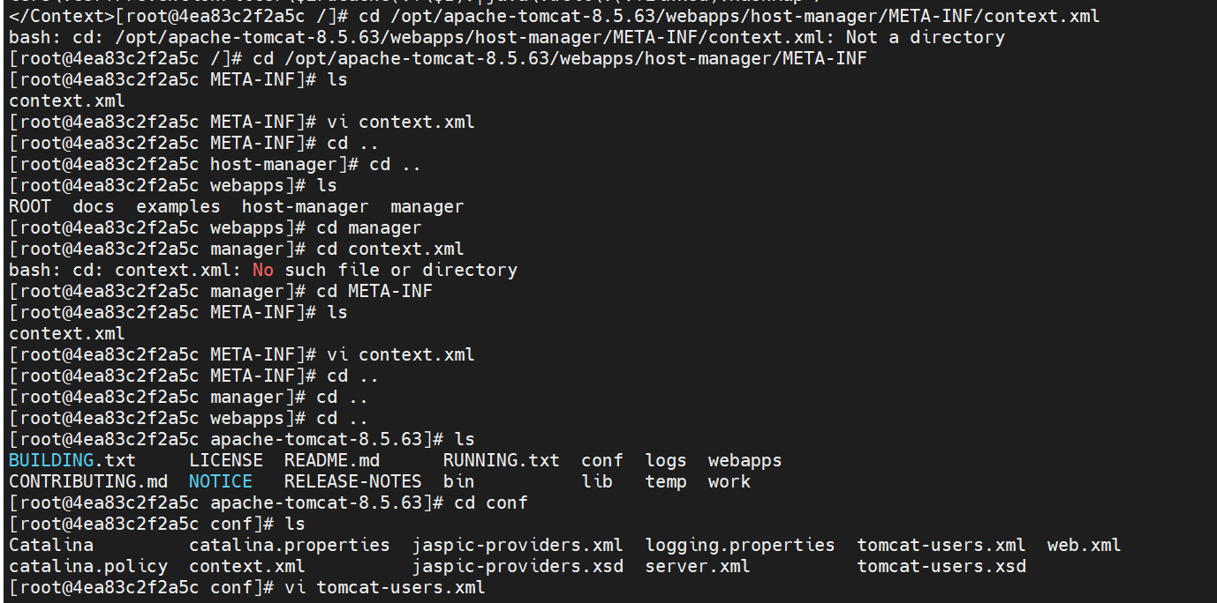

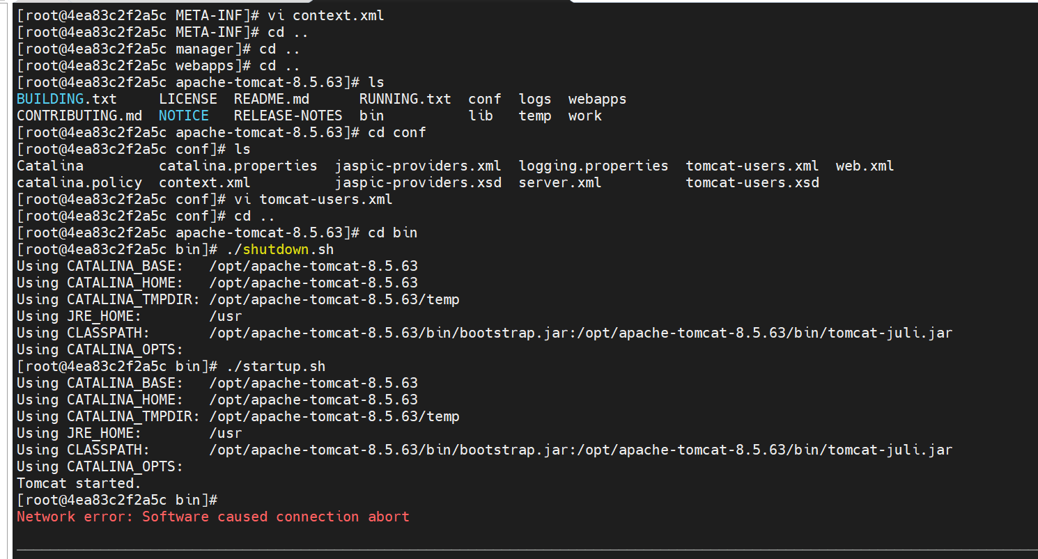

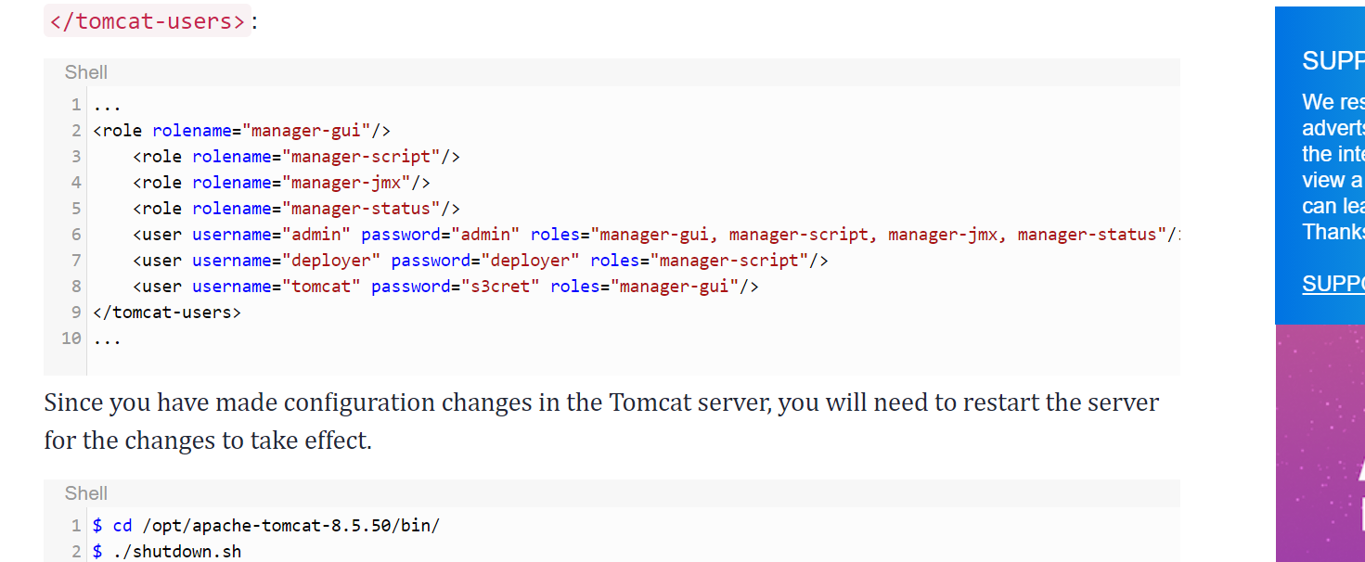\

stage ('deploy-tomcat'){

steps {

sshagent(['deployuserssh2']) {

scp '-o StrictHostKeyChecking=no target/parking-9.0.0-RELEASE.jar test_ans1@34.75.179.130:/root/apache-tomcat-8.5.63-src/webapps'

}

}

}