

Lecture with Computer Exercises:
Modelling and Simulating Social Systems with MATLAB

Project Report

Traffic simulation in the city of Zürich

Jan Dörrie, Simone Forte,
Charalampos Gkonos, Athina Korfiati

Zürich
May, 2014
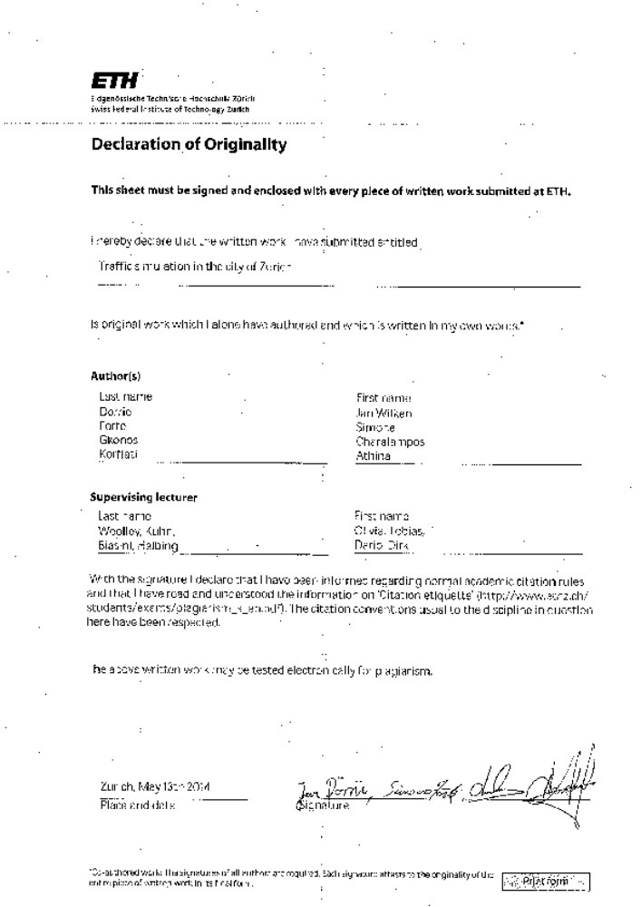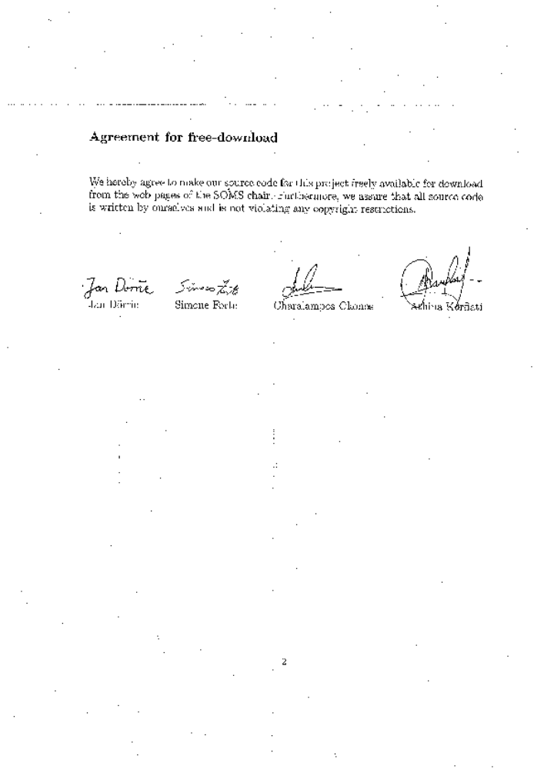

Table of Contents
Abstract 5
Individual contributions 5
Introduction and Motivations 5
Description of the Model 6
Implementation 7
Simulation Results and Discussion 7
Summary and Outlook 7
References 7

Abstract

In this paper, a traffic simulation for the city of Zürich is developed. The representation of traffic flows is a very useful tool for urban planning and is essential in cases that large scale construction works are planned. In the case of the city of Zürich, we were inspired from a proposed project for the construction of an underground tunnel that would connect the East and West side of the lake. The goal of this paper is to examine and derive conclusions whether such a tunnel would affect (improve or even worsen) the traffic situation of the city centre. More specifically, the travelling times from certain starting points to ending ones will be examined before and after the construction of such a technical work. At the end of the simulation, the results will be analysed.

As an initial step, the route of every car is computed, using the shortest path algorithm (A* search algorithm), in the reduced road network that is selected for the project. Then, in order to model traffic propagation on given road segments, Cellular Automata model is used. Finally, the planned tunnel will be introduced not in one, but more possible solutions, and its impact on the traffic situation for each one of them will be examined.

Individual contributions

In our project, all four team members were active and contributed in the development of the simulation. More specifically, MATLAB coding and implementation was done by Jan Dörrie and Simone Forte. Charalampos Gkonos and Athina Korfiati were responsible for the data acquisition and data editing. The final analysis of the results, as well as the report preparation was performed by the whole team.

Introduction and Motivations

Traffic is a serious problem. Almost every big city in the world, no matter if it is in a developed or a developing country has to face this problem. Even in Zürich, the biggest city in Switzerland, where a very good system of public transportation exists and serves every corner of the city, the problem of traffic is not completely solved. Sometimes there is a need to look for innovative thoughts that may lead to perfect solutions. But first of all it is obvious that you have to evaluate all these alternatives in order to take the right decision. In this particular case study, a Highway Tunnel, proposed by the ARGE Züriring consortium (Güller Güller architecture urbanism, Synergo, Heierli Engineering AG, Roland Müller, Metron AG, Ecoplan) to the Department of Civil Engineering of the Canton of Zürich in 2002 is examined. According to this “Highway Tunnel Zürich” project, a tunnel that connects the two sides of the Lake of Zürich is proposed among some other alternatives. (Güller Güller architecture urbanism, 2001-2002)

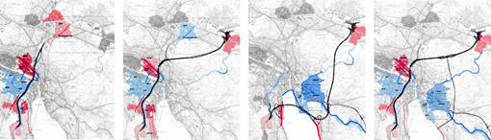
Figure 1: The four different solutions proposed in "Highway Tunnel Zürich" project. (Source: http://www.ggau.net/html/GG03.html)

Fundamental questions

The basic question that this paper aims to answer is whether the construction of a tunnel will eventually improve or worsen the traffic situation in the centre of the city. The goal is to develop an appropriate and efficient traffic model based on the available public data. This model can be used to visualise the existing traffic situation in the city of Zürich, as well as to describe the expected results after the construction of the tunnel. Based on this knowledge, it is possible to draw useful conclusions, which can be analysed in order to evaluate the impact of such a tunnel.

Expected results

As far as the expected results are concerned, it is not easy to make a prediction apart from the most obvious one, that the existence of a tunnel would improve the travelling time and reduce the traffic in the centre. The problem is that the construction of huge technical works has always many more impacts in an area than the obvious (i.e. possible rise of the population living near the tunnel exits). An in-depth study is always needed which takes into account both qualitative and quantitative factors like potential future development opportunities, construction cost, maintenance and safety and many more. Nevertheless, for the purpose of the present case study there was no need for a so detailed analysis and for that reason there is a higher probability of misjudgement.

Description of the Model

A classical urban transportation planning system model usually follows four steps:

- Trip generation determines the frequency of origins or destinations of trips in each zone by trip purpose, as a function of land uses and household demographics, and other socio-economic factors.

- Trip distribution matches origins with destinations, often using a gravity model function, equivalent to an entropy maximizing model. Older models include the fratar model.

- Mode choice computes the proportion of trips between each origin and destination that use a particular transportation mode. (This modal model may be of the logit form, developed by Nobel Prize winner Daniel McFadden.)

- Route assignment allocates trips between an origin and destination by a particular mode to a route. Often (for highway route assignment) Wardrop's principle of user equilibrium is applied (equivalent to a Nash equilibrium), wherein each driver (or group) chooses the shortest (travel time) path, subject to every other driver doing the same. The difficulty is that travel times are a function of demand, while demand is a function of travel time, the so-called bi-level problem. Another approach is to use the Stackelberg competition model, where users ("followers") respond to the actions of a "leader", in this case for example a traffic manager. This leader anticipates on the response of the followers.” (Wikipedia, n.d.)

The model that is developed for this case study is based on cellular automata. Every car is thus represented as an automaton which acts according to a very simple update rule; all the transitions will happen on a graph which represents the road network of a city, in this particular case this will be the city of Zürich. The model has two main parts:

- Trip generation: For every automaton we will generate a path that it will follow; this route will be decided at the beginning and it will stay unchanged for the rest of the simulation. The way this routes will be generated will be based on a probability distribution defined by the use of statistical data (Wikipedia, 2008) for the total of 34 neighbourhoods of the city of Zürich (file: CSVs _les population.csv) and the statistical data (Moneyhouse, 2014) of the number of new companies that are founded in each area (file: companies.csv). What we aimed to model was the everyday morning journey of people from their houses to the workplace; we will thus have that the sources of the paths will be generated with a probability proportional to the number of people living in a certain area of the city and the destinations will be generated with a probability proportional to the number of companies situated in a certain area. Additionally to the city of Zürich we also took into account the population living in smaller towns southern of the river which we aggregated as incoming and 4 outgoing from the major highways located in the south of Zürich; this has been necessary in order to evaluate the impact of a tunnel in that area.

- Trip distribution: After the intended journey for an automaton has been generated we will generate the actual path that the automaton intends to follow. We have in particular considered a realistic assumption that the paths will be decided at the beginning of the journey to be the shortest path between two locations and will remain unchanged regardless of the traffic situation of a road. For the creation of these paths the A* search algorithm has been used.

- Route assignment: At this point the automaton knows the actual path it wants to follow. It will thus be initialized in its starting location and at every time step, having length in milliseconds equal to m, it will simply advance of a quantity equal to the minimum between the distance it can travel given that it travel for m milliseconds at the maximum speed allowed by the road it is following and the distance of the next car on the path minus a safety distance. To decide in which order to update the cars in a timestep, we will simply iterate on the cars in a random order and all the decisions for a car will be taken considering the position of the other cars at the time in which the car is updated.

Implementation

Simulation Results and Discussion

To be able to interpret the results of the modelled simulation in a sensible way, the results are divided in three individual cases. The connecting point of the three cases is the average travel time, that in the end is the parameter that defines the level of success or failure of the individual simulation tests. In the first case, the correlation between the actual number of the cars that use the road network and the travel time they need in order to reach their destination is examined. In the second case, the tunnel is introduced in the existing road network and this time the simulation model calculates the travel time in correlation with some different possible positions for its construction. In the third case, the comparing model parameter is once again the average time needed for cars to move from the traffic generation points to their destination points at first in the current situation where the tunnel does not exist and then in the case the tunnel is constructed.

In correlation with the number of cars

In this first simulation evaluation the travel time is examined using different numbers of cars that actually use the existing road network of the city of Zürich. As it was initially expected and also in the end is confirmed by the results of the simulation (as shown in the figure below) there is a strong correlation between the travelling time and the number of cars that use the road network. Of course this is something that is expected mainly because of the capacity limitations of the existing road network (there is no prediction for a large number of cars in the city of Zürich). More specifically, there is an average increase of around 25% of the travel time when the number of cars is raising from 400 to 1600, more than 50% when the number of cars changes from 2000 to 4000, and finally a massive one of 100% when the number of cars increases from 400 to 4000.

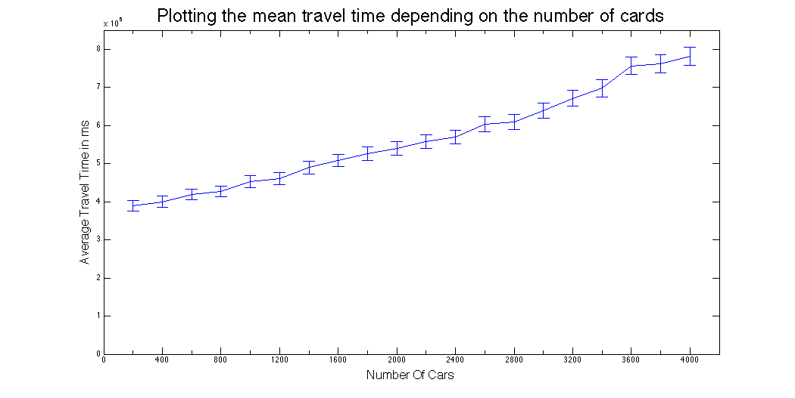

In correlation with the chosen position for the tunnel construction

In this simulation test the travel time is evaluated with respect to the position of the tunnel. Here, sixteen different scenarios are examined, which result from all the possible combinations of eight starting/ending points on the east (four points) and west side (four points) of the lake of Zürich.

From the sixteen different scenarios that are evaluated it comes out as a conclusion that with the available data, the alternative positions for the tunnel construction do not influence significantly the average time that a driver needs to move from his starting point to his destination. This is probably due to the fact that all sixteen tunnel position alternatives are close enough to each other as it can be seen by the graph below.

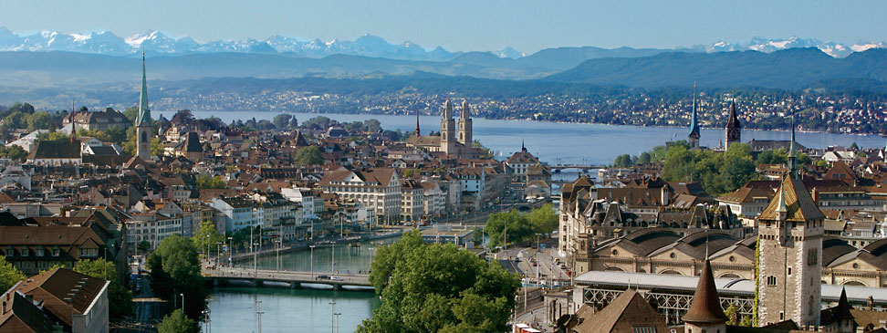

The general outcome of this evaluation is that the tunnel is expected to be used in each case by the same people, no matter its exact position.

In correlation with the construction of the tunnel in general

In the last simulation the average travelling time for the drivers before and after the construction of the tunnel is evaluated. The simulation results are summarized in the following table.

From the examination and interpretation of this simulation results it is obvious that travel time is reduced in the case the tunnel is built. The whole traffic situation in the centre of the city is improved and there are less conjunction points compared to the initial situation. More specifically, it is underlined by the results that...

Summary and Outlook

The present case study tries to visualize the traffic situation in the city of Zürich and evaluate the impact that a tunnel construction could have on the travel time, especially between the two sides of the lake.

The research question defined in the beginning of the research was answered and the conclusion was that the tunnel could improve the travel time for the benefit of the drivers using the road network of Zürich. For the implementation of the simulation, many consumptions were made (e.g. for the population and the travelling purpose) and the data used were limited. For this reason, there are still enough points for improvement.

However, the simulation model is a good base for testing real and official data for the city of Zürich and this is yet a point for future exploration. Future work on this topic should include better data acquisition. The data should refer to a wider region and not focus specifically in the city of Zürich. The main reason for that is that such a technical work is usually expected to influence a wider area and a significantly larger amount of people.

References

http://www.openstreetmap.org/
http://www.ggau.net?html?GG03.html
http://www.its.uci.edu/its/publications/papers/CASA/UCI-ITS-AS-WP-07-2.pdf http://en.wikipedia.org/wiki/Subdivisions_of_Zürich
http://www.moneyhouse.ch?en

