

Lecture with Computer Exercises:
Modelling and Simulating Social Systems with MATLAB

Project Report

Traffic simulation in the city of Zurich
…

Jan Dörrie, Simone Forte,
Charalampos Gkonos, Athina Korfiati

Zürich
May, 2014
IMPORTANT

You MUST include the ETH declaration of originality here; it is available for download on the course website or at

http://www.ethz.ch/faculty/exams/plagiarism/index_EN;

It can be printed as pdf and should be filled out in handwriting.
Agreement for free-download

We hereby agree to make our source code of this project freely available for download from the web pages of the SOMS chair. Furthermore, we assure that all source code is written by ourselves and is not violating any copyright restrictions.

Name 1 | Name 2

Table of Contents
Abstract 5
Individual contributions 5
Introduction and Motivations 5
Description of the Model 6
Implementation 7
Simulation Results and Discussion 7
Summary and Outlook 7
References 7

Abstract

In this paper, a traffic simulation for the city of Zürich is developed. The representation of traffic flows is a very useful tool for urban planning and is essential in cases that large scale construction works are planned. In the case of the city of Zurich, we were inspired from a proposed project for the construction of an underground tunnel that would connect the East and West side of the lake. The goal of this paper is to examine and derive conclusions whether such a tunnel would affect (improve or worsen) the traffic problem of the city centre. More specifically, the travelling times from certain starting points to ending ones will be examined before and after the construction of such a technical work. At the end of the simulation, the results will be analysed.

As an initial step, the route of every car is computed, using the shortest path algorithm (A* search algorithm), in the reduced road network that is selected for the project. Then, in order to model traffic propagation on given road segments, Cellular Automata model is used. Finally, the planned tunnel will be introduced not in one, but more possible solutions, and its impact on the traffic situation for each one of them will be examined.

Individual contributions

In our project, all four team members were active and contributed in the development of the simulation. More specifically, MATLAB coding and implementation was done by Jan Dörrie and Simone Forte. Charalampos Gkonos and Athina Korfiati were responsible for the data acquisition and data editing. The final analysis of the results, as well as the report preparation was performed by the whole team.

Introduction and Motivations

Traffic is a serious problem. Almost every big city in the world, no matter if it is in a developed or a developing country has to face this problem. Even in Zürich, the biggest city in Switzerland, where a very good system of public transportation exists and serves every corner of the city, the problem of traffic is not completely solved. Sometimes there is a need to look for innovative thoughts that may lead to perfect solutions. But first of all it is obvious that you have to evaluate all these alternatives in order to take the right decision. In this particular case study, a Highway Tunnel, proposed by the ARGE Züriring consortium (Güller Güller architecture urbanism, Synergo, Heierli Engineering AG, Roland Müller, Metron AG, Ecoplan) to the Department of Civil Engineering of the Canton of Zürich in 2002 is examined. According to this “Highway Tunnel Zürich” project, a tunnel that connects the two sides of the Lake of Zürich is proposed among some other alternatives. (Güller Güller architecture urbanism, 2001-2002)

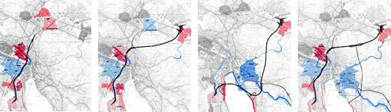
Figure 1: The four different solutions proposed in "Highway Tunnel Zürich" project. (Source: http://www.ggau.net/html/GG03.html)

With the present case study the goal is to develop an appropriate and efficient traffic model based on the available public data. This model can be used to visualise the existing traffic situation in the city of Zürich, as well as to describe the expected results after the construction of the tunnel. Based on this knowledge, it is possible to draw useful conclusions, which can be analysed in order to evaluate the impact of such a tunnel. As far as it concerns the expected results, it is not easy to make a prediction. The problem is that the construction of huge technical works has always many more impacts in an area than the obvious. An in-depth study is always needed which takes into account both qualitative and quantitative factors like potential future development opportunities, construction cost, maintenance and safety and many more. Nevertheless, for the purpose of the present case study there was no need for a so detailed analysis and for that reason there is a higher probability of misjudgement.

Description of the Model

A classical urban transportation planning system model usually follows four steps:

- Trip generation determines the frequency of origins or destinations of trips in each zone by trip purpose, as a function of land uses and household demographics, and other socio-economic factors.

- Trip distribution matches origins with destinations, often using a gravity model function, equivalent to an entropy maximizing model. Older models include the fratar model.

- Mode choice computes the proportion of trips between each origin and destination that use a particular transportation mode. (This modal model may be of the logit form, developed by Nobel Prize winner Daniel McFadden.)

- Route assignment allocates trips between an origin and destination by a particular mode to a route. Often (for highway route assignment) Wardrop's principle of user equilibrium is applied (equivalent to a Nash equilibrium), wherein each driver (or group) chooses the shortest (travel time) path, subject to every other driver doing the same. The difficulty is that travel times are a function of demand, while demand is a function of travel time, the so-called bi-level problem. Another approach is to use the Stackelberg competition model, where users ("followers") respond to the actions of a "leader", in this case for example a traffic manager. This leader anticipates on the response of the followers.” (Wikipedia, n.d.)

The model we developed for this case study is based on cellular automata. Every car is thus represented as an automaton which acts according to a very simple update rule; all the transitions will happen on a graph which represents the road network of a city, in this particular case this will be the city of Zurich. The model has two main parts:

- Trip generation: For every automaton we will generate a path that it will follow; this route will be decided at the beginning and it will stay unchanged for the rest of the simulation. The way this routes will be generated will be based on a probability distribution defined by the use of statistical data (Wikipedia, 2008) for the total of 34 neighbourhoods of the city of Zurich (file: CSVs _les population.csv) and the statistical data (Moneyhouse, 2014) of the number of new companies that are founded in each area (file: companies.csv). What we aimed to model was the everyday morning journey of people from their houses to the workplace; we will thus have that the sources of the paths will be generated with a probability proportional to the number of people living in a certain area of the city and the destinations will be generated with a probability proportional to the number of companies situated in a certain area. Additionally to the city of Zurich we also took into account the population living in smaller towns southern of the river which we aggregated as incoming and 4 outgoing from the major highways located in the south of Zurich; this has been necessary in order to evaluate the impact of a tunnel in that area.

- Trip distribution: After the intended journey for an automaton has been generated we will generate the actual path that the automaton intends to follow. We have in particular considered a realistic assumption that the paths will be decided at the beginning of the journey to be the shortest path between two locations and will remain unchanged regardless of the traffic situation of a road. For the creation of these paths the A* search algorithm has been used.

- Route assignment: At this point the automaton knows the actual path it wants to follow. It will thus be initialized in its starting location and at every time step, having length in milliseconds equal to m, it will simply advance of a quantity equal to the minimum between the distance it can travel given that it travel for m milliseconds at the maximum speed allowed by the road it is following and the distance of the next car on the path minus a safety distance. To decide in which order to update the cars in a timestep, we will simply iterate on the cars in a random order and all the decisions for a car will be taken considering the position of the other cars at the time in which the car is updated.

Implementation

Simulation Results and Discussion

In correlation with the number of cars

The figures that are presented below, show that there is a strong correlation between the travelling time and the number of cars that use the road network. Of course this is something that is expected mainly because of the limitations of the road network (there is no projection for a huge number of cars in the city of Zürich).

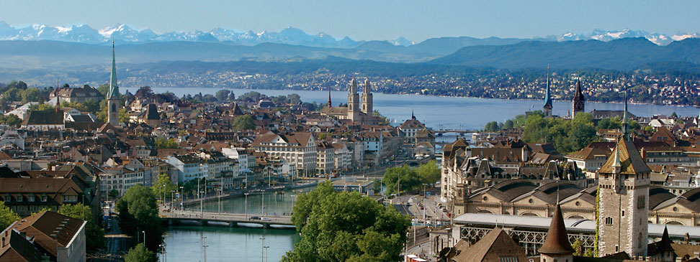

In correlation with the chosen position for the tunnel construction

From the many different scenarios that are evaluated it comes as a conclusion that with the available data, the alternative positions for the tunnel construction do not influence that much the improvement rate

In correlation with the construction of the tunnel in general

By evaluating the average travelling times for the drivers before and after the construction of the tunnel by the forthcoming images:

It can be draw the conclusion that the results in terms of travelling times would be beneficial for the users of the road network. More specifically it is underlined by the results that…

Summary and Outlook

The present case study tried to visualize the traffic situation in the city of Zurich and evaluate the impact that a tunnel construction could have in the travelling times, especially between the two sides of the lake. The research question was answered and the conclusion was that the tunnel could improve the travelling times for the benefit of the drivers using the road network of Zurich. Of course this answer cannot be taken as completely right because of the fact that the used data were limited and many assumptions were made in order to end up with some usable results.
Future work on this topic should include better data acquisition. The data should refer to a wider region and not focus only in the city of Zurich. The reason is that a technical work like this will influence a wider area.

References

http://www.openstreetmap.org/
http://www.ggau.net/html/GG03.html http://www.its.uci.edu/its/publications/papers/CASA/UCI-ITS-AS-WP-07-2.pdf http://en.wikipedia.org/wiki/Subdivisions_of_Zürich
http://www.moneyhouse.ch/en

