**Supplementary Material**

Why did participants rotate their head more when pursuing the target from a standing than a sitting posture? One possibility is that head rotations provide further sensory signals that foster visual pursuing. As postural control can benefit from reliable visual input, such head rotations could improve posture. Separate correlations between the CoP and the amount of relative head rotations for each of the six conditions did not reveal any systematic relationship (all |r| < 0.508, all p > 0.061; corrected for multiple comparisons; Figure S01), however, when pooling the data across the two standing conditions and the three target movement amplitudes, we observed that participants who rotated their head more also exhibited larger CoP paths (r = 0.31, p < 0.001; Figure 5).

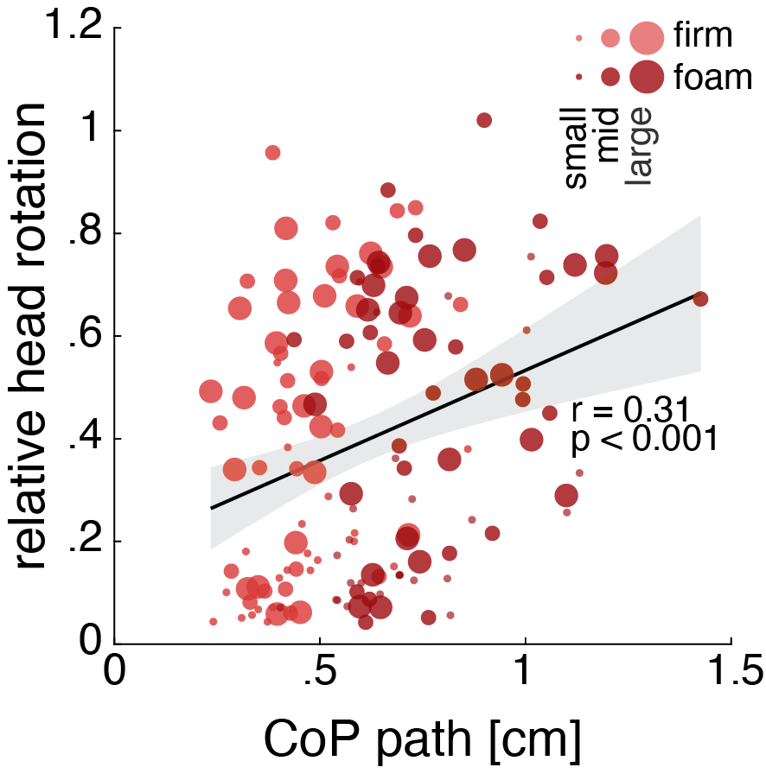

Figure S01: Scatter plot showing the correlation between the CoP path and the relative head engagement, with a fitted regression line (black) and 95% confidence interval (shaded). Data points represent individual values pooled from the two standing postures and the three target movement amplitudes, with the correlation coefficient (r) and p-value (p) displayed within the plot. Postural conditions are color-coded (firm-pink, foam-red), and target movement amplitude is reflected in the size of the scatterdots.

Figure S02: Scatter plot showing the correlation between the CoP path and the relative head engagement, with a fitted regression line (black). Data points represent individual values pooled for each standing posture (firm top row, foam bottom row) and target movement amplitude.

Figure S03: (A) CoP path for each age group and postural configuration, averaged across the two head task conditions. (B) Relative head engagement for each age group and head task, averaged across the three postural configurations. (C) Cross-correlation coefficients for the two tasks and age groups, averaged across the three postural configurations. (D) CoP path for each age group and the two head task conditions, averaged across the three postural configurations. Error bars indicate the standard error of the mean, with small circles representing individual participants.