--------------------------------------------------------

OUTPUT OF LINUX COMMANDS ON KALI LINUX

--------------------------------------------------------

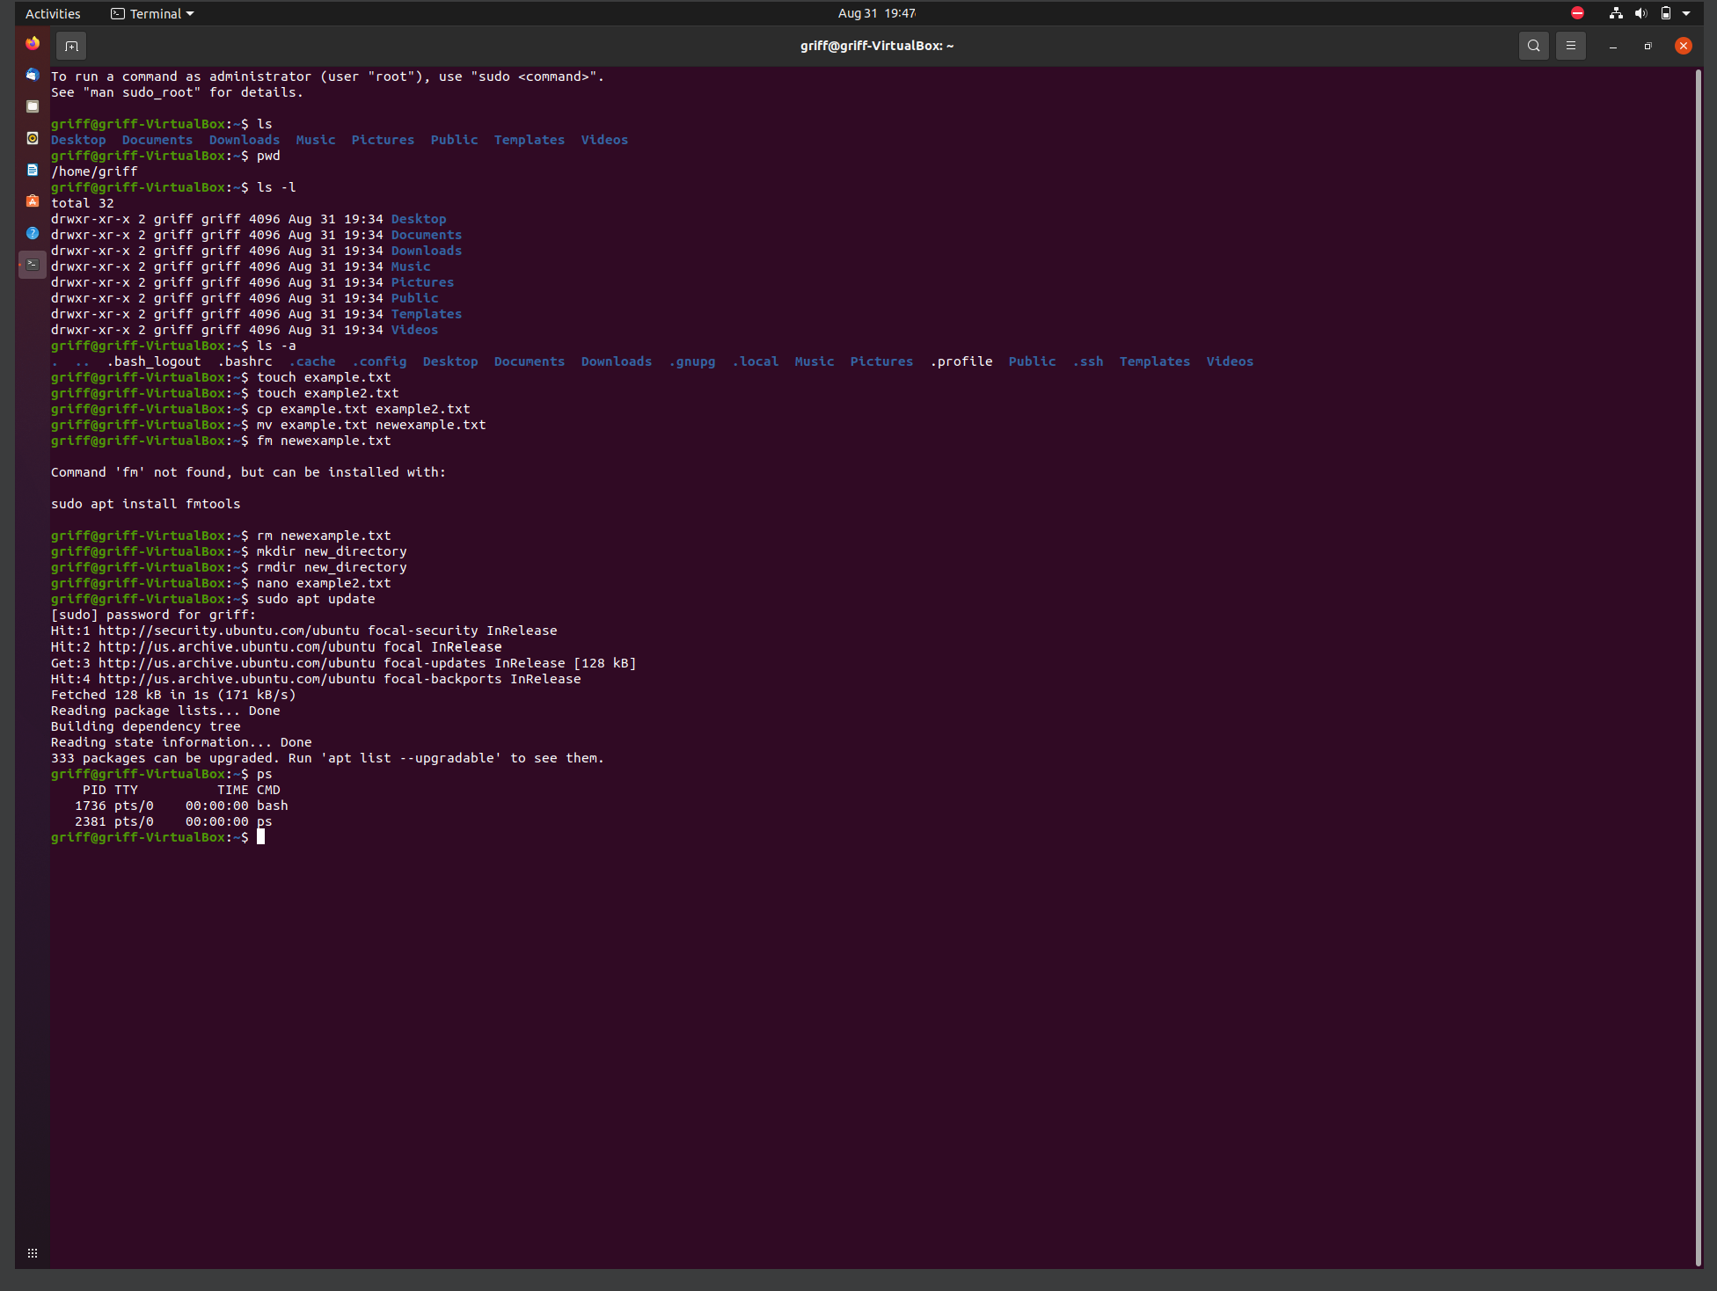

--------------------------------------------------------

OUTPUT OF LINUX COMMANDS ON KALI LINUX

--------------------------------------------------------