**Project Name: Lets Collab**

**Project Member:**

**Varshil Patel 220343120070**

**Bhagyshree Andhare 220343120011**

**Shweta Kamble 220343120043**

**Saurabh Laddha 220343120052**

**Abstract:**

Let’s Collab is a platform where developers can help each other and also work together on freelance projects. Let’s Collab provides a platform for developers where they can find other developers who are interested in collaborating in a freelance job or a personal project. It could be really good for devs who are only familiar with one aspect of a project; they could find people who are willing to work with them on a project and make new friends at the same time.

Let’s Collab provides a project post where you can get help from other people who are ready to help you with a project and another is where you can take a freelance job and collaborate with other devs for that job.

In future updates we can provide hosting services and remote repositories so the devs can work on a single remote repository and don't have to share the code each time they make some changes. We can also add a rating system so the developers who help people on their personal project and have good rating in their freelance work can get some benefits.

**Implementation Technologies:**

1. **React:**

React is a JavaScript-based UI development library. Facebook and an open-source developer community run it. Although React is a library rather than a language, it is widely used in web development.

React can be used as a base in the development of single-page, mobile, or server-rendered applications with frameworks like Next.js. However, React is only concerned with state management and rendering that state to the DOM, so creating React applications usually requires the use of additional libraries for routing, as well as certain client-side functionality.

**1.1 Features of React:**

**1.JSX (JavaScript Syntax Extension)**

JSX is a combination of HTML and JavaScript. You can embed JavaScript objects inside the HTML elements. JSX is not supported by the browsers, as a result Babel compiler transcompile the code into JavaScript code. JSX makes codes easy and understandable. It is easy to learn if you know HTML and JavaScript.

**2. Virtual DOM**

DOM stands for Document Object Model. It is the most important part of the web as it divides into modules and executes the code. Usually, JavaScript Frameworks updates the whole DOM at once, which makes the web application slow. But react uses virtual DOM which is an exact copy of real DOM. Whenever there is a modification in the web application, the whole virtual DOM is updated first and finds the difference between real DOM and Virtual DOM. Once it finds the difference, then DOM updates only the part that has changed recently and everything remains the same.

**3. Performance**

React uses virtual DOM and updates only the modified parts. So , this makes the DOM to run faster. DOM executes in memory so we can create separate components which makes the DOM run faster.

**4. Extension**

React has many extensions that we can use to create full-fledged UI applications. It supports mobile app development and provides server-side rendering. React is extended with Flux, Redux, React Native, etc. which helps us to create good-looking UI.

**5. Components**

React.js divides the web page into multiple components as it is component-based. Each component is a part of the UI design which has its own logic and design as shown in the below image. So the component logic which is written in JavaScript makes it easy and run faster and can be reusable.

**1.2 Advantages of React :**

**1. It is composable**

Composition is a function of combining parts or elements to form a whole. In the old days of web development a website was usually a single html page. So, a lot of time those web pages ended up being very long with thousands of lines of HTML codes. With modern frameworks like React, we can divide these codes and put it in custom components. Then we can utilize these components and integrate them into one place. Hence the code becomes a lot more maintainable and flexible. JSX is used for templating in React.

**2. It is declarative**

In react the DOM is declarative. We can make interactive UIs by changing the state of the component and React takes care of updating the DOM according to it. This means we never interact with DOM. Hence, it makes it easier to design UI and debug them. We can just change the program’s state and see how the UI will look at that particular time. This makes our code more predictable and easier to debug.

**3. It is simple**

The component-based approach, automatic rendering, and use of just plain JavaScript make React very simple to learn, build a web (and mobile applications), and support it. We can mix JavaScript and HTML together to create a special syntax called JSX which makes it easier to grasp and work with it.

**4. JavaScript library**

A strong blend of JavaScript and HTML syntax is always used, which automatically simplifies the entire process of writing code for the planned project. The JS library consists several functions including one that converts the HTML components into required functions and transforms the entire project so that it is easy to understand.

**5. Components Support**

ReactJS is a perfect combination of JavaScript and HTML tags. The usage of the HTML tags and JS codes, make it easy to deal with a vast set of data containing the document object model. During this time, ReactJS works as a mediator which represents the DOM and assists to decide which component needs changes to get the exact results.

1. **Express**

Express is a minimal and flexible Node.js web application framework that provides a robust set of features to develop web and mobile applications. It facilitates the rapid development of Node based Web applications. Following are some of the core features of Express framework −

* Allows to set up middlewares to respond to HTTP Requests.
* Defines a routing table which is used to perform different actions based on HTTP Method and URL.
* Allows to dynamically render HTML Pages based on passing arguments to templates.

**2.1 Advantages of Express:**

* The first and most important advantage of using Express.JS is that you would be able to get fast application development experience with it.
* Several such platforms are unable to handle a higher level of requests, but with the help of Express.JS, you would be able to handle requests efficiently as it offers you the support of I/Q request handling.
* Express.JS has a vast, highly supportive open-source community.
* You would be able to integrate several third-party applications and services with Express.JS.

1. **MongoDB:**

MongoDB is a non-relational document database that provides support for JSON-like storage. The MongoDB database has a flexible data model that enables you to store unstructured data, and it provides full indexing support, and replication with rich and intuitive APIs.

**3.1 Features of MongoDB:**

Ad-hoc queries:

MongoDB supports field, range, and regular-expression queries which can return entire documents, specific fields of documents, or random samples of results.

Indexing:

Fields in a MongoDB document can be indexed with primary and secondary indices. MongoDB supports a number of different index types, including single field, compound (multiple fields), multikey (array), geospatial, text, and hashed.

Replication:

MongoDB provides high availability with replica sets including two or more copies of the data. Writes are handled by the primary replica, while any replica is capable of serving read requests. If the primary replica fails, a secondary replica is promoted to become the primary replica.

1. **Hardware and Software Requirements (Minimum):**

**Hardware:**

1. Intel i3 processor 3rd generation or later / AMD Ryzen 200 2nd generation or later

2. 2 GB ddr3 ram.

3. Windows 7 Home edition or later.

4. 200 GB Sata HDD Space

5. Data Connection 200 kbps

**Software:**

1. Visual Stdio
2. MongoDB
3. Google Chrome
4. React
5. NodeJS
6. **ER Diagram:**

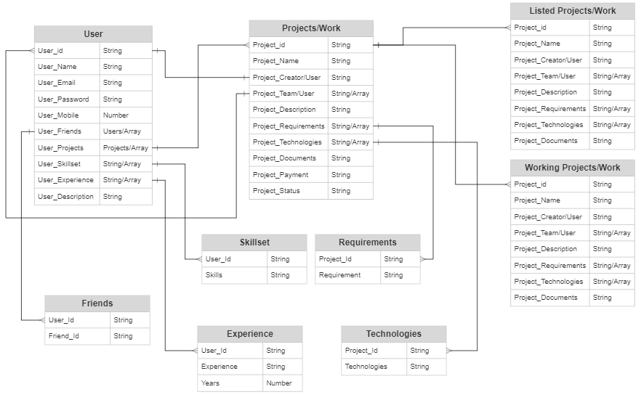

Figure 1: ER Diagram

1. **Table Structures:**
2. **Table name: User**

**Column Name Type**

userid String

name String

surname String

email String

password String

mobile Number

projects String

friends String

skillsets String

experience Number

description String

admin boolean

1. **Table name:Project**

**Column name Type**

projectid String

name String

creatorid String

description String

requirements String

projectDoc String

technologies String

payment String

status String

leaderid String

teamuserd String

1. **UML Diagrams:**

Level 0:

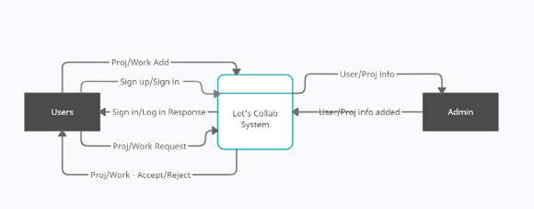

Level 1:

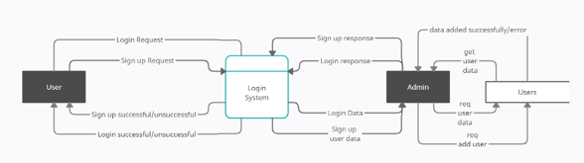

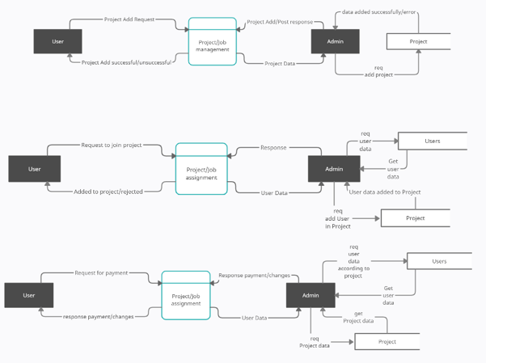

Level 2:

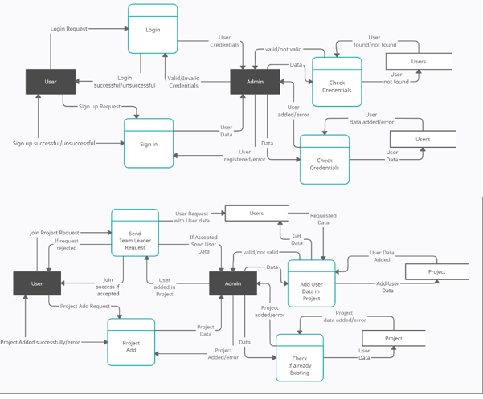

1. **End to End Flow of Application:**

**User:**

* 1. User will login to the portal or will have to register if he is not a registered user.
  2. After registration User will login and Dashboard page will be displayed to him which will display the previous complains and its status if any.
  3. From that page can User can click on the ‘**Sign Up ‘**button and reach the sign up page.
  4. In the sign up page the User has to fill up his data and create an account.
  5. After sign up user can create or join a projects/freelance.

**Admin:**

1. Admin will login as Admin from the ‘ **Login**’ page and will be able to manage database of users and project and over see the payment.
2. Admin can Review the project details.
3. After conforming about the completion of projects admin has to handle the payment of the project.
4. **Future Scope of Project**

In future updates we can provide hosting services and remote repositories so the devs can work on a single remote repository and don't have to share the code each time they make some changes. We can also add a rating system so the developers who help people on their personal project and have good rating in their freelance work can get some benefits.

**Thank You!**