Gwyn Reniers

Exercise 3.1

**Step 2**

Compare and contrast spreadsheets and databases by following the steps below:

1. Drawing on what you’ve learned in previous Achievements, use the appropriate functions in Excel to count all the actors whose first name is “Ed.” Write down the result in a text document.

*Pivot Table From Excel:*

|  |  |
| --- | --- |
| **Row Labels** | **Count of first_name** |
| Ed | 3 |
| **Grand Total** | **3** |
|  |  |

1. Copy the result that tells you the number of times the first name “Ed” appears in the “actor” table from the **Data Output** window into your text document from step 2b. Check that your answer matches your answer from step 2a. Was it easier to use Excel or the SQL statement and database to count the number of “Eds”? Provide an explanation for your answer in the same text document.

Query from SQL: SELECT COUNT(*)FROM actor WHERE first_name = 'Ed'

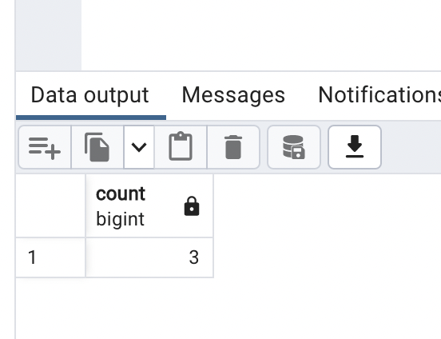

*SQL was much faster and returned the same information with fewer steps.*

**Step 3**

To answer the next set of questions, you’ll be pasting the queries provided into the Query Editor in pgAdmin

4. Note down your answers in your running text document.

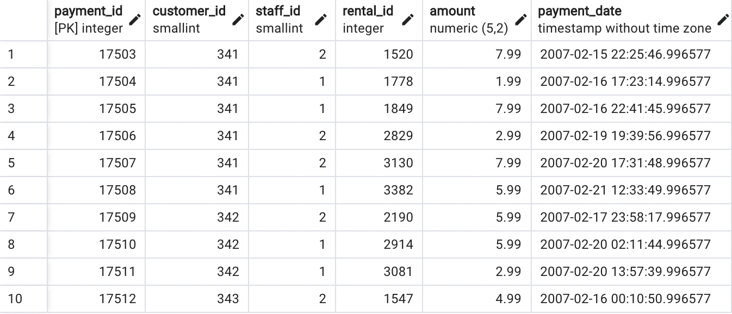

SELECT * FROM information_schema.tables

WHERE table_schema = 'public'

AND table_type = 'BASE TABLE'

* Within the pgAdmin 4 console, can you think of another way to list all the table names in the database instead of the SQL statement above?
  + *Servers -> PostgreSQL 14 -> DataBases -> Rockbuster -> Schemas - > Tables*

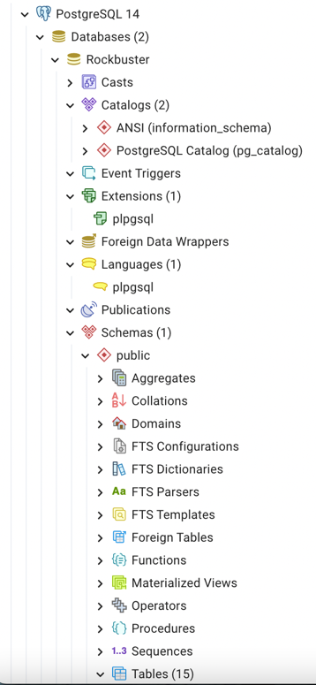 Table Names

* Analyze the rental duration distribution. How many days are most films rented for?
  + *More films are rented for 6 days. The mean rental is 5 days.*

**Step 4**

Think about who in Rockbuster Stealth might want to use an OLAP or OLTP system for their data needs; for example, the sales department, which is interested in sales trends, would likely use an OLAP system. Describe at least 2 situations for each type of system.

*OLAP*

1. *Rockbuster marketing: which genre of movie has been more popular over the last year/6 months. This could influence how many of each genre is ordered.*
2. *Which movies have been the most popular over the last 6 months? Could influence how many of each new movie is ordered to keep up with supply and demand. Conversely, which movies are not being rented often and may need to be phased out.*

*OLTP*

1. *Could be used to track frequent customer “points/rewards”.*
2. *Input new customer information/ history of customer rentals.*

**Step 5**

Rockbuster Stealth has received an invoice for the licenses for its new video collection.

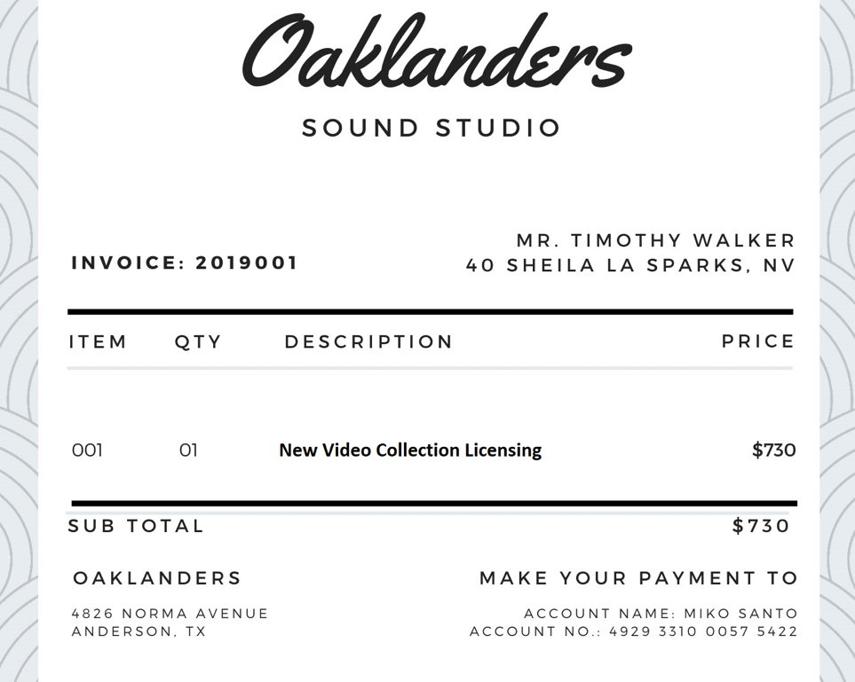

Take a moment to familiarize yourself with data in the invoice, then note down the answers to the questions below.

* Does the invoice contain structured or unstructured data? Write an explanation for your answer.

*The invoice has structured data. It can be stored in tabular form: item, quantity, description, price, address, account number. All of these data points are able to be stored easily and retrieved easily.*

* Organize and store the information on the invoice in a database. Step one will be to create a table in the text document you’ve started (you can insert a table if you’re using MS Word or Google Docs, for example). Make sure your table contains columns with the appropriate labels, as well as the values from the invoice in each column. You're focusing, here, on a high-level structuring of your data.

|  |  |  |  |  |
| --- | --- | --- | --- | --- |
| Invoice Number | Item | Quantity | Description | Price |
| 2019001 | 001 | 1 | New video collection licensing | 730.00 |

**Transaction**

|  |  |  |  |  |  |
| --- | --- | --- | --- | --- | --- |
| First Name | Last Name | Address | City | State | State Abbreviation |
| Timothy | Walker | 40 Shelia La | Sparks | Nevada | NV |

**Customer**

**Supplier**

|  |  |  |  |  |  |
| --- | --- | --- | --- | --- | --- |
| Name | Account Name | Account Number | Address | State | State Abbreviation |
| Oaklanders Sound Studio | Mike Santo | 49293319 99575422 | 4826 Norma Avenue | Texas | TX |

**Bonus Task**:

Visualize the rental duration distribution from step 3d as a histogram using Excel or Tableau Public.

