

News Recommendation System

Group number | Class 2 Group 3
Group leader | Ye Jiahui | Recommendation Algorithm/Back-end
Group member | Wu Jiawang | Back-end
Group member | Zhang Shan | Front-end
Group member | Wei Yefeng | Front-end
Group member | Wu Xiaofeng | Database
Group member | Zhang Yuchao | Database
Teachers | Gong Jibing、Gao Chang
Date | 24/5/2025

Abstract
This project, developed for a big data course, focuses on building a news recommendation system based on Apache Spark. The system analyzes user interaction data such as clicks, likes, and comments, alongside the semantic content of news articles, to construct a hybrid recommendation model. We leverage Spark's MLlib library, particularly the Alternating Least Squares (ALS) algorithm, to efficiently process large-scale behavioral data, significantly improving model training speed and scalability. The system is built on the Flask framework for front-end and back-end integration, with MySQL used to store user, news, and interaction data. By utilizing Spark’s distributed computing capabilities, the system provides real-time, personalized recommendations, helping to mitigate information overload and enhance user experience in accessing news content.
Keywords: Big Data Recommendation; Spark MLlib; Collaborative Filtering; News System; Flask

Content
Abstract I
Content I
1 Preface 1
1.1 Research background 1
1.2 Purpose and significance of research 1
2 Overall design 3
2.1 Choosing technology 3
2.1.1 Back-end framework 3
2.1.2 Front-end technology 3
2.1.3 Database Design 4
2.1.4 recommended system 5
2.2 System architecture 5
2.2.1 Hierarchical architecture 5
2.2.2 Main Functional Modules 7
2.2.3 Data stream 7
2.2.4 API interface 8
3 Detailed Design 9
3.1 Flask Frontend and Backend Development 9
3.1.1 Frontend Development 9
3.1.2 Backend Development 10
3.2 Spark-based Recommendation Algorithm Design 12
3.2.1 Data Preprocessing Based on Spark 13
3.2.2 Recommendation Algorithm Design 14
3.3 MySQL Database Design and Implementation 16
3.3.1 Overview of Database Design 16
3.3.2 Data Table Design 16
4 System test 20
4.1 Login page 20
4.2 Recommended news page 20
4.3 View news details 21
Conclusion 23
Reference 24

1 Preface

1.1 Research background
In the era of deep integration of mobile Internet and social media, the global daily data generation has exceeded 50ZB, and the news and information field has shown an exponential growth trend. On the one hand, users are facing the dilemma of massive information overload. The traditional news - pushing model makes it difficult for users to accurately obtain the content they need during fragmented reading. On the other hand, news platforms release millions of pieces of information every day, and problems such as homogeneous content and poor timeliness restrict the communication efficiency. At the same time, the breakthroughs in artificial intelligence and deep - learning technologies provide the technological foundation for the intelligent upgrade of news recommendation systems. Against this backdrop, a news recommendation system based on big data analysis has become a key approach to solving the contradiction between information supply and demand.

1.2 Purpose and significance of research
This project aims to construct a three - level news recommendation model based on big data analysis. By mining user behavior data, text semantic features, and social relationship networks, it realizes a three - level recommendation system of "real - time access to hot news - precise push of interest - based content - intelligent mining of long - tail information". The research results can not only effectively enhance users' reading experience and information acquisition efficiency, and reduce users' information screening costs; but also help news platforms optimize content distribution strategies, improve user retention and activity rates, and form a differential competitive advantage. Meanwhile, this research has important practical value for promoting the intelligent transformation of the media industry and facilitating the upgrading of information consumption, providing technical support for building a healthy and sustainable digital content ecosystem.

2 Overall design

2.1 Choosing technology
In terms of technology selection for this system, full consideration has been given to performance, scalability, development efficiency and big data processing capabilities. The following core technology stacks have been chosen:

2.1.1 Back-end framework
Flask: As a lightweight Python Web framework, Flask has been selected as the core Web application framework due to its simplicity and flexibility. It can quickly construct RESTful API interfaces and handle HTTP requests, and is suitable for implementing user authentication, session management, and interaction logic with the front end. Its minimalist design enables developers to freely select components according to project requirements, keeping the system lightweight.
PySpark: PySpark is the Python API of Apache Spark and has been selected as the core tool for big data processing and recommendation engines. Its powerful distributed computing capability enables it to efficiently handle massive user behavior data (such as clicks, likes, and dislikes), conduct large-scale collaborative filtering calculations, and generate real-time recommendation results.

2.1.2 Front-end technology
HTML: As the standard for web page structure, it is used to build the framework and content of a page.
CSS: responsible for the visual style of the page design, including the layout, color, font, etc., to ensure that the user interface of beautiful with responsive experience.
JavaScript: at the core of the front-end interactive language, used to implement dynamic content to load, the response of user events and form validation, and by the backend API with AJAX asynchronous communication, improve the user experience.

2.1.3 Database Design
The system uses MySQL as a relational database to store core business data, including user information, news content, and user interaction records. MySQL is known for its maturity, stability, high performance, data consistency (ACID properties), and extensive community support, making it an ideal choice for storing structured data.
users table: Stores basic user information.
user_id (Primary Key): Uniquely identifies a user.
username (Unique): User login name, ensuring uniqueness.
news table: Stores news content metadata.
news_id (Primary Key): Uniquely identifies a news item.
category (News Category): Facilitates news categorization and recommendation.
content (News Content): Detailed text content of the news.
click_count (Click Count): Records the number of times a news item has been clicked, usable for popular news statistics.
user_clicks table: Records user interaction with news.
user_id (Foreign Key): Links to the users table, identifying which user performed the interaction.
news_id (Foreign Key): Links to the news table, identifying which news item was interacted with.
react (like/hate): Records user feedback on news (e.g., like/dislike), a crucial input for collaborative filtering algorithms.

2.1.4 recommended system
Algorithm strategy: The core of this system adopts User-Behavior-Based Collaborative Filtering. This algorithm discovers the similarity of interests among users or the correlation between items by analyzing the historical behaviors of users (such as clicks, likes, and dislikes), and then recommends the news that users may be interested in.
Using tools: PySpark for large-scale data processing and the realization of the recommendation algorithm. The distributed computing capability of PySpark enables it to efficiently handle massive user interaction data, construct the user-news interaction matrix, and run complex recommendation algorithms (such as ALS alternating least squares), thereby generating high-quality personalized recommendation lists.
Considerations: the be fond of of recommender systems not only consider the user explicitly (thumb up/on), also combining news category information, provide diversification and relevance is strong.

2.2 System architecture
The system adopts a clear hierarchical architecture and combines the microservice concept (with the recommendation engine as an independent service) to achieve the design goals of modularization, high cohesion and low coupling, ensuring the maintainability, scalability and performance of the system.

2.2.1 Hierarchical architecture
2.2.1.1 Presentation Layer
Front-end pages (templates/): Responsible for presenting the user interface and capturing user interaction.
index.html: System login page, handling user identity authentication.
recommend.html: The main recommendation page, displaying a personalized news list.
news_detail.html: News detail page, which displays the complete content of a single piece of news and provides interactive functions.
2.2.1.2 Application Layer
app.py (Flask application) : The core business logic layer of the system.
Routing processing: Define RESTful API endpoints and map them to the corresponding business logic based on the URL.
Session management: Maintain the user login status through the Flask Session mechanism.
Business logic: Handle core business processes such as user authentication, news recommendation requests, user interaction feedback, and data updates.
2.2.1.3 Data Layer
MySQL database: Responsible for the persistent storage and management of data.
User data: Store user account information.
News data: Store the detailed content and metadata of news articles.
Interaction data: Records users' behaviors such as clicks, likes, and dislikes on news.
2.2.1.4 Recommendation Engine
spark_recommend.py: An independent recommendation service module.
Data preprocessing: Obtain raw user behavior data from databases or other data sources, clean, transform and format it to meet the requirements of recommendation algorithms.
Recommendation algorithm: Based on preprocessed data, run collaborative filtering and other recommendation algorithms to calculate the matching degree between users and news.
Result generation: Store or directly provide the calculated recommendation list to the application layer.

2.2.2 Main Functional Modules
User authentication module
User login: Process the username submitted by the user and perform identity verification.
Session management: Utilizing the Flask Session mechanism, create and maintain user sessions after the user logs in successfully to ensure the user's status in the system.
News Recommendation Module
Recommendation based on user behavior: According to the user's historical clicks, likes, dislikes and other behaviors, a personalized news recommendation list is generated through the recommendation engine.
News classification: Classifying and managing news not only facilitates users' browsing but also provides additional dimensions for the recommendation system.
News Presentation Module
News list: Display a summary list of personalized or popular news on the recommendation page.
News details: After clicking on the news summary, you will be redirected to the news details page to display the complete content of the news.
User interaction (like/dislike) : Provide a button on the news detail page for users to give feedback on the news. The operation will be recorded and used for the update of the recommendation algorithm.

2.2.3 Data stream
The data flow of the system clearly defines the communication and data transmission paths among each component:
User request: The front-end page initiates an HTTP request (such as login, obtaining recommendations, update feedback, etc.).
Flask Routing: app.py receives requests and distributes them to the corresponding business logic processing functions through routing.
Business processing:
For core businesses (such as login and user data update), interact directly with the MySQL database (add, delete, modify, and query).
For recommendation requests, the business layer will trigger or invoke the recommendation engine.
Recommendation request → PySpark Processing: The recommendation engine (spark_recommend.py) receives the recommendation request, possibly reads the latest user behavior data from MySQL, and uses PySpark for big data processing and recommendation algorithm calculation.
Recommendation results → Return to the front end: The recommendation engine returns the calculated personalized recommendation list to the Flask application layer. The application layer then encapsulates the data and responds to the front end through an API.
After receiving the data, the front end updates the page content to complete the closed loop of user interaction.

2.2.4 API interface
The system provides a clear and standardized set of RESTful API interfaces for invocation by the front end and other services:
GET / : Load the login page.
POST / : Handle user login requests.
GET /recommend: Load the recommended news page.
GET /api/recommend: Obtain the personalized recommended news list of the current user (JSON data).
POST /api/update_reaction: Update users' likes/dislikes feedback on news.
POST /api/update_click: The number of clicks to update the news.
GET /news_detail/<id> : Load the detail page of the specified news ID.
GET /api/news_detail/<id> : Obtain the detailed content (JSON data)

3 Detailed Design

3.1 Flask Frontend and Backend Development
Adopting a frontend-backend separation design pattern
Backend: Flask + MySQL
Frontend: HTML + CSS + jQuery

3.1.1 Frontend Development
3.1.1.1 Page Structure
index.html: Login page
Simple login form
Username input validation
Responsive design
ecommend.html: Recommendation list page
Infinite scroll loading
News card display
Interactive features (like, dislike, browse)
news_detail.html: News detail page
Complete news content display
Interactive features
Return to recommendation list
3.1.1.2 Interaction Logic:
Login Process
Frontend form submission → Backend validation → Redirect to recommendation page
Recommendation Page Interaction
Initial loading → Scroll loading → Interactive feedback (clicking on news redirects to detail page or real-time feedback for likes/dislikes)
Detail Page Interaction
Automatically loads clicked news content → Real-time update of interactive buttons → Return to recommendation page
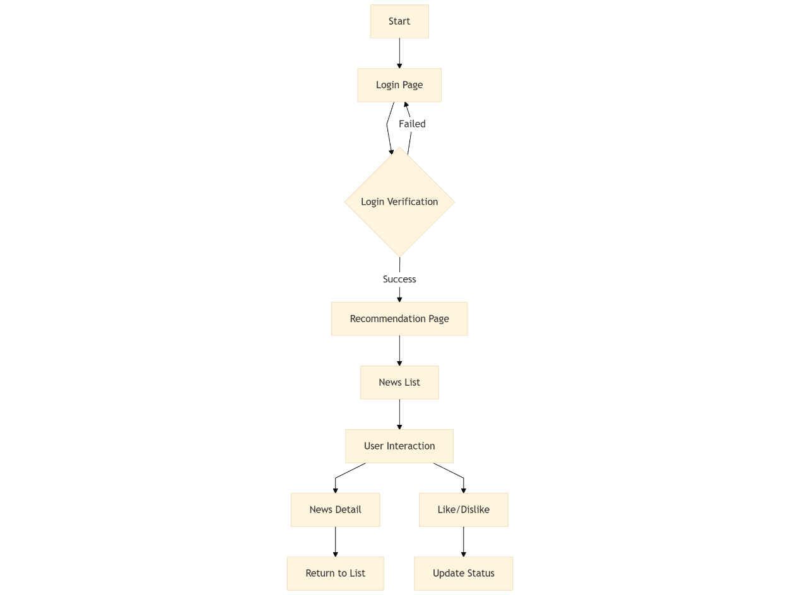
Figure 3-1 Front-end flow chart

3.1.2 Backend Development
3.1.2.1 Database Configuration
app.config['MYSQL_HOST'] = 'localhost'
app.config['MYSQL_USER'] = 'root'
app.config['MYSQL_PASSWORD'] = '123456'
app.config['MYSQL_DB'] = 'news_recommend'
mysql = MySQL(app)
3.1.2.2 Main Route Design:
Login System
@app.route('/', methods=['GET', 'POST'])
def index():
# Handle user login
Handle GET request: Display login page
Handle POST request: Validate user login
Login success: Store user ID in session and redirect to recommendation page
Login failure: Return error message
Recommendation Page
@app.route('/recommend')
def recommend():
# Display recommended news list
Check user login status
Fetch recommended news list
Support pagination loading
Include detailed news information (category, content, click count, like count, etc.)
Handle cases where recommendations are insufficient
News Detail
@app.route('/news_detail/<int:news_id>')
def news_detail(news_id):
# Display news details
Display the news detail page
Retrieve detailed information of a single news item
Includes the complete news content, category, click count, like count, etc.
Handle cases where the news does not exist.
3.1.2.3 API Interfaces
/api/recommend - Fetch recommended news
/api/news_detail/<news_id> - Fetch news details
/api/update_reaction/<news_id>/<reaction> - Update user reactions (like/dislike)
/api/update_click/<news_id> - Update click count
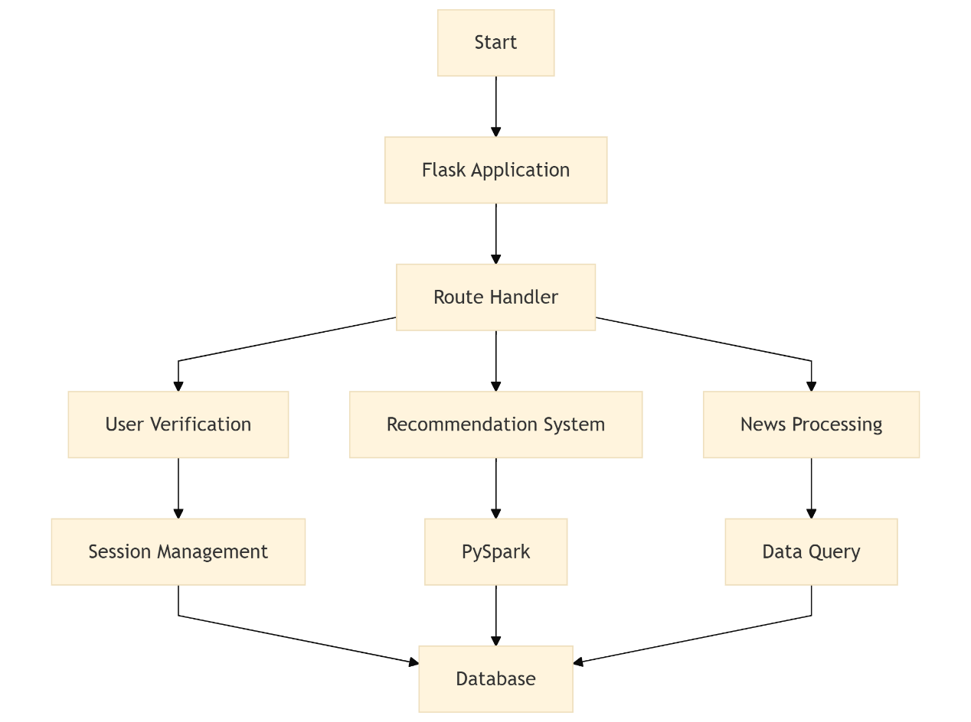
Figure 3-2 Back-end flow diagram

3.2 Spark-based Recommendation Algorithm Design
This project builds a personalized news recommendation system based on Apache Spark, aiming to provide users with efficient and accurate news delivery. The system supports distributed processing and modeling of massive news texts and user behavior data. It integrates multiple strategies such as collaborative filtering, content-based recommendation, and popularity-based recommendation to improve the accuracy and diversity of recommendations.

3.2.1 Data Preprocessing Based on Spark
3.2.1.1 Importing Raw Dataset into the Database
The original news data is stored as text files in the local file system, organized into subdirectories by category. To facilitate unified modeling using Spark, the files are first read, cleaned, and written into the news table in a MySQL database via PySpark.
The main processing flow is as follows:
Supports multiple encoding formats (UTF-8, GBK, BIG5, etc.) to improve compatibility with files from different sources.
Removes numbers from category names, e.g., "Sports450" is converted to "Sports".
Limits the file content to within the maximum length of the LONGTEXT type (4GB).
After processing, the content and category are written into the database as two columns.
clean_category = re.sub(r"\d+", "", category)
with open(file_path, "r", encoding=encoding) as file:
content = file.read()[:4294967295]
spark_df = spark.createDataFrame(all_news_data)
spark_df.select("content", "category").write.jdbc(db_url, "news", mode="append", properties=db_properties)
3.2.1.2 Constructing User Behavior Ratings
The `user_clicks` table in the system records user interactions with news items (clicks, likes, dislikes, etc.). These behaviors are mapped to numerical ratings for use in training recommendation models.
def get_weighted_rating(react):
if react == "like":
return 2
elif react == "hate":
return -1
else:
return 1
ratings_df = user_clicks_df.withColumn(
"rating", F.udf(get_weighted_rating)(F.col("react"))
).withColumn("rating", F.col("rating").cast("float"))

3.2.2 Recommendation Algorithm Design
The recommendation module consists of three types of algorithms: collaborative filtering, content-based recommendation, and popularity-based recommendation. The results from the three algorithms are merged to generate the final recommendation list.
3.2.2.1 Collaborative Filtering Recommendation (ALS Algorithm)
Collaborative filtering is a recommendation method based on the similarity of user behaviors. This system uses Spark MLlib’s ALS (Alternating Least Squares) algorithm to build a user-item matrix based on user ratings of news items. It learns latent vector representations of users and news through matrix factorization and predicts news that users may be interested in.
als = ALS(
maxIter=10,
regParam=0.1,
userCol="user_id",
itemCol="news_id",
ratingCol="rating",
coldStartStrategy="drop"
)
model = als.fit(ratings_df)
user_recommendations = model.recommendForAllUsers(10)
3.2.2.2 Content-Based Recommendation (TF-IDF)
Content-based recommendation analyzes the similarity of news content to recommend news similar to those that users have read. This system uses the TF-IDF (Term Frequency-Inverse Document Frequency) method to extract keyword features from the news text and then calculates cosine similarity between news items.
By calculating the TF-IDF similarity between a user’s recently clicked news items and candidate news items, content-based recommendations can be obtained.
tokenizer=Tokenizer(inputCol="content", outputCol="words")
words_data = tokenizer.transform(news_df)
hashingTF = HashingTF(inputCol="words", outputCol="raw_features", numFeatures=1000)
featurized_data = hashingTF.transform(words_data)
idf = IDF(inputCol="raw_features", outputCol="features")
idf_model = idf.fit(featurized_data)
rescaled_data = idf_model.transform(featurized_data)
3.2.2.3 Popularity-Based Recommendation
Popularity-based recommendation is a non-personalized recommendation strategy. It builds a global popularity score based on overall click counts, likes, and other indicators of news items. News with high scores are recommended to all users, especially those in cold-start scenarios.
popularity_df = news_df.withColumn(
"popularity_score", F.col("click_count") * 0.5 + F.col("like_count") * 0.5
)
popular_news = popularity_df.orderBy(F.desc("popularity_score")).limit(50)
3.2.2.4 Recommendation Result Fusion and Storage
The results from the three recommendation strategies are deduplicated and merged. The final recommendations are stored in JSON format in the `user_recommend` table of the database for frontend system retrieval and display.
final_recommendations = list(set(collaborative + content + popularity))
recommend_df = spark.createDataFrame(recommend_data, ["user_id", "recommendation"])
recommend_df.write.jdbc(jdbc_url, "user_recommend", mode="overwrite", properties=connection_properties)

3.3 MySQL Database Design and Implementation

3.3.1 Overview of Database Design
This system uses MySQL as the database management system. MySQL is open - source, high - performance, and easily extensible, which can meet the system's requirements for data storage and management. The database design adheres to the normalization principle, aiming to ensure data integrity, consistency, and efficient access. Through the analysis of the system's business processes, multiple data tables have been designed to store different types of data. The following provides a detailed introduction to the key data tables.

3.3.2 Data Table Design
3.3.2.1 news Table
Function: Stores news-related information.
Field Description:
news_id: Type int, non-null and auto-incrementing, serving as the unique identifier and primary key of the news. Uses a BTREE index to ensure efficient data retrieval.
content: Type longtext, stores the specific content of the news. Uses the utf8mb4 character set and utf8mb4_0900_ai_ci collation to support multi-language and special character storage.
category: Type varchar(50), stores the category of the news, limited to 50 characters.Also uses the utf8mb4 character set and utf8mb4_0900_ai_ci collation.
click_count: Type int, records the number of clicks on the news, with a default value of 0.
like_count: Type int, records the number of likes on the news, with a default value of 0.
hate_count: Type int, records the number of negative feedbacks on the news, with a default value of 0.
Table 3-1 news table
Attribute Name | Type | Not null Key
news_id | int | yes Primary Key
content | longtext | yes
category  click_count  like_count  hate_count | varchar  int  int  int | yes
2.user_clicks Table
Function: Records users' behavioral operations on news.
Field Description:
user_id: Type int, non-null, serves as the unique identifier of the user, one of the primary keys, and is used to associate user-related information.
news_id: Type int, non-null, associates with the news ID in the news table to identify the news operated by the user, and is a foreign key.
is_clicked: Type float, nullable, records numerical information about whether the user clicked on the news.
react: Type enum, non-null, stores the user's feedback type on the news (e.g., like, dislike, or click).
Table 3-2 user_clicks table
Attribute Name | Type | Not null Key
user_id  news_id | int  int | yes Primary Key/Foreign Key  Foreign Key
is_clicked | float | yes
react | enum | yes
3.user Table
Function: Stores basic user information.
Field Description:
user_id: Type int, non-null, serves as the unique identifier of the user, is the primary key, and associates the user's behavioral records in other tables.
username: Type varchar(255), non-null, stores the user's username, using the utf8mb4 character set and utf8mb4_0900_ai_ci collation.
Table 3-3 user table
Attribute Name | Type | Not null Key
user_id  username | int  varchar | yes Primary Key  yes
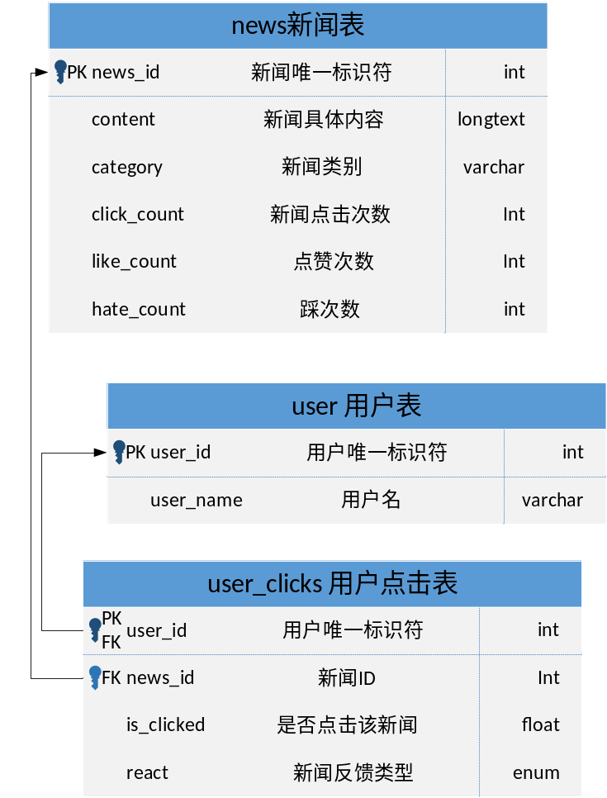
Figure 3-3 Table Design Diagram

4 System test

4.1 Login page
You can access it by typing http://localhost:5000/ in your browser.After entering the website address, you will enter the initial login interface.You can log in by entering your username.
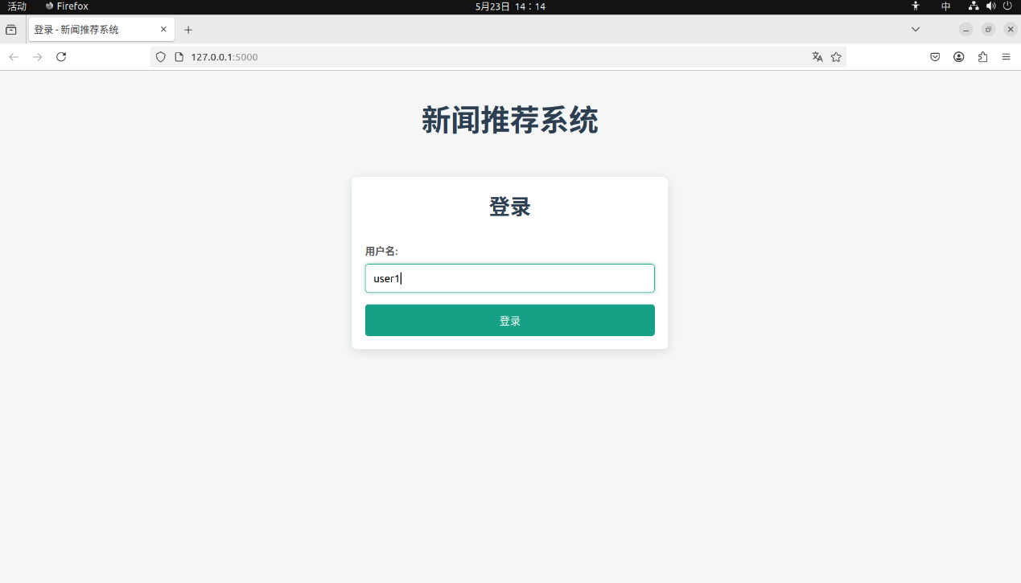
Figure 4-1 Login page

4.2 Recommended news page
After logging in, you can see the initially recommended news, as well as display news categories, content summaries, view counts, like/click buttons, etc.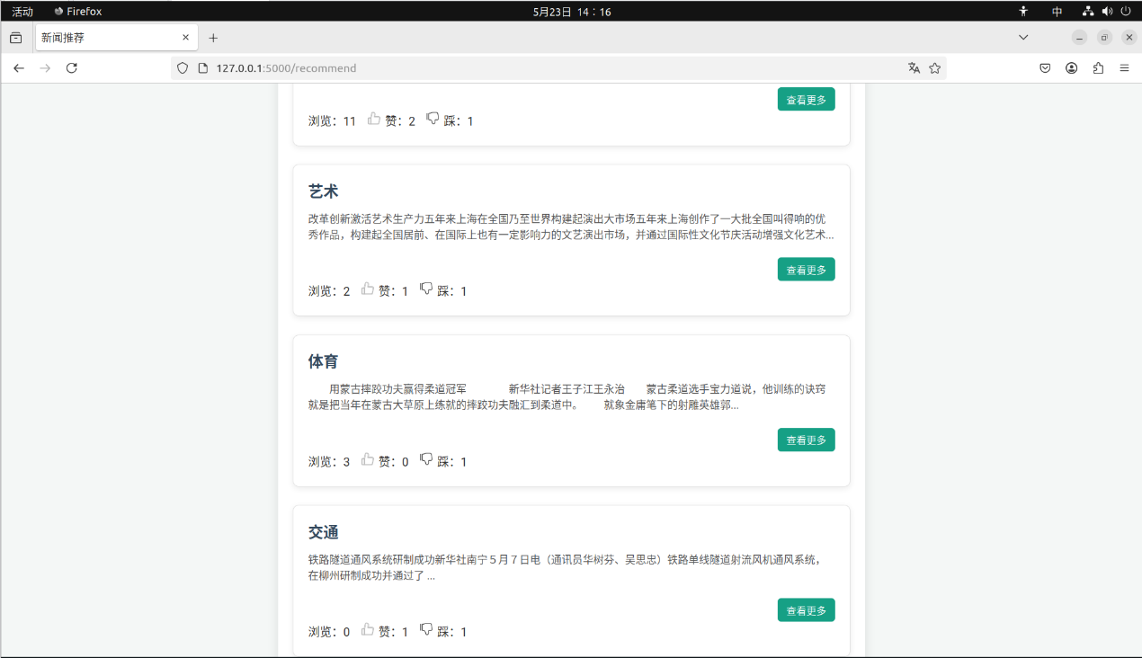
Figure 4-2 Recommended news page

4.3 View news details
Entering the detail viewing page allows you to view the complete news content. At the same time, the page view count increases. You can also perform the function of clicking or stepping on this news. If you click the button, the color of the button icon will change and the count will increase.
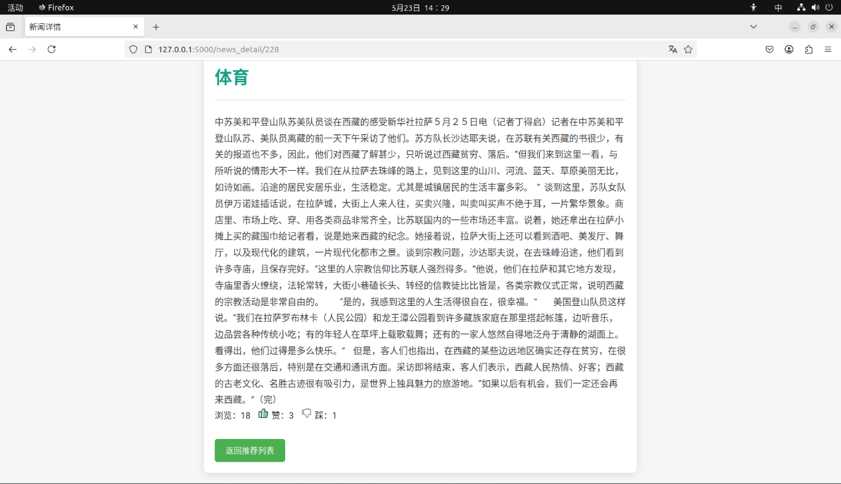
Figure 4-3 View news details page

Conclusion
This project implements a personalized news recommendation system with Apache Spark as the core processing engine. We employed Spark’s distributed computing power and leveraged the ALS algorithm from MLlib to model user-news interactions, enabling collaborative filtering. Throughout the data preprocessing, feature extraction, and model training stages, Spark demonstrated excellent performance and scalability, ensuring stable operation of the system in a big data environment.
The system, developed using Flask, supports features such as user login, news display, behavioral feedback, and recommendation output. MySQL serves as the backend database for data storage. The recommendation algorithm combines collaborative filtering with content-based and popularity-based models, improving recommendation accuracy and coverage. During development, we gained deep insights into Spark’s core programming model and its application in recommendation systems.
Future work will focus on refining the recommendation algorithm, such as incorporating temporal behavior modeling and improving the cold-start recommendation for new users. Additionally, exploring social relationship modeling using Spark’s GraphX will further enhance the personalization of the recommendations.

Reference
- Y. Koren, R. Bell, and C. Volinsky. Matrix Factorization Techniques for Recommender Systems[J]. Computer, 2009, 42(8): 30-37.
- J. Han, M. Kamber, and J. Pei. Data Mining: Concepts and Techniques[M]. 3rd Edition, Burlington: Morgan Kaufmann Publishers, 2011: 102-130.
- P. Resnick, and H. R. Varian. Recommender Systems[J]. Communications of the ACM, 1997, 40(3): 56-58.
- M. J. Pazzani, and D. Billsus. Content-Based Recommendation Systems[M]. In: The Adaptive Web, Lecture Notes in Computer Science, Vol. 4321, Springer, 2007: 325-341.
- X. Su, and T. M. Khoshgoftaar. A Survey of Collaborative Filtering Techniques[A]. In: Proceedings of the 2009 International Conference on Artificial Intelligence and Statistics[C]. 2009: 1-19.
- R. R. Covington, E. Adomavicius, and D. Sarmenta. Practical Techniques for Implementing Large-Scale Recommender Systems[A]. In: Proceedings of the 2015 ACM Conference on Recommender Systems[C]. Vienna: ACM, 2015: 493-494.

