Liyanwei

**1. Basic Tasks**

**1.1 Create a Simple HR System**

1. **Create a Database**: Use the DDL (Data Definition Language) component to create a CREATE DATABASE UniversityHR;

USE UniversityHR;

CREATE TABLE FACULTY (

facultyId INT PRIMARY KEY,

facultyName VARCHAR(100) NOT NULL,

NoOfStaff INT

);

CREATE TABLE STAFF (

staffId INT PRIMARY KEY,

staffName VARCHAR(100),

staffDOB DATE,

staffFaculty INT,

FOREIGN KEY (staffFaculty) REFERENCES FACULTY(facultyId)

);

**1.2 Insert Data into the Tables**

* When inserting data, add the FACULTY data first since the staffFaculty field in the STAFF table references the primary key in the FACULTY table.

INSERT INTO FACULTY (facultyId, facultyName, NoOfStaff)

VALUES (1, 'Engineering', 50), (2, 'Science', 60), (3, 'Arts', 70);

INSERT INTO STAFF (staffId, staffName, staffDOB, staffFaculty)

VALUES (101, 'Alison Green', '1985-04-23', 1),

(102, 'Kieran West', '1979-11-12', 2);

**1.3 Execute Data Retrieval and Modifications**

SELECT * FROM STAFF;

SELECT facultyName FROM FACULTY WHERE NoOfStaff < 75;

SELECT * FROM STAFF WHERE YEAR(staffDOB) BETWEEN 1980 AND 1989;

SELECT staffId AS 'ID', staffName AS 'Name', staffDOB AS 'Date of Birth', staffFaculty AS 'Faculty'

FROM STAFF

ORDER BY staffName DESC;

* **Update Alison Green's faculty to Engineering**:

UPDATE STAFF SET staffFaculty = 1 WHERE staffName = 'Alison Green';

* **Delete Kieran West’s record**:

DELETE FROM STAFF WHERE staffName = 'Kieran West'; 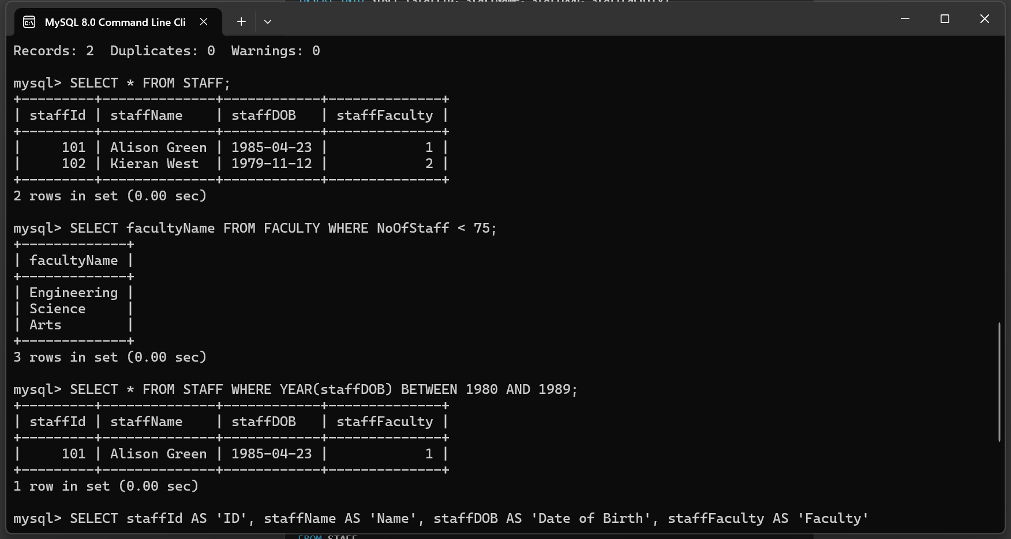

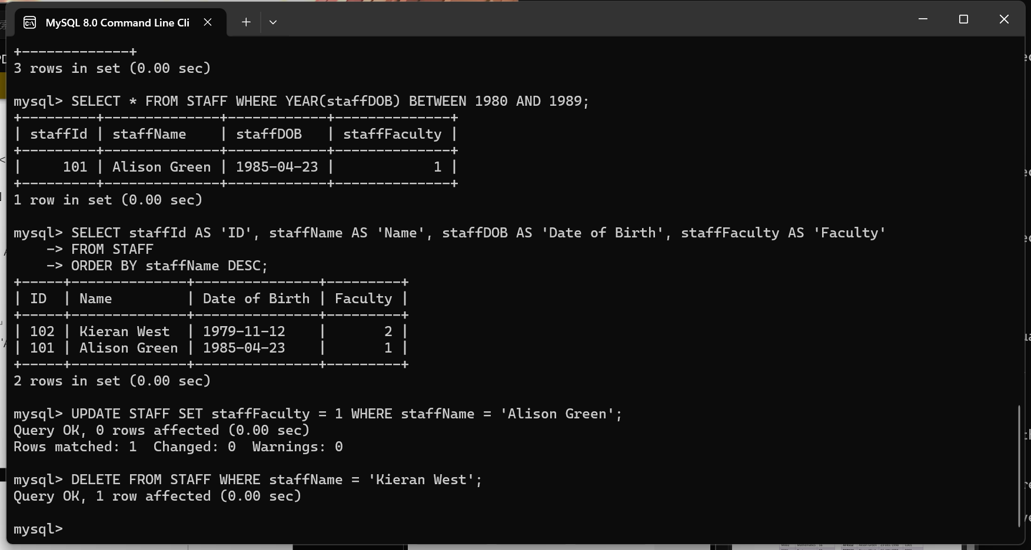

**2. Medium Task**

**2.1 Create a Banking System Database**

1. **Create a Database**:

CREATE DATABASE FriendlyBank;

USE FriendlyBank;

1. **Create Tables (ACCOUNT, ACC_TRANSACTION, BRANCH, etc.)**:

CREATE TABLE CUSTOMER (

custID INT PRIMARY KEY,

firstName VARCHAR(50),

lastName VARCHAR(50),

birthDate DATE,

fedID VARCHAR(20)

);

CREATE TABLE ACCOUNT (

accountID INT PRIMARY KEY,

custID INT,

productCode VARCHAR(10),

availableBalance DECIMAL(10, 2),

pendingBalance DECIMAL(10, 2),

FOREIGN KEY (custID) REFERENCES CUSTOMER(custID)

);

CREATE TABLE ACC_TRANSACTION (

transID INT PRIMARY KEY,

accountID INT,

transDate DATE,

amount DECIMAL(10, 2),

FOREIGN KEY (accountID) REFERENCES ACCOUNT(accountID)

);

**2.2 Answer Questions with SQL Statements**

* **Query to display the result of increasing a value of 28,964 by 18.5%**:

SELECT 28964 * 1.185 AS IncreasedValue;

* **List the first and last names of all employees**:

SELECT firstName, lastName FROM EMPLOYEE;

* **List distinct product types offered by the bank**:

SELECT DISTINCT productType FROM PRODUCT;

* **List all employees whose first name starts with the letter ‘S’**:

SELECT * FROM EMPLOYEE WHERE firstName LIKE 'S%';

* **Delete all transactions made on the 30th of July 2003**:

DELETE FROM ACC_TRANSACTION WHERE transDate = '2003-07-30';

* **Update Susan Tingley’s surname to Brown**:

UPDATE CUSTOMER SET lastName = 'Brown' WHERE firstName = 'Susan' AND lastName = 'Tingley';