Liyanwei

Task 1: Hierarchy of Abstraction

1. Humans, Mammals, Monkeys, Primates

• Hierarchy:

• Primates

• Mammals

• Humans

• Monkeys

2. Linux, Oracle, Software System, Operating System, Database Management System, MySQL, Windows, Chrome

• Hierarchy:

• Software System

• Operating System

• Linux

• Windows

• Database Management System

• Oracle

• MySQL

• Application

• Chrome

Task 2: Definition of Terms in the Entity Relationship Model

1. Entity: An object that exists and is distinguishable, such as a user or product.

2. Entity Type: A classification of entities, like “User” or “Order.”

3. Entity Instance: A specific occurrence of an entity, such as a particular user or order record.

4. Optional: A property in a relationship where an entity may or may not exist.

5. Mandatory: A property in a relationship where an entity must exist.

6. Cardinality: Represents the number of instances of one entity that can be associated with instances of another entity, such as “one-to-many” or “many-to-many.”

Task 3: Definition of Data Model

1. Definition of Data Model:

• A data model is a way of describing the structure, relationships, and constraints of data.

2. Importance of Data Modeling:

• Helps organize data structure.

• Enhances data accessibility and usability.

• Provides a foundation for application development.

Task 4: ER Diagram

• Scenario Description: Design a company structure representing the relationships between a branch, department, employee, and project.

• ER Diagram Constraints:

• An employee belongs to one department.

• A department must be managed by one employee.

• A branch has at least one department.

• An employee can participate in multiple projects.

Task 5: ER Diagram for Hospital Scenario

1. Entity Identification:

• Doctor

• Patient

• Appointment

• Test

2. Attributes:

• Doctor: Doctor ID, Name, Specialty

• Patient: Patient ID, Name, Date of Birth, Address

• Appointment: Appointment ID, Date, Diagnosis, Prescription

• Test: Test ID, Results, Date

3. ER Diagram Example:

• Create an ER diagram using Chen’s notation to represent entities, attributes, and relationships.

Task 6: ER Diagram for Medical Appointments

1. ER Diagram:

• A patient can make an appointment with one doctor only.

Task 7: ER Diagram for Banking System

1. ER Diagram Elements:

• Bank: Each bank is identified by name and contains multiple bank accounts.

• Bank Account: Each account is identified by bank and account holder, with balance calculations.

• Customer: Each customer is identified by customer ID and has a name.

• Transaction: Each transaction is identified by depositor account, withdrawal account, timestamp, currency, and amount.

• Loan: Each loan is identified by loan ID, amount, and date taken out.

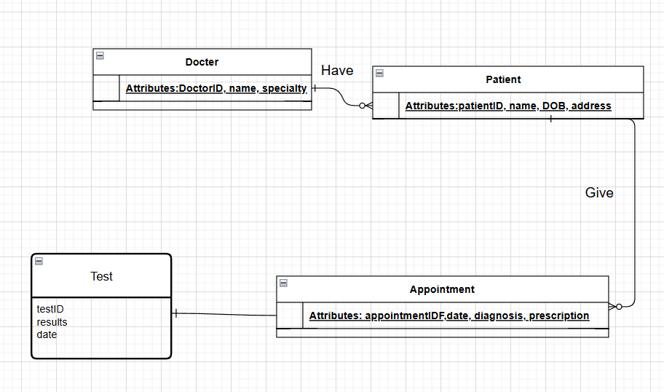

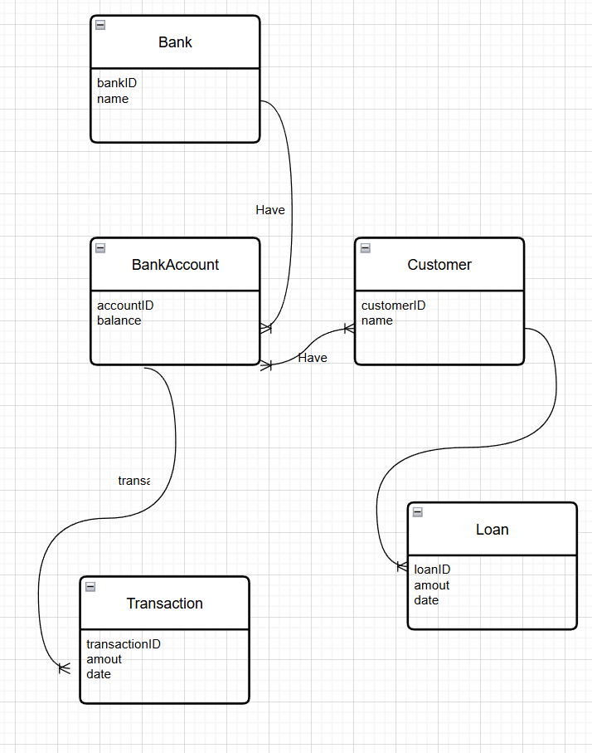

Task 8: ER Model for Customer Order System

1. ER Diagram Design:

• Customer: Customer number, name, address, and multiple professions.

• Order: Order number, date, shipping address, and total amount.

• Product: Unique number, description, and price.

Task 9: Extended ER Diagram for Customer Order System

1. Products and Suppliers:

• Each product is associated with a category and may be supplied by multiple suppliers.

• Each supplier has a supplier number, name, contact number, and email address, and may provide stock for multiple products.

• Each category has a category number and name.