**SINGLE OBJECT DETECTOR BY USING IMAGE PROCESSING**

For this stage of the project the following tools were used

* IBM Cloud annotation was used to create the database with images of the objects that we needed to recognize

Google Colab and the script with tensorflow to generate the "web model" of the deep learning algorithm for object detection

According to the Cloud Annotation documentation, images or videos can be added and the user must manually select the objects in the image. Different classes can be added so that the user can choose more than one type of object in the same scene. For this preliminary case, only 52 images were used with 147 objects selected.

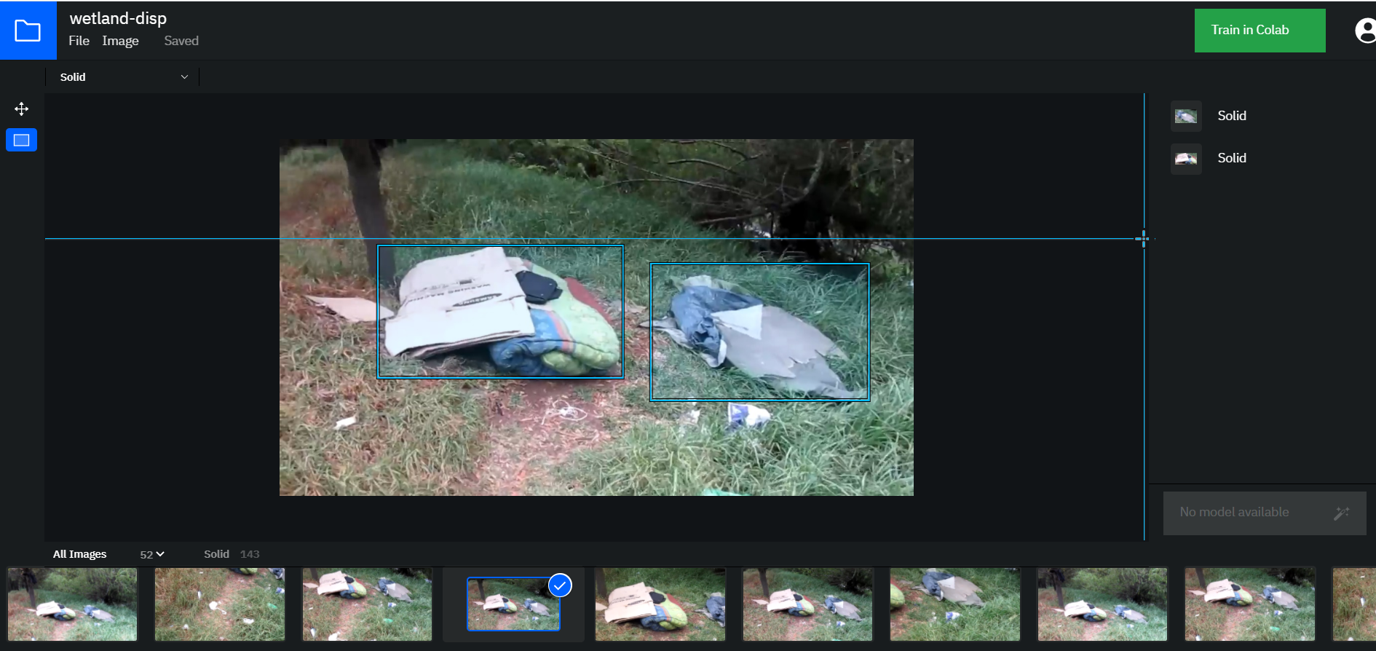

After labeling all the objects on the footage the credentials were genarted for its further use in google colab along with tensor flow.

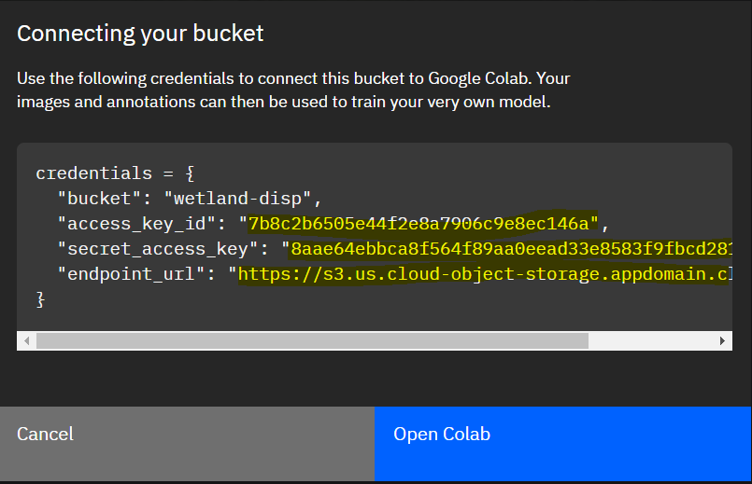

We must copy and paste the information from Cloud Annotation in Google Colab and then run the script. At the end of the run, the deep learning model will be ready for download.

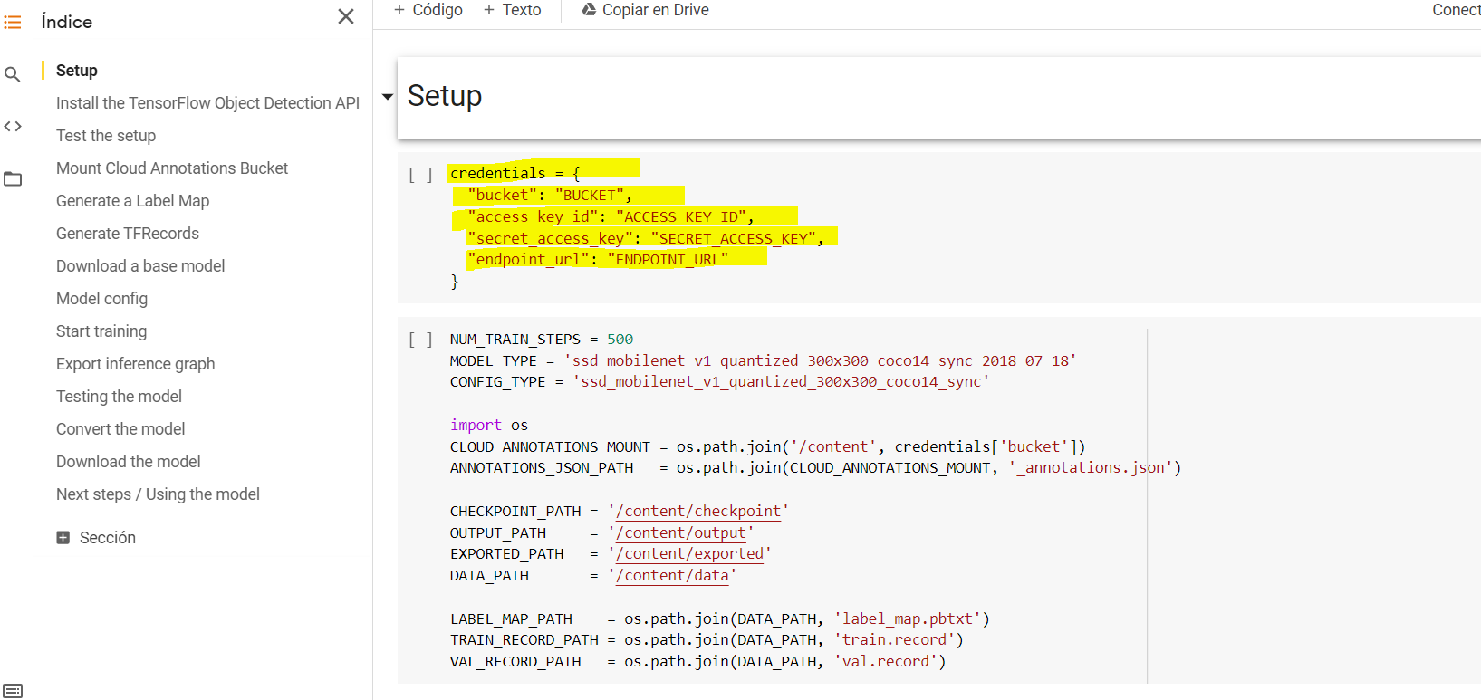

Finally, tests are carried out on the same data used during the training while we have access to new information from the wetlands. Also, instead of the recognition score we show a static text with the object name.

