## CS4121 Assignment 5 Due: 10/12/17

**For each of the following questions, you must write down the steps that lead to your final answer in the box at the bottom of the question.**

## (4 points) Consider two hosts, one is located on the west coast if the US and the other is located on the east coast. The speed-of-light round-trip propagation delay between these two hosts, RTT, is 30 ms (millisecond). Suppose that they are connected by a channel with the transmission rate, R, of 1Gbps (10^9 bits per second). These two hosts run a pipelined/sliding-window protocol where the size of a packet is 1500 bytes (1 byte = 8 bits), including both header fields and data. How big would the window size have to be for the channel utilization to be greater than 90%? You may round up the answer to the closest integer.

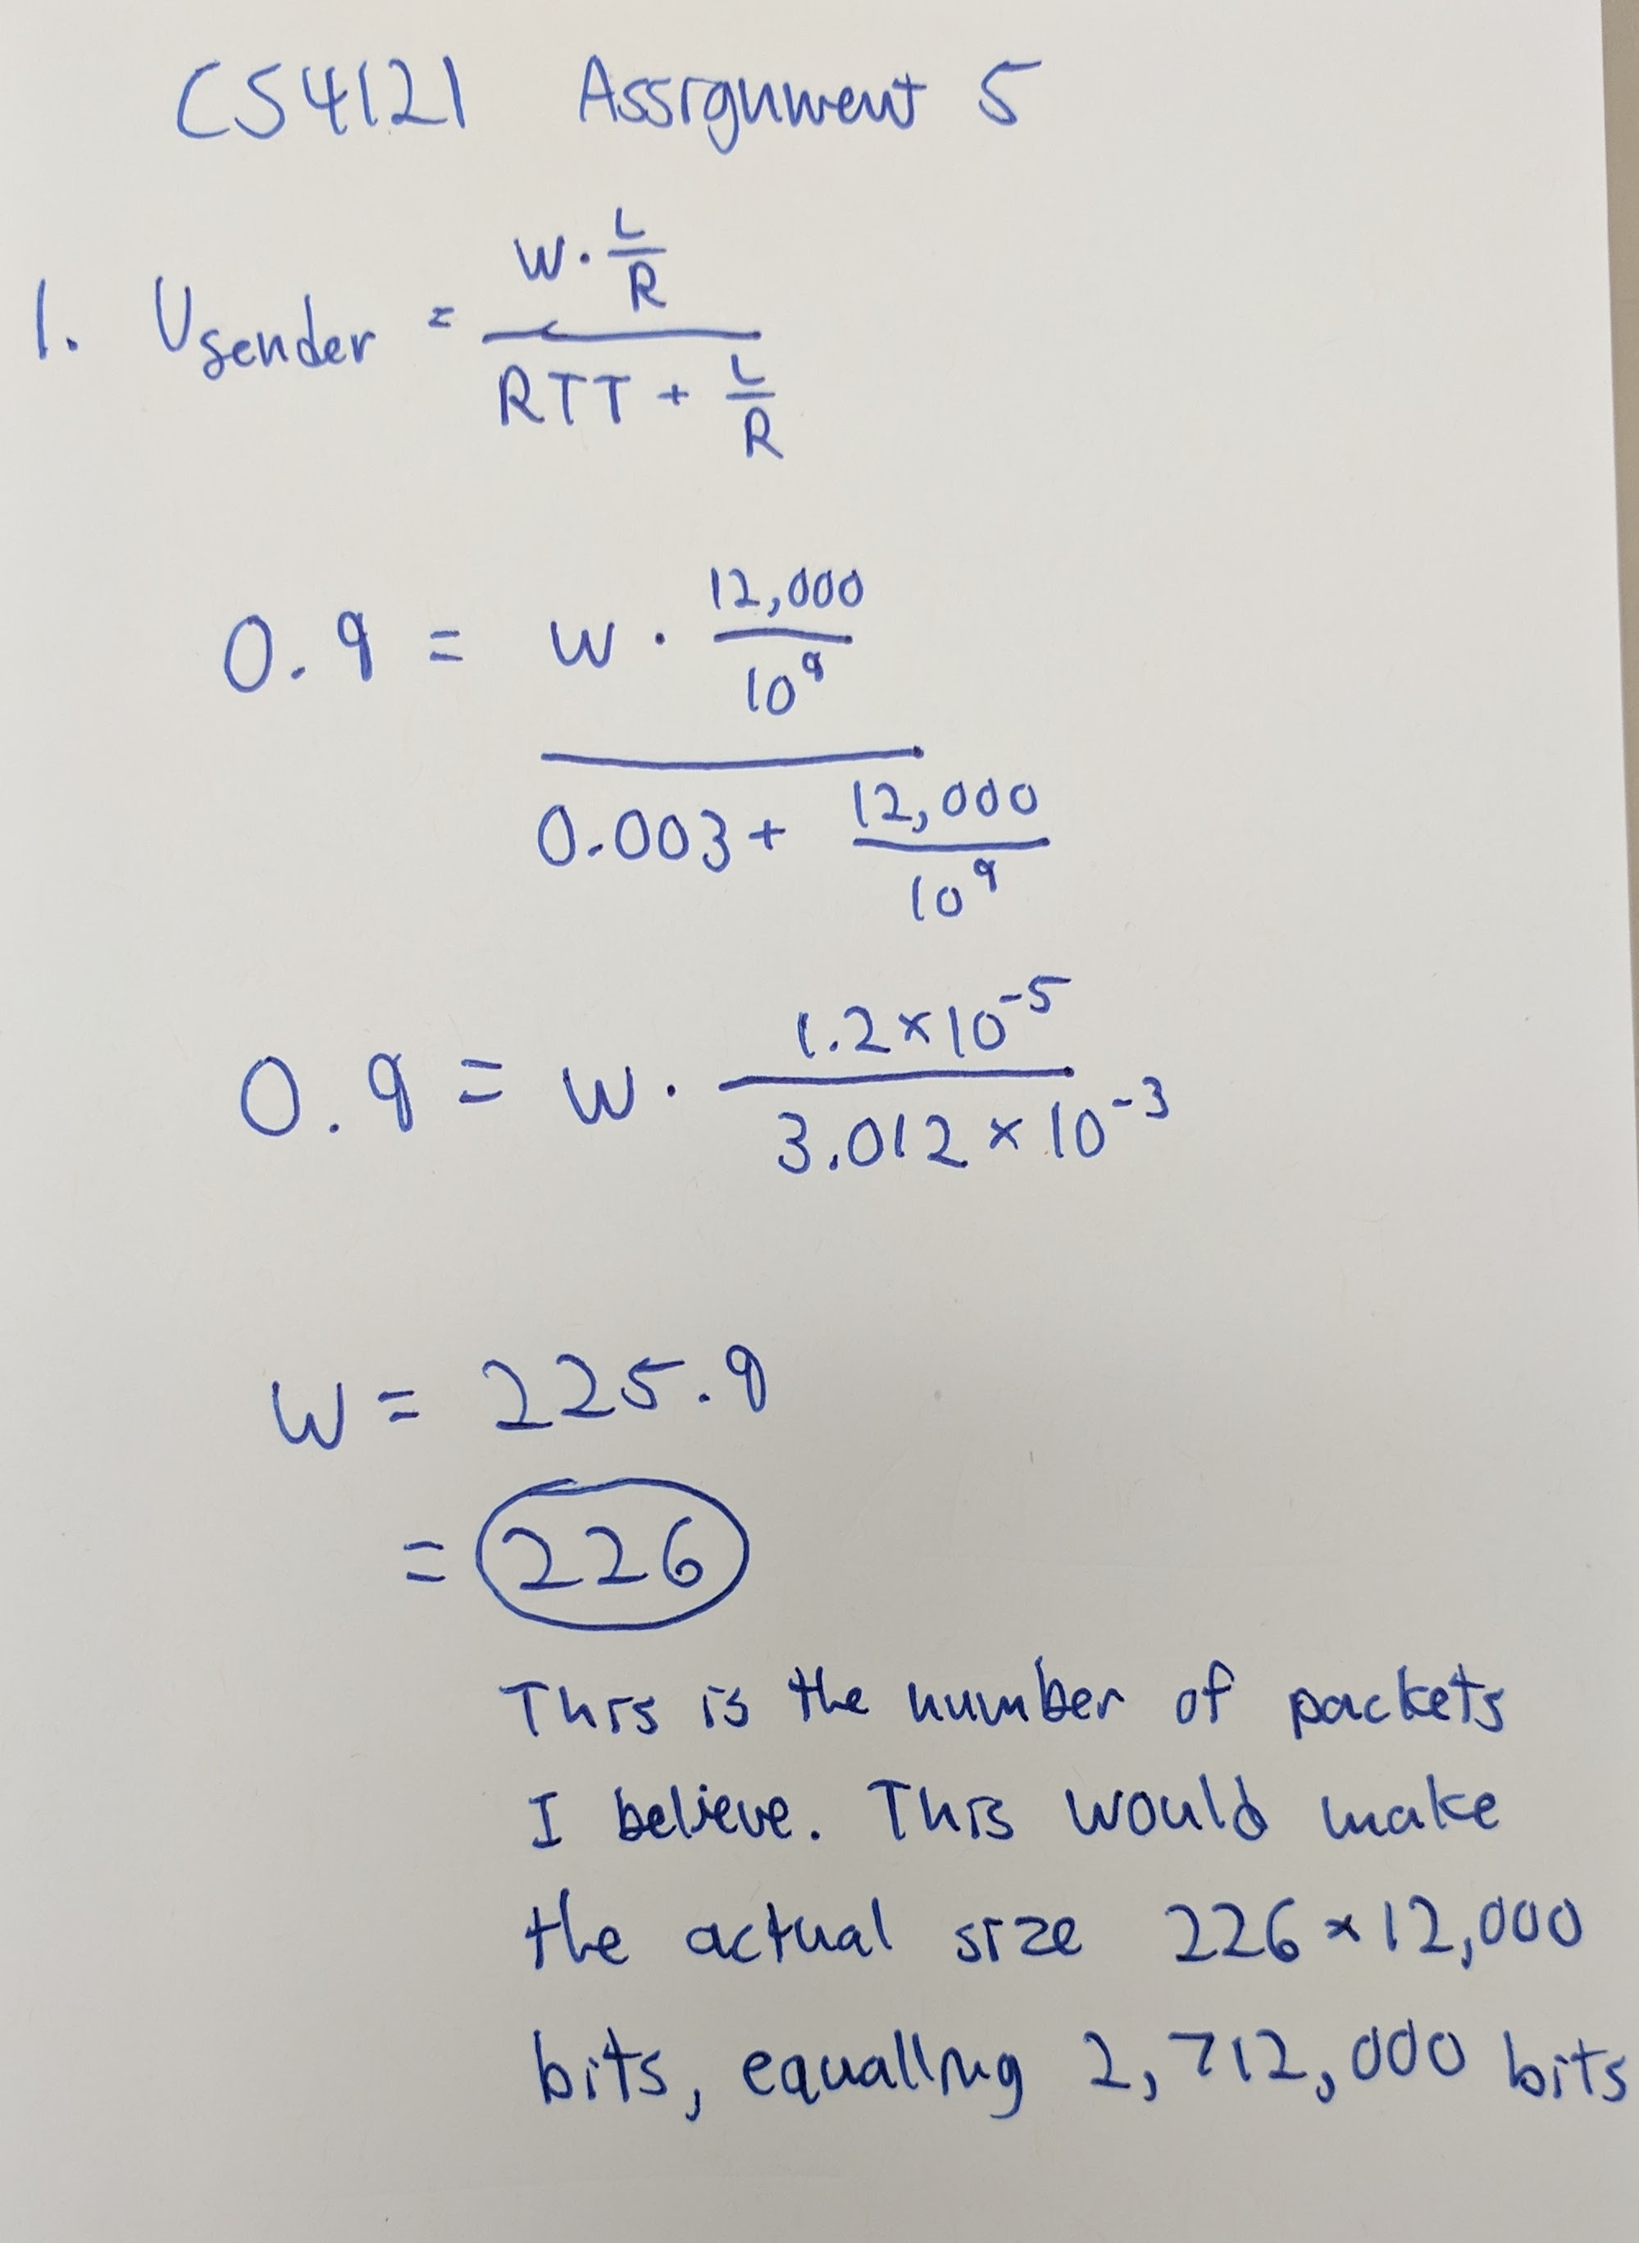

**Final Answer**

Window Size = 226

## (6 points) ACK 5 has been received by the sender in a Go-Back-N system. Now frames 5, 6, 7, 0 are sent and there are no more frames to send. Draw the sender window on receipt of an ACK 7. Show the values of send_base, nextSeqNum. When timer expires, which packets will be retransmitted? You may assume that the window size is the largest allowed.

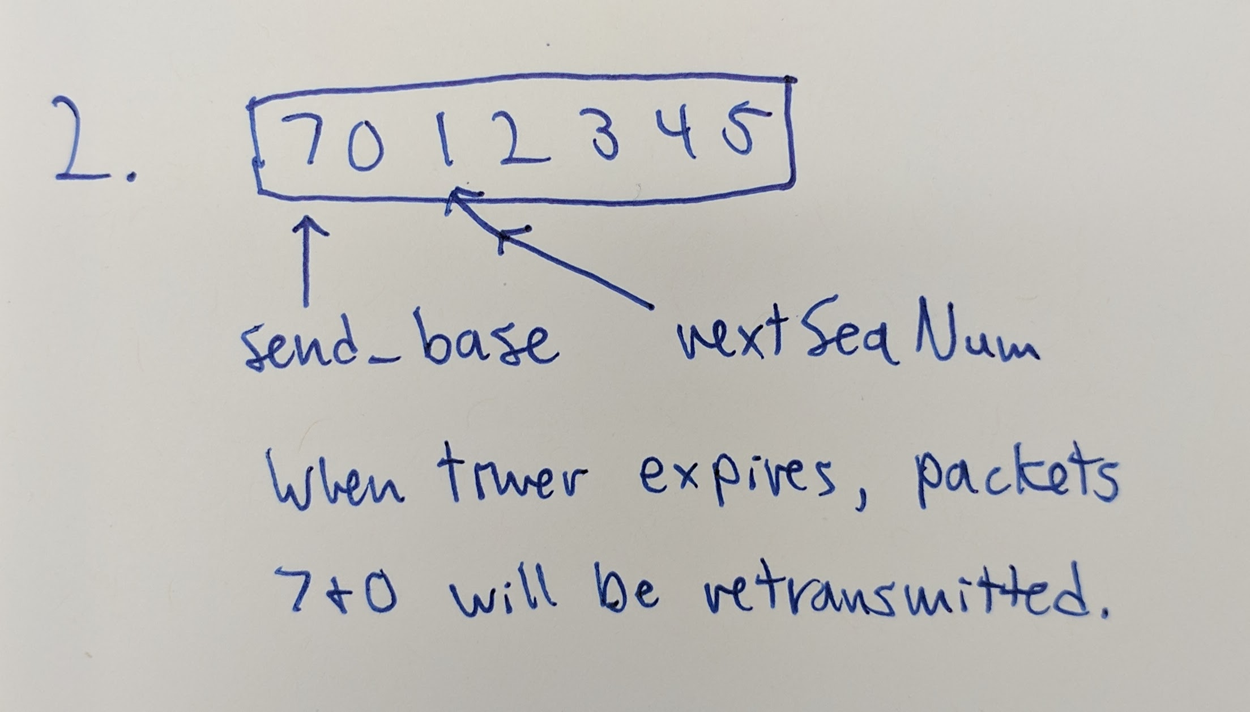

**Final Answer**

Packets to be retransmitted: 7 & 0