GENI Lab 1 (10 points), 08/31/2017

Name: John Weaks

Student #: 870477458

Login to nodes:

Client login: ssh jnweaks@pc3.instageni.stanford.edu -p 27458

Server login: ssh jnweaks@pc3.instageni.stanford.edu -p 27459

Internet

Control Plane Switch

Client

Data i/f: eth1

ip: 10.10.1.2

Data i/f: eth1

ip: 10.10.1.1

Server

Data Plane Switch

Control i/f: eth0

ip: 172.17.3.13

Control i/f: eth0

ip: 172.17.3.12

Answer the following questions

1.2.d.

What is the bandwidth of this link? 95.6 Mbits/sec___________________________

Why -- Attach screenshot of the client ssh terminal:

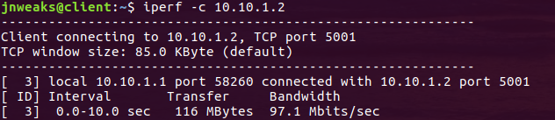

Attach screenshot of the server ssh terminal:

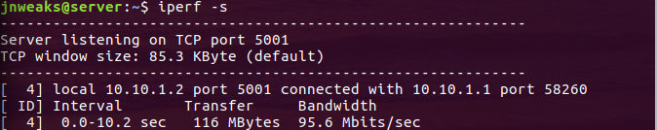

1.2.e.

What is the bandwidth of this link? 3.69 Gbits/sec___________________________

Why -- Attach screenshot of the client ssh terminal:

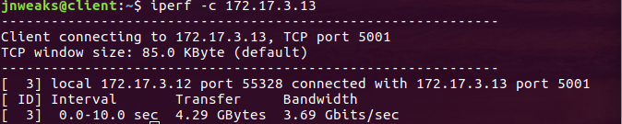

Attach screenshot of the server ssh terminal:

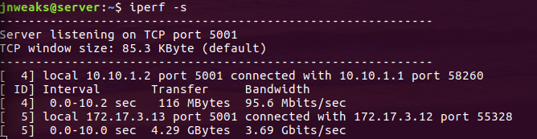

1.3

Attach screenshot of the client ssh terminal. Make sure the screenshot includes the successful pings, “…Destination Host Unreachable” messages, and successful pings again:

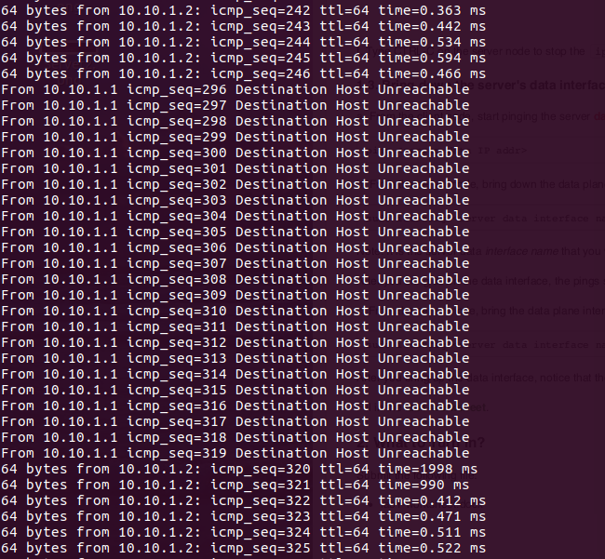

Attach screenshot of the server ssh terminal. Make sure the screenshot includes both the “sudo ifconfig <server data i/f name> down” and “sudo ifconfig <server data i/f name> up” commands.

