CS4121 Assignment 1 Due: 08/24/17
In all the following questions, you should assume
1Kb=10^3b, 1Mb=10^6b, and 1Gb=10^9b

Also, all your answers must be justified.

- (4 points) In Figure 1.24 below, please find a source (node A), a destination (node B), and two intermediate store-and-forward switches. Each packet sent from the source must be transmitted over three links before it reaches the destination. Each of these links has a transmission rate of 4 kbps. Ignore the propagation delays and all other delays.

Note: for parts a and b below, I need you to draw time tables (like the ones I drew in class for question 31) to justify your answers.

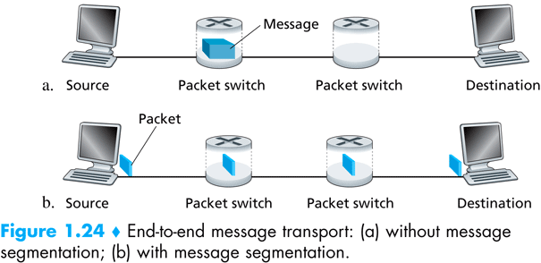

  - (2 points) Consider sending a message of 16 kb from source to destination without message segmentation. This is also called message switching. What is the end-to-end delay?

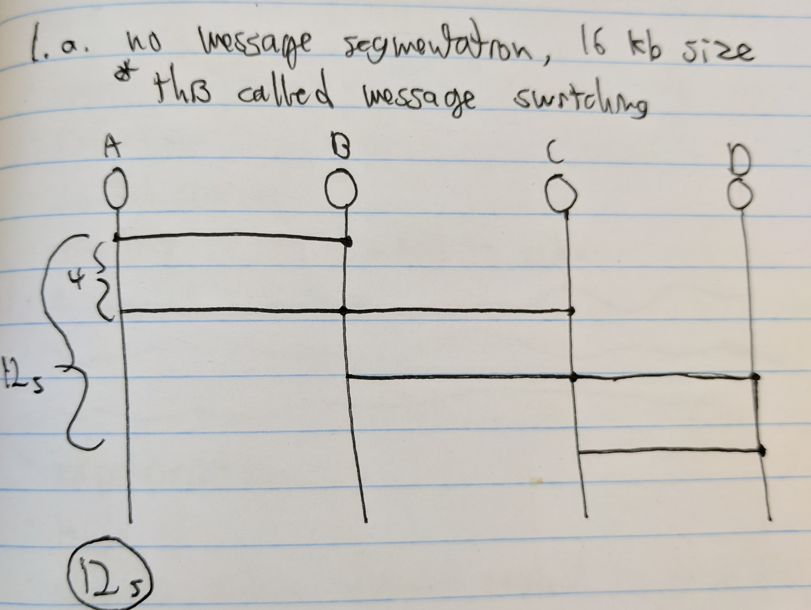

Your answer: 12s

The entire message has to be received by a node before it can be transmitted. Each second 4kb of the message can be transmitted, so it takes 4 seconds per send.

  - (2 points) Consider sending the same message of 16 kb from source to destination with message segmentation. As a result, each packet is of size 4 kb. This is also called packet switching. What is the end-to-end delay?

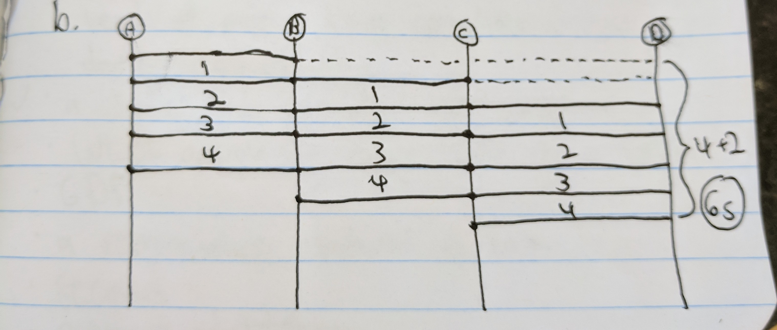

Your answer: 6s

Here, since the message has been broken down into smaller packets, now the process can move much faster.

- (20 points) Too much message segmentation is considered harmful, partially due to the overhead cost caused by the header fields. The same amount of header fields has to be added to each packet, therefore, the more such packets are (i.e. the more message segmentation we perform), the more overhead costs from such header fields will be.
Now, let’s assume that everything stays the same as problem 1.b) above except that the size of each packet varies from 4kb to 2kb, to 1kb, … to 125bits. In other words, the size of each packet is cut in half (correspondingly, the number of packets gets doubled) as we go on in our experiment.

  - Assume no overhead caused by the header fields. Write a program that produces the comparison of size of each packet vs. the end-to-end delay of the transmission of the entire message of 16 kb.
Note: you may use any programing language to write your code. However, make sure all code is contained in ONE SINGLE source code file.

A screenshot of the execution of your program that displays the end-to-end delays as the size of each packet varies:

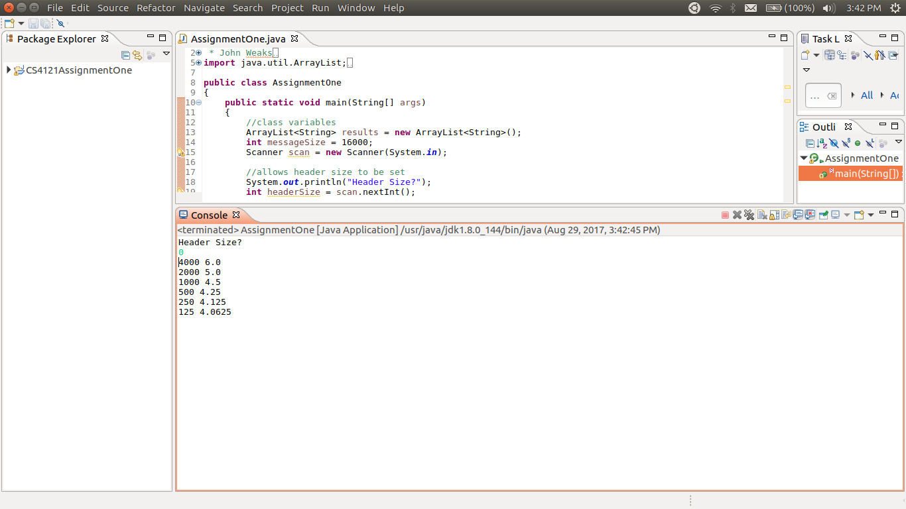

  - Assume the overhead caused by the header fields is 10 bits. Redo part a).

A screenshot of the execution of your program that displays the end-to-end delays as the size of each packet varies:

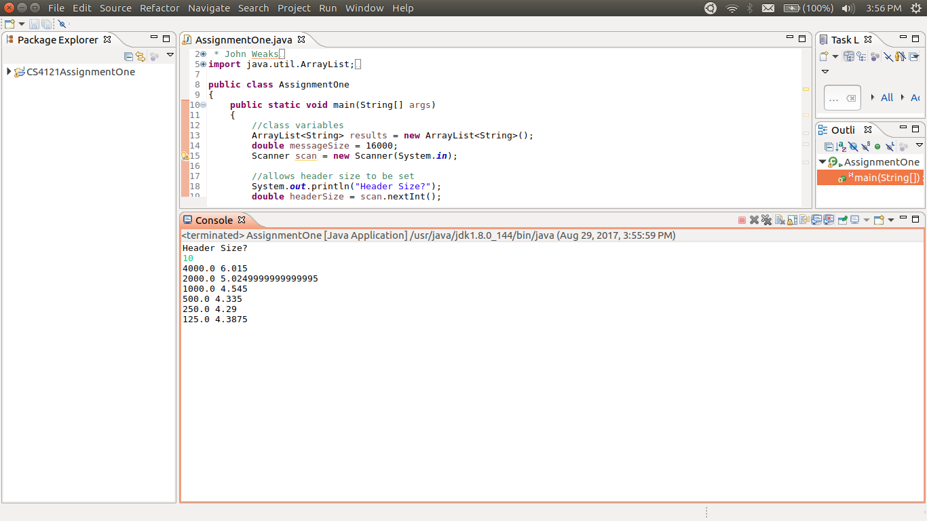

  - Assume the overhead caused by the header fields is 20 bits. Redo part a).

A screenshot of the execution of your program that displays the end-to-end delays as the size of each packet varies:

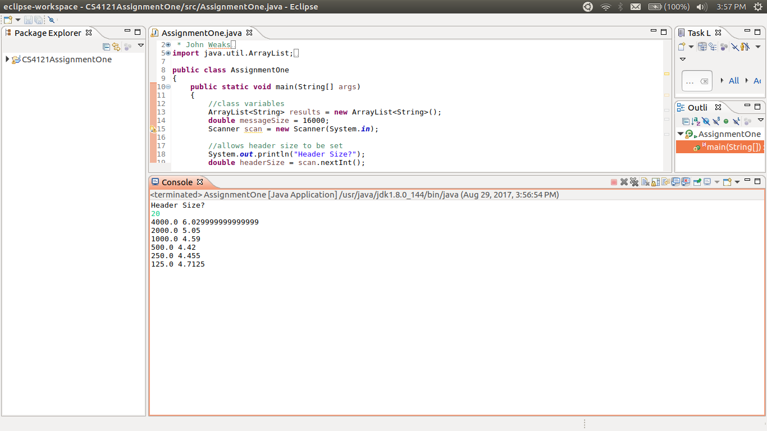

  - Plots of the results. The following two figures are what I am expecting from you.

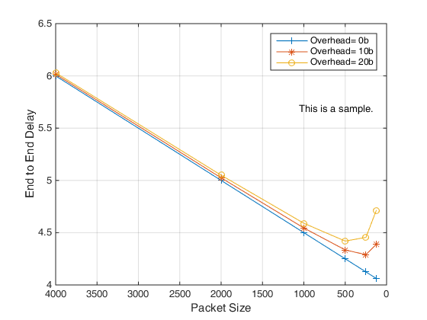
To make the plot easier to read, the packet sizes on the x axle could be scaled logarithmically.
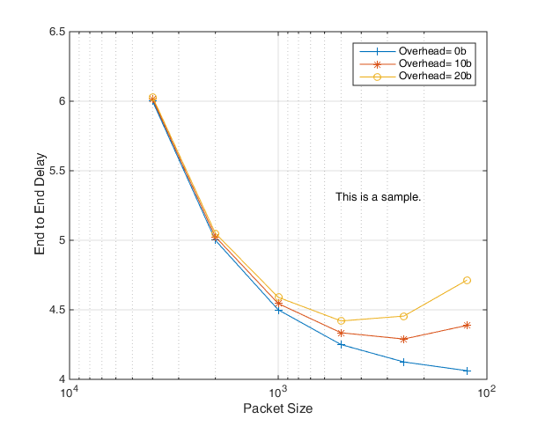

Note: you may use MS excel, MATLAB, or any tool of your choice to plot the figure.

Your two plots:

a. 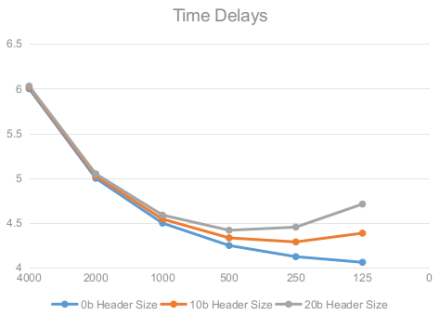

b. 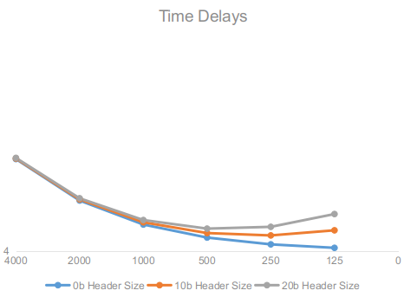

What to turn in?

- This word document with all your answers.
- The SINGLE source code file for problem 2.

