Міністерство освіти і науки України

Національний технічний університет «Дніпровська політехніка»



ЗВІТ

з лабораторної роботи №2

дисципліни «Розробка мікросервісних систем на мові Golang»

Виконав: ст. гр. 123-20ск-1

Гладкий Сергій Сергійович

Прийняв: Реута О.В.

Дніпро 2022

Task 2

“CSV Concurrent Sorter” is a CLI application that allows sorting of its input presented as CSV-text.

**Technical details**

Using the “CSV Sorter” from the Task 1, extend it with the following required features:

1. The application has additional option **-d dir-name** that specifies a directory where it must read input files from. All files in the directory must have the same format. The output stays the same, it is a one file or a standard output with sorted content from all input files.
2. Processing must be implemented concurrently based on pipeline. The pipeline includes three stages:
   * Directory Reading:
     + read the directory content and all its subdirectories
     + send all found file names to a channel for the future processing
   * File Reading – for each file name received from the input channel
     + read the file from the disk
     + send its content line by line to the output channel.
   * Sorting:
     + read lines from the input channel
     + collect them into a buffer
     + when the input channel is exhausted, sort lines in the buffer
     + write the result to the output file (if option **-o** is set) or to the standard output
3. The application must print an error message, if two options **-d** and **-i** are set at the same time.
4. If option **-i** is set the application must read only the file defined by this option and then must use the pipeline to process file content.

Program code:

functions.go:

package functions

import (

"bufio"

"encoding/csv"

"fmt"

"os"

"sort"

"strings"

)

func ReadCsvFile(filePath string) [][]string {

f, err := os.Open(filePath)

if err != nil {

fmt.Println(err)

os.Exit(1)

}

defer f.Close()

content := [][]string{}

csvReader := csv.NewReader(f)

records, err := csvReader.Read()

for records != nil {

if err != nil {

fmt.Println("", err)

os.Exit(1)

}

content = append(content, records)

records, err = csvReader.Read()

}

return content

}

func SortCsvData(content [][]string, ignoreHeader, reverse bool, field int) {

if field > (len(content[0]) - 1) {

fmt.Printf("Error: only %d column in this file.\n", len(content[0]))

os.Exit(1)

}

if reverse {

if ignoreHeader {

sort.Slice(content[1:], func(i, j int) bool {

return content[1:][i][field] > content[1:][j][field]

})

} else {

sort.Slice(content, func(i, j int) bool {

return content[i][field] > content[j][field]

})

}

} else {

if ignoreHeader {

sort.Slice(content[1:], func(i, j int) bool {

return content[1:][i][field] < content[1:][j][field]

})

} else {

sort.Slice(content, func(i, j int) bool {

return content[i][field] < content[j][field]

})

}

}

}

func WriteCsvFile(name string, data [][]string) {

file, err := os.Create(name)

if err != nil {

fmt.Println("Unable to create file:", err)

os.Exit(1)

}

defer file.Close()

csvWriter := csv.NewWriter(file)

err = csvWriter.WriteAll(data)

if err != nil {

fmt.Println("Unable to create file:", err)

os.Exit(1)

}

fmt.Println("File created.")

}

func WriteRecords() [][]string {

s := bufio.NewScanner(os.Stdin)

records := [][]string{}

n := 0

for s.Scan() {

line := s.Text()

if line == "" {

break

}

row := strings.Split(line, ",")

if n == 0 {

n = len(row)

}

if n != len(row) {

fmt.Printf("Error: row has %d column, but must have %d\n", len(row), n)

os.Exit(1)

}

records = append(records, row)

}

return records

}

Task2.go:

package main

import (

"flag"

"fmt"

"log"

"os"

"os/signal"

"path/filepath"

"sync"

"syscall"

"task2/functions"

)

func main() {

var (

inputFileName = flag.String("i", "", "Use a file with the name file-name as an input.")

outputFileName = flag.String("o", "", "Use a file with the name file-name as an output.")

ignoreHeader = flag.Bool("h", false, "The first line is a header that must be ignored during sorting but included in the output.")

sortingField = flag.Int("f", 0, "Sort input lines by value number N.")

reverseSort = flag.Bool("r", false, "Sort input lines in reverse order.")

dirName = flag.String("d", "", "dir-name that specifies a directory where it must read input files from.")

)

flag.Parse()

fmt.Println("===Started===")

done := make(chan struct{})

ListenSignal(done)

var (

inputFileIsPresent = inputFileName != nil && *inputFileName != ""

outputFileNameIsPresent = outputFileName != nil && *outputFileName != ""

dirNameIsPresent = dirName != nil && *dirName != ""

)

if inputFileIsPresent && dirNameIsPresent {

log.Fatal("The application must print an error message, if two options -d and -i are set at the same time.")

}

if !dirNameIsPresent {

var records [][]string

if !inputFileIsPresent {

records = functions.WriteRecords()

} else {

records = functions.ReadCsvFile(*inputFileName)

}

functions.SortCsvData(records, *ignoreHeader, *reverseSort, *sortingField)

if !outputFileNameIsPresent {

fmt.Println(records)

} else {

functions.WriteCsvFile(*outputFileName, records)

}

} else {

// new logic

fnChan := ReadDir(*dirName, done)

contChan := FileReadingStage(fnChan, 1, done)

result := SortContent(contChan, *ignoreHeader, *reverseSort, *sortingField, done)

records := make([][]string, 0, 1000)

for i := range result {

records = append(records, i)

}

if !outputFileNameIsPresent {

fmt.Println(records)

} else {

functions.WriteCsvFile(*outputFileName, records)

}

}

fmt.Println("===Finished===")

}

func ReadDir(dir string, done chan struct{}) (fnames chan string) {

fnames = make(chan string)

go func() {

defer close(fnames)

fileList := ScanDir(dir)

for _, f := range fileList {

select {

case fnames <- f:

{

continue

}

case <-done:

{

break

}

}

}

}()

return fnames

}

func FileReadingStage(fnames chan string, n int, done chan struct{}) (allLines chan [][]string) {

lines := make([]chan [][]string, n)

allLines = make(chan [][]string)

for i := 0; i < n; i++ {

lines[i] = make(chan [][]string)

ReadFiles(fnames, lines[i], done)

}

go func() {

defer close(allLines)

wg := &sync.WaitGroup{}

for i := range lines {

wg.Add(1)

go func(ch chan [][]string) {

defer wg.Done()

for line := range ch {

select {

case allLines <- line:

{

continue

}

case <-done:

{

break

}

}

}

}(lines[i])

}

wg.Wait()

}()

return allLines

}

func ReadFiles(fnames chan string, lines chan [][]string, done chan struct{}) {

go func() {

defer close(lines)

for fname := range fnames {

select {

case lines <- functions.ReadCsvFile(fname):

{

continue

}

case <-done:

{

break

}

}

}

}()

}

func SortContent(cont chan [][]string, ignoreHeader, reverse bool, field int, done chan struct{}) (result chan []string) {

result = make(chan []string)

go func() {

defer close(result)

var buffer = make([][]string, 0, 1000)

for line := range cont {

buffer = append(buffer, line...)

}

functions.SortCsvData(buffer, ignoreHeader, reverse, field)

for _, line := range buffer {

select {

case result <- line:

{

continue

}

case <-done:

{

break

}

}

}

}()

return result

}

func ScanDir(path string) (files []string) {

filepath.Walk(path, func(path string, info os.FileInfo, err error) error {

if err != nil {

log.Fatalf(err.Error())

}

if !info.IsDir() {

files = append(files, path)

}

return nil

})

return files

}

func ListenSignal(done chan struct{}) {

sigs := make(chan os.Signal, 1)

signal.Notify(sigs, syscall.SIGINT, syscall.SIGTERM)

go func() {

sig := <-sigs

fmt.Println()

fmt.Println(sig)

close(done)

}()

}

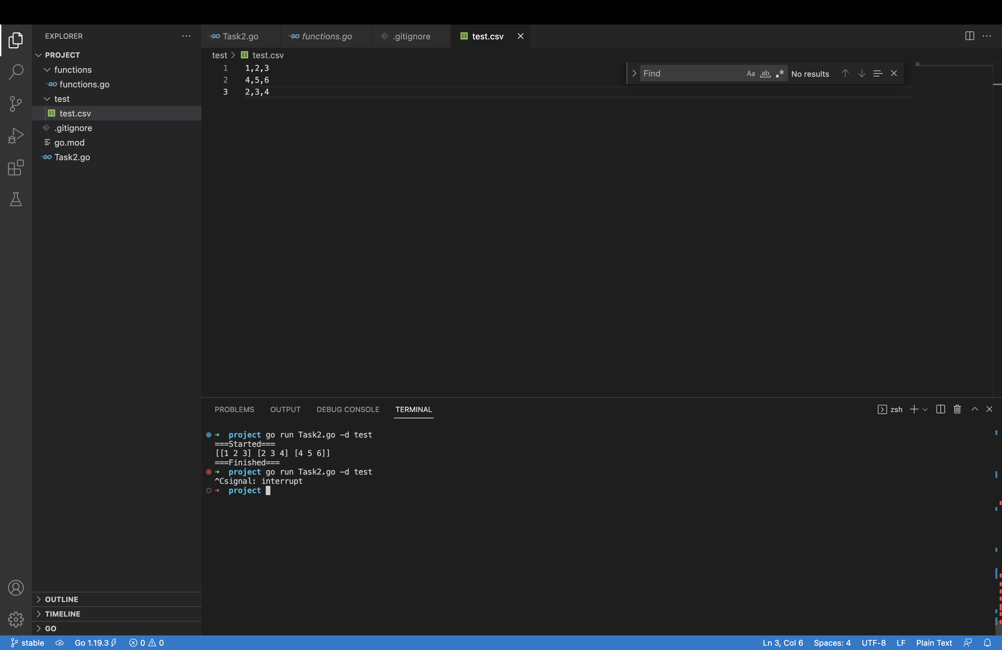

Picture 1 — Result

Link to github - <https://github.com/GladkiySS/Golang.git>