INDIRA GANDHI NATIONAL OPEN UNIVERSITY



**LABORATORY RECORD**

Month &Year : ………………………………………………….…..

Name : …………………………………………………………………

Study Center : 1402, SH College, Thevara, Kochi-13

Course Code : …………….……………………………………………………

Course Title : ………………………………………………………..…….…..

………………………………………………………..…………

Program Code: ……………………..…………………………………………..

Enrolment No: …………………………………………………………………

External Examiner Staff In-Charge

**INDEX**

|  |  |  |
| --- | --- | --- |
| **Sl No.** | **Description** | **Page No.** |
|  | Section 1: Cloud Computing Lab |  |
| 1 | Create a word document of your counselling schedule of the study centre and store locally and on Google Drive with doc and pdf formats. Share it with your peer and faculty in View mode. | 1-2 |
| 2 | Using Google Slides, prepare a Presentation consisting of at least 20 slides on Cloud Computing covering introduction, models, services, architecture, applications and security aspects. | 3-4 |
| 3 | Using Google Docs, create your Resume in a neat format using Google and Zoho cloud. | 5-6 |
| 4 | Explore Amazon Drive and NordLocker file storage and sharing solutions. Use only their trail versions. | 7-12 |
| 5 | Work with SlideShare (<http://www.slideshare.net/)>which is a cloud service for slide sharing owned and controlled by LinkedIn. | 13-14 |
|  | Section 2: Data Science Lab |  |
| 1 | Create a vector of size 10, having the values 5,7,9,11,13,13,11,9,7,5. Compute the sum, mean, highest and lowest of these values. Compute the length of this vector? Find the variance and standard deviation for the data of this vector, using the formula for variance and standard deviation. Compare these values by computing the variance and standard deviation using R function. Sort this array values in decreasing order. | 24-25 |
| 2 | Create a vector of first 50 even numbers, starting from 2. Also create a vector having values 30 down to 1, as 30, 29, ...,1 | 26 |
| 3 | Create a vector of characters of size 5, consisting of values: "This" "is" "a" "character" "vector". Find the index of value "is" in the vector using which() or match(). | 27 |
| 4 | Create a vector of characters of size 5, consisting of values: "This" "is" "a" "character" "vector". Find the index of value "is" in the vector using which() or match(). | 28 |
| 5 | Assuming that the problem, as given above, does not have any categories. Perform k-mean clustering on the data with k = 5 | 29-30 |

# Section 1: Cloud Computing Lab

## Question 1:

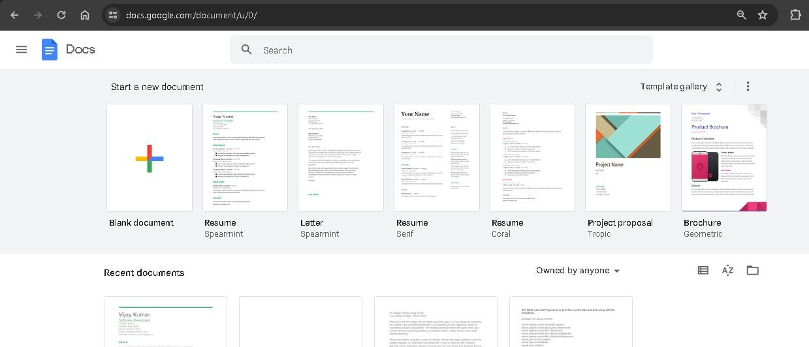

Create a word document of your counselling schedule of the study centre and store locally and on Google Drive with doc and pdf formats. Share it with your peer and faculty in View mode.

## Answer:

# Google Docs Steps:

1. Log in with your Google account.
2. Go to Google Docs: https://docs.google.com

# Create and Save Document:

1. Click on "Blank" to create a new document.
2. Enter counseling schedule details.

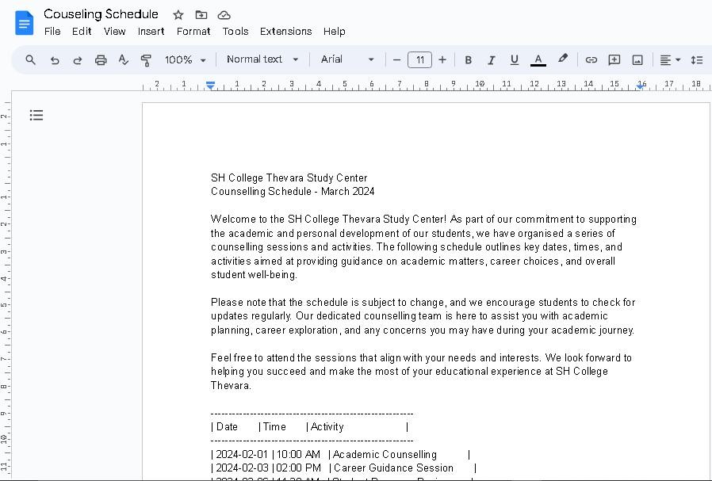

1. Save the document to Google Drive.

# Share Google Docs Document:

1. Click "Share" in the upper-right corner.
2. Enter peer and faculty email addresses.
3. Set permissions to "Viewer."
4. Click "Send."

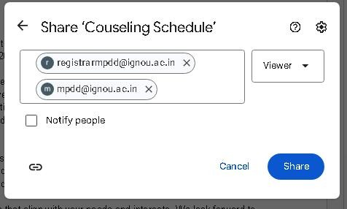

# Export to PDF:

1. While in the document, click on "File" -> "Download" -> "PDF Document (.pdf)".

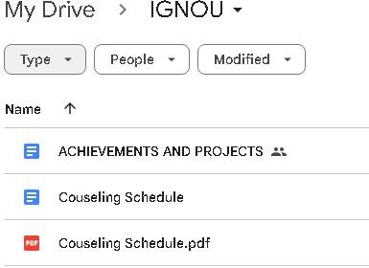

## Question 2:

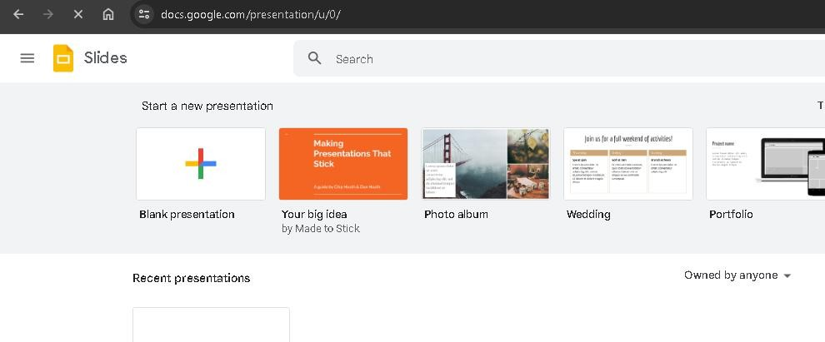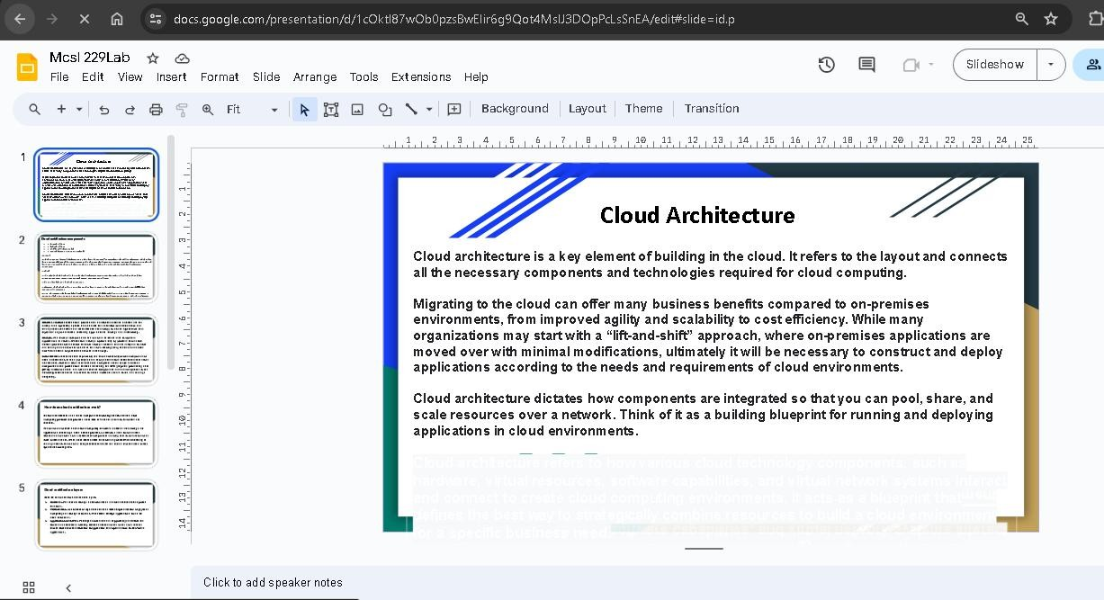

Using Google Slides, prepare a Presentation consisting of at least 20 slides on Cloud Computing covering introduction, models, services, architecture, applications and security aspects.

## Answer:

1. Log in to Google Slides with your account.
2. Start a new presentation, selecting a blank template.
3. Develop a comprehensive presentation on Cloud Computing covering introduction, models, services, architecture, applications, security aspects, and a conclusion with a Q&A session.

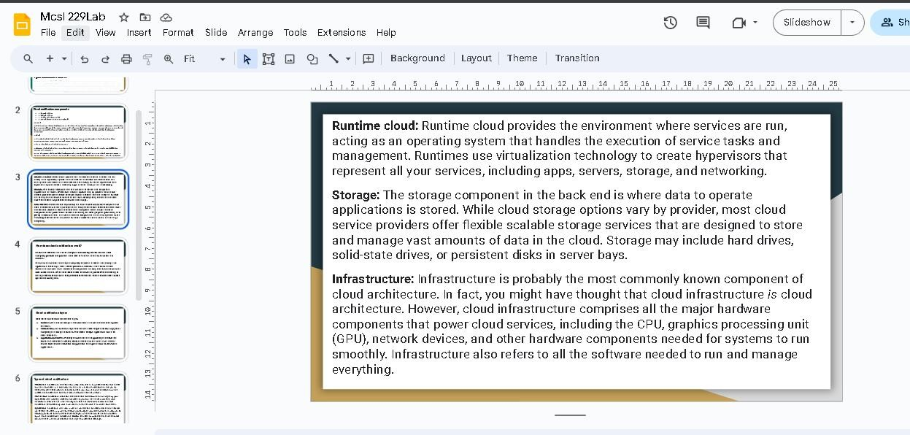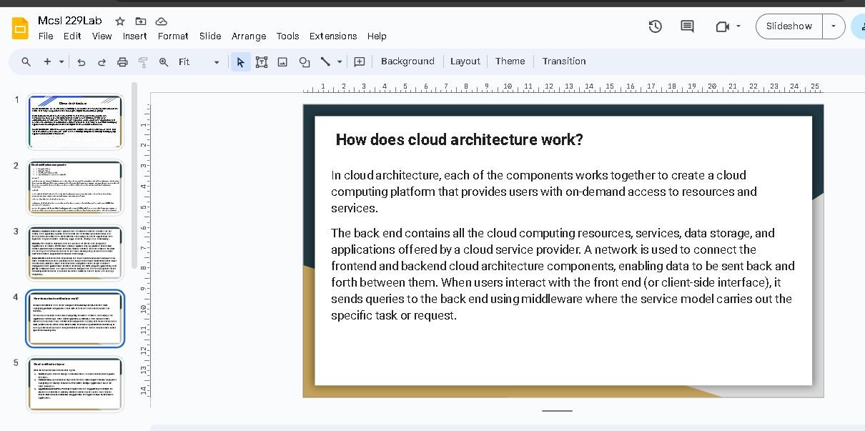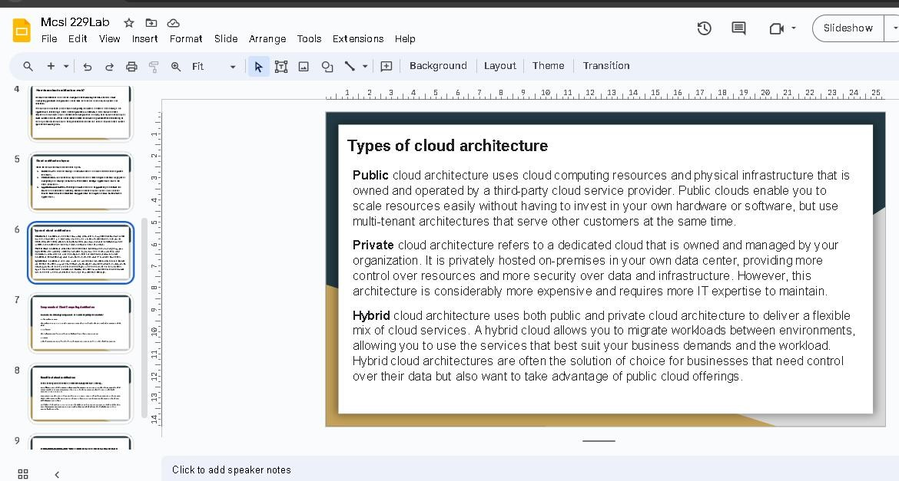

## Question 3:

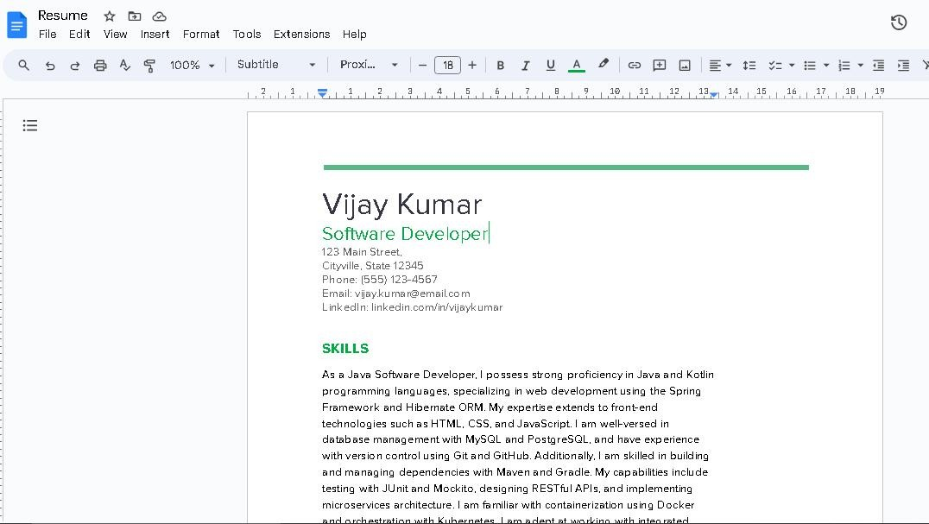

Using Google Docs, create your Resume in a neat format using Google and Zoho cloud.

## Answer:

**Google Docs:**

1. Log in to [Google Docs](https://docs.google.com/).
2. Create and format a new document.
3. Input content for Contact Information, Summary, Education, Experience, Skills.

**Zoho Writer:**

1. Log in to [Zoho Writer](https://[www.zoho.com/writer/).](http://www.zoho.com/writer/))
2. Create and format a new document.

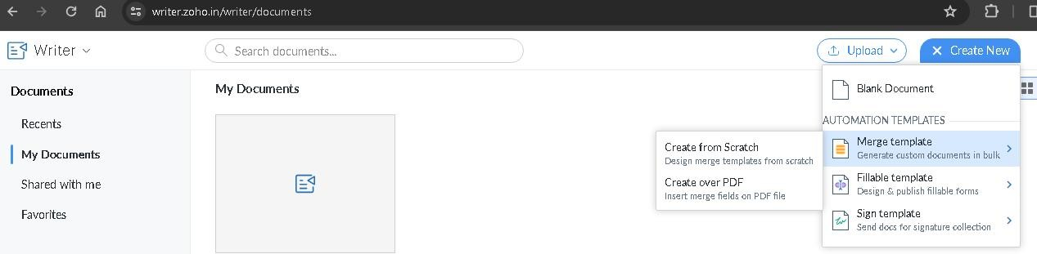

1. Input content for Contact Information, Summary, Education, Experience, Skills.



## Question 4:

Explore Amazon Drive and NordLocker file storage and sharing solutions. Use only their trail versions.

## Answer:

Amazon drive cannot be accessed now, Amazon Photos is available.

Amazon Photos is a cloud-based photo storage service offered by Amazon, allowing users to securely store and organize their digital images. Users can upload photos and videos from various devices, ensuring a centralized and easily accessible repository. The service provides automatic backup, helping users safeguard their cherished memories. Amazon Photos includes features like facial recognition and object detection, enabling efficient organization and search functionalities. Prime members often enjoy additional benefits, such as unlimited photo storage as part of their subscription.

### Accessing Amazon Photos:

1. **Visit Amazon Photos:**

* Go to [Amazon Photos](https://[www.amazon.com/photos)](http://www.amazon.com/photos)) using a web browser.

2. **Log in:**

* Sign in with the Amazon account associated with your Amazon Photos.

1. **Navigate Your Photos:**

- Explore your photos and albums using the navigation options on the Amazon Photos website.

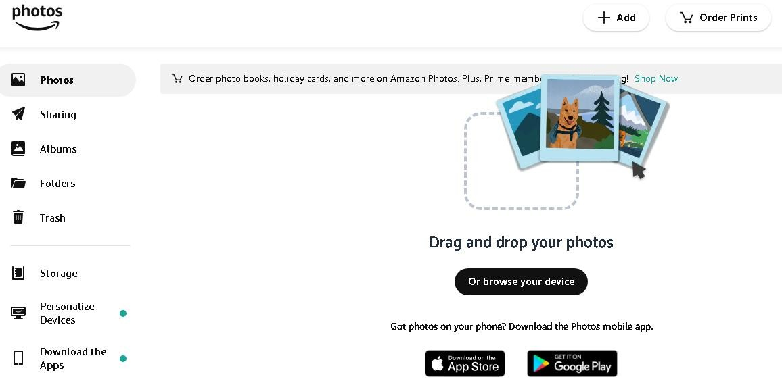

1. **Upload Photos:**

- Use the "Upload" feature to add new photos to your Amazon Photos library.

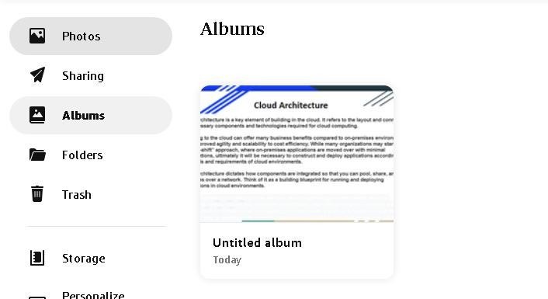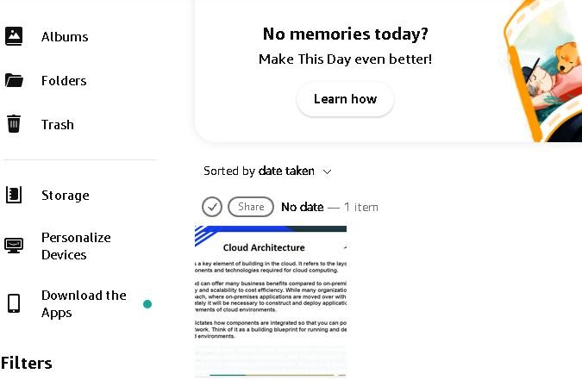

1. **Create Albums:**

- Organize your photos by creating albums within Amazon Photos.

1. **Share Photos:**

- Share your photos with others using the sharing options provided in Amazon Photos.

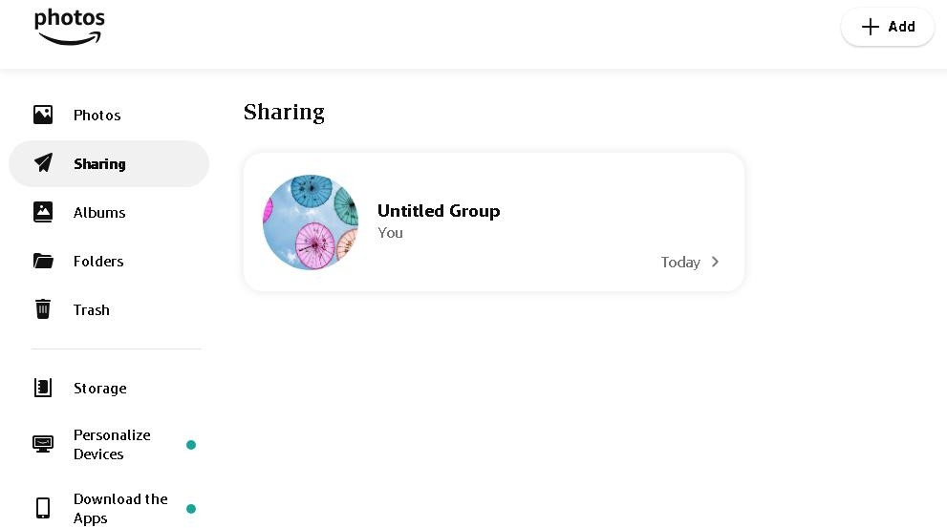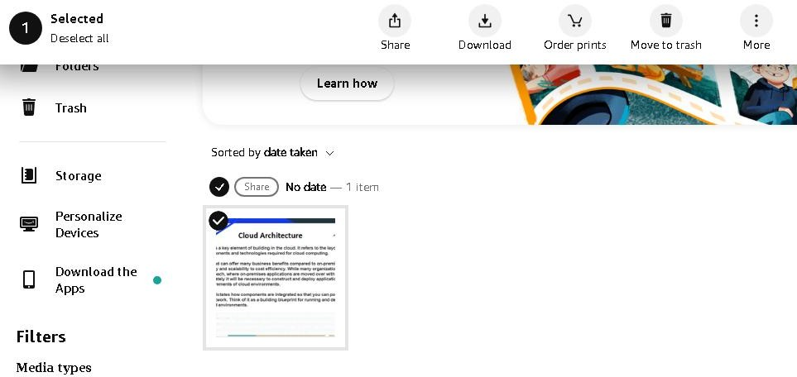

1. **Download Photos:**

- Download photos to your device if needed, using the download options.

### Accessing NordLocker:

NordLocker is a file encryption and security solution developed by the creators of NordVPN. It is designed to protect users' sensitive files and data with robust encryption algorithms, ensuring privacy and security. NordLocker allows users to create secure folders that are encrypted locally on their devices before being uploaded to the cloud for additional protection. The service supports end-to-end encryption, meaning only the user with the encryption key can access the files. NordLocker is known for its user-friendly interface and seamless integration, providing a convenient and effective solution for users seeking enhanced file security.

Exploring NordLocker involves accessing and managing your encrypted files. 1.. **Create an Account:**

* Open NordLocker and create a new account.
* Follow the on-screen instructions to complete the account creation process.

3. **Sign In:**

* Log in to NordLocker using your newly created account credentials.

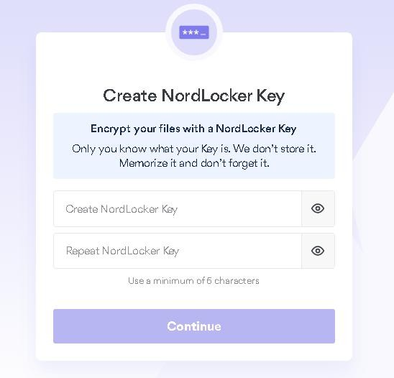

1. **Encrypt Files:**

* Use NordLocker to encrypt your sensitive files and folders.
* Follow the application's interface to select and encrypt the desired files.

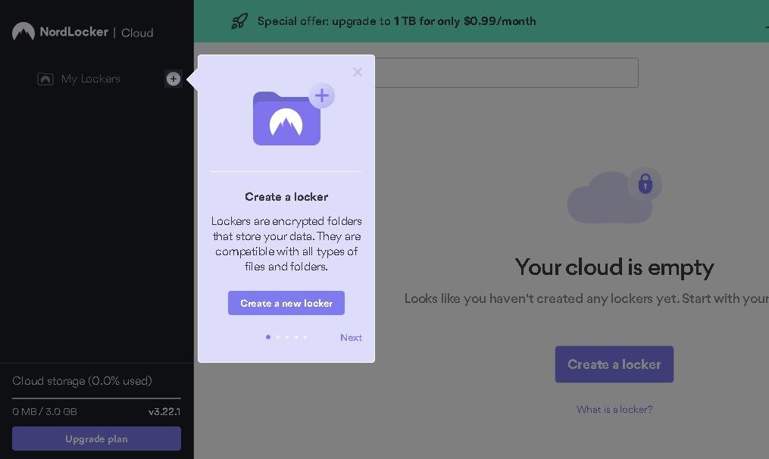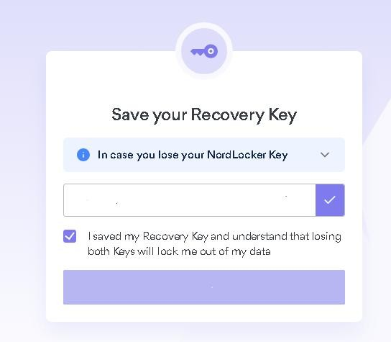

1. **Organize Encrypted Files:**

* Explore the NordLocker interface to organize your encrypted files.
* Create folders, move files, and manage your encrypted content.

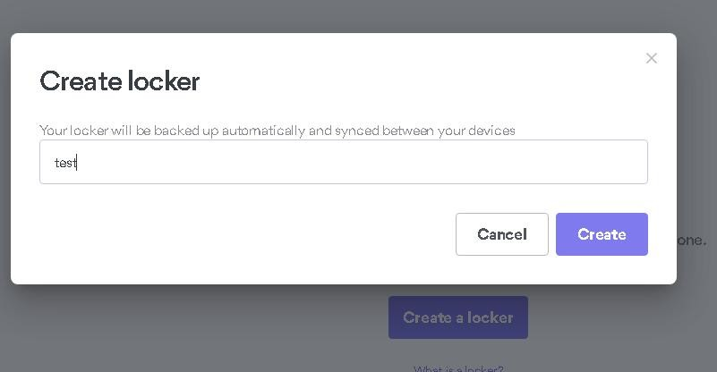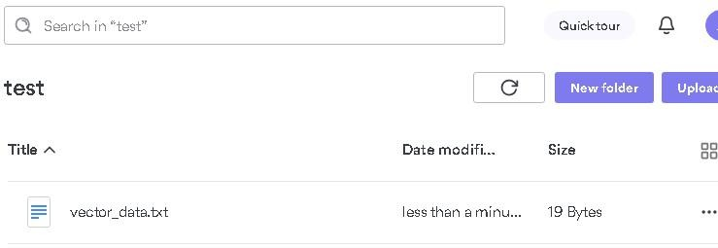

1. **Access and Decrypt:**

* Whenever you need to access your encrypted files, open NordLocker.
* Use your account credentials to log in and decrypt the files you want to use.

## Question 5:

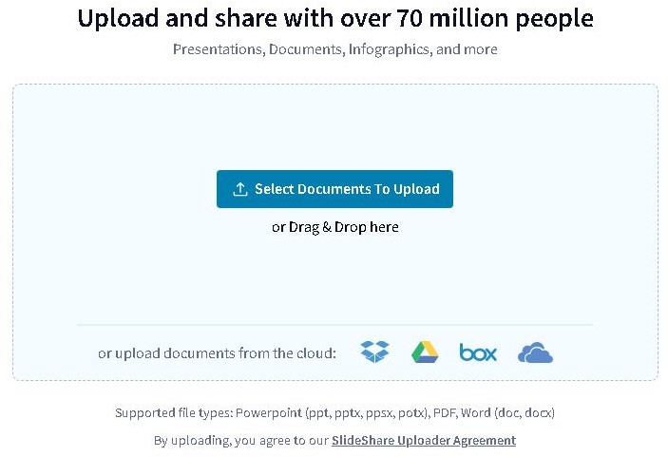

Work with SlideShare (<http://www.slideshare.net/)>which is a cloud service for slide sharing owned and controlled by LinkedIn.

## Answer:

SlideShare is a popular online platform for sharing and discovering professional presentations, documents, and infographics. Acquired by LinkedIn in 2012, it serves as a valuable resource for professionals, educators, and businesses to showcase their expertise and insights. Users can upload, share, and embed presentations across various topics, fostering a collaborative environment for knowledge dissemination and networking.

1. Login to SlideShare.
2. Click on upload and select document to upload.
3. Add information about the document and Publish

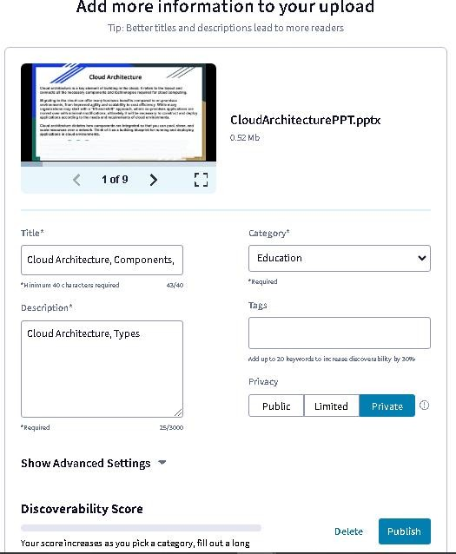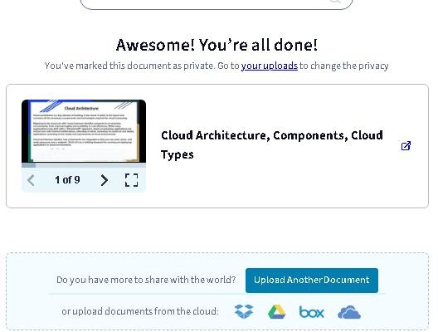

# Section 2: Data Science Lab

## Question 1:

Create a vector of size 10, having the values 5,7,9,11,13,13,11,9,7,5. Compute the sum, mean, highest and lowest of these values. Compute the length of this vector? Find the variance and standard deviation for the data of this vector, using the formula for variance and standard deviation. Compare these values by computing the variance and standard deviation using R function. Sort this array values in decreasing order.

## Program:

# Create a vector

numbers_vector <- c(5, 7, 9, 11, 13, 13, 11, 9, 7, 5)

# Compute the sum, mean, highest, and lowest sum_value <- sum(numbers_vector) mean_value <- mean(numbers_vector) max_value <- max(numbers_vector)

min_value <- min(numbers_vector)

# Compute the length of the vector vector_length <- length(numbers_vector)

# Compute variance and standard deviation using formulas

variance_formula <- sum((numbers_vector - mean_value)^2) / (vector_length - 1) std_dev_formula <- sqrt(variance_formula)

# Compute variance and standard deviation using R functions variance_r <- var(numbers_vector)

std_dev_r <- sd(numbers_vector)

# Sort the vector in decreasing order

sorted_vector <- sort(numbers_vector, decreasing = TRUE)

# Display results

cat("Original Vector:", numbers_vector, "\n") cat("Sum:", sum_value, "\n")

cat("Mean:", mean_value, "\n") cat("Highest Value:", max_value, "\n") cat("Lowest Value:", min_value, "\n") cat("Length of Vector:", vector_length, "\n")

cat("Variance (Formula):", variance_formula, "\n") cat("Standard Deviation (Formula):", std_dev_formula, "\n") cat("Variance (R Function):", variance_r, "\n")

cat("Standard Deviation (R Function):", std_dev_r, "\n") cat("Sorted Vector (Decreasing Order):", sorted_vector, "\n")

## Output:

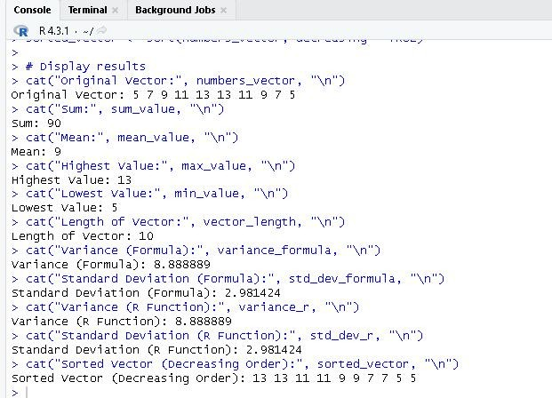

**Question 2:**

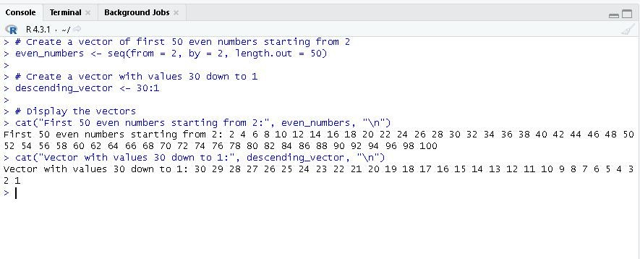

Create a vector of first 50 even numbers, starting from 2. Also create a vector having values 30 down to 1, as 30, 29, ...,1

## Program:

# Create a vector of first 50 even numbers starting from 2 even_numbers <- seq(from = 2, by = 2, length.out = 50)

# Create a vector with values 30 down to 1 descending_vector <- 30:1

# Display the vectors

cat("First 50 even numbers starting from 2:", even_numbers, "\n") cat("Vector with values 30 down to 1:", descending_vector, "\n")

## Output:

**Question 3:**

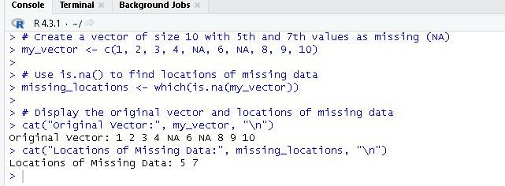

Create a vector of size 10 with 5th and 7th values as missing (store these values as NA). Use the "is.na()" to find locations of missing data.

## Program:

# Create a vector of size 10 with 5th and 7th values as missing (NA) my_vector <- c(1, 2, 3, 4, NA, 6, NA, 8, 9, 10)

# Use is.na() to find locations of missing data missing_locations <- which(is.na(my_vector))

# Display the original vector and locations of missing data cat("Original Vector:", my_vector, "\n")

cat("Locations of Missing Data:", missing_locations, "\n")

## Output:

**Question 4:**

Create a vector of characters of size 5, consisting of values: "This" "is" "a" "character" "vector". Find the index of value "is" in the vector using which() or match().

## Program:

# Create a vector of characters

my_vector <- c("This", "is", "a", "character", "vector")

# Find the index of "is" using which() index_using_which <- which(my_vector == "is")

# Find the index of "is" using match() index_using_match <- match("is", my_vector)

# Display the original vector and the indices cat("Original Vector:", my_vector, "\n")

cat("Index of 'is' (using which()):", index_using_which, "\n") cat("Index of 'is' (using match()):", index_using_match, "\n")

## Output:

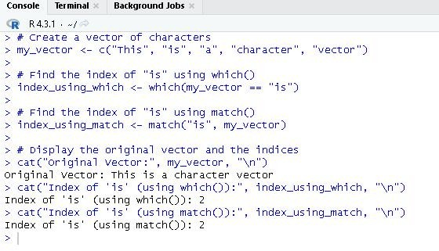

**Question 7:**

Assuming that the problem, as given above, does not have any categories. Perform k-mean clustering on the data with k = 5

## Program:

# Install and load required libraries install.packages("readxl") library(readxl)

# Load data from Excel file (replace 'your_excel_file.xlsx' with your file path)

customer_data <- read_excel("D:/IGNOULab/customer_data.xlsx", sheet = "customer_data")

# Convert the IsSubscriber column to boolean customer_data$IsSubscriber <- as.logical(customer_data$IsSubscriber)

# Select relevant columns for clustering

clustering_data <- customer_data[, c("FamilyIncome", "TotalAmountSpent", "IsSubscriber")]

# Check for missing, NaN, or infinite values clustering_data <- na.omit(clustering_data)

# Set the number of clusters to 5 num_clusters <- 5

# Check if the number of clusters is valid

if (num_clusters < 1 || num_clusters > nrow(clustering_data)) { stop("Invalid number of clusters.")

}

# Perform k-means clustering

kmeans_result <- kmeans(clustering_data[, c("FamilyIncome", "TotalAmountSpent")], centers = num_clusters, nstart = 20)

# Attach the cluster labels to the original data customer_data$Cluster <- as.factor(kmeans_result$cluster)

# Plot the clusters (2D scatter plot using actual values) plot(clustering_data$FamilyIncome, clustering_data$TotalAmountSpent, col =

kmeans_result$cluster, pch = 19, main = "K-Means Clustering Results", xlab = "Family Income", ylab = "Total Amount Spent")

# Add cluster centers to the plot

points(kmeans_result$centers[, c("FamilyIncome", "TotalAmountSpent")], col = 1:num_clusters, pch = 3, cex = 2)

# Add legend

legend("topright", legend = paste("Cluster", 1:num_clusters), col = 1:num_clusters, pch = 19, title

= "Clusters")

# View the result (first few rows) head(customer_data)

## Output:

