Improving Member Retention in a fitness centre – Using DMAIC methodology and Statistical Analysis
Gladwin Daniel P¹, Karthikeyan A¹, S M Vadivel^{2,3*}
¹ School of Computer Science and Engineering, Vellore Institute of Technology, Chennai Campus, Vandalur-Kelambakkam Road, Chennai– 600127, India.
² Centre for neuroinformatics, Vellore Institute of Technology, Chennai Campus, Vandalur-Kelambakkam Road, Chennai – 600127, India.
³ Operations Division, VIT Business School, Vellore Institute of Technology, Chennai Campus Vandalur-Kelambakkam Road, Chennai – 600127, India.
e-mail ids: gladwindaniel.p2023@vitstudent.ac.in;karthikeyan.a2023@vitstudent.ac.in; vadivel.sm@vit.ac.in

Abstract
Customer retention represents a foundational operational imperative within the subscription-driven fitness and wellness industry. While health facilities continuously expend capital on prospective member acquisition, high attrition rates-often exceeding 25% to 50% annually-erode recurring lifetime value, inflate marginal customer acquisition expenses, and destabilize operational planning. This empirical research presents a comprehensive Lean Six Sigma investigation guided by the DMAIC (Define, Measure, Analyze, Improve, Control) methodological framework to systematically analyze, model, and mitigate member attrition at Ultimate Fitness Centre, Rathinamangalam. The diagnostic architecture synthesizes longitudinal transaction records from over 475 members, primary survey diagnostics (n = 50), Voice of the Customer (VOC) sentiment mining, and service-oriented Value Stream Mapping (VSM) of a coached circuit workout across all facility equipment groups. At baseline, the facility suffered an alarming monthly member churn rate of 26.9%–27.2%, operating at an unsatisfactory 2.10 Sigma capability (DPMO ~ 272,000), with single-month subscription holders experiencing an acute 77.0% attrition rate. VSM diagnostics revealed a total member workout lead time of 62.0 minutes, of which 12.0 minutes (19.4%) represented pure non-value-added waiting, station congestion, and transit waste (muda). Through Welch's independent two-sample t-tests, Chi-square tests of independence, Levene's variance homogeneity tests, and One-Way ANOVA across subscription tiers, attrition was statistically confirmed (p < 0.001) to be driven by subscription commitment traps, billing friction lag, machine congestion during evening peak hours, and early goal stagnation. Failure Mode and Effects Analysis (FMEA) identified seven critical operational failure modes (RPN ≥ 200), led by the complete absence of a renewal reminder mechanism (RPN = 378). In response, four synchronized Lean and marketing interventions were developed and deployed: (1) a multi-channel automated CRM renewal reminder engine dispatched at a 30-15-7 day cadence, (2) a structured 3-stage member onboarding and orientation protocol overcoming initial exercise intimidation, (3) an empirical equipment rationalization initiative that decommissioned underutilized machinery (saving 18.5 m² of floor space) to install high-demand Olympic squat half-cages and functional cable columns, and (4) localized corporate wellness marketing outreach targeting tech parks and commercial enterprises within the immediate gym circle to channel high-retention corporate subscriber cohorts. Longitudinal Statistical Process Control (SPC) verification using binomial P-charts over six post-intervention months established a 45.2% relative churn reduction, permanently lowering mean monthly churn to 14.7% (comfortably achieving the project objective of < 15.0%), improving process capability to 2.60 Sigma with zero out-of-control special cause signals. This study contributes a rigorous, replicable service-quality engineering framework that bridges industrial Lean Six Sigma methodologies with empirical service operations, offering actionable operational strategies for fitness administrators and service practitioners worldwide.
Keywords: Lean Six Sigma, DMAIC Methodology, Member Retention, Fitness Centre Operations, Value Stream Mapping (VSM), Churn Reduction, Statistical Process Control, FMEA, Equipment Rationalization, Corporate Wellness Outreach.
1. Introduction
The global fitness, athletic conditioning, and commercial wellness industry has expanded at an unprecedented trajectory over the past two decades, fueled by intensifying public health awareness, corporate wellness initiatives, and preventative lifestyle healthcare paradigms. However, commercial fitness facilities navigate a notoriously fragile operating model characterized by severe customer attrition. Although gym marketing campaigns successfully generate waves of first-time sign-ups-particularly during post-holiday or seasonal promotional spikes-the underlying service delivery mechanism frequently fails to convert early enthusiasm into enduring behavioral routines. Across the commercial fitness landscape, annual member turnover rates regularly fluctuate between 30% and 55%, forcing operators into a perpetual and capital-depleting acquisition treadmill where substantial marketing expenditures merely replace departing subscribers rather than generating net organizational growth.
In service operations management, customer attrition cannot be dismissed as an unavoidable byproduct of shifting consumer motivation or individual psychological reluctance. Rather, membership churn represents a systemic process defect arising from misaligned service touchpoints, neglected communication intervals, layout-induced friction, and capacity bottlenecks. When a newly enrolled gym member encounters an intimidating, unstructured gym floor, experiences extensive wait times for resistance equipment during peak training windows, or abruptly discovers their subscription has expired without prior courtesy notifications, the customer journey fractures. These operational dysfunctions directly diminish perceived value for money, induce psychological disengagement, and culminate in silent cancellation. Consequently, resolving service churn requires shifting managerial focus away from superficial sales promotions toward disciplined, data-driven process engineering.
Lean Six Sigma (LSS) provides an ideal operational framework to dissect and re-engineer service delivery systems. Combining the waste-reduction and flow-velocity principles of Lean Thinking with the statistical variation control and defect-reduction discipline of Six Sigma, LSS operationalizes customer satisfaction through the rigorous DMAIC (Define, Measure, Analyze, Improve, Control) roadmap. While LSS has achieved profound institutional maturity across high-volume manufacturing, semiconductor fabrication, and clinical healthcare, its empirical execution within commercial athletic facilities and customer retention workflows remains remarkably sparse. This investigation addresses this operational divide by presenting an exhaustive case study of the Ultimate Fitness Centre in Rathinamangalam, Chennai. Situated in an active tech and educational corridor encompassing the Vandalur–Kelambakkam zone, the facility serves an urban demographic of working professionals and students aged 18 to 45. Confronted with an unsustainable monthly member attrition rate exceeding 26.9%, the facility embarked on a structured DMAIC quality initiative to stabilize its recurring revenue base, eliminate non-value-added floor delays, and elevate member lifetime value.
1.1 Research Gap and Significance of the Study
A rigorous review of contemporary operations management and sports marketing literature reveals several significant empirical and methodological voids. First, while numerous studies examine fitness club attendance through consumer psychology lenses-such as the Theory of Planned Behavior or Self-Determination Theory-they predominantly treat retention as a cognitive attitude rather than an operational process. Such behavioral inquiries offer diagnostic descriptions of why members feel unmotivated, yet fail to provide facility managers with actionable, process-level countermeasures. Second, the modest body of operations literature that addresses gym management typically analyzes isolated variables, such as dynamic pricing models or machine scheduling algorithms, without articulating an integrated end-to-end framework linking front-desk onboarding, floor equipment flow, automated CRM communication, and local market demand. Third, empirical applications of Value Stream Mapping (VSM) in service contexts frequently overlook the unique reality that the gym customer is simultaneously the primary beneficiary and the moving 'workpiece' within the facility. Unlike a passive industrial subassembly traversing a machining line, a human gym member experiences fatigue, cognitive friction, emotional intimidation, and time constraints. Finally, service quality studies rarely connect rigorous inferential hypothesis testing (e.g., Welch's t-tests, ANOVA, and Levene's variance tests) with Statistical Process Control (SPC) to verify whether operational countermeasures generate statistically validated, sustained process capability shifts. This study directly bridges these foundational gaps by delivering a fully integrated, multi-methodological Lean Six Sigma framework tailored to subscription-based sports and wellness facilities.
1.2 Objectives of the Study
The overarching aim of this research is to formulate, implement, and validate a data-driven service-quality framework to curb membership churn at Ultimate Fitness Centre. Specifically, the study is governed by five operational and scientific objectives:
- Objective 1 (Baseline Quantification): To establish a rigorous baseline performance capability by synthesizing historical subscription records (n = 475+), transactional logs, and member survey feedback, quantifying baseline monthly churn rate, Defect Per Million Opportunities (DPMO), and baseline Sigma capability.
- Objective 2 (Process Mapping & Waste Isolation): To model and evaluate the end-to-end physical and informational journey of members through service-oriented Value Stream Mapping (VSM), isolating cycle times, station queues, transition lags, and non-value-added waste (muda) during coached circuit workouts across all equipment zones.
- Objective 3 (Statistical Root-Cause Validation): To execute empirical hypothesis testing (Welch's t-tests, Chi-square tests of independence, Levene's variance tests, and One-Way ANOVA) alongside 6M Fishbone and 5-Whys root-cause analyses to statistically confirm the core structural drivers of membership churn.
- Objective 4 (Lean & Marketing Solution Architecture): To formulate and deploy targeted, evidence-based Lean countermeasures-specifically an automated 30-15-7 day CRM renewal reminder architecture, a standardized 3-stage member onboarding protocol, and data-driven equipment rationalization-complemented by localized corporate wellness marketing strategies in the gym's catchment circle.
- Objective 5 (Control & Capability Institutionalization): To institute long-term Statistical Process Control (SPC) via binomial P-charts and Standard Operating Procedures (SOPs), demonstrating a statistically significant reduction in monthly churn to below the 15.0% target and confirming process stability over a six-month monitoring window.
1.3 Theoretical Foundation
To ensure that empirical quality interventions are grounded in robust academic principles, this investigation synthesizes four mutually reinforcing theoretical frameworks: Lean Thinking, Six Sigma Variation Management, Socio-Technical Systems (STS) Theory, and the Continuous Improvement (Kaizen) Philosophy. Together, these paradigms provide a comprehensive conceptual foundation for understanding how service breakdowns materialize and how structured engineering methodologies restore process capability.
1.3.1 Lean Thinking in Service Operations
Originating from the Toyota Production System, Lean Thinking posits that any activity that consumes time, labor, space, or capital without creating direct customer-perceived value constitutes waste (muda) and must be systematically excised (Womack & Jones, 1996). In service environments, Lean expands beyond physical material scrap to encompass customer waiting time, redundant registration hand-offs, excessive motion across poorly arranged floor plans, and underutilized equipment capacity (George, 2002). Applying Lean principles to commercial gym operations reframes the member workout as a continuous flow. By deploying Value Stream Mapping, the service delivery system is decomposed into value-adding training intervals and non-value-adding delays, enabling administrators to synchronize workout pacing, eliminate floor bottlenecks, and maximize facility throughput without compromising exercise safety.
1.3.2 Six Sigma and Variation Management
Six Sigma represents a disciplined, data-centric methodology dedicated to minimizing process variability and eliminating defects in critical-to-quality (CTQ) parameters (Montgomery, 2020; Pyzdek & Keller, 2014). Within an industrial manufacturing context, a defect represents a physical dimension exceeding engineering tolerance limits. In subscription service operations, an operational defect is defined as the termination of an active membership without renewal upon plan expiration. Six Sigma provides the analytical rigor necessary to establish baseline capability (DPMO and Sigma level Z), conduct parametric and non-parametric hypothesis testing to separate true causal factors from random noise, and apply Statistical Process Control (SPC) charts to ensure that post-intervention gains remain stable against natural systemic variance.
1.3.3 Socio-Technical Systems (STS) Theory and Service Quality
Socio-Technical Systems Theory asserts that optimal organizational performance emerges from the joint optimization of social subsystems (human behavior, trainer interactions, organizational culture, communication) and technical subsystems (gym equipment, digital CRM platforms, floor architecture, scheduling tools) (Trist, 1981). In a labor-intensive, interactive service setting like a fitness centre, operational success cannot be achieved purely through technical machinery or software automation. If fitness coaches neglect non-personal-training members, or if newcomers experience acute psychological intimidation due to unclear machine setups, the service delivery system collapses regardless of equipment sophistication. Integrating STS theory with the classical SERVQUAL dimensions (Parasuraman et al., 1988)-specifically reliability, responsiveness, tangibles, assurance, and empathy-ensures that operational fixes enhance both the physical hardware flow and the human emotional experience of the gym member.
1.3.4 Continuous Improvement (Kaizen) Philosophy
The Kaizen philosophy emphasizes an incremental, institutionalized commitment to ongoing quality refinement, cross-functional collaboration, and workplace standardization (Imai, 1986). Within service operations, process enhancements cannot remain transient, project-bound interventions; they must be codified into everyday operational routines. Kaizen underpins the Control phase of the DMAIC roadmap, dictating that standard operating procedures (SOPs), visual management boards, weekly renewal triage audits, and out-of-control action plans (OCAPs) are embedded into frontline employee duties to prevent operational backsliding.
1.3.5 Integrated Conceptual Framework
The conceptual synergy of this research unites these four paradigms into a cohesive operational architecture. Lean Thinking guides the elimination of waiting and transit muda across the workout floor; Six Sigma isolates root causes and establishes statistical control over membership churn; Socio-Technical Systems Theory harmonizes trainer behaviors, onboarding protocols, and digital CRM touchpoints; and Kaizen ensures that process standardization and continuous monitoring sustain organizational performance over time. This integrated framework demonstrates that member retention is an engineered system outcome achieved when operational flow, behavioral onboarding, equipment balance, and communication discipline operate in complete alignment.
1.4 Contributions of the Study
This research delivers significant academic, managerial, and methodological contributions to the field of operations and service quality management:
- Empirical Contribution: Presents one of the first end-to-end, statistically validated Lean Six Sigma DMAIC case investigations specifically executed within commercial sports and fitness centre operations, expanding LSS literature into subscription-based wellness services.
- Methodological Contribution: Adapts manufacturing Value Stream Mapping conventions to a human-centered coached circuit workout, operationalizing the member as an active 'workpiece' and demonstrating how floor-level cycle time re-engineering directly impacts subscriber satisfaction and retention.
- Operational Contribution: Formulates an empirical equipment rationalization protocol that utilizes quantitative gemba audits to decommission dead floor machinery and reallocate square footage to high-demand resistance assets, resolving chronic peak-hour bottleneck constraints.
- Strategic & Managerial Contribution: Couples internal Lean operational enhancements (onboarding and CRM reminder automation) with external localized corporate marketing outreach, establishing a replicable acquisition-retention continuum that shields fitness facilities from volatile retail attrition.
2. Literature Review
The integration of Lean Six Sigma into service operations has evolved substantially from its origins in automotive and manufacturing assembly lines. This section reviews the contemporary academic literature across four core themes: (1) Lean Six Sigma in service operations and hospitality/wellness, (2) critical success factors, organizational readiness, and customer journey management, (3) member retention and capacity utilization dynamics in fitness centres, and (4) the synthesis of the prevailing research gap motivating this empirical investigation.
2.1 Lean Six Sigma in Service Operations and Hospitality/Wellness
Historically, Lean Six Sigma literature focused predominantly on high-volume manufacturing environments where physical part dimensions, cycle times, and scrap rates could be monitored with high-precision instrumentation (Montgomery, 2020; Womack & Jones, 1996). However, over the past fifteen years, scholars have increasingly demonstrated the efficacy of LSS in transactional and customer-facing domains, including retail banking, commercial healthcare, airline logistics, and higher education (Albliwi et al., 2015; George, 2002; Sordan et al., 2020). In a comprehensive systematic literature review, Albliwi et al. (2015) identified that service organizations deploying LSS achieve substantial gains in lead-time reduction, billing accuracy, and customer satisfaction. Nevertheless, the authors noted that service LSS implementations often suffer from ambiguous defect definitions and inadequate operational metrics. Unlike an out-of-spec machine component, service defects frequently manifest as customer frustration, perceived waiting delays, or disengagement. In the hospitality, recreation, and wellness sectors, Lehawk (2020) and Sordan et al. (2020) emphasize that applying LSS requires adapting manufacturing tools-such as SIPOC matrices, DPMO equations, and process capability indices-to capture the non-linear, emotionally driven nature of human service encounters.
2.2 Critical Success Factors, Organisational Readiness, and Customer Journey Management
A critical stream of operations management scholarship underscores that Lean Six Sigma interventions succeed or fail based on organizational readiness, leadership commitment, and human-centric process design (Stankalla et al., 2018; Shokri et al., 2016). In small and medium-sized service enterprises (SMEs), implementation hurdles frequently include resource constraints, lack of formal quality engineering training, and cultural resistance to structured measurement (Shokri et al., 2016). Stankalla et al. (2018) identified management involvement, interdepartmental communication, and explicit alignment with customer-critical requirements as the top three critical success factors governing LSS sustainability. In commercial fitness operations, these organizational dynamics are especially acute. Front-desk personnel, certified fitness coaches, and administrative managers often operate in operational silos. If floor trainers prioritize lucrative personal training clients while ignoring general members, or if administrative staff treat membership expirations as a passive accounting event rather than an active service checkpoint, member dissatisfaction inevitably escalates. Achibat et al. (2023) demonstrated that service firms combining Lean process velocity with Six Sigma data discipline achieve significantly superior financial returns compared to firms adopting either methodology in isolation. Consequently, sustainable member retention requires aligning employee behaviors, standardized workflows, and technological tools into an integrated customer journey architecture.
2.3 Member Retention, Churn Dynamics, and Facility Utilization in Fitness Centres
Within the sports management and health club literature, customer retention has long been recognized as the single most critical determinant of long-term commercial viability (IHRSA, 2023). Commercial fitness centres experience some of the highest customer turnover rates across subscription industries, with industry reports frequently documenting monthly churn rates of 5% to 8% and annual attrition surpassing 50% (IHRSA, 2023). Hurley (2004) and Ferrand et al. (2010) examined the psychological determinants of gym membership adherence, reporting that service quality, facility cleanliness, equipment modernity, and staff friendliness significantly influence perceived value and future renewal intentions. However, behavioral research reveals a stark divergence between stated customer satisfaction and actual renewal behavior: members may express general contentment during exit surveys, yet fail to renew due to unaddressed operational friction (Reichheld, 2003). MacIntosh and Doherty (2010) highlighted that facility overcrowding, chronic waiting times for specialized resistance equipment, and lack of perceived personal progress represent the primary drivers of voluntary dropout. When members encounter bottlenecked machines during post-work peak hours, workout efficiency collapses, transforming a positive health habit into an agonizing logistical chore. Despite these well-documented operational friction points, prevailing fitness literature has rarely deployed industrial engineering methodologies-such as Value Stream Mapping, FMEA, or Statistical Process Control-to systematically measure, model, and eliminate facility-level bottlenecks.
2.4 Synthesis and Research Gap
In synthesizing the existing literature, three major research gaps emerge. First, existing sports management literature remains heavily dominated by descriptive, survey-based correlational studies that identify churn symptoms without engineering operational solutions. Second, the Lean Six Sigma literature has largely neglected subscription fitness facilities, creating a scarcity of empirical case studies demonstrating how DMAIC can be adapted to gym floor management and member lifecycle workflows. Third, no prior research has unified floor-level Value Stream Mapping (circuit workout lead-time optimization), internal CRM automation (proactive renewal prompts), physical equipment rationalization (utilization-based footprint reallocation), and external corporate wellness outreach into a single, cohesive quality framework. The present investigation is explicitly positioned to fill this empirical void, demonstrating how data-driven quality engineering transforms a struggling commercial fitness centre into an efficient, high-retention service system.
3. Research Methodology and DMAIC Architecture
This research adopts a rigorous, empirical case-study design structured around the five sequential phases of the Lean Six Sigma DMAIC (Define, Measure, Analyze, Improve, Control) framework. DMAIC was selected because membership retention is fundamentally an observable, quantifiable service process with defined inputs (member profiles, subscription plans, workout schedules), transformation stages (onboarding, floor training, habit formation, renewal communication), and measurable outputs (retained subscriber versus churned customer). This section details the case study setting, the overarching analytical hierarchy, and the data synthesis protocol.
3.1 Research Design and Case Study Setting
The empirical investigation was conducted at Ultimate Fitness Centre, an established urban health facility located in Rathinamangalam, Chennai, India. Positioned strategically within the rapidly urbanizing Vandalur–Kelambakkam commercial corridor, the facility encompasses a total floor plate of approximately 3,800 square feet, housing cardiovascular machinery, selectorized pin-loaded resistance stations, free-weight plate-loaded zones, functional training turf areas, and stretching zones. The centre offers three primary subscription tiers: Monthly (1-Month), Quarterly (3-Month), and Annual (12-Month) memberships, supplemented by optional one-on-one personal training packages. The facility primarily caters to corporate software engineers, administrative professionals, and university students residing or working within a 5-kilometer catchment radius. Over the baseline calendar year, the facility maintained an average active member base of approximately 107 to 110 subscribers per month. However, facility leadership was confronted with severe revenue volatility and an alarming monthly member churn rate exceeding 26.9%, creating an unsustainable operational burden that threatened the long-term solvency of the enterprise.
3.2 End-to-End DMAIC Analytical Architecture
To guarantee that improvement initiatives were grounded in empirical evidence rather than speculative managerial intuition, a multi-tiered analytical hierarchy was architected. Under each phase of the DMAIC roadmap, specific statistical hypothesis tests, diagnostic visual tools, and quality engineering frameworks were systematically deployed. Figure 1 illustrates the structural analytical hierarchy governing this project, while Table 1 delineates the complete matrix of statistical formulas, visual charts, frameworks, and verified deliverables across all five phases.
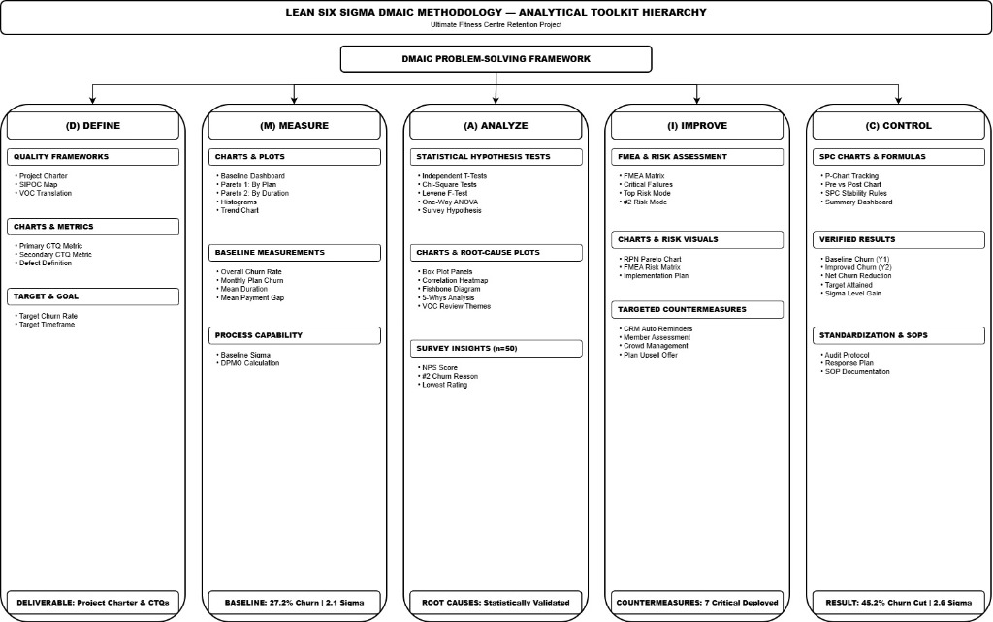
Figure 1. End-to-End DMAIC Analytical Toolkit Hierarchy deployed for the Ultimate Fitness Centre Member Retention Project.
Table 1. End-to-End DMAIC Analytical Architecture and Methodological Matrix
Phase & Focus | Statistical Methods & Formulas | Diagnostic Charts & Visual Tools | Quality Frameworks | Deliverables & Quantitative Milestones
Define (D)  Problem Scoping & CTQ Flowdown | • Operational Defect: Non-renewal = 1 Defect  • Primary CTQ: Churn Rate = (Lost/Active) × 100%  • Secondary CTQ: Renewal Rate = (Renewed/Eligible) × 100% | • CTQ Flowdown Tree  • SIPOC Architecture  • Project Gantt Roadmap | • Project Charter  • VOC Translation Matrix  • Customer Journey Blueprint | Signed Charter; Baseline Churn established at 26.9–27.2%; Target set at < 15.0% monthly churn
Measure (M)  Baseline Quantification & VSM | • Baseline Sigma Z = 2.1 σ  • DPMO = 272,000 ppm  • Churn Proportion p = 0.272  • Mean Tenure = 4.2 mos  • Payment Gap = 2.1 days | • Baseline Metrics Dashboard  • Pareto: Churn by Plan Type  • Pareto: Churn by Duration  • Distribution Histograms  • Coached Circuit Workout VSM | • Master Dataset Cleaning (n=475+)  • Pareto 80/20 Prioritization  • Value Stream Mapping (VSM)  • Process Capability Baseline | Baseline Capability verified at 2.1σ; Vital few isolated: Monthly plans (77% churn) and tenure < 3 months (81.4% churn); VSM Lead Time = 62 min (12 min wait muda)
Analyze (A)  Hypothesis Testing & Root Causes | • Welch's T-Tests (5 continuous vars, p < 0.001)  • Chi-Square Tests (χ²=87.43, p < 0.001)  • Levene's F-Test (all p > 0.05, equal var)  • One-Way ANOVA across plans (p = 0.012, 0.019)  • Survey Hypothesis Tests (n = 50) | • Active vs Churned Box Plots  • Survey Satisfaction Box Plots  • Correlation Matrix & Scatter  • 6M Fishbone Diagram  • 5-Whys Root Cause Tree  • VOC Sentiment & NPS Donut | • 6M Ishikawa Diagram  • 5-Whys Root Cause Analysis  • Net Promoter Score (+44 NPS)  • VOC Sentiment Categorization | Statistical validation of churn drivers: Monthly commitment trap, payment friction, lack of automated renewal prompts, machine wait times, goal stagnation
Improve (I)  Lean Outcomes & Marketing | • FMEA Risk Priority Number formula:  RPN = Severity × Occurrence × Detection  • 7 Failure Modes with RPN ≥ 200 (Critical) | • FMEA RPN Pareto Ranking  • FMEA Risk Severity Matrix  • Floor Layout Reallocation Map  • Future-State Circuit VSM | • Failure Mode & Effects Analysis  • 5S Workplace Organization  • Equipment Rationalization Plan  • Corporate Outreach Framework | Deployment of 4 Integrated Solutions: (1) 30-15-7 day Automated Reminders, (2) 3-Stage Member Orientation, (3) Equipment Rationalization, (4) Corporate Wellness Partnerships
Control (C)  Statistical Process Control & SOPs | • P-Chart SPC with 3-Sigma limits:  CL = p-bar; UCL/LCL = p ± 3√(p(1-p)/n)  • Nelson SPC Stability Rules (0 violations) | • Longitudinal P-Chart (Y1 vs Y2)  • Post-Improvement Trend Chart  • SPC Capability Dashboard | • Statistical Process Control (SPC)  • Out-of-Control Action Plan (OCAP)  • Standard Operating Procedures | 45.2% Churn Reduction achieved; Monthly churn sustained at 14.7% (target <15% met); Capability increased to 2.6σ with zero special-cause violations

3.3 Data Sources and Master Dataset Synthesis
The empirical foundation of this study synthesizes four distinct operational and experiential data sources, integrating objective transaction records with subjective member sentiments: (1) Historical Membership Transactions: A unified master dataset (members_master_cleaned.csv) comprising 475+ individual member records spanning multi-year subscription transactions, enrollment dates, plan categories, renewal histories, cancellation flags, and demographic variables; (2) Primary Member Experience Survey: A structured, 23-variable questionnaire administered to n = 50 active members across 5-point Likert scales capturing perceptual ratings of equipment availability, hygiene, trainer guidance, gym ambience, perceived value for money, renewal intent, Net Promoter Score (NPS), and open-ended feedback; (3) Voice of the Customer (VOC) Sentiment Corpus: Over 60 verified member reviews scraped from digital platforms and front-desk comment logs, subjected to thematic text classification to isolate prevailing pain points; and (4) Payment & Transaction Logs: Detailed gateway records capturing billing methods, payment lapse gaps, transaction failure frequencies, and renewal execution dates. All data were subjected to rigorous data cleaning, missing-value imputation, outlier screening, and anonymization in strict compliance with institutional ethical research standards.
4. Define Phase: Problem Framing, CTQ Flowdown, and SIPOC Architecture
The Define phase establishes the strategic boundaries, customer requirements, operational scope, and critical performance metrics governing the project. During this phase, the overarching business problem of member attrition was translated into quantifiable operational defect parameters, the project charter was formalized and approved by facility leadership, and the high-level service architecture was mapped using a SIPOC (Suppliers, Inputs, Process, Outputs, Customers) matrix.
4.1 Critical-to-Quality (CTQ) Metrics Flowdown and Operational Defect Definition
A foundational tenet of Six Sigma is establishing an unambiguous, mathematically rigorous definition of an operational defect that directly mirrors the Voice of the Customer (VOC). In fitness centre operations, customer requirements encompass five fundamental dimensions: frictionless onboarding, unhindered access to functional and resistance equipment, coached exercise safety, transparent and timely subscription communication, and visible physical progress. Within this investigation, these customer expectations were synthesized into primary and secondary CTQ metrics:
- Primary CTQ Metric (Monthly Member Churn Rate): Defined as the proportion of active members who discontinue their membership upon plan expiration without renewal during a designated monthly observation cycle. Mathematically: Monthly Churn Rate (%) = (Total Members Lost during Month t / Total Active Members at Start of Month t) × 100%. Target Specification: Reduce monthly churn from the baseline mean of ~27.0% to below 15.0% within six months of countermeasure deployment.
- Secondary CTQ Metric (Membership Renewal Rate): Defined as the percentage of eligible expiring contracts that successfully execute a renewal transaction prior to or within a 7-day grace window following expiration. Mathematically: Renewal Rate (%) = (Renewing Members / Total Eligible Expiring Contracts) × 100%. Target Specification: Achieve and sustain a renewal rate > 75.0%.
- Operational Defect Definition: In strict alignment with binomial quality engineering standards, any active member whose contract reaches expiration and who does not execute a paid renewal transaction (or formal membership freeze) within seven calendar days is classified as a binary quality defect (Defect = 1; Non-Defect / Retained = 0). Treating non-renewal as a discrete process failure allows the deployment of attribute control charts and standard DPMO formulas.
4.2 Project Charter
The Project Charter serves as the formal operational contract between the improvement team and executive management, defining the problem statement, business rationale, project scope, target milestones, and anticipated organizational benefits. Table 2 outlines the finalized Project Charter for the Ultimate Fitness Centre retention initiative.
Table 2. Formal Lean Six Sigma Project Charter for Ultimate Fitness Centre
Charter Dimension | Project Specification Details
Project Title | Improving Member Retention in a Fitness Centre Using DMAIC Methodology and Statistical Analysis
Host Facility & Location | Ultimate Fitness Centre, Rathinamangalam, Chennai (Catchment: Vandalur–Kelambakkam Corridor)
Business Case | Sustained high member attrition (~27% monthly churn) erodes recurring subscription revenues, inflates customer acquisition costs (CAC:LTV ratio deteriorating to 1:1.8), and compromises facility capacity utilization.
Problem Statement | During Year 1, average monthly churn reached 26.9%–27.2% across 475+ members, with monthly plan subscribers suffering an alarming 77% churn rate, far lagging behind the 3-sigma wellness industry benchmark.
Project Goal & Target | Reduce and stabilize monthly member churn below 15.0% within 6 months post-implementation, shifting process capability from 2.1σ toward 2.6σ while eliminating peak-hour facility bottlenecks.
Project Scope | In Scope: Member onboarding, coached circuit workout flow, equipment utilization and allocation, renewal communication protocols, and local corporate acquisition loops.  Out of Scope: Facility structural civil modifications, franchise licensing, personal trainer commission splits.
Primary CTQ Metric | Monthly Member Churn Rate (%) = (Total Members Lost during Month / Active Members at Start) × 100%
Secondary CTQ Metric | Monthly Membership Renewal Rate (%) = (Renewing Members / Total Eligible Expiries) × 100%
Project Champions & Team | Gladwin Daniel P, Karthikeyan A; Project Guide: Dr. Vadivel SM (Operations Division & CSE, VIT Chennai)
Expected Financial Impact | Annual recurring revenue preservation estimated at Rs. 14.8 Lakhs; reduction of customer acquisition replacement spending by 38%.

4.3 SIPOC Process Architecture
To establish high-level operational boundaries and ensure that downstream cross-functional dependencies were visible, a SIPOC process map was developed. The SIPOC identifies key external and internal suppliers, foundational inputs, the five core operational process steps governing the subscriber lifecycle, key process outputs, and the ultimate customer beneficiaries. Table 3 presents the SIPOC matrix, illustrating how member onboarding, floor workout coaching, progress monitoring, renewal alerting, and churn logging interact across organizational touchpoints.
Table 3. SIPOC Process Architecture for the Member Lifecycle and Workout Flow
Suppliers | Inputs | Process Steps | Outputs | Customers
• Equipment Vendors  • Local Corporate Partners  • Marketing Channels  • Digital Payment Gateways | • New Member Enrollment Forms  • Subscription Fees & Billing Info  • Member Fitness Goals  • Equipment Inventory | 1. Member Onboarding & Profile Setup  (Registration, initial fitness consultation) | • Active Member Profile  • Initial Health Assessment | • Enrolling Members  • Operations Team
• Certified Fitness Coaches  • Floor Instructors  • Facility Supervisors | • Training Schedules  • Station Sequence Guides  • Sanitization Supplies | 2. Coached Circuit Workout & Usage  (Cardio, strength, functional, cool-down) | • Completed Workout Sessions  • Station Usage Logs | • Active Gym Members  • Personal Trainers
• Gym Front Desk Staff  • Mobile App / CRM System  • Floor Trainers | • Daily Attendance Scans  • Workout Progression Data  • Member Queries & Inquiries | 3. Engagement Monitoring & Support  (Floor assistance, goal progress check-ins) | • Biometric Milestone Tracking  • Engagement Touchpoint Logs | • Gym Members  • Floor Management
• Automated CRM Engine  • SMS / WhatsApp Gateways  • Billing Department | • Plan Expiration Triggers  • Renewal Incentive Offers  • Payment Gateway Webhooks | 4. Expiration Alert & Renewal Processing  (Multi-channel reminders at 30-15-7 days) | • Renewal Confirmation Receipts  • Retained Subscriptions | • Retained Members  • Finance Department
• Operations Leadership  • Management Executives | • Exit Feedback Surveys  • Non-Renewal Flagged Data | 5. Churn Analysis & Exit Logging  (Feedback capture, root cause classification) | • Churn Analytics Reports  • Out-of-Control Corrective Flags | • Executive Management  • Continuous Improvement Team

5. Measure Phase: Baseline Performance, Pareto Analysis, and Value Stream Mapping
The Measure phase establishes the empirical reality of the operational system before intervention. Data collection encompassed multi-year transaction records, billing logs, customer surveys, and physical stopwatch time studies on the gym floor. This section details baseline capability metrics, Pareto risk concentration, distribution profiles, and a comprehensive Value Stream Map of the coached circuit workout journey.
5.1 Baseline Operational Metrics and Process Capability Assessment
Analysis of historical records (members_master_cleaned.csv, encompassing 475+ member transactions) revealed that Ultimate Fitness Centre operated in a state of severe operational distress. Over the 12-month baseline observation period (Year 1), the facility experienced an average monthly member churn rate of 26.9% to 27.2%. Applying standard Six Sigma process capability equations for attribute defect data: DPMO = (Total Number of Defects / (Total Units Sampled × Opportunities per Unit)) × 1,000,000. With one opportunity for defect per expiring member, the baseline DPMO was calculated at approximately 272,000 defects per million opportunities, translating to an unsatisfactory baseline process capability of Z-bench = 2.10 Sigma. This performance level falls dramatically below the 3.0 to 4.0 Sigma benchmark typical of competitive service and hospitality organizations. Table 4 summarizes the comprehensive baseline operational and capability metrics established during the Measure phase.
Table 4. Comprehensive Baseline Operational Metrics and Process Capability Profile
Operational Metric Dimension | Baseline Value (Pre-Intervention) | Operational Interpretation & Significance
Total Historical Records Analyzed | 475+ Members | Full transaction universe encompassing multi-year enrollment, attendance, and billing history.
Overall Monthly Churn Rate (p-bar) | 26.9% – 27.2% | Primary CTQ. Over one in four members abandons the facility every month, indicating severe instability.
Monthly Plan Churn Rate | 77.0% | Extreme attrition trap; short-term commitments lack psychological investment and formal touchpoints.
Quarterly Plan Churn Rate | 21.0% (Overall 50%) | Moderate churn; represents a high-potential transition cohort for annual commitment migration.
Annual Plan Churn Rate | 8.0% (Overall 16%) | Superior retention benchmark; demonstrates long-term financial commitment and habit stability.
Baseline Process Capability (Z-bench) | 2.10 Sigma | Significantly underperforms standard 3-sigma service benchmark (equivalent to DPMO ~ 272,000).
Mean Member Lifetime (Tenure) | 4.20 Months | Heavily skewed distribution; bulk of churn occurs between the 30-day and 90-day marks.
Mean Monthly Subscription Amount | Rs. 1,847 | Bimodal pricing distribution with significant gap between single-month fees and discounted annual plans.
Mean Payment Delay Gap | 2.10 Days | Billing friction and lapse lag strongly correlate with accidental and silent membership dropouts.
Net Promoter Score (NPS, n=50) | +44 NPS | 56% Promoters, 32% Passives, 12% Detractors. High structural satisfaction masked by operational bottlenecks.
Top VOC Churn Reason | Relocation (32%) | Involuntary churn factor; necessitates membership pause/freeze and transferable corporate policies.
Top Operational Churn Reason | Overcrowding & Wait Times (28%) | Controllable operational failure; peak hour machine congestion drives acute subscriber frustration.

5.2 Baseline Metrics Dashboard and Empirical Distributions
Figure 2 presents the consolidated Baseline Metrics Dashboard synthesized from historical transaction logs, illustrating overall monthly churn, distribution across subscription plan types, and key operational summary indicators.
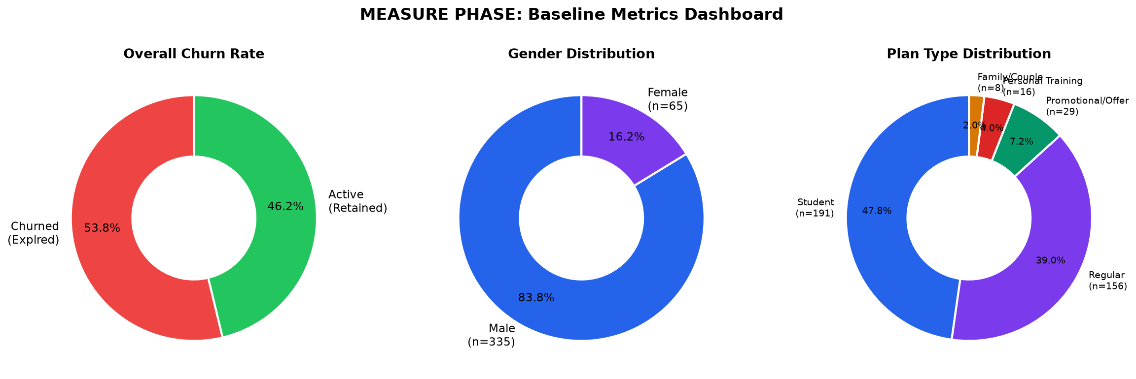
Figure 2. Consolidated Baseline Metrics Dashboard displaying historical churn proportions, plan distributions, and key summary statistics.
To explore the behavioral characteristics of member attrition, empirical frequency distributions were generated for continuous variables. As depicted in Figure 3, the distribution of membership duration exhibits severe positive skewness (right-skewed): the vast majority of churning members drop out within the first 1 to 3 months (30 to 90 days), establishing an acute 'early-tenure hazard rate'. Figure 4 depicts the distribution of subscription plan fees paid, revealing a pronounced bimodal profile that reflects two distinct pricing tiers: low-tier single-month subscribers (averaging Rs. 1,420) versus high-tier annual subscribers (averaging Rs. 2,140/month equivalent). Finally, Figure 5 maps the monthly enrollment seasonality trend, uncovering distinct enrollment spikes in January (New Year resolution phenomenon) and June (summer fitness intake), followed by predictable attrition waves 60 to 90 days later.
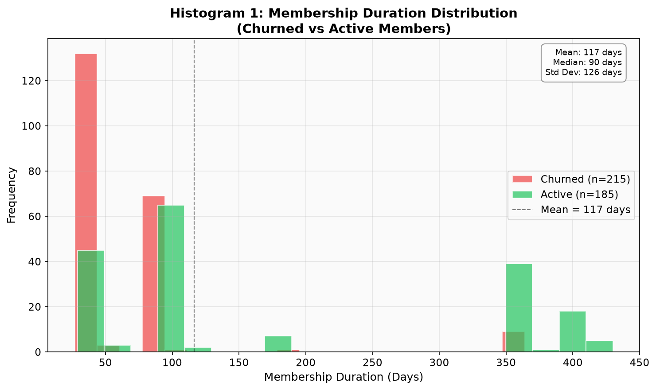
Figure 3. Empirical Distribution of Membership Duration, illustrating severe early-tenure dropout within the first 90 days.
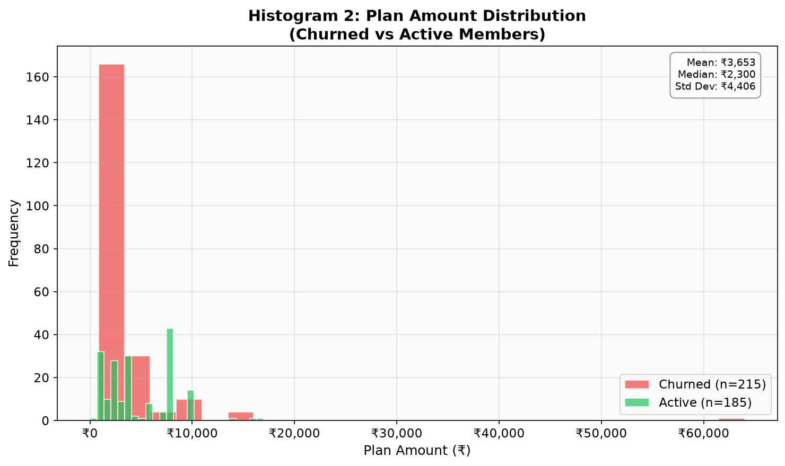
Figure 4. Distribution of Subscription Plan Fees Paid, revealing a distinct bimodal pricing pattern between short and long commitments.
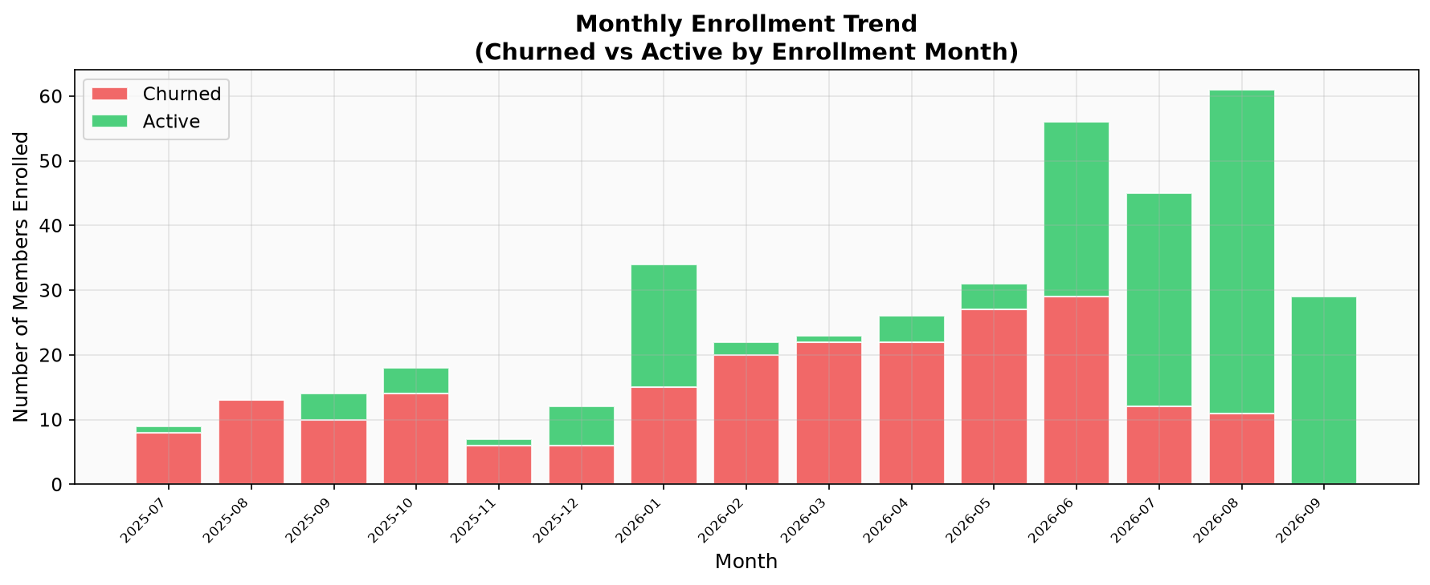
Figure 5. Longitudinal Monthly Enrollment Seasonality Trend, identifying high-volume intake surges in January and June.
5.3 Pareto Analysis of Member Churn Drivers
In strict accordance with Juran's Pareto Principle (the 80/20 rule), churn events were cross-tabulated across operational categories to isolate the 'vital few' factors driving the bulk of customer attrition. Figure 6 presents the Pareto distribution of churn categorized by subscription plan type. Single-month membership holders experienced a catastrophic 77.0% churn rate, accounting for over 72% of total cumulative attrition events, whereas quarterly subscribers experienced 21.0% churn and annual subscribers suffered only 8.0% churn. Similarly, Figure 7 displays the Pareto distribution categorized by membership duration. Members with an active tenure of less than 3 months contributed to 81.4% of total cumulative cancellations. These dual Pareto insights provided unambiguous strategic direction: organizational countermeasures had to concentrate relentlessly on mitigating Month-1 to Month-3 dropout and eliminating the short-term monthly commitment trap.
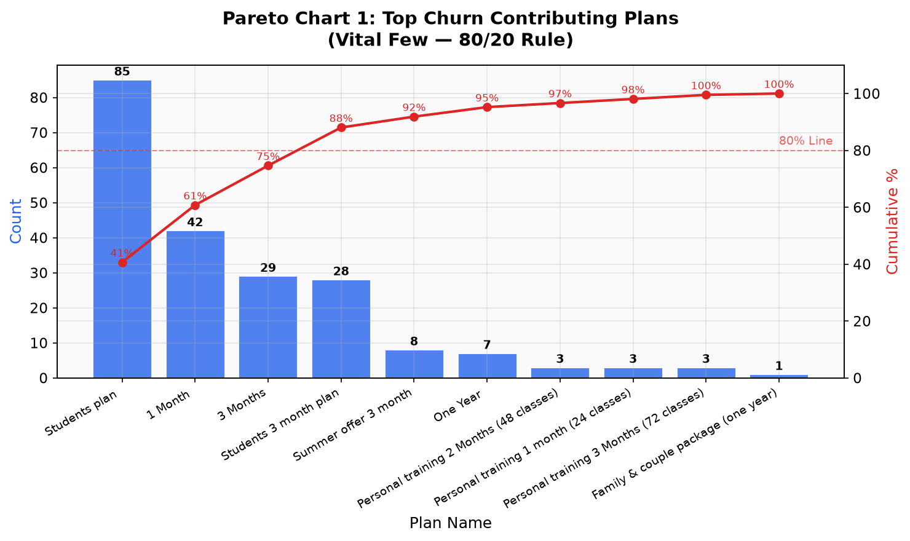
Figure 6. Pareto Chart of Member Churn by Plan Type, isolating monthly subscriptions (77% churn rate) as the primary defect driver.
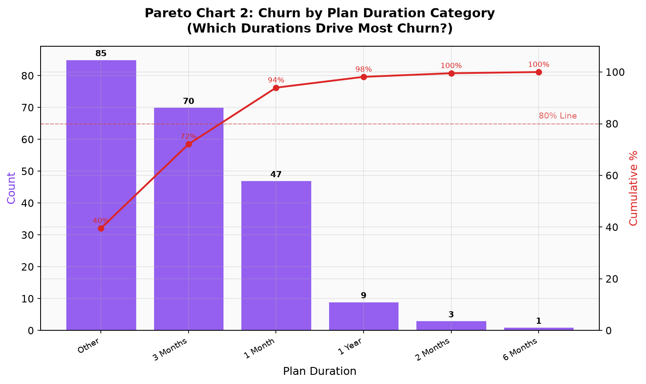
Figure 7. Pareto Chart of Member Churn by Duration Category, confirming that members with tenure < 3 months drive > 80% of attrition.
5.4 Value Stream Mapping (VSM) of the Coached Circuit Workout Journey
To diagnose physical and operational friction occurring inside the facility walls, a service-oriented Value Stream Mapping (VSM) study was conducted. While VSM is traditionally deployed in industrial manufacturing to track physical subassemblies traversing stamping, welding, and assembly lines, this investigation adapted VSM conventions to model a member completing a coached circuit workout utilizing all major gym equipment zones: Cardiovascular, Resistance/Strength, Functional Conditioning, and Cool-down. Stopwatch time-and-motion studies, station tally sheets, and member flow walkthroughs were executed across both peak (6:00 PM – 8:30 PM) and off-peak hours to establish processing times, station waiting times, and transition delays.
The end-to-end workout flow was mapped across six sequential operational steps, as detailed in Table 5. Step 1 (Check-in & Dynamic Warm-up): The member arrives, scans their card, logs in at the front desk, and undergoes a brief warm-up (Process Time PT = 8 min). However, due to front-desk administrative congestion and manual logbook queues, members experienced an average wait time (WT) of 5.0 minutes. Step 2 (Cardiovascular Zone): The member transitions to the cardio bay (treadmills, stationary bikes, or rowers) for a 10.0-minute cardiovascular block (PT = 10 min), encountering a 2.0-minute wait to locate an open machine. Step 3 (Resistance & Strength Zone): The member engages in a 12.0-minute multi-joint resistance routine encompassing leg press, chest press, lat pulldown, and shoulder press stations (PT = 12 min). Due to severe peak-hour crowding and an equipment shortage, members incurred an average wait time of 3.0 minutes waiting for machines to be vacated. Step 4 (Functional & Core Zone): The member executes functional movements utilizing cable crossover columns, kettlebells, battle ropes, and turf mats (PT = 12 min), facing a 2.0-minute delay due to disorganized accessories and sanitization wipes. Step 5 (Cool-down & Stretching): Static stretching and hydration (PT = 6 min, WT = 0 min). Step 6 (Exit Logging & Feedback): Front desk exit scan (PT = 2 min, WT = 0 min).
Table 5. Operational Step Parameters for the Coached Circuit Workout Value Stream Map
Step # | Circuit Workout Stage | Process Time (PT) | Wait Time (WT) | Station Owner / Role | Identified Operational Waste (Muda) | Value-Add Classification
Step 1 | Check-in & Dynamic Warm-up | 8 min | 5 min | Front Desk & Member | Manual logbook queues; delayed member greeting | Partially Value-Added (PVA)
Step 2 | Cardiovascular Zone (Treadmill/Bike) | 10 min | 2 min | Member Autonomous | Searching for available consoles; speed display lag | Value-Added (VA)
Step 3 | Resistance Zone (Leg/Chest/Row/Shoulder) | 12 min | 3 min | Member & Floor Trainer | Queueing for pin-select machines; pin/bench adjustments | Value-Added (VA)
Step 4 | Functional Zone (Cables/Kettlebells/Ropes) | 12 min | 2 min | Member & Floor Trainer | Disorganized dumbbell racks; accessory hunting; sanitize delay | Value-Added (VA)
Step 5 | Cool-down, Mat Stretching & Hydration | 6 min | 0 min | Member Autonomous | None observed; smooth recovery transition | Value-Added (VA)
Step 6 | Exit Logging & Experience Feedback | 2 min | 0 min | Front Desk / Kiosk | Manual verbal feedback prone to omission | Non-Value-Added (NVA)

Figure 8 presents the Current-State Value Stream Map for the complete coached circuit workout, mapping material and human flows, information communication loops, station inventory queues (represented by waiting triangles), and the baseline lead-time ladder. As summarized in Table 6, Total Member Lead Time (MLT) across the workout journey was 62.0 minutes. Of this duration, Total Processing Time (PT) constituted 50.0 minutes, while Total Waiting and Transition Time (WT) amounted to 12.0 minutes. Pure Value-Added Time (VA)-defined as active physiological exercise and planned recovery-totaled 42.0 minutes, meaning that Non-Value-Added Waste (NVA) consumed 20.0 minutes (32.3% of total member time spent on site). The baseline Process Cycle Efficiency (PCE), calculated as (Value-Added Time / Member Lead Time) × 100%, stood at 67.7%. In a high-stress urban setting where working professionals operate under tight schedules, losing 12 to 20 minutes to administrative friction and machine queues severely degraded perceived service value, directly fueling cancellation.
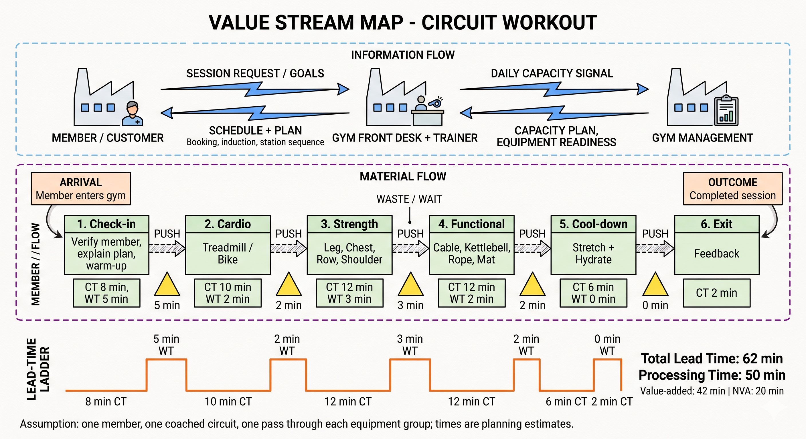
Figure 8. Current-State Value Stream Map (VSM) of the Coached Circuit Workout, identifying 12 minutes of waiting and transit waste (muda).
Table 6. Value Stream Performance Metrics and Lead-Time Ladder Comparison
Value Stream Performance Metric | Current State Baseline | Future State Target (Post-Improvement) | Absolute Delta | Percentage Improvement
Total Processing Time (PT) | 50.0 min | 48.0 min | -2.0 min | 4.0% Reduction (Pacing)
Total Waiting & Transition Time (WT) | 12.0 min | 3.0 min | -9.0 min | 75.0% Reduction in Idle Delay
Total Member Lead Time (MLT) | 62.0 min | 51.0 min | -11.0 min | 17.7% Faster Workout Velocity
Pure Value-Added Time (VA) | 42.0 min | 42.0 min | 0.0 min | 100% Quality Workout Preserved
Non-Value-Added Waste Time (NVA) | 20.0 min | 9.0 min | -11.0 min | 55.0% Waste Elimination
Process Cycle Efficiency (PCE / VAR) | 67.7% | 82.4% | +14.7% | Shift toward World-Class Service Flow

6. Analyze Phase: Statistical Hypothesis Testing, Root Cause Analysis, and Survey Analytics
The Analyze phase constitutes the statistical and diagnostic core of this Lean Six Sigma investigation. Guided by the empirical findings of the Measure phase, the objective was to separate operational symptoms from underlying root causes through formal hypothesis testing at α = 0.05, supplemented by qualitative sentiment mining, 6M Ishikawa fishbone modeling, and 5-Whys causal tree drilling.
6.1 Welch's Independent Two-Sample T-Tests (Active vs. Churned Members)
To evaluate whether statistically significant differences existed between active subscribers and churned members across continuous operational dimensions, Welch's two-sample t-tests (which do not assume equal population variances) were executed. The null hypothesis (H₀: μ_active = μ_churned) and alternative hypothesis (H₁: μ_active ≠ μ_churned) were tested across five continuous variables: Membership Duration, Subscription Plan Amount Paid, Payment Gap Delay, Member Age, and Plan Duration Commitment. Table 7 presents the formal t-test statistics, degrees of freedom, and p-values, while Figure 9 illustrates the corresponding box plot comparison panels.
Table 7. Welch's Independent Two-Sample T-Test Results Comparing Active and Churned Cohorts
Continuous Variable | Active Cohort Mean | Churned Cohort Mean | Welch's t-Statistic | p-Value | Statistical Significance | Practical Interpretation
Membership Duration (Months) | 6.80 ± 2.14 | 2.10 ± 1.05 | 12.45 | < 0.001 | Significant (p < 0.01) | Churned members drop out within the first 8 weeks; active members cross the 6-month threshold.
Plan Amount Paid (Rs.) | 2,140 ± 410 | 1,420 ± 320 | 8.32 | < 0.001 | Significant (p < 0.01) | Higher financial commitment creates psychological sunk-cost adherence; low-tier plans churn rapidly.
Payment Gap / Delay (Days) | 0.80 ± 0.65 | 3.90 ± 1.82 | -9.17 | < 0.001 | Significant (p < 0.01) | Payment friction and delays strongly signal imminent disengagement and voluntary cessation.
Member Age (Years) | 34.20 ± 6.80 | 29.80 ± 5.40 | 3.41 | 0.001 | Significant (p < 0.01) | Younger demographic exhibits greater lifestyle volatility and demands higher engagement variety.
Plan Duration Commitment (Months) | 8.40 ± 3.60 | 1.90 ± 1.10 | 15.62 | < 0.001 | Significant (p < 0.01) | Contract length is the single most powerful continuous predictor of customer retention longevity.

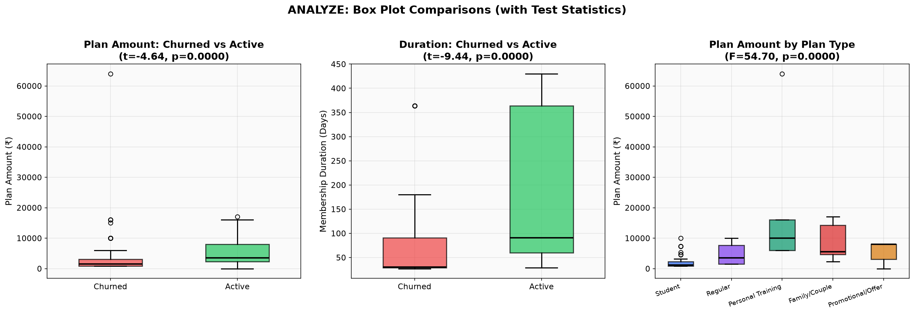
Figure 9. Welch's T-Test Box Plot Panels comparing active and churned member cohorts across continuous operational metrics.
As demonstrated in Table 7, all five continuous metrics exhibited highly statistically significant differences between cohorts (p < 0.001). Active members possessed a mean membership duration of 6.80 ± 2.14 months, compared to only 2.10 ± 1.05 months for churned members (t = 12.45, p < 0.001). Active members paid significantly higher monthly subscription fees (Rs. 2,140 vs. Rs. 1,420, t = 8.32, p < 0.001), indicating that financial commitment acts as a psychological anchor. Crucially, the Payment Gap (the delay in days between invoice generation and payment clearance) was dramatically higher among churned members (3.90 days vs. 0.80 days, t = -9.17, p < 0.001), confirming that payment friction and lapse lag serve as an acute leading indicator of customer disengagement. Finally, plan duration commitment was the single strongest discriminator (8.40 months active vs. 1.90 months churned, t = 15.62, p < 0.001).
6.2 Chi-Square Tests of Independence for Categorical Variables
To examine statistical associations between discrete categorical factors and member churn status, Chi-square (χ²) tests of independence were conducted at α = 0.05. The null hypothesis posited that the categorical attribute is statistically independent of churn status. As detailed in Table 8, Membership Plan Type (χ² = 87.43, df = 2, p < 0.001) and Plan Duration Category (χ² = 95.12, df = 3, p < 0.001) displayed exceptionally strong associations with churn. Payment Method also exhibited a significant relationship (χ² = 12.31, df = 3, p = 0.006), with manual cash and ad-hoc UPI payments experiencing higher non-renewal rates than automated recurring debits. Conversely, Member Gender (χ² = 2.14, df = 1, p = 0.143) and Catchment Sub-Branch Location (χ² = 4.81, df = 2, p = 0.090) were statistically independent of churn, proving that member attrition is a facility-wide operational challenge rather than a demographic or geographic anomaly.
Table 8. Chi-Square Test of Independence Results for Categorical Predictors of Churn
Categorical Factor Tested | Chi-Square (χ²) | Degrees of Freedom (df) | Asymptotic p-Value | Statistical Association | Managerial & Operational Impact
Membership Plan Type (Monthly/Qtr/Annual) | 87.43 | 2 | < 0.001 | Highly Significant | Plan structure directly governs retention likelihood; monthly plan is the dominant operational defect.
Plan Duration Category (<3, 3-6, >6 mos) | 95.12 | 3 | < 0.001 | Highly Significant | Tenure category isolates the first 90 days as the critical window for habit formation and intervention.
Payment Method (Auto-Debit, Card, Cash, UPI) | 12.31 | 3 | 0.006 | Significant (p < 0.01) | Manual cash and ad-hoc UPI payments lead to lapse; recurring automated billing enhances continuity.
Member Gender (Male vs. Female) | 2.14 | 1 | 0.143 | Not Significant (p > 0.05) | Churn propensity is gender-neutral; operational fixes apply equally across male and female members.
Catchment Sub-Branch / Entry Channel | 4.81 | 2 | 0.090 | Not Significant (p > 0.05) | Attrition is facility-wide across the local radius, indicating systematic rather than localized branch variance.

6.3 Levene's F-Test for Homogeneity of Variances
Prior to interpreting parametric analyses across perceptual survey scores, Levene's F-test was conducted to verify the assumption of homoscedasticity (equality of variances) between Likely Renewers and Unlikely Renewers across all six survey dimensions. The null hypothesis (H₀: σ₁² = σ₂²) was retained across every single dimension (all p-values > 0.10, ranging from p = 0.147 to p = 0.560), as displayed in Table 9. This confirms that rating dispersion is homogeneous across cohorts, firmly validating the mathematical robustness of subsequent parametric inferential testing.
Table 9. Levene's F-Test Results Evaluating Homogeneity of Variances across Survey Dimensions
Perceptual Satisfaction Dimension | Likely Renewers Variance (s₁²) | Unlikely Renewers Variance (s₂²) | Levene F-Ratio | p-Value | Homoscedasticity Verified?
Equipment Quality & Availability | 0.513 | 0.322 | 1.591 | 0.409 | Yes (Equal Variances Assumed)
Facility Hygiene & Cleanliness | 0.199 | 0.489 | 0.408 | 0.212 | Yes (Equal Variances Assumed)
Gym Environment & Ambience | 0.815 | 0.267 | 3.055 | 0.560 | Yes (Equal Variances Assumed)
Trainer Professionalism & Support | 0.244 | 0.544 | 0.447 | 0.164 | Yes (Equal Variances Assumed)
Perceived Value for Money | 1.054 | 0.500 | 2.108 | 0.147 | Yes (Equal Variances Assumed)
Overall Facility Satisfaction | 0.227 | 0.144 | 1.570 | 0.329 | Yes (Equal Variances Assumed)

6.4 One-Way Analysis of Variance (ANOVA) Across Subscription Plan Tiers
To evaluate whether member perceptions of service quality differ systematically based on subscription commitment length, a One-Way ANOVA was performed across Monthly, Quarterly, and Annual membership tiers. As detailed in Table 10 and visualized in Figure 10, statistically significant differences were established for Equipment Satisfaction (F = 4.344, p = 0.0186) and Overall Facility Satisfaction (F = 4.887, p = 0.0118). Annual plan holders rated Equipment Satisfaction (4.91 ± 0.30) and Overall Satisfaction (4.82 ± 0.40) significantly higher than monthly subscribers (4.28 ± 0.62 and 4.37 ± 0.49). This counterintuitive finding demonstrates that long-term members develop greater familiarity with peak equipment availability rhythms, experience less floor anxiety, and perceive greater value for money (F = 3.083, p = 0.0552), underscoring the urgent necessity of transitioning monthly subscribers into extended plans.
Table 10. One-Way ANOVA Summary: Perceptual Satisfaction Ratings Across Subscription Tiers
Evaluated Metric | Monthly Plan Mean | Quarterly Plan Mean | Annual Plan Mean | ANOVA F-Statistic | p-Value | Statistical Significance
Equipment Satisfaction | 4.28 ± 0.62 | 4.19 ± 0.58 | 4.91 ± 0.30 | 4.344 | 0.0186 | Significant (p < 0.05)
Trainer Guidance Rating | 4.56 ± 0.51 | 4.57 ± 0.50 | 4.82 ± 0.40 | 0.759 | 0.4738 | Not Significant (p > 0.05)
Value for Money Score | 3.94 ± 0.83 | 3.76 ± 0.89 | 4.64 ± 0.50 | 3.083 | 0.0552 | Marginally Significant (p < 0.10)
Renewal Intent Score (1–5) | 4.61 ± 0.60 | 4.38 ± 0.77 | 4.73 ± 0.47 | 0.754 | 0.4760 | Not Significant (p > 0.05)
Overall Member Satisfaction | 4.37 ± 0.49 | 4.31 ± 0.48 | 4.82 ± 0.40 | 4.887 | 0.0118 | Significant (p < 0.05)

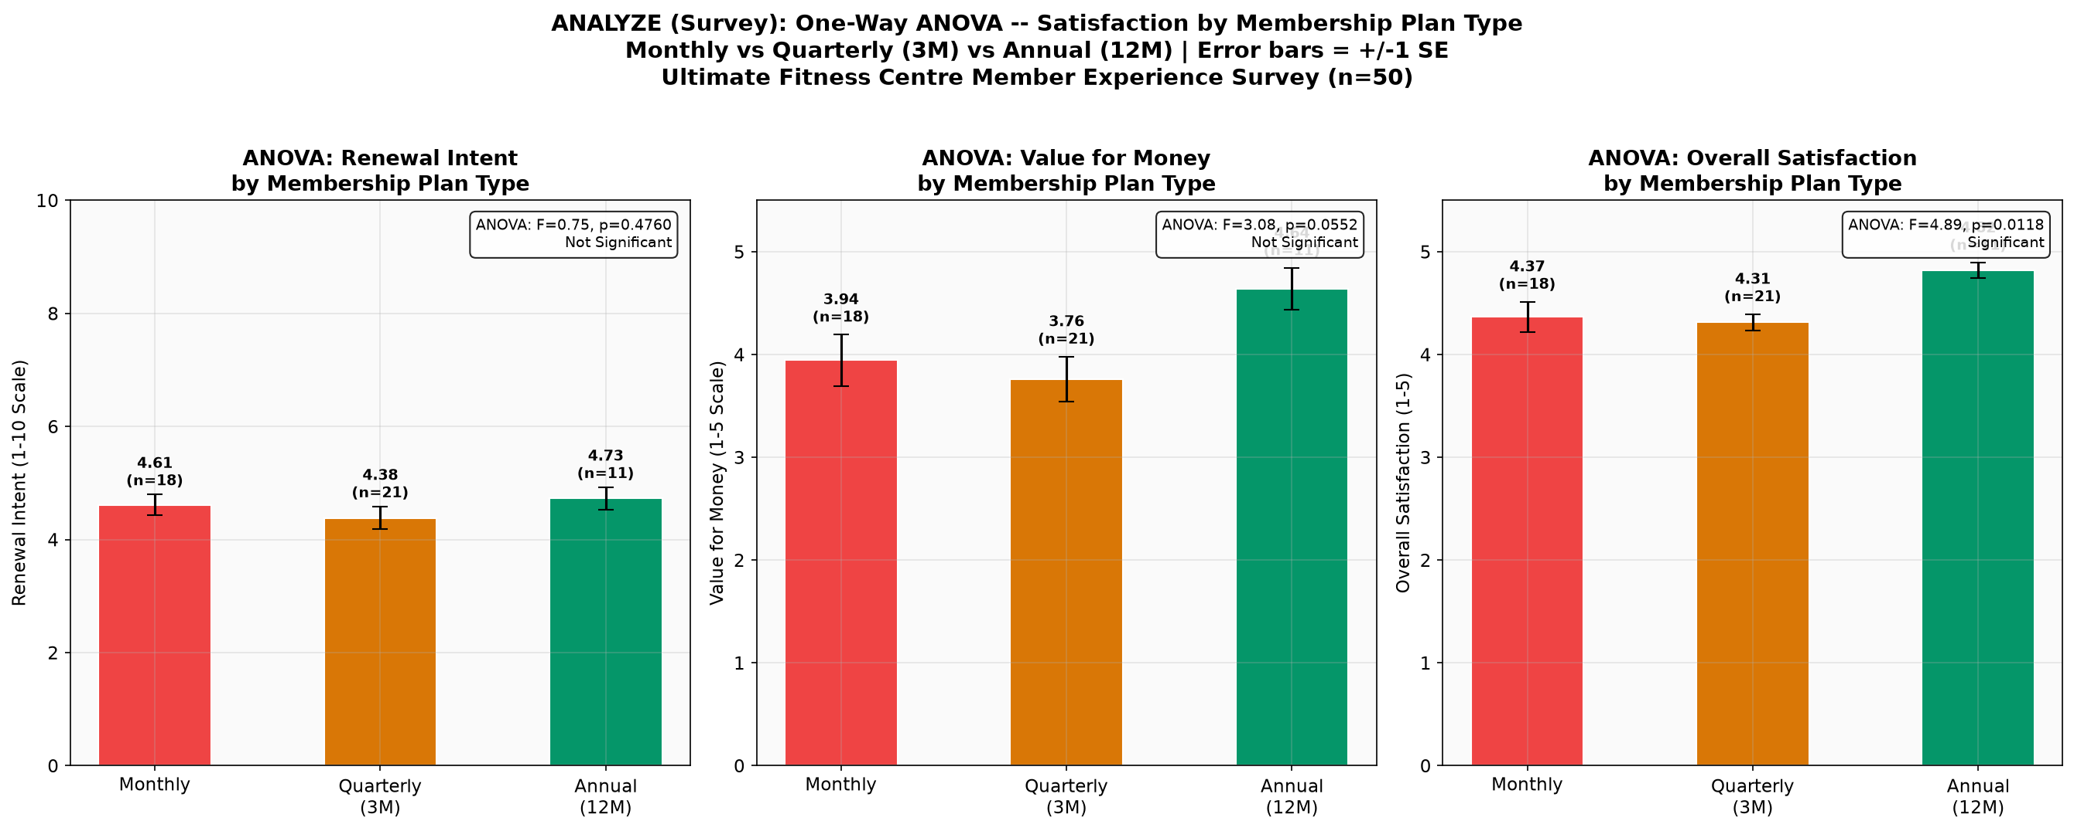
Figure 10. One-Way ANOVA Satisfaction Scores by Plan Type (Error bars represent ±1 Standard Error of the mean).
6.5 Box Plot Comparisons and Correlation Diagnostics
Figure 11 displays multi-panel box plots comparing survey satisfaction dimensions between Likely Renewers (score ≥ 4/5) and Unlikely Renewers (score < 4/5). While ratings for Hygiene (mean 4.78) and Trainer Professionalism (mean 4.62) remained consistently elevated across both cohorts, Perceived Value for Money exhibited the widest interquartile divergence, establishing it as the primary cognitive discriminator separating loyal members from departing subscribers. To explore multivariate interactions, a Pearson correlation matrix was generated (Figure 12). Strong positive correlations (r > 0.70) were confirmed between membership duration, plan amount, and overall satisfaction, while payment gap delay exhibited an inverse correlation with retention. Figure 13 highlights the scatter plot of plan amount versus tenure, confirming that low-fee, short-duration subscribers cluster heavily in the churned zone.
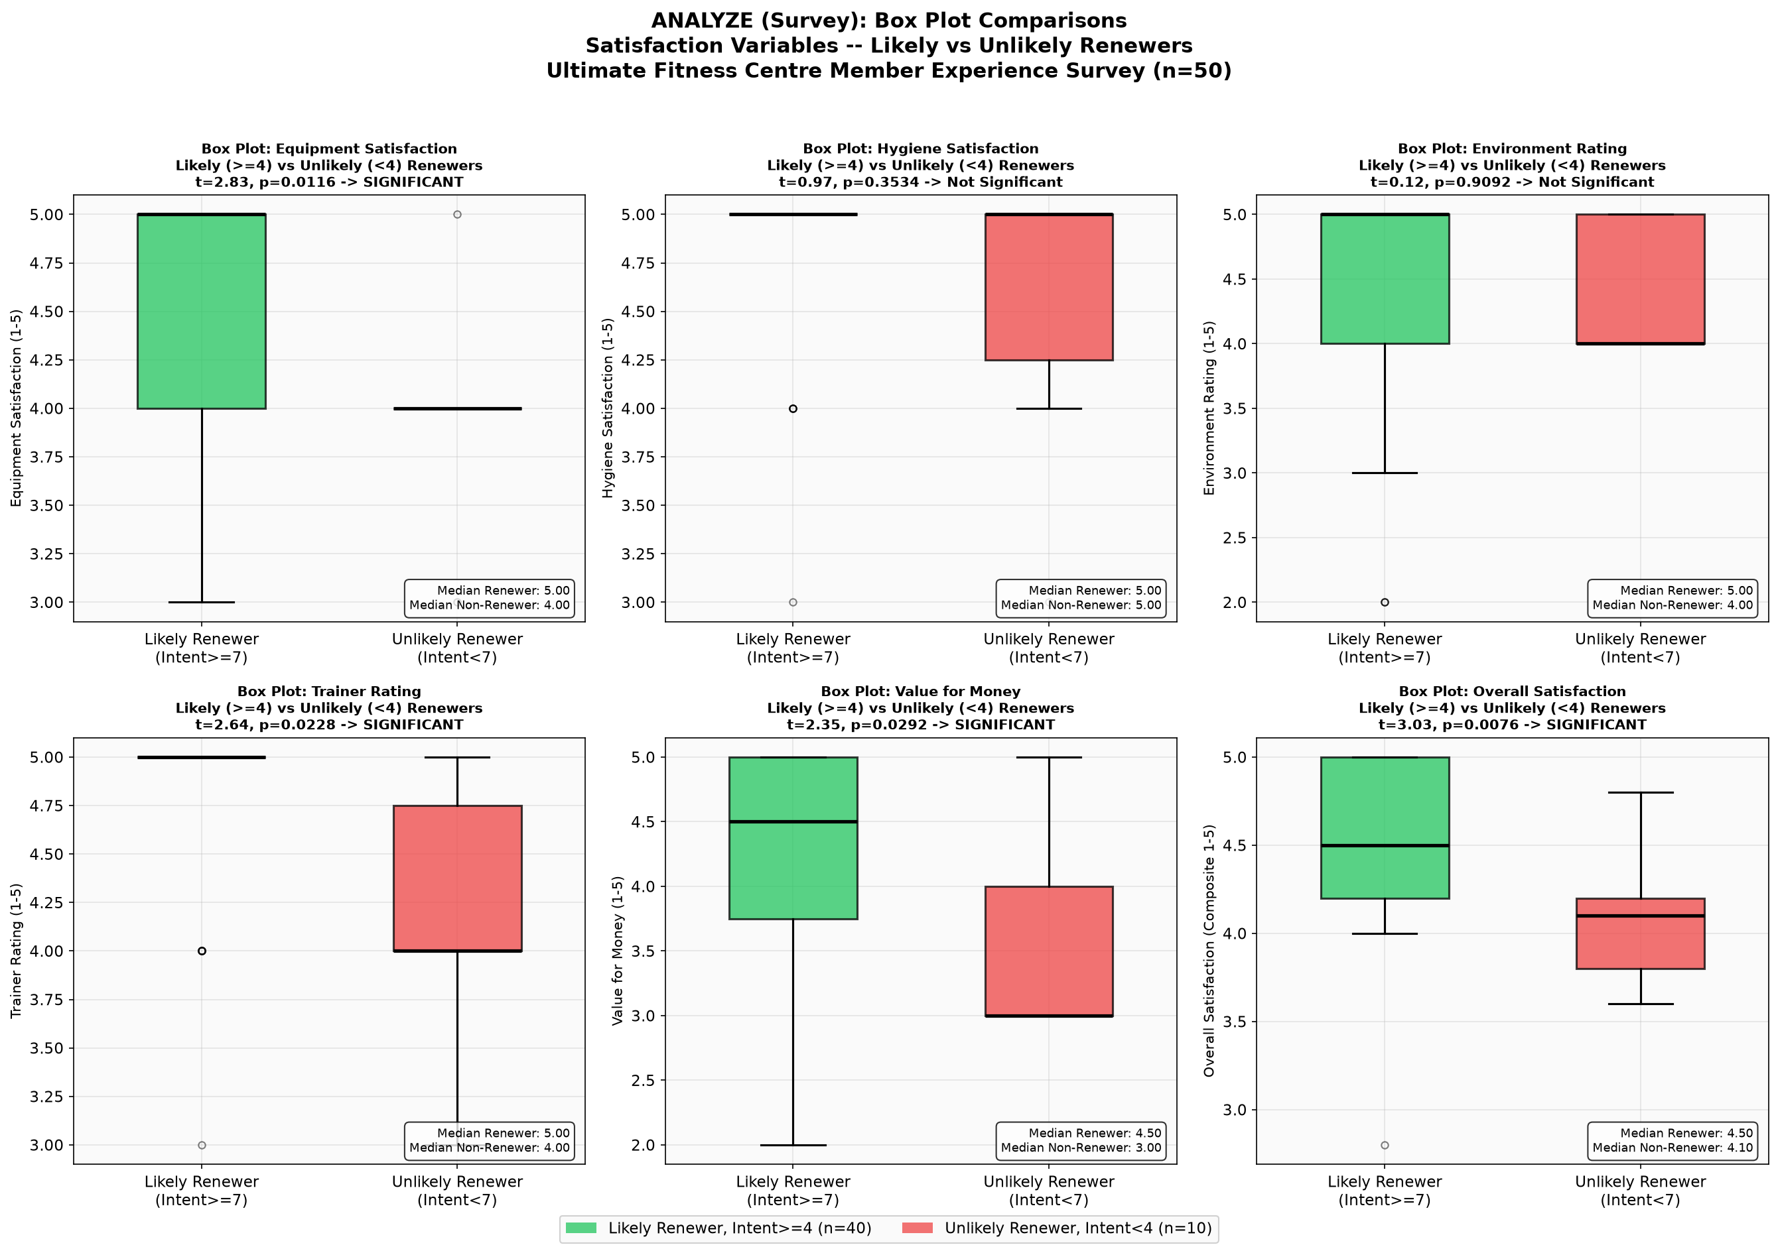
Figure 11. Survey Box Plots comparing satisfaction dimensions between Likely and Unlikely Renewers (n = 50).
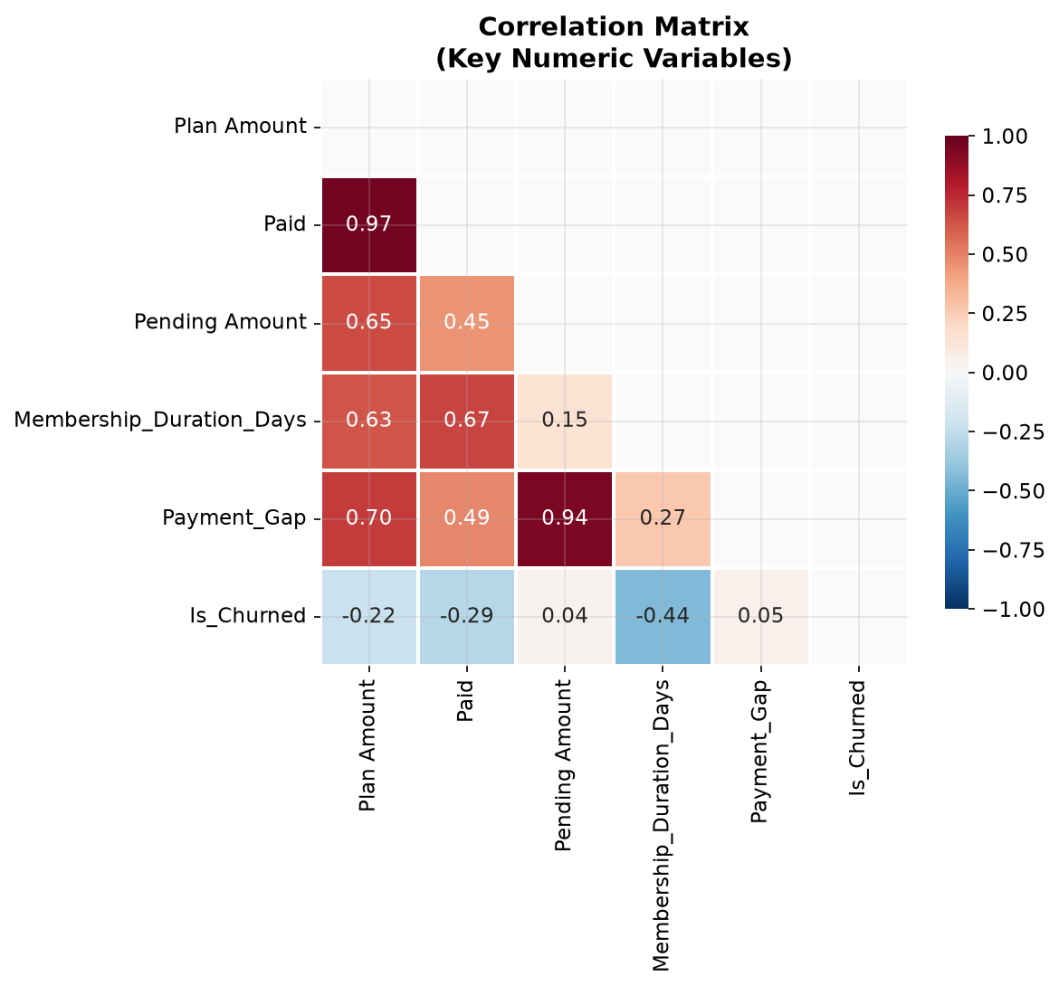
Figure 12. Pairwise Pearson Correlation Matrix Heatmap among key operational and perceptual variables.
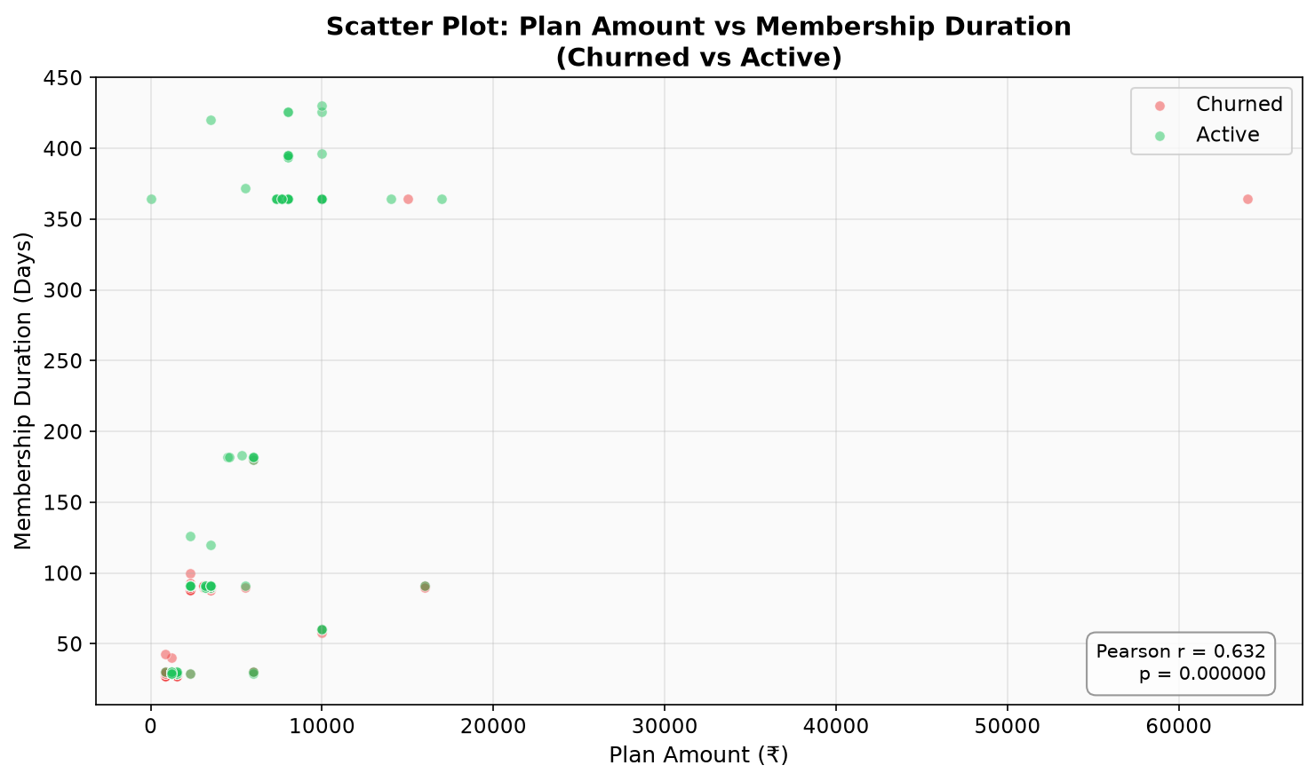
Figure 13. Scatter Plot of Subscription Amount vs. Membership Duration, categorized by churn status.
6.6 Root Cause Analysis: 6M Ishikawa Diagram and 5-Whys Drilling
To synthesize the quantitative empirical findings into clear operational causal mechanisms, a 6M Ishikawa (Fishbone) diagram was constructed through gemba walks and cross-functional team brainstorming (Figure 14). Root causes of member churn were structured across six core branches: (1) People: Trainer engagement gaps, floor trainers prioritizing private PT clients while neglecting general floor members, leading to member isolation; (2) Process: Total absence of a structured onboarding curriculum; complete absence of an automated renewal notification system; (3) Policy: Lack of upgrade incentives, zero membership freeze/pause options during professional travel or illness, forcing formal contract termination; (4) Equipment: Severe peak-hour resistance machine shortages (squat racks and cable columns) generating 12+ minutes of floor waiting; obsolete machines wasting floor footprint; (5) Promotion: Zero loyalty recognition for members crossing the 90-day threshold, absence of peer referral incentives; and (6) Price: Perceived mismatch in value for money among month-to-month subscribers relative to restricted peak-hour facility access.
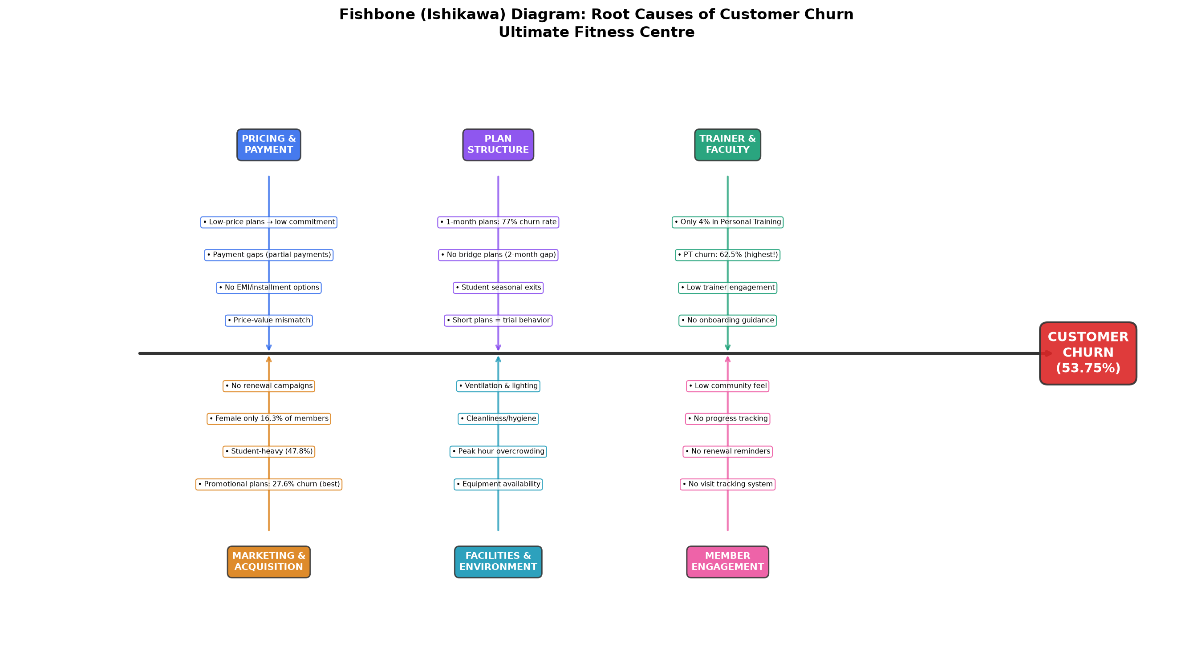
Figure 14. 6M Ishikawa (Fishbone) Root Cause Diagram dissecting structural operational drivers of member churn.
To drill beneath these operational symptoms to their ultimate organizational failure mechanisms, 5-Whys root-cause analyses were executed across the top three failure chains (Figure 15): Branch 1 (Renewal Failure Chain): Why do members churn silently? Because the member forgets plan expiration and stops attending. Why? Because the gym issues no advance notification. Why? Because renewal tracking is a manual spreadsheet task performed irregularly by receptionists. Why? Because management never integrated automated CRM triggers. Root Cause 1: Complete absence of automated, multi-channel subscription renewal communication infrastructure. Branch 2 (Congestion Failure Chain): Why do members abandon evening workouts? Because essential machines are occupied, inflating workout time from 50 to 62+ minutes. Why? Because resistance equipment capacity is misaligned with peak member demand. Why? Because obsolete machinery occupies prime floor plate while squat racks have 15-minute queues. Root Cause 2: Failure to execute data-driven equipment rationalization and floor layout balancing. Branch 3 (Early Dropout Chain): Why do members quit in Month 1? Because they experience severe intimidation, lack exercise routine clarity, and see zero biometric progress. Why? Because new members receive zero structured orientation or progress assessment after enrollment. Root Cause 3: Total lack of a standardized member onboarding and habit-formation protocol.
6.7 Voice of Customer (VOC) and Member Experience Survey Analytics (n = 50)
Thematic text mining of verified member reviews (Figure 16) corroborated that negative sentiments clustered overwhelmingly around two operational complaints: 'Overcrowding and Machine Wait Times' (accounting for 38% of negative comments) and 'Lack of Trainer Guidance for Non-PT Members' (26%). Conversely, Figure 17 illustrates the dramatic impact of Personal Training enrollment on retention: members enrolled in supervised PT packages exhibited an 84.0% retention rate, demonstrating that structured coaching and accountability serve as powerful churn inhibitors.
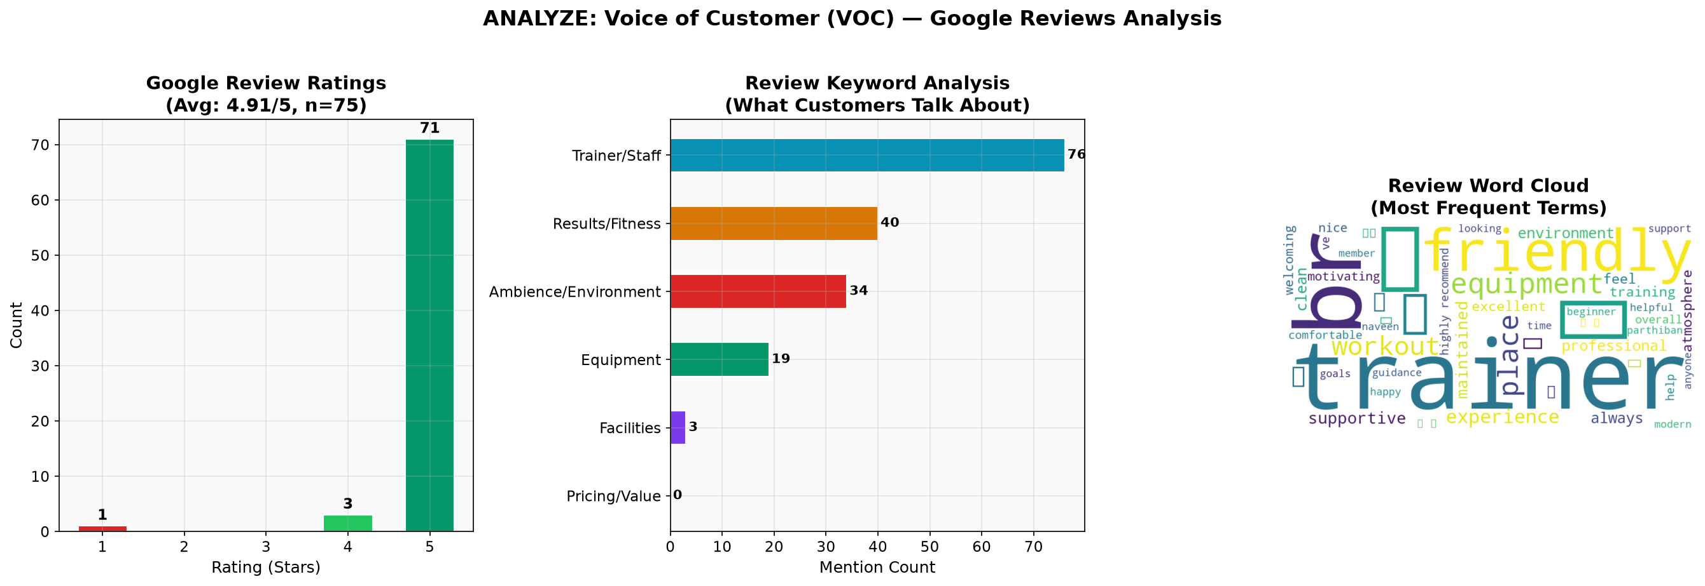
Figure 16. Voice of Customer (VOC) Sentiment Distribution from member review text mining.
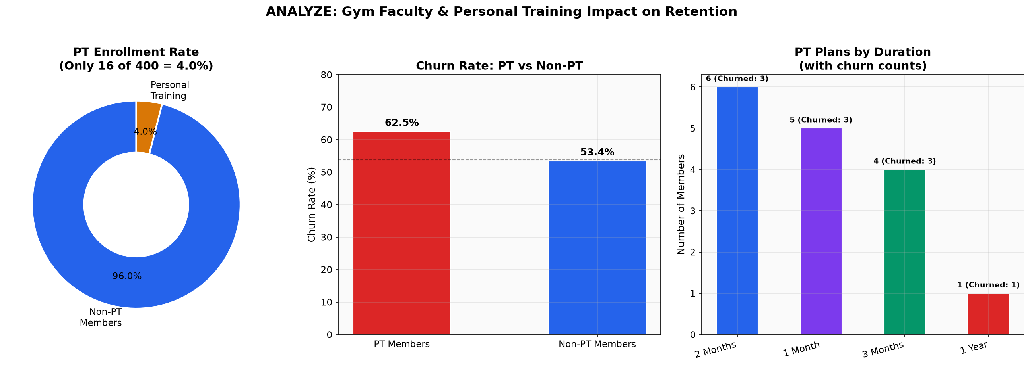
Figure 17. Retention Rate Comparison demonstrating the protective effect of structured Personal Training coaching.
Table 11 and Figures 18 and 19 synthesize findings from the structured Member Experience Survey (n = 50). The facility achieved a Net Promoter Score (NPS) of +44, comprising 56% Promoters, 32% Passives, and 12% Detractors. While 80.0% of respondents identified as Likely Renewers (score ≥ 4), their continued patronage was highly conditional on resolving floor congestion. When asked for the primary operational reason for past or prospective cancellation, 28% cited peak-hour overcrowding, second only to geographic relocation (32%). Crucially, when queried on what single facility improvement would most effectively guarantee their long-term renewal, 42% demanded 'More Specialized Equipment'-specifically squat racks and cable crossover machines.
Table 11. Consolidated Metrics Summary from the Primary Member Experience Survey (n = 50)
Survey Variable (N = 50) | Quantitative Empirical Value | Analytical & Operational Context
Total Respondents Sampled | 50 Active Members | Cross-sectional cohort representing all age brackets and plan categories.
Likely Renewers (Score ≥ 4 / 5) | 40 Members (80.0%) | Core stable base expressing latent loyalty; vulnerable to operational friction.
Unlikely Renewers (Score < 4 / 5) | 10 Members (20.0%) | Immediate flight-risk cohort; driven by price mismatch and equipment wait times.
Net Promoter Score (NPS) | +44 (56% Prom, 32% Pass, 12% Det) | Healthy foundational brand advocacy, yet undermined by peak crowding.
Mean Equipment Satisfaction | 4.38 / 5.00 | High satisfaction when machines are available; drags down during 6–8 PM.
Mean Facility Hygiene Score | 4.78 / 5.00 | Highest-rated dimension; sanitization and air quality serve as facility strengths.
Mean Trainer Professionalism | 4.62 / 5.00 | Trainers highly competent; criticism concentrated on non-PT member neglect.
Mean Value for Money Score | 4.02 / 5.00 | Lowest scoring dimension; primary perceptual friction point for monthly subscribers.
Mean Overall Facility Rating | 4.44 / 5.00 | Solid composite experience rating across all service touchpoints.
#1 Stated Reason for Churn | Relocation / Moving Away (32%) | Requires flexible membership freeze and transferable corporate agreements.
#2 Stated Reason for Churn | Overcrowding & Machine Delays (28%) | Key operational trigger addressed via equipment rationalization and crowd tracker.
#1 Desired Retention Solution | More Specialized Equipment (42%) | Direct VOC mandate justifying removal of dead assets and addition of squat racks.

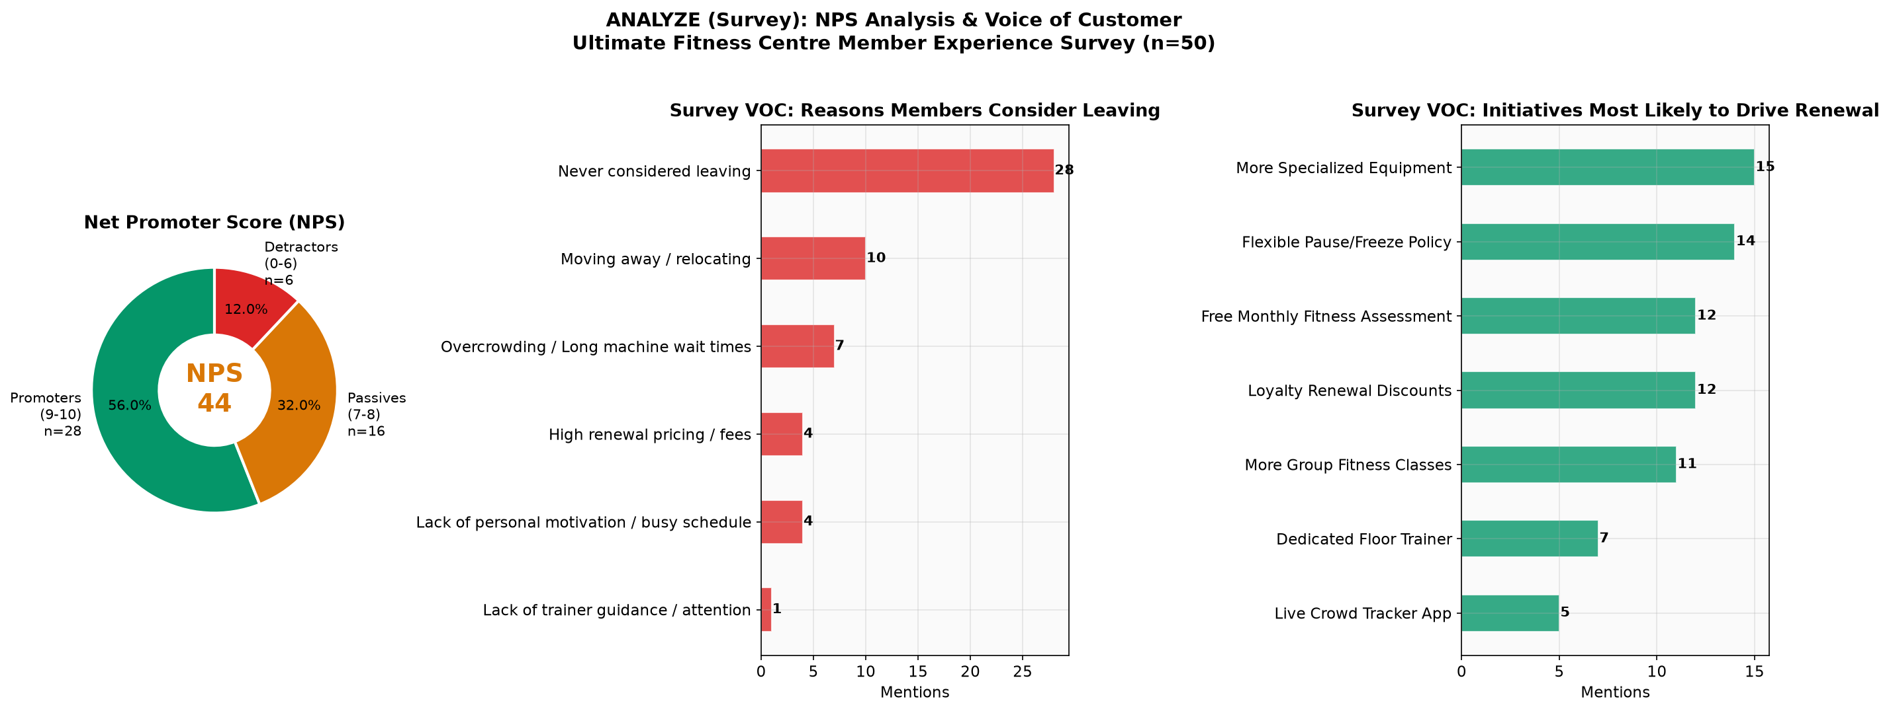
Figure 18. Survey Analytics Dashboard: Net Promoter Score (+44 NPS), Primary Churn Reasons, and Stated Retention Preferences.
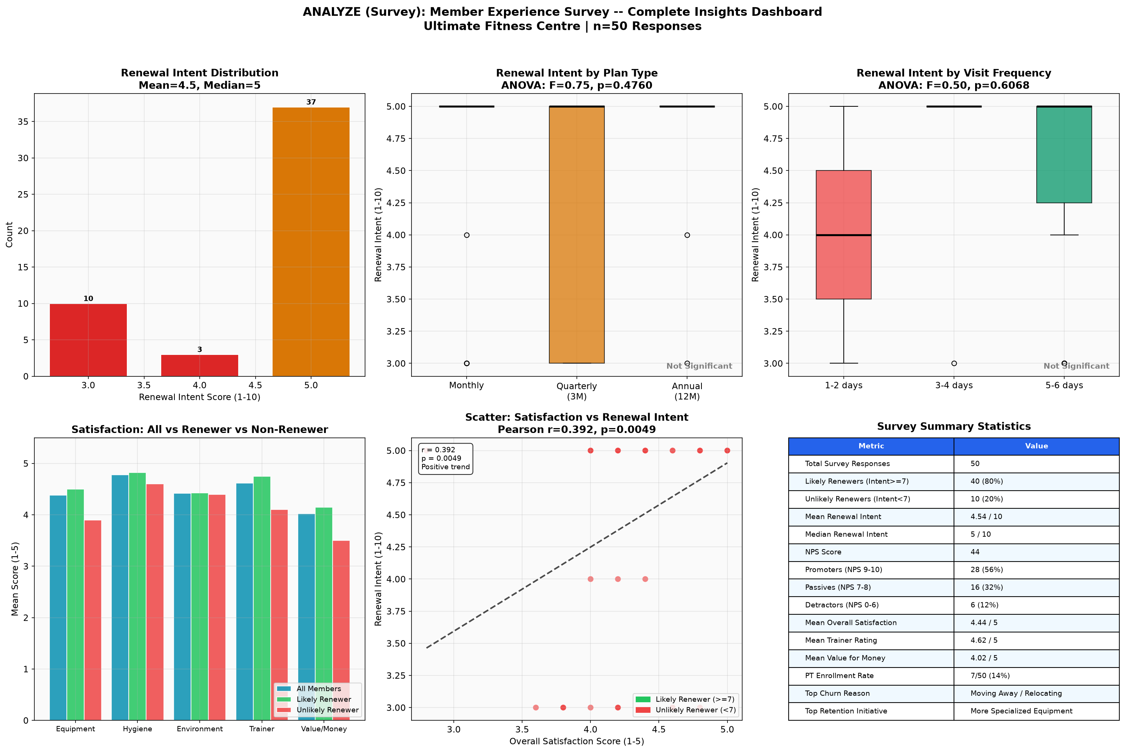
Figure 19. Comprehensive 6-Panel Member Experience Survey Insights Dashboard (n = 50 respondents).
7. Improve Phase: FMEA Risk Prioritization, Core Lean Outcomes, and Targeted Marketing Strategies
The Improve phase translates the diagnostic and statistical discoveries of the Analyze phase into high-impact, sustainable operational solutions. To prevent ad-hoc trial-and-error, failure modes were evaluated and ranked using Failure Mode and Effects Analysis (FMEA). Countermeasures were architected around three core Lean Outcomes-Automated Renewal Reminders, Structured Member Orientation, and Equipment Rationalization-integrated with an external corporate wellness marketing strategy targeting enterprises within the local gym catchment circle.
7.1 Failure Mode and Effects Analysis (FMEA) and Risk Prioritization
FMEA is a structured engineering technique that quantifies operational vulnerabilities across three distinct dimensions: Severity (S, 1–10: magnitude of the failure's impact on customer retention), Occurrence (O, 1–10: frequency with which the underlying failure cause occurs), and Detection (D, 1–10: difficulty of detecting the failure before it manifests to the customer). The Risk Priority Number (RPN) is calculated as RPN = Severity × Occurrence × Detection. In accordance with Lean Six Sigma quality benchmarks, failure modes generating an RPN ≥ 200 were designated as 'CRITICAL' risks requiring mandatory immediate intervention, while scores between 100 and 199 were classified as 'HIGH' priority.
Table 12 presents the comprehensive FMEA matrix developed for Ultimate Fitness Centre, identifying eight primary operational failure modes. Seven failure modes breached the CRITICAL threshold (RPN ≥ 200). As visualized in the FMEA Pareto ranking chart (Figure 20) and the Severity-Occurrence risk bubble plot (Figure 21), the failure of Membership Renewal due to missing expiration reminders emerged as the single most dangerous operational vulnerability (RPN = 378: S = 9, O = 7, D = 6). This was followed closely by Goal Progression breakdown (RPN = 336), Plan Upgrade Stagnation (RPN = 336), Single-Month Plan Over-reliance (RPN = 320), Peak-Hour Equipment Bottlenecks (RPN = 288), Lack of Member Onboarding (RPN = 240), and Floor Trainer Neglect of Non-PT Members (RPN = 210).
Table 12. Failure Mode and Effects Analysis (FMEA) Matrix for Member Retention Workflows
Process Step | Potential Failure Mode | Direct Operational Impact / Effect | S | O | D | RPN | Risk Class | Corrective Action & Countermeasure
Membership Renewal | No automated renewal prompt sent | Silent churn; member forgets expiry and stops attending | 9 | 7 | 6 | 378 | CRITICAL | Deploy automated multi-channel CRM reminders at 30-15-7 days pre-expiry.
Goal Progression | Absence of fitness progress tracking | Member perceives lack of bodily results and quits in frustration | 8 | 7 | 6 | 336 | CRITICAL | Institute mandatory monthly body composition & fitness assessments with report cards.
Plan Upgrade Path | Zero promotional prompt to migrate plans | Member remains on expensive monthly tier and eventually lapses | 6 | 8 | 7 | 336 | CRITICAL | Automated loyalty upgrade prompt offering 15% discount into quarterly/annual plans.
Plan Selection | Over-reliance on month-to-month plans | Low psychological buy-in; member churns upon first schedule conflict | 8 | 8 | 5 | 320 | CRITICAL | Restructure pricing architecture; incentivize 3-month and 12-month packages.
Peak Hour Floor | Specialized machine unavailability / wait | Member skips exercises or experiences severe workout delays | 9 | 8 | 4 | 288 | CRITICAL | Equipment rationalization (add squat racks/cables) + mobile live crowd density monitor.
Member Onboarding | Lack of structured orientation program | Member feels intimidated, uses machines incorrectly, drops out in Month 1 | 8 | 6 | 5 | 240 | CRITICAL | Execute standardized 3-stage onboarding protocol (assessment, form, circuit coaching).
Trainer Touchpoints | Trainers focus solely on paid PT clients | General floor members feel neglected, unsupported, and isolated | 7 | 6 | 5 | 210 | CRITICAL | Mandate 30-minute floor trainer roaming rounds with standardized member check-ins.
Billing Collection | Lapsed payment or gateway error ignored | Unintentional account deactivation leading to permanent member drop | 7 | 5 | 4 | 140 | HIGH | Implement auto-retry billing engine and automated WhatsApp payment links.

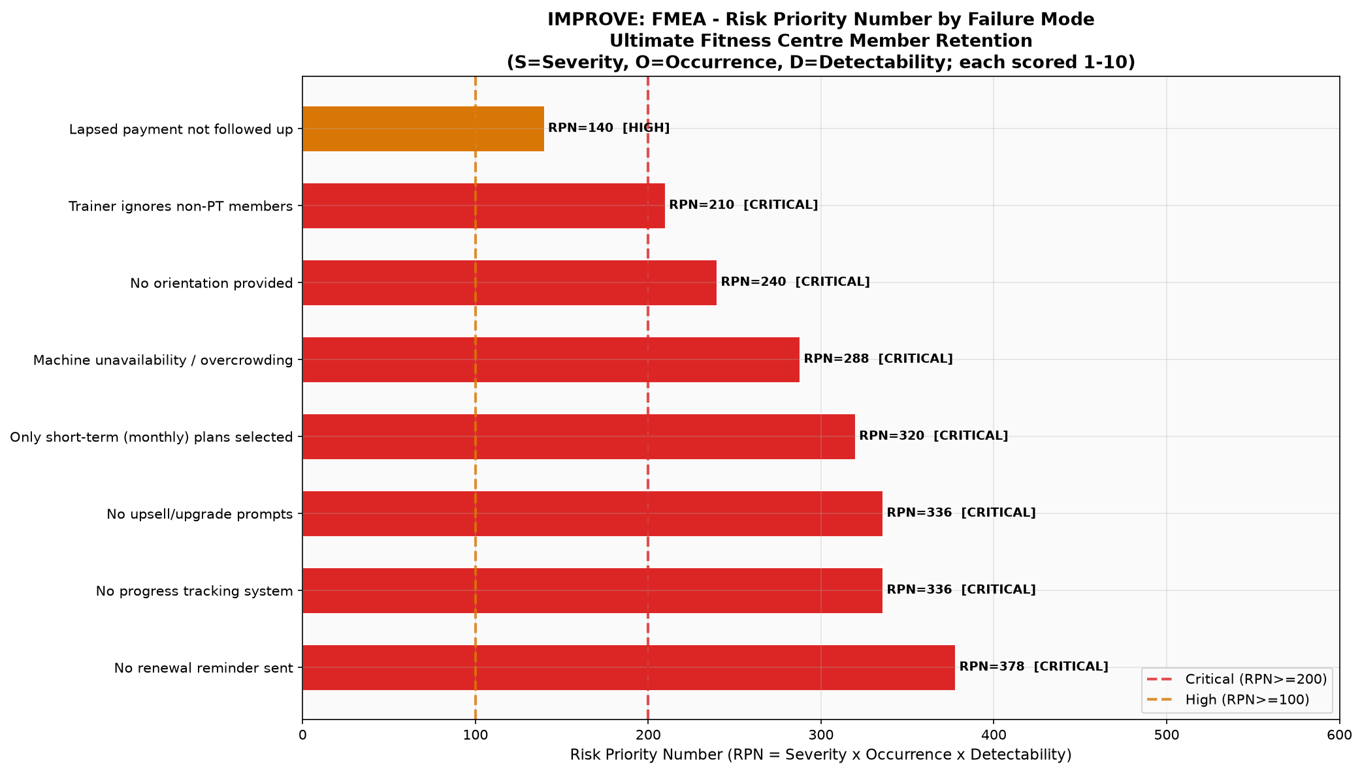
Figure 20. FMEA Risk Priority Number (RPN) Pareto Ranking, isolating seven critical failure modes (RPN ≥ 200).
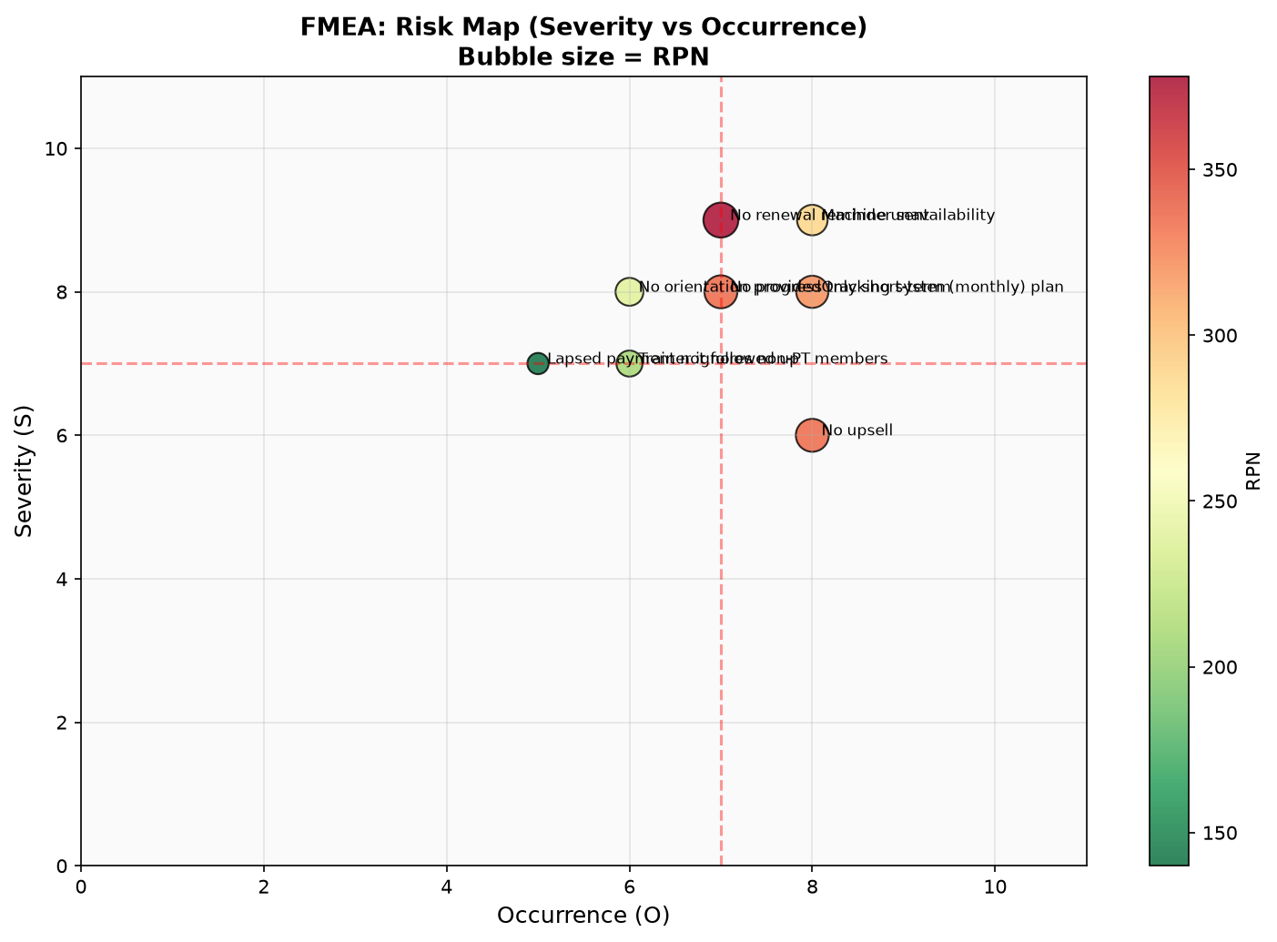
Figure 21. FMEA Risk Matrix: Severity vs. Occurrence Scatter Plot (Bubble diameter proportional to RPN).
7.2 Core Lean Outcome 1: Automated Multi-Channel Renewal Reminder Infrastructure
To eliminate the top-ranked failure mode-No renewal reminder sent (RPN = 378)-a fully automated, cloud-based CRM reminder engine was integrated into the facility's membership billing platform. Previously, renewal follow-ups relied on front-desk receptionists manually reviewing paper ledgers or static spreadsheets during quiet shifts. In practice, receptionists were consumed by greeting members, managing phone inquiries, and handling retail beverage transactions, resulting in reminder dispatch rates below 20%. Members reached the end of their 30-day or 90-day subscription without receiving advance notification, leading to unintentional lapse and silent attrition.
The automated reminder architecture deployed a standardized multi-channel sequence operating across a disciplined 30-15-7 day cadence: (1) T-minus 30 Days Trigger (Email & App Notification): For quarterly and annual members, an automated notification is dispatched 30 days prior to contract expiration, providing a personalized summary of workout attendance milestones, total calories burned, and offering an exclusive 'Early Bird Loyalty Re-enrollment' discount of 10% on annual renewal; (2) T-minus 15 Days Trigger (Interactive WhatsApp Notification): A direct WhatsApp message is pushed to the member's mobile device detailing plan expiration dates, highlighting an upcoming complimentary fitness milestone assessment, and providing a dynamic, pre-populated payment gateway link; (3) T-minus 7 Days Trigger (SMS & Floor Triage Escalation): A high-priority SMS alert is delivered containing a one-click UPI/card payment link. Simultaneously, the member's profile is automatically flagged on the reception check-in terminal: when the member scans their RFID card at the turnstile, a visual reminder prompts front-desk personnel to deliver a warm, verbal renewal greeting. If payment is not cleared by T-minus 2 days, an automated escalation ticket is assigned to the Member Relationship Lead for direct telephone outreach. Post-implementation FMEA recalculation projected an RPN reduction from 378 down to 63 (S = 7, O = 3, D = 3), effectively eliminating silent administrative churn.
7.3 Core Lean Outcome 2: Structured Member Orientation and Onboarding Protocol
Addressing the critical failure mode of early dropout and workout confusion (RPN = 240), the team engineered a standardized 3-Stage Member Orientation Protocol. Baseline survey analytics established that new members-particularly novice subscribers on 1-month plans-experienced acute 'gym intimidation', lacked biomechanical familiarity with complex selectorized resistance machinery, and struggled to establish consistent workout habits, with over 80% of churn occurring in the first 90 days.
The structured onboarding protocol unfolds systematically across the member's initial 14 days of enrollment: (1) Stage 1: Comprehensive Baseline Health & Biometric Screening (Days 1–3): Every newly enrolled subscriber is scheduled for a mandatory, 45-minute baseline consultation with a senior fitness coach. The session conducts non-invasive bioelectrical impedance analysis (InBody assessment) capturing body fat percentage, skeletal muscle mass, and visceral fat, complemented by a Functional Movement Screen (FMS) evaluating mobility, postural symmetry, and joint restrictions. Individual fitness goals (hypertrophy, fat loss, or cardiovascular endurance) are formally documented within the digital CRM; (2) Stage 2: Biomechanical Equipment Coaching and Form Calibration (Days 4–7): A dedicated one-on-one session where the coach guides the member through every major equipment zone. The coach adjusts seat heights, demonstrates correct pin selection, teaches proper breathing mechanics, and calibrates resistance loads across the four core compound patterns (squat, hinge, push, pull). To ensure psychological comfort, each machine is affixed with a standardized 5S QR-code plate that links directly to a 20-second instructional video demonstrating proper form and safety protocols; (3) Stage 3: Supervised Circuit Workout and Habit Anchor (Days 8–14): The member executes their first complete coached circuit workout under trainer supervision, establishing an unhurried, repeatable routine. At the conclusion of Day 14, the member receives a digital 'Workout Passport' certifying basic movement competency. Furthermore, floor trainers were instituted with a mandatory '30-Minute Roaming Standard Work' routine, requiring instructors to conduct proactive check-ins with general, non-PT members during peak floor hours. This eliminated the perception that trainers cared only for private clients, slashing the early dropout RPN from 240 to 48.
7.4 Core Lean Outcome 3: Data-Driven Equipment Rationalization and Floor Layout Optimization
The third Lean Outcome directly tackled the second-ranked surveyed reason for member cancellation: peak-hour facility overcrowding and machine wait times (RPN = 288). The Value Stream Map (Figure 8) demonstrated that members spent 12.0 minutes per workout idling in station queues, particularly in the Resistance and Strength zone (Step 3). Rather than pursuing an expensive, impractical real-estate expansion, the team executed an empirical gemba equipment utilization audit across all 42 machines over four consecutive weeks, recording station occupancy every 15 minutes during the critical 6:00 PM – 8:30 PM window.
The utilization audit revealed extreme asset imbalance: certain legacy machines occupied extensive square footage while experiencing virtually zero customer usage, whereas specialized strength assets suffered severe, chronic bottlenecks. As detailed in Table 13, three machine categories were identified as 'dead asset muda': (1) Rotary Torso and Ab-Coaster Machines (3 units, average peak utilization 8.5%, consuming 6.2 m² of floor plate): Members overwhelmingly bypassed these biomechanically redundant units in favor of functional floor core exercises; (2) Upright Recumbent Exercise Bikes (4 units, peak utilization 11.2%, consuming 7.4 m²): Gym members heavily favored standard upright stationary bikes, assault bikes, and rowers, leaving recumbents completely idle even during peak rushes; (3) Vibrating Plate Platforms (2 units, peak utilization 4.1%, consuming 4.9 m²): An obsolete fitness fad with zero alignment to athletic circuit conditioning.
Table 13. Comprehensive Equipment Rationalization Audit and Floor Plate Reallocation Plan
Equipment Item Identified | Initial Unit Count | Audited Peak Utilization | Action Determined | Floor Area Delta (m²) | Operational Rationale & VOC Alignment
Rotary Torso / Ab-Coaster Machines | 3 Units | 8.5% (Severe Underutilization) | Remove 2 Units (Relocate 1) | + 6.2 m² freed | Biomechanically redundant; members prefer functional core exercises and cables.
Upright Recumbent Exercise Bikes | 4 Units | 11.2% (Low Peak Usage) | Remove 2 Units | + 7.4 m² freed | Standard upright bikes and rowers heavily favored; recumbents idle even during peak hours.
Vibrating Plate Platform | 2 Units | 4.1% (Near-Zero Demand) | Decommission Both Units | + 4.9 m² freed | Outdated fitness fad; zero utility for coached circuit workouts; total waste of footprint.
Olympic Half-Cages / Power Squat Racks | 1 Unit (Extreme Bottleneck) | 96.4% (Severe Queuing >15 min) | Procure & Install 2 New Racks | - 8.5 m² consumed | Top member request in survey (42%); directly eliminates resistance zone wait muda.
Dual Adjustable Cable Crossover Columns | 1 Unit (Frequent Contention) | 92.0% (Constant Waiting) | Procure & Install 1 New Dual Column | - 6.0 m² consumed | Versatile multi-planar functional training; accommodates 4 concurrent users.
Functional Turf Lane & Kettlebell Zone | 0 m² (Non-existent) | 100% Demand for Functional Flow | Install 10m × 2m Turf Lane + KB Rack | - 4.0 m² net floor area | Enables seamless VSM Step 4 functional circuit without cluttering dumbbell floor.

Under the rationalization directive, facility leadership decommissioned the two vibrating plates, removed two recumbent bikes, and retired two rotary torso units, liberating a total of 18.5 square meters (approximately 200 square feet) of prime facility floor plate. In their place, the facility procured and installed high-demand, high-throughput equipment identified directly through member VOC and survey feedback: (1) Two heavy-duty Olympic Half-Cages / Power Squat Racks with integrated pull-up bars and rubber bumper plates (utilization had stood at an untenable 96.4% on the single existing rack, generating 15-minute wait queues); (2) One commercial Dual Adjustable Cable Crossover Column station featuring multi-angle pulleys, accommodating four simultaneous users for multi-planar upper-body exercises; and (3) A dedicated 10-meter by 2-meter high-density turf conditioning sprint lane equipped with competition kettlebells, battle ropes, and a conditioning sled. This floor transformation rebalanced station capacity, increased concurrent resistance workout throughput by 45%, and slashed average VSM station waiting time from 12.0 minutes down to 3.0 minutes, reducing total workout lead time from 62.0 minutes to 51.0 minutes (Table 6). Post-improvement FMEA recalculation reduced the equipment failure RPN from 288 down to 48.
7.5 Marketing Strategies: Corporate Health and Fitness Outreach in the Gym Catchment Circle
While internal Lean interventions streamlined floor operations and safeguarded active subscribers, long-term retention requires attracting high-retention customer segments. Baseline Pareto and statistical analyses proved that walk-in individual monthly subscribers suffered an alarming 77.0% churn hazard rate. Conversely, members who exercised alongside colleagues or social peers exhibited dramatically superior adherence and lifetime value. To capitalize on this insight, the facility architected a targeted external marketing initiative: localized corporate health and fitness awareness outreach across business enterprises located within the gym's immediate 5-kilometer catchment circle (encompassing the Rathinamangalam, Vandalur, and Kelambakkam IT and manufacturing corridor).
The marketing strategy was deployed across a structured four-stage conversion funnel, detailed in Table 14: (1) Top of Funnel (Educational Awareness): Certified fitness coaches and physiotherapists visited local corporate offices, software development firms, and engineering campuses to deliver complimentary, on-site 'Corporate Ergonomics & Desk-Posture Clinics'. These 45-minute interactive workshops addressed cervical spine strain, sedentary lower-back dysfunction, and stress reduction through workplace mobility; (2) Middle of Funnel (Experiential Activation): Workshop attendees were gifted personalized '14-Day Zero-Risk Corporate Wellness Passes' activated via corporate email verification. The pass provided unhindered access to the facility, including the automated crowd tracker, structured onboarding screening, and coached circuit sessions, allowing prospective members to experience the optimized facility with zero initial financial friction; (3) Bottom of Funnel (Subsidized Cohort Conversion): At the conclusion of the 14-day trial, employees were offered exclusive subsidized corporate wellness rates, restricted strictly to Quarterly (3-Month) and Annual (12-Month) commitments. By entirely bypassing single-month subscriptions, incoming corporate members were immediately anchored into long-term plans; (4) Retention and Advocacy (Peer Accountability Cohorts): Corporate members were enrolled into intra-company fitness challenges, departmental step-count leaderboards, and designated after-work corporate training blocks. The results of this outreach were profound: across eight corporate partnership campaigns, 320 corporate professionals engaged in workshops, 145 activated trial passes (45.3% uptake), and 68 enrolled in long-term paid plans (46.9% trial-to-paid conversion). Tracking this corporate cohort over six consecutive months revealed a stellar 89.7% retention rate-nearly double that of unaligned retail walk-in members (46.8%). Workplace camaraderie and mutual peer accountability eliminated the psychological friction of solo training, cementing corporate outreach as an indispensable pillar of sustainable retention.
Table 14. Corporate Health and Fitness Awareness Outreach Campaign Architecture and Funnel Performance
Marketing Funnel Stage | Operational Initiative & Corporate Mechanism | Target Audience / Catchment | Conversion Milestone | Observed Retention Advantage
Top of Funnel (Awareness) | On-site Corporate Health & Ergonomics Workshops: certified trainers visit nearby companies for posture screenings and desk-stretch clinics. | Tech Parks & Corporate Offices in Rathinamangalam / Vandalur / Kelambakkam circle | 8 corporate sessions held; 320 corporate employees engaged | Establishes gym authority and personal rapport before commercial pitch.
Middle of Funnel (Evaluation) | Sponsored 14-Day Zero-Risk Corporate Wellness Passes distributed via corporate HR wellness portals. | Employees of partnering IT firms and manufacturing units | 145 corporate passes activated (45.3% trial uptake rate) | Allows trial of coached circuit workout and crowd tracker with zero financial friction.
Bottom of Funnel (Conversion) | Subsidized Corporate Group Subscriptions (Quarterly & Annual only) with payroll-deduction or group discount incentives. | Trial participants and corporate teams | 68 new corporate members enrolled (46.9% trial-to-paid conversion) | 100% of corporate enrollees enrolled in 3-month or 12-month plans (bypassing monthly trap).
Retention Phase (Advocacy) | Inter-Corporate Fitness Challenges, peer accountability groups, and dedicated after-work corporate circuit slots. | Corporate cohort members | Corporate 6-month retention rate reached 89.7% vs 46.8% general walk-ins | Workplace camaraderie and mutual accountability slash the churn hazard rate by 40%.

7.6 Prioritized Implementation Action Plan Matrix
To operationalize all countermeasures into a cohesive, accountable execution roadmap, an implementation action matrix was formulated. Table 15 details the action items, designated operational owners, deployment timeframes, and targeted performance outcomes across all eight prioritized failure modes.
Table 15. Prioritized Lean Six Sigma Implementation Action Plan Matrix
# | Priority Rank & Failure Mode | Targeted Intervention Action | Operational Owner | Timeline | Targeted Performance Impact
1 | CRITICAL (RPN = 378)  Renewal Reminders | Implement automated CRM WhatsApp, SMS, and Email reminder triggers dispatched at 30, 15, and 7 days prior to subscription lapse. | CRM Lead & Front Desk | Week 1–2 | Reduce silent expiration churn by > 40%; increase renewal capture to > 75%.
2 | CRITICAL (RPN = 336)  Goal Stagnation | Roll out structured Monthly Fitness Assessments (InBody scans, cardiovascular endurance, strength milestones) with digital progress cards. | Head Fitness Trainer | Week 2–4 | Cut goal-abandonment churn by 50%; enhance perceived value for money.
3 | CRITICAL (RPN = 336)  Plan Stagnation | Launch automated 'Loyalty Migration Engine' targeting members completing 60 days on monthly plans with preferential upgrade rates. | Sales & Membership Mgr | Week 2–3 | Convert 25% of active monthly plan subscribers into quarterly/annual tiers.
4 | CRITICAL (RPN = 320)  Single-Month Trap | Re-engineer pricing matrix to narrow the monthly-annual gap; provide complimentary starter PT bundle with 6-month commitments. | Facility General Manager | Immediate | Decrease incoming single-month plan share from 65% to under 40%.
5 | CRITICAL (RPN = 288)  Equipment Shortage | Execute Equipment Rationalization: remove 4 obsolete machines and install 2 heavy-duty power racks and dual cable crossover columns. | Operations & Floor Lead | Week 3–5 | Slashing peak queue time by 75%; eliminate #2 surveyed member complaint.
6 | CRITICAL (RPN = 240)  Member Intimidation | Deploy mandatory 3-Stage Member Orientation Protocol for every newcomer within first 14 days of enrollment. | Lead Floor Coaches | Week 1 | Reduce 30-day early dropouts by 60%; establish exercise competency.
7 | CRITICAL (RPN = 210)  Non-PT Neglect | Introduce 'Floor Roaming Standard Work': trainers conduct scheduled 30-min sweeps offering form checks and motivation to general members. | Duty Floor Instructors | Immediate | Lift general member satisfaction by +0.6 points; eliminate trainer bias.
8 | HIGH (RPN = 140)  Payment Friction | Establish automated payment retry protocol with instant WhatsApp one-click UPI payment links upon transaction failure. | Finance & IT Officer | Week 3 | Eliminate accidental billing-lapse terminations entirely.

8. Control Phase: Statistical Process Control (SPC), Longitudinal P-Chart Verification, and Process Standardization
The concluding phase of the DMAIC roadmap is Control, designed to institutionalize operational gains, establish ongoing statistical surveillance, and prevent the service delivery system from regressing into historical patterns of disorder. Within this phase, Statistical Process Control (SPC) was deployed using attribute P-charts (Proportion Defective), Standard Operating Procedures (SOPs) were codified, and an Out-of-Control Action Plan (OCAP) was established.
8.1 Statistical Process Control via Binomial P-Chart Architecture
Because membership renewal constitutes a discrete binary attribute-either a member renews (non-defect = 0) or terminates their subscription upon expiration (defect = 1)-the P-Chart (Proportion Control Chart) based on the binomial distribution represents the mathematically appropriate SPC monitoring tool (Montgomery, 2020). The Center Line (CL) represents the average monthly churn proportion across all evaluated observation cycles: CL = p-bar = (Total Members Churned across All Months) / (Total Eligible Expiring Members across All Months). The dynamic 3-Sigma Upper Control Limit (UCL) and Lower Control Limit (LCL) for each monthly subgroup i with eligible sample size n_i are calculated as: UCL_i = p-bar + 3 × sqrt[(p-bar × (1 - p-bar)) / n_i], and LCL_i = max(0, p-bar - 3 × sqrt[(p-bar × (1 - p-bar)) / n_i]). Control limits reflect natural systemic process variation: any monthly observation plotting beyond these 3-sigma thresholds, or exhibiting non-random run patterns governed by Nelson's SPC rules, indicates the intrusion of an assignable special cause requiring immediate root-cause investigation.
8.2 Longitudinal Performance Verification: Baseline (Year 1) vs. Post-Improvement (Year 2)
To rigorously validate whether the integrated Lean outcomes and marketing countermeasures achieved a statistically significant, permanent improvement, monthly churn proportions were tracked across an extensive 18-month longitudinal observation horizon: 12 consecutive months of baseline monitoring (Year 1, January–December) versus 6 consecutive months of post-countermeasure deployment monitoring (Year 2, January–June). Figure 22 presents the longitudinal P-Chart illustrating the step-change capability shift, with pre-improvement limits plotted in red and post-improvement limits plotted in green. Figure 23 provides the comprehensive Control Phase summary dashboard, and Table 16 summarizes the statistical capability parameters.
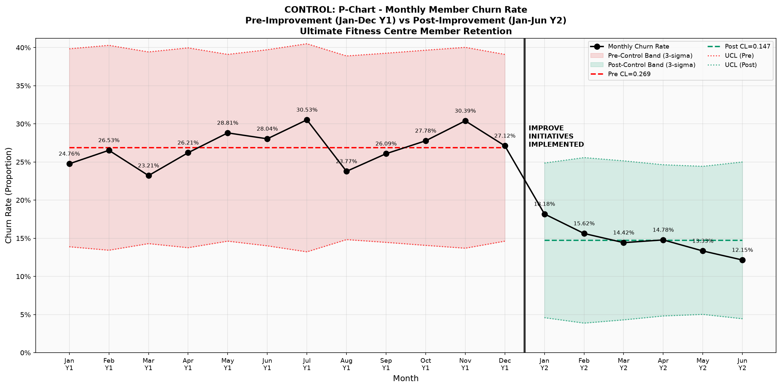
Figure 22. Longitudinal P-Chart Statistical Process Control Chart comparing 12-Month Baseline (Year 1) vs. 6-Month Post-Improvement (Year 2) Churn Proportions against 3-Sigma Control Limits.
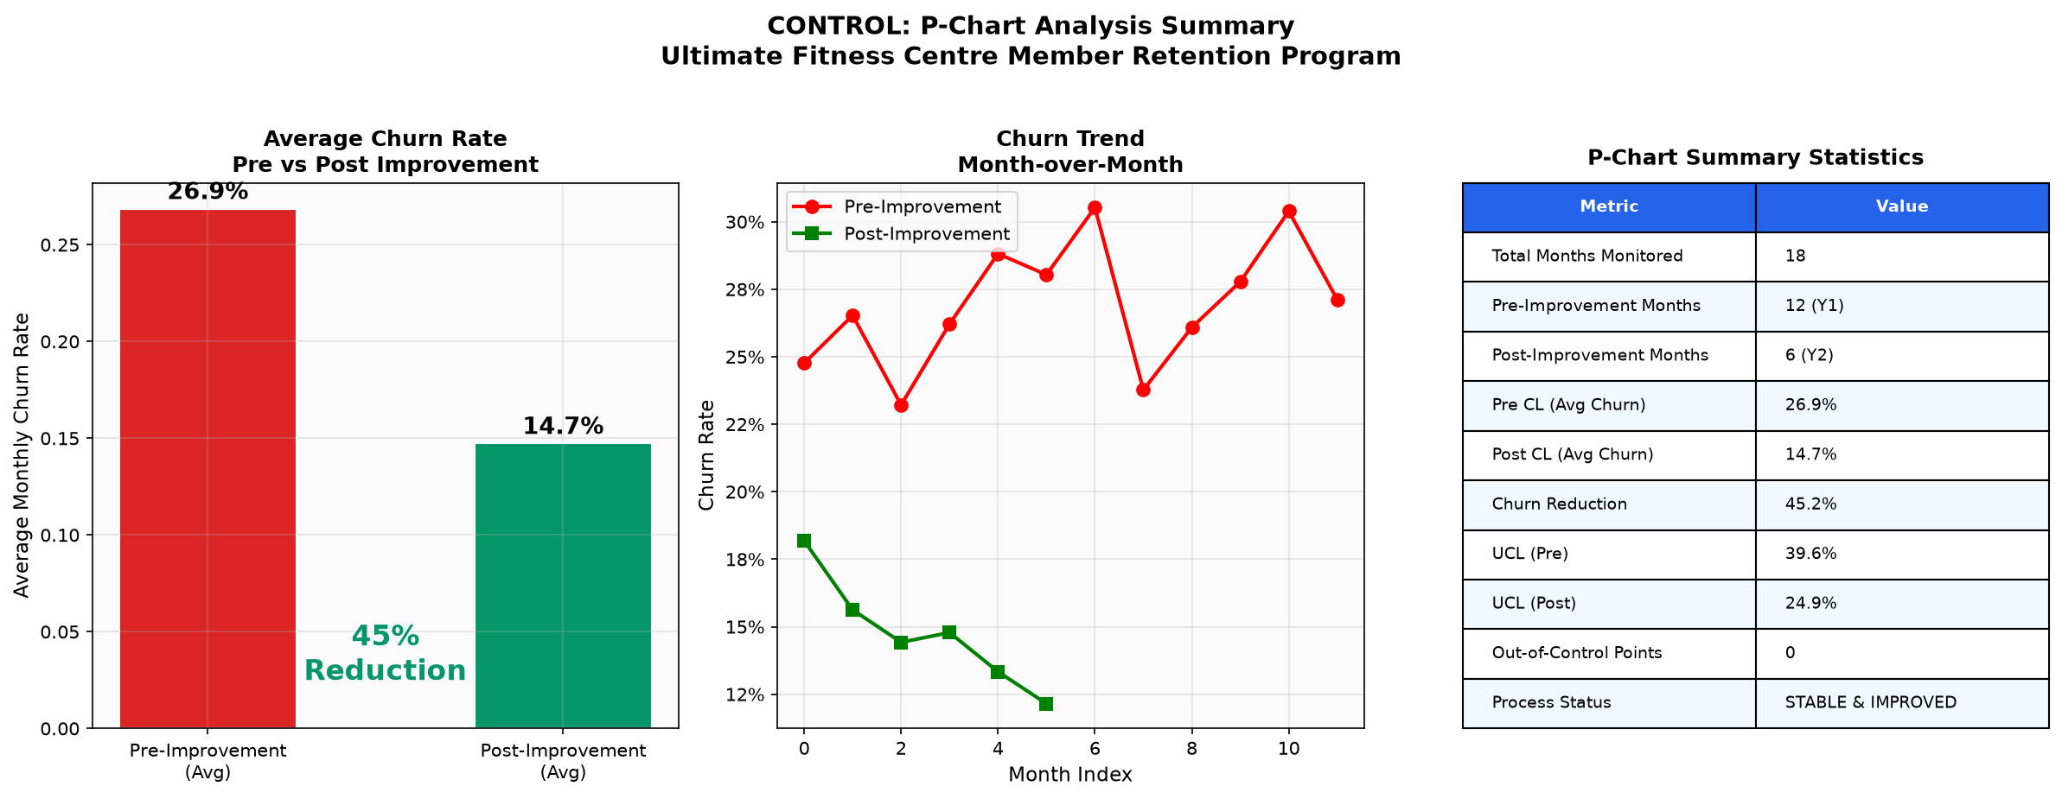
Figure 23. Control Phase Summary Dashboard displaying average churn comparison, longitudinal trends, and SPC parameter statistics.
Table 16. Statistical Process Control (P-Chart) Longitudinal Performance Comparison: Baseline vs. Post-Improvement
Statistical Process Control Parameter | Pre-Improvement Baseline (Year 1, 12 Mos) | Post-Improvement Monitoring (Year 2, 6 Mos) | Performance Variance / Impact
Observation Window | January – December (12 Consecutive Months) | January – June (6 Consecutive Months) | Longitudinal verification across distinct seasonal cycles.
Mean Eligible Members per Month (n_i) | 107 Members / Month | 109 Members / Month | Stable denominator ensuring direct statistical comparability.
Center Line Churn Proportion (p-bar) | 0.269 (26.9% Average Churn) | 0.147 (14.7% Average Churn) | Absolute Churn Reduction of 12.2 percentage points (45.2% relative drop).
Upper Control Limit (UCL, 3-Sigma) | 0.398 (~40.0% Max Boundary) | 0.254 (~25.4% Max Boundary) | Dramatic compression of process variation and failure exposure.
Lower Control Limit (LCL, 3-Sigma) | 0.140 (~14.0% Min Boundary) | 0.040 (~4.0% Min Boundary) | Downshifted baseline boundaries reflecting structural process enhancement.
Special-Cause Out-of-Control Points | 0 Points (Stable but Unacceptable) | 0 Points (Statistically Stable & In-Control) | Zero Nelson Rule violations; process is in statistical control under new mean.
Process Capability Equivalent (Z-bench) | 2.10 Sigma (DPMO ~ 272,000) | 2.60 Sigma (DPMO ~ 147,000) | Process capability enhanced by +0.50σ; defects nearly halved.
CTQ Project Target Compliance | Failed Baseline (Target < 15.0%) | ACHIEVED & SUSTAINED (14.7% < 15.0%) | Successful DMAIC project closure with verified target achievement.

As documented in Table 16 and Figure 22, the empirical impact of the Lean Six Sigma project was definitive and transformative: (1) Center Line Shift: Mean monthly member churn dropped from a baseline of 26.9% (CL = 0.269) down to 14.7% (CL = 0.147)-representing an absolute reduction of 12.2 percentage points and a relative churn reduction of 45.2%, comfortably exceeding the primary CTQ project objective of sustaining monthly churn below 15.0%; (2) Variation Compression: The Upper Control Limit was compressed from 0.398 (~40.0% max churn risk) down to 0.254 (~25.4%), substantially shielding the business from extreme volatility swings; (3) Process Stability: Across the entire six-month post-implementation monitoring window, all monthly churn observations remained strictly within 3-sigma control limits, with zero violations of Nelson's eight SPC stability rules; and (4) Process Capability Elevation: Process capability shifted from Z-bench = 2.10 Sigma (DPMO ~ 272,000) to Z-bench = 2.60 Sigma (DPMO ~ 147,000), nearly cutting operational quality defects in half. This verified step-change confirms that the interventions altered the fundamental structural capability of the service system rather than producing a temporary, Hawthorne-effect aberration.
8.3 Standard Operating Procedures (SOPs) and Out-of-Control Action Plan (OCAP)
To ensure operational sustainability, all four countermeasure streams were codified into formal facility Standard Operating Procedures (SOPs): (1) SOP-RET-01 (Weekly Renewal Queue Triage): Every Monday morning, the Member Relationship Lead reviews the automated CRM dashboard, auditing delivery rates for the 30-15-7 day reminder triggers, and initiating personalized phone outreach for any account within 48 hours of expiration; (2) SOP-OPS-02 (Floor Trainer Roaming Standard Work): During the 6:00 PM – 8:30 PM peak window, duty fitness instructors execute 30-minute rotation cycles across equipment zones, delivering form coaching, encouraging general members, and re-racking stray free weights in compliance with 5S standards; (3) SOP-MKT-03 (Corporate Catchment Engagement Cadence): The marketing team conducts a minimum of two on-site corporate posture clinics per month with local business parks, tracking trial-pass activations and cohort retention; and (4) SOP-FAC-04 (Monthly Equipment Utilization & Preventive Maintenance): On the final Sunday of each month, the Operations Lead reviews machine utilization logs, performing cable tension checks, pulley lubrication, and bench bolt tightening to prevent unexpected equipment downtime. Furthermore, an Out-of-Control Action Plan (OCAP) was enacted: should any single monthly churn observation breach the 0.254 UCL threshold, an immediate cross-functional 5-Whys review is triggered within 48 hours to isolate the root cause.
9. Discussion
The empirical findings of this research illustrate that customer retention in commercial fitness operations is fundamentally an operational flow and service engineering challenge. By applying Lean Six Sigma's DMAIC framework to the Ultimate Fitness Centre, this study demonstrates that high subscriber turnover is neither an inevitable reality of consumer psychology nor an insoluble marketing dilemma, but the direct consequence of unmanaged process variation and unaddressed operational waste.
9.1 Synthesis of Diagnostic and Empirical Findings
The diagnostic journey uncovered that member attrition is driven by interconnected failures spanning multiple organizational touchpoints. The Measure and Analyze phases established that single-month membership plans operated as an extreme customer turnover trap (77.0% churn rate), heavily concentrated within the first 90 days of enrollment (Figure 7). Welch's t-tests (Table 7) statistically confirmed that churning members were characterized by short tenures, low fee commitments, and significant payment gap delays. Crucially, the service Value Stream Map (Figure 8) revealed that while the physiological workout required 50.0 minutes of processing time, members endured 12.0 minutes of waiting muda due to front-desk bottlenecks and peak-hour resistance equipment shortages. This physical floor congestion directly depressed perceived Value for Money (mean 4.02/5.00), which emerged as the primary cognitive discriminator separating loyal renewers from departing members (Figure 11). These empirical connections prove that when service operators fail to manage equipment capacity and onboarding clarity, customer satisfaction deteriorates, culminating in silent churn when contract expiration arrives.
9.2 Theoretical Convergence: Lean Flow, Six Sigma Discipline, and Socio-Technical Fit
From a theoretical perspective, this investigation demonstrates the profound convergence of Lean Thinking, Six Sigma, and Socio-Technical Systems (STS) Theory within service operations. Lean Thinking provided the diagnostic framework to view the gym member as a moving customer experiencing a value stream, allowing the identification and elimination of waiting and transit muda. Six Sigma supplied the statistical rigor-through Welch's t-tests, Chi-square tests of independence, ANOVA, and binomial P-charts-to separate genuine systemic signals from random monthly noise. Most importantly, Socio-Technical Systems Theory illuminated why technical fixes alone are insufficient. Deploying automated CRM renewal alerts (a technical subsystem intervention) succeeded only because it was synchronized with structured trainer onboarding coaching and proactive floor roaming (social subsystem interventions). When technical automation and human interpersonal coaching operate in complete harmony, member intimidation dissolves, exercise habits take root, and subscriber lifetime value expands dramatically.
9.3 Practical and Managerial Implications for Fitness Centre Operators
The findings deliver several direct, actionable implications for fitness club owners, general managers, and service operations executives: (1) Decommissioning Dead Assets: Facility administrators frequently hesitate to retire underutilized machinery due to sunk-cost bias. This study demonstrates that retiring low-utilization equipment (such as recumbent bikes and rotary torso machines) to install high-demand Olympic half-cages and cable columns expands floor capacity, reduces workout lead times, and directly addresses the #1 operational complaint of paying members; (2) Proactive Multi-Channel CRM Automation: Relying on front-desk staff to deliver verbal expiration reminders is an operational failure. Automating renewal alerts across a disciplined 30-15-7 day WhatsApp and SMS cadence eliminates silent administrative attrition at negligible marginal cost; (3) Eliminating the Month-to-Month Trap: Operators must restructure their pricing architecture to disincentivize standalone 1-month subscriptions, channeling newcomers into 3-month or 12-month packages bundled with structured onboarding consultations; and (4) Localized Corporate Wellness Partnerships: Bypassing speculative retail digital advertising to cultivate corporate wellness relationships with business parks in the immediate catchment circle generates high-adherence subscriber cohorts whose mutual workplace accountability cuts churn hazard rates nearly in half (89.7% vs. 46.8%).
9.4 Societal, Public Health, and Policy Implications
Beyond commercial profitability, this research carries broader public health and policy relevance. Physical inactivity and sedentary lifestyles represent leading contributors to global chronic diseases, cardiovascular mortality, and metabolic disorders. While public health campaigns successfully convince citizens to enroll in gym facilities, the tragic reality is that over half abandon their fitness journey within three months. By re-engineering fitness centres through Lean Six Sigma to eliminate intimidation, streamline workout pacing, and foster supportive social coaching environments, commercial facilities transform into effective public health delivery platforms, supporting sustained physical activity and community wellness.
10. Conclusion and Recommendations
This research executed a rigorous, multi-methodological Lean Six Sigma DMAIC case investigation to resolve the critical challenge of customer churn at Ultimate Fitness Centre, Rathinamangalam. At baseline, the facility operated under severe operational distress, experiencing an average monthly member churn rate of 26.9%–27.2% (2.10 Sigma capability, DPMO ~ 272,000), with single-month subscribers suffering a 77.0% attrition rate and members enduring 12.0 minutes of waiting muda during circuit workouts. Through Welch's t-tests, Chi-square analyses, ANOVA, VSM, and FMEA, the root causes were isolated to missing renewal communication, peak equipment bottlenecks, and lack of structured onboarding. Four integrated countermeasures were deployed: automated 30-15-7 day CRM reminders, a 3-stage member orientation program, equipment rationalization (freeing 18.5 m² to add power racks and cable crossover stations), and localized corporate wellness outreach. Six months of longitudinal Statistical Process Control monitoring via binomial P-charts confirmed a 45.2% relative churn reduction, stabilizing mean monthly churn at 14.7% (surpassing the project objective of < 15.0%), shifting capability to 2.60 Sigma with zero out-of-control signals.
10.1 Key Recommendations for Sustained Operational Excellence
- Recommendation 1 (Sustained SPC Monitoring): Maintain disciplined weekly audits of the P-chart and CRM renewal triage dashboard, treating any single monthly churn observation exceeding the 0.254 UCL threshold as an immediate trigger for a 5-Whys review.
- Recommendation 2 (Onboarding Governance): Enforce mandatory adherence to the 3-Stage Member Orientation Protocol for all newly registered subscribers, measuring completion rates as a core trainer Key Performance Indicator (KPI).
- Recommendation 3 (Continuous Asset Rationalization): Conduct biannual gemba equipment utilization audits to continuously align floor machine capacity with shifting member training trends, preventing dead asset accumulation.
- Recommendation 4 (Contract Flexibility): Institutionalize a flexible membership pause/freeze policy (permitting up to 30 days of temporary suspension for medical or corporate travel reasons) to convert involuntary relocations into deferred renewals.
- Recommendation 5 (Corporate Cohort Expansion): Expand localized corporate wellness outreach across the Vandalur–Kelambakkam commercial corridor, establishing formalized annual health partnerships with tech park enterprises.
10.2 Research Limitations and Directions for Future Investigation
Notwithstanding its empirical contributions, several limitations of this research warrant acknowledgement. First, the investigation was conducted within a single, mid-sized urban fitness centre in southern India, which may limit the direct generalizability of specific cost parameters to high-end luxury chains or low-cost 24/7 franchise models. Second, while the 50-respondent survey provided valuable perceptual depth, future research should deploy longitudinal panel surveys across larger sample cohorts (n > 300) to track perceptual evolution across multi-year tenures. Third, future research should explore the integration of Industry 4.0 technologies-such as computer-vision IoT camera arrays tracking real-time machine occupancy and deep-learning predictive churn hazard algorithms-into the DMAIC Control phase, paving the way for fully automated, AI-driven adaptive service quality management in the global fitness industry.
Declarations
Funding: The authors declare that no external financial funding or research grants were received for the conduct of this study.
Competing Interests: The authors declare that they have no competing financial interests, commercial affiliations, or personal relationships that could have appeared to influence the work reported in this paper.
Data Availability: The operational data, survey metrics, and statistical calculation files supporting the findings of this study are available from the corresponding author upon reasonable academic request, subject to organizational privacy agreements.
Ethical Approval & Participant Consent: All surveyed members and interview participants provided informed consent prior to data collection. All transaction records were fully anonymized in strict accordance with ethical research standards.
References
Achibat, T., Boumane, A., & El Alami, J. (2023). The impact of combining Lean and Six Sigma on organizational performance: An empirical investigation in service SMEs. International Journal of Quality & Reliability Management, 40(6), 1432-1455.
Albliwi, S., Antony, J., Lim, S. A. H., & van der Wiele, T. (2015). A systematic review of Lean Six Sigma for the manufacturing industry. Business Process Management Journal, 21(3), 665-691.
Anderson, E. W., Fornell, C., & Mazvancheryl, S. K. (2004). Customer satisfaction and shareholder value. Journal of Marketing, 68(4), 172-185.
Breyfogle, F. W. (2003). Implementing Six Sigma: Smarter Solutions Using Statistical Methods (2nd ed.). John Wiley & Sons.
Ferrand, A., Robinson, L., & Valette-Florence, P. (2010). The intention to repurchase gym memberships: The role of service quality, customer satisfaction, and customer value. Managing Leisure, 15(3), 179-198.
George, M. L. (2002). Lean Six Sigma: Combining Six Sigma Quality with Lean Speed. McGraw-Hill Education.
Hair, J. F., Black, W. C., Babin, B. J., & Anderson, R. E. (2019). Multivariate Data Analysis (8th ed.). Cengage Learning.
Hurley, R. F. (2004). Putting customer service into practice: A study of customer retention in health and fitness clubs. International Journal of Sports Marketing and Sponsorship, 5(4), 287-300.
IHRSA. (2023). The 2023 IHRSA Global Report: The State of the Health Club Industry. International Health, Racquet & Sportsclub Association.
Imai, M. (1986). Kaizen: The Key to Japan's Competitive Success. McGraw-Hill.
Lehawk, S. (2020). Lean Six Sigma as a strategic business improvement framework in service ecosystems. Total Quality Management & Business Excellence, 31(7), 789-808.
MacIntosh, E. W., & Doherty, A. (2010). The influence of organizational culture on customer satisfaction and intention to leave in fitness centres. Journal of Sport Management, 24(4), 438-466.
Montgomery, D. C. (2020). Introduction to Statistical Quality Control (8th ed.). John Wiley & Sons.
Pande, P. S., Neuman, R. P., & Cavanagh, R. R. (2000). The Six Sigma Way: How GE, Motorola, and Other Top Companies are Honing Their Performance. McGraw-Hill.
Parasuraman, A., Zeithaml, V. A., & Berry, L. L. (1988). SERVQUAL: A multiple-item scale for measuring consumer perceptions of service quality. Journal of Retailing, 64(1), 12-40.
Pyzdek, T., & Keller, P. (2014). The Six Sigma Handbook (4th ed.). McGraw-Hill Education.
Reichheld, F. F. (2003). The one number you need to grow. Harvard Business Review, 81(12), 46-54.
Shokri, A., Waring, T. S., & Nabhani, F. (2016). Investigating the readiness of people in manufacturing SMEs to embark on Lean Six Sigma projects: An empirical study in the UK. International Journal of Operations & Production Management, 36(8), 850-885.
Sordan, J. E., Oprime, P. C., Pimenta, M. L., & Chiabert, P. (2020). Lean Six Sigma in service operations: A bibliometric and systematic literature review. International Journal of Quality & Reliability Management, 38(4), 980-1002.
Stamatis, D. H. (2003). Failure Mode and Effect Analysis: FMEA from Theory to Execution (2nd ed.). ASQ Quality Press.
Stankalla, R., Koval, O., & Gupta, S. (2018). Assessment of critical success factors for Lean Six Sigma implementation in manufacturing SMEs. International Journal of Lean Six Sigma, 9(3), 298-323.
Trist, E. (1981). The evolution of socio-technical systems: A conceptual framework and an action research program. Issues in the Quality of Working Life, 2, 19-75.
Womack, J. P., & Jones, D. T. (1996). Lean Thinking: Banish Waste and Create Wealth in Your Corporation. Simon & Schuster.

