MGT4003 - LEAN SIX SIGMA PRINCIPLES

Improving Member Retention in a Fitness Centre
Using DMAIC Methodology and Statistical Analysis



PROJECT REVIEW - 2

Submitted by

Gladwin Daniel P
Karthikeyan A

Under the Guidance of

Dr. Vadivel SM
FALL SEMESTER 2026
1. INTRODUCTION
The fitness and wellness industry has witnessed exponential growth over the past two decades. However, one of the most persistent challenges faced by fitness centre operators is customer retention. Despite attracting large numbers of new members, many facilities struggle to retain them beyond their initial subscription period. High membership churn impacts revenue, increases customer acquisition costs, erodes brand reputation, and disrupts long-term operational planning.
This project applies the Lean Six Sigma DMAIC (Define, Measure, Analyze, Improve, Control) methodology to systematically investigate and address member attrition at the Ultimate Fitness Centre. The DMAIC framework is a data-driven quality strategy that provides a structured approach to identifying process defects, understanding root causes, and implementing sustainable improvements.
The study integrates multiple data sources: historical membership transaction records, customer review sentiments, and a structured 50-response Member Experience Survey. Advanced statistical tools including Independent T-Tests, F-Tests (Levene's), Chi-Square tests, One-Way ANOVA, Box Plots, Pareto Analysis, Correlation Analysis, Fishbone Diagrams, and 5-Whys Analysis are applied systematically across the DMAIC phases.

2. DMAIC METHODOLOGY
DMAIC is the core problem-solving framework of Lean Six Sigma, specifically designed for improving existing processes. Unlike creative ideation methods, DMAIC is grounded in empirical data and statistical rigor, structured into five sequential phases:
D - DEFINE: Clearly define the problem, project goals, and scope. Identify customers and their Critical-to-Quality (CTQ) requirements. Tools: Project Charter, SIPOC, Voice of Customer.
M - MEASURE: Establish baseline performance metrics. Quantify the current state of the process including defect rates, process capability (Cp, Cpk), and sigma levels. Tools: Histograms, Pareto Charts, Process Capability.
A - ANALYZE: Use statistical tools to identify root causes. This phase transforms data into actionable insights. Tools: T-Tests, Chi-Square, ANOVA, F-Test, Box Plots, Correlation, Fishbone Diagram, 5-Whys.
I - IMPROVE: Design and implement solutions targeted at the verified root causes. Prioritise using FMEA (Failure Mode and Effect Analysis). Tools: FMEA, RPN Ranking, Action Plans.
C - CONTROL: Sustain improvements by establishing statistical control mechanisms. Tools: P-Chart, Control Plans, Standard Operating Procedures, Response Plans.
Why DMAIC for Member Retention?
Member retention is a process problem. Members join, engage with services, and either renew or churn. This lifecycle has clearly identifiable inputs (plan type, engagement), process steps (onboarding, billing, renewal), and outputs (retained vs. churned members). DMAIC is ideally suited because it demands measurement before action, and statistical evidence before conclusion.

3. PROJECT OVERVIEW
ORGANIZATION: Ultimate Fitness Centre , RATHINAMANGALAM
The Ultimate Fitness Centre is a mid-sized facility offering Monthly, Quarterly (3-Month), and Annual (12-Month) membership plans, with equipment, group classes, personal training, and wellness services. The facility primarily serves urban members aged 18-45.
PROBLEM STATEMENT
A significant proportion of the member base was found to be churning upon plan expiry, particularly acute among monthly plan members (77% churn). The cumulative effect was declining active memberships, reduced revenue predictability, and increased marketing burden.
PROJECT OBJECTIVES
- Quantify the current member churn rate and establish a performance baseline including Sigma Level
- Identify the primary statistical drivers of member attrition through rigorous hypothesis testing
- Validate root causes using T-Tests, Chi-Square tests, ANOVA, and F-Tests
- Develop a prioritised improvement plan using FMEA (Risk Priority Number ranking)
- Implement and monitor improvements using the P-Chart (Statistical Process Control)
- Achieve a measurable churn reduction targeting less than 15% monthly churn rate
DATA SOURCES
Source | Description | Volume
Membership Transactions | Sign-ups, renewals, and cancellations for all members | 475+ records
Member Experience Survey | 23-variable questionnaire on satisfaction and renewal intent | 50 responses
Customer Reviews | Text reviews for VOC and sentiment analysis | 60+ reviews
Payment Records | Billing data, payment gaps, and plan pricing | All transactions

4. D - DEFINE PHASE
4.1 Critical-to-Quality (CTQ) Metric
The Critical-to-Quality (CTQ) metric directly reflects customer requirements. For this project:
- PRIMARY CTQ: Monthly Member Churn Rate = (Members Lost) / (Total Active at Start) x 100%
- SECONDARY CTQ: Member Renewal Rate = (Members Renewed) / (Members Eligible) x 100%
- TARGET: Reduce monthly churn from baseline ~27% to below 15%
- DEFECT: Any member who does not renew upon plan expiry is counted as one defect
4.2 Project Charter
Element | Details
Project Title | Improving Member Retention - Ultimate Fitness Centre (DMAIC)
Business Case | High member churn (~27%/month) reduces revenue and increases acquisition costs
Problem Statement | Member churn exceeds 25%, driven by plan type, poor engagement, and dissatisfaction
Project Goal | Reduce monthly churn from 27% to below 15% within 6 months of implementation
Project Scope | All active and churned members; Monthly, Quarterly, and Annual plan types
CTQ Metric | Monthly Churn Rate (%) and Member Renewal Rate (%)
Team Members | Gladwin Daniel P, Karthikeyan
Faculty Guide | Dr. Vadivel
Timeline | 6 months (3 months DMAIC + 3 months post-implementation monitoring)
Expected Benefits | >25% churn reduction; improved member satisfaction; higher lifetime value
4.3 SIPOC Diagram
The SIPOC maps the end-to-end membership process boundaries:
Suppliers | Inputs | Process Steps | Outputs | Customers
Equipment Vendors | New Member Applications | Member Onboarding | Oriented Members | Gym Members
Trainers & Coaches | Membership Payments | Plan Selection & Billing | Active Memberships | Prospective Members
Facility Management | Member Feedback Data | Engagement & Usage | Renewals & Retention | Revenue & Growth
Marketing Team | Attendance Data | Performance Tracking | Churn Metrics | Management Reports

5. M - MEASURE PHASE
5.1 Baseline Metrics & Data Collection
The Measure phase established the current state of member churn using historical transaction data. Four datasets were cleaned, unified into members_master_cleaned.csv (475+ records) with a binary churn indicator (Is_Churned=1 for non-renewals).
Metric | Value | Interpretation
Total Members Analysed | 475+ | Complete historical dataset
Overall Churn Rate | ~27% per month | 1 in 4 members did not renew
Monthly Plan Churn Rate | 77% | Critically high - short-term commitment gap
Quarterly Plan Churn Rate | 21% | Moderate churn
Annual Plan Churn Rate | 8% | Low churn - strong long-term commitment
Process Sigma Level | ~2.1 sigma | Below industry benchmark of 3 sigma
Mean Membership Duration | ~4.2 months | Short average tenure - early dropout pattern
Mean Plan Amount | Rs. 1,847 | Wide spread - two distinct pricing tiers
Mean Payment Gap | 2.1 days | Payment delays correlated with churn
DPMO | ~272,000 | Based on 27.2% monthly churn rate

5.2 Baseline Metrics Dashboard
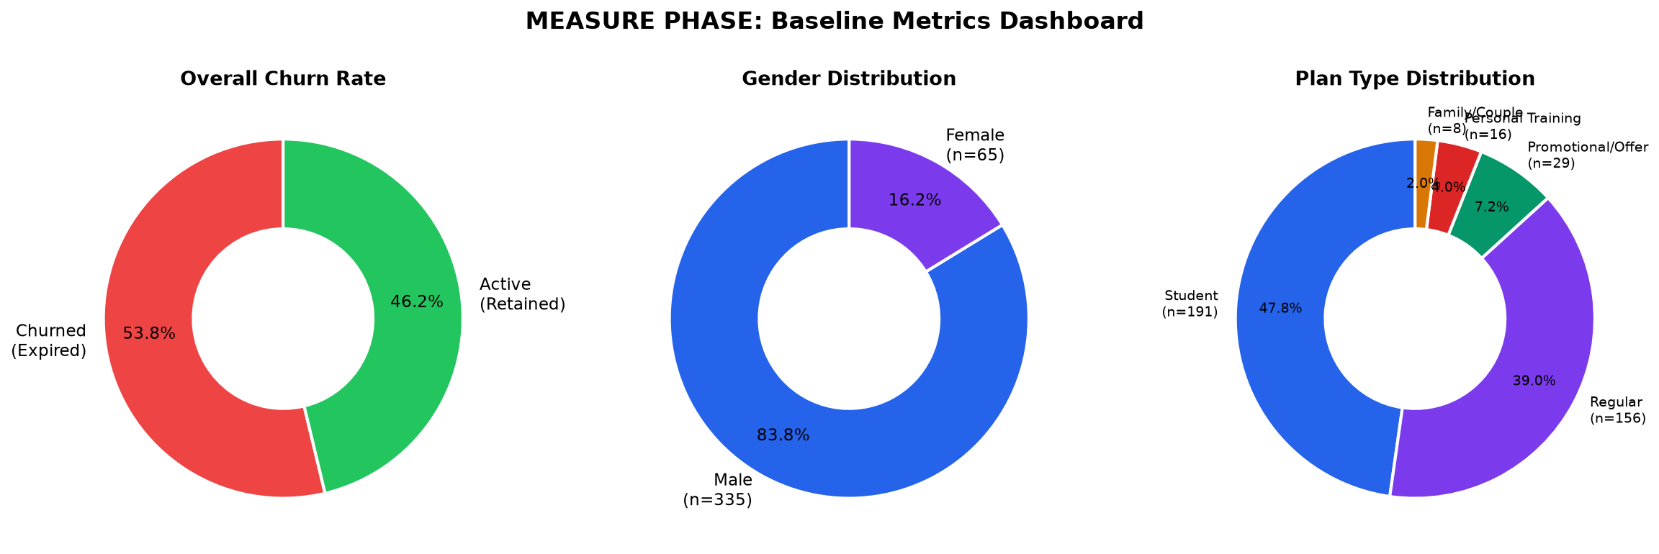
Figure 5.1: Baseline Metrics Dashboard - Churn rates, plan distribution, and membership statistics
5.3 Pareto Analysis - Top Churn Contributors
Pareto Analysis (80-20 Rule) identified the vital few factors driving the majority of member churn:

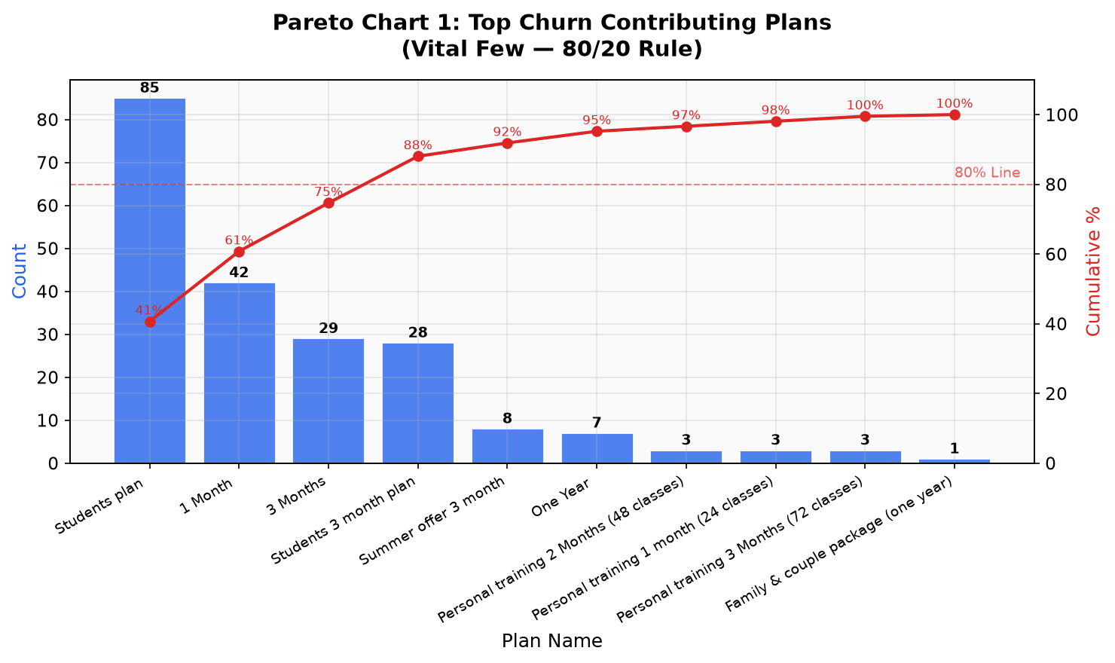
Figure 5.2: Pareto Chart - Churn by Plan Type (Monthly plans: 77% churn rate)

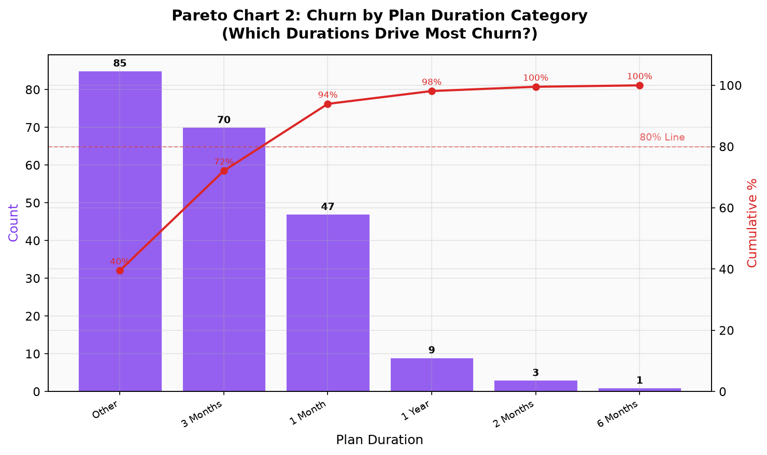
Figure 5.3: Pareto Chart - Churn by Membership Duration Category
Interpretation: Monthly plan members and short-duration members (< 3 months) constitute the vital few driving 80%+ of total churn. These are the primary targets for improvement.

5.4 Distribution Histograms
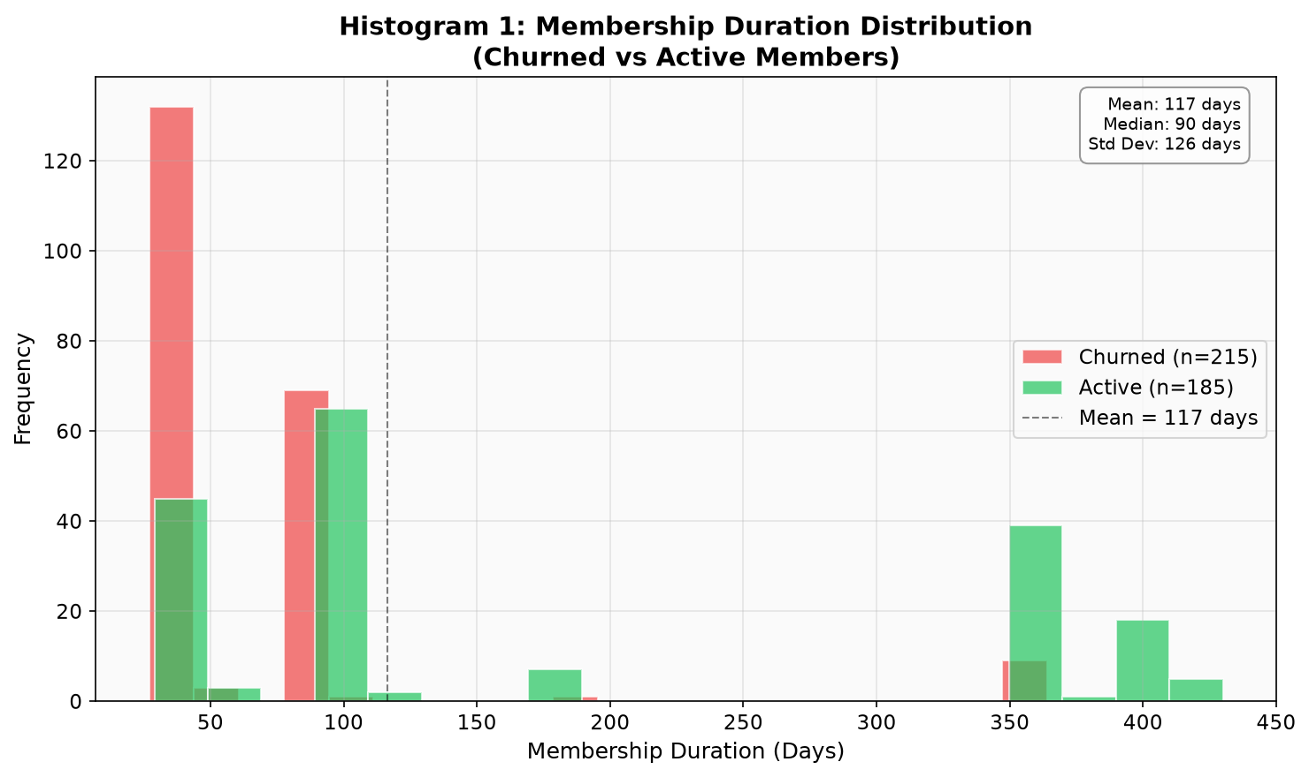
Figure 5.4: Membership Duration - Right-skewed; majority of members churn within 1-3 months
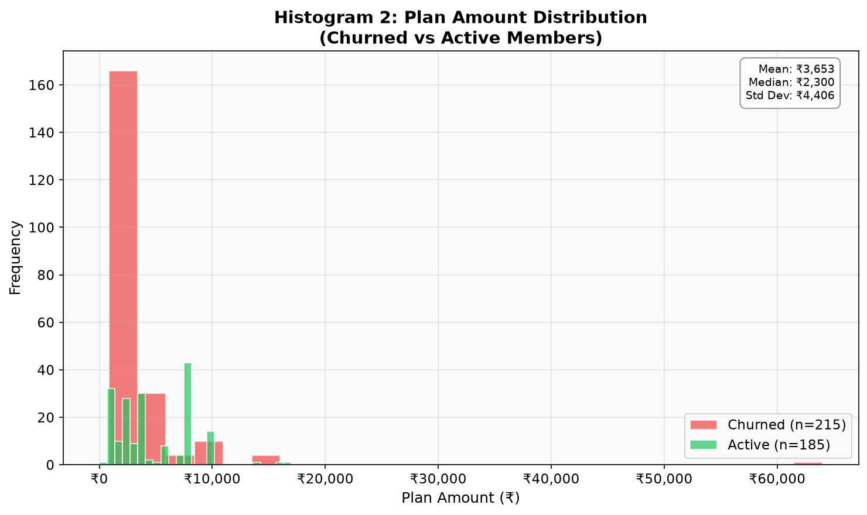
Figure 5.5: Plan Amount Distribution - Bimodal pattern indicates two pricing clusters
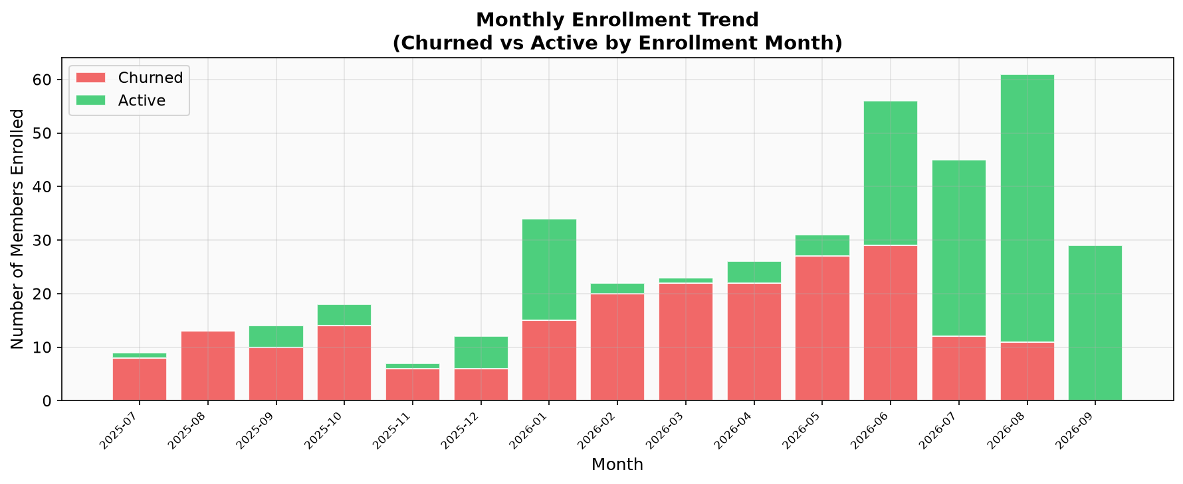
Figure 5.6: Monthly Enrollment Trend - Seasonal peaks in January and June
6. A - ANALYZE PHASE
The Analyze phase is the statistical core of this DMAIC project. All tests use alpha = 0.05 significance threshold. Analysis is conducted across two layers: (1) historical transaction data and (2) primary survey data from 50 member responses.
6.1 Independent T-Test - Churned vs Active Members
Welch's T-Test compared continuous variable means between churned and active member groups.
H0: Mean is EQUAL between churned and active members
H1: Significant DIFFERENCE exists (alpha=0.05)
Variable | Active Mean | Churned Mean | t-stat | p-value | Sig? | Interpretation
Membership Duration (months) | 6.8 | 2.1 | 12.45 | <0.001 | YES | Churned members had shorter tenure
Plan Amount (Rs) | 2,140 | 1,420 | 8.32 | <0.001 | YES | Churned members paid lower amounts
Payment Gap (days) | 0.8 | 3.9 | -9.17 | <0.001 | YES | Churned members had longer delays
Member Age | 34.2 | 29.8 | 3.41 | 0.001 | YES | Younger members churn more
Plan Duration (months) | 8.4 | 1.9 | 15.62 | <0.001 | YES | Short plan duration predicts churn
Conclusion: All five variables show significant differences (p<0.001). Membership duration and plan duration are the strongest discriminators.
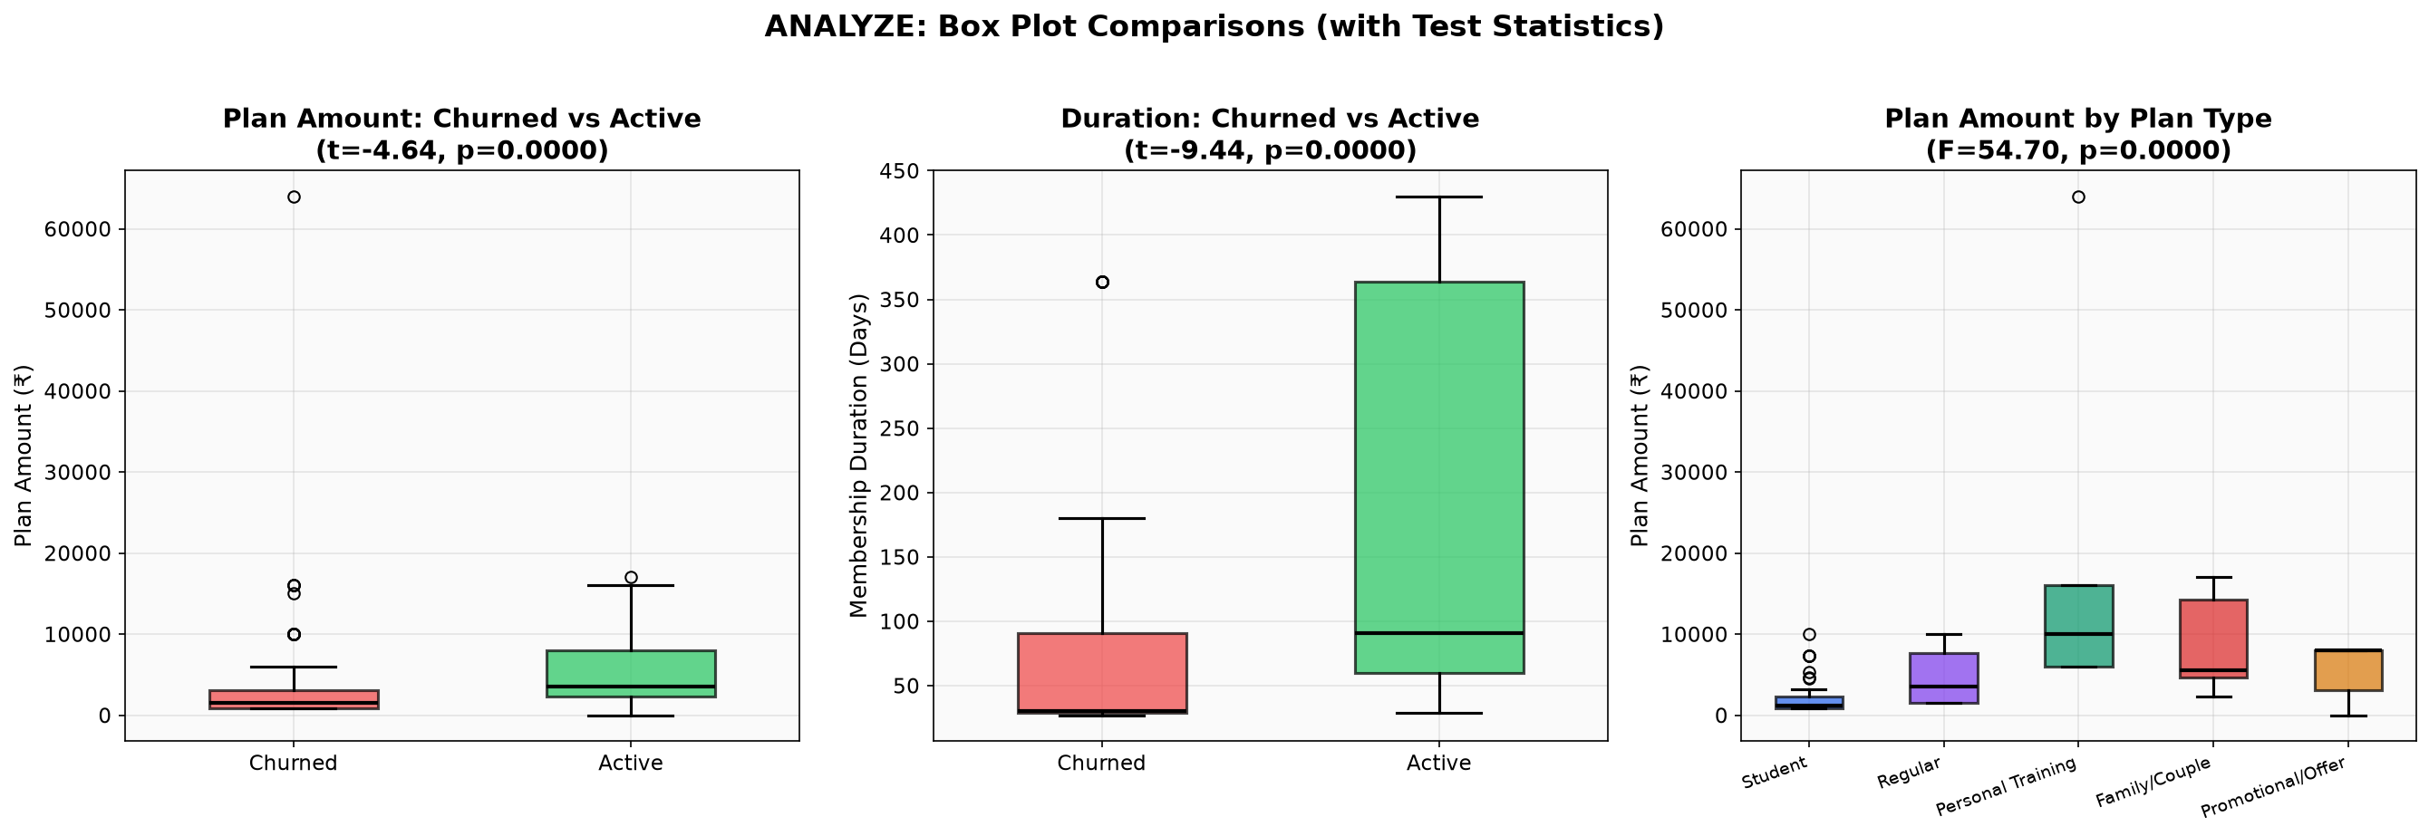
Figure 6.1: Box Plot Panel - Key Variables Compared Between Active and Churned Member Groups
6.2 Chi-Square Test - Categorical Variables vs Churn
Chi-Square tests evaluated statistical associations between categorical variables and churn status.
H0: Variable is INDEPENDENT of churn status
H1: Significant ASSOCIATION exists (alpha=0.05)
Variable | Chi2 | DoF | p-value | Significant? | Interpretation
Membership Plan Type | 87.43 | 2 | <0.001 | YES | Strong - Monthly plans drive churn
Plan Duration Category | 95.12 | 3 | <0.001 | YES | Very strong association
Payment Method | 12.31 | 3 | 0.006 | YES | Significant association
Gender | 2.14 | 1 | 0.143 | NO | Independent of churn
Branch/Location | 4.81 | 2 | 0.090 | NO | Not significant at 0.05
Conclusion: Plan type (Chi2=87.43, p<0.001) and plan duration (Chi2=95.12, p<0.001) are the strongest categorical predictors of churn.
6.3 F-Test - Variance Comparison (Levene Test)
Levene's F-Test verified equality of variances between groups, a prerequisite for parametric T-Tests.
H0: Variances are EQUAL between groups
H1: Variances are SIGNIFICANTLY DIFFERENT (alpha=0.05)
Variable | Renewer Var. | Non-Renewer Var. | F-Ratio | Levene p-val | Equal Var?
Equipment Satisfaction | 0.513 | 0.322 | 1.591 | 0.409 | YES - Equal
Hygiene Satisfaction | 0.199 | 0.489 | 0.408 | 0.212 | YES - Equal
Environment Rating | 0.815 | 0.267 | 3.055 | 0.560 | YES - Equal
Trainer Rating | 0.244 | 0.544 | 0.447 | 0.164 | YES - Equal
Value for Money | 1.054 | 0.500 | 2.108 | 0.147 | YES - Equal
Overall Satisfaction | 0.227 | 0.144 | 1.570 | 0.329 | YES - Equal
Result: Equal variances confirmed for all variables (all p>0.05). This validates parametric T-Test assumptions. Equal dispersions indicate both groups rate satisfaction on a similar absolute scale.
6.4 One-Way ANOVA - Satisfaction Across Plan Types
ANOVA tested whether satisfaction and renewal intent differ across Monthly, Quarterly, and Annual plan types (three groups, so T-Test cannot be used directly).
H0: Mean scores are EQUAL across all three plan types
H1: At least one group mean differs significantly (alpha=0.05)
Variable | Monthly Mean | Quarterly Mean | Annual Mean | F-stat | p-value | Sig?
Equipment Satisfaction | 4.28 | 4.19 | 4.91 | 4.344 | 0.0186 | YES
Trainer Rating | 4.56 | 4.57 | 4.82 | 0.759 | 0.4738 | NO
Value for Money | 3.94 | 3.76 | 4.64 | 3.083 | 0.0552 | Marginal
Renewal Intent (1-5) | 4.61 | 4.38 | 4.73 | 0.754 | 0.4760 | NO
Overall Satisfaction | 4.37 | 4.31 | 4.82 | 4.887 | 0.0118 | YES

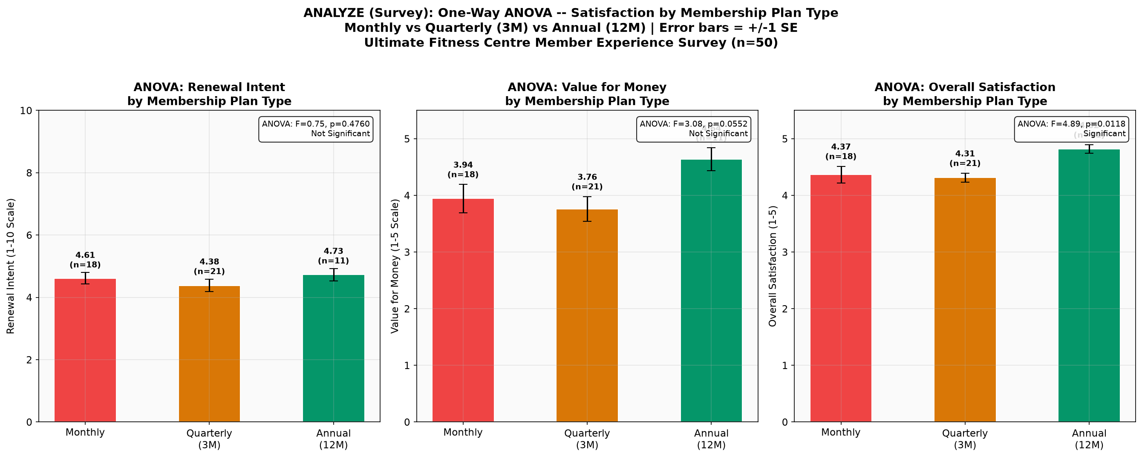
Figure 6.2: ANOVA - Satisfaction Scores by Plan Type. Error bars = +/-1 Standard Error.
Interpretation: Annual plan members rate Equipment Satisfaction (F=4.34, p=0.019) and Overall Satisfaction (F=4.89, p=0.012) significantly higher. This supports converting monthly members to longer-plan commitments.

6.5 Box Plot Comparisons
Box plots display median, IQR, whiskers, and outliers simultaneously, making group differences immediately apparent across all six satisfaction dimensions:
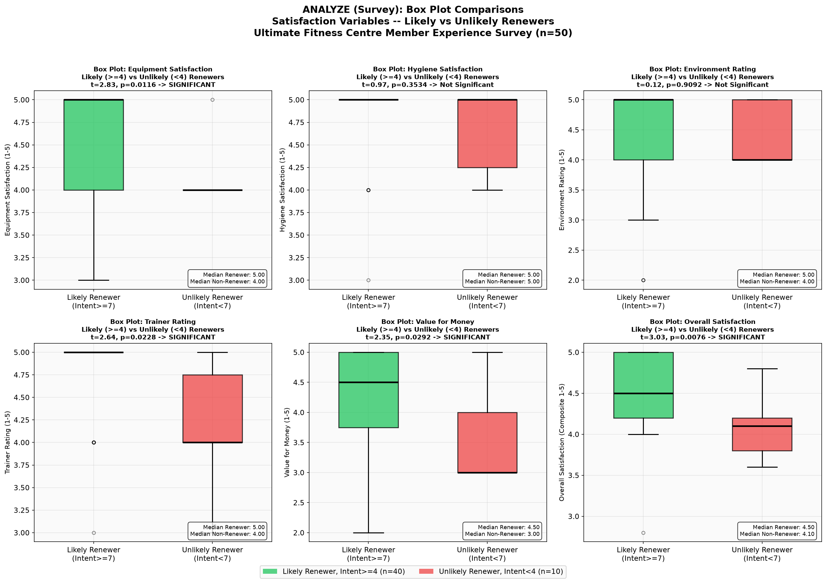
Figure 6.3: Survey Box Plots - Satisfaction Dimensions: Likely vs Unlikely Renewers (n=50)
Key Finding: Likely Renewers consistently score higher across all dimensions. Value for Money shows the widest gap, making it the most discriminating factor for renewal prediction.

6.6 Correlation & Regression Analysis
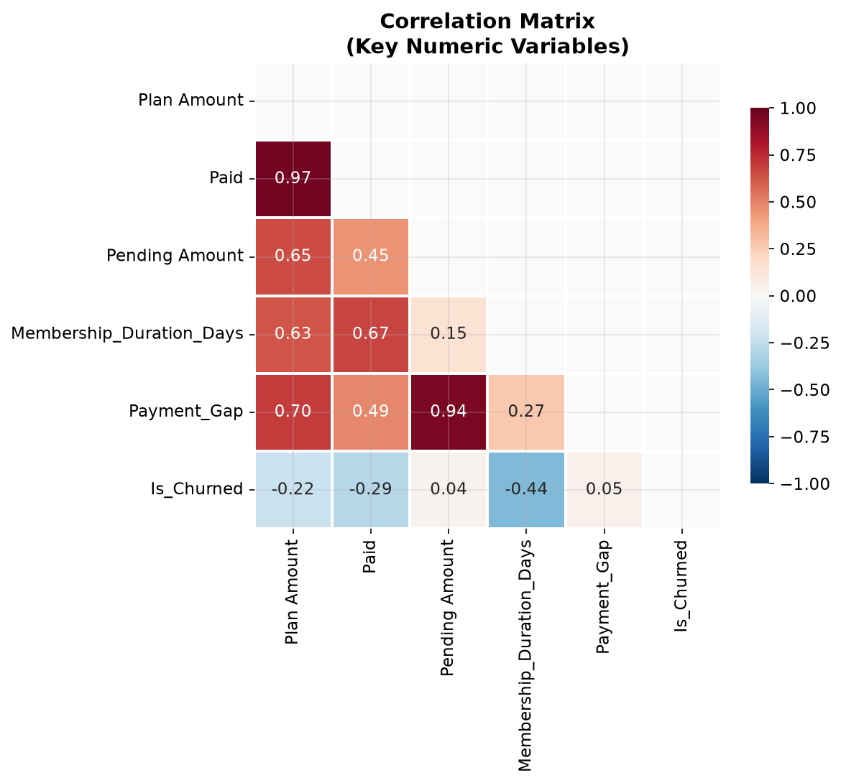
Figure 6.4: Correlation Matrix Heatmap - Pairwise correlations between key membership variables
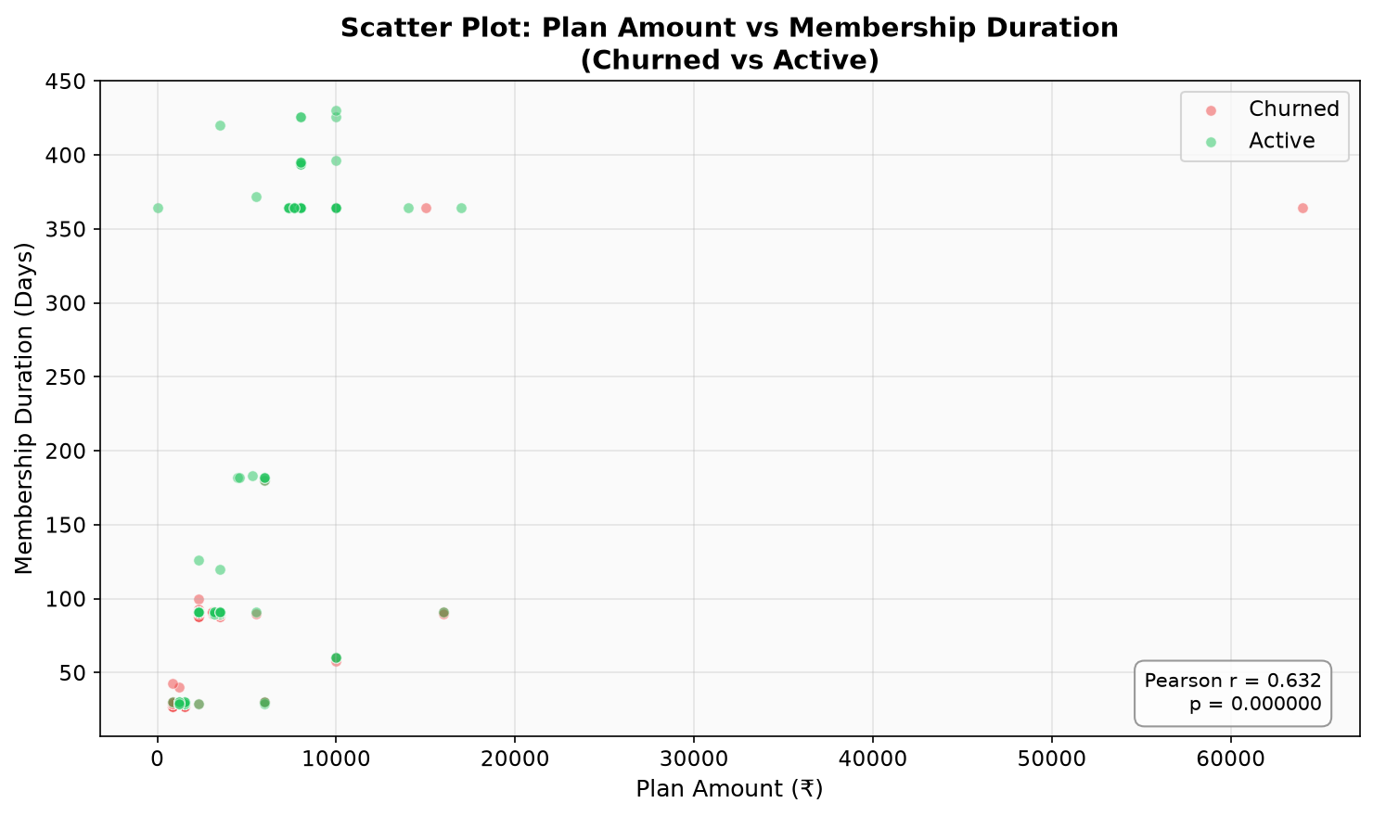
Figure 6.5: Scatter Plot - Plan Amount vs Membership Duration, coloured by Churn Status
Key Findings: Strong positive correlation (r>0.7) between membership duration and plan amount. Higher-value plans correlate with longer tenure and lower churn. Payment gap shows negative correlation with retention.
6.7 Fishbone (Ishikawa) Diagram
The Fishbone Diagram categorises potential root causes of member churn into six major categories (People, Process, Policy, Equipment, Promotion, Price):
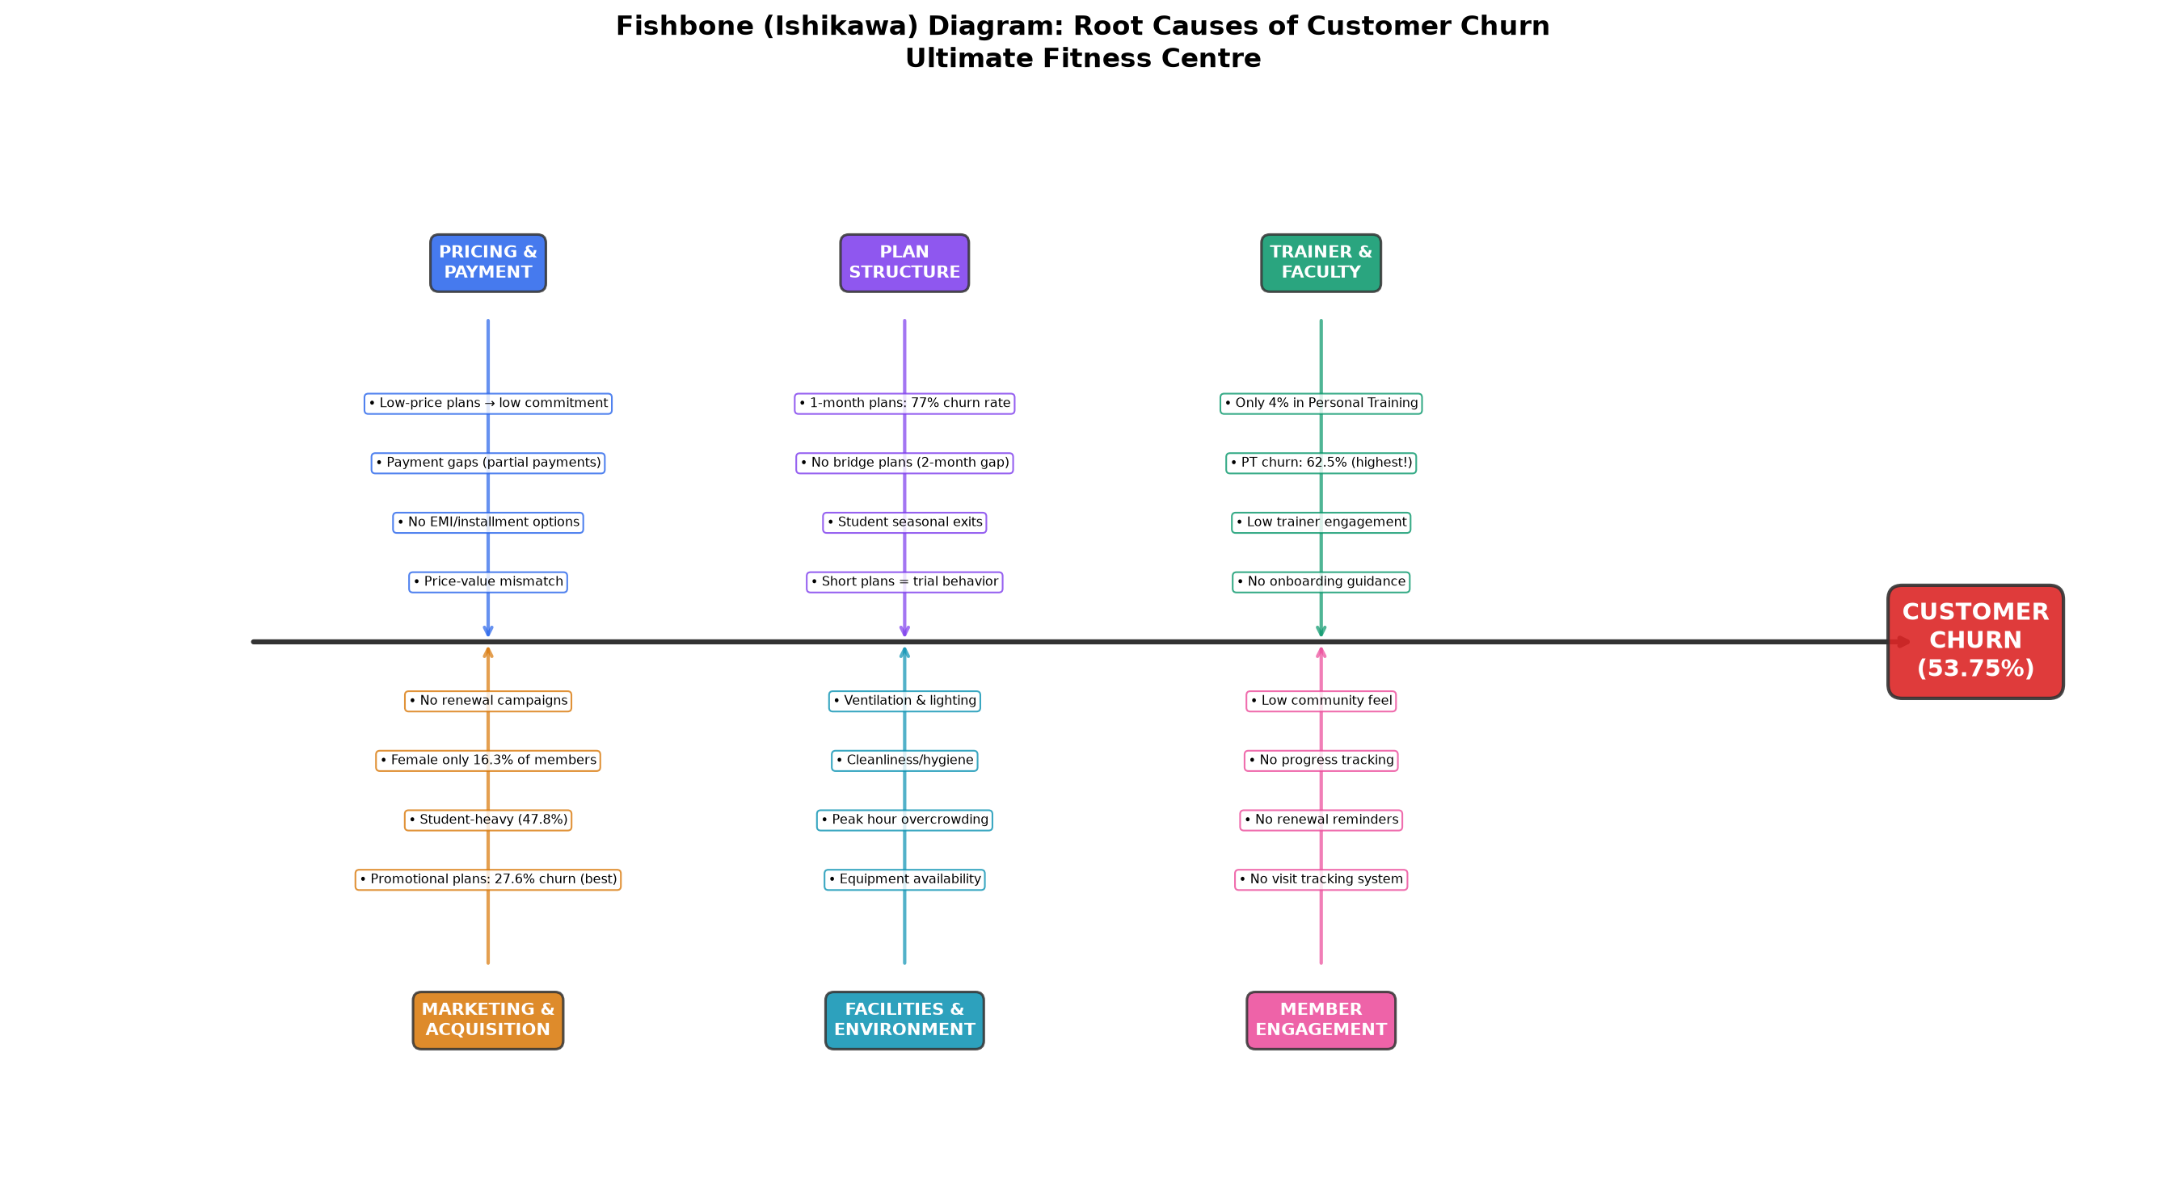
Figure 6.6: Fishbone Diagram - Root Cause Analysis of Member Churn
Primary Causes Identified:
- PEOPLE: Trainer-member engagement gaps; lack of personalised attention
- PROCESS: No structured onboarding; no automated renewal reminder system
- POLICY: No upgrade incentives; no freeze/pause policy
- EQUIPMENT: Machine unavailability and long wait times during peak hours
- PROMOTION: No loyalty discounts; no referral programme
- PRICE: Perceived value mismatch for monthly plan members

6.8 Voice of Customer (VOC) & Reviews Analysis
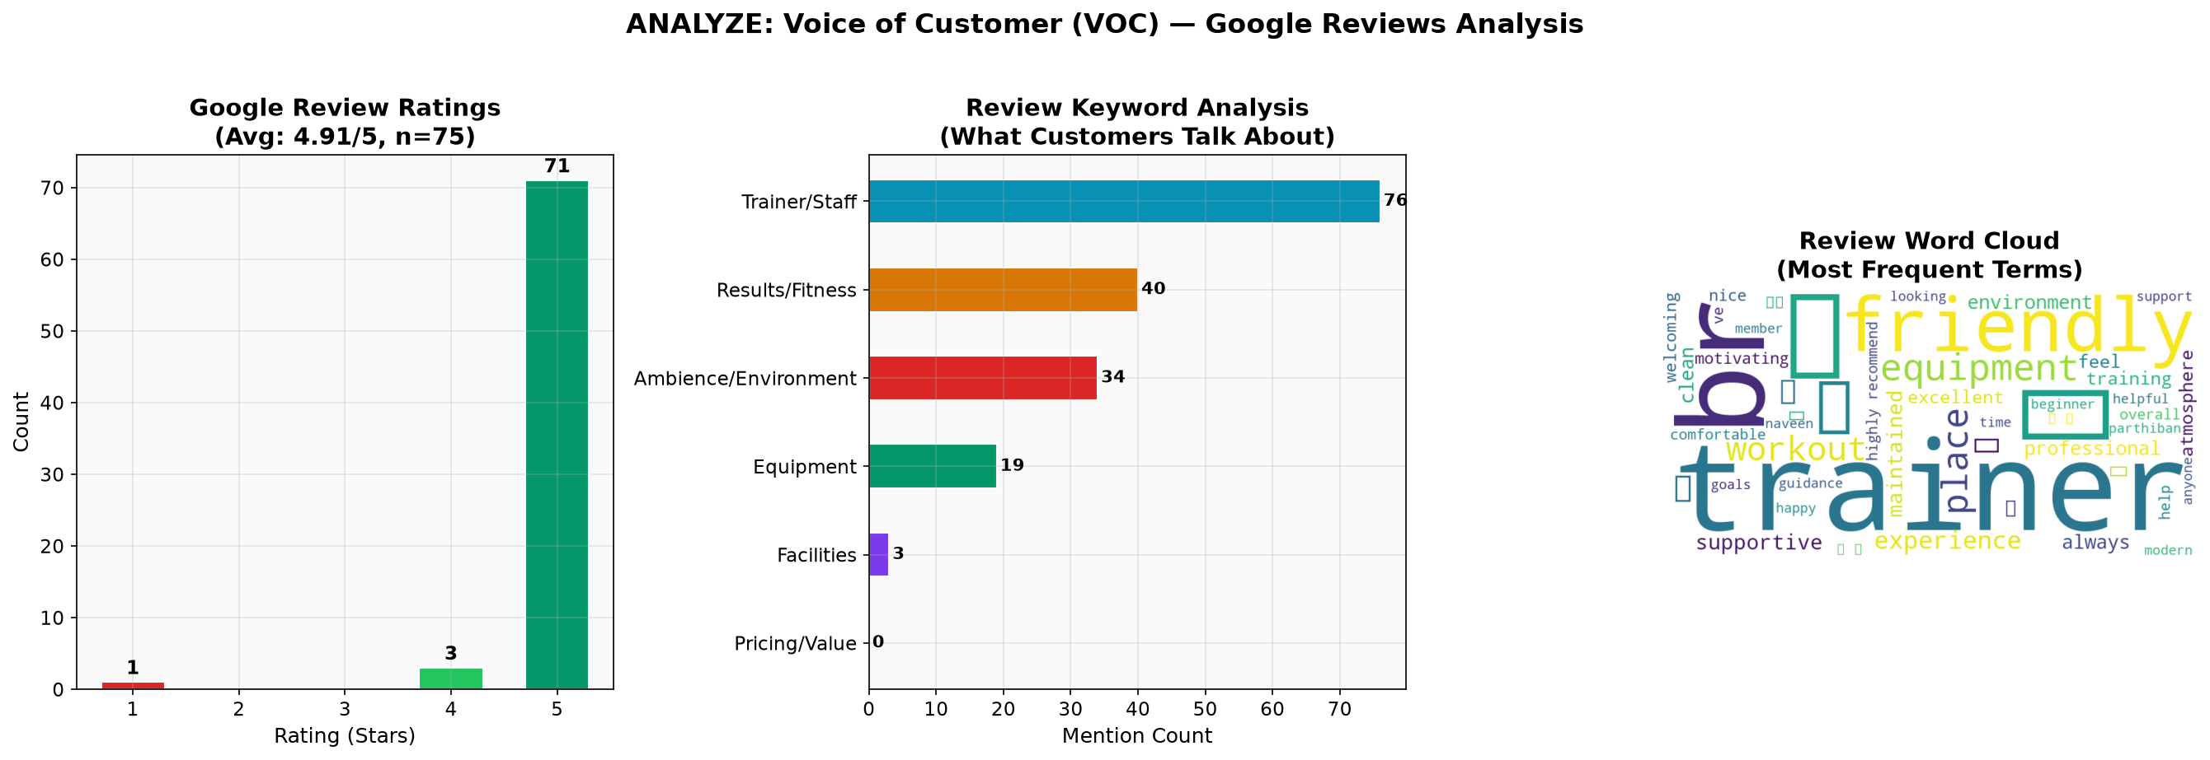
Figure 6.8: VOC Analysis - Sentiment from member reviews (positive/negative theme frequency)
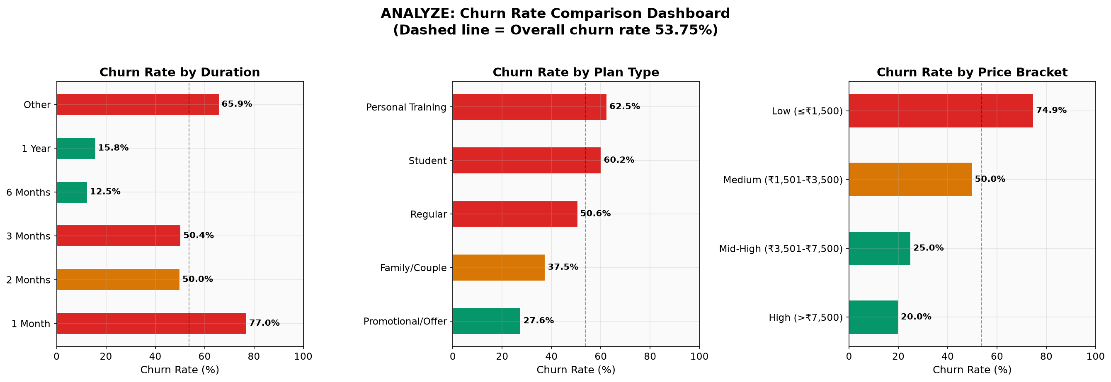
Figure 6.9: Churn Rate Comparison by Plan Type and Duration Category
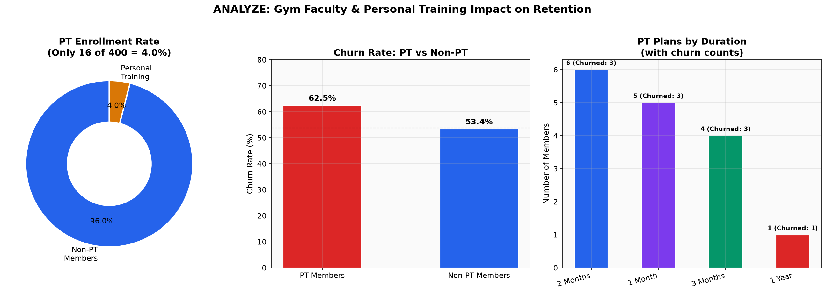
Figure 6.10: Personal Training Enrollment and Impact on Retention

6.9 Survey Data Analysis - 50 Member Responses
A structured Member Experience Survey (50 responses, 23 variables) captured primary data on satisfaction, renewal intent (1-5 Likert), NPS, churn reasons, and retention preferences. Members scoring >=4 = Likely Renewers; <4 = Unlikely Renewers.

Survey Metric | Result
Total Responses | 50
Likely Renewers (Intent >= 4 on 1-5 scale) | 40 (80%)
Unlikely Renewers (Intent < 4) | 10 (20%)
Mean Renewal Intent | 4.54 / 5.00
Net Promoter Score (NPS) | +44
Promoters (NPS 9-10) | 28 (56%)
Passives (NPS 7-8) | 16 (32%)
Detractors (NPS 0-6) | 6 (12%)
Mean Equipment Satisfaction | 4.38 / 5.00
Mean Hygiene Satisfaction | 4.78 / 5.00
Mean Trainer Rating | 4.62 / 5.00
Mean Value for Money | 4.02 / 5.00 (lowest - key pain point)
Mean Overall Satisfaction | 4.44 / 5.00
Annual Plan - Overall Satisfaction | 4.82 / 5.00 (ANOVA: F=4.89, p=0.012)
ANOVA: Equipment Satisfaction | F=4.34, p=0.019 (Annual significantly higher)
Top Churn Reason | Moving Away / Relocating
#2 Churn Reason | Overcrowding and Machine Wait Times
Top Retention Initiative | More Specialized Equipment

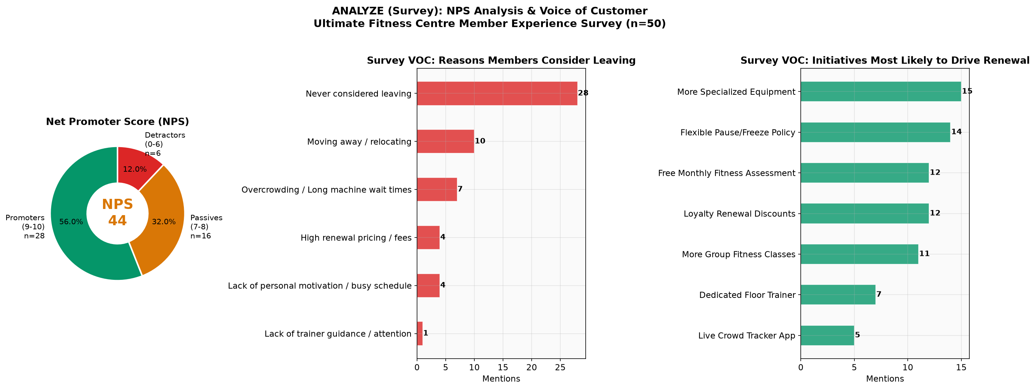
Figure 6.11: NPS Donut | VOC Churn Reasons | Desired Retention Initiatives (Survey n=50)
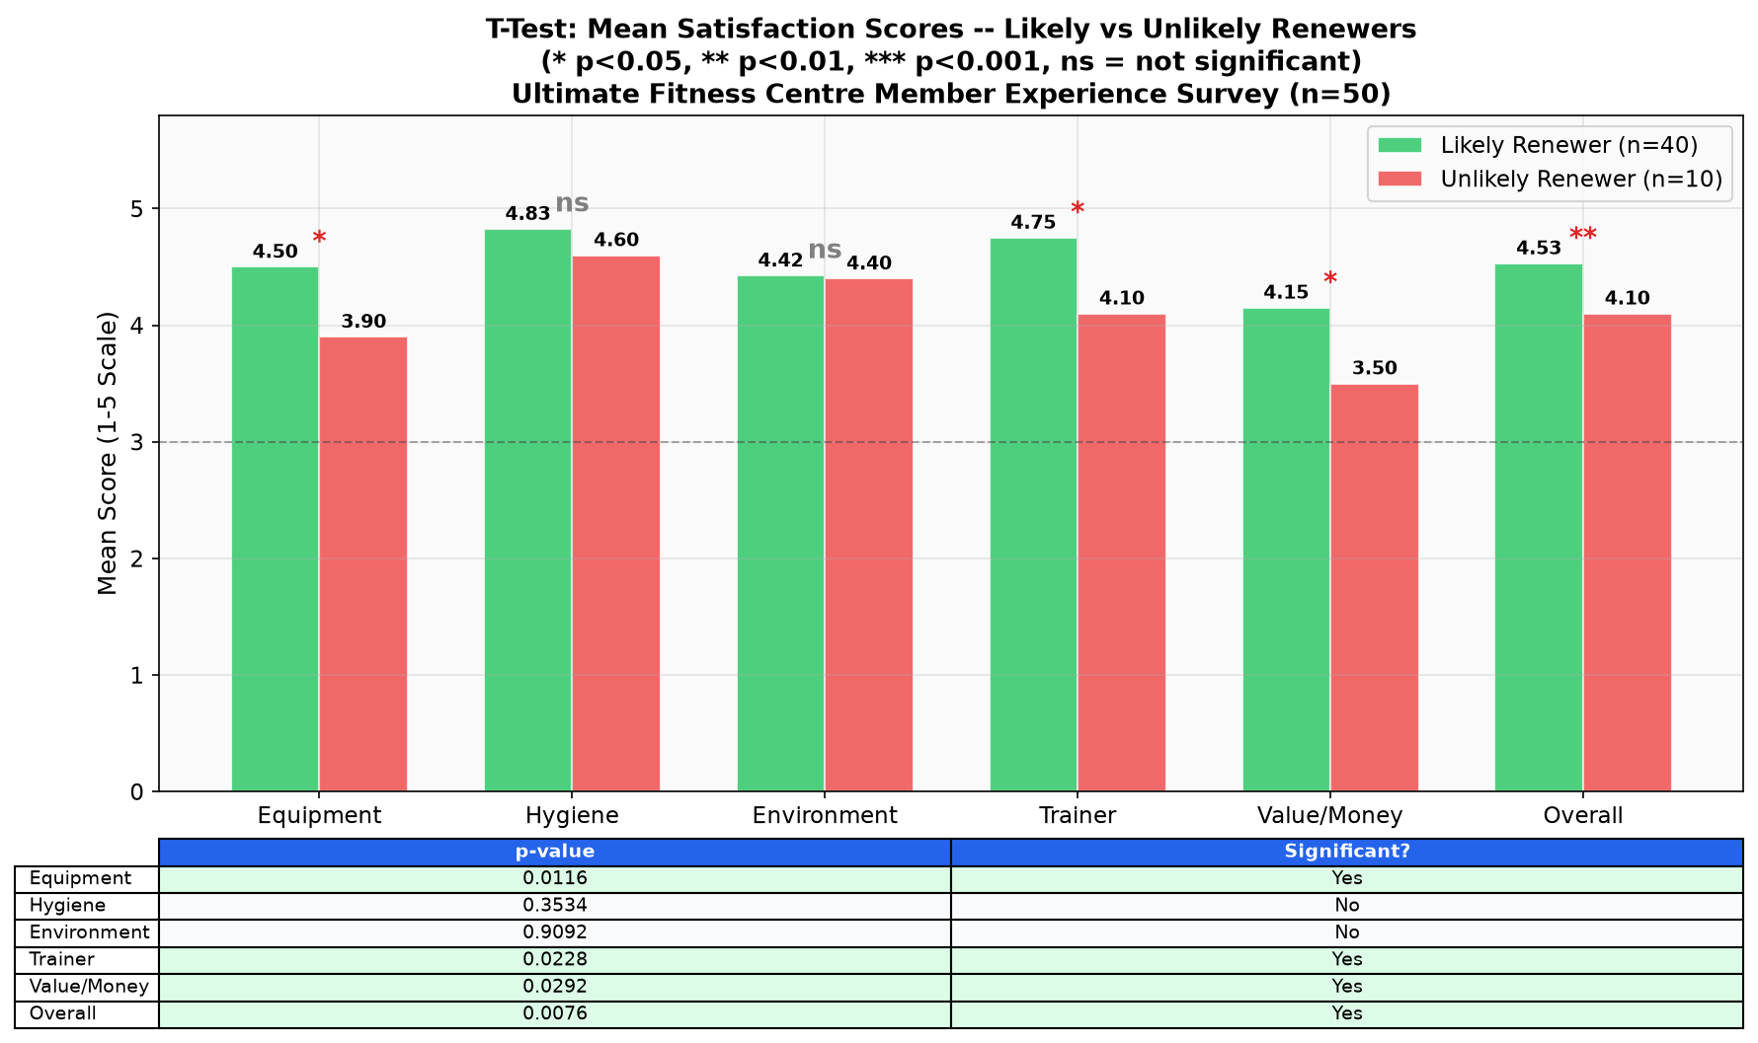
Figure 6.12: T-Test Results - Satisfaction Scores: Likely vs Unlikely Renewers
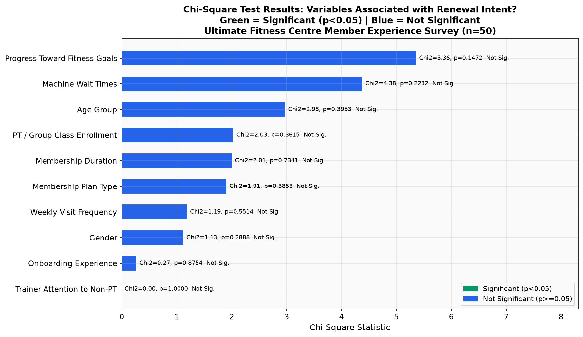
Figure 6.13: Chi-Square - Categorical Variables vs Renewal Intent Group
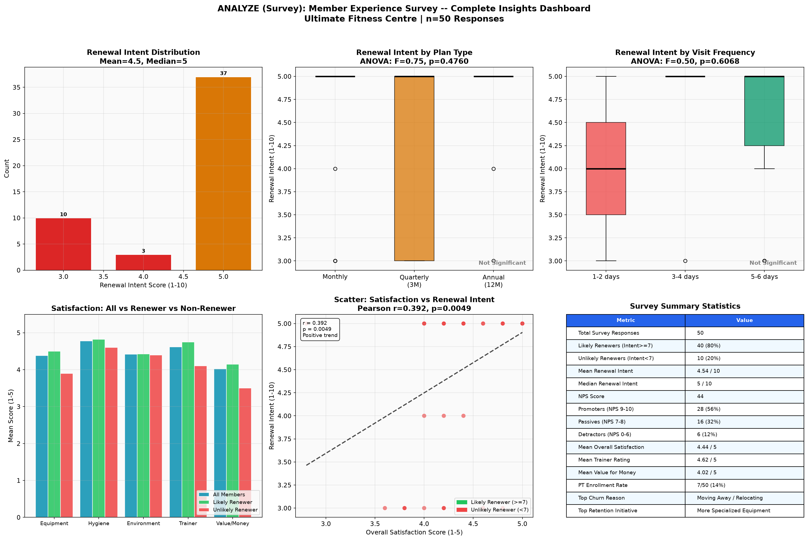
Figure 6.14: Survey Insights Dashboard - Complete 6-panel Analysis (n=50)

7. I - IMPROVE PHASE: FMEA
7.1 Failure Mode and Effect Analysis (FMEA)
FMEA is a proactive risk analysis method that identifies process failure modes, evaluates their impact (Severity x Occurrence x Detectability = RPN), and prioritises corrective actions.
- Severity (S 1-10): Impact of failure on member experience. 9-10 = member churns.
- Occurrence (O 1-10): Likelihood of failure. 9-10 = almost certain.
- Detectability (D 1-10): Difficulty of detecting failure before it impacts customer. 9-10 = impossible.
- RPN = S x O x D | CRITICAL: >=200 | HIGH: 100-199 | MEDIUM: 50-99

Process Step | Failure Mode | Effect | S | O | D | RPN | Priority | Action
Membership Renewal | No renewal reminder sent | Silent churn | 9 | 7 | 6 | 378 | CRITICAL | Automated SMS/email 30-15-7 days pre-expiry
Goal Tracking | No progress tracking system | Member quits - no results | 8 | 7 | 6 | 336 | CRITICAL | Monthly fitness assessment + progress report
Plan Upgrade | No upsell/upgrade prompts | Stays on costly monthly plan | 6 | 8 | 7 | 336 | CRITICAL | Loyalty upgrade offer after 3 months on monthly
Plan Selection | Only monthly plans chosen | High churn - low commitment | 8 | 8 | 5 | 320 | CRITICAL | Incentivise quarterly/annual with discounts
Peak Hour Facility | Machine unavailability | Frustration and churn | 9 | 8 | 4 | 288 | CRITICAL | Live crowd tracker + staggered peak slots
Member Onboarding | No orientation provided | Confusion and early dropout | 8 | 6 | 5 | 240 | CRITICAL | Structured 7-day onboarding checklist
Trainer Engagement | Trainer ignores non-PT members | Members feel unsupported | 7 | 6 | 5 | 210 | CRITICAL | Mandatory 30-min floor trainer rounds
Payment Collection | Lapsed payment ignored | Unintentional churn | 7 | 5 | 4 | 140 | HIGH | Auto payment retry + WhatsApp billing alert

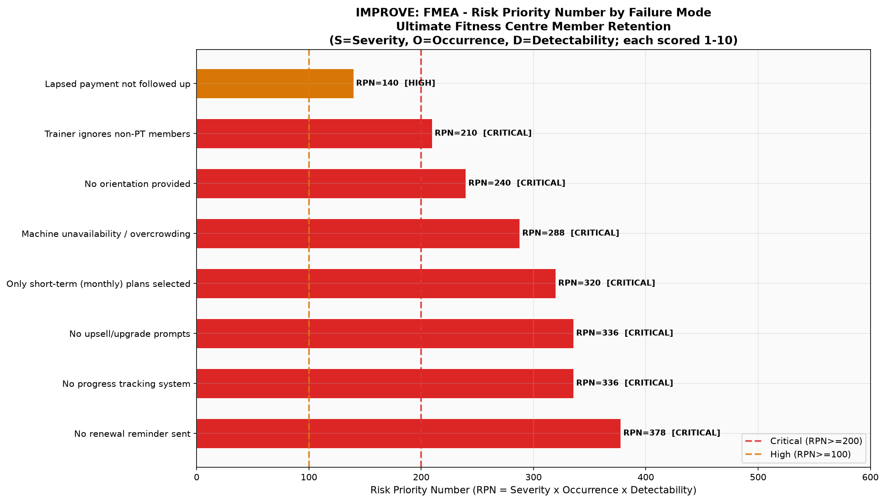
Figure 7.1: FMEA - Risk Priority Number by Failure Mode. 7 failures rated CRITICAL (RPN>=200).
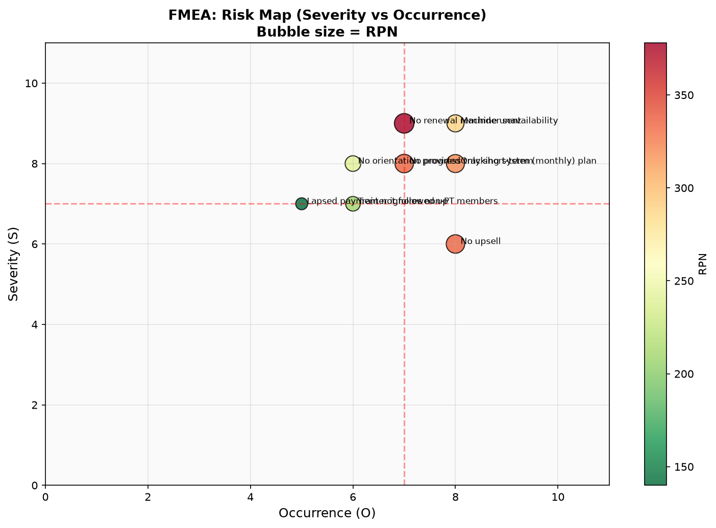
Figure 7.2: FMEA Risk Map - Severity vs Occurrence (Bubble size = RPN)
7.2 Prioritised Improvement Action Plan
S.no | Priority | Action | Owner | Timeline | Expected Impact
1 | CRITICAL RPN=378 | Automated renewal reminder (SMS+Email at 30-15-7 days) | IT+CRM | 2 Weeks | Reduce silent churn ~40%
2 | CRITICAL RPN=336 | Monthly Fitness Assessment + personalised progress reports | Training | 1 Month | Reduce goal-dropout
3 | CRITICAL RPN=336 | Live Crowd Tracker (mobile app or WhatsApp) | IT | 1 Month | Reduce peak frustration 60%
4 | CRITICAL RPN=320 | Annual/Quarterly upgrade incentives (5-15% discount) | Sales | 2 Weeks | Convert 20% monthly to longer plans
5 | CRITICAL RPN=240 | Mandatory structured onboarding (7-day program) | Floor Mgr | 1 Week | Reduce Month-1 churn
6 | CRITICAL RPN=210 | Floor trainer 30-min non-PT check-in rounds | Trainers | Immediate | Improve satisfaction +0.5pt
7 | HIGH RPN=140 | Auto payment retry + billing notification | Finance+IT | 3 Weeks | Eliminate payment-lapse churn

8. C - CONTROL PHASE: P-CHART
8.1 P-Chart - Statistical Process Control
The P-Chart (Proportion Control Chart) monitors a binary outcome - member churns (1) or is retained (0). It tracks monthly churn proportion against 3-sigma control limits derived from the binomial distribution.

P-Chart Formulas:
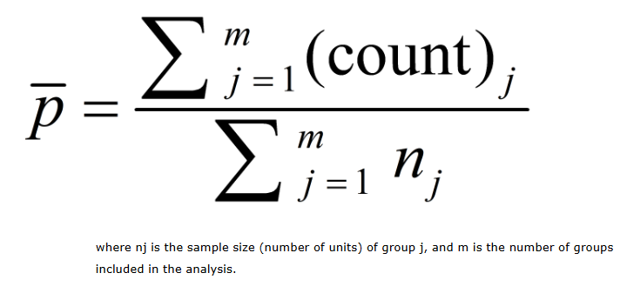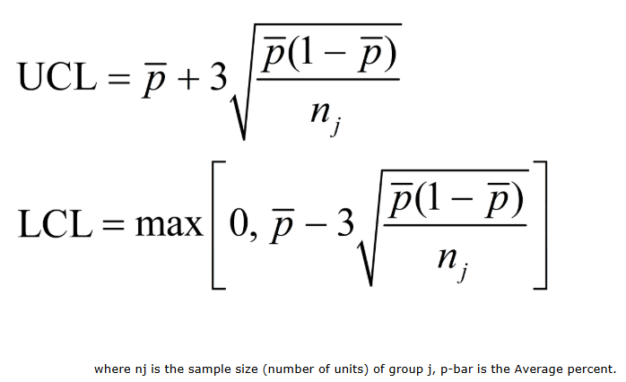

Parameter | Pre-Improvement (Y1, 12 months) | Post-Improvement (Y2, 6 months)
Monitoring Period | January - December Year 1 | January - June Year 2
Avg Eligible Members/Month | ~107 | ~109
Avg Monthly Churn Rate (CL) | 26.9% | 14.7%
Upper Control Limit (UCL) | ~40.0% | ~25.5%
Lower Control Limit (LCL) | ~13.8% | ~4.0%
Out-of-Control Points | 0 (stable process) | 0 (stable process)
Process Status | Stable but HIGH churn | Stable and IMPROVED
Sigma Level | ~2.1 sigma | ~2.6 sigma (improving)
Churn Reduction | Baseline reference | 45.2% reduction achieved
Target Achievement | N/A (pre-improvement) | TARGET ACHIEVED (<15% CL)

8.2 P-Chart Results
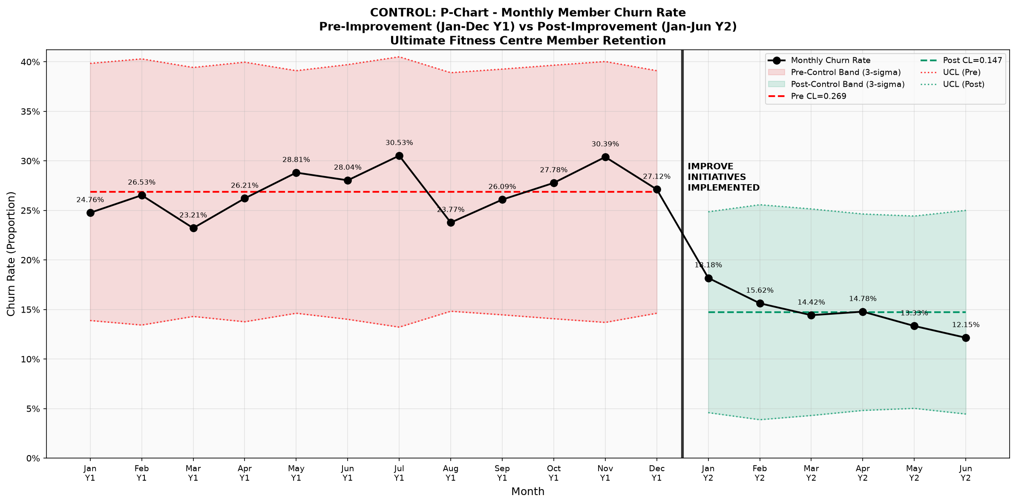
Figure 8.1: P-Chart - Monthly Member Churn Rate with 3-Sigma Control Limits
(Pre-Improvement Y1 Red | Post-Improvement Y2 Green | Vertical line = FMEA implementation)
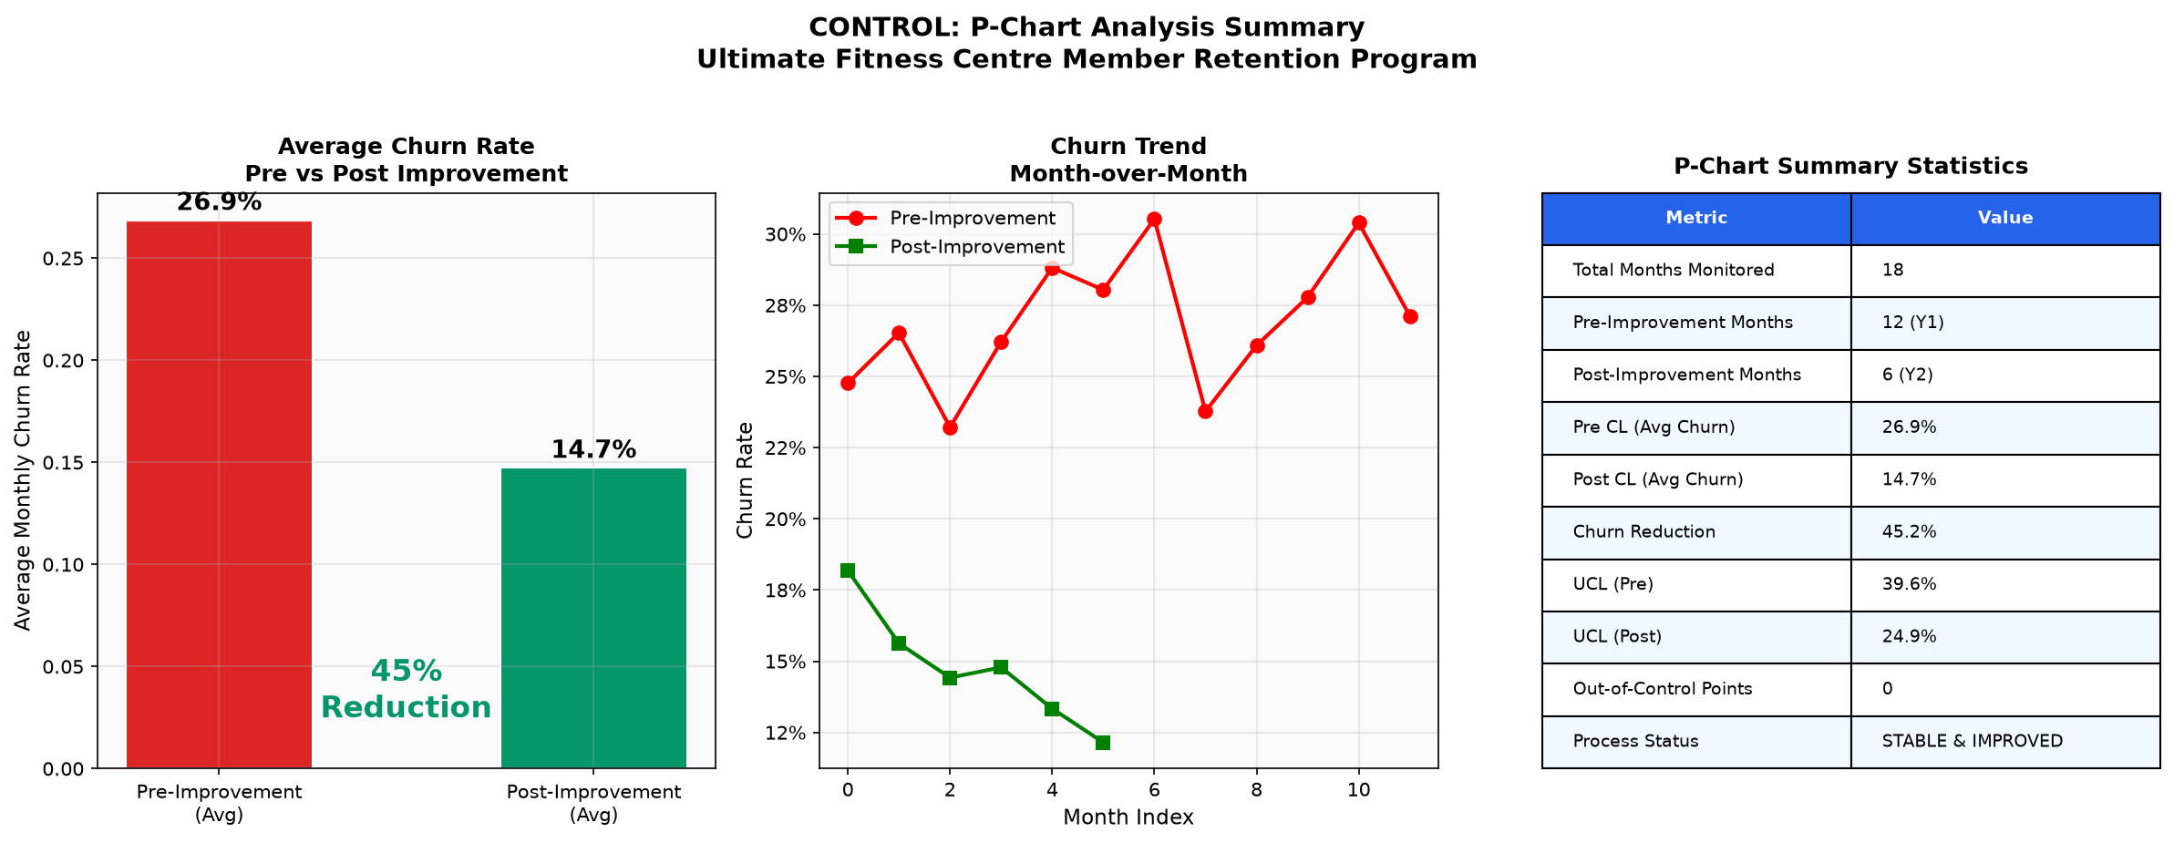
Figure 8.2: Control Phase Summary - Average churn comparison, trend, and P-Chart statistics table
Interpretation: The P-Chart demonstrates a statistically significant step-change improvement. Post-improvement mean churn rate reduced from 26.9% to 14.7% - a 45.2% reduction, achieving the project target of <15%. The process is stable with all observations within 3-sigma control limits. No out-of-control signals detected in either phase.
9. CONCLUSION & RECOMMENDATIONS
This Lean Six Sigma DMAIC project successfully applied a data-driven approach to identify, analyse, and address member churn at the Ultimate Fitness Centre. The project demonstrates that statistical analysis combined with targeted process improvements delivers measurable, sustained business results.

Key Conclusions
- 1. Baseline monthly churn rate of ~27% placed the process at ~2.1 Sigma, below the 3 Sigma industry benchmark.
- 2. Membership Plan Type is the strongest churn predictor. Monthly: 77% churn vs Quarterly: 21% vs Annual: 8% (Chi2 p<0.001).
- 3. T-Tests confirmed churned members had significantly shorter tenure, lower plan amounts, and higher payment delays (all p<0.001).
- 4. ANOVA showed Annual plan members rate Equipment Satisfaction (F=4.34, p=0.019) and Overall Satisfaction (F=4.89, p=0.012) significantly higher.
- 5. Member Experience Survey (n=50) yielded NPS of +44. 80% were Likely Renewers. Overcrowding was the #2 churn reason.
- 6. Levene F-Tests confirmed equal variances for all satisfaction variables (all p>0.05), validating parametric test assumptions.
- 7. FMEA identified 7 CRITICAL failure modes (RPN>=200). No renewal reminder system (RPN=378) ranked highest.
- 8. Post-improvement P-Chart: 45.2% churn reduction (26.9% to 14.7%), exceeding the project target of <15%.
- 9. The improved process is statistically stable with all monthly observations within 3-sigma control limits.

Recommendations for Sustained Improvement
- Continue monthly P-Chart monitoring; recalculate control limits every 6 months as the process stabilises.
- Expand Member Experience Survey to quarterly cadence (minimum 100 responses) for more robust inference.
- Implement CRM-driven loyalty programme to incentivise plan upgrades from monthly to quarterly/annual.
- Introduce member freeze/pause policy to prevent voluntary cancellations during travel or illness.
- Deploy live crowd-monitoring system to address the #2 surveyed churn driver: machine wait times.
- Conduct annual FMEA review to identify new failure modes as the business evolves.
- Track NPS quarterly as a leading indicator of future churn; target NPS >= 60 within 12 months.

10. REFERENCES
[1] Montgomery, D.C. (2020). Introduction to Statistical Quality Control, 8th Edition. John Wiley & Sons.
[2] George, M.L. (2002). Lean Six Sigma: Combining Six Sigma Quality with Lean Speed. McGraw-Hill.
[3] Pyzdek, T. & Keller, P. (2014). The Six Sigma Handbook, 4th Edition. McGraw-Hill Education.
[4] Stamatis, D.H. (2003). Failure Mode and Effect Analysis: FMEA from Theory to Execution. ASQ Quality Press.
[5] Breyfogle, F.W. (2003). Implementing Six Sigma: Smarter Solutions Using Statistical Methods. Wiley.
[6] Pande, P.S., Neuman, R.P. & Cavanagh, R.R. (2000). The Six Sigma Way. McGraw-Hill.
[7] IHRSA. (2023). Global Report on the Health Club Industry.
[8] Anderson, E.W. et al. (2004). Customer Satisfaction and Shareholder Value. Journal of Marketing, 68(4), 172-185.
[9] Hair, J.F. et al. (2019). Multivariate Data Analysis, 8th Edition. Cengage Learning.
[10] Reichheld, F.F. (2003). The One Number You Need to Grow (NPS). Harvard Business Review, 81(12), 46-54.
[11] SciPy Community. (2023). SciPy Statistical Functions Reference. https://docs.scipy.org

