LEAN SIX SIGMA APPLICATION

Value Stream Mapping (VSM)
Circuit Workout Using All Gym Equipment
Fitness-centre member journey | Current-state process map
Prepared for academic review | 28 October 2026
Project context | Details
Project context | Improving Member Retention in a Fitness Centre Using DMAIC Methodology
Process scope | One member completing a coached circuit workout and using all equipment groups
Customer / demand | Member wants a safe, complete, time-bounded workout with minimal waiting
Mapping basis | Illustrative current-state estimates; validate with stopwatch observations before implementation

1. Purpose and scope
This VSM maps the end-to-end flow experienced by one gym member who completes a circuit workout using the available equipment groups. It shows the information flow that creates the workout plan, the physical movement of the member through the gym, waiting or hand-off time between stations, and the lead-time ladder used to identify improvement opportunities.
The map is a current-state teaching model for the fitness-centre DMAIC project. Times are planning estimates, not measured observations, and should be replaced with actual time-study data during the Measure phase.

2. Process assumptions
- One member follows one coached circuit: check-in/warm-up ? cardio ? strength ? functional circuit ? cool-down ? exit.
- Equipment is represented by groups: treadmill/bike; leg press/chest press/row/shoulder press; cable/kettlebell/battle rope/mat.
- The member completes one pass through each group. A second round can be added by repeating process boxes and updating totals.
- The trainer or front desk provides the sequence, checks readiness, and gives basic coaching; the member provides the goal and feedback.
- Waiting time represents queueing, equipment availability, transitions, or instruction?not exercise time.

3. Current-state VSM
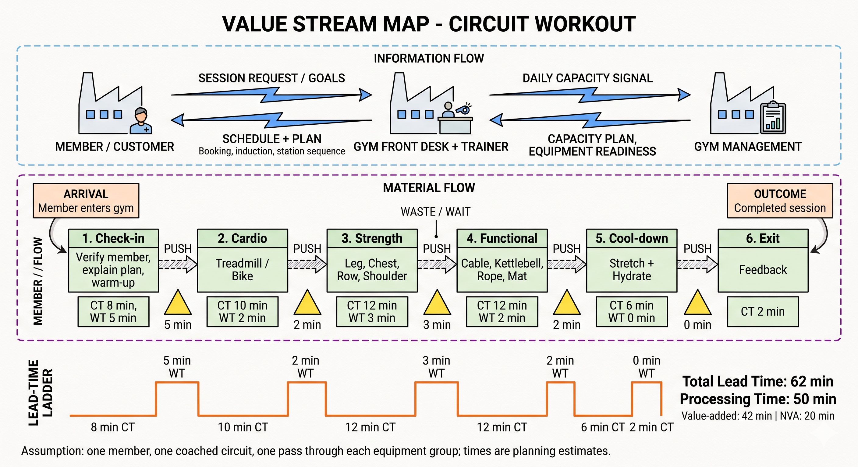

Figure 1. Current-state value stream map for a complete circuit workout.

4. Process data table
Step | Member / equipment flow | Cycle | Wait | Owner | Potential waste | VA?
1 | Check-in + warm-up | 8 min | 5 min | Front desk / trainer | Registration queue | Partial
2 | Cardio: treadmill or bike | 10 min | 2 min | Member | Searching for free machine | Yes
3 | Strength: leg press, chest press, row, shoulder press | 12 min | 3 min | Member / trainer | Equipment imbalance | Yes
4 | Functional: cable, kettlebell, battle rope, mat | 12 min | 2 min | Member / trainer | Set-up and cleaning | Yes
5 | Cool-down, stretch, hydrate | 6 min | 0 min | Member | None planned | Yes
6 | Feedback and exit | 2 min | 0 min | Front desk / member | Data entry delay | Support

5. Lead-time summary
Metric | Calculation | Result
Total processing time | 8+10+12+12+6+2 | 50 min
Total waiting / transition time | 5+2+3+2 | 12 min
Total member lead time | 50+12 | 62 min
Estimated value-added time | Workout + recovery activity | 42 min

6. Information and member-flow interpretation
Information flow: the member communicates goals and availability to the front desk or trainer. The gym responds with a schedule and station sequence. Management uses capacity and equipment-readiness information to balance demand across stations. Member feedback returns to the gym and can improve the next plan.
Member flow: the member moves from arrival to each equipment group. The yellow inventory triangles represent waiting or queue points. In a service process, the ?material? is the member?s time, attention, effort, and movement through the facility.

7. Waste identified and improvement opportunities
Waste / issue | Where | Effect | Improvement
Waiting | Check-in and station hand-offs | Longer session and lower satisfaction | Pre-book a circuit slot and display station readiness
Motion | Member searches for equipment | Unproductive fatigue | Fixed station sequence and visible signage
Uneven flow | Strength equipment group | Peak-hour bottleneck | Balance exercises across machines and free weights
Set-up / cleaning | Functional circuit | Interruptions and safety risk | 5S layout with a reset standard
Information delay | Feedback at exit | Missed retention signal | Short digital feedback form linked to member record

8. Recommended future-state direction
- Create a 60-minute reservation slot with a defined arrival window and visible ready/occupied/reset status for each station.
- Arrange the equipment sequence in physical proximity where possible, or provide a floor map and numbered station cards.
- Use standard work showing exercise, duration, repetitions, rest, safety cue, and cleaning/reset responsibility.
- Measure actual cycle time, queue time, equipment utilization, first-time-right completion, and member satisfaction for at least 10 sessions.
- Re-map after the Measure and Improve phases to confirm lead time and waiting have reduced without compromising safety or workout quality.

9. Reference VSM format supplied
The following page includes the reference image supplied for this assignment. Its information-flow, material-flow, inventory, process-data, and lead-time-ladder conventions were adapted for the gym service process.

Figure 2. Supplied reference value-stream-mapping image.

10. Validation checklist
- Observe and record actual time at every step.
- Count queues by time of day and equipment group.
- Confirm that each equipment item is appropriate for the member?s goal and fitness level.
- Review the map with a trainer and at least one member.
- Update metrics and redraw the future-state map after improvements.

