4. Alkynes

Alkynes
- contain only carbon and hydrogen atoms
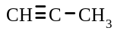
- have at least one triple carbon-carbon bond , for example, propyne, , is an alkyne.
- have a general formula of C_{n}H_{2n-2} where n = 1, 2, 3 etc
- are colourless compounds
- have relatively low melting and boiling points
- are sparingly soluble in water.

Nomenclature

Alkynes are named in the same way as alkenes except, the suffix ‘yne’ is used to indicate the presence of a triple bond.

The position of the triple bond is identified by numbering the carbon chain so that the triple bond has the smallest number.

If there are two or three triple bonds then the suffixes 'diyne' and 'triyne', respectively, are used.

For example, the name of the following alkyne is 5,5-dimethylhex-1-yne
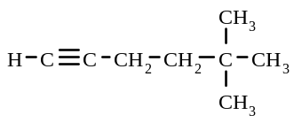

32. Draw an electron dot representation of
a) ethyne b) propyne

33. Name the following alkynes

a) | 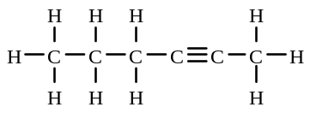 | b) | 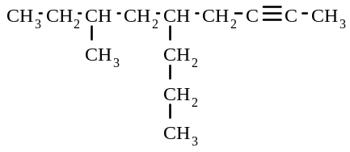
c) | 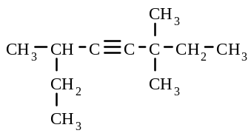 | d) | 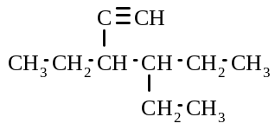

34. Give the structural formulae of the following compounds:
a) oct-3-yne
b) 4-ethyl-5,4-dimethylhept-2-yne
c) dimethylbut-1-yne

Reactions of alkynes

Addition reactions

Alkynes undergo addition reaction with the halogens to form halogen-substituted alkenes or alkanes and with hydrogen (in the presence of a catalyst) to form alkenes or alkanes.

Addition reactions of alkynes occur in a two step process - first to form an alkene and then an alkane. The organic product formed in these addition reactions depends on the relative amounts of alkyne and halogen or hydrogen present. If the alkyne and halogen or hydrogen are present in a 1:1 mole ratio, then the major product formed will be a haloalkene or a alkene. If the alkyne and halogen (or hydrogen) are present in a 1:2 mole ratio, then the major organic product formed with be a haloalkane (or an alkane).

For example,
i) when ethyne reacts with excess chlorine, in the dark, the following occurs

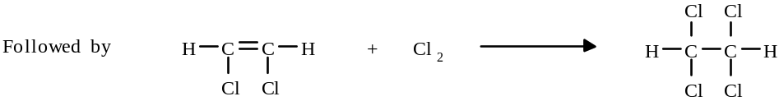

Or, overall CH ≡ CH + 2Cl₂ → Cl₂CH - CHCl₂

ii) when but-2-yne reacts with hydrogen in a 1:1 mole ratio, in the presence of a catalyst, the following occurs:

Addition and Substitution reactions
If an alkyne is reacted with an excess of a halogen in the presence of UV light, an addition reaction occurs first to form the halogen-substituted alkane, then substitution reactions occur to replace all the hydrogen atoms. The major organic product formed will again depend on the relative amounts of alkyne and halogen present in the reaction mixture.

For example, if propyne reacts with an excess of bromine in the presence of UV light the following occurs:

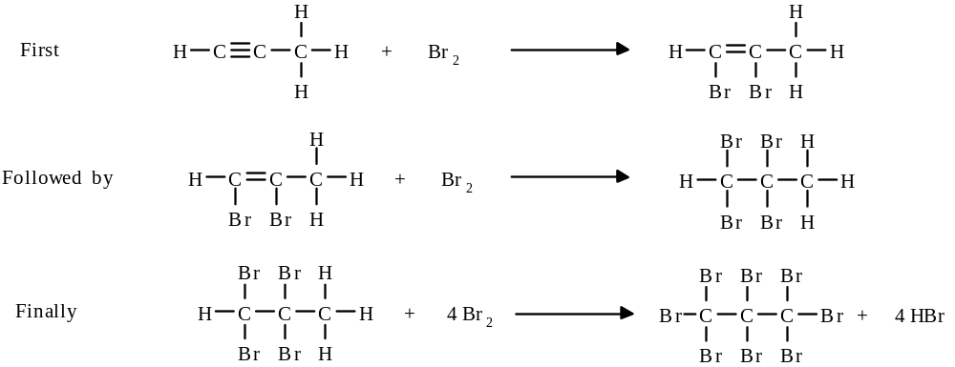

Or, overall HC ≡ C - CH₃ + 6 Br₂ → CBr₃ - CBr₂ - CBr₃ + 4 HBr

Combustion

Alkynes undergo combustion to form carbon dioxide and water.
For example, the equation for the combustion of pent-2-yne is
C₅H₈ + 7 O₂ → 5 CO₂ + 4 H₂O

35. Give the structural formulae of the organic product formed in each of the following reactions:
a) ethyne is mixed with bromine in a 1:1 mole ratio.
b) ethyne is mixed with chlorine in a 1:2 ratio, in the presence of UV light
c) ethyne is mixed with an excess of chlorine in the absence of ultraviolet light
d) ethyne is mixed with an excess of fluorine in the presence of ultraviolet light
e) 1 mole of ethyne is reacted with 1 mole of hydrogen

36. Write balanced equations, using structural formulae, for the following reactions:
a) a mixture of propyne and an excess of fluorine are placed in a dark cupboard
b) ethyne is allowed to react with an excess of chlorine in the presence of sunlight
c) 1 mole of but-1-yne is mixed with 2 moles of chlorine
d) pent-2-yne is reacted with an excess of hydrogen, in the presence of a catalyst
e) hex-3-yne is mixed with an excess of bromine and the mixture exposed to ultraviolet light for several hours.
f) a 1:1 mole ratio mixture of but-2-yne and fluorine is allowed to react

Alkanes, alkenes & alkynes

37. Which of the formulae given in the box could be that of an
C₄H₈ CH₄
C₈H₁₄ C₂H₂
C₉H₂₀ C₁₅H₃₀
a) alkane?
b) alkene, with one double bond?
c) alkyne, with one triple bond?

38. Which of the following are structural isomers of hex-1-ene?

A hexane B hex-1-yne
C 2-methylhex-1-ene D 2-methylhex-3-yne
E 2-methylpent-2-ene F ethylpent-2-ene
G dimethylbut-2-ene H dimethylbutyne
I dimethylpropane J methylpropene
K 2,3-dimethylbut-1-ene L hex-3-ene
39. The reactants, products and reaction conditions are summarised for some reactions in the following table.
Complete the table by giving the structural formula of the product/s or the reactant/s. The first example has been
completed.

 |  | Reaction Conditions
Reactants |  | Mole ratio (organic: halogen/H₂) |  |  | UV light | No UV light | Product/s
 |  | 1:1 | 1:2 | excess halogen
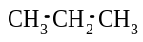 | Cl₂ |  |  |  |  |  | 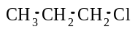 | HCl
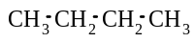 | Br₂ |  |  |  | 
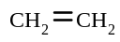 | F₂ |  |  |  | 
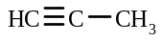 | H₂ |  |  |  | catalyst used
 |  |  |  |  |  |  | 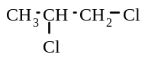
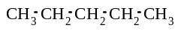 | Cl₂ |  |  |  |  | 
 |  |  |  |  |  |  | CBr₄
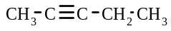 | F₂ |  |  |  |  | 

40. Name the following compounds:

a) | 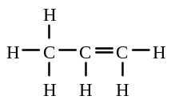 | b) | 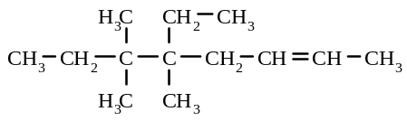
c) | 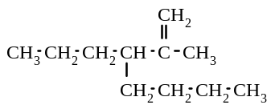 | d) | 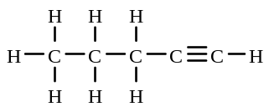
e) | 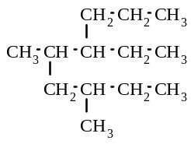 | f) | 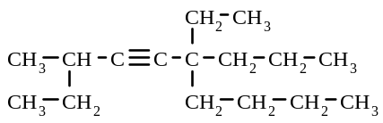

5. Hydrocarbons

Some words/terms used to describe organic compounds are:

Hydrocarbon - a compound that contains only hydrogen and carbon atoms. For example, alkanes, alkenes and alkynes are examples of hydrocarbons.

Saturated compounds - compounds which contain only single covalent bonds. For example, alkanes are saturated compounds.

Unsaturated compounds - compounds which contain at least one double or triple covalent bond. For example, alkenes and alkynes are unsaturated compounds.

Aliphatic hydrocarbons - hydrocarbons which exist as open-chain molecules. For example, CH₃-CH₂-CH₂-CH₂-CH₃ is an aliphatic alkane.

Alicyclic (cyclic) hydrocarbons - hydrocarbons in which the carbon atoms are joined in a ring. For example
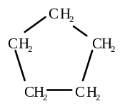

is a cyclic alkane.

Aromatic hydrocarbons - hydrocarbons which contain a benzene ring

Aliphatic compounds

The alkanes, alkenes and alkynes referred to in the previous sections were all aliphatic hydrocarbons i.e. their carbon atoms were arranged in an open chain arrangement.

Alicyclic compounds

In alicyclic compounds, the hydrocarbon chain is joined up in a ring.
Alicyclic alkanes (cycloalkanes) and alicyclic alkenes (cycloalkenes) exist.

Cycloalkanes

The general formula of cycloalkanes is C_{n}H_{2n} (i.e. the same as the general formula of alkenes) .

In naming cycloalkanes, the ring is regarded as the parent chain and the prefix 'cyclo' is used. The ring is numbered so that the side-chains/groups have the smallest possible number.

For example, the name of the following compound is 1,2-dimethylcyclohexane
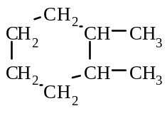

The structural formulae of cycloalkanes can also be written without showing the hydrogen and carbon atoms e.g. cyclohexane can be represented as
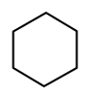

The properties and reactions of cycloalkanes are similar to those of aliphatic alkanes i.e. they undergo substitution and combustion reactions

For example, the reaction of cyclohexane with chlorine, in a 1:1 molar ratio, and in the presence of UV light, is

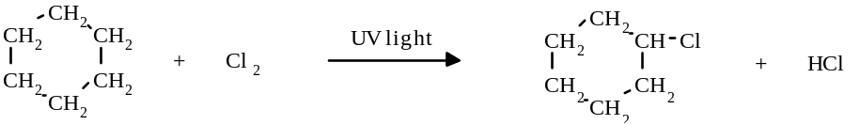

Cycloalkenes

The general formula of cycloalkenes is C_{n}H_{2n-2} (i.e. the same as the general formula of alkynes).

Cycloalkenes are named in a similar way to cycloalkanes, except, the double bonded carbon atoms are always numbered carbons 1 and 2. Consequently, it is not necessary to include a number in the name for this double bond. The numbering of the ring can occur clockwise or anticlockwise, depending on which direction will give the side groups the smallest number (after assigning “1” to the double bond). For example, the following compound is named
3-methylcyclopentene
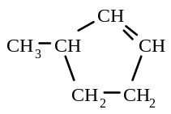

The reactions of cycloalkenes are similar to those of aliphatic alkenes, i.e. they undergo addition followed substitution reactions, and combustion reactions

For example:
i) when cyclopentene reacts with bromine (in a 1:1 mole ratio), the following occurs
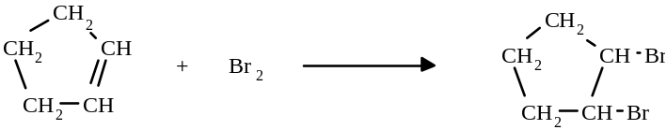

ii) when cyclohexene undergoes combustion, the following occurs:
C₆H₁₂ + 9 O₂ → 6 CO₂ + 6 H₂O

(Note that in the above reactions, except for combustion reactions, the ring of carbon atoms remains intact.)

Aromatic hydrocarbons

These hydrocarbons contain a benzene ring. Benzene has the formula C₆H₆ and it is composed of six carbon atoms bonded in a ring, with one hydrogen atom singly bonded to each carbon.

All the carbon-carbon bonds in benzene are equivalent. These bonds are neither single nor double bonds. Some of the carbon bonding electrons are shared (delocalised) over the whole ring, and this results in an average of one and a half pairs of bonding electrons between the carbon atoms. Because of this structure, the benzene ring is a reasonable stable unit.

The structural formula of benzene is often written as

Simple aromatic compounds are named by adding the appropriate prefix of the substituent group to the name "benzene".
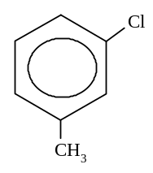

For example, is called 1-chloro-3-methylbenzene

Hydrocarbons as fuels

The major sources of hydrocarbons are natural gas, crude oil (petroleum) and coal.

Hydrocarbons are very important as fuels because their combustion reactions are highly exothermic. Some hydrocarbons that are used for fuels are natural gas (methane), LNG (methane), LPG gas (ethane/propane), petrol (octane), kerosene and coal.

41. Name the following cyclic compounds:

a) | 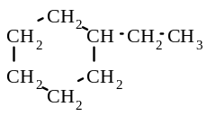 | b) | 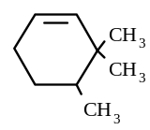 | c) | 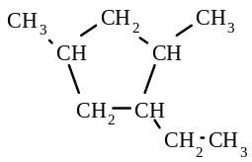
d) | 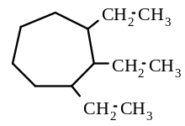 | e) | 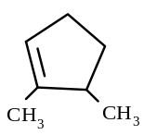 | f) | 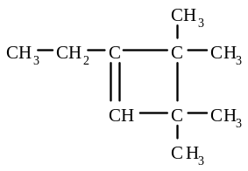
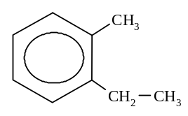
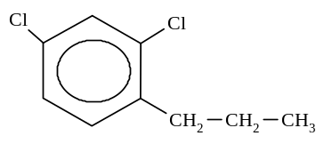
g) h)

42. Give the structural formulae of the following compounds:
a) 1,1-dimethylcyclohexane
b) 2,3-diethylcyclooctene
c) 1,2,3-trimethylcyclopropane
d) 4-propylcyclohexene
e) 1,4-diethylbenzene
f) 1-bromo-3-methylbenzene

43. Give the formulae and names of all the alicyclic structural isomers with the molecular formula of C₆H₁₂.

44. Some different types of hydrocarbons are listed below
aliphatic alkane aliphatic alkene aliphatic alkyne
cycloalkane cycloalkene cycloalkyne

Which type or types of these hydrocarbons could have the following molecular formulae?
a) C₇H₁₄
b) C₄H₆
c) C₁₀H₂₂
d) C₁₅H₃₀

45. Give the names and structural formulae of all of the aromatic isomers with the molecular formula of C₈H₁₀.
6. Halogen-substituted alkanes

Halogen-substituted alkanes or haloalkanes contain C, H and halogen atoms.

They are named by using the prefixes 'chloro-', 'fluoro-', 'bromo-' and 'iodo-'. These prefixes are placed alphabetically in the name of the compound. Numbers are used to show the position of the halogen atoms on the carbon chain.

For example, CH₃I iodomethane CH₃-CH₂-CH₂Br 1-bromopropane

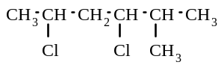  3,5-dichloro-2-methylhexane |  | 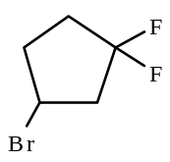
 |  | 3-bromo-1,1-difluorocyclopentane

Haloalkanes are prepared by:
i) the substitution reaction of an alkane with a halogen in the presence of UV light

ii) the addition reaction of an alkene or an alkyne with a halogen.

The properties of haloalkanes are similar to those of alkanes, except they tend to be more reactive.

46. Give the structural formulae and names of the isomers with the formula C₃H₆Cl₂.

47. Name the following compounds:
a) | 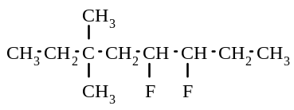 | b) | 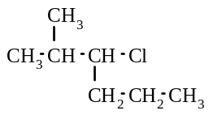 | c) | 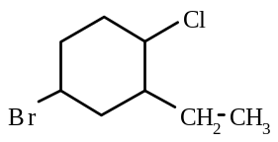

48. Give the formulae of the chemicals and describe the reaction conditions you could use to prepare the following
compounds:
a) CH₃Br
b) 1,2-dichloroethane
c) CF₃ - CF₂ - CF₃
d) CH₃ - CBr = CHBr
e) CH₃ - CCl₂ - CCl₂ - CH₃

Alcohols
Alcohols
- contain the functional group -OH. For example, methanol, CH₃OH, is an alcohol
- are colourless compounds
- are often liquids at room temperature
- have higher boiling points than their parent alkane. This occurs because of the stronger hydrogen bonds
between the alcohol molecules, compared to dispersion forces between the alkane molecules
- are often soluble in water (because of the hydrogen bonding which can occur between the water molecules and the alcohol molecules). However, as the length of the carbon chain increases, the solubility in water decreases.

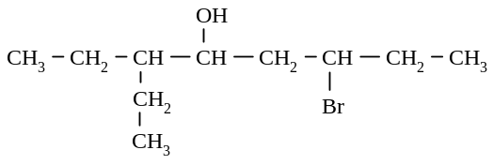Nomenclature

i) Alcohols are named by adding the suffix “-ol” in the place of the “e” in the alkane name.
ii) The position of the alcohol functional group is indicated by the use of a number placed before the suffix “ol”.
(The prefix “hydroxy” is used for some compounds).
iii) If a halogen atom or an alkyl group is present in the alcohol molecule, the chain is numbered so that the
alcohol group has the "smallest" number i.e. the chain is numbered from the end closest to the alcohol group.
iv) If two alcohol functional groups are present then the suffix “diol” is used and the “e” is not dropped from the alkane name.

For example

i) is called 6-bromo-3-ethyloctan-4-ol

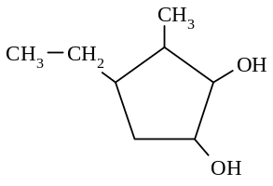

ii) is called 4-ethyl-3-methylcyclopentane-1,2-diol

49. Name the following alcohols, according to the I.U.P.A.C. rules
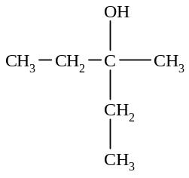
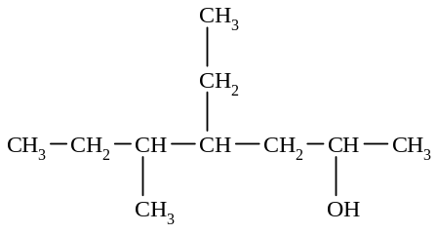
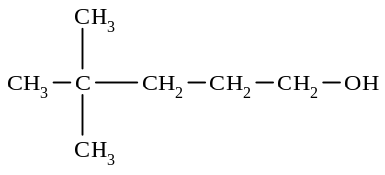
a) b) c)

50. Give the structural formulae of the following compounds:
a) ethanol
b) butan-2-ol
c) 3,3,4,4-tetramethylpentan-1-ol
d) butane-1,2-diol

Types of alcohols

Alcohols are often classified according to the number of carbon atoms (or hydrogen atoms) attached to the carbon atom to which the -OH group is bonded.

Primary alcohol - one carbon atom and 2 hydrogen atoms are attached to the carbon atom to which the -OH group is bonded

For example butan-1-ol 3-methylbutan-1-ol
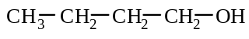 | 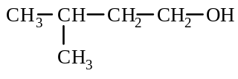

Secondary alcohol - two carbon atoms and one hydrogen atom are attached to the carbon atom to which the -OH group is bonded

For example propan-2-ol 2-methylpentan-3-ol
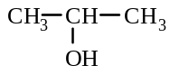 | 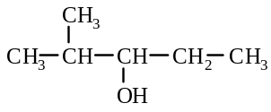

Tertiary alcohol - three carbon atoms and no hydrogen atoms are attached to the carbon atom to which the -OH group is bonded

For example: methylpropan-2-ol 3-ethylhexan-3-ol
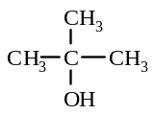 | 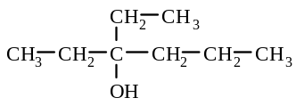

51. Identify the following alcohols as primary, secondary or tertiary alcohols:
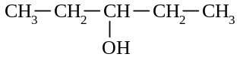
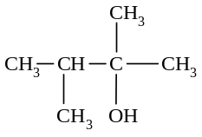
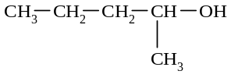
a) b) c)

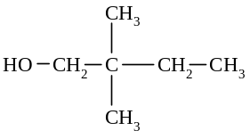

(CH₃)₃COH
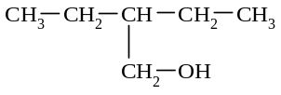
d) e) f)

Reactions of alcohols

Alcohols react readily with sodium to form hydrogen gas and an alkoxide ion (RO⁻).
For example, when propan-1-ol is added to sodium, the following reaction occurs
2 CH₃ - CH₂ - CH₂ - OH + 2 Na → 2 CH₃ - CH₂ - CH₂ - O⁻ Na⁺ + H₂

Alcohols can also be oxidised. (These oxidation reactions will be covered in Organic 2.)

52. Give the equations for the following reactions:
a) small pieces of sodium are added to some methanol
b) some butan-2-ol is mixed with some sodium.

Amines

Amines
- have the functional group -NH₂
- are often soluble in water (they hydrogen bond with water molecules)
- often have a "fishy" smell

Nomenclature

i) Amines are named by using the suffix “-amine” in place of the "e" on the name of the hydrocarbon chain, or
by using the prefix “amino-”.
ii) The prefix “amino-” is used when an alcohol functional group is present in the molecule, as the alcohol group
takes precedence i.e. the chain is numbered from the end closest to the alcohol group.
iii) The amine group, however, takes precedence over a halogen group i.e. the chain is numbered from the end closest to the amine group, and the suffix “-amine” is used in the name.

For example
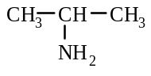 | 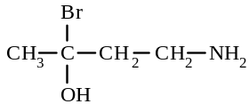
propan-2-amine 4-amino-2-bromobutan-2-ol

Reactions of amines

Animes act as weak bases in a similar way to ammonia i.e. they can accept a proton from an acid to form a positive ion

For example, when methanamine is added to hydrochloric acid, the following reaction occurs:
CH₃ - NH₂ + H⁺ → CH₃ - NH₃⁺

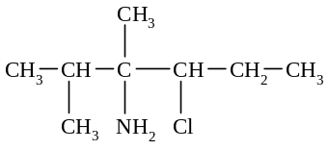
53. Name the following compounds:
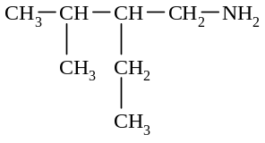
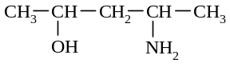
a) b) c)

54. Write equations for the following reactions:

a) dilute hydrochloric acid is added to some ethanamine

b) pentan-3-amine is mixed with some 2 mol L⁻¹ sulfuric acid

Organic Chemistry 1. - Answers

1. B, D, E
2. a) C₃H₃Br₃ b) C₅H₁₂ c) C₄H₁₀O
3. a) pentane b) octane c) 2-methylhexane
d) propane e) 3-ethylnonane f) 2-methylpentane
g) 2,2-dimethylbutane h) 4-ethyl-6-methylnonane i) 4-ethyl-2,5-dimethylheptane
j) decane k) 3-ethyl-6-methyl-4-propyloctane l) ethane
4. | a) | 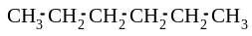 | b) | 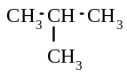 | c) | 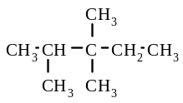
 | d) | 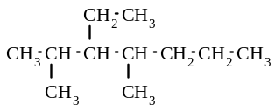 | e) | 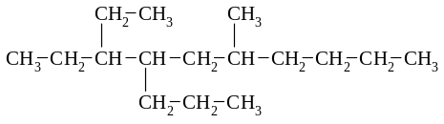

5. | a) | 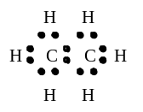 | b) | 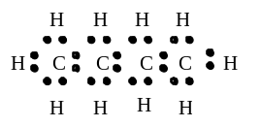

6. | a) | 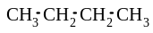 | butane |  | methylpropane
 | b) |  | hexane | 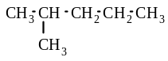 | 2-methylpentane
 |  | 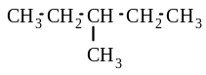 | 3-methylpentane | 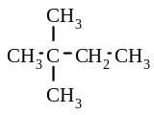 | 2,2-dimethylbutane
 |  | 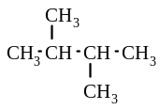 | 2,3-dimethybutane

7. B, D, E, F
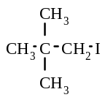
8. D, E, F, G
9. a) CH₃Cl b) CH₃CH₂Br c) CH₃CH₂CH₂F d)

10. a) CH₃F b) CBr₄
c) CH₃CH₂CH₃ d) CH₃CH₂CH₂CH₂CH₂CH₃ + Cl₂, HCl
e) CH₃CH₃, 6HCl f) + 12 HBr
CBr₃-CBr-CBr₂-CBr₃
CBr₃

11. a) CH₃-CH₃ + 6F₂ → CF₃-CF₃ + 6HF
b) 2C₄H₁₀ + 13 O₂ → 8CO₂ + 10H₂O
c) No reaction
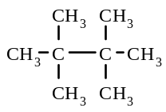
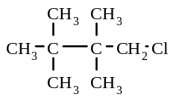
d)
+ Cl₂ → + HCl

11. e) + 10Br₂ → + 10HBr
CH₃-CH-CH₃
CH₃
CBr₃-CBr-CBr₃
CBr₃

12. a) incorrect - 3-methylpentane b) incorrect - 3-methylheptane
c) incorrect - 2,2-dimethylpentane d) correct
13. a) CH₃Br + HBr b) Cl₂, HCl
c) CH₃CH₃ d) CH₄, 4HCl
e) no reaction f) 8 O₂ → 5CO₂ + 6H₂O
14. a) False b) False c) False d) False
15. a) hept-3-ene b) 4-methylpent-2-ene c) 4-methyloct-3-ene
d) 5-ethyl-3-methylhept-2-ene e) propene f) 2-ethylpent-1-ene
16. | a) | 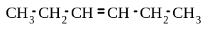 | b) | 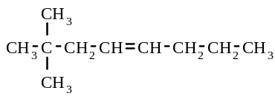 | c) | 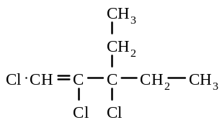
 | d) | 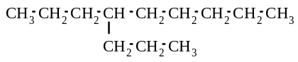 | e) | 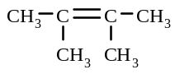

17. | a) | 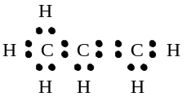 | b) | 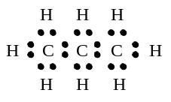

18. B and C

19. | 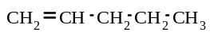  pent-1-ene | 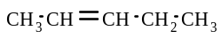  pent-2-ene | 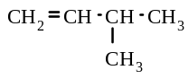
 |  |  | 3-methylbut-1-ene
 | 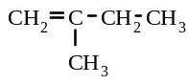 | 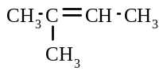
 | 2-methylbut-1-ene | methylbut-2-ene

20. | a) | 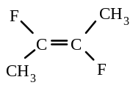 | b) | 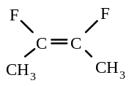 | c) | 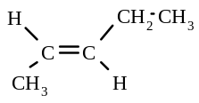 | d) | 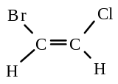

21. a) cis-hept-3-ene b) trans-2,3-dichlorobut-2-ene c) cis-3-methylhex-2-ene

22. | a) | 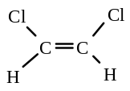 |  | 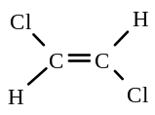
 |  | cis-1,2-dichloroethene |  | trans-1,2-dichloroethene
 | b) | 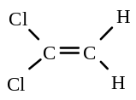 | 1,1-dichloroethene | - does not form geometrical isomers

23. A, B, C, D

24. a) CH₂Cl - CH₂Cl b) CH₃ - CHBr - CH₂Br
c) CH₃ - CH₂ - CH₂ - CH₃ d) CCl₃ - CCl₂ - CCl₃

25. a) CH₃ - CH = CH₂ + F₂ → CH₃ - CHF - CH₂F
b) CH₃ - C = CH₂ + Br₂ → CH₃ - CBr - CH₂Br
CH₃ CH₃
c) CH₂ = CH₂ + H₂ → CH₃ - CH₃
d) CH₂ = CH - CH₂ - CH₃ + Cl₂ → CH₂Cl - CHCl - CH₂ - CH₃
e) CH₃ - CH = CH - CH₂ - CH₃ + 11Br₂ → CBr₃ - CBr₂ - CBr₂ - CBr₂ - CBr₃ + 10HBr
f) C₆H₁₂ + 9 O₂ → 6CO₂ + 6H₂O

26. a) 1:1 mole ratio of (ethene and F₂), or excess F₂ in the dark
b) excess of Cl₂ in the presence of ultraviolet light
c) 1:1 mole ratio of reactants (pent-2-ene and Br₂), or excess Br₂ in the dark
d) excess F₂ in presence of UV light

27. a) Br₂ and CH₃ - CH = CH₂ propene
b) Cl₂ and CH₂ = CH₂ ethene (or CH₃ - CH₃ ethane)
c) H₂ and CH₂ = CH - CH₃ methylpropene
CH₃
d) F₂ and CH₃ - CH₂ - CH = CH - CH₂ - CH₂ - CH₃ hept-3-ene
e) Br₂ and CH₃ - CH₂ - CH₂ - CH₃ butane (or but-1-ene or but-2-ene)
f) Cl₂ and CH₂ = CH₂ ethene

28. a C b A c E d F e D f B

29. a) CH₃ - CH₃ + 6Cl₂ → CCl₃ - CCl₃ + 6HCl
b) CH₃ - CH = CH - CH₂ - CH₂ - CH₃ + Br₂ → CH₃ - CHBr - CHBr - CH₂ - CH₂ - CH₃
c) CH₃ - CH = CH - CH₃ + 9F₂ → CF₃ - CF₂ - CF₂ - CF₃ + 8HF
CH₃ CH₃
d) CH₃ - C - CH₃ + Br₂ → CH₃ - C - CH₂Br + HBr
CH₃ CH₃
e) CH₃ - CH₂ - CH₂ - CH₂ - CH₂ - CH₂ - CH₂ - CH₃ + 12O₂ → 8CO₂ + 8H₂O

30. C, F
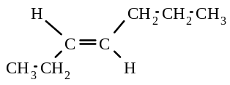
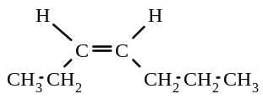
31. a)

b) “Trans” isomer

32. | a) | 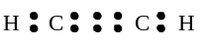 | b) | 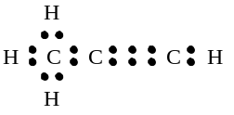

33. a) hex-2-yne b) 7-methyl-5-propylnon-2-yne
c) 3,3,6-trimethyloct-4-yne d) 3,4-diethylhex-1-yne

34. | a) | 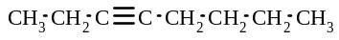 | b) | 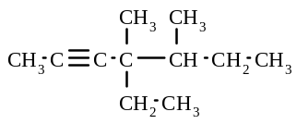 | c) | 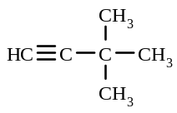

35. a) CHBr = CHBr b) CHCl₂ - CHCl₂ c) CHCl₂ - CHCl₂
d) CF₃ - CF₃ e) CH₂ = CH₂

36. a) CH₃ - C ≡ CH + 2F₂ → CH₃ - CF₂ - CHF₂
b) CH ≡ CH + 4Cl₂ → CCl₃ - CCl₃ + 2HCl
c) CH ≡ C - CH₂ - CH₃ + 2Cl₂ → CHCl₂ - CCl₂ - CH₂ - CH₃
d) CH₃ - C ≡ C - CH₂ - CH₃ + 2H₂ → CH₃ - CH₂ - CH₂ - CH₂ - CH₃
e) CH₃ - CH₂ - C ≡ C - CH₂ - CH₃ + 12Br₂ → CBr₃ - CBr₂ - CBr₂ - CBr₂ - CBr₂ - CBr₃ + 10HBr
f) CH₃ - C ≡ C - CH₃ + F₂ → CH₃ - CF = CF - CH₃

37. a) CH₄, C₉H₂₀ b) C₄H₈, C₁₅H₃₀ c) C₈H₁₄, C₂H₂

38. E, G, K, L

39.
 |  | Reaction Conditions
Reactants |  | Mole ratio (organic: halogen/H₂) |  |  | UV light | No UV light | Product/s
 |  | 1:1 | 1:2 | excess halogen
 | Cl₂ |  |  |  |  |  |  | HCl
 | Br₂ |  |  |  |  |  | CBr₂-CBr₂-CBr₂-CBr₃ | HBr
 | F₂ |  |  |  |  |  | CH₂F-CH₂F
 | H₂ |  |  |  | catalyst used |  | CH₃-CH₂-CH₃
CH₃-CH=CH₂ | Cl₂ |  |  |  | 
 | Cl₂ |  |  |  |  |  | no reaction
CH₄ | Br₂ |  |  |  |  |  | CBr₄ | HBr
 | F₂ |  |  |  |  |  | CH₃-CF₂-CF₂-CH₂-CH₃

40. a) propene b) 5-ethyl-5,6,6-trimethyloct-2-ene
c) 2-methyl-3-propylhept-1-ene d) pent-1-yne
e) 6-ethyl-3,5-dimethylnonane f) 6-ethyl-3-methyl-6-propyldec-4-yne

41. a) ethylcyclohexane b) 3,3,4-trimethylcyclohexene
c) 1-ethyl-2,4-dimethylcyclopentane d) 1,2,3-triethylcycloheptane
e) 2,3-dimethylcyclopentene f) 1-ethyl-3,3,4,4-tetramethylcyclobutene
g) 1-ethyl-2-methylbenzene h) 2,4-dichloro-1-propylbenzene

42. | a) | 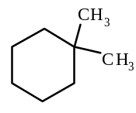 | b) | 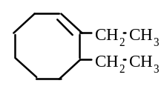
 | c) | 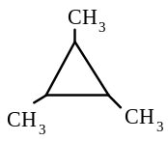 | d) | 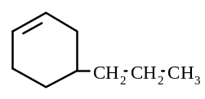
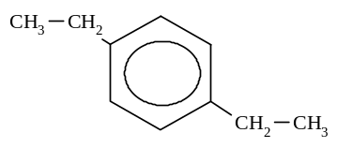
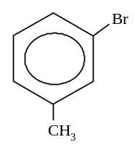
e) f)

43. | 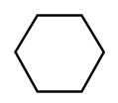 | 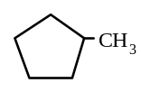 | 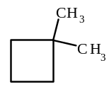 | 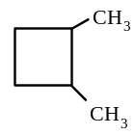
 | cyclohexane | methylcyclopentane | 1,1-dimethylcyclobutane | 1,2-dimethylcyclobutane
 | 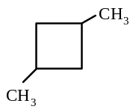 | 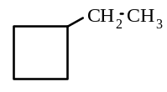 | 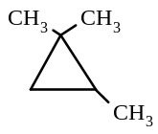 | 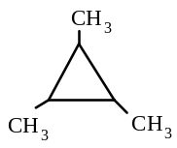
 | 1,3-dimethylcyclobutane | ethylcyclobutane | 1,1,2-trimethylcyclopropane | 1,2,3-trimethylcyclopropane
 | 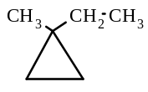 | 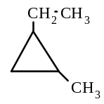 | 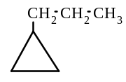
 | 1-ethyl-1-methylcyclopropane | 1-ethyl-2-methylcyclopropane propylcyclopropane

44. a) cycloalkane, aliphatic alkene b) aliphatic alkyne, cycloalkene
c) aliphatic alkane d) cycloalkane, aliphatic alkene

45.
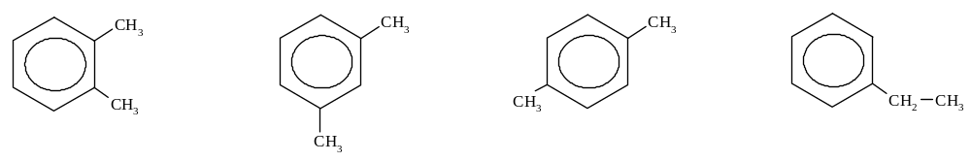

1,2-dimethylbenzene 1,3-dimethylbenzene 1,4-dimethylbenzene ethylbenzene

46. | CH₃ - CH₂ - CHCl₂ 1,1-dichloropropane | CH₃ - CHCl - CH₂Cl 1,2-dichloropropane
 | CH₂Cl - CH₂ - CH₂Cl 1,3-dichloropropane | CH₃ - CCl₂ - CH₃ 2,2-dichloropropane

47. a) 5,6-difluoro-3.3-dimethyloctane b) 3-chloro-2-methylhexane
c) 4-bromo-1-chloro-2-ethylcyclohexane

48. a) CH₄ + Br₂ - 1:1 mole ratio, in presence of ultraviolet light
b) CH₂=CH₂ + Cl₂ - excess Cl₂, in absence of UV light or 1:1 mole ratio
c) CH₃-CH₂-CH₃ + F₂ - excess F₂ in presence of UV light
or CH₂=CH-CH₃ + F₂ - excess F₂ in presence of UV light
or CH₃-C≡CH + F₂ - excess F₂ in presence of UV light
d) CH₃-C≡CH + Br₂ - 1:1 mole ratio
e) CH₃-C≡C-CH₃ + Cl₂ - in 1:2 mole ratio

49. a) 4-ethyl-5-methylheptan-2-ol b) 4,4-dimethylpentan-1-ol c) 3-methylpentan-3-ol
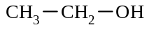
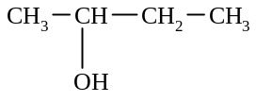
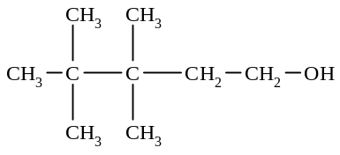
50. a) b) c)

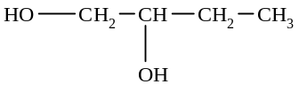
d)

51. a) secondary alcohol b) tertiary alcohol c) secondary alcohol
d) primary alcohol e) primary alcohol f) tertiary alcohol

52. a) 2 CH₃OH + 2 Na → 2 CH₃ONa + H₂
b) 2 + 2Na → 2 + H₂
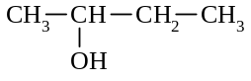
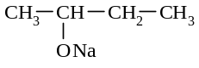

53. a) 2-ethyl-3-methylbutan-1-amine b) 4-chloro-2,3-dimethylhexan-3-amine c) 4-aminepentan-2-ol

54. a) CH₃ - CH₂ - NH₂ + H⁺ → CH₃ - CH₂ - NH₃⁺
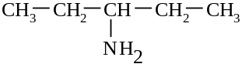
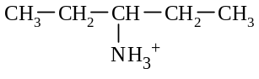
b) + H⁺ →

