ORGANIC CHEMISTRY - 1.

1. Bonding in Carbon Compounds

Carbon has the electron configuration of 1s² 2s² 2p², that is, it has four electrons in its outermost shell. As a result carbon tends to form compounds in which each carbon atom gains a share of four extra electrons i.e. a carbon atom
almost always forms four single covalent bonds.
For example, the arrangement of electrons in methane (CH₄) is shown below:
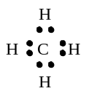 | 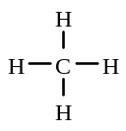
electron dot diagram structural formula

When one pair of electrons is shared between two atoms, the two atoms are said to be bonded by a single covalent bond
In structural formulae, a single line between two atoms represents one shared pair of electrons i.e. a single bond.

The four single bonds around a carbon atom are positioned as far apart as possible. For example, the three dimensional arrangement of the bonds in methane could be represented as shown below.
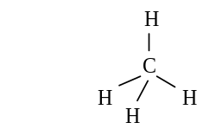
This arrangement of atoms is called a tetrahedral arrangement. Each bond angle i.e. the angle between two C - H bonds, in this molecule is approximately 109º.

In some compounds, the carbon atoms are joined by a double bond (4 electrons are shared) or a triple bond (6 shared
electrons). For example
ethene (C₂H₄) | 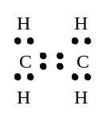 | 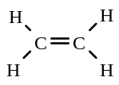
 | electron dot diagram | structural formula
ethyne (C₂H₂) | 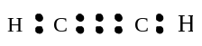 | 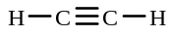
 | electron dot diagram | structural formula

There are a vast number of compounds containing carbon i.e. organic compounds because
i) each carbon atom can form four covalent bonds with most other non-metal atoms e.g. H, Cl, O, Br, S, N
ii) carbon atoms can form chains of virtually unlimited length containing a succession of carbon-carbon bonds.

Some simple bonding rules for organic compounds are
- carbon atoms form four bonds
- hydrogen atoms form single bonds
- oxygen atoms form two bonds
- halogen atoms (F, Cl, Br, I) form one bond
- a double bond "counts" as two bonds, and a triple bond "counts" as three bonds

1. Which of the following formulae are incorrect?

A | 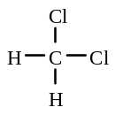 | B | 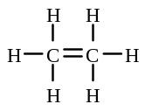 | C | 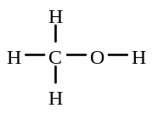
D | 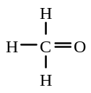 | E | 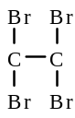 | F | 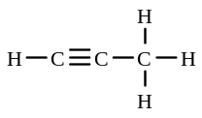

Representing the Structures of Carbon Compounds

Organic chemists use various ways to represent organic molecules:

i) molecular formula - indicates the number and type of atoms present in a molecule e.g. C₃H₈

ii) structural formula - shows the bonding and the arrangement of the atoms in a molecule
e.g. | 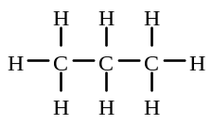

Structural formulae are sometimes written in more abbreviated ways e.g. CH₃ CH₂ CH₃ or CH₃ - CH₂ - CH₃.

2. Give the molecular formulae of the compounds with the following structural formulae:

a)  CH₃ CH₂ CH₂ CH₂ CH₃ | 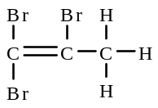 | b) |  | c) | 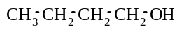

2. Alkanes

Alkanes
- contain only carbon and hydrogen atoms
- have only single bonds between the carbon atoms, for example, propane, CH₃ - CH₂ - CH₃ , is an alkane.
- have a general formula of C_{n}H_{2n+2} where n = 1, 2, 3 etc
- are colourless compounds
- have relatively low melting and boiling points e.g. the first four alkanes in the series are gases at room temperature. Melting and boiling points increase with increasing number of carbons because of an
increase in strength of dispersion forces between the molecules.
- are insoluble in water.

Nomenclature (naming) of alkanes

Organic compounds are named according to a set of rules called the I.U.P.A.C. rules.
The names of many organic compounds are based on the names of the straight chain alkanes given in the table below:
Name of alkane | Number of carbon atoms in straight chain | Structural formula | Molecular formula
methane | one | 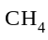 | CH₄
ethane | two | 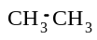 | C₂H₆
propane | three | 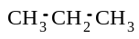 | C₃H₈
butane | four | 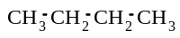 | C₄H₁₀
pentane | five | 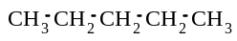 | C₅H₁₂
hexane | six | 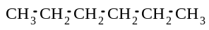 | C₆H₁₄
heptane | seven | 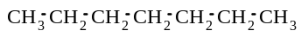 | C₇H₁₆
octane | eight | 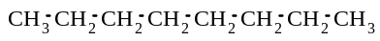 | C₈H₁₈
nonane | nine |  | C₉H₂₀
decane | ten |  | C₁₀H₂₂

Many alkanes are composed of branched chains i.e a straight chain to which side-chains are joined. For example, butane,
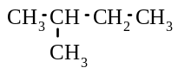
CH₃ CH₂ CH₂ CH₃ , is a straight chain alkane, but methylbutane, , is a branched chain alkane.

The rules that are used to name alkanes are as follows:
i) choose the longest carbon chain, and name it, as an alkane, according to the number of carbons present (often called the parent chain)
ii) number this longest chain from one end, so that the side chains present have the smallest numbers possible
iii) identify the side chains (see below) 'joined' onto this parent chain and write them, in alphabetical order, as prefixes to the parent name.
iv) place the number used to indicate the position of the side-chain before the side-chain name.
v) if two identical side-chains are present, use ‘di-’ as a prefix to the side-chain name, if three identical side chains are present, then include ‘tri’- as a prefix to the side-chain name, if four identical side-chains are present, use ‘tetra’ as a prefix etc.
vi) in names of organic compounds, hyphens are placed between words and numbers, and commas are used
between two numbers
Some of the more common side-chains are CH₃- methyl
CH₃ CH₂ - or C₂H₅- ethyl
CH₃ CH₂ CH₂ - or C₃H₇ - propyl
CH₃ CH₂ CH₂ CH₂ - or C₄H₉ - butyl

For example:
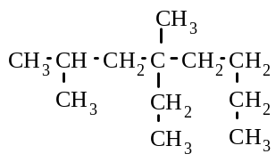
i) - the longest chain is 8 carbons long, and so the parent chain is octane. The side-chains on this parent carbon are two methyl groups (on carbons 2 and 4) and an ethyl group (on carbon 4).
So the name is 4-ethyl-2,4-dimethyloctane.

ii) - the longest chain contains 10 carbons, so the parent chain is decane. The side-chains on this parent chain are an ethyl group on carbon 3, two methyl groups on carbons 4 and 6, and a propyl group on carbon 5.
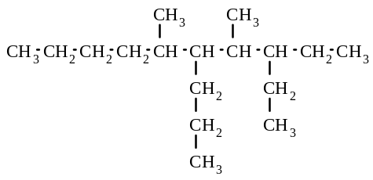
So the name is 3-ethyl-4,6-dimethyl-5-propyldecane

3. Name the following alkanes, according to the IUPAC rules:

a) | 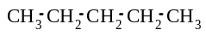 | b) | 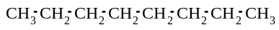 | c) | 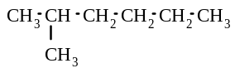
d) | 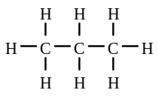 | e) | 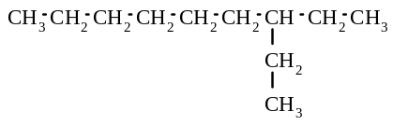 | f) | 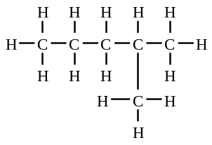
g) | 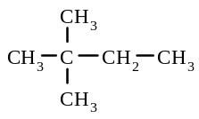 | h) | 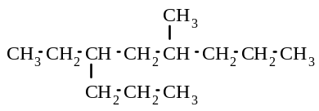 | i) | 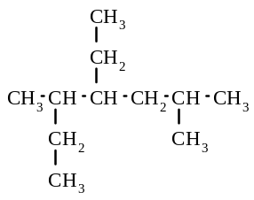
j) | CH₃(CH₂)₈CH₃ | k) | 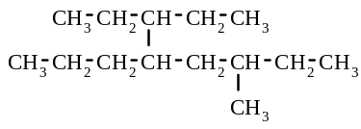 | l) | C₂H₆

4. Give the structural formulae of the following alkanes:
a) hexane
b) methylpropane
c) 2,3,3-trimethylpentane
d) 3-ethyl-2,4-dimethylheptane
e) 3-ethyl-6-methyl-4-propyldecane

5. Draw electron dot representations for the following molecules:
a) C₂H₆
b) butane

Structural Isomers

Structural isomers are compounds which have the same molecular formula but different structural formulae.
(Or an isomer has the same molecular formula but a different structural formula compared to another substance)
For example, the following compounds are the isomers with the molecular formula of C₅H₁₂
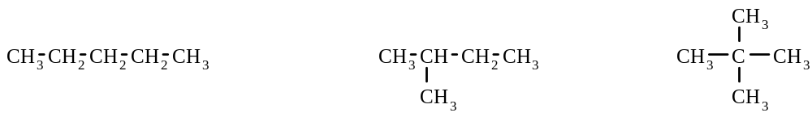
pentane methylbutane dimethylpropane

6. Give the structural formulae and names of the isomers with the following molecular formulae:
a) C₄H₁₀
b) C₆H₁₄

7. Which of the following substances are isomers?

A | CH₃(CH₂)₈CH₃ | B |  | C | 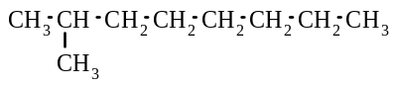
D | 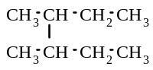 | E | 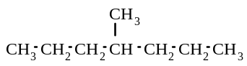 | F | 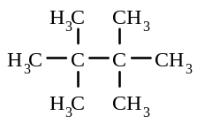

8. Which of the following substances are isomeric with 2,2-dimethylpentane?

A pentane
B methylpentane
C 2,2-dimethylhexane
D ethylpentane
E trimethylbutane
F 3-methylhexane
G heptane

Reactions of alkanes

Substitution reactions

A substitution reaction is one in which an atom in a molecule is replaced by a different atom to form a new molecule.

The reactions of alkanes with the halogens (particularly Cl₂ and Br₂) are substitution reactions. In these reactions, the H atoms of the alkane are replaced, one after the other, by the halogen atoms. Haloalkanes (a compound that contains C and halogen atoms and possibly hydrogen atoms) together with a hydrogen halide are formed in these reactions. The reaction mixture must be exposed to ultraviolet light (or sunlight) for substitution reactions of alkanes to occur. These substitution reactions of alkanes are often very slow

For example, when methane is mixed with an excess of bromine, and exposed to UV light, the following reactions take place:
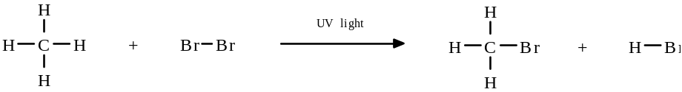
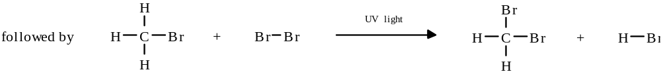
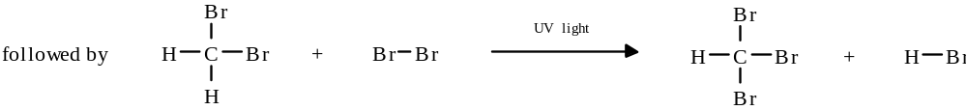

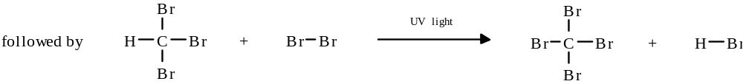

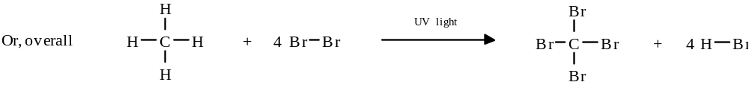

(or CH₄ + 4Br₂ → CBr₄ + 4HBr )

If a 1:1 molar mixture of methane and bromine was reacted, then the major product formed would be bromomethane i.e. only one hydrogen atom in each alkane molecule would be substituted by a Br atom
i.e. CH₄ + Br₂ → CH₃Br + HBr

However, if an excess of bromine is used, then tetrabromomethane would be the major product. That is, the major organic product formed depends on the amount of reactants present.

Also, if the reaction is carried out in the dark, no substitution reaction occurs.

Combustion Reactions

Alkanes readily undergo combustion, that is, they burn.
In a combustion reaction, the alkane reacts with oxygen to form carbon dioxide, water and a large amount of heat (combustion reactions are exothermic)

For example, the equation for the combustion of octane is
2C₈H₁₈ + 25 O₂ → 16 CO₂ + 18 H₂O

9. Give the structural formula of the major organic product formed when the following reaction mixtures are exposed to
UV light. Assume that the reactants are present in a 1:1 mole ratio.
a) CH₄ and Cl₂
b) CH₃CH₃ and Br₂
c) CH₃CH₂CH₃ and F₂
d) dimethylpropane and I₂

10. Complete each of the gaps in the following equations. Assume each reaction mixture is exposed to sunlight.
a) CH₄ + F₂ → ................... + HF

b) CH₄ + 4Br₂ → .................. + 4HBr

c) ............................ + Br₂ → CH₃CH₂CH₂Br + HBr

d) ...................................... + ................. → CH₃CH₂CH₂CH₂CH₂CH₂Cl + ...................
10. e) ................... .. + 6Cl₂ → CCl₃CCl₃ + .......................
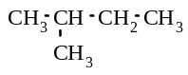
f) + 12Br₂ → .................................. + ......................

11. Write balanced equations, using structural formulae, for each of the following reactions:
a) Ethane is mixed with an excess of fluorine, in the presence of UV light

b) Butane is burnt in air.

c) A mixture of propane and bromine is placed in a dark cupboard.

d) Tetramethylbutane is mixed with chlorine, in a 1:1 mole ratio, and exposed to sunlight.

e) A mixture of methylpropane and an excess of bromine is exposed to UV light.

Alkanes

12. Which of the following names are correct? If the name is incorrect, give the correct name.
 | Structural formula | Name.  Is it correct or incorrect? | Correct name.
a) | 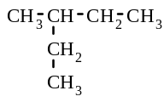 | ethylbutane
b) | 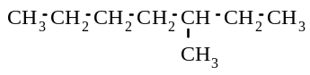 | 5-methylheptane
c) | 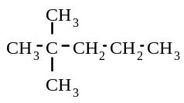 | 2-dimethylpentane
d) | 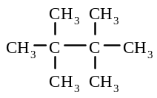 | tetramethylbutane

13. Complete the following equations by filling in the gaps:
UV light
a) CH₄ + Br₂ ........................ + .........................
UV light
b) CH₄ + ............... CH₃Cl + .........................
UV light
c) .................... + F₂ CH₃CH₂F + HF

UV light
d) .................... + 4Cl₂ CCl₄ + ............. HCl
in the dark
e) CH₃CH₂CH₃ + Br₂ .....................................

f) C₅H₁₂ + .......... O₂ .......... ............. + .......... ..........

14. Identify the following statements as true or false:
a) Pentane and 2-methylpentane are structural isomers.
b) Structural isomers have the same structural formula but different molecular formulae
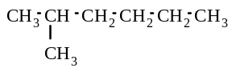
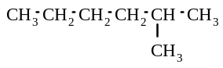
c) and are structural isomers.

d) There are three structural isomers with the molecular formula of C₃H₈

3. Alkenes

Alkenes
- contain only carbon and hydrogen atoms
- have at least one double carbon-carbon bond , for example, propene, , is an alkene.
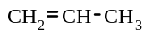
- have a general formula of C_{n}H_{2n} where n = 1, 2, 3 etc
- are colourless compounds
- have relatively low melting and boiling points.
- are insoluble in water.

Nomenclature for alkenes

Alkenes are named in much the same way as alkanes, except
- the longest carbon chain chosen as the parent chain, must contain the double carbon-carbon bond
- this parent chain is numbered from the end which gives the double bond the smallest number possible
- the suffix ‘-ene’ is used as the ending of the parent name, rather than ‘-ane’
- the position of the double bond within the chain is given as the lower number of the two double bonded carbons. The number is placed just before the suffix “-ene”

For example
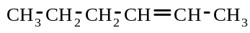
i) - the parent chain contains six carbon atoms and the double bond is between
carbon 2 and carbon 3, so the name is hex-2-ene
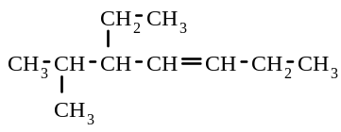
ii) - the parent chain contains seven carbon atoms and the double bond is between carbon 3 and carbon 4. There is an ethyl group on carbon 5 and a methyl group on carbon 6. So, the name is 5-ethyl-6-methylhept-3-ene.

15. Name the following alkenes, according to the I.U.P.A.C. rules:
a) | 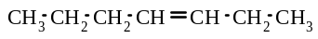 | b) | 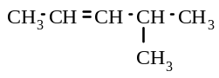 | c) | 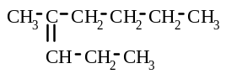
d) | 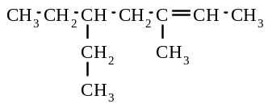 | e) | 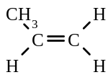 | f) | 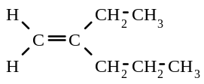

16. Give the structural formulae of the following compounds:
a) hex-3-ene
b) 2,2-dimethyloct-4-ene
c) 1,2,3-trichloro-3-ethylpent-1-ene
d) 4-propylnonane
e) dimethylbut-2-ene

17. Give the electron dot representation for the following molecules:
a) propene
b) propane

Structural isomers

Structural isomerism also occurs with alkenes.
For example, the structural isomers of alkenes with the formula C₄H₈ are

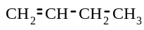 | 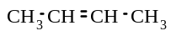 | 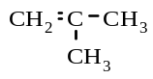
but-1-ene but-2-ene methylpropene

Geometrical isomers

Some alkenes can exhibit geometrical isomerism.

Geometric isomers have the same molecular formula, but the groups, attached to carbon atoms joined by a double bond, are in different positions.

For example, the geometrical isomers of the alkene 1,2-dibromoethene are:
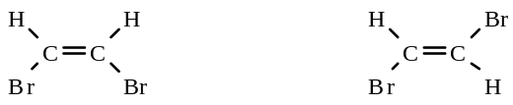
cis-1,2-dibromoethene trans-1,2-dibromoethene

The isomer with the two groups on the same side of the double bond, is called the 'cis' isomer. The isomer with the groups on the opposite side of the double bond is called the 'trans' isomer.

Geometrical isomerism occurs for alkenes because the carbon atoms joined by the double bond are unable to rotate about the double bond. However, if there is only a single bond between two carbon atoms, then the carbon atoms can rotate about the bond. Consequently, geometrical isomerism does not exist for alkanes (only structural isomerism exists for alkanes).

An alkene will exhibit geometrical isomerism if each of the carbons joined by the double bond has different groups attached to them.
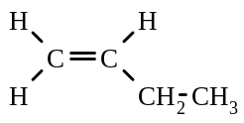

For example, CH₂=CH-CH₂-CH₃ ( ) will not exhibit geometrical isomerism but

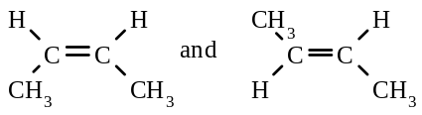

CH₃-CH=CH-CH₃ ( ) will exhibit geometrical isomerism.

18. Which of the following compounds are structural isomers of hex-1-ene?
A | 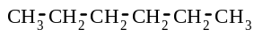 | B | 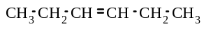 | C | 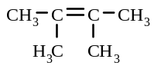

19. Give the names and structural formulae of the five isomers with the molecular formula C₅H₁₀. Assume that
each isomer contains a double carbon-carbon bond.

20. Give the structural formulae of the following geometrical isomers:
a) trans-2,3-difluorobut-2-ene
b) cis-2,3-difluorobut-2-ene
c) trans-pent-2-ene
d) cis-1-bromo-2-chloroethene

21. Give the I.U.P.A.C. name of each of the following geometrical isomers:

a) | 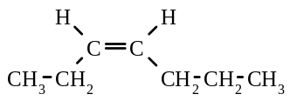 | b) | 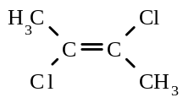 | c) | 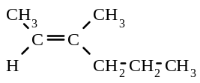

22. a) Draw the two geometric isomers of 1,2-dichloroethene, and name them.
b) Draw a structural isomer of 1,2-dichloroethene, and name it. Can this compound exhibit geometrical
isomerism?

23. Which of the following compounds can NOT exist as geometrical isomers?

A | 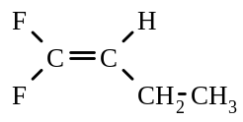 | B | 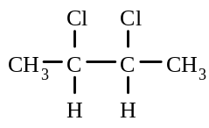
C | propene | D | but-1-ene
E | 2,3-dibromobut-2-ene | F | hex-3-ene

Reactions of alkenes

Addition reactions

Alkenes undergo addition reactions readily with substances such as chlorine (Cl₂), bromine (Br₂), fluorine (F₂) and hydrogen (H₂).

In an addition reaction, two new atoms are added 'across the double bond' and the double bond becomes a single bond.

Addition reactions are normally much faster than substitution reactions.
For example, ethene reacts with bromine, Br₂, in the following way:
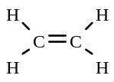

+ Br - Br
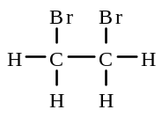

(or CH₂ = CH₂ + Br₂ → CH₂Br - CH₂Br )

(Note:
i) An aqueous solution of bromine is an orange colour and when it reacts with either an alkane or alkene, a colourless mixture is formed.

ii) Experimentally an alkane and an alkene can be distinguished by adding an aqueous solution of bromine. With an alkene, the orange colour of bromine disappears almost instantly, but with an alkane, the orange colour takes a much longer time to become colourless.

Another example of an addition reaction is the reaction of propene with hydrogen, as shown below:
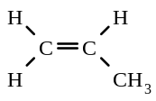
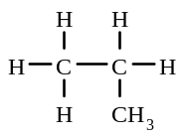
+ H - H

(or CH₂ = CH - CH₃ + H₂ → CH₃ - CH₂ - CH₃ )

Alkenes can undergo an addition reactions followed by substitution reactions with the halogens if UV light is present and if the reaction mixture is allowed to react for sufficient time. Also, for a substitution reaction to occur after an addition reaction, the halogen and alkene need to be initially present in a greater than a 1:1 mole ratio mixture.

For example, in the presence of UV light and excess chlorine, ethene will react with chlorine in the following way:
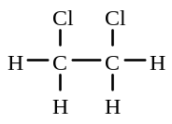

+ Cl - Cl
first:

+ 4 Cl - Cl
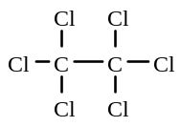
UV light
+ 4 HCl
followed by:

(or CH₂ = CH₂ + 5Cl₂ → CCl₃ - CCl₃ + 4HCl )

(Note: if an alkene is mixed with excess halogen and allowed to react in the dark, then only an addition reaction will occur.)

Combustion

When alkenes undergo combustion (burning in air), they react with oxygen to form carbon dioxide and water

For example, the equation for the combustion of propene is 2 C₃H₆ + 9 O₂ → 6 CO₂ + 6 H₂O

24. Give the structural formula of the organic product formed in each of the following reactions
a) CH₂ = CH₂ + Cl₂ →
b) CH₃ - CH = CH₂ + Br₂ →
c) CH₃ - CH = CH - CH₃ + H₂ →
UV light
d) CH₃ - CH = CH₂ + excess Cl₂

25. Write a balanced equation, using structural formulae for the following reactions:
a) propene is mixed with fluorine in a 1:1 mole ratio.
b) methylpropene is mixed with an excess of bromine and the mixture is put in a dark cupboard.
c) ethene is reacted with hydrogen in the presence of a catalyst
d) 1 mole of but-1-ene is mixed with 1 mole of chlorine, in the presence of UV light
e) pent-2-ene is reacted with an excess of bromine in the presence of UV light
f) hex-3-ene is burnt in air

26. Describe the reaction conditions you could use to carry out the following reactions e.g. in 1:1 mole ratio of reactants, in the dark:

a) the formation of 1,2-difluoroethane from ethene
b) the formation of CCl₃ - CCl₂ - CCl₃ from propene
c) the preparation of 2,3-dibromopentane from pent-2-ene
d) the preparation of hexafluoroethane from ethene

27. Give the names and structural formulae of the chemicals you could use to form each of the following organic compounds:

a) 1,2-dibromopropane
b) hexachloroethane
c) methylpropane
d) 3,4-difluoroheptane
e) CBr₃ - CBr₂ - CBr₂ - CBr₃
f) CH₂Cl - CH₂Cl

Alkanes & alkenes

28. Match up each formula with its correct name:

Formulae |  | Names
a | 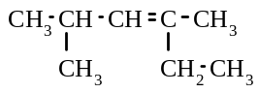 | A | ethyl-2-methylpentane
b | 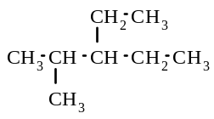 | B | pentane
c | 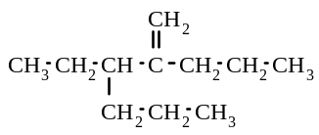 | C | 2,4-dimethylhex-3-ene
d | 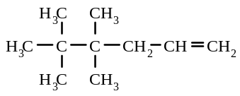 | D | propane
e | 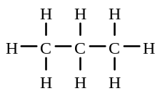 | E | 3-ethyl-2-propylhex-1-ene
f | 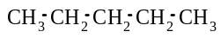 | F | 4,4,5,5-tetramethylhex-1-ene

29. Write a balanced equation for each of the following reactions (use structural formulae):
a) ethane is mixed with an excess of chlorine and exposed to UV light
b) an excess of hex-2-ene is shaken with bromine water
c) but-2-ene is mixed with an excess of fluorine and the mixture exposed to bright sunlight
d) dimethylpropane is mixed with bromine in a 1:1 mole ratio, and the mixture is exposed to UV light
e) oct-4-ene is burnt in air

30. Which of the substances given in the box below are isomers of pentane?
A | 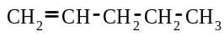 | B | 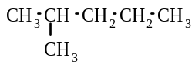 | C | 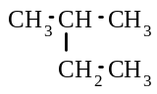
D | 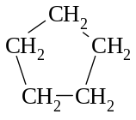 | E | 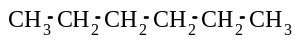 | F | 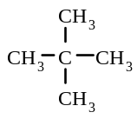

31. a) Give the structural formulae of the geometrical isomers of hept-3-ene.
b) Which is the “trans” isomer drawn in part a)?

