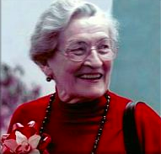
Psych Theorists A-Z

Ainsworth, Mary
SOCIAL PSYCHOLOGY – OTHERS: ATTACHMENT THEORIES
- Levels of attachment
- Parenting styles
The Strange Situation Experiment 1969

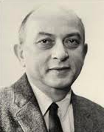
Asch, Soloman
SOCIAL PSYCHOLOGY – INFLUENCE OF GROUPS ON BEHAVIOUR: CONFORMITY
- Conformity
Asch Line Experiment (1951)
Criticised by Perrin & Spencer – Showed bias of 1950s American Culture

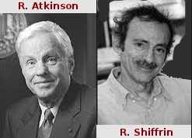
Atkinson & Shiffrin
COGNITIVE PSYCHOLOGY – PSYCHOLOGICAL CONCEPTS: MEMORY
- Multi-Store Model of Memory (1968)
Studies of Amnesiacs:
HM Case Study– Scouville & Milner (1957)
KF Case Study
Clive Wearing Study (1985)


Baddley & Hitch
COGNITIVE PSYCHOLOGY – PSYCHOLOGICAL CONCEPTS: MEMORY
- Working Memory Model (1974)
Supported by Craik & Lockharts Levels of Processing
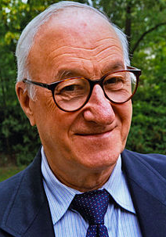

Bandura, Albert
COGNITIVE PSYCHOLOGY – LEARNING: SOCIAL LEARNING THEORY
- Observational Learning Theory
- Social Learning Theory
- Social Cognitive Personality Theory (Reciprocal Determinism)
- Mediating processes (ARRM)
The Bobo Doll Experiment 1961


Diana Baumrind
SOCIAL PSYCHOLOGY – PARENTING STYLES AND FEATURES
- Authoritative
- Authoritarian
- Permissive



Bernstein, Basil
COMMUNICATION – SOCIAL BACKGROUND COMMUNICATION: SOCIOLINGUISTIC THEORY
- Restrictive and Elaborative code
Hasan – Macquarie University Study
Comic Strip Explanation Study

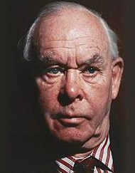
Bowlby, John
SOCIAL PSYCHOLOGY – ATTACHMENT THEORIES: EVOLUTIONARY APPROACH
- Social Releasers
- Monotropy & Critical Period
- Maternal Deprivation Hypothesis
- Internal Working Model
Investigated the Impacts of Hospitalisation on Children (1958-69)
Supported by Harlows Monkeys and Lorenz’ Geese
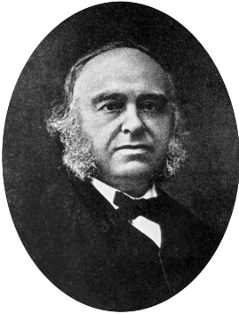

Broca
BIOLOGICAL INFLUENCES ON BEHAVIOUR – LOBES OF THE CEREBRAL CORTEX: FRONTAL LOBE
- Broca’s Area
- Broca’s Aphasia

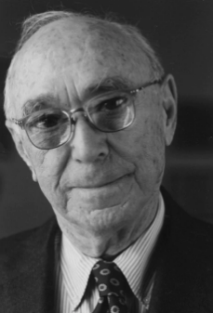

Bruner, Jerome
COMMUNICATION – LANGUAGE ACQUISITION THEORY: INNATE AND LEARNED LANGUAGE DEVELOPMENT
- Language Acquisition Support System (LASS)
- Scoffolding, Referencing, Joint Attention, Motherese, Book Reading


Chomsky, Naom
COMMUNICATION – LANGUAGE ACQUISITION THEORY: INNATE LANGUAGE DEVELOPMENT
- Language Acquisition Device (LAD)
- Universal Grammar Theory

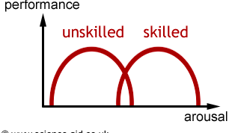
Cottrell
SOCIAL PSYCHOLOGY - INFLUENCE OF GROUPS: SOCIAL FACILITATION & INHIBITON
- Evaluation Apprehension Theory
Basketball Experiment:
Confident in ability = being watched increases desire to do well
Not Confident = worrying about being judged
Bartis et. Al – Knife Experiment
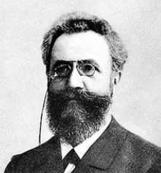

Ebbinghaus, Hermann
COGNITIVE PSYCHOLOGY – PSYCHOLOGICAL CONCEPTS: SERIAL POSITION EFFECT
- Primacy effect
- Recency effect
- Forgetting curve
Nonsense Syllables – study: Hermann = first to notice

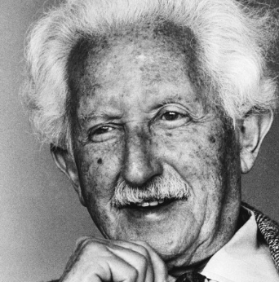
Erikson, Erik
SELF – DEVELOPMENTAL PSYCHOLOGY: PSYCHOSOCIAL DEVELOPMENT
- Trust vs. Mistrust
- Autonomy vs. Shame and Doubt
- Initiative vs. Guilt
- Industry vs. inferiority
- Identity vs. Role Confusion
- Intimacy vs. Isolation
- Generativity vs. Stagnation
- Ego Integrity vs. Despair

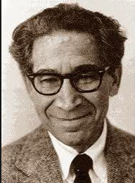
Festinger, Leon
SOCIAL PSYCHOLOGY – COGNITIVE DISSONANCE THEORY
- Cognitive Dissonance Theory (1957)
- Forced Compliance Behaviour
Festinger & Carlsmith – Peg Turning (1957)
- Decision Making
Brehm – Women Rating Household Products (1956)
- Effort
Aronson & Mills (1959) – Students reading uncomfortable texts

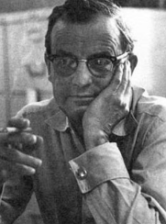
Harlow, Harry
SOCIAL PSYCHOLOGY – ATTACHMENT THEORIES: EVOLUTIONARY APPROACH
- Evolutionary Attachment
- Cupboard Love
Monkey Experiment

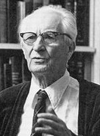
Heider
SOCIAL PSYCHOLOGY – ATTRIBUTION THEORIES
- Internal/Dispositional Attribution
- External/Situational Attribution
- Fundamental Attribution Error
- Just World Phenomenon
- Self-Serving Bias
- False-Consensus Effect
- Actor-Observer Bias

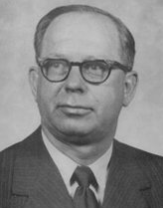
Kelley, Harold H.
SOCIAL PSYCHOLOGY – ATTRIBUTION THEORIES
- Covariational Model (1967)
- Consensus, Distinctiveness, Consistency

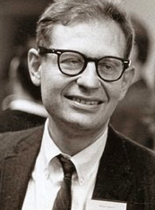
Kohlberg, Lawrence
SELF – DEVELOPMENTAL PSYCHOLOGY: MORAL DEVELOPMENT
Level 1: Pre Convetional
- Stage 1: Obediance and Punishment
- Stage 2: Individualism and Exchange
Level 2: Conventional
- Stage 3: Good Boy/Good Girl
- Stage 4: Law and Order
Level 3: Post Conventional
- Stage 5: Rights and Social Contract
- Stage 6: Universal Ethical Principles
Heinz Dilema (1958)


Gilligan, Carol
SELF – DEVELOPMENTAL PSYCHOLOGY: MORAL DEVELOPMENT
- Criticism of Kohlberg
Kohlberg’s principles only applied to men,



Labov, William
COMMUNICATION – SOCIAL BACKGROUND COMMUNICATION
- Black English Vernacular (BEV)
Supported by Malcolm (2003) – Studies on Aboriginal Children


Loftus, Elizabeth
COGNITIVE PSYCHOLOGY – PSYCHOLOGICAL CONCEPTS: MEMORY
- Memory Representation
Colliding Cars Experiment – Changing response words

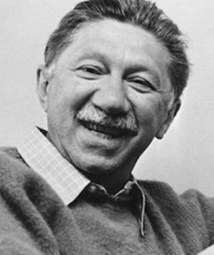
Maslow, Abraham
SELF – PERSONALITY THEORIES: HUMANISTIC THEORY
- Hierachy of Needs (1943)
- Self-Actualisation


McCrae and Costa
SELF – PERSONALITY THEORIES: TRAIT THEORY
- Openness
- Conscientiousness
- Extraversion
- Altruism
- Neuroticism


McMillan and Chavis
SOCIAL PSYCHOLOGY – OTHERS: COMMUNITY
- Sense of Community
- Impact of Significant Events – Positive and Negative Responses

Michaels et. Al.
SOCIAL PSYCHOLOGY - INFLUENCE OF GROUPS: SOCIAL FACILITATION & INHIBITON
- Mere Presence Theory
Pool Room Study
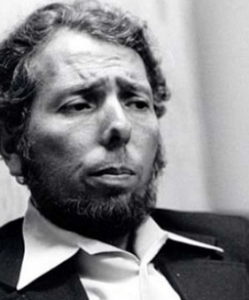
Milgram, Stanley
SOCIAL PSYCHOLOGY – INFLUENCE OF OTHERS: OBEDIANCE
Milgram Electric Shock Experiment


Mischel, Walter
SELF – PERSONALITY THEORIES: SOCIAL-COGNITIVE THEORY
- Situation vs. Personality Controversy / Trait vs. State Debate
- Behaviour Specificity
- Delayed Gratification
Stanford Marshmallow Experiment

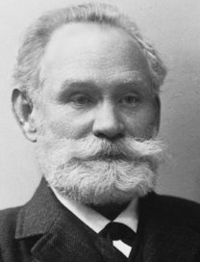

Pavlov, Ivan
COGNITIVE PSYCHOLOGY – PROCESSES OF LEARNING
- Classical Conditioning
Pavlov’s Dogs Experiment
Little Albert Experiment

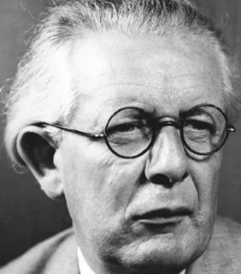
Piaget
DEVELOPMENTAL PSYCHOLOGY – COGNITIVE DEVELOPMENT
- Schemas
- Adaption Processes (Assimilation, Accommodation, Equilibrium)
- Stage 1: Sensorimotor (Object Permanence)
- Stage 2: Preoperational Stage (Symbolic thinking, Egocentrism)
Conservation of Liquid Task – Water in Containers
Three Mountains Task
- Stage 3: Concrete-Operational Stage (Conservation)
Conservation of Mass Task - Plasticine
- Stage 4: Formal Operational Stage (Propositional Thinking)
Piaget’s Pendulum Problem
Seagrim & Lendon (1980) – Hermannsberg Project: Piagetian tasks on Indigenous Australians
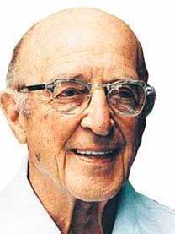
Rogers, Carl
SELF – PERSONALITY THEORIES: HUMANISTIC THEORY (PERSON CENTERED THEORY)
- Self Concept
- Growth Promoting Climate
- Personality Congruency

Seagrim & Lendon
DEVELOPMENTAL PSYCHOLOGY – COGNITIVE DEVELOPMENT: IN INDIGENOUS AUSTRALIANS
Hermannsburg Project: 1965-78
Compared the cognitive performance of children from the Aranda and Loritja people, reared in the isolates Lutheran Mission Station in Central Australia, with other Aboriginal children reared elsewhere in different circumstances.
- Intellectual performance based on Piagetian tasks: Conservation, classification & seriation
- Longitudinal study
- Cross-sectional comparative element
- Aim: Investigate the universality of Piaget’s theory
- Conclusions: Aboriginal children were just as capable as white children in different thinking at different ages – but only when immersed in white culture – otherwise they lagged considerably in exhibiting expected behaviour in Piagetian tasks


Sperling, George
COGNITIVE PSYCHOLOGY – PSYCHOLOGICAL CONCEPTS: MEMORY
- Iconic Memory
- Rate of forgetting from senspry memory
Tachistoscope test
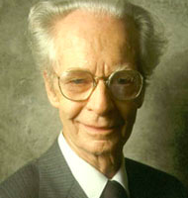
B. F. Skinner
COGNITIVE PSYCHOLOGY – PROCESSES OF LEARNING
- Operant Conditioning
- Positive Reinforcement
- Negative Reinforcement
- Punishment
- Schedules of reinforcement
- Behaviour Modification (Shaping)
- Token Economy
Skinner Box


Tannen, Deborah
COMMUNICATION – SOCIAL BACKGROUND COMMUNICATION: GENDER DIFFERENCES IN COMMUNICATION
- Rapport Talk
- Report Talk
- Hedging

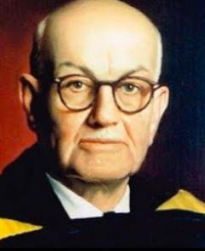

Tolman, Edward
COGNITIVE PSYCHOLOGY – PROCESSES OF LEARNING
- Latent Learning
- Cognitive Map
Tolman & Hoznick (1930) Mouse Maze Experiment

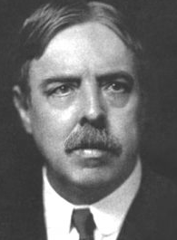
Thorndike
COGNITIVE PSYCHOLOGY – PROCESSES OF LEARNING
- Operant Conditioning
Places Kitten in Puzzle Box and Fish outside – Cat to reach the fish
- Law of Effect

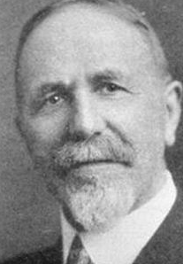
Triplett, Norman
SOCIAL PSYCHOLOGY - INFLUENCE OF GROUPS: SOCIAL FACILITATION & INHIBITON
- Mere Presence Theory
- Co-action Effect
- Audience Effect
Cyclists Experiment (1898)

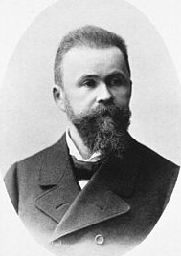

Wernicke, Carl
BIOLOGICAL INFLUENCES ON BEHAVIOUR – LOBES OF THE CEREBRAL CORTEX: TEMPORAL LOBE
- Wernicke’s Area
- Wernicke’s Aphasia


Wolpe, Joseph
COGNITIVE PSYCHOLOGY – PROCESSES OF LEARNING
- Classical Conditioning
- Systematic Desensitization

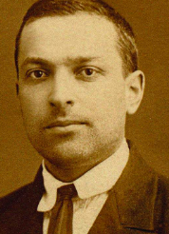
Vygotsky, Lev
DEVELOPMENTAL PSYCHOLOGY – COGNITIVE DEVELOPMENT
- Culture affecting cognitive development
- Social factors affecting cognitive development
- Language affecting cognitive development
- Adults as an important source of cognitive development
- More Knowledgeable Other (MKO)
- Zone of Proximal Development (ZPD)


ZaJonc
SOCIAL PSYCHOLOGY - INFLUENCE OF GROUPS: SOCIAL FACILITATION & INHIBITION
- Mere Presence Theory
- Drive Theory
(Michaels et al)
Poor pool players worsened in front of a crowd
Good pool playerys accuracy increased in front of a crowd


Zimbardo
SOCIAL PSYCHOLOGY – INFLUENCE OF OTHERS: OBEDIANCE & CONFORMITY
Stanford Prison Experiment

