3AB Chemistry

Organic chemistry

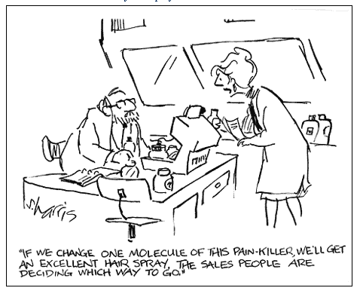
http://www.sciencecartoonsplus.com/gallery/chemistry/galchem2d.php#

Tyson

Name: _________________________

Organic chemistry
- Write balanced equations for the following reactions of hydrocarbons:
- Substitution reactions of alkanes
- Addition reactions of alkenes
- Combustion
- Draw and name structural isomers of alkanes and structural and geometric isomers of alkene
- Recognise the functional groups – alcohols, aldehydes, ketones, carboxylic acids and esters and name simple straight chain examples to C₈
- Explain the relationship between the presence of a functional group and chemical behaviour alcohols:
- Name simple straight chain examples to C₈
- Draw simple structural formula for primary, secondary and tertiary alcohols
- Explain physical properties of alcohols such as melting and boiling points and solubility in polar and non-polar solvents in terms of the intermolecular interactions
- Describe, write equations for and predict and interpret observations for the following reactions of alcohols:
- With carboxylic acids
- With acidified Cr₂O₇²⁻ and MnO₄⁻ to produce:
- aldehydes
- ketones
- carboxylic acids
- Amines:
- Recognise primary amines
- Name and draw simple structural formulae for primary amines only
- Amino acids:
- Recognise general structural formula for amino acids
Applied chemistry
- Describe the chemistry of common organic substances such as soaps, detergents, amino acids and trans-fatty acids
- Apply and explain the concept of polymerisation such as polypeptides, silicones or plastics

What did we learn in year 11?
Organic chemistry is the study of carbon based compounds. There are 1000’s of such compounds so we need a system for naming them.
IUPAC nomenclature

The beginning of name indicates the number of carbon atoms
- meth
- eth
- prop
- but
- pent
- hex
- hept
- oct

The ending of the name describes the C-C bond
-ane only single bonds between C atoms
-ene at least one double C to C bond
-yne at least one triple C to C bond

Prefixes can be used to indicate other atoms that have been added onto the chain
Chloro Cl
Fluoro F
Iodo I
Bromo Br

Alkyl groups
-CH₃ methyl
-CH₂CH₃ ethyl
-CH₂CH₂CH₃ propyl

Cyclic compounds
If the carbon chain is joined in a circle we indicate this by use of the prefic cyclo
Numbers
Are used to indicate position
Remember – commas between numbers and dashes between numbers and words
Some examples
1.
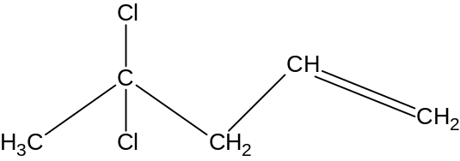 _________________________
2.
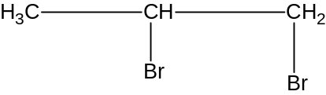 _________________________
3.
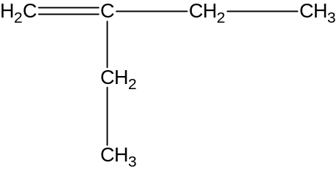 __________________________
4.
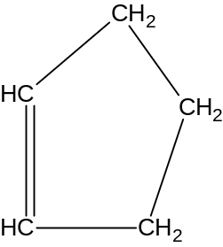 __________________________
5.
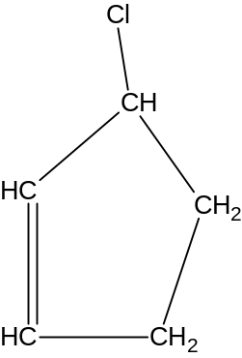 __________________________

6.
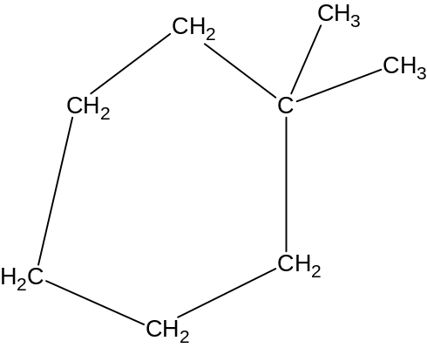 _____________________________
7.
Vocabulary from year 11

Alkane ______________________________________________________________
Alkene ______________________________________________________________
Alkyne ______________________________________________________________
Alycyclic ____________________________________________________________
Aliphatic ____________________________________________________________
Aromatic ____________________________________________________________
Saturated ____________________________________________________________
Unsaturated __________________________________________________________
Addition reaction ______________________________________________________
Substitution reaction ____________________________________________________
Halogenation _________________________________________________________
Isomer _______________________________________________________________

Geometric isomer ______________________________________________________
Isomerism
Addition reactions
Substitution reactions
11.2 Alkanes notes from textbook

The general features of the straight chain and branched chain alkanes include the following:
- They consist only of carbon and hydrogen.
- They have only single bonds between the carbon atoms, e.g. propane CH₃-CH₂-CH₃.
- They have the general formula C_{n}H_{2n+2}, where n = 1, 2, 3 etc.
- They are colourless and may be gases, liquids or solids at room temperature depending on their relative formula mass.
- They are insoluble in water

Why are alkanes insoluble in water?

____________________________________________________________

____________________________________________________________

____________________________________________________________

The structural formulas and boiling points of the first eight straight chain alkanes are shown in Table 11.1.

TABLE 11.1 THE FIRST EIGHT STRAIGHT CHAIN ALKANES

Name of alkane | Number of carbon atoms in straight chain | Structural formula | Molecular formula | Boiling point (°C)
Methane | one | CH₄ | CH₄ | -161.5
Ethane | two | CH₃-CH₃ | C₂H₆ | -88.6
Propane | three | CH₃-CH₂-CH₃ | C₃H₈ | -42.1
Butane | four | CH₃-CH₂-CH₂-CH₃ | C₄H₁₀ | -0.5
Pentane | five | CH₃-CH₂-CH₂-CH₂-CH₃ | C₅H₁₂ | 36.1
Hexane | six | CH₃-CH₂-CH₂-CH₂-CH₂-CH₃ | C₆H₁₄ | 68.7
Heptanes | seven | CH₃-CH₂-CH₂-CH₂-CH₂-CH₂-CH₃ | C₇H₁₆ | 98.4
Octane | eight | CH₃-CH₂-CH₂-CH₂-CH₂-CH₂-CH₂-CH₃ | C₈H₁₈ | 125.7

QUESTIONS page 323

1. Name the following alkanes according to the IUPAC rules.

a) CH₃CH₂CH₂CH₂CH₃
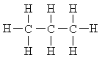
b)

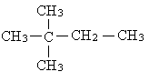
c)

d) CH₃(CH₂)₅CH₃

e) CH₃CH₂CH₂CH₂CH₂CH₂CH₂CH₃

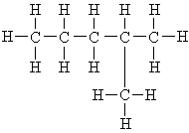
f)

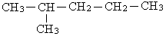
g)

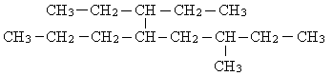
h)

2. Write the structural formulas for the following alkanes.

a) hexane
b) methylpropane
c) 2,3,3-trimethylpentane
d) 3-ethyl-2,4-dimethylheptane

3. Give the structural formula of an example of each of the following.

a) An aliphatic hydrocarbon
b) A straight chain alkane
c) A branched chain hydrocarbon
d) An alicyclic alkane

4. Draw the structural formulas and name the isomers of the compounds with the following molecular formulas.

a) C₄H₁₀
b) C₆H₁₄

5. Which of the following substances are isomers?

a) CH₃(CH₂)₈CH₃
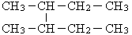
b)

c) CH₃CH₂CH₂CH₂CH₂CH₂CH₂CH₃
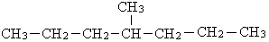
d)

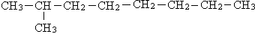
e)

6. Which of the following substances are isomeric with 2,2-dimethylpentane?

a) pentane
b) methylpentane
c) 2,2-dimethylhexane
d) ethylpentane
e) trimethylbutane
f) 3-methylhexane
g) heptanes

7. Give the structural formula of the major organic product formed when the following reaction mixtures are exposed to ultraviolet light. Assume that the reactants are present in a 1:1 mole ratio.

a) CH₄ and Cl₂
b) CH₃CH₃ and Br₂
c) CH₃CH₂CH₃ and F₂
d) dimethylpropane and I₂

8. Complete each of the gaps in the following equations. Assume each reaction mixture is exposed to sunlight.

a) CH₄ + F₂ → __________ + HF
b) CH₄ + 4Br₂ → __________ + 4HBr
c) _________ + Br₂ → CH₃CH₂CH₂Br + HBr
d) ________ + _________ → CH₃CH₂CH₂CH₂CH₂CH₂Cl + ___________
e) ________ + 6Cl₂ → CCl₃CCl₃ + ___________
f) CH₃CH(CH₃)CH₃ + 10Br₂ → __________ + __________
g) C₅H₁₂ + _________ O₂ → _________ ________ + ________ ________

9. Write balanced equations, using structural formulas, for each of the following reactions.

a) Ethane is mixed with an excess of fluorine, in the presence of UV light.
b) Cyclobutane is burnt in air.
c) A mixture of propane and bromine is placed in a dark cupboard.
d) Tetramethylbutane is mixed with chlorine, in a 1:1 mole ratio, and exposed to sunlight.
e) A mixture of methylcyclopropane and an excess of bromine is exposed to UV light.

10. Which of the following names are correct? If the name is incorrect, give the correct name.

Structural formula | Name. Is it correct or incorrect?
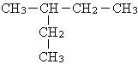  a) | Ethylbutane
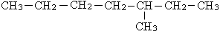  b) | 5-Methylheptane
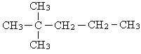  c) | 2-Dimethylpentane
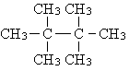  d) | Tetramethylbutane

11. The boiling points of the five isomeric alkanes with formula C₆H₁₂ are listed below.

Alkane | Boiling point (°C)
Hexane  3-Methylpentane  2-Methylpentane  2,3-Dimethylbutane  2,2-Dimethylbutane | 68.7  63.3  30.3  58.0  49.7

Draw the structural formulas of each of these alkanes and explain qualitatively the differences in the boiling points in terms of the intermolecular bonding between the hydrocarbon molecules.

12. Which of the following statements is true about structural isomers?

a) They have the same structural formula but different molecular formulas.
b) They have the same relative formula mass.
c) Their atoms are connected in the same way.
d) They have the same physical properties.

13. a) Table 11.1 gave the boiling points for the first eight alkanes. Successive members of the alkane family differ by just –CH₂–. Account for the fact that the difference in boiling points between CH₄ and C₂H₆ is so much larger than the difference between the boiling points of C₇H₁₆ and C₈H₁₈.
b) Sketch a plot of boiling point vs relative formula mass for the first eight straight-chain alkanes.

14. The shiny skin of a fruit such as an apple contains hydrocarbons with between 27 and 30 carbon atoms. Explain why the skin of an apple would help prevent water from being lost from the fruit.

15. Name the following alkenes, according to the IUPAC rules:

a) CH₃-CH₂-CH₂-CH=CH-CH₂-CH₃
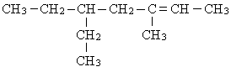
b)

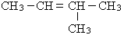
c)

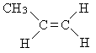
d)

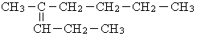
e)

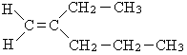
f)

16. Give the structural formulas of the following compounds

a) hex-3-ene
b) 2,2-dimethyloct-4-ene
c) 1,2,3-trichloro-3-ethylpent-1-ene
d) 4-propylhept-1-ene
e) dimethylbut-2-ene

17. Which of the following compounds are structural isomers of hex-1-ene?

a) CH₃CH₂CH₂CH₂CH₂CH₃
b) CH₃CH₂CH=CHCH₂CH₃
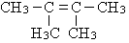
c)

18. Give the names and structural formulas of the five isomers with the molecular formula C₅H₁₀. Assume that each isomer contains a double carbon-carbon bond.

19. Give the structural formulas of the following geometrical isomers.

a) trans-2,3-diflyorobut-2-ene
b) cis-2,3-difluorobut-2-ene
c) trans-pent-2-ene
d) cis-1-bromo-2-chloroethene

20. Give the IUPAC name of each of the following alkenes (including the appropriate suffix of ‘cis’ or ‘trans’ in each name).

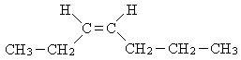
a)

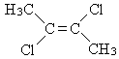
b)

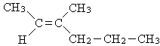
c)

21. a) Draw the two geometric isomers of 1,2-dichlorothene, and name them.
b) Draw a structural isomer of 1,2-dichloroethene, and name it.

22. Which of the following compounds cannot exist as geometrical isomers?

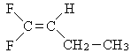
a)

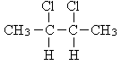
b)

c) propene
d) but-2-ene
e) 2,3-dibromobut-2-ene
f) hex-3-ene

23. Give the structural formula (showing all bonds including those to hydrogen) of the organic product formed in each of the following reactions.

a) CH₂=CH₂ + Cl₂ →
b) CH₃-CH=CH₂ + Br₂ →
c) CH₃-CH=CH-CH₃ + H₂ →
d) CH₃-CH=CH₂ + excess Cl₂ ^{uv light}
e) CH₃-CH=CH-CH₃ + steam →
f) CH₃-CH₂-CH=CH-CH₃ + HI →

24. Describe the reaction conditions you could use to carry out the following reactions, for example, in 1:1 mole ratio of reactants, in the dark.

a) The formation of 1,2-difluoroethane from ethene
b) The formation of CCl₂-CCl₂-CCl₃ from propene
c) The preparation of 2,3-dibromopentane from pent-2-ene
d) The preparation of hexafluoroethane from ethene

25. Give the name and structural formula of the organic compound you could use to form each of the following.

a) 1,2-dibromopropane
b) hexachloroethane
c) methylpropane
d) 3,4-difluoroheptane
e) CBr₃-CBr₂-CBr₂-CBr₃
f) CH₂Cl-CH₂Cl

26. Write a balanced equations, using structural formulas for the following reactions.

a) Propene is mixed with fluorine in a 1:1 mole ratio.
b) Methylpropene is mixed with an excess of bromine and the mixture is put in a dark cupboard.
c) Ethene is reacted with hydrogen in the presence of a catalyst.
d) 1 mole of but-1-ene is mixed with 1 mole of chlorine, in the presence of UV light.
e) Pent-2-ene is reacted with an excess of bromine in the presence of UV light.
f) Hex-3-ene is burnt in air.
g) But-2-ene is reacted with hydrogen bromide gas.

27. Match each formula, in the following table, with its correct name.

Formula | Name
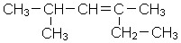a) | A Ethyl-2-methylpentane
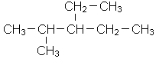b) | B Pentane
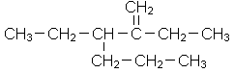c) | C 2,4-Dimethylhex-3-ene
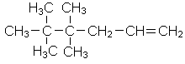d) | D Propane
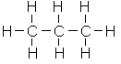e) | E 3-Ethyl-2-propylhex-1-ene
f) CH₃CH₂CH₂CH₂CH₃ | F 4,4,5,5-Tetramethylhex-1-ene

Functional groups

functional groups are specific groups of atoms within molecules that are responsible for the characteristic chemical reactions of those molecules. The same functional group will undergo the same or similar chemical reaction(s) regardless of the size of the molecule it is a part of
If two or more functional groups occur in the same molecule then the order of priority for the principal functional group is carboxylic acid, aldehyde, ketone, alcohol, amine, alkene, alkyne, halogen and alkyl group.
Functional group | Condensed formula | Class of compound | Prefix or suffix | Example
 | -CHCH- | alkene | -ene | 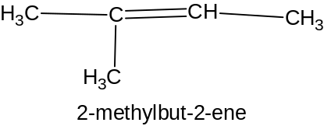or  2-methyl-2 butene
 | -CC- | alkyne | -yne | 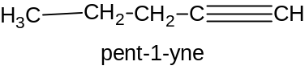or  pentyne
-F  -Cl  -Br  -I |  | haloalkane | Fluoro-  Chloro-  Bromo-  Iodo- | 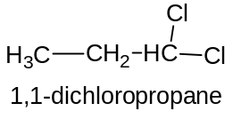
-O-H | -OH | alcohol | -ol or  hydroxy | 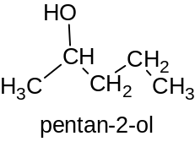or  2-pentanol
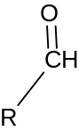 | -CHO | aldehyde | -al | 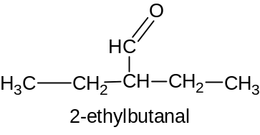
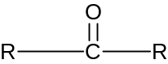 | -CO- | ketone | -one | 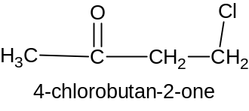or  4-chloro-2-butanone
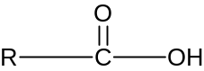 | -COOH | Carboxylic acid | -oic acid | 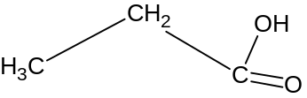  propanoic acid
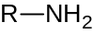 | -NH₂ | amine | -amine or  amino- | 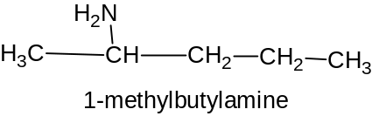  2-pentanamine
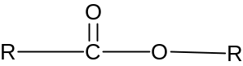 | -COO- | ester | -oate | 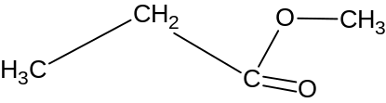  methyl propanoate

Naming alcohols notes from textbook page 329

The following steps describe how alcohols are named, as recommended by IUPAC.

i The alcohol is named by selecting the longest carbon chain that contains the –OH functional group. This longest chain becomes the parent alkane and the alcohol is named by adding the suffix ‘ol’ in the place of the ‘e’ in the alkane name.
ii The position of the alcohol functional group is indicated by the use of a number placed before the suffix ‘ol’.
(The prefix ‘hydroxy’ is used for some compounds where there is more than one functional group present).
iii The alcohol functional group is given the smallest possible number in the chain and take priority over any side-chain alkyl groups.
iv If two alcohol functional groups are present then the suffix ‘diol’ is used and the ‘e’ is not dropped from the alkane name.
v For cyclic alcohols, the numbering begins at the carbon atom attached to the alcohol functional group.

Some examples of alcohols and their names are shown below.

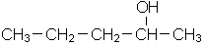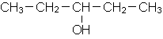
propan-2-ol propan-3-ol

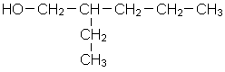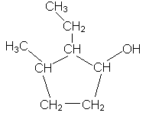
The name of the alcohol shown above is The cyclic alcohol shown above is
2-ethylpentan-1-ol. The dotted line shows 2-ethyl-3-methylcyclopentanol.
the longest chain with the alcohol functional
group is a pentane, though is a longer
carbon chain in the molecule.
TABLE 12.1 BOILING POINTS OF SOME ALCOHOLS

Number of carbon atoms | Name | Formula | Boiling point (°C)
1 | Methanol | CH₃OH | 65
2 | Ethanol | CH₃CH₂OH | 78
3 | Propan-1-ol | CH₃CH₂CH₂OH | 97
4 | Butan-1-ol | CH₃CH₂CH₂CH₂OH | 118

Hydrogen bonding occurs between molecules where a hydrogen atom is bonded to one of the three highly electronegative atoms – nitrogen, oxygen or fluorine. Alcohols have an –OH group so the hydrogen attached to the oxygen in one molecules can hydrogen bond to an oxygen atom in another alcohol molecule as shown in Figure 12.5. However, in the alkanes there are only carbon and hydrogen atoms, so no hydrogen bonding is possible. Only dispersion force can exist between alkane molecules.

Since hydrogen bonds are stronger than dispersion forces, and because there will be dispersion forces present between the alcohol molecules as well, the alcohols have much higher melting and boiling points than the parent alkanes.

The increasing strength of the dispersion forces as successive –CH₂– groups are added to the molecule best explain the gradual increase in boiling points of the alcohols. The hydrogen bonding interaction will be much the same for all the alcohols as they contain only one alcohol functional group. However, the strength of dispersion forces increases with increasing number of electrons in the molecule. The alcohol molecules with larger molecular masses have more atoms present in the molecule and so have more electrons.

Alcohols with smaller molecule masses are soluble in water, but as molecular mass increases, the solubility of the alcohol in water decreases. After butanol, the alcohols are essentially insoluble in water.

Explain why methanol is soluble in water.

___________________________________________________________________

___________________________________________________________________

___________________________________________________________________

___________________________________________________________________
Primary, secondary and tertiary alcohols
Ref page 331 textbook

Review exercise 12.1

1. Name the following alcohols according to IUPAC rules.

a) CH₃CH₂CH₂CH CH₂CH CH₂CH₃

OH CH₃

b) CH₃CH CH₂CH CH₂OH

CH₃ CH₃

c) CH₂CH₃

CH₃CH₂CH₂CH₂CH₂C CH₂CH₃

OH

2. Give the structural formulas of the following compounds.

a) ethanol
b) butan-2-ol
c) 3,3,4,5-tetramethylpenta-1-ol
d) butane-1,2-diol

3. A group of organic compounds called ethers are isomeric with some alcohols. Ethers contain a C-O-C bond. The simplest ether has the formula CH₃OCH₃.

a) Which alcohol is isomeric with this ether?
b) Predict how the boiling point and water solubility of the alcohol in part a) would compare with this isomeric ether. Justify your prediction.

4. Place the following three molecules in order of increasing boiling point and increasing solubility in water. Explain any similarities in the order of these compounds in the two lists.

a) CH₃CH₂CH₂OH
b) CH₃CH₂CH₂CH₃
c) CH₃CH₂OCH₃

5. Identify the following alcohols as primary, secondary or tertiary.

a) CH₂CH₃

CH₃CH₂CH₂CH₂CH₂CCH₂CH₃

OH

b) CH₃CH CH₂CHCH₂OH

CH₃ CH₃

c) CH₃CH₂CH₂CH₂CHCH₃

CH₃OH

d) CH₃CH₂CH₂CH CH₂CH CH₂CH₃

OH CH₃

e) CH₂CH₃

CH₃CH₂CH₂CH₂COH

CH₃
Reactions of alcohols

Alcohols undergo combustion reactions to produce carbon dioxide and water

Oxidation of alcohols

Incomplete oxidation of a primary alcohol produces an aldehyde
Example: propanol is reacted with a limited amount of cold acidified potassium dichromate
3 x (CH₃CH₂CH₂OH → CH₃CH₂CHO + 2H⁺_{(aq)} + 2e⁻) oxidation half eqn
Cr₂O₇²⁻_{(aq)} + 14H⁺_{(aq)} + 6e⁻ → 2Cr³⁺_{(aq)} + 7H₂O reduction half eqn
___________________________________________________________________
3CH₃CH₂CH₂OH + Cr₂O₇²⁻_{(aq)} + 8H⁺_{(aq)} → 3CH₃CH₂CHO + 2Cr³⁺_{(aq)} + 7H₂O

Complete oxidation of a primary alcohol produces a carboxylic acid
Example: Ethanol is added to excess acidified potassium permanganate
5 x (CH₃CH₂OH + H₂O → CH₃COOH + 4H⁺ + 4e⁻)
4 x (MnO₄⁻_{(aq)} + 8H⁺_{(aq)} + 5e⁻ → Mn²⁺_{(aq)} + 4H₂O)
____________________________________________________________________
5CH₃CH₂OH + 4MnO₄⁻_{(aq)} + 12H⁺_{(aq)} → 5CH₃COOH + 4Mn²⁺_{(aq)} + 11H₂O

Oxidation of a secondary alcohol always produces a ketone
Example: 2-propanol is treated with acidified potassium dichromate
3 x (CH₃CHOHCH₃ → CH₃COCH₃ + 2H⁺ + 2e⁻)
Cr₂O₇²⁻_{(aq)} + 14H⁺_{(aq)} + 6e⁻ → 2Cr³⁺_{(aq)} + 7H₂O
_______________________________________________________________
3CH₃CHOHCH₃ + Cr₂O₇²⁻ + 8H⁺ → 3CH₃COCH₃ + 2Cr³⁺ + 7H₂O

Review exercise 12.2 page 340 textbook

1. Give the name and formula of the organic compound formed in each of the following reactions.

Reaction mixture | Name of product | Formula of product
a) CH₃CH₂CH₂OH is mixed with an acidified solution of potassium permanganate for a short time, and the product is then removed from the reaction mixture by distillation.
b) CH₃CH₂CH₂CH₂CH₂OH is boiled with an acidified solution of potassium dichromate.
c) Hexan-3-ol is reacted with an acidified solution of sodium dichromate.
d) 2-Methylbutan-2-ol is boiled with a solution of acidified potassium permanganate.
e) CH₂CH₃

CH₃CH₂CH₂CH₂COH

CH₃ is heated with an acidified solution of potassium dichromate.
f) Pentan-3-ol is mixed with an acidified solution of potassium permanganate and the mixture is heated.
g) A piece of potassium is added to propan-2-ol.

2. First write the two relevant half-equations, then derive the overall ionic equation for each of the following reactions (use structural formulas for the organic compounds).

a) Propan-2-ol is heated with an acidified solution of potassium permanganate.
b) Butan-1-ol is mixed for a short time with an acidified solution of sodium dichromate.
c) Pentanal is heated with an acidified solution of potassium permanganate.

3. Hexan-1-ol, hexanal and pentanoic acid have approximately the same relative formula mass. Place these three compounds in order of increasing boiling point (lowest to highest) and justify your answer.

4. Write the equation for the complete combustion of butan-1-ol in excess air.

12.3 Esters page 340 textbook

Esters are a group of compounds formed in the reaction between a carboxylic acid and an alcohol. They occur naturally in many fruits and are responsible for the ‘fruity odour’ of many of these. They are also present in fats and vegetable oils. Commercially, esters are used to make food flavours, perfumes, scents, industrial solvents, and as softening agents in the plastic industry.

The functional group present in an ester is – C – O – or – COO –.

O

For example:

from carboxylic from from from carboxylic
acid alcohol alcohol acid

CH₃-CH₂-C-O-CH₂-CH₃ H₃C-O-C-CH₂CH₂CH₂CH₃

O O

ethyl propanoate methyl pentanoate

CH₃CH₂OOCH CH₃CH₂CH₂OOCCH₂CH₂CH₃

ethyl metanoate propyl butanoate

Esters can be converted back to the original carboxylic acid and alcohol when reacted with an acid, usually with warming. The reverse of the esterification reaction is called hydrolysis.

Warming the ester with a solution of sodium hydroxide (or similar base) can also result in the hydrolysis of the ester. In this case, the products of the reaction are the alcohol and the salt of the carboxylic acid.

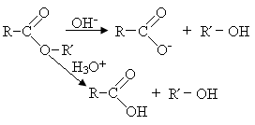

FIGURE 12.20 General equations for the hydrolysis of an ester in the presence of acid and base

Review exercise 12.3 page 342 textbook

1. Give the structural formula and name of each of the esters that are formed when the following carboxylic acids and alcohols react.

a) CH₃ – C – OH + HO – CH₂CH₂CH₃

O

b) CH₃ – C – OH + CH₃ – CH₂ – OH

O

c) CH₃ – CH₂ – CH₂ – CH₂OH + CH₃ – CH₂ – CH₂ – C – OH

O

2. Name the following esters.

a) O

CH₃ – CH₂ – CH₂ – C – O – CH₃

b) O

CH₃ – C – O – CH₂CH₂CH₂CH₃

c) O

CH₃ – CH₂ – O – C – CH₂ – CH₂ – CH₂ – CH₂ – CH₃

3. Give the formulas of the organic compounds formed in the following reactions.

a) Methyl ethanoate (acetate) is boiled with a solution of hydrochloric acid.
b) Propyl butanoate is heated with a solution of sodium hydroxide.

4. The reaction of propene with mercuric acetate in the presence of water produced a compound, A, with the formula C₃H₈O. If propene is reacted with diborane (B₂H₆) and then water, it produces a compound, B, with the same formula C₃H₈O.

Both A and B react with a solution of acidified potassium dichromate. A produces a colourless liquid, C, with the formula C₃H₆O and B produces a colourless liquid, D, with the formula C₃H₆O₂.

Compound D can react with both A and B in the presence of a trace amount of concentrated sulfuric acid to produce two different compounds with the same molecular formula.

a) Name and draw the structural formulas of the organic compounds A, B, C and D.
b) Draw the structural formulas of the two different compounds that D forms with A and B, identifying which comes from A and which comes from B.

Primary amines page 343 textbook

Primary amines contain the –NH₂ functional group where the nitrogen is bonded directly to a carbon atom. Figure 12.21 shows a range of primary amines, some of which are biologically active (but whose structures you do not need to know).

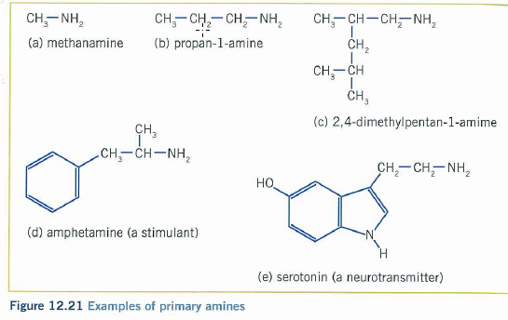

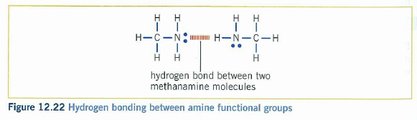

Alpha amino acids
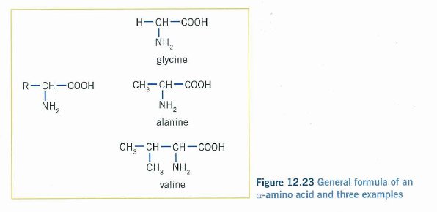

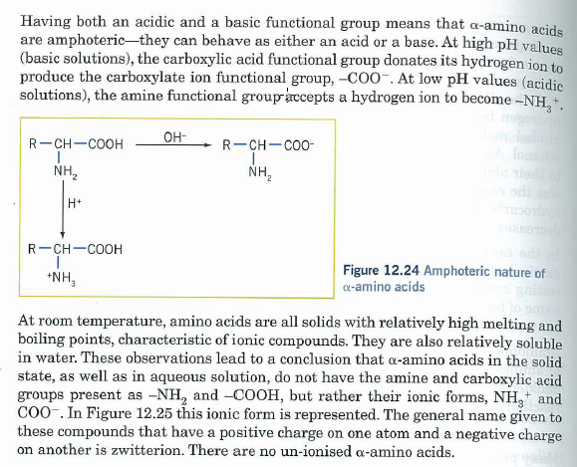

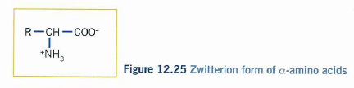

Review exercise 12.5

1. An organic amine contains the elements carbon, hydrogen and nitrogen only. It was found to contain 54.5% carbon and 13.7% hydrogen by mass. A 0.106 mol L⁻¹ solution of the amine was prepared. 20.00 mL of this solution was neutralised completely by 23.49 mL of 0.181 mol L⁻¹ HCl solution.

a) Calculate the empirical formula of the amine.
b) Using the titration data, determine the number of amine groups in each molecule of the amine.
c) Determine the molecular formula of the amine.
d) Draw two possible structural formulas for the amine.

2. An organic compound on analysis is found to contain 40.0% carbon and 6.67% hydrogen by mass. The remaining element is oxygen. 0.24 mole of the compound has a mass of 14.4 g.

a) Determine the empirical and molecular formulas of the compound.
b) Draw and name all of the possible structures for this compound.

3. A compound obtained from the hydrolysis of protein with hydrochloric acid is subjected to analysis.
2.2274 g of the compound, on complete combustion, produced 3.301 g of carbon dioxide and 1.576 g of water.
A further 1.782 g of the compound is reacted with sulfuric acid to convert any nitrogen in the compound to NH₄⁺. This solution containing ammonium ions is then heated with a sodium hydroxide solution to drive off ammonia. The vapour from this reaction is passed into 100.0 mL of 0.510 mol L⁻¹ HCl. The excess HCl was then titrated with 1.211 mol L⁻¹ potassium hydroxide and required 25.60 mL to reach the methyl orange end point.

a) The only other element that could be present in the compound is oxygen. From this information, determine the empirical formula of the compound.
b) Assuming the empirical formula is also the molecular formula, and knowing the building blocks of protein, suggest a likely structure for this compound.

QUESTIONS

1. Using examples of your own choosing, explain the difference in the structure of primary, secondary and tertiary alcohols.

2. a) Use a book of chemical data to tabulate the boiling points of the first nine straight chain alkanes and alcohols.
b) Plot the boiling points against the number of carbon atoms in the chain for both the alkanes and alcohols on the same graph.
c) Explain the similarities and differences between the two plots.

3. There have been proposals to use molecules such as that shown below on dams to prevent evaporation.

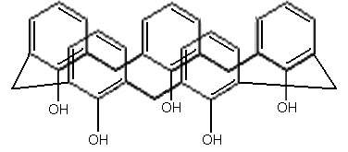

Explain why such a molecule might be considered for this purpose.

4. There are eight isomeric alcohols with the formula C₅H₁₂O. Draw and name all of these alcohols.

5. Name the following alcohols:

a) CH₃

CH₃-C-CH₂-CH₂-CH₃

OH

b) CH₃-CH₂-CH₂-CH₂-CH-CH₃

OH

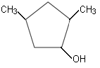
c)

d) CH₃-CH₂-CH-CH₂-CH-CH₂-CH₃

OH CH₂

CH₃

e) (CH₃)₂CHCH(OH)CH₂CH₂CH₃

6. Draw the structural formula and name the alcohol that can be used to prepare each of the following. Describe the reaction conditions that would be chosen for each reaction.

a) pentan-3-one
b) 3,4-dimethylhexanal
c) 3-ethyloctanoic acid
d) ethyl ethanoate (or ethyl acetate)

7. Propan-1-ol, propan-2-ol and methylpropane-2-ol are each heated with an acidified solution of potassium permanganate.

a) What observations would be made for each alcohol?
b) Write the individual half-equations and overall equation for any reaction that takes place.
c) Assuming the labels on the containers of each alcohol had been removed, how could you determine the identity of each?

8. 1-Methylbutanal is warmed with a solution of acidified sodium dichromate. Copy and complete the table below.

Oxidation half-equation
Reduction half-equation
Overall equation

9. Analysis of an unknown compound shows that it contains 62.0% carbon and 10.4% hydrogen, by mass. The remaining element in the compound is oxygen.

a) Determine the empirical formula of this compound.
b) A compound with this empirical formula could be aldehyde, a ketone, a carboxylic acid or an ester. Draw and name one example of each type of compound having this empirical formula.
c) When the unknown compound is warmed in the presence of sulfuric acid, it produces two new organic compounds. Which functional group must be present in the unknown compound? Write a general equation to justify your answer.
d) The two new compounds, A and B, obtained from the reaction in part c) are separated from one another. When A is warmed with an acidified solution of potassium dichromate, it is converted into a compound that is identical to B. Using equations to justify your answer, determine the identity of the unknown compound from the beginning of this question.

10. Predict the order of reactivity of butan-1-ol, 2-methylpropan-2-ol and butan-2-ol with sodium metal and explain how you reached this conclusion.

11. A colourless liquid has the molecular formula C₆H₁₂O₂.

a) What are the two general types of functional group that could be present in this substance?
b) Describe a simple test that would allow you to distinguish between these two types of compound.

When the liquid was warmed with a solution of sulfuric acid, it decomposed into two different compounds, A and B, that were separated by fractional distillation.

c) What must be the functional group present in the original liquid?

Compound A had a distinct smell of vinegar. When potassium metal was added to compound B, there was a very slow reaction with a small amount of gas produced. Compound B did not undergo any observable change when it was treated with an acidified solution of potassium permanganate.

d) From this information suggest the structural formula and name for the original liquid at the start of the question.

12. The field of green chemistry emerged in the early 1990s as the US Environmental Protection Agency urged the development of technologies to ‘reduce or eliminate the use or generation of hazardous substances in the design, manufacture and use of chemical products.’ A number of ‘principles of green chemistry’ have been developed including the following.

- Prevention of waste is better than treating or cleaning up waste after use.
- Chemical synthesis should be as efficient as possible with maximum incorporation of the reacting materials in the desired product.
- Synthetic methods should use and generate substances that have little or no toxicity.
- Use of solvents and other auxiliary materials in a chemical reaction should be minimised. If their use is necessary, these materials should not be harmful.
- Energy requirements for chemical reactions should be kept to a minimum.
- Catalytic agents should be used wherever possible.

Methyl esters are commercially important as products in the fragrance industry or as solvents for other chemical reactions.

The formation of methyl ethanoate from ethanol by conventional oxidation requires that the ethanol be heated with a solution of potassium dichromate acidified with sulfuric acid, followed by distillation of the ethanoic acid (acetic acid) from the reaction mixture. The ethanoic acid is then mixed with methanol and heated with methanol in the presence of a small amount of concentrated sulfuric acid in order to convert it to methyl ethanoate.

In 2007 the synthesis of methyl esters using gold/titanium dioxide catalysts was first reported. In this reaction the primary alcohol (for example, ethanol) is reacted with oxygen (air) in the methanol as the solvent. The only other product of the reaction is water and the solid catalyst can be recovered from the reaction products.

a) Write the two half-equations for the oxidation of ethanol to ethanoic acid in the presence of acidified potassium dichromate.
b) What is the overall ionic equation for this reaction?
c) What else is present in the reaction mixture after the reaction that is not already shown in the ionic equation?
d) Write the equation for the conversion of ethanoic acid to methyl ethanoate.
e) What else is present with the reaction product?
f) Write the balanced equation for the conversion of ethanol to methyl ethanoate in the presence of methanol and oxygen using the gold-based catalyst.
g) Using the green chemistry dot points above, compare the two methods of synthesis of methyl ethanoate with respect to their environmental sensitivity and sustainability.

13. Describe a chemical test that would allow you to distinguish between the following:

a) propane and propanol
b) propanone and propan-1-ol

14. Propanone can form hydrogen bonds to water but not with itself. Explain these observations.

15. The boiling points of propanone and propan-2-ol are respectively 56°C and 82°C. The molecules have approximately the same relative molecular mass, so how can this difference be explained?

16. Draw the structures of the following molecules.

a) octanoic acid
b) 3,3-dimethylpentanoic acid
c) 2-methyl-3-ethylheptanal
d) butyl propanoate

17. Name the following structures:

a) CH₃

CH₃-CH-CH₂-CH₂-COOH

b) O

CH₃-CH₂-CH₂-CH₂-C-H

c) CH₃-CH₂-C-CH₂-CH-CH₂-CH₃

O CH₂

CH₃

d) COOH

CH₃-CH-CH₂-CH₃

e) O

CH₃-CH₂-CH₂-CH₂-C-O-CH₂-CH₃

18. Butanoic acid and ethyl ehtanoate are structural isomers. One of these compounds has a boiling point of 77°C and the other has a boiling point of 163°C.

Draw the structural formula of each and identify which compound has which boiling point. Explain how you arrived at your conclusion.

19. The structure of the natural insecticide pyrethrum is shown below.

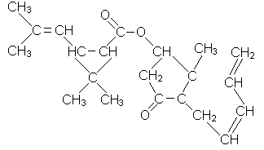

a) What are the two functional groups present in this molecule?
b) One of the compounds used to prepare a sample of pyrethrum is chrysanthemic acid, name after the species of chrysanthemum from which the insecticide is obtained. Draw the structure of chrysanthemic acid.

20. Aspirin has the structure shown in the diagram below.

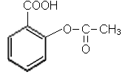

a) Identify the functional groups in the molecule.
b) The synthesis of aspirin usually involves the reaction between two compounds. From the structure given, propose structures for these two organic compounds.
c) Suggest the experimental conditions that might be used to prepare aspirin from these two organic compounds.

Deep Heat is an ointment that is used to relieve muscle pain. The structure of Deep Heat is shown below.

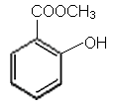

d) Deep Heat and aspirin can be formed from the same organic compound. Using your answers from parts b) and c), suggest how you would experimentally prepare Deep Heat.

21. Butan-1-ol has a boiling point of 117°C while butan-1-amine boils at 78°C. Explain the difference.

22. Methanamine, ethanamine and propan-1-amine are very soluble in water. Why are these amines so much more soluble in water than the parent alkanes from which they are derived?

23. The structure of amphetamine was given in Figure 12.21 and is given again below.

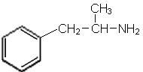

a) The pH of the digestive juices of the stomach are usually between pH 1 and 2. Draw the structure of amphetamine as it would exist in the stomach.
b) How might this affect the solubility of amphetamine?

24. A mixture of hexan-1-ol and hexan-1-amine is placed in a beaker of water.

a) Describe the appearance of the resulting mixture.
b) Dilute hydrochloric acid is added to the beaker and the pH drops to 2. Describe and explain any change that is observed when the contents of the beaker are stirred.

25. What does the prefix ‘’ mean when referring to an -amino acid?

26. Explain why all amino acids are solids at room temperature.

27. The structure of the -amino acid glycine is drawn in Figure 12.23.

a) What is wrong with this structural presentation?
b) Use equations to show how glycine can act as a buffer in aqueous solution at around pH 7.

28. Electrophoresis is a process in which a substance is placed on a piece of porous paper soaked in an electrolyte. The paper has an electrode attached at each end, one of which is connected to the positive terminal of a battery and the other to the negative terminal of the battery. If the substance moves in one direction along the paper, it is possible to establish whether it has an overall positive or negative charge.

The amino acid alanine is placed on three strips of paper as shown in the diagram below. The first strip of paper has been soaked in an electrolyte at a pH 6-7. The second strip has been soaked in an electrolyte with a pH of 9-10 and the third strip has been soaked in an electrolyte with a pH of 3.

Strip 1: pH 6-7

Strip 2: pH 9-10

Strip 3: pH 3

Describe how the alanine will move (if at all) on the three strips when an electric current flows, and explain the observations.

Soaps and detergents
Polymers

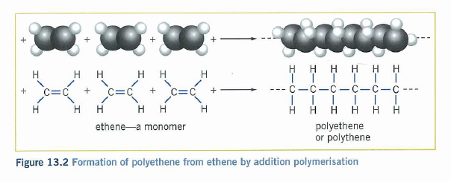
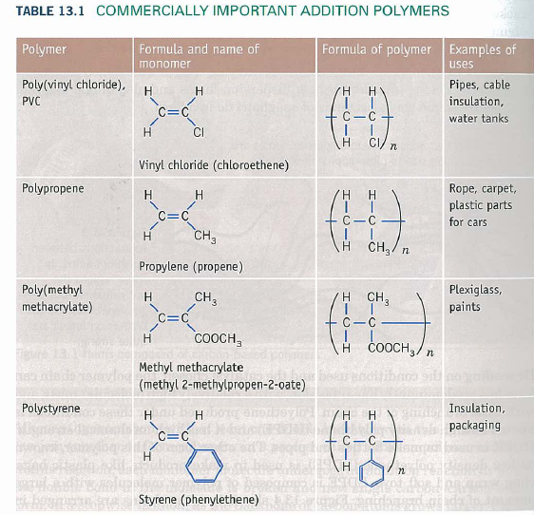
Condensation polymerisation

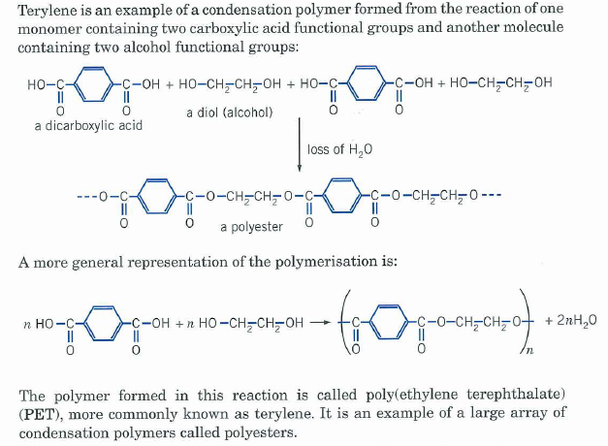
Proteins

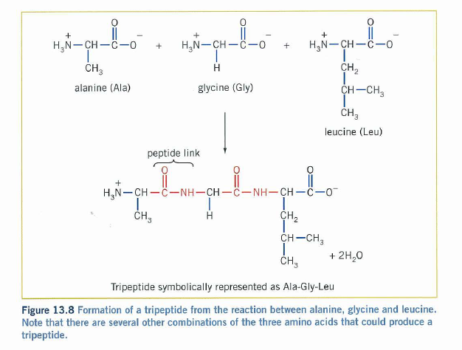

Review exercise 13.1

1. In what way does the monomer for addition polymerisation differ from the monomer involved in condensation polymerisation? Give an example to support your answer.

2. a) Draw the repeating unit in the polymer made from the polymerisation of but-2-ene.
b) Give the structural formula of the monomer that was used to make the polymer represented in the segment below:

H CH₃ COCH₃ H H CH₃

- - - C C C C C C - - -

H COCH₃ CH₃ H H COCH₃

3. Substance X has the structure:

H CH₃

C = C

Br H

a) Draw the structural formula of substance Y, a geometrical isomer of X.
b) X and Y each undergo addition polymerisation. Draw the structure of part of the polymer formed from each, including at least six carbon atoms in the backbone of the chain. How do the addition polymers from these two geometrical isomers compare?
c) Z is a structural isomer of X. Draw the structural formula of Z.
d) Z also undergoes addition polymerisation. Draw the structure of part of the polymer formed from Z, showing at least six carbon atoms in the backbone of the chain.

4. Draw the repeating unit in polymers made from the following monomers:

a) CH₂ CH₂ CH₂ CH₂
+
OH OH COOH COOH

b) Cl CH₃

CH₂ CH + CH CH₂

COOH COOH NH₂ NH₂

5. The structures of the amino acids isoleucine and alanine are shown below:

O

H₂N – CH – C – OH NH₂

CH – CH₃ CH₃ – CH

CH₂ C = O

CH₃ OH

isoleucine alanine

Draw the structures of the two dipeptides that can be formed from these two substances.

6. A 1:1 molar mixture of (C₂H₅)₂SiCl₂ and (CH₃)₂SiCl₂ is polymerised in the presence of water.

a) If these monomers combine in an ‘ideal’ fashion on the basis of the 1:1 mole ratio, what would be the formulas of the repeating unit?
b) Explain why this ‘ideal’ polymer structure is not likely to be obtained.

Review exercise 13.2

1. Copy and fill in the gaps for the following paragraphs:

Soap as a cleaning agent

A soap is often described as a s______________. Its function is to assist water to remove g______________, o______________, d______________ and other water-i______________ materials that adhere to surfaces.
To understand the cleaning process, the nature of the surfactant needs to be examined. The surfactant is a large ion consisting of a n______________ charged end and an uncharged, n______________-p______________ end. Polar or charged particles tend to dissolve in p______________ solvents, whereas non-polar substances tend to dissolve in n______________ solvents. Water is a p______________ solvent which can form h______________ b______________ with the c______________ end of the surfactant. This c______________ end is known as the h______________ or ‘water-loving’ end of the surfactant. As a result, this end of the surfactant ion tends to d______________ readily in water.
On the other hand, the other n______________-p______________ end tends not to dissolve in water. However, this h______________ or ‘water-hating’ end of the ion can readily mix with n______________-p______________ dirt, g______________ or o______________. Hence, the n______________-p______________ hydrocarbon end of the surfactant attaches to the n______________-p______________ grease or oil while the charged end if h______________ b______________ to the water molecules.
When the water is agitated, the o______________ and g______________ are removed from the surface being cleaned because they are attached by d______________ forces to the h______________ end of the surfactant ion. The grease tends to be surrounded by spherical aggregates of s______________ i______________ whose polar ‘heads’ are directed towards the w______________ and the non-polar ‘tails’ are attached to the g______________.

2. A Year 12 test paper gave the structure of glyceryl tripalmitate as:

O

CH₂-C-OCH₂CH₂CH₂CH₂CH₂CH₂CH₂CH₂CH₂CH₂CH₂CH₂CH₂CH₂CH₃

O

CH-C-OCH₂CH₂CH₂CH₂CH₂CH₂CH₂CH₂CH₂CH₂CH₂CH₂CH₂CH₂CH₃

O

CH₂-C-OCH₂CH₂CH₂CH₂CH₂CH₂CH₂CH₂CH₂CH₂CH₂CH₂CH₂CH₂CH₃

a) Draw the correct structure for this molecule (palmitic acid is C₁₅H₃₁COOH).

Glycerol tripalmitate is boiled with a concentrated solution of sodium hydroxide. Salt is added to the mixture and the solid precipitate is collected and washed.

b) Draw the structural formula of the solid obtained.
c) The aqueous filtrate is fractionally distilled under reduced pressure. After the water is boiled off another colourless, organic liquid if collected. Draw the structure of this liquid.

3. Compare and contrast the properties and action of soap and detergent.

QUESTIONS

1. Draw the structure of the monomer(s) used to make polymers having the following partial structures.

a) CH₃ Br Cl H CH₃ Br

- - - C – C – C – C – C – C - - -

H Cl Br CH₃ H Cl

b) CH₃ H COOCH₃ H CH₃ CH₃ COOCH₃

- - - C – C – C C C – C – C - - -

H CH₃ H COOCH₃ H H H

2. a) Write the equation for the formation of Teflon from tetrafluorethene.
b) RESEARCH – Recently there have been concerns expressed about the use of Teflon in cookware. List these concerns and debate whether the use of Teflon cookware should be banned.

3. a) Explain why the branched chain polymer of ethene is called low density polyethylene (LDPE).
b) Why is high density polyethylene (HDPE) less flexible than LDPE?
c) LDPE has a density of around 0.92 g cm⁻³ while HDPE has a density above 0.94 g cm⁻³. How do the structures of the carbon skeletons of these two polymers account for these differences?
d) Predict the differences, if any, between the melting (or softening) points of LDPE and HDPE. Justify your answer.
e) Why is it preferable to make children’s toys from polyethene rather than from metals?

4. The cling wrap plastic used in kitchens to wrap food were originally made from PVC (poly(vinyl chloride)). However there were concerns about the possible toxicity and leaching of the plasticisers added to the PVC to produce the thin flexible film. As a result, this material is now made predominantly from LDPE, even though in this form it is less ‘clingy’ than PVC.

a) What properties of LDPE make it suitable for use as a plastic cling wrap?
b) Draw a partial structure for LDPE and PVC, showing at least six carbon atoms in the backbone.
c) Why would LDPE be ‘less clingy’ than PVC?

To deal with the problems associated with the LDPE film having inferior sticking properties, ethylene vinyl acetate (EVA) is incorporated into the cling film as it is made. EVA is a copolymer of ethaene and vinyl acetate (ethenyl acetate, CH₂=CHOCOCH₃).

d) Assuming ethene and vinyl acetate are mixed in a 1:1 ratio during the polymerisation, draw an ideal representation of the repeating unit in the EVA polymer.
e) Why is this repeating unit unlikely to be the best representation for the structure of the polymer?
f) What properties of EVA would enhance the ‘clinginess’ of a plastic wrap made from a combination with LDPE?

5. Polyacrylonitrile is made from the monomer shown below. Draw the structure of the polymer, showing at least three repeating units.

H H

C = C

H CN

6. What are the similarities and differences in the structures of the polymers obtained from using the reactants in part (i) below compared with using the reactant in part (ii)?

(i) O O

HO – C C – OH with H₂N NH₂

(ii) O

H₂N C – OH

7. Lactic acid is a molecule with both alcohol and carboxylic acid functional groups present in the same compound (see below). Lactic acid is produced during the metabolism of glucose to carbon dioxide and water.

CH₃

CH – CH – OH

OH O

a) Draw at least three repeating units in the polymer obtained from lactic acid.
b) What is the general name given to polymers of this type?
c) What other biologically important monomer has a structure similar in type to lactic acid? What is this similarity?

8. The lactic acid in question 7 can also form a condensation polymer with glycolic acid, shown below:

CH₂ – C – OH

OH O

a) Draw the structure of the repeating unit for the polymer formed from the reaction between these two monomers (lactic acid and glycolic acid).
b) This polymer is used in medicine to make stitches that dissolve over a period of time in the body. Explain what is likely to happen to these stitches in the body over the 2 weeks that it takes for them to ‘dissolve’.

9. Part of the structure of a polymer is shown in the diagram below:

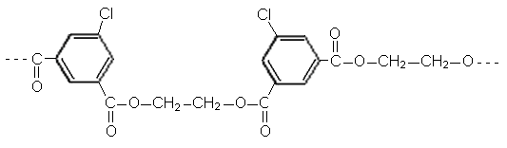

a) What type of polymer is this?
b) What else is produced in the reaction between the monomers during the formation of this polymer?
c) Draw the structure of the monomers that were used in the formation of this polymer.

10. The repeating unit in Kevlar is drawn below:

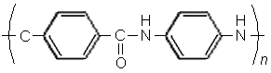

Draw the structure of the monomer(s) from which this polymer is made.

11. Consider the structures of Kevlar, nylon 6,6 and nylon 6,10:

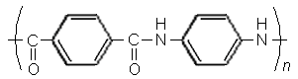
Kevlar

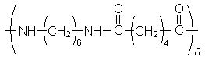
Nylon 6,6

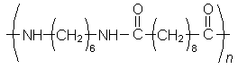

a) What is common to each of these polymers?
b) Which one of nylon 6,6 or nylon 6,10 would you expect to be more flexible? Explain your answer.
c) Which one of nylon 6,6 or nylon 6,10 would you expect to be stronger when used as a rope or as a fibre?
d) Kevlar is used in bullet-proof vests. What properties does Kevlar possess, in comparison to the two forms of nylon, that make it suitable for this use?
e) Nylon 6 is the name given to a form of nylon made by condensation polymerisation using only one monomer. Using the information above about the structure of nylon 6,6 and nylon 6,10, propose a structure for this monomer and draw the repeating unit in nylon 6.

12. In Figure 13.9 the structure of a tripeptide formed from alanine, glycine and leucine is drawn. When peptides such as this are drawn, it is convention to have the amino group on the right. The short-hand representation of Ala-Gly-Leu then conveys not only the sequence of amino acids, but also the way that the peptide or amide link is formed between the monomers.

a) Are the tripeptides Ala-Gly-Leu and Ley-Gly-Ala the same molecules? Explain your answer.
b) Represent all the possible sequences of these three amino acids that could exist using the three letter codes and the convention that the amine group is always on the left.

13. A particular polypeptide undergoes partial hydrolysis to produce several smaller peptides. Four of the hydrolysis products are found to be (the three-letter code represents a particular amino acid):

Glu-Trp-Met-Arg
Ser-Glu-Trp
Arg-Gly-Pro-Val
Met-Arg-His-Arg-Gly

Assuming all of the amino acids in the polypeptide are represented in these hydrolysis products, use this information to draw a representation (showing the correct order of amino acids) of the polypeptide.

14. What is the difference between the primary structure and the secondary structure of a protein in terms of the types of bond involved?

15. Recent research from teams of chemists in Turkey and the USA has produced a polymer materials with the repeating unit shown below:

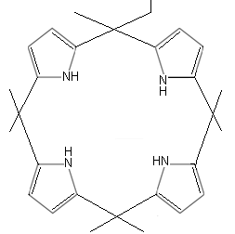
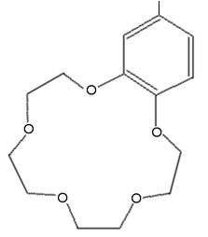
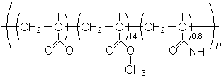

a) What are the two functional groups joined to the carbon backbone of the polymer?
b) Draw the structures of the three monomers that would be used to construct the polymer.
c) The polymer was designed to be able to remove cations and anions from an aqueous medium and was found to be effective in the removal of fluoride ions, chloride ions and potassium ions. Using your knowledge of ion-dipole interactions, suggest which of the two large side groups collects the cations and which collects the anions, explaining how you reached your conclusion.
d) The polymer was found to be more efficient at removing potassium ions than sodium ions. What factor might be responsible for this observation?
Note: This last observation opens up options to alter the structure of such polymers for specific purposes such as the desalination of water supplies or the removal of phosphates from water supplies. Perhaps it is possible to suggest what changes might be considered.

16. How does the backbone of a silicon polymer differ from that of an addition polymer such as polyethene?

17. Draw three repeating units in the silicone polymer prepared from the chlorosilane shown below:

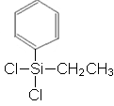

18. Explain why the addition of a silane of general formula R₃SiCl will control the molecular mass of the resulting polymer.

19. Silicone sealants are supplied in a tube containing linear silicones with the following structural representation:

OCOCH₃ CH₃ OCOCH₃

- - - - Si – O – Si – O – Si – O - - - -

OCOCH₃ CH₃ OCOCH₃

The sealant forms a cross-linked polymer and the reaction is enhanced by the presence of water. As the silicone hardens and seals, it is possible to smell and odour like vinegar.

Suggest what is happening to this structure and draw a representation of the polymer chain after it has hardened and formed a seal. (Hint: Draw an identical linear chain underneath the first structure and look for a small molecule that can be eliminated in the presence of moisture). What general type of reaction is taking place during the cross-linking?

20. Identify each of the following as glycerol, a fatty acid, a fat, a soap or a detergent.

Compound A
Na+ ⁻OOCH(CH₂)7CH=CH(CH₂)₇CH₃
Compound B
O
CH₂-O-C-CH₂CH₂CH₂CH₂CH₂CH₂CH₂CH₂CH₂CH₂CH₂CH₂CH₂CH₂CH₂CH₂CH₃
O
CH-O-C-CH₂CH₂CH₂CH₂CH₂CH₂CH₂CH₂CH₂CH₂CH₂CH₂CH₂CH₂CH₂CH₂CH₃
O
CH₂-O-C-CH₂CH₂CH₂CH₂CH₂CH₂CH₂CH₂CH₂CH₂CH₂CH₂CH₂CH₂CH₂CH₂CH₃
Compound C
CH₂-CH-CH₂
OH OH OH
Compound D
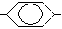CH₃CH₂CH₂CH₂CH₂CH₂CH₂CH₂CH₂CH₂CH₂CH₂CH₂CH₂CH₂ SO₃⁻Na⁺
Compound E
CH₃CH₂CH₂CH₂CH₂CH₂CH₂CH₂CH₂CH₂CH₂CH₂CH₂CH₂CH₂CH₂CH₂CH₂COOH

21. Copy and complete the equation to show the formation of soap in the reaction of the following fat with sodium hydroxide solution:

CH₂ – OOC – (CH₂)₁₆CH₃

CH – OOC – (CH₂)₁₆CH₃ + ______ NaOH → _______ + _______

CH₂ – OOC – (CH₂)₁₆C₃

22. Match the word or term with its correct definition:

a) saponification A an ion that consists of a negatively charged ‘end’ and a long non-polar chain ‘end’
b) hydrophobic group B the water-loving or charged ‘end’ of a surfactant ion

c) hydrophobic group C process in which a fat or an oil is reacted with NaOH or KOH

d) surfactant ions D the water-hating or non-polar ‘end’ of a surfactant ion

23. Consider the substances shown below:

i. CH₃CH₂CH₂CH₂CH₂CH₂CH₂CH₂CH₂CH₂CH₂CH₂CH₂CH₂CH₂CH₂ COO⁻
end A end B
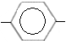
ii. R SO₃⁻ where R is a long hydrocarbon chain
end A end B

iii. ⁻OOC-(CH₂)₂₀CH₃
end A end B

a) Identify the non-polar end and the polar end in each substance.
b) Identify the hydrophobic end and the hydrophilic end in each substance.
c) Which end of each substance would be soluble in grease?

24. Soap micelles form when the hydrocarbon ends of the soap molecules bond together by dispersion forces and leave the polar anionic ends on the outside of the spherical surface. The formation of micelles is necessary for the soap to remain dispersed in the water.

Explain how the presence of unsaturated hydrocarbon chains in the triglyceride used to make a particular soap might affect:

a) the properties of the soap in terms of the intermolecular bonding between soap molecules
b) other chemical reactions of the soap
c) how solid the soap is.

25. A newspaper advertisement announces a new detergent that is on the market. The advertisement identifies the active ingredient as trimethylhexadecylammonium chloride. When you look up the formula of this substance it is listed as CH₃(CH₂)₁₅N(CH₃)₃⁺Cl⁻.

a) Explain why you think this would or would not be a suitable detergent for everyday use in Western Australia.
b) What general name might be used to classify a detergent such as this?

Chemistry 12 2009
Organic Assignment
Multiple choice

1. A compound has the formula C₆H₁₂. Which one of the following could it be?
(a) A straight chain alkane.
(b) A branched chain alkane.
(c) An alkene with one double bond.
(d) An alkyne with one triple bond.

2. Only one of the following is a correct formula. Which is it?

(a) CH₃ - CH - CH₂ - CH₃
(b) CH₃ – CH₂ - CH - CO -C(CH₃)₃
(c) CH₃ - CH₂ - NH₂ - CH - CH₂
(d) (CH₃)₂CH₂

3. How many compounds are possible with formula C₂F₄Cl₂?

(a) 1
(b) 2
(c) 3
(d) 4

4. Which formula represents two substances which are geometric (cis/trans) isomers?
(a) C₃H₆
(b) C₃H₈
(c) H₂CC(CH₃)₂
(d) CH₃CHCHCH₃

5. Which one of the following substances would yield a carboxylic acid when treated with a solution containing sodium dichromate and sulfuric acid?
(a) 1-propanol
(b) 2-propanol
(c) 2-methyl-2-propanol
(d) propanone

6. Which one of the following substances would yield a ketone when treated with a solution containing sodium dichromate and sulfuric acid?

(a) 1-propanol
(b) 2-propanol
(c) 2-methyl-2-propanol
(d) 1,3-propanediol

7. Which one of the following is an esterification reaction?
(a) CH₃CH₂CH₃ + Br₂  CH₃CH₂CH₂Br + HBr
(b) CH₃COOH + CH₃OH  CH₃COOCH₃ + H₂O
(c) CH₃CHCH₂ + HBr  CH₃CH₂CH₂Br
(d) CH₃COOCH₃ + OH⁻  CH₃COO⁻ + CH₃OH

8. Which one of the following organic structural formulae is correct?

(a) CH₃-CH₂ -CH₂ = CH₂ -CH₃
(b) CH₃-CH₂ –O-CH₃
(c) CH₃-CH₂ = C = CH
(d) CH₃ CH₃

C

CH₃

9. Which one of the following could be formed by the reaction between sodium and ethanol?

- CH₃CH₂Na
- CH₃CH₂⁻
- CH₃CH₂O⁻
- CH₃CHO

10. Which one of the following substances can be made from just the materials listed?

Substance Starting Materials
(a) propyl ethanoate propanoic acid, ethanol, and concentrated sulfuric acid.

(b) polyvinyl chloride dichloroethane and a catalyst.

(c) soap concentrated sodium hydroxide solution and glycerol.

(d) ethanoic acid ethanal, sodium dichromate, and dilute sulfuric acid.
Short answer questions

1. A solution containing potassium permanganate and sulfuric acid is warmed with ethanol: the purple colour in the solution disappears, and a vinegar odour due to the formation of ethanoic acid is observed. Write the equation for the reaction that has occurred.

Oxidation half-equation

2 marks
1 mark
Redox equation

2 marks

[5 marks]

2. Classify each of the substances in the table below as one of the following:
aldehyde | ester
alkane | haloalkane
alkene | ketone
alkyne | primary alcohol
amine | secondary alcohol
carboxylic acid | tertiary alcohol

Compound | Class | Compound | Class
CH₃CH₂CHFCHFCH₃ |  | CH₃CHCHCH₃
CH₃CH₂COOH |  | CH₃COCH₃
CH₃COOCH₂CH₃ |  | CH₃CHNH₂CH₃
CH₃CH₂CH₂CHO |  | CH₃C(CH₃)OHCH₃

[4 marks]

3. Draw structural formulae for and name four isomers of formula C₄H₈O₂
(8 marks)

4. An amine may be regarded as a relative of ammonia. Methanamine is a liquid with a low boiling point and has a smell like stale biscuits.
When methanamine is shaken with hydrochloric acid the smell disappears.
What has happened ?

When a little sodium hydroxide is added to the resulting mixture the smell returns. Why is this ?
.

(4 marks)

5. The table below lists some organic compounds and identifies one of the reactants needed to prepare it. Complete the table by inserting the names of suitable reagents.
reagent 1 + | reagent 2 → | product
 | ethanoic (acetic) acid | ethanol
 | methanoic acid | 1-butyl methanoate
 | ethyne | 1,1-difluoroethane

(3 marks)

Calculation
Two different compounds, A and B, are shown on analysis to consist of 40.0% carbon, 6.70% hydrogen and 53.3% oxygen by mass.
Tests show the following:
Compound A can be vaporised so that 4.88g of it occupy 5.00L at 100 kPa and 97ºC.
Compound A can be oxidised with acidified potassium permanganate solution to yield a substance that reacts with magnesium ribbon.
Compound B has a molar mass of 60.0 gmol⁻¹ and reacts with 1-propanol in the presence of concentrated sulfuric acid to form a fruity smelling liquid.

(a) Determine the empirical formula of compounds A and B.
(4 marks)
(b) Determine the molar mass of compound A and state what class of compound it is.
(4 marks)
(c) Draw a structure for a molecule of compound B and name the compound.
(2 marks)
(d) Name the substance formed by the reaction of compound B with 1-propanol.
(1 mark)
(11 marks)

Organic assignment 2009 ANSWERS

Name ____________________________________

/45
1 | 2 | 3 | 4 | 5 | 6 | 7 | 8 | 9 | 10
a | a | a | a | a | a | a | a | a | a
b | b | b | b | b | b | b | b | b | b
c | c | c | c | c | c | c | c | c | c
d | d | d | d | d | d | d | d | d | d

Short answer questions

1. A solution containing potassium permanganate and sulfuric acid is warmed with ethanol: the purple colour in the solution disappears, and a vinegar odour due to the formation of ethanoic acid is observed. Write the equation for the reaction that has occurred.

Oxidation half-equation
CH₃CH₂OH + H₂O → CH₃COOH + 4H⁺ + 4e

2 marks
MnO₄⁻ + 8H⁺ + 5e → Mn²⁺ + 4H₂O
1 mark
Redox equation

5C₂H₅OH + 4 MnO₄⁻ + 12H⁺ → 5CH₃COOH + 4 Mn²⁺ + 11 H₂O

2 marks

[5 marks]

2. Classify each of the substances in the table below as one of the following:

aldehyde | ester
alkane | haloalkane
alkene | ketone
alkyne | primary alcohol
amine | secondary alcohol
carboxylic acid | tertiary alcohol

Compound | Class | Compound | Class
CH₃CH₂CHFCHFCH₃ | haloalkane | CH₃CHCHCH₃ | alkene
CH₃CH₂COOH | carboxylic acid | CH₃COCH₃ | ketone
CH₃COOCH₂CH₃ | ester | CH₃CHNH₂CH₃ | amine
CH₃CH₂CH₂CHO | aldehyde | CH₃C(CH₃)OHCH₃ | tertiary alcohol

[4 marks]

3. Draw structural formulae for and name four isomers of formula C₄H₈O₂
(8 marks)

propyl methanoate

methyl ethyl methanoate

ethyl ethanoate

methyl propanoate
4. An amine may be regarded as a relative of ammonia. Methanamine is a liquid with a low boiling point and has a smell like stale biscuits.
When methanamine is shaken with hydrochloric acid the smell disappears.
What has happened ?
CH₃NH₂ + H⁺ → CH₃NH₃⁺ 1 mark
The amine molecule accepts a proton from the acid and is neutralised 1 mark
When a little sodium hydroxide is added to the resulting mixture the smell returns. Why is this ?
CH3NH3⁺ + OH- → CH3NH2 + H2O 1 mark
The hydroxide ion accepts the proton and the amine is regenerated. 1 mark

(4 marks)

5. The table below lists some organic compounds and identifies one of the reactants needed to prepare it. Complete the table by inserting the names of suitable reagents.
reagent 1 + | reagent 2 → | product
Oxalic acid | ethanoic (acetic) acid | ethanol
butanol | methanoic acid | 1-butyl methanoate
Hydrogen fluoride | ethyne | 1,1-difluoroethane

(3 marks)

Calculation
Two different compounds, A and B, are shown on analysis to consist of 40.0% carbon, 6.70% hydrogen and 53.3% oxygen by mass.
Tests show the following:
Compound A can be vaporised so that 4.88g of it occupy 5.00L at 100 kPa and 97ºC.
Compound A can be oxidised with acidified potassium permanganate solution to yield a substance that reacts with magnesium ribbon.
Compound B has a molar mass of 60.0 gmol⁻¹ and reacts with 1-propanol in the presence of concentrated sulfuric acid to form a fruity smelling liquid.

(a) Determine the empirical formula of compounds A and B.
(4 marks)
(b) Determine the molar mass of compound A and state what class of compound it is.
(4 marks)
(c) Draw a structure for a molecule of compound B and name the compound.
(2 marks)
(d) Name the substance formed by the reaction of compound B with 1-propanol.
(1 mark)
(11 marks)
(a)
C | H | O
% = 40.0 | 6.70 | 53.3
n = 40/12.01 = 3.33 | 6.70/1.008 = 6.65 | 53.3/16 = 3.33
Ratio 1 | 2 | 1

Empirical formula is CH₂O

(b) PV = nRT n = 0.1625 mol 1 mark
Mr = m/n = 4.88/0.1625 = 30 1 mark
Mr / EF m = 1 true formula is CH₂O 1 mark
an aldehyde. 1 mark

(c) Compopund B has the empirical formula CH₂O

Mr / EF m = 2 1 mark
The formula is C₂H₄O₂

acetic acid structure 1 mark

(d) propyl ethanoate 1 mark

