3AB Chemistry

redox

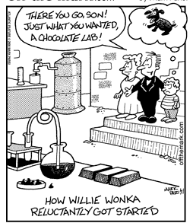
http://www.google.com.au/imgres?imgurl=http://www.offthemarkcartoons.com/cartoons/2001-09-29.gif&imgrefurl=http://www.offthemark.com/search-results/key/chemistry&h=320&w=240&sz=16&tbnid=K7yFo3p23vYLnM:&tbnh=118&tbnw=89&prev=/images%3Fq%3Dchemistry%2Bcartoons&hl=en&usg=__yAcZCwPFRJV_0FSnxscvLAvXC2A=&ei=quu_S4bSI47i7AOUi4nCCQ&sa=X&oi=image_result&resnum=2&ct=image&ved=0CA0Q9QEwAQ

Tyson

Name: _________________________

Oxidation and reduction
- Apply the table of Standard Reductions Potentials to determine the relative strength of oxidising and reducing agents to predict reaction tendency
- Apply oxidation numbers to identify redox equations and/or oxidants and reductants
Identify by name and/or formula common oxidising and reducing agents including O₂, Cl₂, MnO₄⁻, Cr₂O₇²⁻, ClO⁻, H⁺, concentrated sulfuric acid, concentrated nitric acid and common reducing agents (reductants) including Zn, C, H₂, Fe²⁺, C₂O₄²⁻

- Describe and explain the role of the following in the operation of an electrochemical (galvanic) cell:
- Anode processes
- Cathode processes
- Electrolyte
- Salt bridge and ion migration
- Electron flow in external circuit
- Describe the electrical potential of a galvanic cell as the ability of a cell to produce an electric current
- Describe and explain how an electrochemical cell can be considered as two half-cells
- Describe the role of the hydrogen half-cell in the table of Standard Reduction Potentials
- Describe the limitations of Standard Reduction Potentials table
You are already very familiar with a wide range of redox reactions including metal displacement reactions, combustion reactions and the reactions of metals with acids.
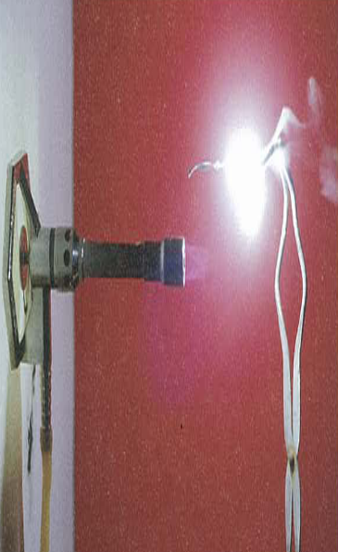
Let’s burn a piece of magnesium ribbon

Magnesium burning
Chemistry WA Stage 2 2A/2B Pearson Heinemann
Figure 14.2 Page 336

Write a balanced chemical equation for this reaction

___________________________________________

Do you think the magnesium ribbon has gained electrons or lost electrons?

___________________________________________

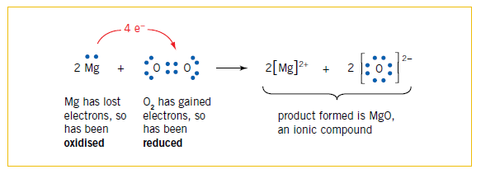

Electron dot representation of magnesium reacting with oxygen
Chemistry WA Stage 2 2A/2B Pearson Heinemann
Figure 14.3 Page 337

Let’s react zinc metal with hydrochloric acid

How do we define a redox reaction?

____________________________________________________________________

____________________________________________________________________

Define the term oxidation

_____________________________________________________________________

Define the term reduction

_____________________________________________________________________

Define the term oxidant (oxidising agent)

_____________________________________________________________________

Define the term reductant (reducing agent)

_____________________________________________________________________
Identify which reactant has been oxidised and which has been reduced in the following examples

a) 2Fe³⁺(aq) + Cu(s) → Cu²⁺(aq) + 2Fe²⁺(aq)

b) Br₂(aq) + S²⁻(aq) → 2Br ⁻(aq) + S(s)

c) Pb²⁺(aq) + 2Cl⁻(aq) → PbCl₂(s)

Rules for assigning oxidation numbers
- Combined hydrogen is ___________
- Combined oxygen is _________ except in peroxides when it is __________
- Atoms of elements in elemental state are
- The sum of the oxidation numbers is equal to the charge on the atom or ion

Review exercise 9.1 text page 265

1. Which of the following equations represent redox reactions? For those that are redox, identifying the oxidant and the reductant.

a) Na(l) + Cl₂(g) → NaCl(s)
b) Cu²⁺(aq) + 2OH⁻(aq) → Cu(OH)₂(s)
c) Mg(s) + S(s) → MgS(s)
d) Br₂(aq) + 2I⁻(aq) → 2Br⁻(aq) + I₂(s)

2. Use the information in Figure 9.2 to write the two half-equations and the overall ionic equation for any reaction that takes place when the two substances named are combined.

a) Iron is placed into a solution of silver nitrate.
b) Magnesium is added to a copper(II) sulfate solution.
c) Zinc chloride solution is poured into an iron vessel.
d) A solution of silver nitrate is placed in a copper container.
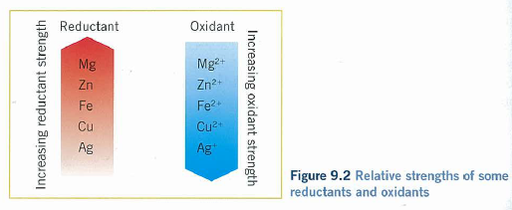
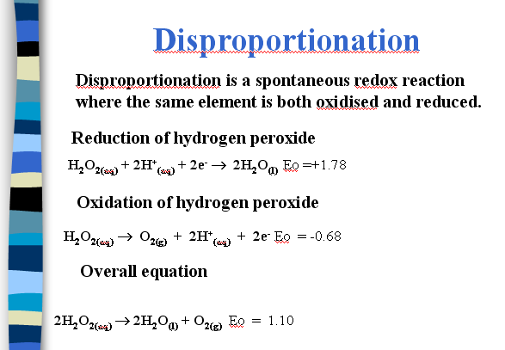

Review exercise 9.2 text page 271

1. What is the oxidation number of sulfur in each of the following?

a) H₂S
b) S₈
c) H₂SO₃
d) SO₃
e) Na₂SO₄
f) CS₂

2. Write formulas for compounds in which nitrogen has the following oxidation numbers.

a) -3
b) 0
c) +1
d) +2
e) +3
f) +5

3. As shown in Figure 9.5 when ammonium dichromate is ignited a spectacular explosive reaction occurs to produce dark green flakes of chromium(III) oxide, nitrogen gas and steam. Write an equation for this decomposition reaction and use oxidation numbers to determine if it is a redox reaction.
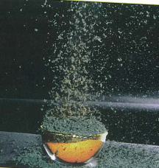
Figure 9.5 Decomposition of ammonium dichromate

4. Write the individual oxidation and reduction half-equations and the balanced overall ionic equation for the following reactions carried out in an acidic solution.
a) Cr₂O₇²⁻(aq) + SO₃²⁻(aq) → Cr³⁺(aq) + SO₄²⁻(aq)
b) Cu(s) + NO₃⁻(aq) → Cu²⁺(aq) + NO₂(g)
c) Br⁻(aq) + MnO₄⁻(aq) → Mn²⁺(aq) + Br₂(aq)

5. Write balanced ionic equation for the following reactions.

a) When sulfur dioxide is bubbled through an acidified solution of potassium permanganate the sulfur dioxide is converted to sulfate ions and a pale pink solution forms.
b) When a solution of iron(II) sulfate is added to an acidified solution of sodium dichromate a green solution forms.
c) Zinc metal is added to concentrated sulfuric acid and sulfur dioxide is produced.

Table 9.2 lists some common oxidants and reductants, together with the product of the reaction and the relevant half-equation.

TABLE 9.2 SOME COMMON OXIDANTS AND REDUCTANTS

Reactant | Product | Half-equation
Oxidants
O₂ | H₂O | O₂(g) + 4H⁺(aq) + 4e⁻ → 2H₂O(l)
Cl₂ | Cl⁻ | Cl₂(g) + 2e- → 2Cl⁻(aq)
MnO₄⁻  purple | Mn²⁺  pale pink | MnO₄⁻(aq) + 8H⁺(aq) + 5e⁻ → Mn²⁺(aq) + 4H₂O(l)
Cr₂O₇²⁻  orange | Cr³⁺  green | Cr₂O₇²⁻(aq) + 14H⁺(aq) + 6e⁻ → 2Cr³⁺(aq) + 7H₂O(l)
ClO⁻ | Cl⁻ | ClO⁻(aq) + 2H⁺(aq) + 2e⁻ → Cl⁻(aq) + H₂O(l)
H⁺ | H₂ | 2H⁺(aq) + 2e⁻ → H₂(g)
H₂SO₄ | SO₂ | H₂SO₄(l) + 2H⁺(aq) + 2e⁻ → SO₂(g) + 2H₂O(l)
HNO₃ | NO₂  brown gas | NO₃⁻(aq) + 2H⁺(aq) + e⁻ → NO₂(g) + H₂O(l)
Reductants
Zn | Zn²⁺ | Zn(s) → Zn²⁺(aq) + 2e⁻
C | CO₂ | C(s) + 2O²⁻(s) → CO₂(g) + 4e⁻
H₂ | H⁺ | H₂(g) → 2H⁺(aq) + 2e⁻
Fe²⁺  pale green | Fe³⁺  orange | Fe²⁺(aq) → Fe³⁺(aq) + e⁻
C₂O₄²⁻ | CO₂ | C₂O₄²⁻(aq) → 2CO₂(g) + 2e⁻

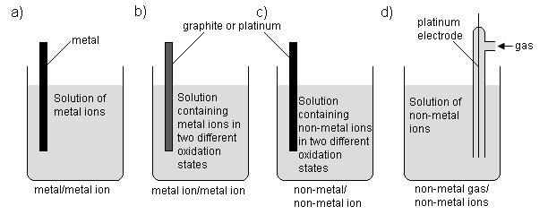
Electrochemical cells
Use chemical reactions to produce electricity.

Why do we need 2 half cells?

What are electrodes?

What is purpose of electrolyte?

Where do electrons flow?

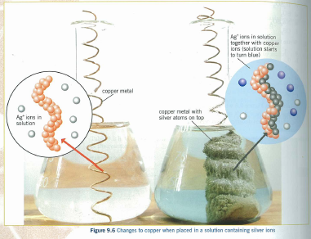

Review exercise 9.3 text ref page 276

1. Draw and label an electrochemical cell that produces electrical energy from the reaction:

Fe(s) + Cu²⁺(aq) → Fe²⁺(aq) + Cu(s)

Your diagram should include the anode and cathode, the half-equations for each electrode, the nature of the electrolyte in each half-cell, the direction of electron flow and the direction of ion migration. In which half-cell does the oxidation reaction take place and in which does the reduction reaction occur?

2. For an electrochemical cell, explain why anions in the salt bridge migrate towards the half-cell containing the anode.

3. Account for the observation that a piece of copper placed in a beaker with a solution of sodium sulfate, connected by a salt bridge to a solution of silver nitrate in another beaker containing a piece of graphite, will produce electrical energy in the same way as the cell depicted in Figure 9.7. (Assume the copper and graphite are connected by a wire in the external circuit.)
Fig 9.7
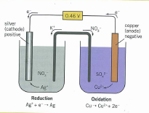
4. The redox reaction:

Zn(s) + 2H⁺(aq) → Zn²⁺(aq) + H₂(g)

can be used to convert chemical energy into electrical energy.

a) Draw and label an electrochemical cell in which this energy transformation can take place.
b) Identify the anode and cathode.
c) Give the half-equation that occurs at each electrode.
d) Identify the electrolyte in each half-cell.
e) Show the direction of electron flow and the direction of ion migrati
f) In which half-cell does the oxidation reaction take place and in which the reduction reaction.
g) Describe what you would expect to see in each of the half-cells during the operation of the electrochemical cell.
h) If the half-cells remain connected to one another for a long period of time, what till finally happen? Why?
Standard Reduction Potentials

Review exercise 9.4 text ref page 286

1. An electrochemical cell is composed of a Pb²⁺(aq)/Pb(s) half-cell, a Ag⁺(aq)/Ag(s) half cells and a potassium nitrate salt bridge.

a) Draw and label a diagram of the electrochemical cell and indicate the direction of electron flow in the external circuit.
b) Label the anode and the cathode, and write the reaction that occurs at each electrode.
c) What is the overall ionic equation for the cell reaction?
d) Describe the movement of ions within the solutions and the salt bridge.
e) Calculate the voltage (cell potential) produced by the cell under standard conditions.
f) During the operation of the cell the silver electrode changes in mass by 1.19 g. Will this be an increase or decrease in the mass of the electrode? Explain your answer.

2. For each of the cells drawn below determine the:

i) strongest oxidising agent in the electrochemical cell
ii) direction of the electron flow through the wire
iii) half-equations for the half-reactions that will occur in the cell
iv) equation for the overall reaction for the electrochemical cell
v) anode and cathode
vi) cell potential (assume standard conditions)
vii) direction of flow of the positive ions and negative ions

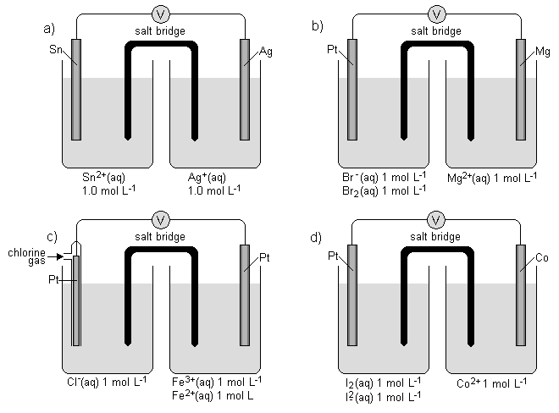

3. If the reaction Cu²⁺(aq) + 2e⁻ ⇌ Cu(s) had been chosen as the standard reference half-cell and had been assigned an E° of 0 V.

a) How would the table of standard reduction potentials differ?
b) How would the values of cell potentials for complete electrochemical cells differ?

4. You have been provided with the following materials:

- Strips of nickel, lead, tin, copper, a graphite rod and material to construct a salt bridge.
- 1 mol L⁻¹ solutions of the following: HCl, CuSO₄, Fe(NO₃)₂, NiSO₄, Sn(NO₃)₂, Fe(NO₃)₃, Pb(NO₃)₂

a) Draw a diagram of the electrochemical cell that would give the greatest voltage (cell potential) if constructed from these materials.
b) What would be the cell potential recorded under standard conditions?
c) On the cell diagram label the following:
anode, cathode, direction of electron movement, direction of movement of anions, half-cell in which oxidation takes place, half-cell in which reduction takes place, half-cell reactions.

Review exercise 9.5 text ref page 289
1. a) List the following in increasing strength (from weakest to strongest) as oxidants.

i I₂(aq)
ii Pb²⁺(aq)
iii Cr₂O₇²⁻/H⁺(aq)
iv Fe²⁺(aq)

b) List the following in order of decreasing tendency to undergo oxidation.

i Fe²⁺(aq)
ii Ag(s)
iii H₂O₂(aq)
iv Mg(s)

c) List the following in order of decreasing tendency to gain electrons in a redox reaction.

i Cu²⁺(aq)
ii Br₂(aq)
iii concentrated nitric acid
iv H⁺(aq)

2. For each of the following predict whether a redox reaction would occur. If a reaction does take place write the overall ionic equation and give any observations that would be made.

a) Chlorine gas is bubbled through a solution of potassium iodide.
b) A solution of cobalt sulfate is added to a solution of magnesium chloride.
c) Aluminium is added to a solution of silver nitrate.
d) An acidified solution of potassium permanganate is added to a solution of iron(II) sulfate.
e) Hydrogen sulfide gas is bubbled through a solution of concentrated nitric acid.
3. The standard reduction potentials for two different chromium-containing species are given below:

Cr₂O₇²⁻(aq) + 14H⁺(aq) + 6e⁻ ⇌ 2Cr³⁺(aq) + 7H₂O(l) E° = +1.33 V
Cr³⁺(aq) + e- ⇌ Cr²⁺(aq) E° = -0.42 V

Which one or more of the following would convert an acidified solution of sodium dichromate to chromium(III) ions but not to chromium(II) ions?

a) Zn(s)
b) I⁻(aq)
c) Au(s)
d) Fe²⁺(aq)

QUESTIONS page 290 text

1. Vanadium, being a typical transition metal, exhibits different oxidation states in its compounds. Four vanadium compounds are shown in solution in Figure 9.15. Determine the oxidation number of vanadium in each.
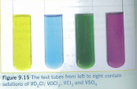
Figure 9.15 The test tubes from left to right contain solutions of VO₂Cl, VOCl₂, VCl₂, VCl₃ and VSO₄.

2. For each of the following reactions, identify which reactant has been oxidised and which has been reduced. If the reaction is not redox, then state that it is ‘NR’.

a) Zn(s) + 2H⁺(aq) → Zn²⁺(aq) + H₂(g)
b) Sn⁴⁺(aq) + Mg(s) → Sn²⁺(aq) + Mg²⁺(aq)
c) Br2(aq) + Ni(s) → 2Br⁻(aq) + Ni²⁺(aq)
d) Cu²⁺(aq) + CO₃²⁻(aq) → CuCO₃(s)
e) Cl₂(g) + 2Br⁻(aq) → 2Cl⁻(aq) + Br₂(aq)
f) 10Br⁻(aq) + 2MnO₄⁻(aq) + 16H⁺(aq) → 5Br₂(aq) + 2Mn²⁺(aq) + 8H₂O(l)
g) Ag⁺(aq) + Br⁻(aq) → AgBr(s)
h) 2Na(s) + 2H₂O(l) → 2Na⁺(aq) + 2OH⁻(aq) + H₂(g)
i) 3SO₂(g) + Cr₂O₇²⁻(aq) + 2H⁺(aq) → 3SO₄²⁻(aq) + 2Cr³⁺(aq) + H₂O(l)

3. Determine the oxidation number of chlorine in each of the following.

a) HCl
b) KCl
c) AlCl₃
d) HClO
e) NaClO
f) HClO₂
g) Mg(ClO₂)₂
h) HClO₃
i) KClO₃
j) HClO₄
k) NaClO₄
l) Cl₂O
m) SnCl₄
n) Cl₂

4. Balance the following equations by first writing the two half-equations.

a) Al(s) + Sn⁴⁺(aq) → Al³⁺(aq) + Sn²⁺(aq)
b) MnO₄⁻(aq) + H⁺(aq) + Fe²⁺(aq) → Mn²⁺(aq) + H₂O(l) + Fe³⁺(aq)
c) Cu(s) + NO3⁻(aq) + H⁺(aq) → Cu²⁺(aq) + NO₂(g) + H₂O(l)
d) MnO₄²⁻(aq) + H⁺(aq) → MnO₄⁻(aq) + MnO₂(s) + H₂O(l)
e) Cr₂O₇²⁻(aq) + I⁻(aq) + H⁺(aq) → Cr³⁺(aq) + IO₃⁻(aq) + H₂O(l)
f) ClO₃⁻(aq) + MnO₄⁻(aq) + H⁺(aq) → MnO₂(s) + ClO₄⁻(aq) + H₂O(l)
g) As₂O₃(s) + H⁺(aq) + NO₃⁻(aq) + H₂O(l) → H₃AsO₄(aq) + N₂O₃(g)
h) H₂SO₃(aq) + MnO₄⁻(aq) → Mn²⁺(aq) + H₂O(l) + SO₄²⁻(aq) + H⁺(aq)
i) CuS(s) + H⁺(aq) + NO₃⁻(aq) → Cu²⁺(aq) + S(s) + NO(g) + H₂O(l)
j) H₂C₂O₄(aq) + MnO₂(s) + H⁺(aq) → CO₂(g) + Mn²⁺(aq) + H₂O(l)

5. Write balanced ionic equations for the following.

a) When nickel is added to a dilute solution of nitric acid, gaseous NO is evolved and the solution becomes pale green.
b) Acidified potassium permanganate solution is de-colourised by oxalic acid.
c) When SO₂ gas is bubbled through an acidified solution of potassium dichromate, the SO₂ is oxidised to SO₄²⁻.
d) Oxygen gas is formed when a solution of hydrogen peroxide is added to an acidified solution of potassium permanganate.

6. Around 50 years ago the first compounds of the noble gases of group 18 were made. Today there are quite a few examples of these compounds and they have significant redox properties.

A compound with the formula H₄XeO₆ is added to a solution of hydrobromic acid, HBr. The solution turns orange and an unreactive gas (Xe) is produced. Write the half-equations for the oxidation and reduction reactions taking place and also the ionic equation for the overall reaction.

7. The active constituents of household bleach are chloride ions (Cl⁻) and hypochlorite ions (ClO⁻), which react in the presence of acid to form chlorine.

a) Write a half-equation for the reduction of ClO⁻ to Cl₂.
b) Write a half-equation for the oxidation of Cl⁻ to Cl₂.
c) Hence write an overall ionic equation for the reaction between chloride and hypochlorite ions to produce chlorine.

8. For each of the cells drawn on the next page determine the:

i stongest oxidant in the electrochemical cell
ii direction of the electron flow through the wire
iii half-equations that will occur in the cell
iv ionic equation for the overall reaction for the electrochemical cell
v anode and the cathode
vi cell potential (assume the solutions are 1.0 mol L⁻¹)
vii direction of flow of the positive ions and the negative ions.

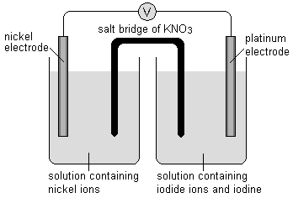
a)

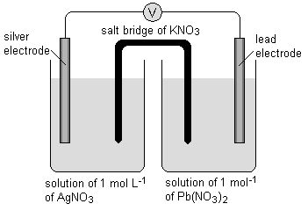
b)

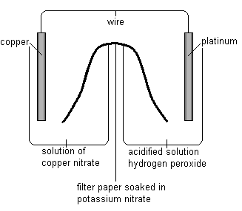
c)

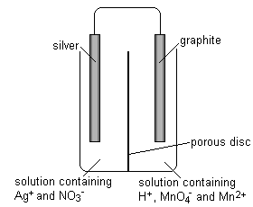
d)

9. An electrochemical cell consisting of Cr³⁺(aq)/Cr(s) and Fe³⁺(aq)/Fe²⁺(aq) half-cells is connected to a voltmeter. For this cell:

a) draw a diagram, labelling the anode and cathode and indicating the direction of charge flow through the circuit
b) write the separate half-equations, indicating which electrode each occurs at, and the equation for the overall cell reaction
c) calculate the standard cell potential.

10. Consider the following electrochemical cell.

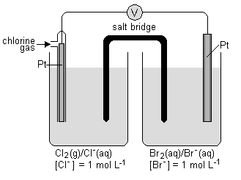

a) Write the equation for the cathode reaction.
b) In which direction do the electrons flow (towards Cl₂/Cl⁻ or towards Br₂/Br⁻)?
c) In which direction do the positive ions flow (towards Cl₂/Cl⁻ or towards Br₂/Br⁻)?
d) What is the oxidant in the cell reaction?
e) Write the overall cell reaction.
f) Calculate the cell potential of the cell under standard conditions.

11. A useful electrochemical cell for small articles such as watches makes use of silver oxide and zinc as described by the equation:

Zn(s) + Ag₂O(s) + H₂O(l) → 2Ag(s) + Zn²⁺(aq) + 2OH⁻(aq)

The cell produces 1.50 V.

a) Write half-equations for the reactions occurring at the anode and the cathode.
b) Name the oxidant and the reductant in the cell.
c) What is the standard reduction potential for the half-cell containing Ag₂O(s)? What has been assumed in this calculation and is it a reasonable assumption? Explain your answer.

12. Electrochemical cells can be represented using a ‘shorthand’ method. For example, the copper/silver ion cell is represented as:

Cu(s)/Cu²⁺(aq)//Ag⁺(aq)/Ag(s)

In this representation, the electrode at which oxidation takes place is written on the left and the electrode at which reduction takes place is written on the right.

This representation of the contents of the cell can be generalised as follows:

anode/anode solution//cathode solution/cathode

The single slash ‘/’ represents a change in phase, usually between a solid electrode and a solution. The double slash ‘//’ represents a salt bridge or similar porous barrier through which ions can move.

a) Sketch the cell represented by Zn/Zn²⁺//Co²⁺/Co. Identify the anode and cathode, write the half-cell equations and determine the cell potential under standard conditions.
b) Using this way of representing an electrochemical cell, the standard hydrogen half-cell is written as Pt/H₂/H⁺. Draw a diagram of this particular half-cell and use it to explain this representation.
c) A more complex electrochemical cell has the representation Cu/Cu²⁺//ClO³⁻, Cl⁻/Pt. Assuming that the anode and cathode are correctly identified, write the two half-equations that contribute to this cell and the ionic equation for the overall cell reaction.

13. A half-cell is made by placing a copper electrode in a solution of copper sulfate. Another half-cell is constructed using a graphite rod in a mixture containing iodine dissolved in a solution of potassium iodide. A salt bridge is used to connect the two solution and a wire to connect the electrodes. All solution concentrations are 1 mol L⁻¹.

a) Write the half-equation for each half-cell and the ionic equation for the full cell reaction.
b) (i) What is the direction of electron flow (which particular half-cell is the electron source and which half-cell receives the electrons)?
(ii) In which direction do anions flow in the salt bridge?
(iii) Which electrode is the cathode?
c) What is the overall cell potential (assuming standard conditions)?
d) (i) What is the purpose of the graphite electron?
(ii) What would happen if the graphite was replaced by iron?
(iii) What would happen if the graphite was replaced by silver?
e) What changes in the electrodes and the solutions would be observed over a period of time while the cell is producing an electric current?

14. Two electrochemical cells were set up as shown in the following diagram.

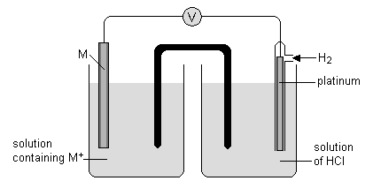

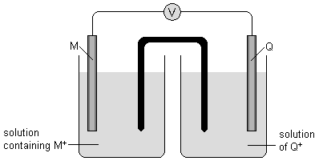

In the first cell the electrons flow from platinum to M and the cell potential is 0.11 V.

In the second cell the electrons flow from M to Q and the cell potential is 1.61 V.

Determine the standard reduction potentials for M⁺ + e⁻ → M and for Q⁺ + e⁻ → Q and explain how you obtained your answer.

15. The following problem has been set on an examination paper.

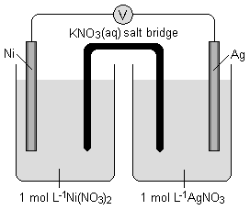

‘For the following electrochemical cell determine the standard cell potential and the overall equation for the reaction taking place. Use the table of standard reduction potentials provided.’

In answering this question one student writes the following:
Oxidation takes place at the anode which is the electrode that has the most positive E° value. In this case this is the silver as it has an E° of +0.80 V while the nickel has the lower value at -0.26 V. So the oxidation reaction is:

Ag(s) → Ag+(aq) + e-

This means that the reduction reaction is at the nickel electrode so:

Ni2+(aq) + 2e- → Ni(s)

The overall reaction is:

2Ag(s) + Ni2+(aq) → 2Ag+(aq) + Ni(s)

The cell potential is calculated using the expression:

E° = E°oxidation - E° reduction

Since the half-equation for the oxidation of silver has to be doubled to balance the electrons, the E° for the half-cell has to be doubled as well.

So E° = +1.60 – (-0.26) = 1.86 V

The cell potential is 1.86 V.

What (if anything) is wrong with the answer given by the student?

16. The University of New South Wales has developed an electrochemical cell, based on the redox chemistry of vanadium, that has been used as a small-scale energy source (battery). One half-cell contains two vanadium-containing ions, VO₂⁺(aq) and VO²⁺(aq), while the other half-cell is a mixture of solution of vanadium(II) and vanadium(III) sulfate.

a) What are the oxidation numbers of vanadium in the two ions in each half-cell?
b) Write the half-equation for the possible reduction reaction in each half-cell.

When this cell is delivering an electric current it is observed that the concentration of V³⁺(aq) increases.

c) What is the ionic equation for the overall cell reaction?

The cell produces a voltage of 1.26V when operating under standard conditions. When the half-cell comprising vanadium(II) and vanadium(III) is connected to a standard hydrogen half-cell it generates a cell potential of 0.26V, and in this cell the hydrogen ions are reduced.

d) What is the standard reduction potential (E°) for the VO₂⁺(aq)/VO²⁺(aq) half-cell?

17. Consider the following standard reduction potentials:

Sn⁴⁺(aq) + 2e⁻ ⇌ Sn²⁺(aq) E° = +0.15V
Ti²⁺(aq) + 2e⁻ ⇌ Ti(s) E° = -1.63V
Au³⁺(aq) + 3e⁻ ⇌ Au(s) E° = +1.50V
Ce⁴⁺(aq) + e⁻ ⇌ Ce³⁺(aq) E° = +1.74V
Pb²⁺(aq) + 2e⁻ ⇌ Pb(s) E° = -0.13V

Using just these half-cells, draw a diagram of an electrochemical cell that would generate a voltage closest to 1.50V. On your diagram mark the anode, cathode, direction of electron flow and the direction in which the cations will migrate in the cell.

18. A standard hydrogen half-cell is connected to a half-cell in which oxygen gas is bubbled over platinum immersed in a solution of 1 mol L⁻¹ HCl.

a) Draw a diagram of the cell labelling the anode, cathode, direction of electron flow and direction in which anions migrate.
b) What is the cell potential of this cell under standard conditions?
c) What happens to the pH in each half-cell?

19. Two hypothetical metals, A and D, have the following standard reduction potentials:

A²⁺(aq) + 2e⁻ ⇌ A(s) E° = +0.63V
D⁺(aq) + e⁻ ⇌ D(s) E° = -1.95V

An electrochemical cell is constructed from these two metals, immersed in a 1 mol L⁻¹ solution of the sulfate of each metal.

a) What would be the reading on a voltmeter placed in the external circuit?
b) In which direction would electrons flow in this cell?

20. An electrochemical cell is set up as shown in the diagram below.

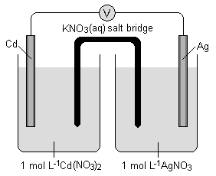

a) What is the cell potential produced by this cell if standard conditions are used?
b) Write the half-reactions for each half-cell.

Some of the chemicals in the two half-cells can be removed and the cell will still produce approximately the same voltage.

c) What can be replaced in each half-cell and still allow it to operate as the same cell in the diagram above, and what could you use to replace each substance?

21. An electrochemical cell is set up as shown using tin and iron electrodes.

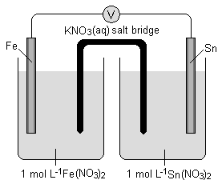

a) What is the cell potential for the cell under standard conditions?

A piece of magnesium is placed in the solution containing the tin electrode, but not touching the tin.

b) What would be observed in the tin half-cell?
c) What would be observed on the voltmeter as the magnesium was placed in the tin(II) solution?

22. The first electrochemical cell was constructed by Count Alessandro Volta in 1880. In this cell Volta placed cardboard or porous paper soaked in a solution of sulfuric acid between a sheet of zinc and copper.

a) What is the likely anode reaction?
b) What observation, made over a long period of time, would confirm this prediction?
c) The other electrode did not change during the operation of the cell, even for very long periods of time. Explain this observation.
d) When Volta replaced the zinc by tin the power of the cell decreased, but when he used silver to replace the copper there was no change in the power of the cell. Explain this observation.
e) If the porous paper was soaked in water rather than sulfuric acid, the cell did not produce any electricity. Explain
f) After some period of time the cell ceased to operate as effectively as it did at the beginning.
However, if the plates were removed from the porous paper and then returned a short time later, the cell operated as it did at the beginning. How can this observation be explained?

23. Write the ionic equations for any reaction that occurs in the following procedures.

In each case describe in full what you would observe, including any colours, odours, precipitates and gases evolved.

a) Chlorine gas is bubbled into a solution of potassium bromide.
b) Hydrogen sulfide is bubbled into an aqueous solution of bromine.
c) Concentrated nitric acid is added to zinc metal.
d) Potassium metal is placed in water.
e) Very dilute nitric acid is added to zinc solid.
f) Potassium permanganate solution is added to acidified hydrogen peroxide solution.
g) Aluminium metal is rubbed with abrasive and then placed in a solution of copper(II) sulfate.
h) Silver metal is warmed with concentrated nitric acid.
i) Acidified potassium dichromate solution is added to a solution of sodium oxalate.
j) Bromine is added to a 1 mol L⁻¹ solution of potassium chloride.
k) Copper is added to a solution containing silver nitrate.
l) Zinc is added to a solution of iron(III) nitrate.
m) A solution of zinc nitrate and sodium chloride are mixed.

24. Briefly explain the following situations. Support your answers with the appropriate equations.

a) A solution of nickel nitrate can be satisfactorily stored in a copper pot, but a solution of silver nitrate can not.
b) If left in an open container, a solution of hydrogen peroxide will slowly decompose.
c) Copper metal will not react with hydrochloric acid, but it will react with nitric acid.
d) An acidified solution of potassium permanganate is a strong oxidising agent. However, hydrochloric acid cannot be used to acidify the solution of potassium permanganate.
e) Sodium metal cannot be prepared by adding a reductant to an aqueous solution of sodium chloride.

25. A chemist investigating the redox reactions of transition metals set up the following half-cells:

Y³⁺/Y Nb³⁺/Nb Zr⁴⁺/Zr Sc³⁺/Sc Mn²⁺/Mn

She tested some combinations of two half-cells and tabulated her results. The values in the boxes indicate the cell potentials, in volts, obtained from the combinations, and the metal that acts as the anode is in brackets.

 | Y³⁺/Y | Nb³⁺/Nb | Zr⁴⁺/Zr | Sc³⁺/Sc | Mn²⁺/Mn
Y³⁺/Y |  | 1.27 (Y) | 0.82 (Y) | i | 1.19 (Y)
Nb³⁺/Nb |  |  | 0.45 (Zr) | 0.93 (Sc) | 0.08 (Mn)
Zr⁴⁺/Zr |  |  |  | ii | iii
Sc³⁺/Sc |  |  |  |  | iv
Mn²⁺/Mn

a) What are the missing values i, ii, iii and iv? Which metal would act as the anode in each case?
b) If the standard reduction potential (E°) for the Sc³⁺/Sc standard half-cell is -2.03V, list the standard reduction potential (E°) for the other four half-cells.

Application of redox
chapter 10 textbook

commercial cells

The car battery
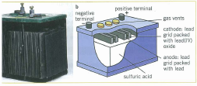
Dry cell

corrosion

Review exercise 10.1

1. Give the equations for the anode and cathode half-cell reactions in the following cells for which the cell reactions are given.

a) Dry cell: Zn(s) + 2MnO₂ (s) + 2H⁺(aq) → Zn²⁺(aq) + Mn₂O₃(s) + H₂O(1)
b) Lead-acid accumulator: Pb(s) + PbO₂(s) + 4H⁺(aq) + 2SO₄²⁻(aq) → 2PbSO₄(s) + H₂O(1)
c) Hydrogen/oxygen fuel cell: 2H₂(g) + O₂(g) →2H₂O(1) (acidic conditions)

2. Electron transfer reactions produce a cell potential of about 1.48V in the commercially available Eveready dry cell.

The equation for the reduction half-cell reaction occurring in the dry cell is:

2MnO₂ (s) + 2H⁺(aq) + 2e⁻ → Mn₂O₃(s) + H₂O(1)

a) What is the equation for the oxidation half-cell reaction in the dry cell? What is the standard reduction potential for this half-cell?
b) Assuming standard conditions, calculate the reduction potential for the reduction reaction of MnO₂.
c) State one advantage and one disadvantage of using a dry cell in electrical appliances.
d) It is observed that the paste in the dry cell becomes less acidic as the cell operates. Suggest a reason for this.
e) Why is the dry cell described above called a primary cell?

3. The lead-acid accumulator, or car battery, uses a redox reaction to produce a steady voltage of about 12 V. The lead-acid accumulator is composed of six cells that are each made up of a lead electrode and a lead (IV) oxide electrode, PbO₂, in a sulphuric acid solution. Assume standard conditions are present.

a) The following reaction occurs at the lead(IV) oxide electrode:

PbO₂(s) + 4H⁺(aq) + SO₄²⁻(aq) + 2e⁻ → PbSO₄(s) + 2H₂O(l) E° = +1.69 V

Write the half-equation for the reaction occurring at the other lead electrode, and quote its standard reduction potential, which is -0.36 V.

b) Which electrode is the anode and which is the cathode?
c) Calculate the theoretical voltage for a car battery cell.
d) The actual voltage produced by each of the six cells in the car battery is about 2.2 v. Suggest a reason for the different between this value and the voltage calculated in part c).
e) Write the equation for the reaction that occurs during the charging of a discharged battery.
f) Explain why measuring the density of the sulfuric acid in the battery can indicate how ‘charged’ the battery is. (Liquid sulfuric acid is more dense than water.)

4. Some time ago button cells were based on a mercury/mercury(II) oxide reaction rather than the silver/silver(I) oxide reaction.

a) Write the equations for the anode and cathode reactions for a mercury button cell, assuming the only difference between this cell and the silver oxide cell is the presence of mercury in place of silver.
b) Why do you think this type of cell has been replaced by silver oxide button cells?

5. It is possible to construct a fuel cell based on the oxidation, by oxygen, of methanol, CH₃OH.

a) Assuming the cell operates using an acid electrolyte, write the equations for the anode and cathode reactions for this fuel cell. (Carbon dioxide and water are formed during the oxidation of methanol.)
b) How does this cell differ from a dry cell or nickel-cadmium cell?
c) In what ways are fuel cells similar to other types of electrochemical cells?
d) What advantage does a methanol/oxygen fuel cell have over a hydrogen/oxygen fuel cell?
e) Compare the environmental impact of the products of the methanol/oxygen fuel cell with those from a hydrogen/oxygen fuel cell.

6. Calculate and compare the mass of each element that needs to be oxidised at the anode in a dry cell, a lead-acid accumulator and a lithium cell in order to produce 1 mole of electrons. Why does this information make the lithium cell such a popular choice as a cell?

Review exercise 10.2

1. Iron is corroded by the action of certain substances in the atmosphere.

Figure 10.13 Rust experiment: The four test tubes originally contained, from left to right: nails, water and air; nails with calcium oxide (absorbs water); nails under water that has had the dissolved air removed; and nails in salt water.

a) Four test tubes were set up to demonstrate the conditions necessary for rusting. The results of this experiment are shown in Figure 10.13. From these results, decide which two substances cause the corrosion of iron. Explain how you decided on your answer.
b) Write equations to show that the oxidation of iron metal by these substances causes a precipitate of iron(II) hydroxide to form.
c) Use the equations you wrote in part b) to explain why the corrosion process is slowed under conditions of high pH.
d) If a copper pipe is used to replace a section of iron pipe, a plastic washer (a ‘separator’) must be used to separate the iron and copper. Explain why.

2. The supporting posts of some jetties are made of iron and are connected to zinc bars below the waterline to protect the iron from corrosion by seawater. Use standard reduction potentials to explain:

a) how zinc protects the iron against corrosion
b) whether a lead bar would be effective in protecting the iron from corrosion
c) whether sodium metal would be a suitable alternative for a protecting iron.
3. Chemical engineers are developing alloys that can be used in combination with iron. One of the issues faced is the possibility of increased corrosion rate when two different metals are combined. Alloy X is found to have a standard reduction potential (E°) of around +0.27 V. Alloy Y has a standard reduction potential of -0.59 V. From this information, predict the issues with corrosion facing the engineers if they place these two alloys in contact with an iron structure in a moist environment.

4. In a car, the negative terminal of the battery is usually connected to the body of the car. it is claimed that this protects the body of the car from rusting.

a) Discuss whether this claim is reasonable.
b) What would be the consequence of attaching the positive terminal of the battery to the body of the car, instead of attaching the negative terminal?

5. A block of cadmium and a block of copper are joined together and the combined block is placed in a solution of dilute hydrochloric acid. It is observed that bubbles of gas are only evolved from the surfaces of copper. However, if the two blocks are separated and placed in the same acid, the bubbles only appear on the cadmium surface. Explain this observation.

QUESTIONS

1. AAA- and D-type conventional dry cells both produce about 1.5 V.

a) Write the anode and cathode reactions for these cells.
b) Given your answer to part a), what difference is there between these two cells and how would this affect the performance?
c) Why are the contents of the cell in the form of a paste?

2. During discharge, a 12 V car battery converts 200 g of lead into PbSO₄. What mass of lead(IV) oxide is consumed in the process?

3. A useful electrochemical cell for small articles such as watches makes use of silver oxide and zinc as described by the equation:

Zn(s) + Ag₂O(s) + H₂O(l) → 2Ag(s) + Zn²⁺(aq) + 2OH⁻(aq)

The cell potential of the cell is 1.50 V.

a) Write half-equations for the reactions occurring at the anode and the cathode.
b) Name the oxidant and the reductant in the cell.
c) What is the standard reduction potential for the half-cell containing Ag₂O(s)?

4. When a ‘flat’ lead accumulator (car battery) is being charged, the following overall reaction occurs:

2PbSO₄(s) + 2H₂O(l) → Pb(s) + PbO₂(s) + 4H⁺(aq) + 2SO₄²⁻(aq)

a) Give the half-equations for the cathode and anode reactions during charging.
b) Does the density of the electrolyte increase or decrease as the battery is charged? Explain your answer.

5. Lithium-manganese dioxide batteries are used in portable electronic devices that need to deliver significant currents for short intervals of time. Such devices include cameras with inbuilt flash units. They can also be used for operating an external flash unit. The anode is made from lithium foil and cathode is made from manganese dioxide and carbon. The electrolyte is lithium perchlorate, LiClO₄, dissolved in an organic solvent.

a) What is the half-equation for the most likely reaction occurring at the anode?
b) From a table of standard reduction potentials, what is the standard reduction potential (E°) for this anode reaction?

The cathode reaction has been variously proposed as:

MnO₂(s) + e⁻ → MnO₂⁻
or 2MnO₂(s) + 2e⁻ → Mn₂O₃ + O²⁻

c) Other than starting with MnO₂, what is common about these two reactions?

The battery produces an initial voltage around 3.3 V.

d) What is the standard reduction potential of the cathode reaction?
e) Why would standard reduction potentials not be a particular good way of predicting the cell potential of this battery?
f) The electrolyte is an organic solvent. How is it possible for this battery to produce an electric current without water being present? Why is it not possible to use an aqueous electrolyte in this battery?

6. Dry cells that have been operating for some time and have ‘gone flat’ are often also observed to be leaking. Using the electrode reactions as a guide, explain why these cells often leak.

7. In a dry cell, the anode is the zinc casing. In an alkaline cell, the anode is powered zinc. The cathode reaction is the same in both types of cell. How would this difference in zinc affect the:

a) voltage of the cell? Justify your answer.
b) current delivered by the cell? Justify your answer. (Hint: The current is a measure of the rate of electron flow.)

8. One of the first attempts to develop an alternative energy source for the operation of a heart pacemaker was the construction of a biobattery. This biobattery operated by inserting a zinc electrode and platinum electrode into body tissue. Using the electrolytes in the bloodstream and other body fluids it was hoped that a voltage would be produced by the combination.

a) What is the equation for the most likely anode reaction in this biobattery?
b) Assuming platinum is an inert electrode, what is likely to be the equation for the cathode reaction? (Hint: What does blood transport around the body?)
c) What voltage would this combination produce in theory?
d) Why is the voltage obtained in practice significantly less than this predicted value?
e) From a health point of view, what questions would you want answered about such a biobattery?

9. In 2007 the Sony Corporation announced the development of a biobattery based on glucose and using biological catalysts (enzymes) to promote the reaction. The cell consists of porous carbon electrodes, a cellophane sheet to separate the anode and cathode compartments and a solution of glucose in a pH 7 buffer of sodium phosphate.

When the cell is operating, it is observed that glucose, C₆H₁₂O₆, is converted to gluconolactone, C₆H₁₀O₆, at one electrode. There is no evidence of gas production at the other electrode.

a) Write the half-equation for the reaction of glucose. Is this oxidation or reduction and at which electrode will this reaction take place?
b) What will happen to the other product (apart from gluconolactone) of this reaction of glucose?
c) What property must the cellophane sheet have for this cell to operate?
d) Given the observation at the other electrode of ‘no evidence of gas production’, predict the likely reaction occurring here. (Hint: What common substance in the environment could be acting as the other half of the redox combination?)
e) What is the purpose of having carbon electrodes that are porous?
f) What is the purpose of the sodium phosphate buffer?
g) The glucose cell produces a voltage of around 0.8 V. Using a table of standard reduction potentials, predict the standard reduction potential of the glucose/gluconolactone half-cell.
h) Why is this estimate of the standard reduction potential only approximate?

10. A normal AA dry cell produces a cell potential or voltage of around 1.5 V. Theoretically, an external voltage of slightly more than 1.5 V should be able to recharge this battery. However, in practice the advice from manufacturers and others is that recharging these batteries is dangerous, and could result in an explosion.

a) If a voltage of 1.6 V was applied to the electrodes of a dry cell, what are the most likely products of the reaction? (Consult a table of standard reduction potentials for this.)
b) Comment on the statement that attempting to recharge a dry cell could result in an explosion.

11. In which of the following experiments would the nail rust quickest, and in which will the nail rust slowest? Explain your reasoning.

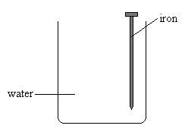
Experiment A

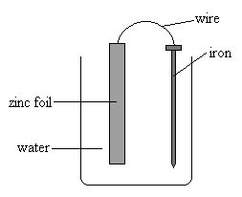
Experiment B

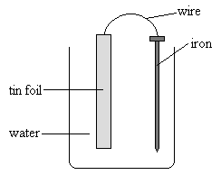
Experiment C

12. Some preventative methods used to protect iron from rusting are:
- Cathodic protection
- Sacrificial anodes
- Exclusion of air/water.

Which of these three methods is used to protect the following iron objects from corrosion?

For each object, briefly describe what is done to achieve the protection.

- A sheet of iron roofing
b) A large iron water pipe buried underground
c) A ‘tin’ (coated) can
d) A car body
e) An iron wharf
f) The hull of a ship

13. In an experiment, a nail with copper wrapped around it and a nail with zinc wrapped around it were placed on an agar plate. The agar gel had phenolphthalein and cyanide ions (CN⁻) in it. The results of this experiment are show in Figure 10.14.

Explain these results.

(Hint: Phenolphthalein turns pink in the presence of OH- ions and CN- ions combine with Fe²⁺ ions to form the dark blue colours complex ions, [Fe(CN)₆]₄⁻.)

Figure 10.14

14. Deep-sea divers sometimes report that the metal on vessels they find on the seabed does not appear to have been corroded. What property or properties of this deep-sea environment might contribute to this lack of corrosion?

15. A farmer decides it is time to remove an old rusty iron fence from his property. As he attempts to remove an iron pole from the ground, it snaps just below where it meets the ground. He finds that the pipe below ground level is much more corroded than that above the ground. Explain this observation.

16. The black coating that forms on silverware over time is silver sulphide, Ag2S. This black coating (tarnish) can be removed by rubbing with a mild abrasive, but this also removes some of the silver.

Some street traders try to sell an ‘expensive’ remedy that does not involve removing any silver. They demonstrate that a tarnished silver object when placed on the ‘magic metal’ in a solution of warm sodium bicarbonate (sodium hydrogencarbonate) ‘magically’ turns the silver surface back to the bright lustre. Bubbles of gas may be observed on the silver surface during the demonstration.

You decide that you are not going to spend $10 on the ‘magic metal’ and that you should be able to use your knowledge of chemistry to clean the silver.

a) Write the half-equation for the corrosion of silver in the presence of sulfide ions.
b) What type of reaction will be necessary to reverse this corrosion?
c) What is the general name given to the type of chemical substance that will produce the reaction in part b)?
d) Using your knowledge of chemistry and the substances that may be present in the family home, suggest what might be used as the ‘magic metal’.
e) Write equations to explain how your ‘magic metal’ converts the tarnished silver back into the shiny metal.
f) If a warm salt solution is used in place of the sodium hydrogencarbonate, a smell of rotten eggs can be noticed. Write an equation to explain where this rotten egg smell might be coming from.
g) There is no noticeable smell when sodium hydrogencarbonate is used in the solution with the ‘magic metal’ but bubbles of gas are observed on the silver. Write an equation to explain the bubbles of gas and the lack of rotten egg smell.

worksheet 9.2 electrochemical cells
Introduction
In order to investigate the relative reductant strength of metals, a series of electrochemical cells may be used. One such cell (cell 1) is shown below. All solutions used are 1.0 mol L^{–1}.

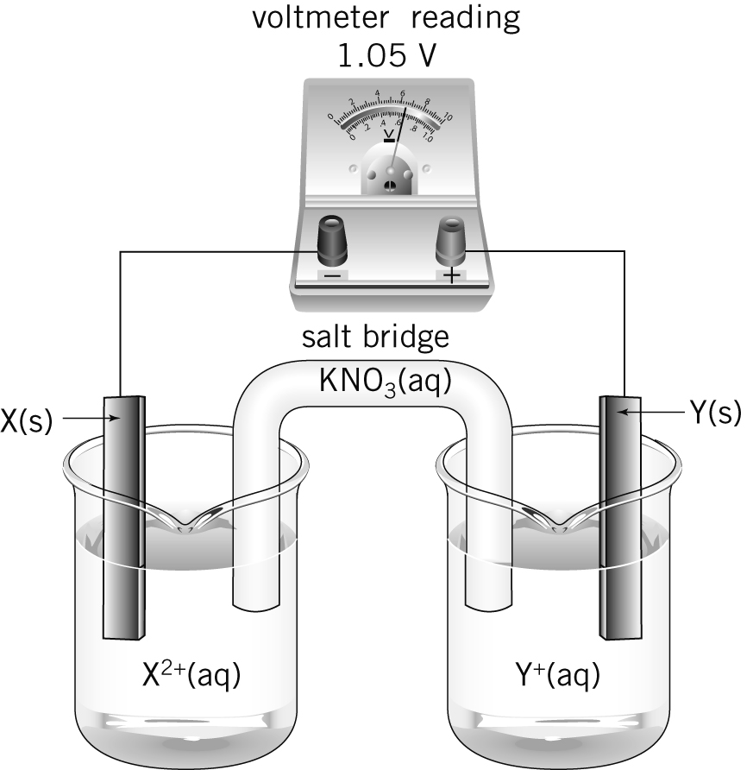

No. | Question | Answer
For the cell shown above:
a which electrode (X or Y) is positive?
b in which direction are the electrons flowing?
c which electrode (X or Y) is the anode?
d in which direction are anions flowing through the salt bridge?
For the cell shown above, write balanced half-equations for the reactions occurring at:
a electrode X
b electrode Y.

A second cell (cell 2) was set up. A strip of metal, Z, was placed in a beaker containing a
1.0 mol L^{–1} solution of Z(NO₃)₂. This half-cell was connected to the X²⁺/X half-cell used in cell 1. Electrons flowed from electrode X to electrode Z, and a cell potential of 0.59 V was recorded.

For this cell, write balanced half-equations for the reactions occurring at:
a electrode X
b electrode Z.
Based on the observations made in questions 1–3, list the metals X, Y and Z in order of decreasing reductant strength. Explain how you arrived at your order.
For a cell constructed by connecting the Z²⁺/Z and Y⁺/Y half-cells, predict the following:
a the direction of electron flow
b the anode
c the reduction half-equation
d the cell potential.
If the set of half-cells used above was constructed using 0.5 mol L^{–1} solutions and the experiment was repeated, what changes in results, if any, would you expect?
All half-cells in this series of cells have been connected using filter papers dipped in potassium nitrate solution. Explain why potassium nitrate is a suitable substance to use in this way.
If metal Z is identified as copper, suggest a possible identity for:
a metal X
b metal Y.

Worksheet 9.2 electrochemical cells - solutions

No. | Answer
1 | a Y  b From X to Y  c X (site of oxidation)  d From the Y half-cell to the X half-cell
2 | a X(s) → X²⁺(aq) + 2e–  b Y⁺(aq) + e → Y(s)
3 | a X(s) → X²⁺(aq) + 2e–  b Z²⁺(aq) + 2e → Z(s)
4 | In cell 1, the strongest reductant is X, since it is the metal oxidised; therefore X > Y  In cell 2, the strongest reductant is X, since it is the metal oxidised; therefore X > Z  The cell potential in cell 2 is less than that in cell 1, hence the difference in reductant strength between X and Z is less than that between X and Y; therefore reductant strength order is X > Z > Y.
5 | a From Z to Y  b Z (site of oxidation)  c Y⁺(aq) + e– → Y(s)  d 0.46 V (X to Y = 1.05 V, X to Z = 0.59 V; therefore Y to Z = 1.05 – 0.59 = 0.46 V)
6 | Cell potentials would vary, as reduction potential varies with concentration.
7 | It is highly soluble and does not react with any of the half-cell chemicals.
8 | a Any metal above copper in the activity series.  b Any metal below copper in the activity series.

worksheet 9.3 the electrochemical series
Introduction
The electrochemical series is a valuable tool for predicting whether or not a redox reaction will occur under standard conditions. For the following questions you will need to refer to the electrochemical series (standard reduction potentials) printed in your textbook or on your data sheet.

No. | Question | Answer
1 | Where on the electrochemical series will each of the following be found?  a strongest oxidant  b weakest oxidant  c strongest reductant  d weakest reductant
2 | a List the following species in order from strongest to weakest oxidant: Cu²⁺, Zn²⁺, H₂O₂, Fe²⁺, H⁺  b List the following species in order from strongest to weakest reductant: Cl–, Pb, Fe²⁺, Na, Ag
3 | The electrochemical series is constructed by comparing the oxidant/reductant strengths of various conjugate pairs to a standard or reference cell. Describe the reference cell used.
4 | The electrochemical series is constructed under standard conditions. What are these conditions?
5 | State two reasons why the electrochemical series may not accurately predict whether or not a redox reaction will be observed to occur in any given situation.
6 | Strips of tin are placed into separate beakers containing solutions of AgNO₃, SnCl₂, Cu(NO₃)₂ and ZnCl₂. In which beaker(s) will a metal coating form on the tin?
7 | A small quantity of an unknown metal is placed into separate solutions of Fe(NO₃)₂, KI, SnCl₂ and Zn(NO₃)₂. Over a period of time, a reaction is noted in only one of the containers. Use the electrochemical series to predict the possible identity of the unknown metal and the solution with which it reacts.
8 | Use the electrochemical series to deduce whether or not a reaction would occur in each of the following cases. Where a reaction would be expected, write the half-equations and the overall equation.  a Chlorine gas is bubbled through a solution of nickel sulfate.  b Iron filings are sprinkled into a solution of potassium hydroxide.  c A strip of tin is placed into a solution of hydrochloric acid.
 | Group 1 metals such as potassium must be stored in oil as they are very reactive in the presence of air and water. Write half-equations and an overall equation for the reaction of potassium with water.
In order to construct a list of relative strengths of four oxidants, A²⁺, B⁺, C²⁺ and D, a series of cells were constructed. The cells, and the resultant electron movement and cell voltages, are shown below. Based on the results, list the oxidants in order of decreasing strength.

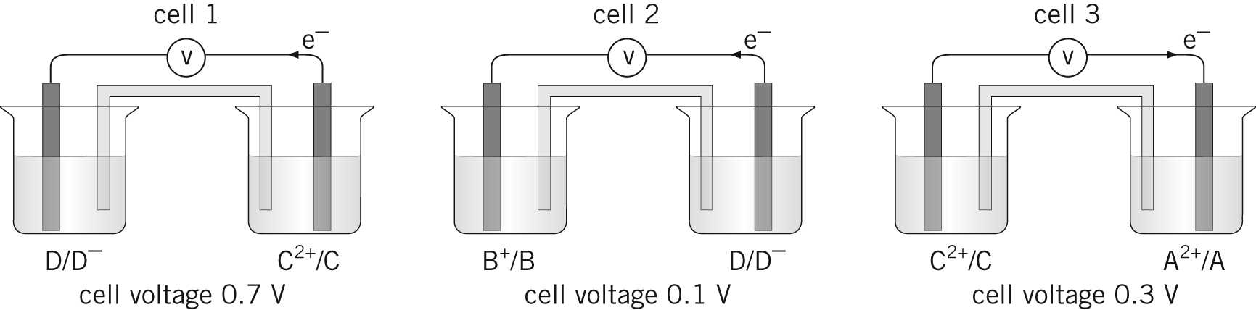
cell potential
cell potential
cell potential

Worksheet 9.3 solutions

No. | Answer
1 | a Top left-hand corner  b Bottom left-hand corner  c Bottom right-hand corner  d Top right-hand corner
2 | a H₂O₂ > Cu²⁺ > H⁺ > Fe²⁺ > Zn²⁺  b Na > Pb > Fe²⁺ > Ag > Cl–
3 | The reference cell is the hydrogen half-cell, which consists of a 1 mol L^{–1} solution of hydrochloric acid at 25°C through which hydrogen gas at 1 atm pressure is bubbled. The electrode is platinum coated with platinum black.
4 | 25°C, aqueous concentrations of 1 mol L^{–1}, and gas pressures of 1 atm
5 | The reaction may not be proceeding under standard conditions of temperature and pressure and/or the reaction may be proceeding at too slow a rate to be noticeable.
6 | A coating of silver and copper metal will occur on the tin in the beakers containing AgNO₃ and Cu(NO₃)₂ respectively.
7 | The unknown metal is nickel or cobalt and it will react with the solution of tin(II) chloride (SnCl₂).
8 | a Cl₂(g) + 2e– → 2Cl–(aq)  Ni²⁺(aq) + 2e– → Ni(s)  Cl₂(g) + Ni(s) → 2Cl–(aq) + Ni²⁺(aq)  b No reaction  c 2H⁺(aq) + 2e– → H₂(g)  Sn(s) → Sn²⁺(aq) + 2e–  2H⁺(aq) + Sn(s) → H₂(g) + Sn²⁺(aq)
9 | 2H₂O(l) + 2e– → H₂(g) + 2OH–(aq)  K(s) → K⁺(aq) + e–  2K(s) + 2H₂O(l) → 2K⁺(aq) + 2OH–(aq) + H₂(g)
10 | B⁺ > D > A²⁺ > C²⁺  In cell 1, the electrons flow towards the strongest oxidant, D; hence D > C²⁺.  In cell 2, the electrons flow towards the strongest oxidant, B⁺; hence B⁺ > D.  In cell 3, the electrons flow towards the strongest oxidant, A²⁺; hence A²⁺ > C²⁺.  The cell potential in cell 1 (0.7) is greater than that in cell 3; hence D > A²⁺.

worksheet 10.2
Introduction
You can apply the fundamental electrochemical cell concepts you have learned to any cell. All electrochemical cells will have an anode and a cathode. The reactants at these electrodes will be separated within the cell so that electrons cannot be exchanged directly: they must travel through the external circuit. There will also be a substance within the cell that provides mobile ions that maintain electrical neutrality throughout the cell.
The nickel–hydrogen cell is a relatively new type of battery that was developed for the US space program. They are currently used in the International Space Station (ISS) for energy storage. The ISS circles the Earth every 90 minutes. While it is in sunlight, solar cells may be used to generate electricity. The nickel–hydrogen cells store some of this electrical energy and release it again when the ISS is in darkness.
Each cell consists of a nickel–nickel oxyhydroxide (NiOOH) cathode, and a platinum anode at which hydrogen gas is oxidised. The electrolyte is concentrated potassium hydroxide, about 30% m/m. The cell is a pressure vessel, since it must hold a significant quantity of hydrogen gas. It is thus very expensive but long-lived, with a lifespan of up to 20 years. Each cell consists of many ‘stacks’. One such stack is shown below.

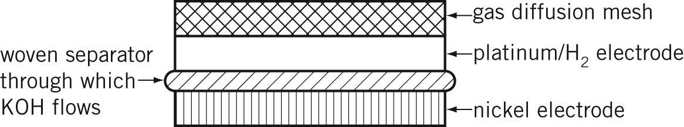

The major electrode reactions during the discharge process are listed:
Cathode: NiOOH(s) + H₂O(l) + e– → Ni(OH)₂(s) + OH–(aq)
Anode: H₂(g) + 2OH–(aq) → 2H₂O(l) + 2e–

No. | Question | Answer
 | Why is it necessary to have energy-storage cells such as the nickel–hydrogen battery aboard the International Space Station?
What is the oxidation number of nickel in:
a NiOOH
b Ni(OH)₂
During the recharging process, what is the
a reductant?
b oxidant?
 | Write a balanced redox equation for the discharge process.
 | Calculate the concentration, in mol L^{–1}, of the KOH electrolyte if 50.0 mL of electrolyte has a mass of 54.8 g.
 | How would the concentration of the electrolyte change during the recharging process?
How would the pressure inside the cell change during:
a recharging?
b discharge?
 | What would be three requirements of the material used for the separator?
 | What would happen if the separator were left out of the stack?
 | State one advantage and one disadvantage of this cell.

Worksheet 10.2 solutions

No. | Answer
1 | The International Space Station gets energy from the Sun when it can, but sometimes it is in darkness, so cells are needed to store energy that can be used during the ‘dark’ times.
2 | a +3  b +2
3 | a Ni(OH)₂  b H₂O
4 | 2NiOOH(s) + H₂(g) → 2Ni(OH)₂(s)
5 | 30% m/m means 30 g of KOH in 100 g of solution  ∴ 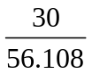 mol of KOH in 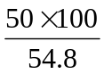 mL of solution  [KOH] = 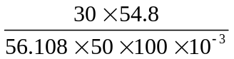 = 5.9 mol L^{–1}
6 | It does not change. Although OH– is consumed at the anode, it is produced at the cathode.
7 | a It increases (H₂ produced).  b It decreases (H₂ consumed).
8 | It must be unreactive in a highly alkaline solution, allow good ion flow, and be structurally stable so that good separation is maintained.
9 | The oxidant and reductant could react directly and no electrons would flow through the external circuit.
10 | For example:  Advantage: long life  Disadvantage: expensive

ST MARY’S ANGLICAN GIRLS’ SCHOOL



YEAR 12 CHEMISTRY IN-CLASS ASSIGNMENT 4 (2009)

PUT A CROSS (X) THROUGH THE CORRECT ANSWER.

1. | a | b | c | d
2. | a | b | c | d
3. | a | b | c | d
4. | a | b | c | d
5. | a | b | c | d
6. | a | b | c | d
7. | a | b | c | d
8. | a | b | c | d
9. | a | b | c | d
10. | a | b | c | d

PART A
/ 10
PART B
/ 33
TOTAL
/ 43
PART B - Answer all questions in the spaces provided.

1. Write equations for any reactions that occur in the following procedures. If no reaction occurs write ‘no reaction’. In each case describe what you would observe, including any: colours, gases evolved, odours and precipitates. If no change is observed you must state this as the observation.

a) Aluminium metal is added to a solution of cobalt nitrate.

Equation

Observation

b) Zinc metal is added to concentrated nitric acid solution.

Equation

Observation

c) Black manganese (II) oxide powder is added to hydrogen peroxide solution.

Equation

Observation

(9 marks)

2. A student, while preparing for her TEE Chemistry Examination, studies the
table of Standard Reduction Potentials provided in your data sheet. In her notes, she lists the halogens in order of oxidising strength. This is her list:
fluorine
bromine decreasing
chlorine oxidising
iodine strength
a) What is the correct order for the halogens?

b) Show by equation, chlorine acting as an oxidising agent with a metal.

c) Halide ions can act as reducing agents. List the halide ions in order of
decreasing strength as reducing agents.
d) Show by equation, a halide ion acting as a reducing agent with a metal ion.

e) If excess fluorine gas was bubbled through a solution containing a mixture of
chloride, bromide and iodide ions, what effect would this have? Equations and observations are not necessary.
(8 marks)
3. One method of analysing the manganese content of steel is to dissolve the steel in nitric acid; producing a solution of manganese (II) ions, Mn²⁺(aq). The Mn²⁺(aq) ions are then treated with an excess of acidified solution of periodate ions, IO₄–(aq). The products of this reaction are iodate ions, IO₃–(aq), and the deeply purple-coloured permanganate ions, MnO₄–(aq). The concentration of MnO₄–(aq) is then determined by titration.
a) Calculate the oxidation number of iodine in the IO₄–(aq) ion.
b) Write the half equation for the conversion of IO₄–(aq) ion into IO₃–(aq) in acid solution.

c) Write the half equation for the conversion of Mn²⁺(aq) ion into MnO₄–.

d) Combine these half equations to produce the overall equation.

(6 marks)

4. An experiment was carried out to determine the percentage of manganese in a particular sample of steel by the above method. A 13.936 g sample of steel was dissolved in acid and the manganese was converted to MnO₄–(aq) ions. The solution containing the MnO₄–(aq) ions was filtered and made up to a volume of 1.00 L.

19.55 g of iron (II) ammonium sulfate {(NH₄)₂Fe(SO₄)₂.6H₂O} were dissolved in distilled water to make 500.0 mL of solution. Three 20.0 mL samples of this solution, were acidified with sulfuric acid, titrated and required 24.02, 23.96 and 24.01 mL the permanganate solution for complete reaction.
a) Use the unbalanced half equations below to write the equation used in the titration.
Fe²⁺ → Fe³⁺
MnO₄⁻ → Mn²⁺

(2 marks)

b) From the mass and volume, determine the concentration of the iron (II)
ammonium sulfate solution.

(2 marks)

c) Use the titration to determine the concentration of the permanganate solution.

(3 marks)

d) Calculate the mass of manganese in the steel sample. The moles of permanganate will be equal to the moles of manganese in the steel.

(2 marks)

e) Calculate the percentage, by mass, of manganese in the steel sample.

(1 mark)
NAME:

PART A - Answer all questions on the answer sheet.

1. The oxidation number of chlorine in KClO₄ is:
a) –3
b) +7
c) -7
d) +3

2. For the reaction below, the oxidation number of the nitrogen changes from:
NO₂ + H₂O → e⁻ + NO₃⁻ + 2H⁺
a) 0 to +1
b) 0 to –1
c) +2 to –3
d) +4 to +5

3. Which one of the following is NOT a redox reaction?
a) 2NO + O₂ → 2NO₂
b) K₂O + H₂O → 2KOH
c) 2CO + O₂ → 2CO₂
d) C₂H₄ + H₂ → C₂H₆

4. Which one of the following pairs of reactants could NOT be used to produce hydrogen gas in the laboratory?
a) Tin and dilute hydrochloric acid.
b) Copper and dilute sulfuric acid.
c) Zinc and dilute hydrochloric acid.
d) Iron and dilute sulfuric acid.

5. A redox reaction involves
a) a transfer of electrons from the oxidizing agent to the reducing agent.
b) a transfer of electrons from the reducing agent to the oxidizing agent.
c) either a reduction or an oxidation.
d) a transfer of a proton between two chemical agents.

Use the following information for question 6 to 8.

Four metallic elements A, B, C and D form soluble nitrates having formulae: ANO₃, B(NO₃)₂, CNO₃ and D(NO₃)₃.

When pieces of each of the four metals were placed in 0.10 mol L⁻¹ aqueous solutions of the other metal nitrates the following reactions occur:

I Metal B reacted with all solutions.
II Metal A only reacted with CNO₃.

6. Metal D could react with:
a) ANO₃ and CNO₃ only.
b) B(NO₃)₂ and CNO₃ only.
c) ANO₃ and B(NO₃)₂ only.
d) ANO₃, B(NO₃)₂ and CNO₃.

7. In order of increasing strength of the metals as reducing agents is:
a) C, A, D, B.
b) B, C, D, A.
c) A, D, C, B.
d) B, D, A, C.

8. Which of the following ions is the weakest oxidizing agent?
a) A⁺
b) B²⁺
c) C⁺
d) D³⁺

9. The tarnish on silverware, Ag₂S, can be removed by placing the articles in an aluminium pan and covering them with a warm solution of sodium carbonate. The following half-reactions show why this method is effective.

Ag₂S(s) + 2 e⁻ → 2 Ag(s) + S²⁻(aq)
Al(s) + 3 OH⁻(aq) → Al(OH)₃(s) + 3 e⁻

Which of the following equation represents a balanced IONIC equation for the reaction that occurs?
a) 3 Ag₂S(s) + 2 Al(s) + 6OH⁻(aq) → 6Ag(s) + 3S²⁻(aq) + 2Al(OH)₃(s)
b) Ag₂S(s) + Al(s) + 3OH⁻(aq) → 2Ag+(aq) + S²⁻(aq) + Al(OH)₃(s) + e⁻
c) Ag₂S(s) + Al(OH)₃(s) → 2 Ag+(aq) + S²⁻(aq) + Al(s) + 3 OH⁻(aq)
d) Al(s) + 3OH⁻(aq) + 2Ag(s) + S²⁻(aq) → Ag₂S(s)+ Al(OH)₃(s) + 3 e⁻

10. Which of the following reactions represent disproportionation (self oxidation –
reduction)?

I 2CrO₄²⁻(aq) + H⁺(aq) → Cr₂O₇²⁻(aq) + OH⁻(aq)
II 3I₂(s) + 6OH⁻(aq) → 5I⁻(aq) + IO₃⁻(aq) + 3H₂O(l)
III Zn(s) + 2H⁺(aq) → Zn²⁺(aq) + H₂(g)
IV 2Cu⁺(aq) → Cu(s) + Cu²⁺(aq)

a) I only
b) II and IV only
c) III only
d) IV only
ANSWERS

1. | a | b | c | d
2. | a | b | c | d
3. | a | b | c | d
4. | a | b | c | d
5. | a | b | c | d
6. | a | b | c | d
7. | a | b | c | d
8. | a | b | c | d
9. | a | b | c | d
10. | a | b | c | d

PART B

1. a) 2 Al + 3 Co²⁺ → 2 Al³⁺ + 3 Co
A silver solid is added to a pink solution to form a silver solid and a colourless solution.

b) Zn + 4 H⁺ + 2 NO₃⁻ → Zn²⁺ + 2 NO₂ + 2 H₂O
A silver solid is added to a colourless solution to form a brown, pungent gas and a colourless solution.

MnO₂
c) 2 H₂O₂ → 2 H₂O + O₂
A black solid is added to a colourless solution to form a colourless, odourless gas and a colourless solution.
(9 marks)
2. a) fluorine
chlorine decreasing
bromine oxidising
iodine strength [1]

b) 2 Na + Cl₂ → 2 NaCl [2]
c) iodide
bromide decreasing
chloride reducing
fluoride strength [1]
d) Cu²⁺ + 2 e⁻ → Cu
2 I⁻ → I₂ + 2 e⁻
Cu²⁺ + 2 I⁻ → I₂ + Cu [2]

e) Fluorine would oxidise all the other ions. [1]
Fluorine would be reduced to F⁻ ions. [1]
(8 marks)

3. a) +7 [1]

b) IO₄– + 2 H⁺ + 2e⁻ → IO₃– + H₂O [2]

c) Mn²⁺ + 4 H₂O → MnO₄– + 8 H⁺ + 5 e⁻ [1]

d) 5 IO₄– + 2 Mn²⁺ + 3 H₂O → 2 MnO₄– + 6 H⁺ + 5 IO₃– [2]
(6 marks)

4. a) 5 Fe²⁺ → 5 Fe³⁺ + 5 e⁻
MnO₄– + 8 H⁺ + 5 e⁻ → Mn²⁺ + 4 H₂O

MnO₄– + 8 H⁺ + 5 Fe²⁺ → Mn²⁺ + 4 H₂O + 5 Fe³⁺
(2 marks)

b) n = m/M = 19.55/392.15 = 0.04985
c = n/V = 0.04985/0.5 = 0.0997 molL⁻¹
(2 marks)
c) Av titre = 23.99 mL
n(Fe²⁺) = c x V = 0.0997 x 0.02 = 0.001994
n(MnO₄–) = 1/5 x 0.001994 = 0.000399 mol
c = n/V = 0.000399/0.02399 = 0.0166 molL⁻¹
(3 marks)

d) n(MnO₄–) = c x V = 0.0166 x 1 = 0.0166 = n(Mn)
m = n x M = 0.0166 x 54.94 = 0.913 g
(2 marks)

e) % Mn = 0.913/13.936 x 100 = 6.55 %

(1 mark)



Year 12 Chemistry
Test: Redox 2009

Name: ________________________ Time allowed : 45min

1 | A | B | C | D
2 | A | B | C | D
3 | A | B | C | D
4 | A | B | C | D
5 | A | B | C | D
6 | A | B | C | D
7 | A | B | C | D
8 | A | B | C | D
9 | A | B | C | D
10 | A | B | C | D

 | Mark | Out of
Part 1 |  | 10
Part 2 |  | 19
Part 3 |  | 9
Total |  | 38

PART ONE: MULTIPLE CHOICE (10 QUESTIONS 10 MARKS)

Please answer these questions on the separate multiple choice answer sheet provided.

- When Fe²⁺ is oxidised to Fe³⁺, the Fe²⁺ ion

- loses 1 electron
- gains 1 electron
- loses 1 proton
- gains 1 proton

- Each of the elements below is placed in water. Which one will react violently with the water?

- Ne
- Fe
- Cu
- Na

- The following redox reaction occurs in an acidic solution:

Ce⁴⁺ + Bi → Ce³⁺ + BiO⁺

What is the coefficient before the Ce⁴⁺ when the equation is fully balanced?

- 1
- 2
- 3
- 6

- Which of the following elements will NOT react with hydrochloric acid to produce hydrogen gas?

- Zn
- Fe
- Hg
- Ca

- In which one of the following reactions is disproportionation taking place?

a) 4H⁺ + 3 MnO₄²⁻ → 2MnO₄⁻ + MnO₂ + 2H₂O
b) 2 FeCl₂ + Cl₂ → 2 FeCl₃
c) H₂O₂ + 2 NO₃⁻ + 2H⁺ → O₂ + 2 NO₂ + 2 H₂O
d) 2 Cu⁺ + Sn²⁺ → 2Cu + Sn⁴⁺

- A student performed three tests to investigate the relative activity of metals. In each test a metal strip was placed in a solution containing ions of a different metal. The results are shown in the diagram below.

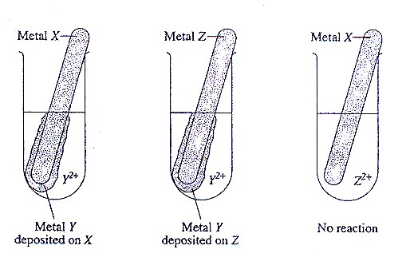

What is the order of activity of the metals, based on these results?

a) X > Z > Y
b) Y > X > Z
c) Z > Y > X
d) Z > X > Y

- Use the Standard Reduction Table to predict the reaction products when copper (II) chloride solution is shaken with an iron nail.
a) Fe²⁺ and Cu⁺
b) Fe³⁺ and Cu⁺
c) Fe³⁺ and Cu²⁺
d) Fe²⁺ and Cu
8. Which one of the following species is the strongest oxidising agent at 25 ºC?
a) F₂(g)
b) F⁻(aq)
c) Na(s)
d) Na⁺(aq)

9. Consider the following equation, which represents a reaction in the extraction of chromium from its ore
Which of the following statements about the oxidation states of the substances is correct?
a) The iron has been reduced from a +3 to a +2 oxidation state
b) The chromium has been oxidised from a +3 to a +6 state
c) The carbon has been oxidised from a +2 to a +4 state
d) The reaction is not a REDOX reaction and no species have changed oxidation state
10. According to the Standard Reduction Table, which of the following 1.0 mol L⁻¹ solutions is not stable due to a predicted spontaneous redox reaction between its ions?

a) Hg₂(NO₃)₂
b) CuBr
c) MgSO₄
d) FeI₃

PART TWO WRITTEN 5 QUESTIONS 19 MARKS

- In a lightning flash the following reaction occurs

N₂ + O₂ ↔ 2NO ∆ H = +180kJmol⁻¹

- Give the oxidation number for nitrogen in N₂ and NO

N₂ ____________________

NO ____________________ (2 marks)

b) Name the oxidising agent in the forward reaction (1 mark)

__________________________________

2. The green manganate ion MnO₄²⁻_{(aq)} in an acidic solution spontaneously undergoes a disproportionation reaction forming the pink-purple permanganate ion MnO₄⁻_{(aq)} and colourless manganese (II) ions Mn²⁺_{(aq)}

- Write a balanced half equation to represent the oxidation process

_______________________________________________________________
(2 marks)
b) Write a balanced half equation to represent the reduction process

_______________________________________________________________
(2 marks)

c) Write a balanced equation that represents the redox process

_______________________________________________________________
(1 mark)

3. The addition of lead (II) nitrate , Pb(NO₃)_{2(aq)} to a solution containing I⁻_{(aq)} ions, such NaI_{(aq)}, produces a bright yellow precipitate of PbI_{2(s)}. Is this a redox reaction? Explain your answer. (2 marks)

_______________________________________________________________

_______________________________________________________________

4. Write balanced ionic equations for the following reactions. In each case describe observations such as colour changes, precipitate formation (give colour) or gas evolution (give colour or describe as colourless)

- Concentrated nitric acid is added to magnesium metal.

Equation _________________________________________________________

_________________________________________________________________

Observation _______________________________________________________

- Hydrogen gas is heated strongly in an atmosphere of chlorine gas.

Equation _________________________________________________________

_________________________________________________________________

Observation _______________________________________________________

- Bromine water is added to zinc metal

Equation _________________________________________________________

_________________________________________________________________

Observation _______________________________________________________
(6 marks)

5. Acidified potassium permanganate solution oxidises ammonium iron (II) sulfate, (NH₄)₂SO₄. FeSO₄.6H₂O .

Write a balanced overall ionic equation for the reaction and describe what is observed.

Equation _________________________________________________________
(2 marks)

Observation _______________________________________________________

_________________________________________________________________
(1 mark)
PART THREE CALCULATIONS 1 QUESTION 9 MARKS

  - Pyrolusite, an ore of manganese, contains manganese in the form of MnO₂. A sample of pyrolusite from a newly discovered deposit is analysed to determine the degree of purity of the deposit.
To determine the amount of Mn in the pyrolusite sample, 1.25g of dried pyrolusite was heated with 100mL of 0.150M oxalic acid (H₂C₂O₄). The oxalic acid was in excess, so that all of the MnO₂ reacted according to the following equation

MnO_{2(s)} + H₂C₂O_{4(aq)} + 2H⁺_{(aq)} → Mn²⁺_{(aq)} + 2CO_{2(g)} + 2H₂O_{(l)}

20.00mL of the resulting solution is then titrated with an 0.0510M solution of the triiodide ion

I₃⁻_{(aq)} + H₂C₂O_{4(aq)} → 2CO_{2(g)} + 2H⁺_{(aq)} + 3I⁻_{(aq)}

22.00mL of the 0.0510M triiodide solution was needed to react with the remaining oxalic acid.

  - Calculate the moles of oxalic acid remaining in the original 100mL solution after the pyrolusite had been reacted with the oxalic acid.

(4 marks)
  - Calculate the moles of oxalic acid used to reduce the MnO₂ in the 1.25g of pyrolusite.

(2 marks)
  - Calculate the percentage by mass of MnO₂ in the pyrolusite.

(3 marks)

Year 12 Chemistry
Test: Redox 2009 ANSWERS
Multiple choice
1. a 2. d 3. c 4. c 5. a 6. d 7. d 8. a 9. b 10. d

Part Two
  - In a lightning flash the following reaction occurs

N₂ + O₂ ↔ 2NO ∆ H = +180kJmol⁻¹

- Give the oxidation number for nitrogen in N₂ and NO

N₂ 0

NO +2 (2 marks)

b) Name the oxidising agent in the forward reaction (1 mark)

oxygen gas

2. The green manganate ion MnO₄²⁻_{(aq)} in an acidic solution spontaneously undergoes a disproportionation reaction forming the pink-purple permanganate ion MnO₄⁻_{(aq)} and colourless manganese (II) ions Mn²⁺_{(aq)}

- Write a balanced half equation to represent the oxidation process

MnO₄²⁻ → MnO₄⁻ + e⁻
(2 marks)
b) Write a balanced half equation to represent the reduction process

MnO₄²⁻ + 8H⁺ + 4e⁻ → Mn²⁺ + 4H₂O
(2 marks)

c) Write a balanced equation that represents the redox process

5MnO₄²⁻ + 8H⁺ → 4 MnO₄⁻ + Mn²⁺ + 4H₂O

(1 mark)

3. The addition of lead (II) nitrate , Pb(NO₃)_{2(aq)} to a solution containing I⁻_{(aq)} ions, such NaI_{(aq)}, produces a bright yellow precipitate of PbI_{2(s)}. Is this a redox reaction? Explain your answer. (2 marks)

- Not redox (1mk)
- No change in oxidation number for any species (1mk)
4. Write balanced ionic equations for the following reactions. In each case describe observations such as colour changes, precipitate formation (give colour) or gas evolution (give colour or describe as colourless)

- Concentrated nitric acid is added to magnesium metal.
e- + NO₃⁻ + 2H⁺ → NO₂ + H₂O ) x 2
Mg → Mg²⁺ + 2e-

Equation Mg + 2NO₃⁻ + 4H⁺ → Mg²⁺ + 2NO₂ + 2H₂O (1mk)

Observation a colourless liquid is added to a silver grey solid and a brown pungent gas forms in a colourless solution, the solid begins to disappear (1mk)

- Hydrogen gas is mixed with chlorine gas.

Equation Cl_{2(g)} + H_{2(g)} → 2HCl_{(s)} (1mk)

Observation a colourless, odourless gas is mixed with a pale yellow, pungent gas and a white solid is formed (1mk)

- Bromine water is added to zinc metal

Equation Br₂ + Zn → Zn²⁺ + 2Br – (1mk)

Observation a red/brown solution is added to a silver/grey solid, the red/brown colour fades and the solid begins to disappear (1mk)
(6 marks)

5. Acidified potassium permanganate solution oxidises ammonium iron (II) sulfate, (NH₄)₂SO₄. FeSO₄.6H₂O .

Write a balanced overall ionic equation for the reaction and describe what is observed.
Fe²⁺ → Fe³⁺ + e- )x5
5e- + MnO₄⁻ + 8H⁺ → Mn²⁺ + 4H₂O
Equation 5Fe²⁺ + MnO₄⁻ + 8H⁺ → 5Fe³⁺ + Mn²⁺ + 4H₂O
(2 marks)

Observation a purple solution is added to a pale green solution and a brown solution forms

_________________________________________________________________
(1 mark)

PART THREE CALCULATIONS 1 QUESTION 9 MARKS

1. Pyrolusite, an ore of manganese, contains manganese in the form of MnO₂. A sample of pyrolusite from a newly discovered deposit is analysed to determine the degree of purity of the deposit.
To determine the amount of Mn in the pyrolusite sample, 1.25g of dried pyrolusite was heated with 100mL of 0.150M oxalic acid (H₂C₂O₄). The oxalic acid was in excess, so that all of the MnO₂ reacted according to the following equation

MnO_{2(s)} + H₂C₂O_{4(aq)} + 2H⁺_{(aq)} → Mn²⁺_{(aq)} + 2CO_{2(g)} + 2H₂O_{(l)}

20.00mL of the resulting solution is then titrated with an 0.0510M solution of the triiodide ion

I₃⁻_{(aq)} + H₂C₂O_{4(aq)} → 2CO_{2(g)} + 2H⁺_{(aq)} + 3I⁻_{(aq)}

22.00mL of the 0.05M triiodide solution was needed to react with the remaining oxalic acid.

  - Calculate the moles of oxalic acid remaining in the original 100mL solution after the pyrolusite had been reacted with the oxalic acid.

I₃⁻_{(aq)} + H₂C₂O_{4(aq)} → 2CO_{2(g)} + 2H⁺_{(aq)} + 3I⁻_{(aq)}

V = 22mL v = 20mL
c = 0.0510 n H₂C₂O₄ = n I₃⁻ = 0.001122 (1mk)
n I₃⁻ = cv c = n/v = 0.001122/0.02 = 0.0561M (1mk)
= (0.0510)(0.022) n H₂C₂O₄ (in 100mL) = (0.0561)(0.1) = 0.00561mol (1mk)
= 0.001122mol (1mk)

b) Calculate the moles of oxalic acid used to reduce the MnO₂ in the 1.25g of pyrolusite.

MnO_{2(s)} + H₂C₂O_{4(aq)} + 2H⁺_{(aq)} → Mn²⁺_{(aq)} + 2CO_{2(g)} + 2H₂O_{(l)}
V = 100mL
C= 0.150M
N=cv = (0.150)(0.1) = 0.015 (1mk)

Started with – used = 0.015 – 0.00561 = 0.00939mol (1mk)

c) Calculate the percentage by mass of MnO₂ in the pyrolusite.

n MnO₂ = n H₂C₂O₄ = 0.00939mol (1mk)

mass MnO₂ = 0.00939 x (54.94 + 2x16) = 0.00939 x 86.96 = 0.816g (1mk)

%MnO₂ in ore = 0.816/1.25 x 100 = 65.3% (1mk)

