Year 12 Chemistry Semester One Exam Revision
Mastery Test : Dot diagrams

Name: ________________

Draw electron dot diagrams for the following species:

1. CO 2. MgCO₃

3. NH₃ 4. H₂S

5. MgCl₂ 6. BH₃

7. O₂ 8. CH₃CH₃

9. SO₄²⁻ 10. CF₄

11. SO₂ 12. NH₄⁺

SOLUTIONS

Year 12 Chemistry Semester One Exam Revision
Mastery Test : Dot diagrams

Name: ________________

Draw electron dot diagrams for the following species:

1. CO 2. MgCO₃

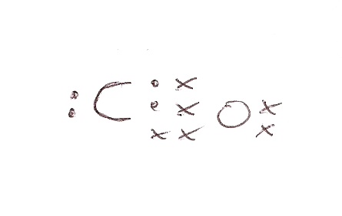
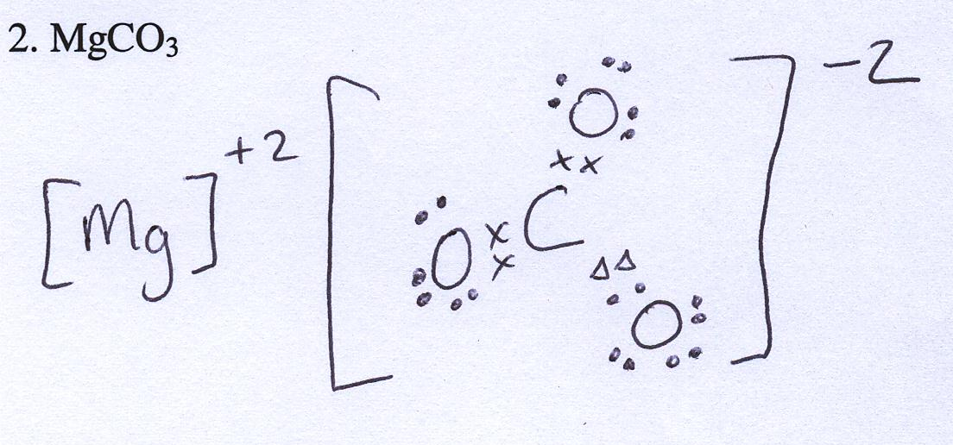

3. NH₃ 4. H₂S

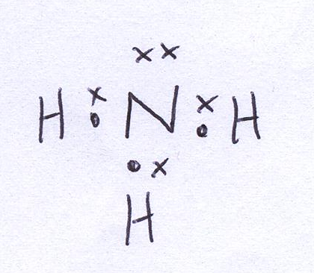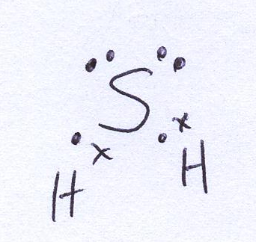

5. MgCl₂ 6. BH₃

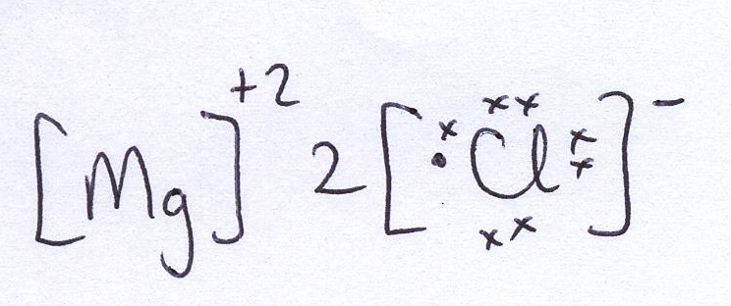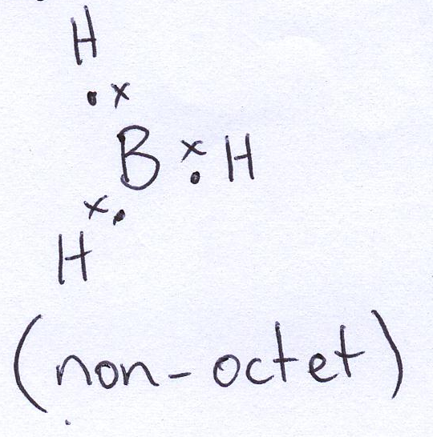

7. O₂ 8. CH₃CH₃

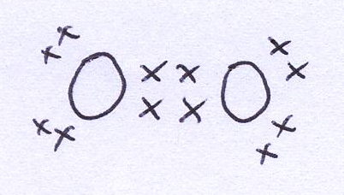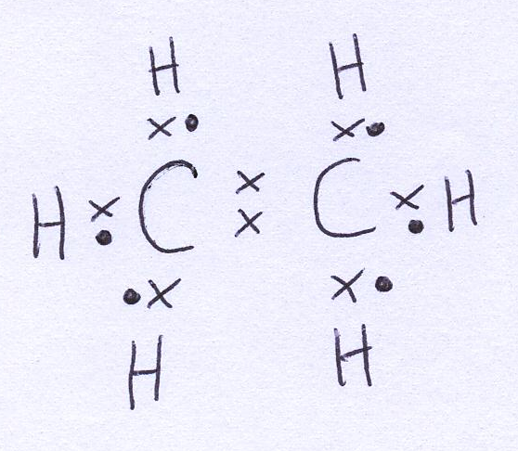

9. SO₄²⁻ 10. CF₄
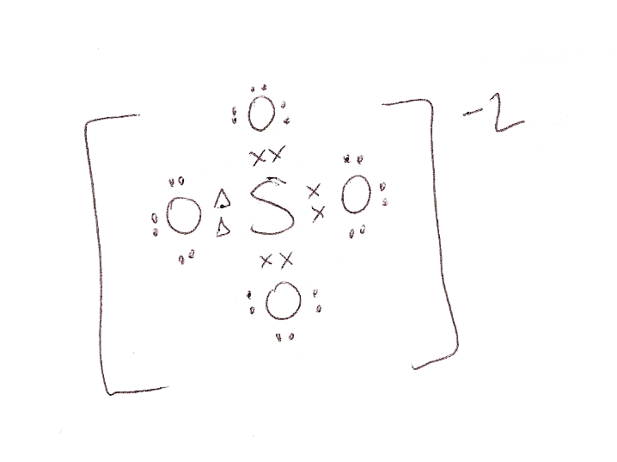
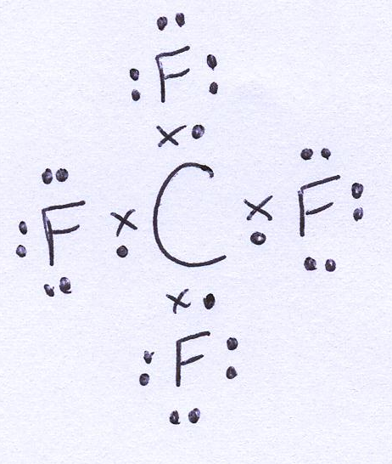

11. SO₂ 12. NH₄⁺

