Year 12 Chemistry
Mastery Test : Electron Dot Diagrams

Name___________________

Draw electron dot diagrams for the following species

1. SO₄²⁻ 2. NO₂

3. BCl₃ 4 MgCl₂

5. CaCO₃ 6. CO₂

7. N₂ 8. H₃CCH₃

SOLUTIONS
Year 12 Chemistry
Mastery Test : Electron Dot Diagrams

Name___________________

Draw electron dot diagrams for the following species

1. SO₄²⁻ 2. NO₂

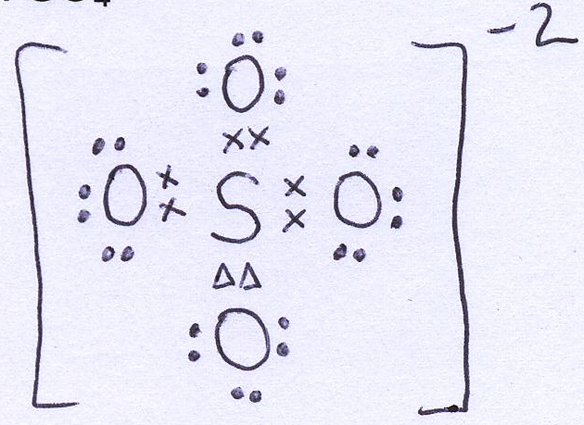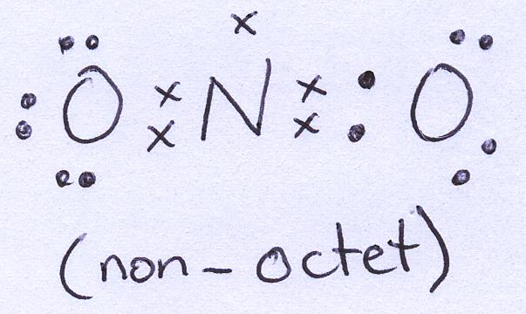

3. BCl₃ 4 MgCl₂

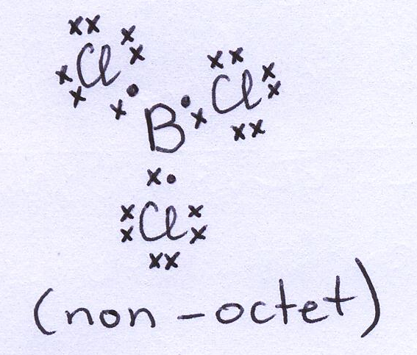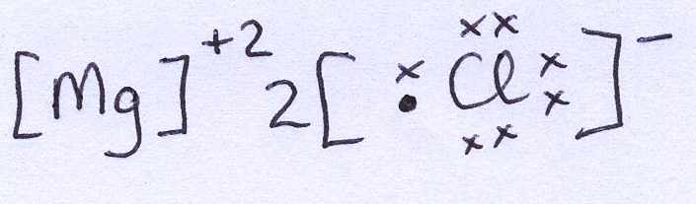

5. CaCO₃ 6. CO₂

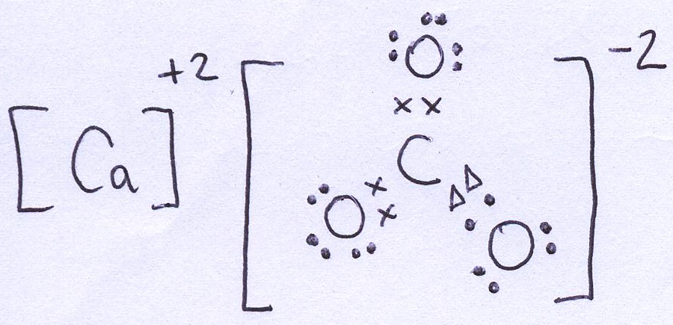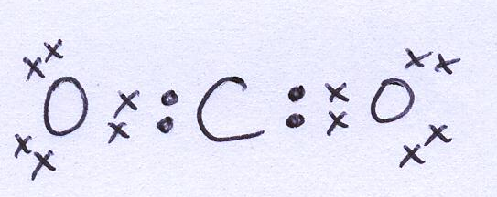

7. N₂ 8. H₃CCH₃

