Mr SGs Energy & Rates Notes

Energy Changes in Chemical Reactions
-All chemical reactions involve energy changes

-Energy is transferred between the system (the reactants and products) and the surroundings (everything else)

-These changes usually involve an exchange of chemical potential energy in the system and heat energy in the surroundings

-Reactions are classified based on the direction of the energy transfer
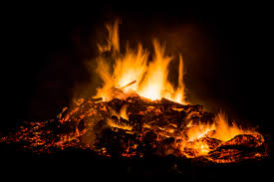

-Exothermic reactions release heat to the surroundings
-A test tube containing an exothermic reaction will feel hot
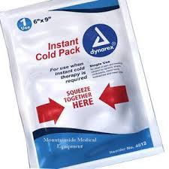
-Endothermic reactions absorb heat from the surroundings
-A test tube containing an endothermic reaction will feel cold

Chemical Potential Energy
-All substances contain chemical potential energy due to their bonding

-In general, the amount of chemical potential energy that a substance possesses increases as the particles become more separated (the potential energy increases as the boding decreases)

-Breaking bonds requires energy (it is an endothermic process)

-Forming bonds releases energy (it is an exothermic process)

-Exothermic reactions are those where more energy is released forming bonds than is used to break bonds (overall, more/stronger bonds are formed than are broken)

-Endothermic reactions are those where more energy is used to break bonds than is released by forming bonds (overall less/weaker bonds are formed than are broken)

-The law of conservation of energy states that energy cannot be created or destroyed, meaning that heat energy must be removed from the surroundings to provide the energy to break bonds

-When bonds are formed, the energy released is transferred to the surroundings as heat energy

-Breaking and forming intermolecular forces also involves energy changes, but these are on a smaller scale than those associated with breaking and forming bonds
Enthalpy (H) & Enthalpy Change (ΔH)
-When we consider the energy changes in chemical reactions, it is more common to discuss enthalpy rather than chemical potential energy

-Enthalpy (H) is the total stored energy in a substance
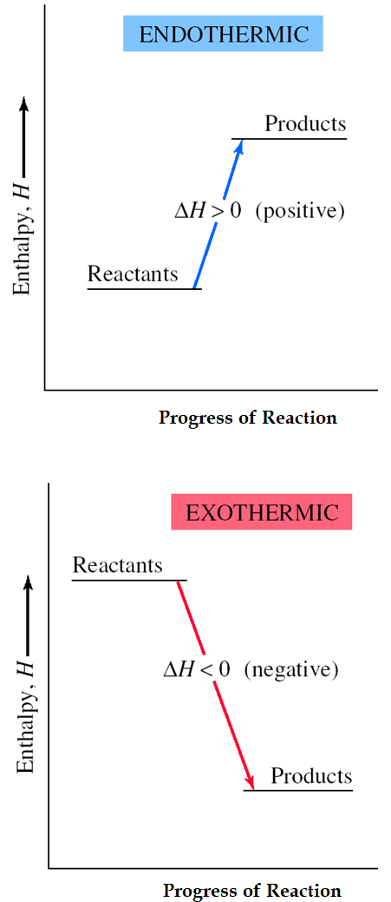
-While enthalpy encompasses more than stored chemical potential energy, in practice, enthalpy changes in reactions are due to changes in chemical potential energy

-Enthalpy change (ΔH) is a measure of how much enthalpy (eg potential energy) is lost or gained in a reaction

-Endothermic reactions have a positive ΔH, as heat energy is transformed into chemical potential energy, causing an increase in enthalpy as reactants are converted into products

-Exothermic reactions have a negative ΔH, as chemical potential energy is transformed into heat energy, causing a decrease in enthalpy as reactants are converted into products

-These enthalpy changes are often shown graphically in energy profile diagrams

-They can also be shown in a thermochemical equation, where the enthalpy change (in kJ or kJmol⁻¹) is shown, either by quoting the ΔH value, or by showing the energy lost or gained by the system as either a reactant (endothermic reactions) or product (exothermic reactions)

eg C₃H_{8(g)} + 5O_{2(g)} → 3CO_{2(g)} + 4H₂O_{(g)} ΔH = -2043 kJ
OR
C₃H_{8(g)} + 5O_{2(g)} → 3CO_{2(g)} + 4H₂O_{(g)} + 2043 kJ

-If a reverse reaction occurs, it will have an enthalpy change with an equal magnitude, but opposite sign to that of the forward reaction (eg the reverse of the reaction above will have a ΔH of + 2043 kJ)

-By treating the energy as a reactant or product, it is possible to calculate the amount of heat energy that is lost or gained when a particular amount of reactants are consumed or products are produced

eg Calculate the amount of heat energy produced when 450.0 g of propane combusts according to the equation above.

Types of Enthalpy Changes
Heat of combustion: The enthalpy change that occurs when a substance combusts in oxygen

Heat of fusion: The enthalpy change when one mole of a substance solidifies at its melting point

Heat of vaporisation: The enthalpy change when one mole of a substance vaporises at its boiling point

Activation Energy (E_{a})
-In chemical reactions, reactant bonds must be broken before product bonds can form

-Breaking bonds is an endothermic process that increases the enthalpy of the system

-This means that during a chemical reaction, the system will pass through a transition state, a short-lived state of highest enthalpy that exists after the reactant bonds have been broken, but before the product bonds have formed

-A reaction is only able to proceed if the reactants must have enough energy to reach the transition state (eg to break the bonds in the reactants)
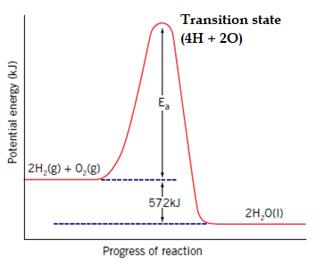
-The energy difference between the reactants and products is known as the activation energy (E_{a})

-The activation energy is a major factor in determining how likely/how rapidly a reaction is to proceed

-The activation energy for the reverse reaction is the enthalpy difference between the products and the transition state and will be different from the E_{a} of the forward reaction

-Activation energy is commonly indicated on reaction profile diagrams

Reaction Rate
-Chemical reactions can occur at very different rate (eg of burning H₂ and iron rusting)

-For many of the applications of the chemical reactions we study, we need to be able to measure or manipulate the rate of the reactions we study (eg food going off, fuel burning in a power station, fibreglass mouldings etc)

-Reaction rate can be calculated by measuring the rate at which a reactant is consumed, or the rate at which a product is produced (eg g/kg/L/mol reactant/product produced/consumed per min/s/hr)

-Instantaneous reaction rate can be determined by graphing the amount of reactant consumed or product produced over time

-The instantaneous reaction rate is equal to the slope of the tangent to the curve at a particular point. This is calculated by drawing the tangent to the curve and calculating its gradient (rise/run)

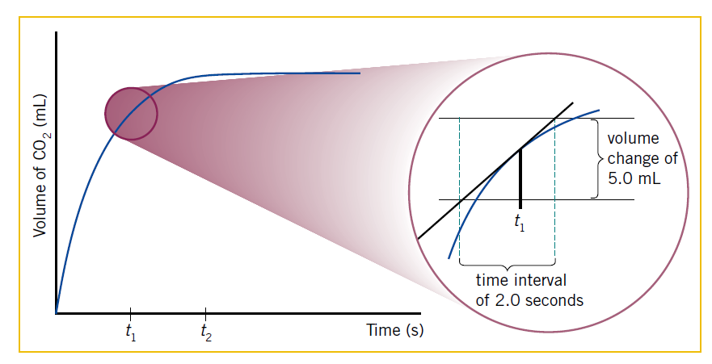
-eg at time t₁ the reaction rate = ΔV / Δt = 5 / 2 = 2.5 mLs⁻¹

Collision Theory
-In order to understand reaction rate, we need to understand what is happening in a chemical reaction at the atomic level

-Collision theory describes the conditions that are necessary for particles to react

-It states that for a reaction to occur between molecules, they need to:
-collide with each other
-in a favourable orientation (one that allows reactant bonds to be broken)
-with enough energy to disrupt the bonds of the reactant molecules
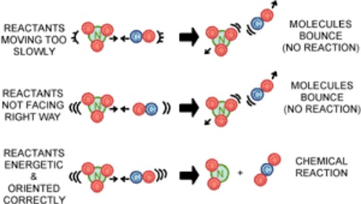

Effect of activation energy on reaction rate

-While the temperature of a material corresponds its average kinetic energy, the particles within a substance have a range of kinetic energies/velocities
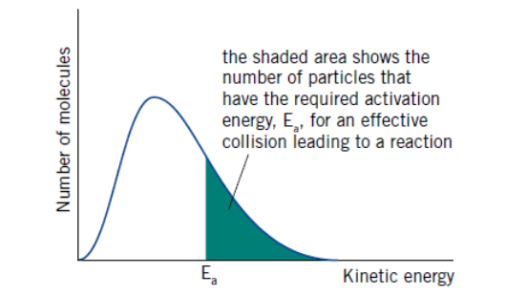

-The distribution of energies is shaped like a normal distribution within a long tail

-Within the distribution, only some particles will have enough energy to react when they collide with other reactant particles (eg only some have E_{k} > E_{a})
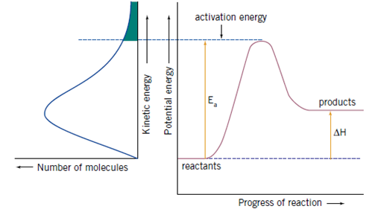

-The proportion of particles with E_{k} > E_{a} is one of the major factors affecting the rate of a reaction

-Reactions that are rapid at room temperature tend to have low activation energies

-These include precipitation reactions and others that do not involve the large scale breaking of chemical bonds

Factors affecting Reaction Rate

-All factors affecting reaction rate need to be understood in the context of collision theory

-Temperature: Increasing temperature leads to increase in E_{k} of reactant particles

-Increased velocity of reactants leads to increased collisions, therefore an increase in successful collisions and RR

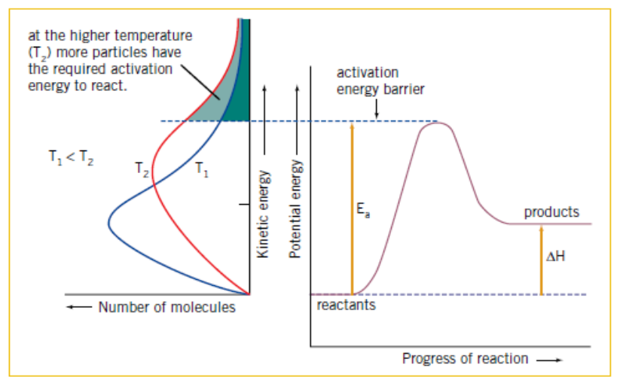
-It also increases the proportion of reactant particles with sufficient energy to overcome the activation energy barrier, leading to an increased proportion of successful collisions and increased RR

-Concentration: Increasing concentration leads to increased collisions, therefore an increase in successful collisions and RR

-Pressure: Increasing the pressure of gaseous reactants leads to increased collisions, therefore an increase in successful collisions and RR

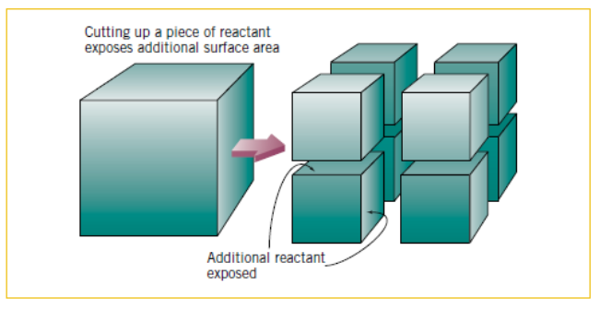
-State of sub-division: Increasing the state of sub-division of solid reactants increases the surface area over which collisions can occur, which leads to increased collisions, therefore an increase in successful collisions and RR

-Catalysts: Catalysts are substances that increase the rate of a chemical reaction without themselves undergoing any permanent chemical change.

-Catalysts work by providing an alternative reaction pathway with a lower activation energy.

-As the activation energy is lower, a greater proportion of particles will have the required activation energy to react, leading to an increase in successful collisions and RR
