**CAN THO UNIVERSITY SOFTWARE CENTER**

**MEKONG DELTA - APTECH**

**‑‑‑‑‑‑‑‑**

**LEARN ABOUT**

**AZURE TECHNOLOGY**

|  |  |
| --- | --- |
| **Instructor:**  **Mr.** Duong Nguyen Phu Cuong | **Class: CP2396G05**  **Group 5:**  A22064 – Cao Thi Hong Gam  A22066 – Huynh Gia Phuoc  A22050 – Nguyen Thi Cam Tien |

Can Tho, 12/2023

1. **CLOUD COMPUTING**
2. **Cloud computing**

Cloud Computing is a service model that allows people to access shared computing resources (network, server, storage, applications, services) through a network connection easily, anytime, anywhere, on demand. bridge. Cloud computing resources can be quickly established or destroyed by users without the intervention of the Service Provider. -It can be simply understood that the nature of cloud computing is just someone else's computer. For example, when you use Cloud Azure service, you are using Microsoft machines to host the database and host the app. Besides, you also use their infrastructure

1. **Advantages and disadvantages of cloud computing**

1. Advantages

- Low initial cost For example: If you want to use a certain server but the price to buy is quite high. Instead, you will rent a server, charge by the hour, you will have a server to use immediately, if you don't need to use it later, you can quit renting it.

- Datacenter in many national regions For

Example: Instead of needing to build a separate data center, you just need to rent a server in that country and region and you can deploy your service - Many services available such as:

+ Monitoring: Allows us to monitor CPU and RAM of servers on the Cloud

+ Analytic: Record requests to the server, commands in the database, helps us know how often this command is used, how fast or slow it runs so we can optimize

+ Alert: Notify users via email, SMS, Slack when CPU or RAM is too high for us to handle

+ Role-based Authorization: Decentralize permissions to accounts, for example: only developers can create servers on staging, only team leaders or sysadmins can touch production

+ Quickly scale, automatically scale: for example: when the number of users is large, when CPU and RAM increase, at certain time frames, etc., we can also set up the system to automatically scale.

2. Disadvantages

- Depends on the Internet: Cloud uses the Internet as a bridge between providers and users, and between users. When the Internet has problems or loses connection, users cannot access and use data in the cloud.

- Long-term price: After a period of use, the rental cost may be more expensive than the initial price. Therefore, large companies or companies with strong IT teams will often rarely use Cloud or only use it for some unimportant components, and the rest they build their own infrastructure.



- Dependent on Cloud Provider: When using Cloud services, you must trust that they will not take your data, trust that their system will not crash midway

- Security: When your server is on the Cloud, it can be on the same real machine with many other servers. Many hackers have taken advantage of virtualization technology vulnerabilities to steal data located on real computers. Additionally, the main Cloud account has control over everything (billing, creating and deleting virtual machines/servers). Therefore, these accounts must be kept absolutely safe. There was once a company... that went bankrupt because hackers stole the authorization key, wiped out the entire server and data on the cloud, and could not restore it.

- Geographic location: In addition, one reason that domestic companies rarely use Cloud is because... Azure and AWS do not have servers in Vietnam, only servers in Singapore. If they use it, they use homegrown Cloud services provided by Vietnamese companies

1. **Some related issues**

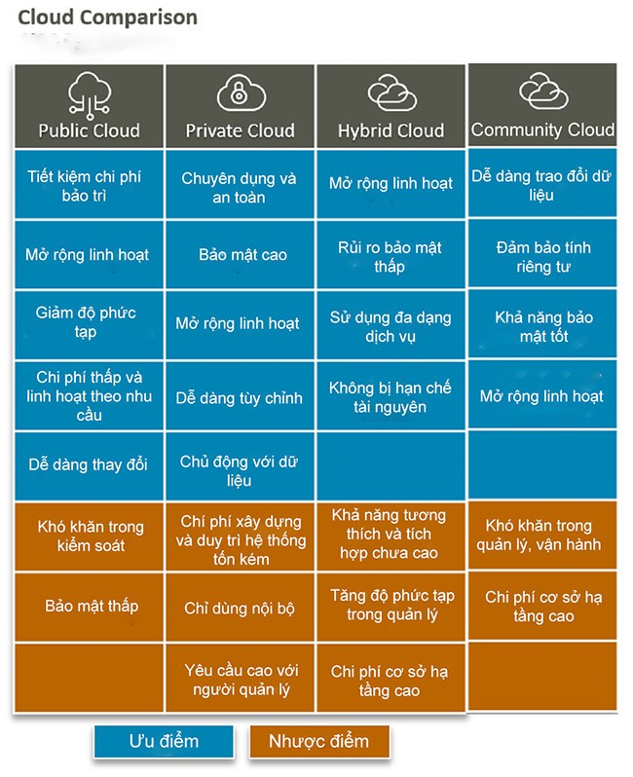 1. Classification of cloud computing

+Public Cloud (Public Cloud) Public Cloud is a platform that uses a standard cloud computing model to make resources available remotely. This method is used for all customers on the service provider's shared infrastructure, suitable for small and medium-sized organizations that do not need high levels of data security.

+Private Cloud (Private Cloud) Private Cloud are services provided via the Internet or intranet that are used by internal members, not publicly available. Thanks to this feature, Private Cloud provides businesses with many benefits such as self-service, the ability to expand and contract flexibly, in addition to additional control and customized support from specialized resources. Applications are stored on-site (internal).

+ Hybrid Cloud Hybrid Cloud is a cloud computing model that combines the combination of Public Cloud and Private Cloud platforms. Hybrid clouds are created to serve an organization and are provided by a third party. Because of the combination of two platforms, Hybrid Cloud inherits the advantages of those platforms, with more customization when deploying data.

+ Community Cloud (Community Cloud) This is a cloud computing model that provides solutions to a limited number of individuals/organizations. The platform manages and secures data by the organization or third-party service provider that manages the computer.

2. Application

- To help people better understand this technology, let's take a look at the applications of cloud computing in practice with bePOS.

a) Cloud computing database

To operate a business, it is necessary to store a very large amount of data. Many businesses have tight budgets and do not have enough professional staff to deal with them. In this case, choosing a cloud database is a perfect choice. In addition to providing a large, powerful database, cloud computing also helps maintain and operate the system. It is your sole responsibility to process the data accurately. In addition, cloud databases also have flexible scalability for businesses. Businesses can use cloud computing databases

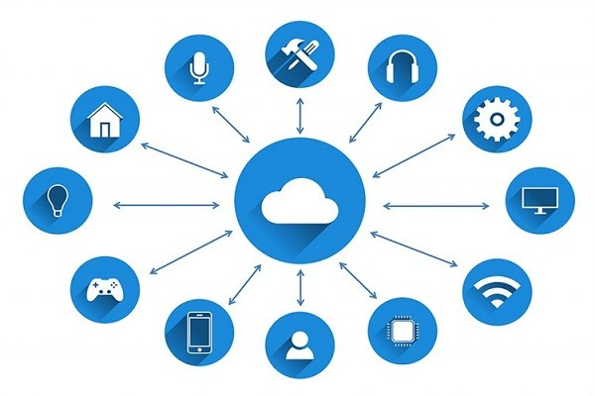

b) Website hosting service

Website hosting is a need for most businesses, especially those promoting business on the Internet platform. Applying cloud computing technology will help your business update and store websites quickly and most economically. Businesses only need to pay according to their actual needs. Note, you need to always ensure network connection and security throughout the operation process.

c) Big data analysis

Updating data to the cloud may not reduce the size of the data, however, it will help you make data management and storage easier. When combined with analytical reports, businesses will quickly draw assessments, comments and adjust reasonable business plans. Extensive data analysis system

d) Store and share data quickly

This is one of the most basic features of cloud computing. Cloud storage data systems will create opportunities for easier sharing and retrieval. Such as sharing data via Google Drive, Dropbox, Shutterstock, etc. Everyone in the business will easily transmit and share data with each other, update the situation quickly, and increase work efficiency.

e) Overall business management application

Currently, there are many business management applications created on cloud computing. The interfaces are intuitive, easy to use and suitable for many different industries. In Vietnam, there are also many businesses that have started building their own cloud computing systems with the aim of providing cheaper and more convenient services to customers. One of them is the bePOS sales management Super App with many useful features such as: tracking sales, managing warehouses, updating revenue, sales,... continuously and accurately. All are integrated right on one platform. All information is stored on cloud computing, tightly managed and analyzed daily. bePOS sales management software is suitable for many industries such as F&B, Spa, retail,...

3. Some achievements Cloud computing services are leading the hosting service trend. Below are the 5 best quality services from leading suppliers today.

a) Microsoft (Aka MS Azure)

Microsoft has been a central member of the tech world for many years now. Although Microsoft entered the cloud fray relatively late, its deep ambitions into all layers of the cloud have propelled the company to the top. Additionally, its immense commitment is to develop and support customers in implementing Blockchain, Machine Learning (ML) and Intelligence artificial intelligence (AI) in innovative production environments as well as market-leading revenue, allowing Microsoft to maintain the top stack position. Microsoft has continued to deliver strong energy since Satya Nadella took over as CEO in 2014. The Azure platform, the company's public cloud service, has played a key role in its work. Effects installation equipment is the number one player in the space. Microsoft's business is well organized into three segments: intelligent cloud (including Windows Server OS, Azure and SQL Server), personal computing (including Xbox, Surface, Bing Search Advertising and Windows Client) and business processes including Microsoft Office and Dynamics.

b) Amazon Web Service (also known as AWS)

Amazon Inc. is the first bird in the deep with Amazon Web Service (AWS) and has taken advantage of businesses large and small looking to move operations from data centers to the cloud. Amazon Web Services has always benefited from the biggest startup in the cloud computing market. More than a decade ago and long before competition in the cloud world began, AWS began offering cloud infrastructure solutions such as storage and compute. Clearly, the startup continues to serve them well and helps them maintain a massive market share advantage, despite the presence of other brands in this space including Microsoft and Google (and yes, even Alibaba and Oracle). The process continues unhindered as it is supported by the latest changes.

c) Google Cloud Platform (also known as GCP)

When Alphabet launched Google Cloud Platform, the tech giant chose to target small and medium-sized businesses rather than go after established players, but now boasts major customers like eBay, Snap and HSBC. , although the latter also uses Azure and AWS. After Google announced its second-quarter earnings midway through this year, investors are now paying significant attention to the progress made in the company's cloud computing business. While the company has been subdued by Microsoft, IBM, and Amazon in this regard, the Google Cloud platform has recently made some moves to beef up its entire address space and offer several other features from other service infrastructures as a service (IaaS). The late point is that Google's cloud platform is embroiled in a fierce battle with its partners, including AWS and Microsoft Azure.

d) Prophet Oracle

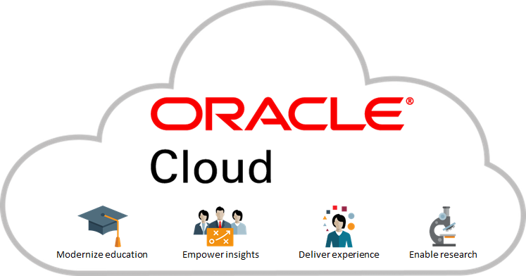Corp, a leading provider of database software, revealed its ambitious program in the field of cloud computing in 2015. The company announced its plans during the Oracle event OpenWorld to expand its portfolio in analytics cloud services, cloud applications, IaaS and cloud cloud service offerings. Since then, Oracle has not looked back and has grown at an unprecedented pace. Oracle Corp. has been competing in the cloud race, allowing upstarts like Salesforce.com that have gained significant ground with software delivered over the internet and have struggled as a result. However, it now appears that Oracle has finally found the bigger picture, is in aggressive innovation mode, and has a solid strategy for the future.

e) VMware Cloud

After becoming an established virtualization company, VMware entered the cloud space with its innovative cloud platform, allowing customers to provide secure access to data and applications to users. their last from multiple devices. Recently, VMware partnered with cloud computing powerhouse AWS for an online offering to provide customers with a more streamlined analytics solution.

1. **AZURE**
2. **Concept**

Microsoft Azure is a public cloud computing platform with solutions including Infrastructure as a Service (IaaS), Platform as a Service (PaaS), and Software as a Service ( SaaS). It can be used for services such as analytics, computer "virtualization", storage, networking... Azure can be used to replace or supplement your on-premises servers.

1. According to the model of providing cloud computing services

- Types of cloud computing divided by service delivery model include Infrastructure as a Service (IaaS), Platform as a Service (PaaS), and Software as a Service (SaaS). Each model represents a different part of the cloud computing model.

+ Infrastructure as a service (IaaS) resources IaaS (Infrastructure as a Service) means that you can access the hardware of a computer network system. IaaS gives you access to networking, computing features, and creates huge data storage space. This infrastructure has the ability to control information technology resource data management at the highest level and flexibility.



+ Platforms as a service (PaaS) PaaS (Platform as a Service) is a service that supports cloud computer users through operating systems, databases, website servers and programming environments. PaaS eliminates the need to manage your organization's underlying infrastructure and allows you to focus on deploying and managing your applications. This platform will make your work more efficient and easier in application operations.

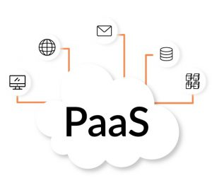

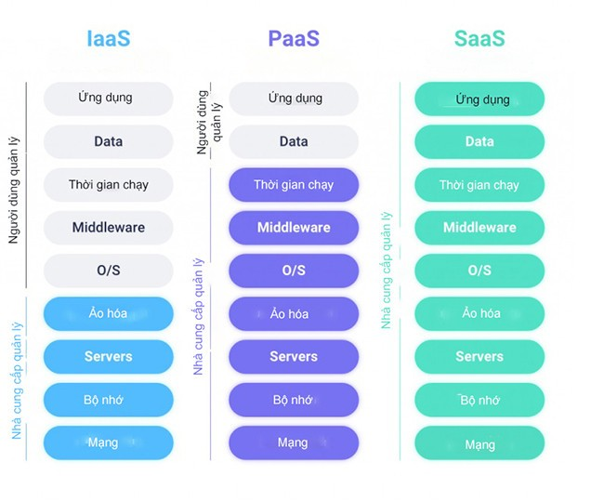 +Software as a service (SaaS) SaaS (Software as a Service) is complete software that is operated and managed by the service provider and distributed to the end user. With SaaS software, you don't have to think about how to continue maintaining the service or how to manage the infrastructure; your job is to learn how to use the software effectively. b) According to the implementation method of cloud computing Cloud computing models are classified according to their deployment method into 4 types as follows: Public Cloud, Private Cloud, Hybrid Cloud and Community Cloud. Each type will have its own unique texture and characteristics.

2. Azure operations

- When customers sign up for Azure, they have access to all the services available in the Azure portal. Registered users can use services to create cloud-based resources, such as virtual machines (VMs) and databases.

* In addition to the services offered through the Azure portal, some third-party vendors also offer software directly through Azure. Billing costs for third-party apps vary widely, but can involve paying a subscription fee for the app and a fee to use the infrastructure to host the app.

**II. Azure Services**

1. Azure Desktop Services

- Azure provides services for products at the build or development level, defining the execution of an application deployed within the Azure platform provisioning.

+ Azure virtual machine: An environment that allows users to have an experience similar to when using specialized hardware.

+ Azure Virtual Machine: Used to create thousands of identical virtual machines in a short period of time.

+ Azure Container Service: Containers are packages that do not require virtual machines, instead relying on virtual isolation to run applications.

+ Azure Container Registry: Used to store and manage container images.

+ Azure Batch: Used to scale the number of virtual machines at a time.

+ Azure Service Fabric: This is a distributed platform that simplifies deployment and lifecycle management of an application.

+ Azure cloud service: Focuses on applications and supports Java, PHP, Python, Ruby,...

+ Azure Web Apps: Create and deploy web apps at scale very quickly.

+ Azure Mobile App: Use to build and host the backend for any mobile app.

+ API App: used to build cloud APIs easily.

+ Azure Search: Provides fully managed search services.

+ Notification Center: Used to send push notifications to any platform from the backend.

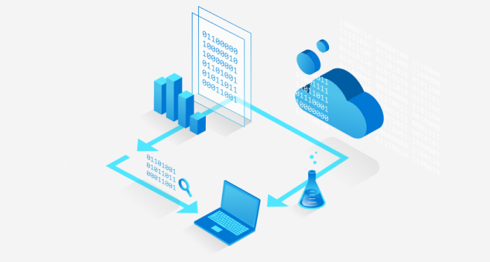

+ Azure Logic App: This is a cloud service that will help you automate workflows, business processes,…

+ Azure Event Hub: This is a collection of storable events.

2. Azure Network Service

- Azure provides mesh networks that enable businesses to securely connect to their cloud resources. The services are used to manage private virtual networks and further create multiple virtual networks.

+ Azure Virtual Network: Implement network isolation and segmentation with traffic routing filters, including Azure Connect allowing you to set up IP-based traffic managers.

+ Azure Load Balancer: Load balance traffic to virtual machines and isolate external traffic to another virtual machine.

+ Azure Express Route: Allows you to extend your existing network into the Microsoft cloud via a private connection.

+ Azure CDN: Improves content delivery and enables content streaming using the location of different locations distributed across countries.

+ Azure VPN Gateway: Send encrypted traffic over a public connection.

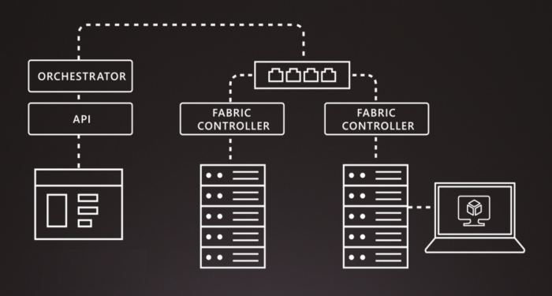

3. Azure Storage Service

- Azure provides more durable storage solutions, and you can build large-scale applications that can still scale larger if needed. Azure storage self-balances data based on traffic.

+ Azure Blob Storage: Azure embraces storage as binary large objects with the Blob service, giving you the ability to describe data.

+ Azure Queue Storage: Allows applications to communicate through exchanging messages on a queue, preventing messages from being lost or not processed.

+ Azure File Storage: Provides cloud file sharing using standard protocols.

+ Azure Table Storage: Store semi-structured NoSQL data in the cloud.

4. Azure Database Service

- Azure Database is a relational database service that is reliable and secure, and delivers high performance without you having to worry about any infrastructure.

+ Azure SQL: It is a relational database hosted in Azure and built on SQL server technologies, providing a scalable, highly available, and fault-tolerant database.

+ Azure DocumentDB: A NoSQL database as a schema-free exchange, rich queries, and query processing.

+ Azure Redis Cache: This is a database structure that implements key-value with optional durability.

**III. Advantages and disadvantages of Azure**

1. Advantage

+ Provides high availability

+ Provides strong security features

+ The options have good scalability

+ Performance and cost effective solutions

+ Allows you to build a hybrid infrastructure

+ Automate many tasks with repetitive processes.

1. Defect

+ Requires platform expertise to operate.

+ Speed is an issue for some developers

+ Access to services hinders small businesses.

+ Some services do not provide good performance to serve users