|  |  |  |
| --- | --- | --- |
|  |  |  |
| **CAN THO UNIVERSITY SOFTWARE CENTER**  **MEKONG DELTA APTECH** |

**SEMESTER EPROJECT – III**

**ONLINE JEWELLERY SHOPPING**

|  |  |  |
| --- | --- | --- |
| **Instructor:** | **Class: CP2396G05** |  |
| Ms.Nguyen Vo Thong Thai | **Group: 4** |  |
| 1. **Student1409503** | **LAC PHAN GIA** |
|  | 1. **Student1409767** | **PHUOC HUYNH GIA** |
|  | 1. **Student1409473** | **THINH LE PHU** |
|  | 1. **Student1409765** | **GAM CAO THI HONG** |
|  | 1. **Student1409469** | **TIEN NGUYEN THI CAM** |

Can Tho, January 2024

This is to certify that

| **LAC PHAN GIA** |
| --- |
| **PHUOC HUYNH GIA** |
| **THINH LE PHU** |
| **GAM CAO THI HONG** |
| **TIEN NGUYEN THI CAM** |

Has successfully Designed & Developed

**PROBLEM DEFINITION OF PROJECT**

Mr. Robert D’costa started the business from the scratch in 2005. The flagship company of Yash Gems &amp; Jewelleries (P) ltd was formed to carry on the business of manufacturing and trading of Gold &amp; Diamond Jewellery.

- To manufacture diamond Jewelry with ultimate brilliance, Yash has employed the latest and most advanced technologies for manufacturing diamond jewelry.

- As a supplier to some of the most exclusive retailers, Yash have intimate knowledge of the cultures and trends of the markets served. The national sales and distribution network team allows them to cultivate a close relationship with the customers and guarantees efficient services.

- Yash believes in reflecting their jewelry with special magic, conjured by melting of spirit and dedication, labor and craftsmanship, and art of work. The talented designers, skilled craftsmen and dedicated managers use state-of-the- art technology to produce the finest level of diamond jewelry for leading retailers.

- The company’s sincere desire is to give every client a reason to feel good. And policy is to offer top quality merchandise to the customers at the best possible price.

With a vision and motto of providing its customers products of impeccable quality, Yash has outnumbered many in innovative design and quality, making itself the benchmark and hallmark of the Indian jewelry industry.

**Customer Requirement Specification(CRS)**

**Client:** Online Jewellery Shopping

**Business/project Objective:**

Building an Online Jewellery Shopping website with the purpose of providing customers with jewelry shopping services in the fastest way. No need to go to the store, you can still choose a suitable piece of jewelry for yourself. The website was created to create convenience and save as much time as possible for customers.

**Inputs provided by the Client:**

**Process Involved in the System:**

**1.** Admin

· Sign In

+ Description: Log in to your account to manage the store.

+ Input: administrator's userName and password.

+ Output: Notify results after logging in.

· Brand Manager

+ Description: Add/edit/delete/search and display retail brand information.

+ Input: ID , Brand Type of the retail Brand Information

+ Output: Notify results after adding/editing/deleting/searching for retail brand

· Category Manager

+ Description: Add/edit/delete/search and display retail category information.

+ Input: ID , Category name of the retail category Information

+ Output: Notify results after adding/editing/deleting/searching for retail category

· Certification Manager

+ Description: Add/edit/delete/search and display retail certification information.

+ Input: ID , certification Type of the retail certification Information

+ Output: Notify results after adding/editing/deleting/searching for retail certification

· Diamond Manager

+ Description: Add/edit/delete/search and display retail diamond information.

+ Input: Dim_Crt,Dim_Pcs,Dim_Gm,Dim_Size,Dim_Rate,Dim_Amt Type of the retail Diamond Information

+ Output: Notify results after adding/editing/deleting/searching for retail Diamond

· Diamond Quanlity Manager

+ Description: Add/edit/delete/search and display Diamond Quanlity information.

+ Input: DimQlty_ID,DimQlty of Diamond Information

+ Output: Notify results after adding/editing/deleting/searching for retail Diamond Quanlity

· GoldKrtMst Manager

+ Description: Add/edit/delete/search and display Carat of Gold information.

+ Input: Gold_Crt of carat Gold Information

+ Output: Notify results after adding/editing/deleting/searching for retail Carat Gold

· ProdMst Manager

+ Description: Add/edit/delete/search and display Carat of Gold information.

+ Input: Prod_ID,Prod_Type of Product Information

+ Output: Notify results after adding/editing/deleting/searching for Product

· StoneMst Manager

+ Description: Add/edit/delete/search and display Stone information.

+ Input: Stone_Gm, Stone_Pcs, Stone_Crt, Stone_Rate, Stone_Amt of Stone Information

+ Output: Notify results after adding/editing/deleting/searching for Stone Information

· StoneQltyMst Manager

+ Description: Add/edit/delete/search and display Stone Quanlity information.

+ Input: StoneQlty_ID, StoneQlty of Stone Quanlity Information

+ Output: Notify results after adding/editing/deleting/searching for Stone Quanlity Information

· UserRegMst Manager

+ Description: Add/edit/delete/search and display User information.

+ Input: userID, userFname, user:Lname, address, city, state, mobNo, emailID, dob, cdate, Avatar, AvatarPath, password of User Information

+ Output: Notify results after adding/editing/deleting/searching for User Information

· ItemMst Manager

+ Description: Add/edit/delete/search and display Item information.

+ Input: Style_Code, Pairs, Brand_ID, Quanlity, Cat_ID, Prod_Quanlity,

Certify_ID, Prod_ID, GoldType_ID, Gold_Wt, Stone_Wt, Net_Gold, Wstg_Per, Wstg, Tot_Gross_Wt, Gold_Rate, Gold_Amt, Gold_Making, Stone_Making, Other_Making, Tot_Making, MRP

+ Output: Notify results after adding/editing/deleting/searching for Item Information

· Diamond Quanlity Sub Type Manager

+ Description: Add/edit/delete/search and display User information.

+ Input: DimSubType_ID, DimQlty of User Information

+ Output: Notify results after adding/editing/deleting/searching for Diamond Quanlity sub type Information

· Diamond Information Manager

+ Description: Add/edit/delete/search and display Diamond information.

+ Input: DimID, DimType, DimSubType, DimCrt, DimPrice, DimImg of Diamond Information

+ Output: Notify results after adding/editing/deleting/searching for Diamond Information

· Inquiry Manager

+ Description: Add/edit/delete/search and display Inquiry

+ Input: ID, Name, City, Contact, EmailID, Comment, Cdate of User

+ Output: Notify results after adding/editing/deleting/searching for Inquiry

· JewelTypeMst Manager

+ Description: Add/edit/delete/search and display Inquiry

+ Input: ID, Jewellery_Type of Jewel Type

+ Output: Notify results after adding/editing/deleting/searching for Jewel Type

· Order Manager

+ Description: Add/edit/delete/search and display Order Information

+ Input: ID, Product_Name, MRP, Email_ID, OrderDate, ShipName, ShipAddress, OrderCode, ShipCity, ShipCode, ShipCountry, Username, User_ID,Payment_ID

+ Output: Notify results after adding/editing/deleting/searching for Order

· Orderdetails Manager

+ Description: Add/edit/delete/search and display Orderdetails Information

+ Input: Orderdetails_ID, Quantity, UnitPrice

+ Output: Notify results after adding/editing/deleting/searching for Orderdetails Information

· Payment Manager

+ Description: Add/edit/delete/search and display Payment Information

+ Input: Orderdetails_ID, Quantity, UnitPrice

+ Output: Notify results after adding/editing/deleting/searching for Orderdetails Information

**2.** **Client**

· Sign In

+ Description: Log in to your account to sales jewelly

+ Input: Username and Password

+ Output: Notify results after logging in.

· Sign Up

+ Description: Log in to your account to sales jewelly

+ Input: userFname, userLname, address, city, state, mobNo, emailID, dob, cdate and Password

+ Output: Notify results after signing up then go to log in page

· Order

+ Description: Customer can add Items they like then that will go to Payment

+ Input: Email_ID, ShipName, ShipAddress, ShipCity, ShipCountry, Payment_type

+ Output: Notify results after Order

· Inquiry

+ Description: Customer can comment about Page or any items they had bought

+ Input: ID, Name, City, Contact, EmailID, Comment, Cdate of User

+ Output: Notify results after Comment

· Person Information

+ Description: Customer can update information of themselves

+ Input: userFname, userLname, address, city, state, mobNo, emailID, dob, cdate, Avatar of User

+ Output: Notify results after Update

· Forget Password

+ Description: when customer forget password process will play

+ Input: Email and Username

+ Output: Notify results after

· Change Password

+ Description: customer update password

+ Input: Current Password and New Password

+ Output: Notify results after

**2.4 Expected Delivery Dates:**

17-May-2023

**2.5 List of Deliverable:**

Document:

+ Problem definition

+ Customer Requirement Specification (CRS)

+ Architecture and Design of the Project

+ Flow Chart

+ Data Flow Diagram

+ Entity Relationship (ER) Diagram

+ Database Design/Structure

+ Task Sheet

+ Checklist of validations

+ Submission Checklist

Database.

Source code of website.

Install manual

User guide

|  |  |  |
| --- | --- | --- |
|  | **Client** | **Server** |
| **Hardware Requirements** | 64 Megabytes of RAM or better | 64 Megabytes of RAM or better, 128GB Memory, Pentium 166 or later |
| **Software Requirements:** | Browsers | Microsoft SQL Server 18,  .NET 4.8 and IIS Server |

**2.6 Hardware Requirements**

**2.7 Software Requirements**

**2.8 Scope of the Work (in brief):**

Website contains the following pages:

**1.** **Client**

- Home page

- Our Story

- Contact

- Personal Information

…..

**2.** **Admin**

- Personal Information

- Item management

- Product management

- Diamond management

- Jewelly Management

…….

**Architecture and Design of the Project**

**3.1 Architecture:**

**3.2 SiteMap:**

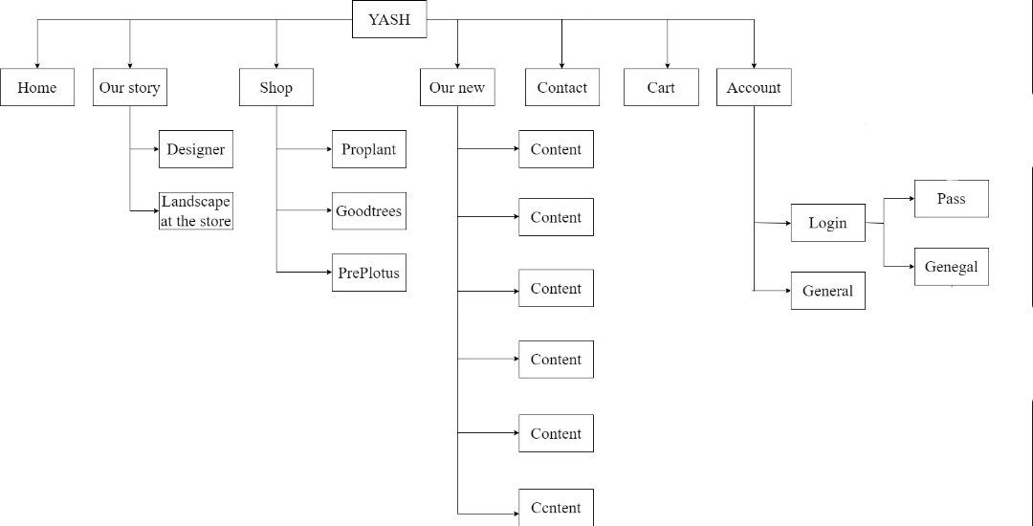

**3.3 Design:** *(User Interface Design Templates)*

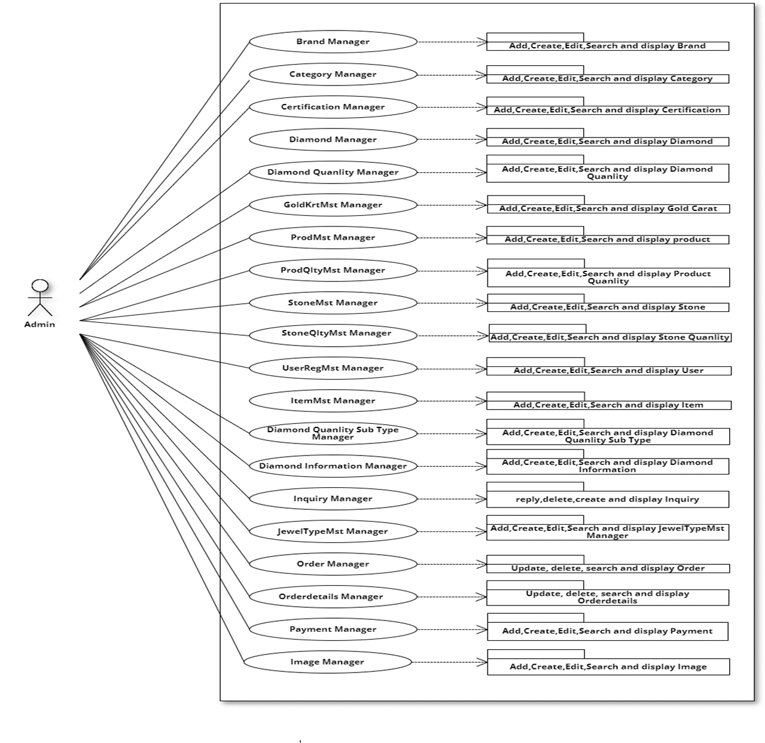

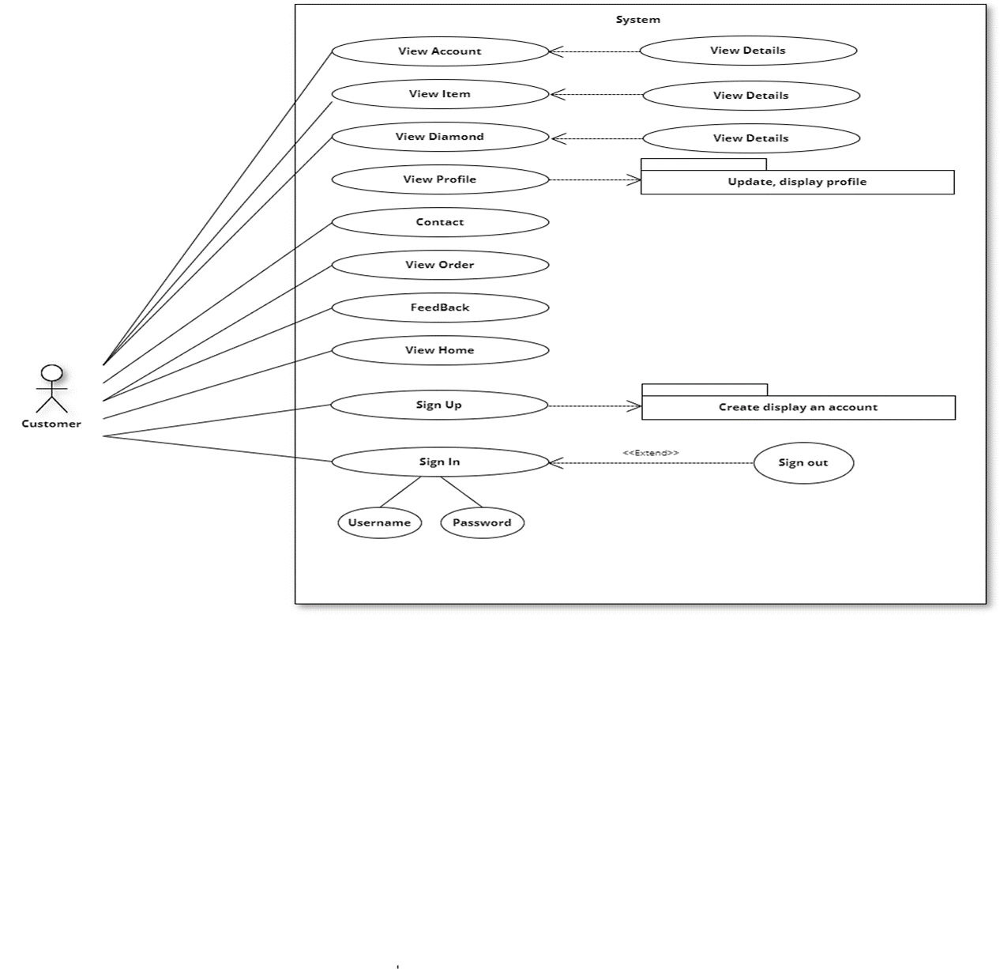

|  |  |  |  |  |
| --- | --- | --- | --- | --- |
| **Use Case Name** | **User object (Actor)** | **Description** | **Implementation steps** | **Pre-condition** |
| Use case brand | Admin | This use case is used to manage brand of item | + Admin click on “Brand” to see the list of Brand.  +Admin click "search" and enter information Brand type ... to quickly find the Brand you need to find.  + Admin click "Add new Brand" and input the brand type to be able to create a new  + Admin click "Delete Brand" then the confirm page will appear, admin must click “OK” to delete | Actor must login with Admin account.  Actor must have an internet connection when logging in. |
| Use case Category | Admin | This use case is used to manage Category of item | + Admin click on “Category” to see the list of Category.  +Admin click "search" and enter information Category Name ... to quickly find the Category you need to find.  + Admin click "Add new Category" and input the Category Name to be able to create a new  + Admin click "Delete Category" then the confirm page will appear, admin must click “OK” to delete | Actor must login with Admin account.  Actor must have an internet connection when logging in. |
| Use case Certification | Admin | This use case is used to manage Certification of item | + Admin click on “Certification” to see the list of Certification.  +Admin click "search" and enter information Certification type ... to quickly find the Certification you need to find.  + Admin click "Add new Certification" and input the Certification type to be able to create a new  + Admin click "Delete Certification" then the confirm page will appear, admin must click “OK” to delete | Actor must login with Admin account.  Actor must have an internet connection when logging in. |
| Use case Diamnd | Admin | This use case is used to manage Diamondof item | + Admin click on “Diamond” to see the list of Diamond.  +Admin click "search" and enter information Diamond type ... to quickly find the Diamond you need to find.  + Admin click "Add new Diamond " and input the Dim_Crt,Dim_Pcs,Dim_Gm,Dim_Size,Dim_Rate,Dim_Amt to be able to create a new  + Admin click "Delete Diamond " then the confirm page will appear, admin must click “OK” to delete | Actor must login with Admin account.  Actor must have an internet connection when logging in. |
| Use case  Diamond Quanlity | Admin | This use case is used to manage Diamond Quanlity of item | + Admin click on “Diamond Quanlity” to see the list of Diamond Quanlity.  +Admin click "search" and enter information Diamond Quanlity type ... to quickly find the Diamond Quanlity you need to find.  + Admin click "Add new Diamond Quanlity" and input the Diamond Quanlity to be able to create a new  + Admin click "Delete Diamond Quanlity" then the confirm page will appear, admin must click “OK” to delete | Actor must login with Admin account.  Actor must have an internet connection when logging in. |
| Use case  Gold Carat | Admin | This use case is used to manage Gold Carat of item | + Admin click on “Gold Carat” to see the list of Gold Carat.  +Admin click "search" and enter information Gold Carat type ... to quickly find the Gold Carat you need to find.  + Admin click "Add new Gold Carat " and input the Gold Carat to be able to create a new  + Admin click "Delete Gold Carat " then the confirm page will appear, admin must click “OK” to delete | Actor must login with Admin account.  Actor must have an internet connection when logging in. |
| Use case  Product | Admin | This use case is used to manage Product of item | + Admin click on “Product” to see the list of Product  +Admin click "search" and enter information Product type ... to quickly find the Product you need to find.  + Admin click "Add new Product" and input the Product type to be able to create a new  + Admin click "Delete Product" then the confirm page will appear, admin must click “OK” to delete | Actor must login with Admin account.  Actor must have an internet connection when logging in. |
| Use case  Product Quanlity | Admin | This use case is used to manage Product Quanlity of item | + Admin click on “Product Quanlity” to see the list of Product  +Admin click "search" and enter information Product Quanlity type ... to quickly find the Product Quanlity you need to find.  + Admin click "Add new Product Quanlity" and input the Product Quanlity to be able to create a new  + Admin click "Delete Product" then the confirm page will appear, admin must click “OK” to delete | Actor must login with Admin account.  Actor must have an internet connection when logging in. |
| Use case  Stone | Admin | This use case is used to manage Stone of item | + Admin click on “Stone” to see the list of Stone  +Admin click "search" and enter information Stone... to quickly find the Stone you need to find.  + Admin click "Add new Stone" and input the Stone_Gm, Stone_Pcs, Stone_Crt, Stone_Rate, Stone_Amt to be able to create a new  + Admin click "Delete Stone" then the confirm page will appear, admin must click “OK” to delete | Actor must login with Admin account.  Actor must have an internet connection when logging in. |
| Use case  Stone Quanlity | Admin | This use case is used to manage Stone Quanlity of item | + Admin click on “Stone Quanlity” to see the list of Stone Quanlity  +Admin click "search" and enter information Stone Quanlity... to quickly find the Stone Quanlity you need to find.  + Admin click "Add new Stone" and input the Stone Quanlity to be able to create a new  + Admin click "Delete Stone Quanlity" then the confirm page will appear, admin must click “OK” to delete | Actor must login with Admin account.  Actor must have an internet connection when logging in. |

**3.4 Data Flow Diagram (DFD)**

**3.5 Flowchart**

3.5.1 Home page

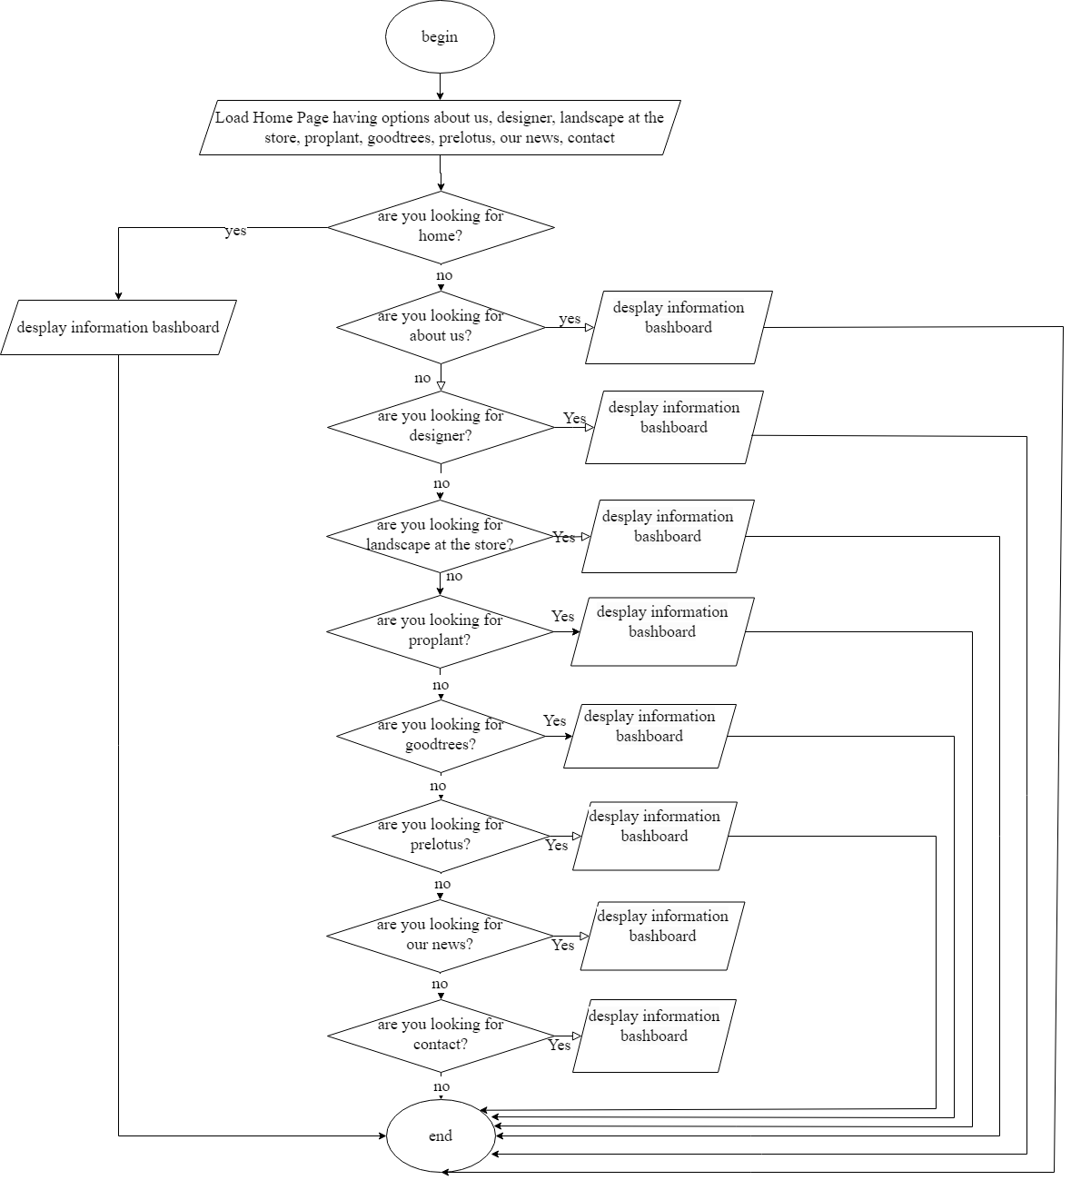

3.5.2 Order

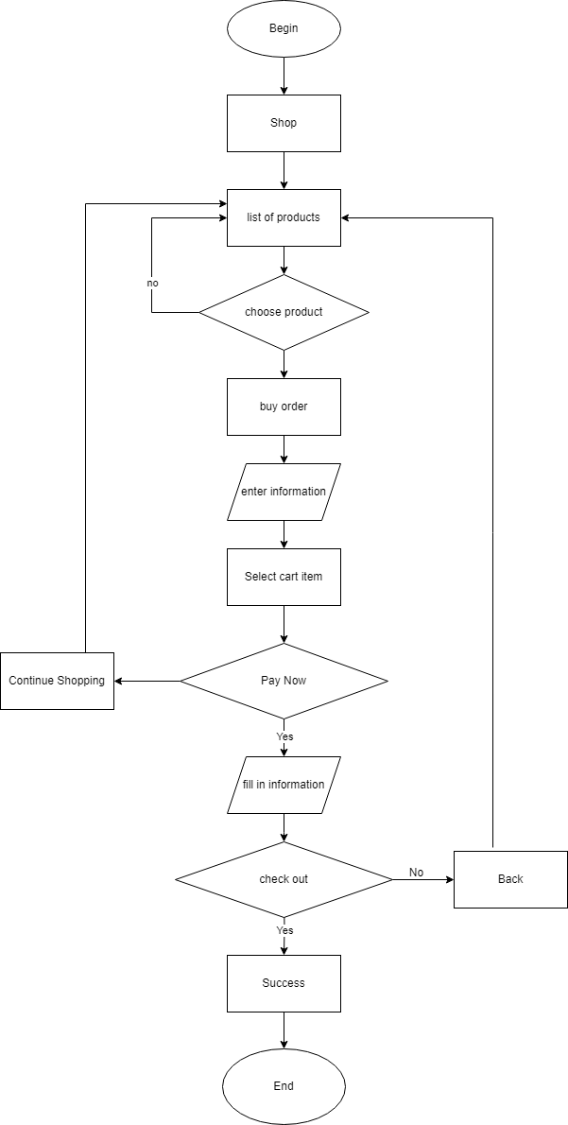

3.5.3 Our New

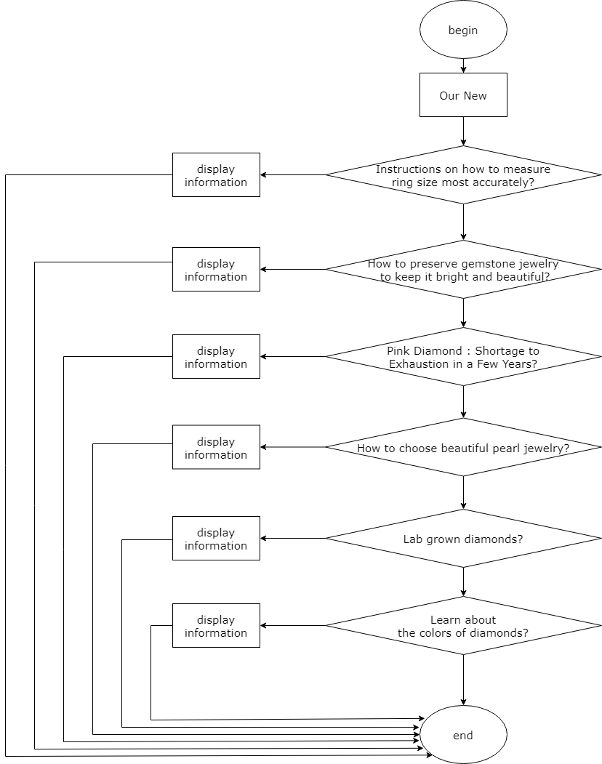

3.5.4 Product

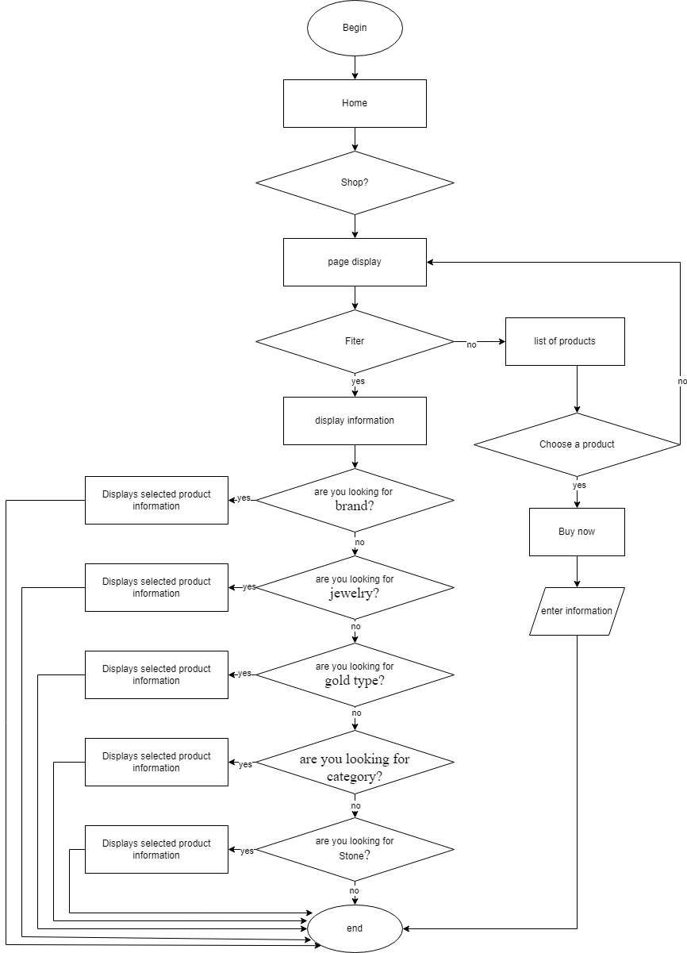

3.5.5 Register

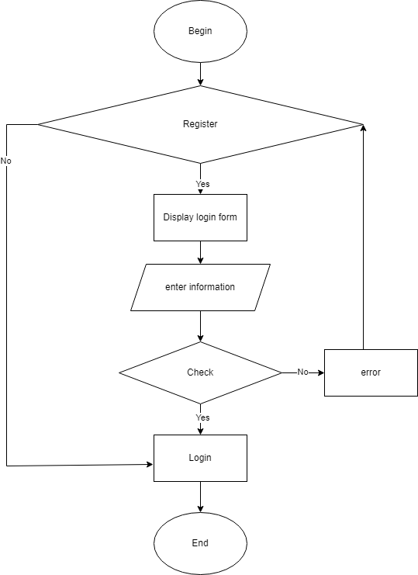

3.5.6 Sign In

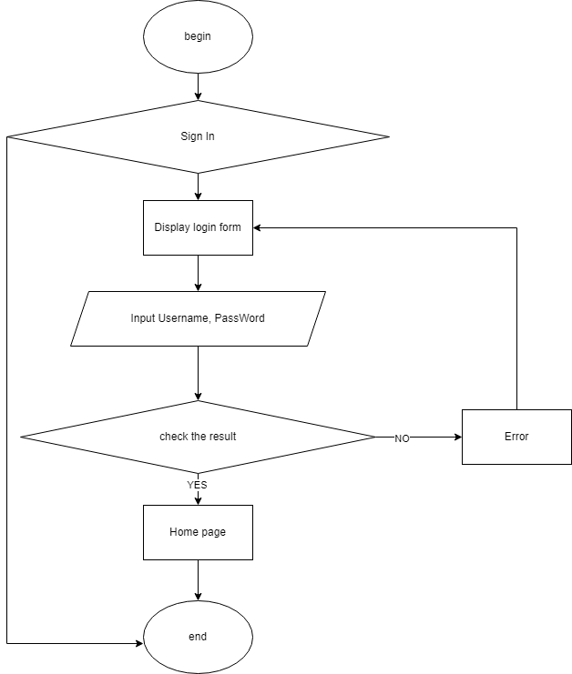

**3.6 Entity Relationship (ER) Diagram :**

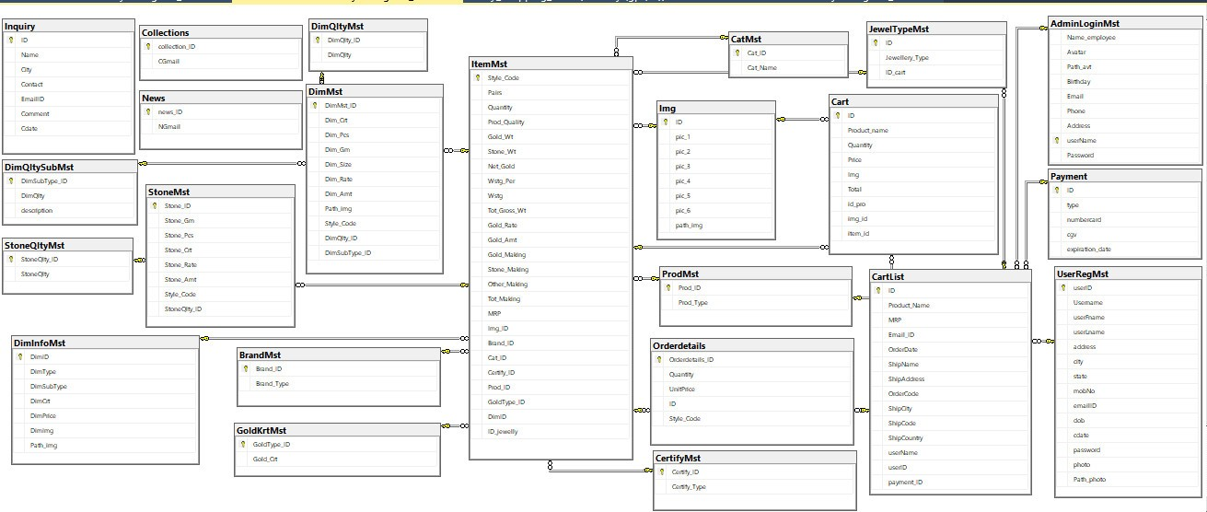

**Database Design/Structure**

**I. ER/Class Diagram:**

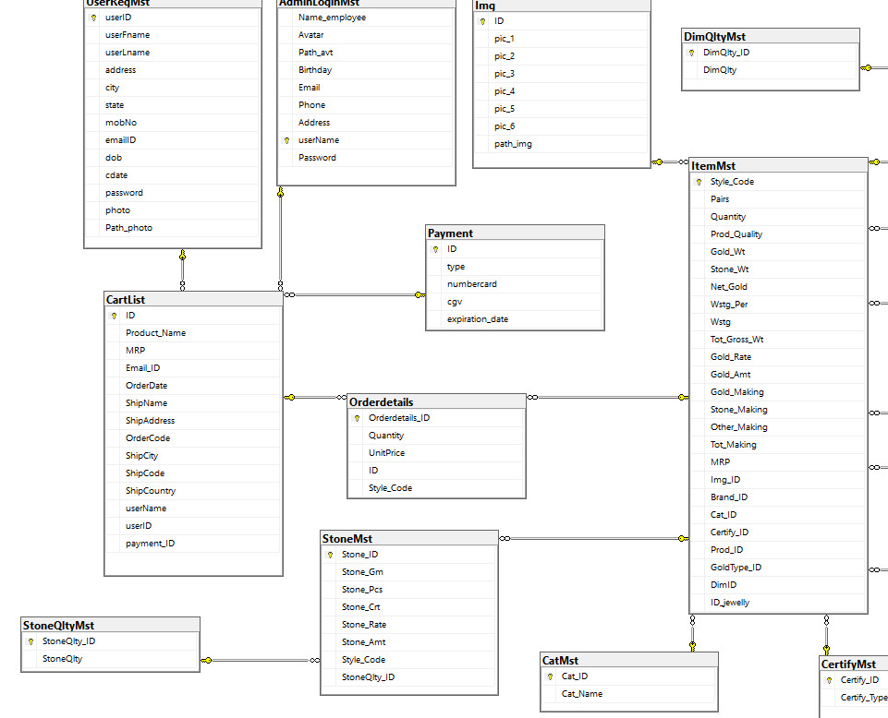

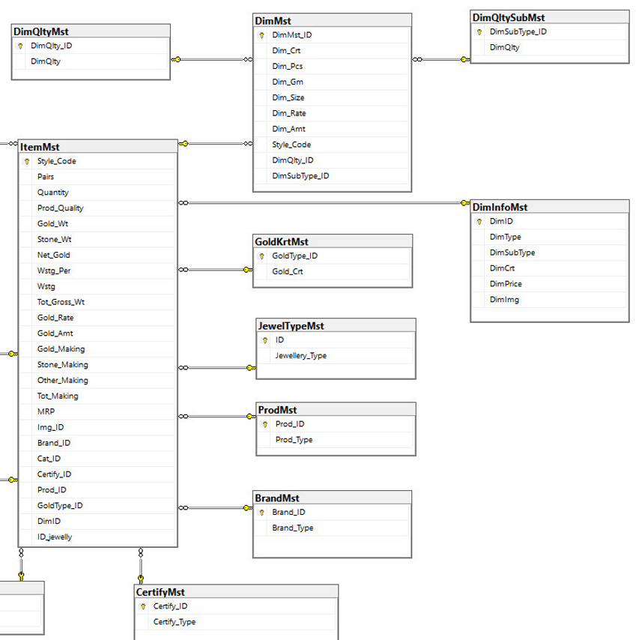

**II. Table Description:**

|  |  |  |  |
| --- | --- | --- | --- |
| **AdminLoginMst** | | | |
| **Field Name** | **Data Type** | **Constraint  (Primary Key, Foreign Key, Identity, Not Null,...)** | **Description** |
| **CustomerID** | **varchar(255)** | **Identity(1, 1), Primary key** | **Customer code** |
| **Fullname** | **nvarchar(255)** | **Not null** | **Customer's full name** |
| **Phone** | **varchar(10)** | **Unique Key, Not null** | **Customer's of phone** |
| **Email** | **varchar(100)** | **Not null** | **Customer’s of email** |
| **Password** | **varchar(255)** | **Not null** | **Password log in to the customer's account** |
| **Address** | **nvarchar(255)** | **Not null** | **Client's residential address** |
| **AddressDetail** | **nvarchar(255)** | **Not null** | **Customer-specific address details** |
| **Avatar** | **varchar(255)** | **Not null** | **Customer profile picture** |
| **Birthday** | **varchar(255)** | **Not null** |  |
| **UpdatedAt** | **date** | **Not null** | **Customer information update date** |

|  |  |  |  |
| --- | --- | --- | --- |
| **BrandMst** | | | |
| **Field Name** | **Data Type** | **Constraint  (Primary Key, Foreign Key, Identity, Not Null,...)** | **Description** |
| **userName** | **Varchar(50)** | **Primary key** | **ID Of Particular**  **Brand** |
| **Password** | **Varchar(50)** | **Not null** | **Type Of Brand**  **(Asmi,D’damas,e**  **tc…)** |

|  |  |  |  |
| --- | --- | --- | --- |
| **CatMst** | | | |
| **Field Name** | **Data Type** | **Constraint  (Primary Key, Foreign Key, Identity, Not Null,...)** | **Description** |
| **Cat_ID** | **nchar(10)** | **Primary key** | **ID Of Category** |
| **Cat_Name** | **Varchar(50)** | **Not null** | **Name Of Category** |

|  |  |  |  |
| --- | --- | --- | --- |
| **CertifyMst** | | | |
| **Field Name** | **Data Type** | **Constraint  (Primary Key, Foreign Key, Identity, Not Null,...)** | **Description** |
| **Certify_ID** | **nchar(10)** | **Primary key** | **ID Of Certification** |
| **Certify_Type** | **Varchar(50)** | **Not null** | **Name Of**  **Certification**  **(918,920,etc…)** |

|  |  |  |  |
| --- | --- | --- | --- |
| **DimMst** | | | |
| **Field Name** | **Data Type** | **Constraint  (Primary Key, Foreign Key, Identity, Not Null,...)** | **Description** |
| **Style_Code** | **Varchar(50)** | **Foreign Key** | **ID Of Certification** |
| **DimQlty_ID** | **nchar(10)** | **Foreign Key** | **ID Of Diamond Quality** |
| **DimSubType_ID** | **nchar(10)** | **Foreign Key** | **Sub Type ID Of Diamond** |
| **Dim_Crt** | **Numeric(10,2)** | **Not Null** | **Carat Of Diamond** |
| **Dim_Pcs** | **Numeric(10,2)** | **Not Null** | **Total Pcs Of Diamond In Item** |
| **Dim_Gm** | **Numeric(10,2** | **Not Null** | **Weight Of Each Diamond(Grams)** |
| **Dim_Size** | **Numeric(10,2** | **Not Null** | **Size Of Each Diamond** |
| **Dim_Rate** | **Numeric(10,2** | **Not Null** | **Rate Of Each Diamond** |
| **Dim_Amt** | **Numeric(10,2** | **Not Null** | **Total Amount Of All Diamonds In Item** |

|  |  |  |  |
| --- | --- | --- | --- |
| **DimQltyMst** | | | |
| **Field Name** | **Data Type** | **Constraint  (Primary Key, Foreign Key, Identity, Not Null,...)** | **Description** |
| **DimQlty_ID** | **nchar(10)** | **Primary key** | **ID Of Certification** |
| **Certify_Type** | **Varchar(50)** | **Not null** | **Name Of**  **Certification**  **(918,920,etc…)** |

**Checklist of validations:**

|  |  |
| --- | --- |
| **Option** | **Validated** |
| Do all numeric variables have a default value of zero? | Yes |
| Does the administrator have all the rights to create and delete the records? | Yes |
| Are all the records properly fed into the appropriate database? | Yes |
| Have all the modules been properly integrated and are completely functional? | Yes |
| Have all the Design and Coding Standards been followed and implemented | Yes |
| Is the GUI design consistent all over? | Yes |
| Is the navigation sequence correct through all the forms/screens in the application? | Yes |
| Is exception handling mechanism implemented in all the screens ? | Yes |
| Are all the program codes working? | Yes |

**Submission Checklist:**

|  |  |  |  |  |  |
| --- | --- | --- | --- | --- | --- |
| **Sr.NO**. | **Particulars** | **Yes** | **No** | **NA** | **Comments** |
| 1. | Are all the users able to search for a particular record? | Yes |  |  |  |
| 2. | Are all the old records properly saved and retrieved when required? | Yes |  |  |  |
| 3. | Have all the modules been properly integrated and are completely functional? | Yes |  |  |  |
| 4. | Are the GUI contents devoid of spelling mistakes? |  | No |  |  |
| 5. | Is the application user-friendly? | Yes |  |  |  |
| 6. | Is the project published properly into a setup file? | Yes |  |  |  |