1.Introduction

1.1 Purpose

This document holds the low level design specification for the Web app component of the project “Anotode”. It is supposed to be followed during the coding phase and will be used as a reference for developing the Android app part of the project.

1.2 Document Conventions
App here means “Anotode Web app”. Rest things is followed according to the Document convention doc of our project.

1.3 Intended Audience and Reading Suggestions
The audience of this document is assumed to be the development team and whosoever who is part of development of the Android app and in some cases, the entire project. It is recommended that anyone reading this document must have prior knowledge of how Web app work. An experience in developing Web app would come really handy.

1.4 References
Various references were used in preparing this document. A non-exhaustive list of them can be listed as follows -

- AngularJs refference - https://angularjs.org/
- AngularJs tutorial- http://www.w3schools.com/angular/
- AngularJs Quick Guide- https://www.tutorialspoint.com/angularjs/angularjs_quick_guide.htm
- AngularJs documents for concepts- https://docs.angularjs.org/guide/concepts

2. Design Overview
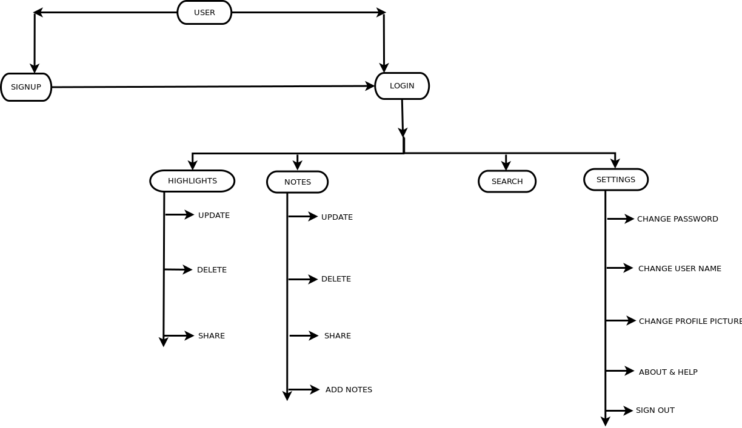

3. Design Description

3.1. Codebase structure
1.WelcomePage
2.User-username,email,password,picture_url
a)SignUpPage
b)LogInPage
3.Highlight-id,time,url,title,notedtext,comment,tags,category
a)HighlightPage
b)HighlightDetailPage
c)HighlightEditPage
d)NotesPage
e)NotesEditPage
f)NotesDetailPage
h)AddNotesPage
4.AnotodeStore
5.ChangeProfilePage
6.ChangePwdPage
7.ChangeUserNamePage
8.AboutPage
9.SearchResultPage
10.SettingPage

3.2. User Interface
As detailed in the prototype designs.
For backend, UI is API.
1.AddNotesActivity-”http://anotode.herokuapp.com/api/highlights?token=”
2.UserDetail-”http://anotode.herokuapp.com/api/users/user?token=”
3.GetCategory-”http://anotode.herokuapp.com/api/highlights/categories?token=”
4.SendingImage-”http://uploads.im/api”
5.UpdateHighlights & UpdateNotes-”http://anotode.herokuapp.com/api/highlights/id?token=”
6.FetchHighlights & UpdateNotes-”http://anotode.herokuapp.com/api/highlights?token=”
7.LogIn-”http://anotode.herokuapp.com/api/login”
8.Search-”http://anotode.herokuapp.com/api/highlights?token= &contains=”
9.SignUp-”http://anotode.herokuapp.com/api/users”

3.3. Class Diagrams

3.4 Event/Message flow diagrams

1.Registration
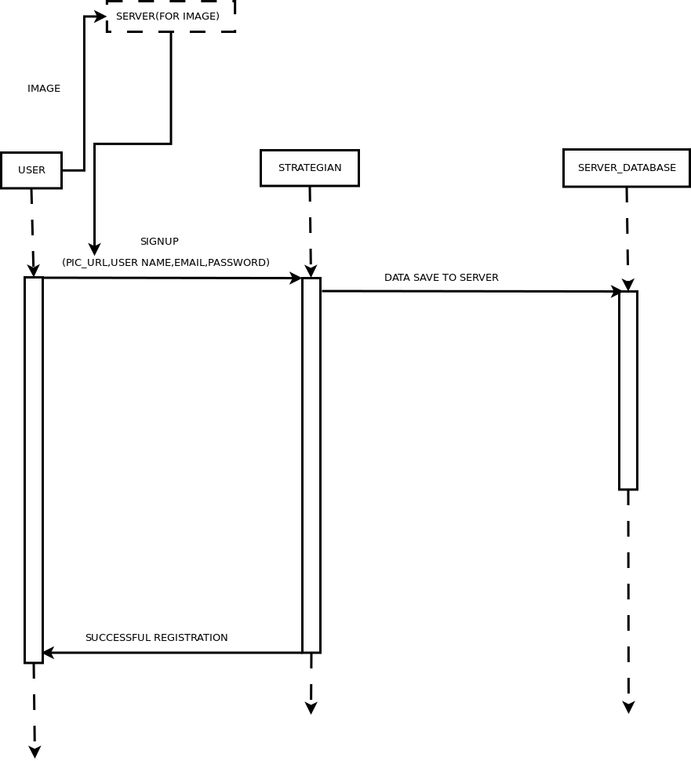

2.LogIn
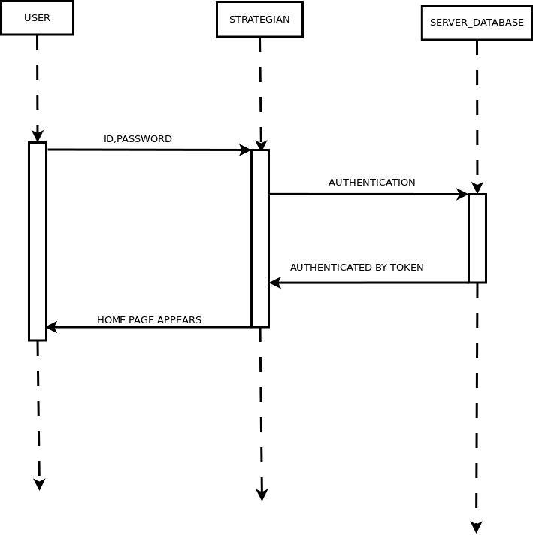

3.Add Notes
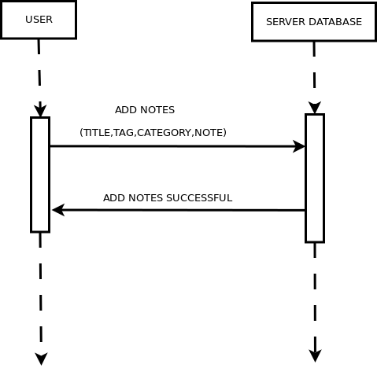

4.Fetch Highlights & Notes
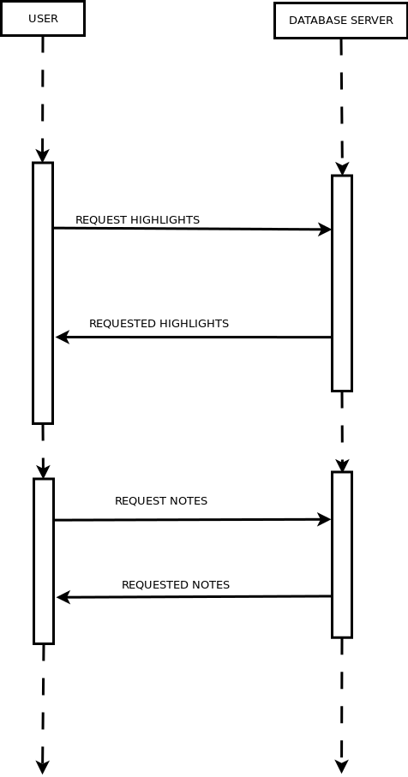

5.Update Highlights & Notes 6.Delete Highlights & Notes
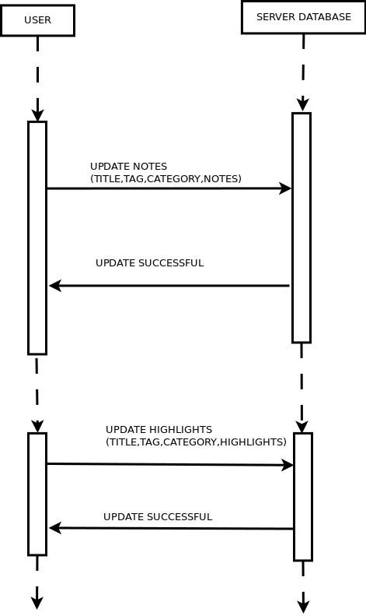
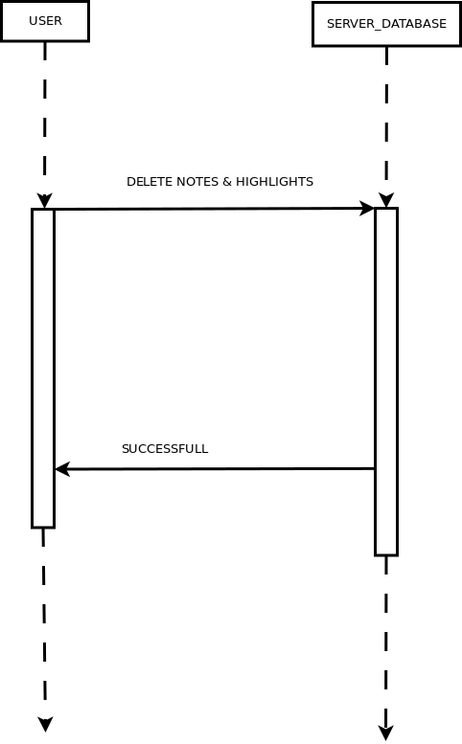

7.Settings

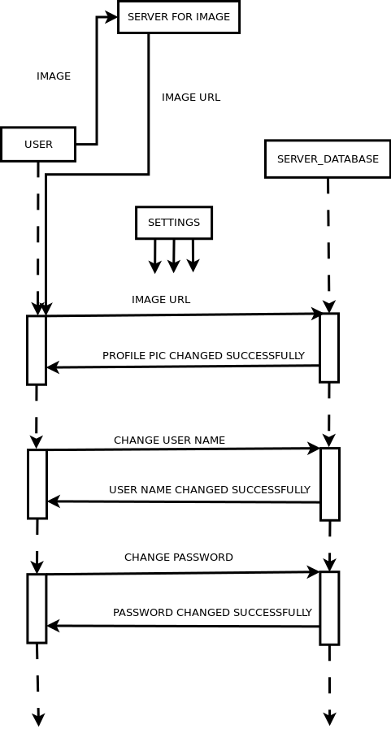

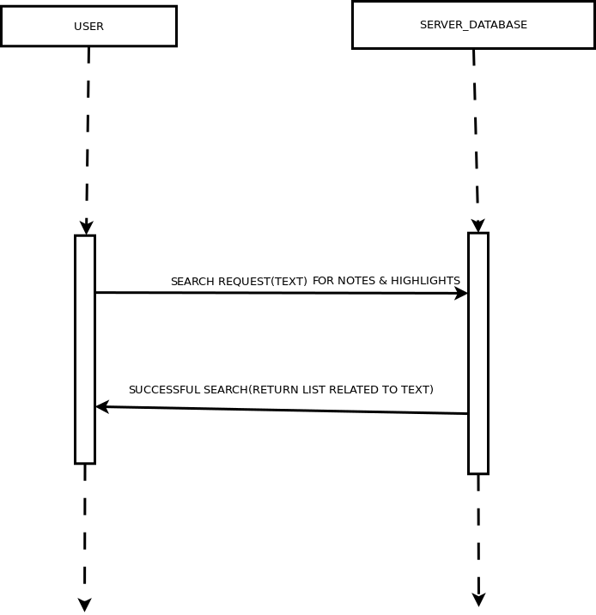
8.Search

3.5. Error/Exception Handling
a) Exception is handled by JSONException.
Many console.log are printed to detect the error.

4. Configuration
This section lists the configurations that need to be done in order to get the system running.

4.1 Views
AngularJS supports Single Page Application via multiple views on a single page. To do this AngularJS has provided ui-view directives and $routeProvider services.

a) index.html– Main page which have nested views in it.
b) basic.html and dashboard.html – All the other pages when register or login are nested in this view.

4.2 Controllers
AngularJS controllers control the data of AngularJS applications.
AngularJS controllers are regular JavaScript Objects.

4.3 Services

In AngularJS, a service is a function, or object, that is available for, and limited to, your AngularJS application.

4.4 Third Party tool Configuration
a) Upload.im database server – server for storing images
API is “http://uploads.im/api”.
b) Google API – Used for google sign in.

5. Customization
We can improve Layout for next version.Adding Facebook signin option for user.Can also attach images,files with our custom note feature.We can use camera action for profile picture upload.

6. Assumptions
a) The user will have a basic knowledge of APIs.
b) The user knows basic of the deploying to WEB APP.
c) The user know how heroku Deployment works.

7. Dependencies
Dependencies of the component.

{
"name": "Anotode",
"description": "Highlighting the world",
"main": "",
"license": "",
"homepage": "",
"ignore": [
"**/.*",
"node_modules",
"bower_components",
"test",
"tests"
],
"dependencies": {
"angular-snap": "^1.8.5",
"angular": "^1.5.8",
"angular-ui-router": "ui-router#^0.3.2",
"angular-animate": "^1.5.8",
"angular-mocks": "^1.5.8",
"components-font-awesome": "^4.7.0",
"json3": "^3.3.2"
}
}

