

Grimmetropolis

„Attac & Protec“

TEASER

Manuel Serquet – Programmer, Designer, Visual Artist

Michael Giger – Producer, Programmer, Designer, Visual Artist

Tianyu Wu – Programmer, Designer, Visual Artist

Yelan Tao – Programmer, Designer, Visual Artist

Contents

Chapter 1. Formal Project Proposal 4

1.1. Game Description 4

1.1.1. Overview 4

1.1.2. Background Story 4

1.1.3. Design Decisions 4

1.2. ‚Big Idea‘ Bullseye 7

1.3. Technical Achievement 7

1.4. Development Schedule 8

1.4.1. Layered Task Breakdown 8

1.4.1.1. Functional Minimum 8

1.4.1.2. Low Target 8

1.4.1.3. Desired Target 8

1.4.1.4. High Target 9

1.4.1.5. Extras 9

1.4.2. Task List 9

1.4.3. Timeline 11

1.5. Assessment 11

Chapter 2. Prototype 12

2.1. Prototype Setup 12

2.2. Playing Experience 12

2.3. Findings and Conclusion 12

Chapter 3. Interim Report 13

3.1. Progress 13

3.2. Challenges 13

3.3. Future Work 13

Chapter 4. Alpha Release 14

4.1. Progress 14

4.2. Challenges 14

4.3. Future Work 14

Chapter 5. Playtest 15

5.1. Playtesting Session 15

5.2. Questions and Comments 15

5.3. Design Revisions 15

Chapter 6. Conclusion 16

6.1. Final Results 16

6.2. Experience 16

6.2. Personal Impressions 16

Chapter 1. Formal Project Proposal

* 1. Game Description
     1. Overview

The idea is a tower defense game with co-op multiplayer capabilities. Each player will control a character in a 3D top-down game world. The players will start at a castle which they have to protect. The players have to collect resources in order to construct buildings. Buildings have mainly two purposes: They help you collect more resources or defend against the enemies. The enemies will constantly come to attack the castle, buildings or the players. They will sometimes attack in smaller groups or in bigger waves. In the course of the game, the enemies become stronger and stronger. Therefore, you need to upgrade buildings or train your character. This also requires more resources which can be accessed when you expand around you castle. Eventually, you will lose. The premise of this game is to find the best strategy to defend against the enemy as long as possible.

* + 1. Background Story

You are in the hands of some very powerful magical items. Protect them at all costs! With the power of the magical items, you can harvest the resources of the world and build a strong economy. But you are not alone! Enemies will come for you and the magical items! Work hand in hand in a team with Puss in Boots, Rapunzel, Cinderella and other famous fairy tale characters, each one of them with their own special quirks.

* + 1. Design Decisions

Introduction

The game genre is mainly a tower defense game, but it also contains elements from a strategy and role play game. The visual style is kept simple with low poly art. The camera is looking from the sky down to the world like in a typical top down view in games like *The Legend of Zelda: Link's Awakening (2019).* The players start as a Grimm's fairy tale character in a world around a castle. The players can collect resources from the world and construct buildings. Buildings support the players at collecting resources or defending against enemies. The players themselves can attack the enemies as well. The goal is to defend the castle as long as possible. The game is over when the castle is completely looted.

World

The world is a finite map which is structured in square tiles. A tile can be clear or occupied by some natural structures. Natural structures include trees, big stones, rivers, hills or mountains. In the middle of the map is the castle. It will cover three by three tiles. Other buildings can occupy from a single tile to three by three tiles. As an initial step, only one map is planned. The reason for this is that people can compare their score with other players and optimize their strategy. On a later stage of the game development, new maps with interesting features can be played as well. Such features might be a castle surrounded by a river or at the border of the mountains which allow for new defense strategies during game play. A possible addition might be randomly generated maps. It might be difficult to create interesting maps by a random algorithm, but it is certainly considered as goal at a very late stage of game development.

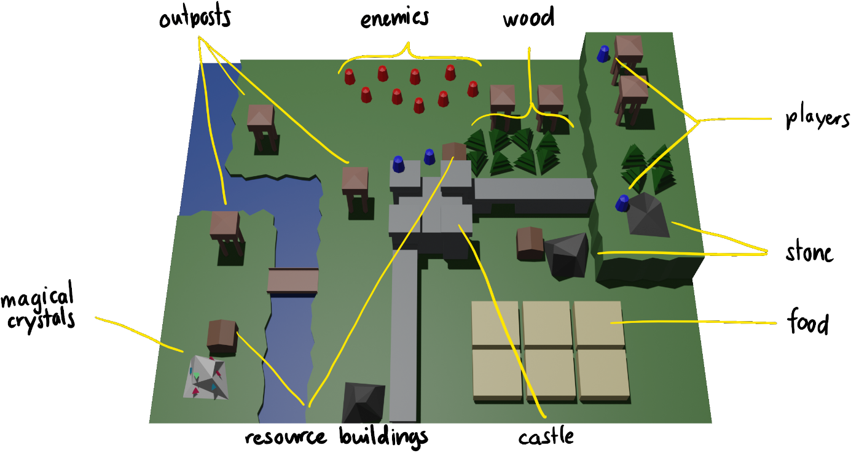

Figure 1: Truncated part of the game world. A possible base configuration during gameplay.

Player

The players can choose a character from the Grimm's fairy tales. When every player is ready, they will start in the world around the castle. A player is around half the size of a map tile. That means, two players can walk side by side when walking along a one tile wide path. A player can carry two items which he can use to do various tasks in the world map. Depending on the items the player holds, he can collect resources, construct buildings or fight enemies. The more a player does a certain task, the faster he becomes at doing it permanently. Therefore, a good team distributes the various tasks between the players. Every player has a unique skill which is dependent on the character he chose at the beginning of the game. Such unique skills might be for example pushing enemies away, jumping over stone walls or special magic abilities.

Resources

The map contains resources distributed in clusters all over the map. There are three common resources: wood, stone, and food. Wood can be collected from trees around the map and stone from stone quarries. These resources are used to construct buildings. They can be collected by the players or by buildings and are directly transferred to a common resource pool. The resources gradually regenerate after some time. This also means, a player cannot harvest infinitely much resources from a single deposit in a short time. The regeneration of a resource can be supported by buildings. Food can be harvested from farms, another type of building. It is required for certain types of buildings or as an upkeep. A rare resource is the magical crystal. It is only available further away from the castle. Therefore, it is not easy to harvest this resource. This resource is needed for special buildings or temporary buffs for buildings or players.

Buildings

Buildings can be categorized in two types of buildings: defensive and supporting buildings. The defensive buildings include a castle, outposts, stone walls and trenches. The castle and outposts attack close by enemies. Stone walls hinder enemies from walking freely around. Trenches offer more protection to the player from incoming fire. Supporting buildings include resource buildings, farms, hospitals, maintenance buildings, bridges and tunnels. Resource buildings give the player a passive resource income if build near resource deposits. Farms deliver food. Hospitals heal the players. Maintenance buildings repair other buildings or give them permanent buffs if they are close enough. These buildings all have a nonlinear upgrade tree. Bridges can be built over rivers to reach new areas of the map. Tunnels have the same use as the bridges but are used for mountains. The enemies will use these structures as well to reach the castle.

Items

In order for the players to do certain tasks, they need to equip themselves with the right items. The player can get their items at the castle and change it whenever they want to do so. At a later stage of the game development, an idea might be that the players start with some necessary tools but have to produce the other items at a special building. There are two types of items: weapons and tools. Weapons include swords, lances, shields, bows, crossbow or muskets. The weapons feel different to use and have different efficiency against certain types of enemies. Tools include items to harvest the resources: food requires a scythe, wood requires an axe, stone requires a hammer, magical crystals require a pickaxe. Buildings can be built with a trowel.

Enemies

The enemies will attack from any direction if the map layout does not hinder it. They usually attack in waves. Between the waves, the player has time to collect resources and construct buildings. The enemies will attack between the waves as well, but only in very small groups. There are going to be different types of enemies available: close combat fighters (sword fighter, lance fighter, beasts), ranged units (archer, wizard) and siege units (catapult, trebuchet, giants), maybe even flying units (crows). Depending on the base the players have built or the map layout, the enemies should attack cleverly. As an example, if the player is completely protected by stone walls, the enemies will first try to breach the wall with siege units before attacking with all their close combat units. After defeating enemy units, they will drop resources. An idea is also to introduce boss enemies which will come at certain waves. They will drop special items which the player can equip.

Tutorial

Whenever the players start a new game, another character spawns around the castle. He will talk about the first steps to build up a working economy and how to build a defense against the enemies. The player can skip the tutorial by killing him. He will drop some resources for the players to collect.

* 1. ‚Big Idea‘ Bullseye

Core Idea

Players cooperate with each other and defend the castle as long as possible by fighting against the enemies, collecting common and rare resources, constructing and upgrading buildings and improving skills.

Technical Innovation

Each player has his own special ability depending on the character from the Grimm's Fairy Tale. Different tools can be used to harvest resources and constructing buildings. The players need to expand to get more resources. An algorithm needs to be developed for enemy attacking routes.

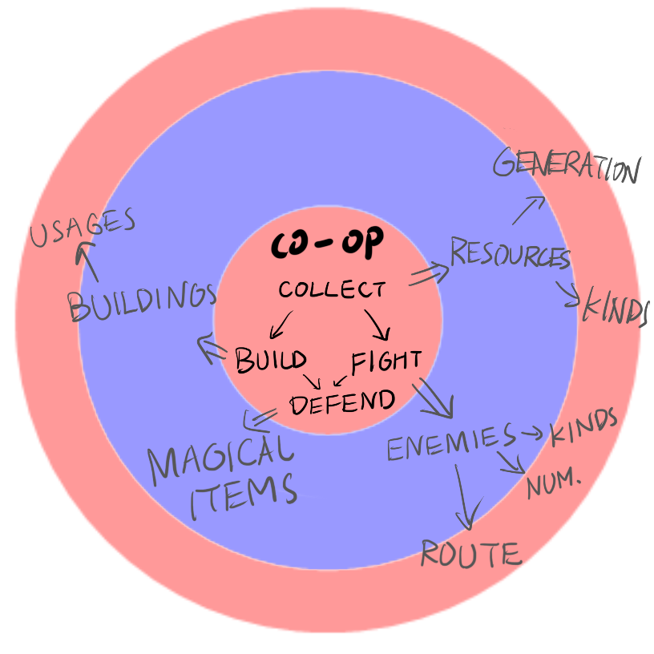

* 1. Technical Achievement

In the tower defense genre, usually the enemies either take a predefined path or the shortest path to the base while ignoring towers. This leads to the incentive of placing walls to create artificial choke points and build defenses around them such that the enemies stay under fire as long as possible and run to their death.

The enemies however should act in an intelligent way using their knowledge of the map. They should avoid well defended choke points if they can simply take a longer path. Furthermore, they will retaliate against towers and try to breach walls where they are less defended.

* 1. Development Schedule
     1. Layered Task Breakdown
        1. Functional Minimum
* A single character can play the game.
* The map contains no natural structures apart from the trees.
* The only resource available is wood.
* The character can collect resources, build outposts and fight enemies without any items.
* A single type of close combat enemy will attack the castle by going straight to it.
  + - 1. Low Target
* Multiple people can play the game at the same time. The camera will zoom out so that all players are always visible.
* The map now also has more natural structures like big stones or rivers.
* Stone can be now collected as an additional resource.
* New buildings like resource collecting buildings and stone walls should be available.
* The outposts should have a simple upgrade tree available.
* Close combat weapons and tools have to be used by the players now.
* A single type of ranged unit and siege unit will appear in the waves.
* The enemies attack with more intelligence: If they are attacked by something, they counterattack.
* A simple game menu to start with.
* Add some music to the game.
  + - 1. Desired Target
* The player has some basic skills which they can improve.
* The players are unique characters with a special skill.
* The map contains now also hills and mountains.
* Magical crystals can now be collected.
* At least two enemies of each type except the flying type should appear in waves.
* Further buildings like the trenches, farms, hospitals, maintenance buildings and bridges should be available.
* All added buildings should have a unique upgrade tree.
* The player should also have access to ranged weapons like a bow.
* The tutorial character exists in the world map.
* The players have the possibility to pause the game.
* The game over screen should appear when the players lose.
* Creation of the trailer.
  + - 1. High Target
* All previously mentioned enemy types should be available
* Boss enemies are introduced which attack at certain waves.
* Boss enemies will drop very strong and unique items which the players can equip.
* All previously mentioned weapons should be now available.
* More maps are created which should offer very interesting strategies.
  + - 1. Extras
* Each player has their own camera view when the camera must zoom too far away to get all players on one screen.
* Map generation should deliver always new experiences while the playing the game.
* The game can be played online with other players.
  + 1. Task List

In the following two pages, a list of all tasks can be seen. They are listed with the responsible person and the initial planned duration for this task.

|  |  |  |  |
| --- | --- | --- | --- |
| 1 | Functional Minimum |  |  |
| 1.1 | Inital engine setup | Michael, Manuel | 24h |
| 1.2 | Create map consisting of tiles | Yelan, Tianyu | 16h |
| 1.3 | Player control | Manuel | 16h |
| 1.4 | Assets (player, castle, enemy, tree) for the functional minimum | Yelan, Tianyu | 16h |
| 1.5 | Player can collect wood as a resource | Yelan | 32h |
| 1.6 | Fighting system with the player | Michael | 24h |
| 1.6 | Very simple AI pathing aiming for the castle | Manuel | 32h |

|  |  |  |  |
| --- | --- | --- | --- |
| 2 | Low Target |  |  |
| 2.1 | Player can build an outpost | Michael | 24h |
| 2.2 | Implement multiple players | Manuel | 24h |
| 2.3 | Adding new map features like big stones or rivers | Tianyu | 32h |
| 2.4 | Add new stone resource | Yelan | 16h |
| 2.5 | Asset creation for buildings (stone wall) | Yelan | 16h |
| 2.6 | Asset creation for enemies | Yelan | 40h |
| 2.7 | Asset for items (5 items) | Tianyu | 32h |
| 2.8 | Asset for UI | Tianyu | 16h |
| 2.9 | Adding new resource buildings | Michael | 32h |
| 2.10 | Adding stone walls | Michael | 4h |
| 2.11 | Adding UI for building's upgrade tree | Michael | 32h |
| 2.12 | The player can take items with themselves | Manuel | 16h |
| 2.13 | Adding items like swords and their behaviour | Manuel | 16h |
| 2.14 | Adding tools | Manuel | 16h |
| 2.15 | Add a ranged and siege enemy unit | Michael | 32h |
| 2.16 | Enhancing enemy AI (counterattack) | Manuel | 48h |
| 2.17 | Adding a simple game menu | Michael | 32h |
| 2.18 | Testing out the game | Everyone | 32h |
| 2.19 | Balancing the game | Everyone | 32h |
| 2.20 | Add music to the game | Tianyu, Yelan | 8h |

|  |  |  |  |
| --- | --- | --- | --- |
| 3 | Desired Target |  |  |
| 3.1 | Players have a basic skill | Michael | 24h |
| 3.2 | Assets and implementation of unique characters | Michael, Yelan | 64h |
| 3.3 | Map contains hills and mountains | Tianyu | 24h |
| 3.4 | Adding magical crystal as a new resource | Tianyu | 12h |
| 3.5 | Asset creation for buildings | Michael, Yelan | 40h |
| 3.6 | Asset creation for enemies | Yelan | 40h |
| 3.7 | Asset for bow | Tianyu | 16h |
| 3.8 | Add more enemy types (3 enemies) | Manuel | 32h |
| 3.9 | Add more buildings: trenches, farms, hospitals, maintenance buildings and bridges | Michael | 16h |
| 3.10 | Add functionality to buildings | Michael | 40h |
| 3.11 | Add upgrade tree to buildings | Michael | 24h |
| 3.12 | Adding a bow for the player | Manuel | 32h |
| 3.13 | Adding pause menu | Michael, Yelan | 32h |
| 3.14 | Adding a game over screen | Michael, Tianyu | 24h |
| 3.15 | Testing out the game | Everyone | 32h |
| 3.16 | Balancing the game | Everyone | 32h |
| 3.17 | Create a trailer | Everyone | 16h |

|  |  |  |  |
| --- | --- | --- | --- |
| 4 | High Target |  |  |
| 4.1 | Add all enemy types (4 more enemies) | Manuel | 32h |
| 4.2 | Asset for additional items | Tianyu | 24h |
| 4.3 | Asset creation for boss and enemies | Yelan | 48h |
| 4.4 | Add a boss enemy | Michael | 16h |
| 4.5 | Add special items dropped by the boss enemy | Michael | 8h |
| 4.6 | Adding different kinds of weapons | Manuel | 24h |
| 4.7 | Add more maps | Tianyu | 16h |
| 4.8 | Improve intelligence of the AI | Michael, Manuel | 64h |
| 4.9 | Add some cool information to the game over screen | Manuel | 32h |
| 4.10 | Testing out the game | Everyone | 32h |
| 4.11 | Balancing the game | Everyone | 32h |

* + 1. Timeline



* 1. Assessment

Compared to conventional tower defence games, our game offers more varieties with the add-on RTS elements and multi-player collaborations. Players are free to choose different characters inspired by the Grimm's fairy tales with their unique abilities and fight together to protect the castle in a fantasy world. During the game, players have a lot of freedom in what they do. Therefore, the players can develop various strategies to fight against the enemies. The enemies of the games are designed to be more intelligent who can also make use of their knowledge of the map to avoid choke points, unlike taking a predefined or shortest path to the base in traditional tower defence games. This innovation adds more fun to the game, making the game experience more thrilling and challenging. The collaborative setting of the game makes our game a perfect fit for a multiplayer couch game with friends and may be of particular interest to strategy game addicts ranging from young teenagers to adults, seeking challenging and off-centre gameplay.

Chapter 2. Prototype

2.1. Prototype Setup

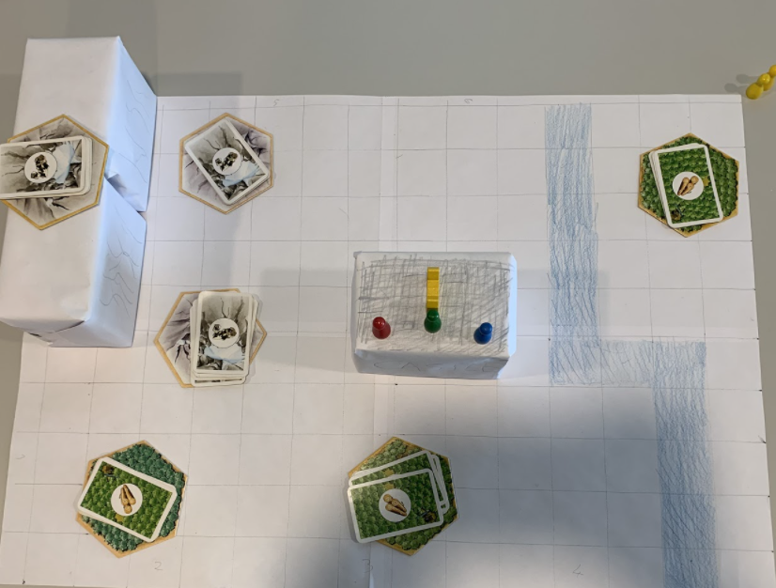

The board game consists of a map divided into a grid. In the middle of the map, a castle serves as the starting point of the players (red, green, blue). Besides the players, the castle also contains a magical artifact (yellow). On the top left side of the map, mountains can be seen. On the right-hand side, a river (blue) covers the whole right side. On the map, wood (green two by two tiles) and stone (grey two by two tiles) resource deposits are distributed.

The board game has a turn-based game mechanic. The goal of the players is to defend the magical artifact from incoming enemies. The enemies will try to steal the magical artifact and escape the map with the magical artifact in their possession.

The players have various abilities in order to defend against the enemies. Players can walk two grid units per turn (not diagonally). All players can discuss their next move with each other and can play in an arbitrary sequence. The players can collect a single resource card if they stand on top of a resource deposit which will end their turn. Players can also attack enemies which stand right next to them (not diagonally) which will also end their turn. Players cannot walk over rivers, mountains, enemies and some buildings (stone walls, defense towers). They cannot end their turn on a grid cell where a player already stands. A player can be attacked three times by the enemy. After that, he cannot play anymore.

The players can also construct buildings. This action also ends the player’s turn. There are various buildings: bridges cost two wood resource cards, farms cost two wood resource cards, stone walls cost two stone resource cards and defense towers cost one stone and one wood resource card. Bridges can be built over rivers to make new lands accessible. Farms are two by two buildings which produce a single food resource card every turn automatically. Stone walls serve as an obstacle for advancing enemies. Defense towers can shoot down an enemy once per turn if the enemy has a Manhattan distance of two grid units from the defense tower. They cost one food resource card per turn. If they do not get food, all towers will have a reduced shooting range of one grid unit. Stone walls and defense towers are non-passable buildings for players and enemies. Each building has three health points and can be destroyed by the enemy. Buildings can be repaired anytime (even when once destroyed) with a single wood resource. The player will have to stand next to the damaged building and end their move to do so.

Resources collected from the resource deposits or farms are stored in a resource pool which is shared between all the players at all times. Each resource deposit has five resource cards. The resource deposits will restore their resource cards every second turn until it has five resource cards again. This way, a player cannot overuse a resource deposit.

The enemies will come in waves. Every fifth turn, the enemies will start their wave at a random location at the border of the map. In the first wave, five enemies will spawn. In every consecutive wave, the amount of enemies increases by half of the amount from last round. This way, waves become more and more difficult. Enemies can move only one grid unit per turn. If they want to attack, they have to stand right next to the building or player (not diagonally). This will also end their turn.

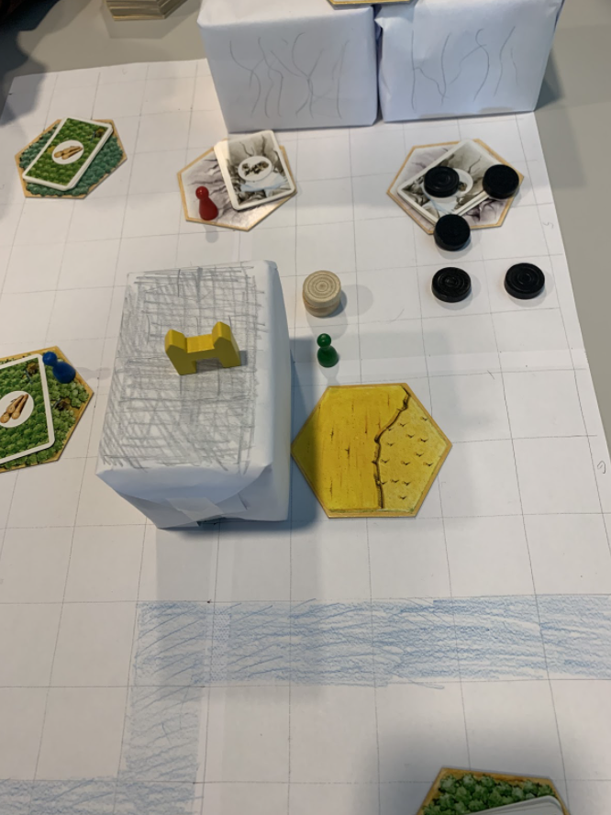Here is an exemplary moment in the board game: The green player has built a farm (yellow, below the green player) and a defense tower (white, above the green player). The enemies (black) are advancing from right to left. The defense tower will be able to shoot down the lower left enemy of the advancing wave. The blue and red players are collecting resources.

2.2. Playing Experience

Overall, the playing experience of the game is challenging yet interesting. Although simulating such a complex interaction in a turn-based game mechanic is a bit tiring and time-consuming process, the game turned out to be playable with only some slight adjustments. During the process, we realize that the balancing of the game is crucial and need to be fine-tuned in the implementation. Because the map we created for the physical prototype is relatively small, the enemies came with a large amount can have more advantages, making it very difficult to defend. We are also quite happy to find out that the collaboration and coordination between players are the key to defense longer towards the enemies, which is exactly the aim of our game. As the resources are distributed in the entire map and enemies can come from any direction, players need to actively communicate with each other to work together and find the best strategy to fight against the enemies. This makes the game challenging and not boring at all playing with friends.

2.3. Findings and Conclusion

The main takeaway from the prototype is that properly balancing the game is a challenging but important aspect of the game. One of the larger balancing issues was that the scale of the physical prototype was too small. The map itself needs to be bigger while both the players and the enemies need to move faster around the map. The towers should also cover a larger portion of the map. Another balancing issue was the food production. Due to the somewhat larger size of the fields and the small map, we quickly ran out of farm space to sustain a larger amount of towers, a one to one ratio of fields and towers proved to be too tight. The fields either need to be smaller or provide more food per field. However, we need to keep in mind that the map will be bigger at the same time. A third issue was that the time between two consecutive waves was too short. There was barely any time left after defeating a wave to build defenses for the next one.

Chapter 3. Interim Report

(Max 5 pages)

3.1. Progress

@Note: Describe how many layers you have finished. You can include screen shots to help explain your game so far, and text to describe how a user would interact with it. Our hope is that you have completely finished layer 2 and are well into layer 3.

3.2. Challenges

@Note: Explain what has proved to be harder (or easier) than expected. What design revisions have you made to your game as a result of what you've learned with the implementation? Discuss the implementation challenges you faced. Were there aspects that you wanted to build but were unable to do so?

3.3. Future Work

@Note: What are the planned tasks that will be implemented next? Shortly explain.

Chapter 4. Alpha Release

(Max 5 pages)

@Note: Follows the same guidelines as the interim report chapter.

4.1. Progress

@Note: Comment on how far you have progressed and show us what is exciting about your game. Ideally, you will have met the goals outlined in layer 3 (your desired target) and possibly part or all of layer 4 (your high target). You can include screenshots.

4.2. Challenges

@Note: Explain what has proved to be harder (or easier) than expected. What design revisions have you made to your game as a result of what you've learned with the implementation? Discuss the implementation challenges you faced. Were there aspects that you wanted to build but were unable to do so?

4.3. Future Work

@Note: What are the planned tasks that will be implemented next? Shortly explain.

Chapter 5. Playtest

(Max 5 pages)

5.1. Playtesting Session

@Note: Describe who you recruited for playtesting and how you organized the playtesting sessions. If possible, include some photos.

5.2. Questions and Comments

@Note: List the questions you chose to ask the testers. Summarize their answers. Comment on overall trends you learned from the exercise, as well as any specific suggestions that were particularly useful.

5.3. Design Revisions

@Note: Finally, describe any changes you made to your game based on the playtesting.

Chapter 6. Conclusion

(Max 5 pages)

6.1. Final Results

@Note: In this chapter, first provide a summary of your final results including screenshots from your final game. Comment on any significant changes from the alpha release.

6.2. Experience

@Note: Here you should provide commentary about your experience during the class. How well did your initial design ideas materialize into the final game. Were you able to follow your development schedule, or did you deviate significantly from it? How did the different elements of the project structure (development schedule, prototype, playtesting, etc.) contribute to or hinder your progress?

Rough draft of the project proposal

6.2. Personal Impressions

@Note: Did it meet your expectations? Are you happy and proud of your game? Do you feel there wasn't enough time or that the schedule was too compressed?

@Note: You might also consider these questions:

* What was the biggest technical difficulty during the project?
* What was your impression of working with the theme?
* Do you think the theme enhanced your game, or would you have been happier with total freedom?
* What would you do differently in your next game project?
* What was your greatest success during the project?
* Are you happy with the final result of your project?
* Do you consider the project a success?
* To what extend did you meet your project plan and milestones (not at all, partly, mostly, or always)?
* What improvements would you suggest for the course organization? (Perhaps in D1 evaluation)?
* Did you like using MonoGame?