Courtney Ward

CSCI 1470-1

Dr. Davari

Term Project

**FODMAP Journey README**

**PROBLEM SPECIFICATIONS**

**Problem Statement:** This application will allow users following a low FODMAP diet to:

1. Create and view a personal FODMAP database/dictionary by inputting information about FODMAP content in foods
2. Create personalized lists of foods: Those certified as low-FODMAP by MONASH, those the user has found to be safe to eat, those they need to be cautious about and those they need to completely avoid
3. Input recipe data (number of servings and amount of ingredients) and view a print out of the recipe they entered as well as the amount of each type of FODMAP per serving of the recipe

**Inputs:**

* User will input menu selections to move between application functions and loop the main function
* Users will input food name and its numerical FODMAP data to be added to a dictionary
* User will input food names to add to personalized tracking lists
* User will input recipe information to have it checked for amount of FODMAPS
  + Food names and amounts and any needed conversion factors (used unit to grams)
  + Serving size & number of servings

**Outputs:**

* Output menu of program options to choose from at the beginning, while looping, and within functions
* Output prompts asking user to enter necessary information or select a menu option
* Output any lists, dictionaries, or entries as selected by user
* Output recipe information, including amount of each FODMAP within a recipe
* Output prompts asking for new or updated information if food or conversion being looked up isn’t in database or if data isn’t the right type

**Constraints:**

* Only user entered data or data saved previously to program files can be used to calculate total FODMAPS, this isn’t a pre-loaded database
* Units used for amounts of foods will have to be standardized to grams for calculations to take place: users will have to know the amount in grams or be able to provide a unit to grams conversion factor
* Numerical data cannot be entered with units for calculations to work; units will have to be stored separately

**Relevant Equations:**

* for any food in recipe not in grams:
  + mass of food = quantity in recipe(unit) * given conversion (g/unit)
* for each food in recipe & each fodmap type:
  + mass of fodmap per recipe += (mass of food) * (fodmap per 100g food) / 100
  + fodmap per serving = (mass fodmap per recipe) / (number of servings)

FODMAP Journey Pseudocode

START

import os, csv, and namedtuple

VARIABLE ASSIGNMENTS

Commonly used strings for later use in prompts and menus

File Names

Fixed lists & dictionaries

Empty dictionaries to be updated by program

DATA VALIDATION & CHANGES FUNCTIONS

Check if input is a positive integer and is in given range

Check if input is a positive integer

Check if input is a floating-point number

Change input from a string to a float; if not numerical, get new input

Change input from a string to a float; if not numerical, leave as string

Convert a list to a dictionary where list entries alternate between keys and values

Convert a list to a dictionary where list entries alternate between keys and values & values are converted to float

Convert a list to a nested dictionary where final value is changed to float

FILE MANAGEMENT:

If fodmap data csv file doesn’t exist

create one

write first row headings

close

Open fodmap data csv file for reading

populate fodmap data dictionary with data from file

Close file

If food conversion data csv file exists

Open it

Populate the food conversion dictionary

Close file

If food tracking txt file doesn’t exist

create one

write each needed heading, one per line,

close

Open food tracking txt file

use data to populate the food tracking dictionary

close

If recipe data csv file exists

open for reading

use data to populate the recipe dictionary

close

FUNCTIONS TO SAVE DATA

Save fodmap data to csv file

Save conversion data to csv file

Save food tracking data to txt file

Save recipe data to csv file

PROGRAM LOOPING CONTROL FUNCTIONS

Continue looping

Save data & end program

MENU FUNCTIONS

Call function based on menu selection

Accept user input for menu selection

Print formatted menus

Print formatted lists

FODMAP DATA FUNCTIONS

Look up FODMAP data for food

Add FODMAP data for food

FOOD TRACKING FUNCTIONS

Add food to tracking list

View items in tracking list

RECIPE FUNCTIONS

Print formatted view of saved recipe with calculated FODMAP data

Check if recipe exists & display it if it does. Give menu options for recipes

List names of all saved recipes

Allow user to add an ingredient and all of its data to a recipe

Allow user to add conversion factor for ingredients between user unit and grams

Allow user to input and save recipe serving and ingredient information

Calculate the amount of each type of fodmap in a recipe and per serving of the recipe

MENU DICTIONARIES

Define namedtuples for menu and function

Create function dictionary with namedtuple as value, giving function name, title, and arguments

Create menu dictionary with namedtuple as value, giving menu name and list of menu options based on function dictionary

MAIN PROGRAM

While user wants to continue

Print main menu and follow user menu selections to call other functions

END

**FLOWCHART**

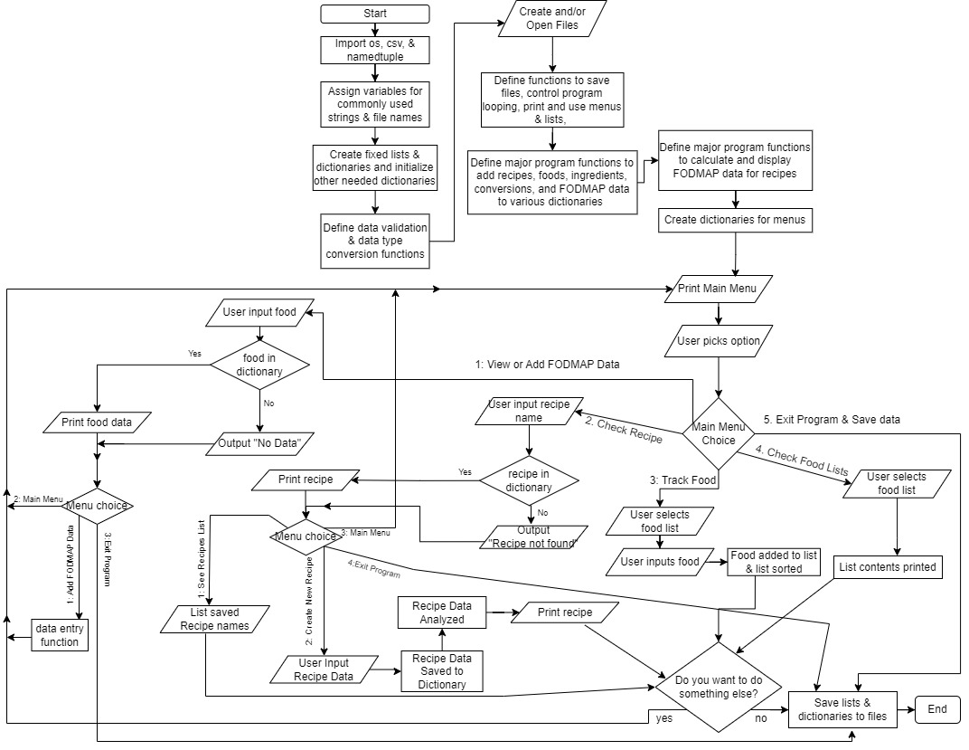

**Operating Instructions**

* The program has three main components:
  + Allowing user to create a personal database of FODMAP data for specific foods
    - First option in main menu
    - Also added to from within the create a recipe function if an ingredient doesn’t already exist in the FODMAP database
  + Allowing user to make personalized lists of foods
    - Four lists currently exist: Products that are certified by MONASH, foods that user has found safe to eat, those they find they need to be cautious with, and those they need to avoid.
    - Currently, users cannot add any customized list names. This will be updated in the future.
    - Currently, users cannot remove items from a list through the program. This will be updated in the future
    - Option 3 of the main menu allows users to add foods to any of these four lists
    - Option 4 of the main menu allows users to view any of these four lists
  + Check recipes for FODMAP content & keep record of recipe serving and ingredient information
    - Option 2 of the main menu allows users to look up a recipe.
    - If that recipe is in the database (case doesn’t matter), the saved recipe information and FODMAP data per serving will be displayed.
    - Currently, while the FODMAP data is calculated for each ingredient in a recipe, this data is neither displayed nor saved.
    - A second menu will be displayed, regardless of whether the recipe exists, allowing the user to view a list of names of all recipes, make a recipe, return to the main menu, or exit the program.
    - If the user selects make a recipe and then enters a recipe name already used, a prompt warning of existing recipe will be displayed, and a menu of options will be given
      * View existing recipe entry, list all saved recipe names, create a recipe by either renaming the new recipe or keep the name and save over the existing recipe, or return to main menu
* Be prepared to enter FODMAP content in grams per 100 g of each food you want to include in a recipe for analysis.
  + Currently, you cannot skip over adding any of this data once the data entry selection has been made or once a new food is added to a recipe.
  + If you want to ignore the food’s FODMAP impact, you can opt to put 0 for each FODMAP
    - NOTE: This will cause the FODMAP calculation to be inaccurate for the current and future recipes that contain that food
    - NOTE: Currently, food FODMAP entries cannot be changed once entered to prevent accidental overwriting of data. This will later be updated.
* Be prepared to enter any food amounts within a recipe in grams or know the conversion factor for how many grams are in the used unit.
  + Without having these amounts in grams, the calculations can’t be done properly
  + The program won’t move forward unless you enter a conversion factor or change the unit to grams
* FODMAP content for foods can be added while creating a recipe or ahead of time by selecting the first option in the main menu
* Know the number of servings a recipe makes. This is used to calculate the FODMAPs in each serving
* The program will also ask for serving size. This is for user reference only and is not used in any analysis
* The program will create files to save FODMAP data, food tracking lists, conversion factors, and recipes. Currently there is no file created to save the calculated FODMAP data – this data is recalculated as needed when a program is reloaded.
* Data is only saved to file when the program is terminated via the exit program option. If the program is force terminated rather than going through the exit program branch, the updated data will not save. If you don’t want to save the new data, force close the program. Otherwise, be sure to stop the program properly.
* Keep the saved files in the same directory as the program. If these files are stored somewhere else, currently the program will not find them and will instead create new files within the directory.
* Saved data will be loaded at the beginning of the next time the program is launched

Test Plan

|  |  |  |
| --- | --- | --- |
| Test to add food data entry | Input | Expected Output |
|  | 1 | /--------------------------------------\  | |  | MAIN MENU |  | |  | 1. View or Add FODMAP Data |  | 2. Check Recipe |  | 3. Track Food |  | 4. Check Food Lists |  | 5. Exit Program |  | |  \--------------------------------------/  Please select an option from the menu.  Enter food: |
|  | Orange | No data found for ORANGE.  What would you like to do?  /--------------------------------------\  | |  | WHAT WOULD YOU LIKE TO DO? |  | |  | 1. Add FODMAP Data |  | 2. Return to Main Menu |  | 3. Exit Program |  | |  \--------------------------------------/  Please select an option from the menu. |
|  | 1  Orange  5.0  5  5.00  g  5  5 | Enter food:  Enter numerical amount of grams of FRUCTANS in 100g of ORANGE  Enter numerical amount of grams of FRUCTOSE in 100g of ORANGE  Enter numerical amount of grams of GALACTANS in 100g of ORANGE  Enter numerical amount of grams of LACTOSE in 100g of ORANGE  Please only enter a numerical value.  Enter numerical amount of grams of POLYOLS in 100g of ORANGE  /--------------------------------------\  | |  | MAIN MENU |  | |  | 1. View or Add FODMAP Data |  | 2. Check Recipe |  | 3. Track Food |  | 4. Check Food Lists |  | 5. Exit Program |  | |  \--------------------------------------/  Please select an option from the menu. |
|  | 1  orange | Enter food:  Current FODMAP data for ORANGE  ------------------------------  FRUCTANS: 5.0g/100g ORANGE  FRUCTOSE: 5.0g/100g ORANGE  GALACTANS: 5.0g/100g ORANGE  LACTOSE: 5.0g/100g ORANGE  POLYOLS: 5.0g/100g ORANGE  What would you like to do?  /--------------------------------------\  | |  | WHAT WOULD YOU LIKE TO DO? |  | |  | 1. Add FODMAP Data |  | 2. Return to Main Menu |  | 3. Exit Program |  | |  \--------------------------------------/  Please select an option from the menu. |
|  | 4 | Invalid Selection.  Select an option from the menu: |
|  | 3 | DATA SAVED  GOODBYE |

|  |  |  |
| --- | --- | --- |
| Test Food Tracking | Input | Expected Output |
|  | 4  1 | /--------------------------------------\  | |  | MAIN MENU |  | |  | 1. View or Add FODMAP Data |  | 2. Check Recipe |  | 3. Track Food |  | 4. Check Food Lists |  | 5. Exit Program |  | |  \--------------------------------------/  Please select an option from the menu.  /-----------------------------\  | |  | FOOD LISTS |  | |  | 1. MONASH Certified Foods |  | 2. Safe Foods |  | 3. Caution Foods |  | 4. Foods to Avoid |  | |  \-----------------------------/  Which list would you like to view?  MONASH Certified Foods  ------------------------------  /--------------------------------------\  | |  | MAIN MENU |  | |  | 1. View or Add FODMAP Data |  | 2. Check Recipe |  | 3. Track Food |  | 4. Check Food Lists |  | 5. Exit Program |  | |  \--------------------------------------/  Please select an option from the menu. |
|  | 3  1  oil | /-----------------------------\  | |  | FOOD LISTS |  | |  | 1. MONASH Certified Foods |  | 2. Safe Foods |  | 3. Caution Foods |  | 4. Foods to Avoid |  | |  \-----------------------------/  Which list would you like to add to?  Enter food to add to MONASH Certified Foods:  OIL has been added to your MONASH Certified Foods list.  MONASH Certified Foods  ------------------------------  OIL  /--------------------------------------\  | |  | MAIN MENU |  | |  | 1. View or Add FODMAP Data |  | 2. Check Recipe |  | 3. Track Food |  | 4. Check Food Lists |  | 5. Exit Program |  | |  \--------------------------------------/  Please select an option from the menu. |
|  | 4  1 | /-----------------------------\  | |  | FOOD LISTS |  | |  | 1. MONASH Certified Foods |  | 2. Safe Foods |  | 3. Caution Foods |  | 4. Foods to Avoid |  | |  \-----------------------------/  Which list would you like to view?  1  MONASH Certified Foods  ------------------------------  OIL  /--------------------------------------\  | |  | MAIN MENU |  | |  | 1. View or Add FODMAP Data |  | 2. Check Recipe |  | 3. Track Food |  | 4. Check Food Lists |  | 5. Exit Program |  | |  \--------------------------------------/  Please select an option from the menu. |
|  | b  0  6  4  2  4  3  4  4 | Invalid Selection.  Select an option from the menu:  Invalid Selection.  Select an option from the menu:  Invalid Selection.  Select an option from the menu:  /-----------------------------\  | |  | FOOD LISTS |  | |  | 1. MONASH Certified Foods |  | 2. Safe Foods |  | 3. Caution Foods |  | 4. Foods to Avoid |  | |  \-----------------------------/  Which list would you like to view?  Safe Foods  ------------------------------  /--------------------------------------\  | |  | MAIN MENU |  | |  | 1. View or Add FODMAP Data |  | 2. Check Recipe |  | 3. Track Food |  | 4. Check Food Lists |  | 5. Exit Program |  | |  \--------------------------------------/  Please select an option from the menu.  /-----------------------------\  | |  | FOOD LISTS |  | |  | 1. MONASH Certified Foods |  | 2. Safe Foods |  | 3. Caution Foods |  | 4. Foods to Avoid |  | |  \-----------------------------/  Which list would you like to view?  Caution Foods  ------------------------------  /--------------------------------------\  | |  | MAIN MENU |  | |  | 1. View or Add FODMAP Data |  | 2. Check Recipe |  | 3. Track Food |  | 4. Check Food Lists |  | 5. Exit Program |  | |  \--------------------------------------/  Please select an option from the menu.  /-----------------------------\  | |  | FOOD LISTS |  | |  | 1. MONASH Certified Foods |  | 2. Safe Foods |  | 3. Caution Foods |  | 4. Foods to Avoid |  | |  \-----------------------------/  Which list would you like to view?  Foods to Avoid  ------------------------------  /--------------------------------------\  | |  | MAIN MENU |  | |  | 1. View or Add FODMAP Data |  | 2. Check Recipe |  | 3. Track Food |  | 4. Check Food Lists |  | 5. Exit Program |  | |  \--------------------------------------/  Please select an option from the menu. |

|  |  |  |
| --- | --- | --- |
| Test to Check Recipe | Input | Expected Output |
|  | 2  pie  8  slice  flour  -1  .3  ..2  0.2  5  3  f  o0  0  cups  2  g  34  y  apple  45  34  2  3  2  slice  1  14  50  n  2  pie  2  pie  2  3  4 | /--------------------------------------\  | |  | MAIN MENU |  | |  | 1. View or Add FODMAP Data |  | 2. Check Recipe |  | 3. Track Food |  | 4. Check Food Lists |  | 5. Exit Program |  | |  \--------------------------------------/  Please select an option from the menu.  What's the name of your recipe?  How many servings does this recipe make?  (input whole number only)  How large is a serving?  Enter ingredient name.  There is no FODMAP data for FLOUR.  Please enter it now.  Enter numerical amount of grams of FRUCTANS in 100g of FLOUR  Please only enter a numerical value.  Enter numerical amount of grams of FRUCTOSE in 100g of FLOUR  Please only enter a numerical value.  Enter numerical amount of grams of GALACTANS in 100g of FLOUR  Enter numerical amount of grams of LACTOSE in 100g of FLOUR  Enter numerical amount of grams of POLYOLS in 100g of FLOUR  Please only enter a numerical value.  Please only enter a numerical value.  How is this ingredient measured?  (Enter name of unit of measurement)  You don't have a conversion factor between cups and grams for FLOUR.  Would you like to (1) enter a conversion factor or (2) change unit?  How is this ingredient measured?g  How much FLOUR in grams are in this recipe?  (input number only)  Are there more ingredients?  (Type 'y' or 'n')  Enter ingredient name.  There is no FODMAP data for APPLE.  Please enter it now.  Enter numerical amount of grams of FRUCTANS in 100g of APPLE  Enter numerical amount of grams of FRUCTOSE in 100g of APPLE  Enter numerical amount of grams of GALACTANS in 100g of APPLE  Enter numerical amount of grams of LACTOSE in 100g of APPLE  Enter numerical amount of grams of POLYOLS in 100g of APPLE  How is this ingredient measured?  (Enter name of unit of measurement)  You don't have a conversion factor between slices and grams for APPLE.  Would you like to (1) enter a conversion factor or (2) change unit?  How many grams of APPLE are there per slices?  (input number only)  How much APPLE in slices are in this recipe?  (input number only)  Are there more ingredients?  (Type 'y' or 'n')  PIE  ------------------------------  SERVING SIZE: slice  NUMBER OF SERVINGS: 8  ------------------------------  Ingredients  34.0 grams FLOUR  50.0 slices APPLE  ------------------------------  FODMAPs Per Serving  FRUCTANS: 2.83 g  FRUCTOSE: 2.13 g  GALACTANS: 0.34 g  LACTOSE: 0.32 g  POLYOLS: 0.12 g  ------------------------------  /--------------------------------------\  | |  | MAIN MENU |  | |  | 1. View or Add FODMAP Data |  | 2. Check Recipe |  | 3. Track Food |  | 4. Check Food Lists |  | 5. Exit Program |  | |  \--------------------------------------/  Please select an option from the menu.  What's the name of your recipe?  PIE  ------------------------------  SERVING SIZE: slice  NUMBER OF SERVINGS: 8  ------------------------------  Ingredients  34.0 grams FLOUR  50.0 slices APPLE  ------------------------------  FODMAPs Per Serving  FRUCTANS: 2.83 g  FRUCTOSE: 2.13 g  GALACTANS: 0.34 g  LACTOSE: 0.32 g  POLYOLS: 0.12 g  ------------------------------  /--------------------------------------\  | |  | WHAT WOULD YOU LIKE TO DO? |  | |  | 1. List Recipes |  | 2. Make Recipe |  | 3. Return to Main Menu |  | 4. Exit Program |  | |  \--------------------------------------/  Please select an option from the menu.  What's the name of your recipe?  A recipe for 'PIE' already exists.  What do you want to do?  1. View existing recipe 'PIE'  2. View list of all saved recipe names  3. Rename current recipe  4. Save over current recipe  5. Return to main menu  CURRENT RECIPES  ------------------------------  PIE  What's the name of your recipe?  A recipe for 'PIE' already exists.  What do you want to do?  1. View existing recipe 'PIE'  2. View list of all saved recipe names  3. Rename current recipe  4. Save over current recipe  5. Return to main menu  What's the name of your recipe?  A recipe for 'PIE' already exists.  What do you want to do?  1. View existing recipe 'PIE'  2. View list of all saved recipe names  3. Rename current recipe  4. Save over current recipe  5. Return to main menu  How many servings does this recipe make?  (input whole number only) |
|  |