to use this project, you will need to have installed node JS and python.
You will also need to install the dependencies ( can be found in the app.js file, at the start of it).
And to make the database : "interface"
you will also need to change the password of the access to the database in two file : app.js and support_handler.py
in the database you will need for the moment 2 tables :
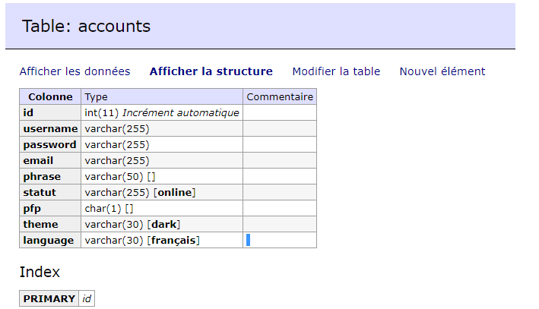
and
