PORTFOLIO CASE STUDY
Revenue Quality &
Customer Profitability
A distributor company case study | Recognized-period analysis, 2018-2024
Growth was profitable and customer-level diversification was strong. The next value opportunity is to defend the core segment, improve margin where scale is under-monetized, and prioritize retention by recoverable revenue.
Business report | SQL and analyst outputs available in the companion repository

Executive Summary
The company’s 2018-2024 growth was profitable and broadly diversified across individual customers. Recognized revenue increased every year, gross profit grew faster, and gross margin expanded. The main strategic exposures are concentrated at the customer-segment level and in a sizable dormant-account pool.
Validated measure | Result
2018-2024 revenue growth | 65.0% ($79.4M to $131.0M)
2018-2024 gross-profit growth | 89.6% ($15.2M to $28.8M)
Gross-margin change | +2.86 percentage points
Largest segment revenue share | 48.75%
Largest customer revenue share | 1.13%
Trailing revenue baseline at risk | $23.0M (17.60% of 2024 revenue)

What leadership should do
Priority | Action | Expected benefit
1 | Protect Independent Retail while expanding high-margin segments | Defend the main profit pool and improve diversification
2 | Launch a monthly value-based retention queue | Prioritize recent, high-value risk and measure reactivation
3 | Review pricing and cost-to-serve in margin-light segments | Convert existing scale into incremental gross profit
The conclusion is descriptive, not predictive. Gross profit excludes operating expenses, inactivity is not confirmed churn, and the revenue-at-risk measure is a trailing historical baseline rather than a forecast of future loss.

1. Revenue and Margin Trends
Recognized revenue rose every year, and gross profit grew faster than revenue.
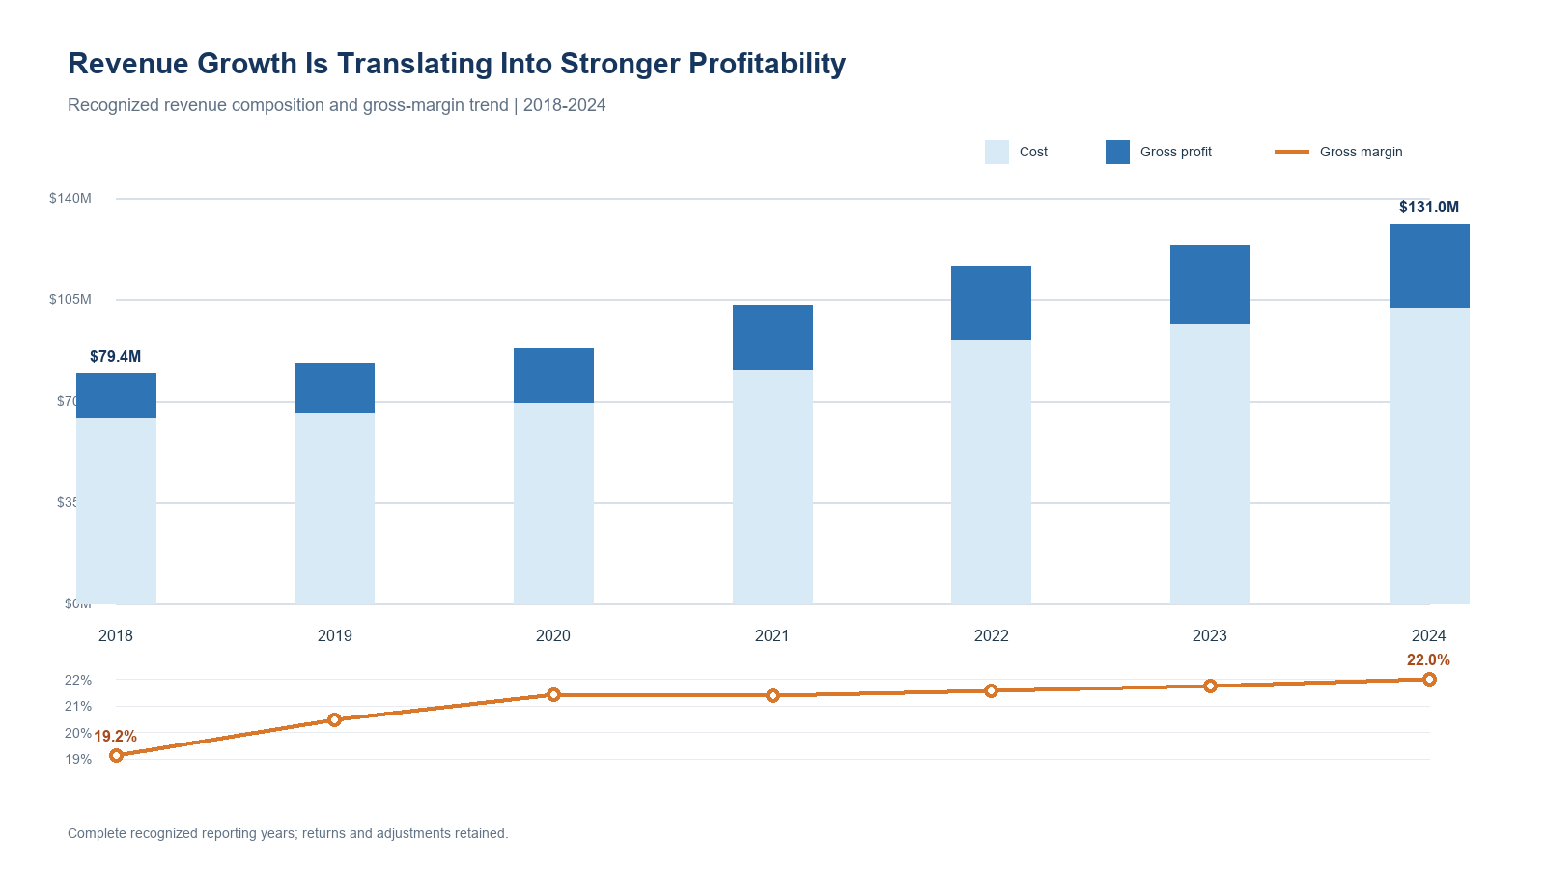
Figure 1. Annual recognized revenue composition and gross-margin trend.
Year | Revenue | Gross profit | Margin | Revenue YoY
2018 | $79.4M | $15.2M | 19.15% | -
2019 | $82.9M | $17.0M | 20.47% | 4.49%
2020 | $88.3M | $18.9M | 21.43% | 6.44%
2021 | $103.0M | $22.0M | 21.39% | 16.65%
2022 | $116.4M | $25.1M | 21.56% | 12.99%
2023 | $123.5M | $26.9M | 21.76% | 6.15%
2024 | $131.0M | $28.8M | 22.01% | 6.05%
Revenue increased 65.0% over the period, while gross profit increased 89.6%. Margin expanded in five of six year-over-year comparisons. Revenue growth slowed to about 6% in both 2023 and 2024, but profit still outpaced revenue, which is consistent with maturing rather than deteriorating growth.

2. Customer Segment Profitability
Independent Retail is both the economic engine and the principal segment-level exposure.
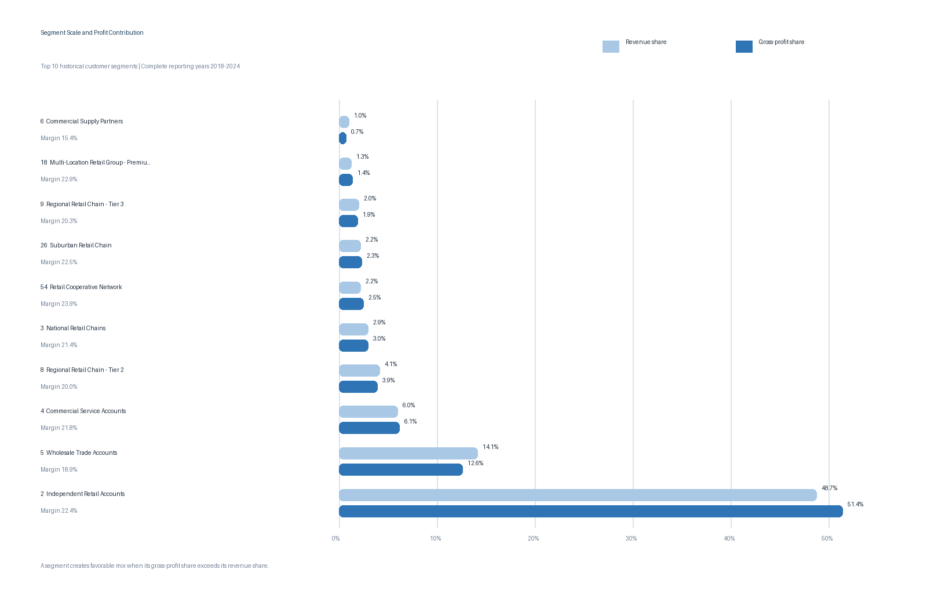
Figure 2. Segment scale compared with profit contribution.
# | Customer segment | Revenue | Gross profit | Margin | Rev. share
1 | Independent Retail Accounts | $353.1M | $79.1M | 22.39% | 48.75%
2 | Wholesale Trade Accounts | $102.3M | $19.4M | 18.94% | 14.12%
3 | Commercial Service Accounts | $43.1M | $9.4M | 21.85% | 5.95%
4 | Regional Retail Chain - Tier 2 | $30.0M | $6.0M | 19.98% | 4.14%
5 | National Retail Chains | $21.4M | $4.6M | 21.44% | 2.95%
6 | Retail Cooperative Network | $15.9M | $3.8M | 23.91% | 2.20%
7 | Suburban Retail Chain | $15.7M | $3.5M | 22.51% | 2.17%
Independent Retail produced 48.75% of revenue and 51.37% of gross profit at a 22.39% margin. It also generated 43.04% of company revenue growth from 2018 to 2024. Wholesale Trade is more margin-light: 14.12% of revenue but 12.59% of gross profit at an 18.94% margin. Retail Cooperative Network is a credible expansion candidate because its 2024 revenue was 111.18% above 2018 while margin improved to 25.40%.

3. Revenue Concentration Risk
Single-customer dependency is low; segment dependency is materially higher.
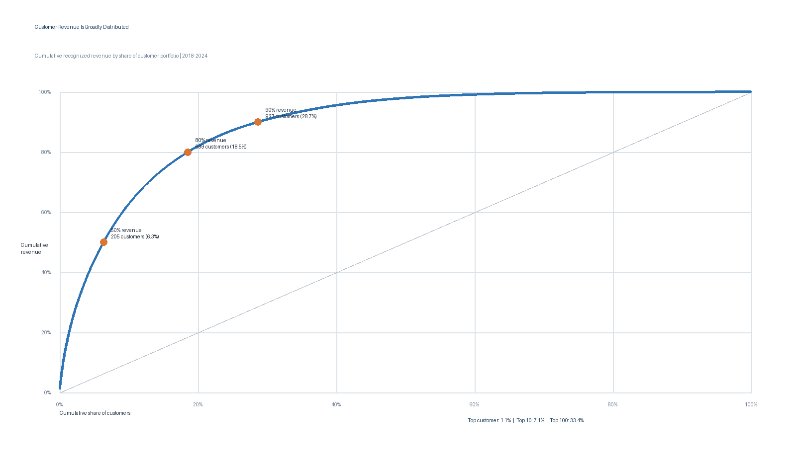
Figure 3. Customer-level cumulative revenue concentration.
Concentration measure | Customer level | Segment level
Largest entity share | 1.13% | 48.75%
Top 3 share | 2.97% | 68.82%
Top 5 share | 4.31% | 75.91%
Entities needed for 80% | 599 | 7
HHI | 19.36 | 2,662.59
The largest customer contributes only 1.13% of revenue, the top 10 contribute 7.09%, and the top 100 contribute 33.41%. It takes 599 customers, or 18.54% of the portfolio, to reach 80% of revenue. Leadership should therefore monitor correlated segment risks—pricing pressure, channel disruption, competitive shifts, or service failures—more closely than the loss of any single account.

4. Customer Lifecycle and Retention Risk
The non-active portfolio carries a $23.0M trailing revenue baseline; 82.27% sits in dormant accounts.
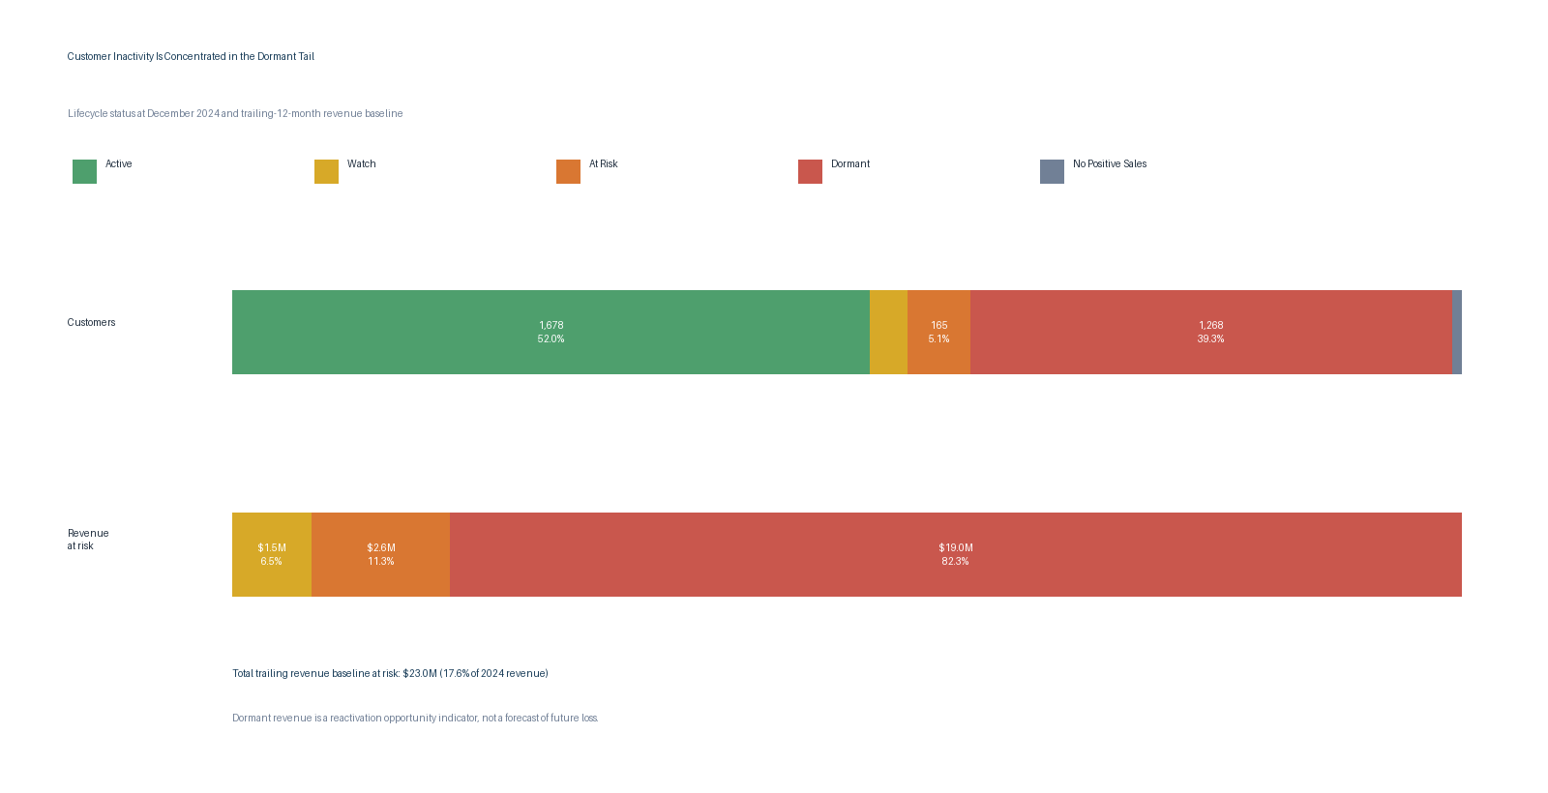
Figure 4. Lifecycle mix and trailing revenue baseline at risk.
Lifecycle status | Customers | Share | Revenue at risk | Risk share
Active (0-3 months) | 1,678 | 51.95% | $0.0M | 0.00%
Watch (4-6 months) | 98 | 3.03% | $1.5M | 6.47%
At Risk (7-12 months) | 165 | 5.11% | $2.6M | 11.26%
Dormant (13+ months) | 1,268 | 39.26% | $19.0M | 82.27%
No Positive Sales | 21 | 0.65% | $0.0M | 0.00%
The first outreach wave should focus on high-value customers inactive for 7-12 months, where intervention is still timely. Watch customers should receive lower-cost proactive outreach, while dormant accounts should be handled as a controlled reactivation test. Inactivity is only a behavioral flag; seasonality, planned buying cycles, mergers, or historical class changes may explain the absence of recent sales.

Strategic Recommendations

1. Protect the core while diversifying the growth pipeline
Create an Independent Retail operating review covering revenue, margin, active customers, retention status, service, and company revenue share. In parallel, test repeatable acquisition plays in high-margin segments such as Retail Cooperative Network and Independent Distribution Partner.
Primary measures: Core-segment retention and margin; new revenue and gross profit from targeted expansion segments.

2. Build a value-based retention queue
Run the lifecycle logic monthly. Prioritize the highest-baseline 7-12 month accounts for human outreach, use low-cost interventions for 4-6 month accounts, and test reactivation only on the most valuable dormant accounts.
Primary measures: Watch-to-active and at-risk-to-active conversion, recovered gross profit, time to intervention, and campaign cost per reactivation.

3. Improve margin in large, margin-light segments
Start with Wholesale Trade and other material segments whose gross-profit share trails their revenue share. Diagnose price realization, discounting, product mix, purchasing, freight recovery, and service intensity before setting blanket growth targets.
Primary measures: Segment gross margin, gross profit per customer, realized price, freight recovery, returns, and cost-to-serve where available.

Management scorecard
Dimension | Core metric | Decision signal
Growth | Recognized revenue growth | Growth slowing without margin support
Profitability | Gross-profit growth and margin | Revenue-heavy, profit-light segment
Concentration | Largest-segment share | Segment share rising faster than diversification
Retention | Trailing revenue baseline at risk | Watch and at-risk pool expanding
Seasonality | Q4 revenue share | Peak-quarter service or cash strain

Methodology, Limitations, and Reproducibility

Core analytical rules
Rule | Application
Reporting authority | Recognized accounting Period in YYMM format; complete window 1801-2412
Historical segment | Customer class recorded on each transaction; current class does not rewrite history
Gross profit | SUM(Sales) - SUM(Cost); aggregate margin equals gross profit divided by revenue
Activity definition | Positive sales reset the lifecycle clock; credits and returns do not
Revenue at risk | Net revenue in the 12 periods ending with last positive sale, floored at zero, for non-active customers
Ledger treatment | Returns, credits, financial edge cases, and duplicate candidates are retained and flagged

Important limitations
The analysis is descriptive and ends in December 2024. Gross profit excludes operating expenses. Historical segment comparisons include reclassification effects. Inactivity is not confirmed churn, and the revenue-at-risk baseline is not expected future revenue, lifetime value, or forecast loss. Product, market, pricing, service-level, and sales-activity data are not available to establish causal drivers.

Reproduce the work
The repository contains the canonical question sheet, portable ingestion scripts, SQL for every analysis, validation checks, compact CSV outputs, and documentation for rebuilding the local SQLite database. The large annual transaction files are designed to be distributed through an external dataset host and verified with the included checksum manifest.
Repository: Distributor Company Case Study on GitHub
Rebuild sequence: normalize UTF-8 encoding, prepare reference data, build the canonical SQLite database, run the validation suite, and execute the question-level analysis scripts. The companion Excel workbook provides a compact reviewer path without attempting to place the 3.7-million-row fact table into a worksheet.
Conclusion: The company’s growth history is economically healthy. The highest-value next step is to manage revenue quality explicitly—protecting the profitable core, improving scale economics, and focusing retention effort on the accounts most worth recovering.

