Create New District Tech Lead
The Manage District Tech Leads module enables ScholarPath Admins to create, invite, manage, deactivate, and reactivate District Tech Leads across all associated districts. It also provides visibility into the tech leads’ activation status, their district information, and associated school counts.
The purpose of the Manage District Tech Leads module is to allow ScholarPath Admins to:
- Add new District Tech Leads
- Send account activation invitations
- Resend invitations for unactivated (Pending) users
- Deactivate active tech leads
- Reactivate inactive tech leads
- View associated districts and school counts
- Maintain system access security at the district level
ScholarPath Admin is the only role allowed to access and manage District Tech Leads. No other user role has access to this module.

1.1 Manage District Tech Leads
Header Section
- Title: Manage District Tech Leads
- Subtitle: “Manage all District Tech Leads by viewing their details, sending invitations, and tracking activation status.”
Search Field
- Placeholder: “Search by name, email or district”
- Function: Filters the grid in real time by:
  - District Name
  - District Tech Lead Name
  - Email Address
Status Filter Dropdown
- Options:
  - All Status
  - Active
  - Pending
- Default Value: All Status
- Function: Filters the grid based on status.
Add District Tech Lead Button
- Label: + Add District Tech Lead
- Function: Opens Create District Tech Lead modal.
District Tech Lead Grid
Displayed Columns:
- District Name
- District Tech Lead Name
- Email Address
- No. of Schools
- Status (Active / Pending)
- Actions
- Expand Icon (for associated schools list – per use case)
Status Rules:
- Active → Green badge
- Pending → Yellow badge
Actions Column Rules:
Status | Action Shown
Pending | Resend Invitation
Active | Deactivate
Inactive | Reactivate
Pending | Deactivate must NOT appear (BR-08)
- Deactivate button is disabled when the district has only one active tech lead.
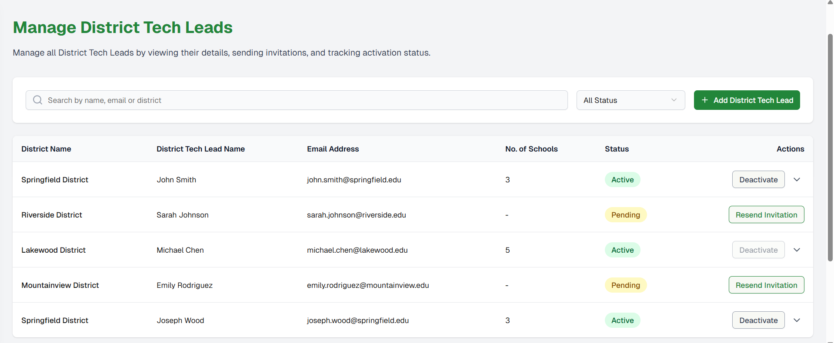
Figure 1: Manage District Tech Leads
- If no Tech Leads exist (Initial Load / No Records in System), a message should be displayed as “No District Tech Leads found. Please click “Add District Tech Lead” to create a new one.”.
- If no results are found on the Search/Filter, a message should be displayed as “No matching District Tech Leads found. Try adjusting your search or filters.”.
- Expand the district, and if no schools are available, display a message as “No schools are associated with this district.”.

1.2 Create District Tech Lead Modal
Modal Title: Create District Tech Lead
Subtitle: Enter district and contact details to send an invitation to the new District Tech Lead.
District Name
- Placeholder: Enter district name
- Validation: Required
- Error Message: “District Name is required.”
District Tech Lead Name
- Placeholder: Enter your name
- Validation: Required
- Error Message: “District Tech Lead Name is required.”
Email Address
- Placeholder: Enter email address
- Validation Rules:
  - Required
  - Must be in valid email format.
  - Must be unique.
- Error Messages:
  - “Invalid email address.” On entering an invalid email ID.
  - “This email address is already associated with another District Tech Lead.” On entering an existing email ID.
Buttons
Cancel
- Closes modal
- Does not save data
Send Invite
- Default State: Disabled
- Enabled When: All mandatory fields are valid
- On Click:
  - Creates District Tech Lead
  - Sets status to Pending
  - Sends invitation email
  - Closes modal
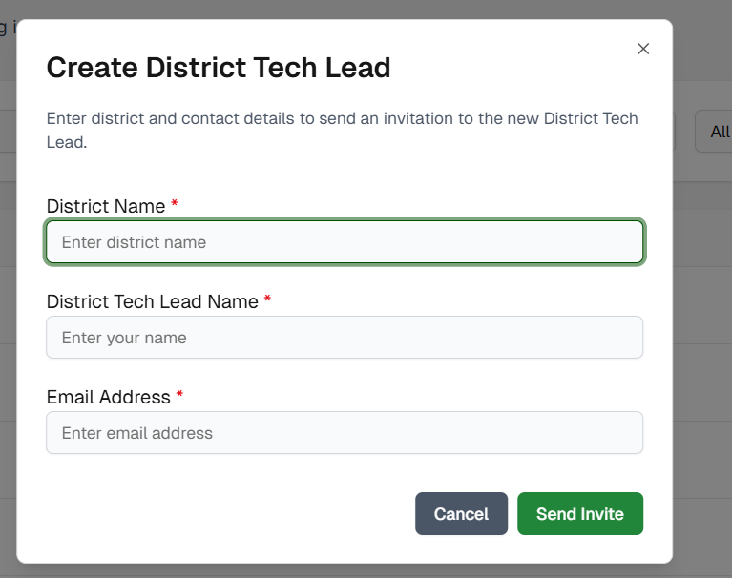
Figure 2: Create District Tech Lead

Resend Invitation Modal
Message Body: A new invitation email has been sent successfully to <Tech Lead Name>.
Buttons: OK
- Closes modal
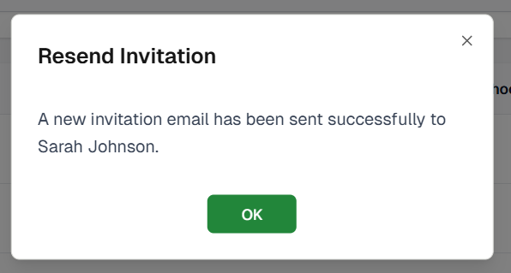
Figure 3: Resend Invitation

Deactivate District Tech Lead Modal
Message Body: Are you sure you want to deactivate <Name>?
This action will immediately remove their access to all district-level tools and permissions.
This change cannot be undone without reactivating the user.
If the district has only one active tech lead, the Deactivate button is disabled.
Buttons:
  - Cancel: Closes the modal
  - Yes, Deactivate:
- Enabled When:
  - User is Active
  - District has more than one active tech lead (BR-09)
- On Click:
  - Changes status to Inactive
  - Updates grid action → Reactivate
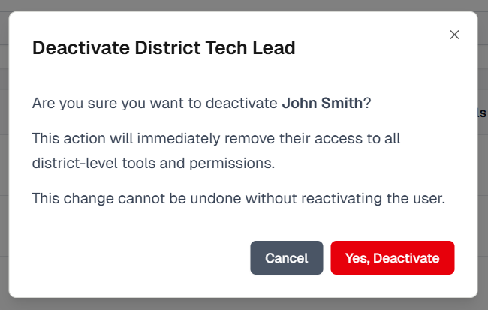
Figure 4: Deactivate District Tech Lead
After Deactivation:
- Modal closes
- Status becomes “Inactive”
- Action becomes Reactivate

Reactivate District Tech Lead Modal
Message Body: Are you sure you want to reactivate <Name>?
Reactivating will restore their access to all district-level tools and permissions.
Buttons:
  - Cancel
- Closes modal
  - Yes, Reactivate
- Enabled When: User is inactive
- On Click:
  - Changes status → Active
  - Grid action changes → Deactivate
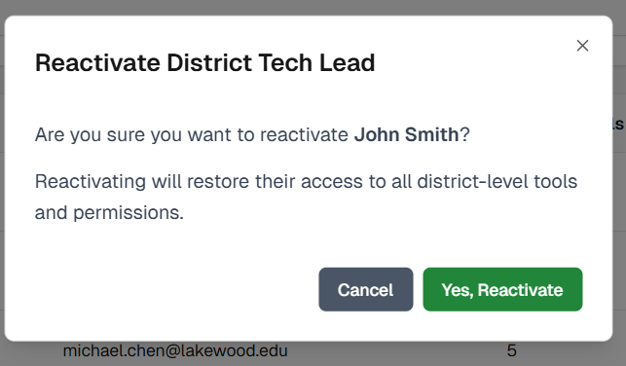
Figure 5: Reactivate District Tech Lead
After Reactivate:
- Modal closes
- Status becomes “Active”
- Action becomes Deactivate

Dashboard

District Tech Lead Onboarding Process
The District Tech Lead Onboarding Wizard is a 5-step guided activation process that must be completed the first time a District Tech Lead logs into ScholarPath. The workflow collects essential district information, uploads the required MOU, configures basic security settings, optionally invites additional tech team members, and finally activates the district account.
Page Header:
- “Welcome to ScholarPath - District Setup”
- Subtext: “Let’s set up your district so you can get started.”
Setup Progress Tracker
Displays setup completion percentage (0–100%). Updates as each step is completed.
Step Indicators
Shows current and pending steps. Current step = green “Active” status. Automatically updated after completing each step.
Step indicator: “Step 1 of 5”
Fill level: 20%
Figure 6: Step Indicator

Step 1: District Profile Setup
The District Tech Lead provides basic information required to initialize the district account.
Page Header: “Welcome to ScholarPath - District Setup”
Subtext: “Let’s set up your district so you can get started.”
District Name
Type: Read-only text
Value: Pre-filled from backend
Element | Value
Header Title | “Welcome to ScholarPath - District Setup”
Subtext | “Let’s set up your district so you can get started.”
Card Title | “District Profile”
Card Subtitle | “Basic information about your district and account”
Step Indicator | Step 1 of 5
Progress Bar | 20% filled

Field Name | Description | Options (Dropdown Only) | Validations / Success / Error Messages
District Name | Read-only district name pre-filled from backend | - | No validation (read-only)
Your Name (District Tech Lead) | User enters their name | - | Required → Error: “Your name is required.”
Email Address | Read-only verified email address | - | Success badge: Verified
Phone Number (Optional) | Optional district lead phone number | - | Invalid format → “Please enter a valid phone number.”
Time Zone * | Required selection of the district time zone | "Eastern Time (ET)"  "Central Time (CT)"  "Mountain Time (MT)"  "Pacific Time (PT)"  "Arizona Time (MST)"  "Alaska Time (AKT)"  "Hawaii Time (HST)" | Required → Error: “Time Zone is required.”

Step 2 - Upload Required MOU
This screen requires the District Tech Lead to upload the signed District–ScholarPath MOU. Only PDF files are accepted. The user must upload the file before continuing.
Element | Value
Header Title | “Upload Required Agreement”
Subtext | “Drag & drop or click to upload your signed MOU document.”
Card Title | “MOU Document”
Card Subtitle | “Upload the signed Memorandum of Understanding (PDF format required)”
Step Indicator | Step 2 of 5
Progress Bar | 40% filled

Field Name | Description | Options | Validations / Success / Error Messages
MOU Document Upload | Drag-and-drop or click-to-upload field for the signed MOU | - | Required; PDF-only → Error: “Only PDF files are allowed.”
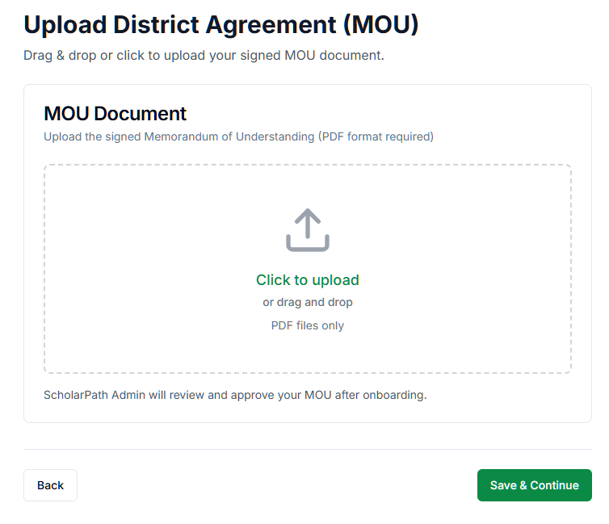
Figure 7: Upload District MOU
Button | Behavior
Back | Returns to Step 1
Save & Continue | Enabled only after a valid PDF is uploaded  On Click:  • Upload validated  • MOU stored  • Status = “Pending Review”  • Navigates to Step 3

Step 3 - Basic Security Setup
This screen captures basic account security requirements, including MFA enforcement and session timeout duration.
Element | Value
Header Title | “Security Setup”
Subtext | “Configure basic security settings for your district.”
Card Title | “Security Configuration”
Card Subtitle | “Essential security settings for district administrators”
Step Indicator | Step 3 of 5
Progress Bar | 60% filled

Field Name | Description | Options | Validations / Success / Error Messages
Require MFA for District Tech Leads | Toggle, ON by default | On/Off | No validation; default is valid
Session Timeout | Dropdown selecting auto-logout interval  30 min by default | 15 min, 30 min (default), 60 min | Required; Server/network failure → “Unable to save settings. Please try again.”

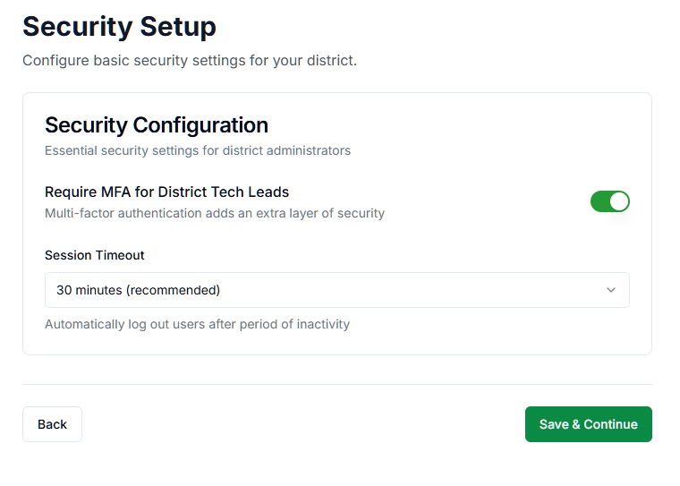
Figure 8: Basic Security Setup
Button | Behavior
Back | Returns to Step 2
Save & Continue | On Click:  • Saves settings  • Navigates to Step 4

Step 4 - Invite Tech Team
Allows the main District Tech Lead to optionally invite additional tech team members. This is the only step that allows skipping.
Element | Value
Header Title | “Invite Additional District Tech Leads”
Subtext | “You may invite more District Tech Leads now or skip this step.”
Card Title | “Team Member Invitations”
Card Subtitle | “All invited users automatically become District Tech Leads with full access.”
Step Indicator | Step 4 of 5
Progress Bar | 80% filled

Field Name | Description | Options | Validations / Success / Error Messages
Team Member Name | Name of additional tech lead | N/A | Required ONLY if sending invites → Error: “Name is required.”
Team Member Email | Email for invited member | N/A | Must be valid email format → Error: “Invalid email address.”

Button | Behavior
Back | Returns to Step 3
+ Add Team Member | Adds a new row for name + email
Skip | Bypasses Step 4 and moves to Step 5
Send Invites & Continue | Enabled only when all rows are complete & valid  On Click:  • Sends email invites  • Moves to Step 5

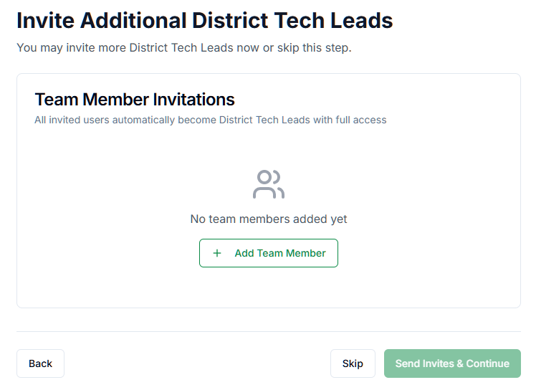
Figure 9: Invite Tech Team

Step 5 - Completion Screen
Final confirmation screen indicating district activation. Provides links to setup actions.
Element | Value
Header Title | “Your District Is Ready”
Subtext | “Your district account has been successfully set up. You can now configure data integrations, SSO, and manage security settings.”
Step Indicator | Step 5 of 5
Progress Bar | 100% filled

Field Name | Description | Options (If Dropdown) | Validations / Success / Error Messages
Configure SIS Sync | Clickable quick link block to navigate to the SIS integration setup | N/A | No validations; Navigates to SIS Sync configuration screen
Set Up SSO | Clickable quick link block for starting SSO configuration | N/A | No validations; Navigates to SSO setup screen
Upload Additional Compliance Documents | Quick link for uploading further district documents | N/A | No validations; Navigates to Compliance Documents upload page
Review Security Policies | Quick link for configuring district-wide policies & access controls | N/A | No validations; Navigates to Security Policies configuration screen
Go to Dashboard | Primary action button; completes onboarding | N/A | Success Condition: Marks onboarding completed & activates district; Navigates user to ScholarPath Dashboard

This is the final screen (Step 5 of 5) in the onboarding flow.
It serves three purposes:
- Confirm successful onboarding and district activation
- Show recommended next actions via quick links
- Provide a call-to-action button to enter the main ScholarPath Dashboard
- Final onboarding status is saved as Complete
- District is marked as Active
- Onboarding flow is permanently disabled for this district
- User is redirected to the main platform Dashboard
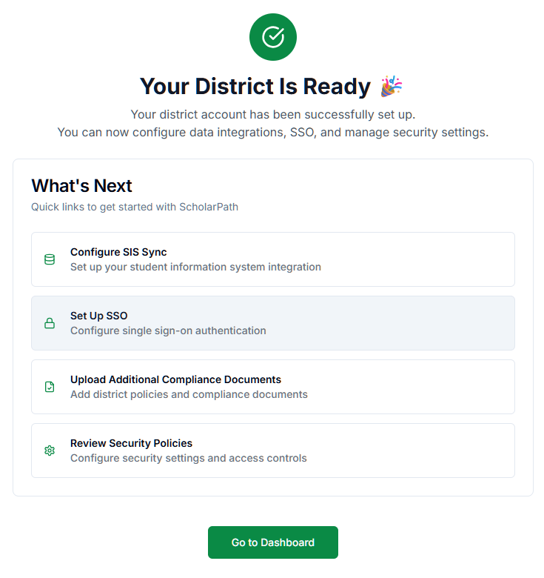
Figure 10: Completion Screen

File Naming Conventions - District Tech Lead Onboarding
Step / Document Type | File Naming Format | Example File Name | Notes / Validation
MOU Document | MOU_[DistrictName]_[YYYYMMDD]_v[Version].pdf | MOU_GreenwoodISD_20251112_v1.pdf | - Must be PDF- Max size: 10MB- File name auto-populates when uploaded, editable before saving.
Privacy Policy | PrivacyPolicy_[DistrictName]_[YYYYMMDD]_v[Version].pdf | PrivacyPolicy_GreenwoodISD_20251112_v1.pdf | - Must be PDF- Max size: 10MB- Only one version active at a time; older versions archived.
Security Standards Document | SecurityStandards_[DistrictName]_[YYYYMMDD]_v[Version].pdf | SecurityStandards_GreenwoodISD_20251112_v1.pdf | - Must be PDF- Max size: 10MB- Version auto-increments if replaced.
SIS Connection Configuration Export (System Generated) | SISConfig_[DistrictName]_[YYYYMMDD]_v[Version].json | SISConfig_GreenwoodISD_20251112_v1.json | - Automatically created when “Test Connection” succeeds.- Stored for audit purposes.
SSO Configuration Export (System Generated) | SSOConfig_[DistrictName]_[YYYYMMDD]_v[Version].json | SSOConfig_GreenwoodISD_20251112_v1.json | - Generated upon successful SSO test.- Captures provider, domain, and client ID.
Data Sync Report (System Generated) | DataSyncReport_[DistrictName]_[YYYYMMDD]_v[Version].pdf | DataSyncReport_GreenwoodISD_20251112_v1.pdf | - Automatically generated after first data sync.- Includes counts of imported students and staff.

Dashboard Overview
Provides the District Tech Lead with a consolidated, real-time view of the district’s integration health, data synchronization status, security posture, and compliance status.
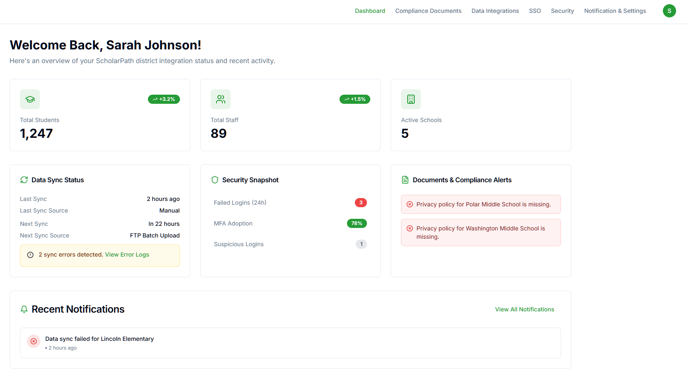
Figure 11: Dashboard Overview Screen
This section welcomes the District Tech Lead and introduces the high-level purpose of the dashboard: monitoring sync status, security, compliance, and notifications.
Element | Value
Header | “Welcome Back, Sarah Johnson!”
Subtext | “Here’s an overview of your ScholarPath district integration status and recent activity.”
Navigation Menu | Dashboard, Compliance Documents, Data Integrations, SSO, Security, Notification & Settings
Profile Icon | Top right corner

District Overview Cards
Displays high-level metrics for district data: Total Students, Total Staff, and Active Schools. These are display-only (no interactive behavior).
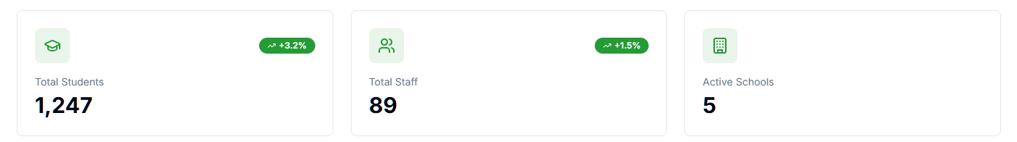
Figure 12: District Overview Cards
Field Name | Description | Options | Validations / Success / Error Messages
Total Students | Displays total student count from SIS dataset | N/A | None
Total Staff | Displays staff count | N/A | None
Active Schools | Shows number of active schools | N/A | None
Trend Badge | Shows % increase/decrease | N/A | None

Data Sync Status
Shows the most recent manual or batch sync, next scheduled sync, sync sources, and any sync-related errors.
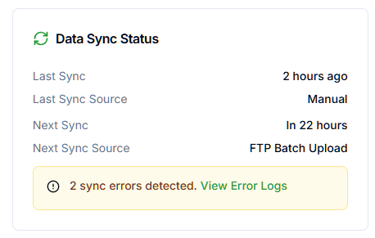
Figure 13: Data Sync Status
Field Name | Description | Options | Validations / Messages
Last Sync | Time since last sync | N/A | Hide if no sync data available
Last Sync Source | Manual or FTP Batch Upload | N/A | None
Next Sync | Time until next scheduled sync | N/A | None
Next Sync Source | Manual or FTP | N/A | None
Sync Error Banner | Displays number of detected errors | N/A | Hidden if errors = 0 Text: “2 sync errors detected. View Error Logs”
View Error Logs (Link) | Opens Recent Sync Errors modal | N/A | Must open modal successfully

If no sync has ever occurred
Section | Message
Data Sync Status | “No sync activity recorded yet.”
Last Sync | “—”
Last Sync Source | “—”
Next Sync | “Scheduled sync not configured.”

After the first sync, for example:
Element | Value
Section Title | “Data Sync Status”
Last Sync | “2 hours ago”
Last Sync Source | “Manual”
Next Sync | “In 22 hours”
Next Sync Source | “FTP Batch Upload”
Error Banner | “⚠️ 2 sync errors detected. View Error Logs”

Recent Sync Errors
Shows file-level validation errors from the last batch upload.
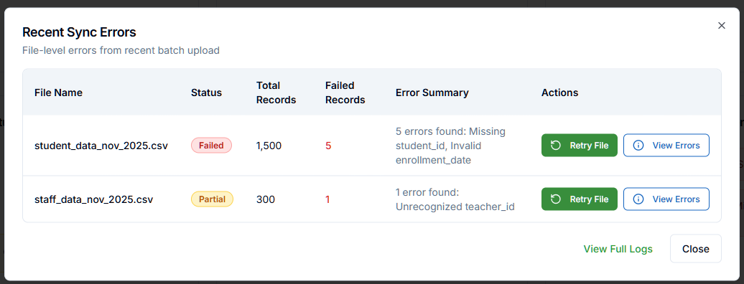
Figure 14: Recent Sync Errors
If no recent batch errors exist, instead of the file table, show: “No recent sync errors found.”

Field Name | Description | Options | Validations / Error Messages
File Name | Name of uploaded file | N/A | None
Status | Failed / Partial | N/A | None
Total Records | Total # of rows processed | N/A | None
Failed Records | Number of rows with errors | N/A | None
Error Summary | Summary of row errors | N/A | None
Retry File | Retries only that file | N/A | Only shown for FTP batch uploads
View Errors | Opens Error Details modal | N/A | Must open modal successfully
View Full Logs | Link to Sync Logs page | N/A | Must navigate to Sync Logs
Close | Closes modal | N/A | None

Actions
  - Retry File
- Triggers reprocessing of only that file
- Only shown for FTP batch files
- Not shown for manually uploaded CSVs
  - View Errors
- Opens Error Details modal
  - View Full Logs
- Navigates to Data Integrations → Sync Logs (filtered to latest batch)
  - Close
- Closes modal
Error Details
Displays row-by-row validation errors from the selected file.
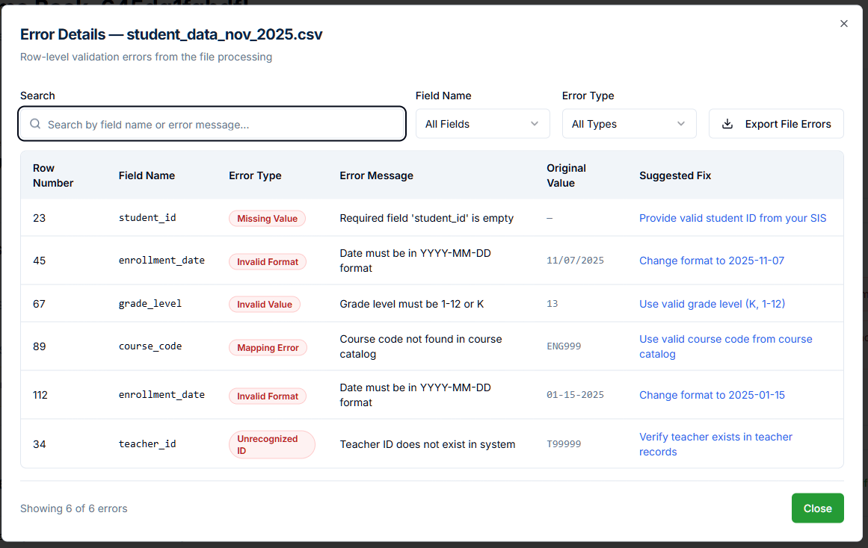
Figure 15: Error Details
Field Name | Description | Options | Validations / Messages
Search | Search by field name or error text | N/A | None
Field Name Filter | Filter dropdown | All Fields + list of fields | None
Error Type Filter | Filter dropdown | All Types + list of error types | None
Export File Errors | Downloads error CSV | N/A | Must trigger file download
Row Number | Row index | N/A | None
Field Name | Error-causing field | N/A | None
Error Type | Missing Value, Invalid Format, Unrecognized ID, etc. | N/A | None
Error Message | Exact validation failure | N/A | None
Original Value | Value from file | N/A | None
Suggested Fix | Recommended solution | N/A | None
Close | Close modal | N/A | None

Security Snapshot
Displays district-level security health metrics.
Field Name | Description | Options | Validations / Messages
Failed Logins (24h) | Count of failed login attempts | N/A | If data unavailable → “No data available.”
MFA Adoption | Percentage of MFA-enabled users | N/A | If data unavailable → “No data available.”
Suspicious Logins | # of suspicious login events | N/A | If data unavailable → “No data available.”
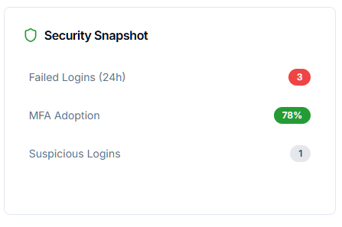
Figure 16: Security Snapshot
- If no data is available, display “—” beside the fields.
Actions
- Click - Failed Logins
Opens Failed Login Attempts modal, pre-filtered to 24 hours.
- Click - MFA Adoption
Opens MFA Adoption Overview modal.
- Click - Suspicious Logins
Navigates to Access Monitoring → Suspicious activity filter.

Failed Login Attempts — Last 24 Hours
Shows a table of all failed login attempts in the last day.
Field Name | Description | Options | Validations / Messages
Search | Search by email address | N/A | None
Providers Filter | Filter by login provider | All Providers + each SSO provider | None
Failure Type Filter | Filter by failure reason | All Types + reasons | None
Time Filter | Range selector | 24 Hours, 7 Days, etc. | None
Export Logs | Button to export data | N/A | Must download CSV

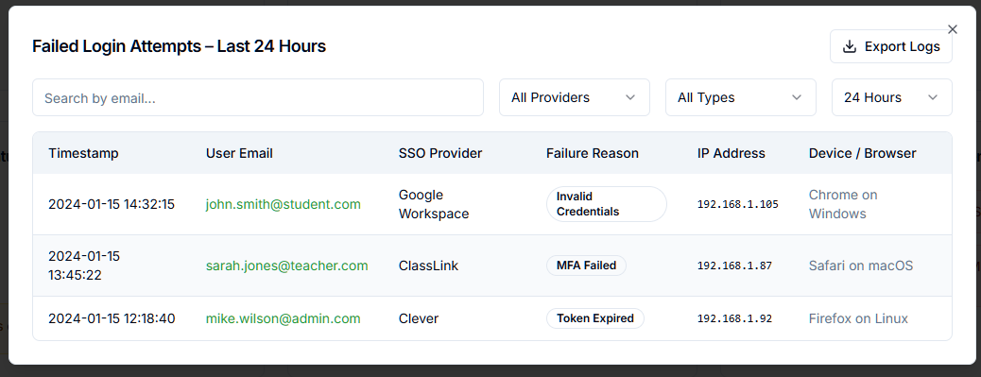
Figure 17: Failed Login Attempts - Last 24 Hours pop-up screen
Column | Description
Timestamp | Date & time of failed attempt
User Email | Account email
SSO Provider | Source (Google, ClassLink, etc.)
Failure Reason | Tag (Invalid Credentials, MFA Failed, Token Expired)
IP Address | IP captured from login attempt
Device / Browser | Browser/platform info

- No failed logins in the selected time range
Show inside table area: “No failed login attempts found for the selected period.”

MFA Adoption Overview
Shows MFA adoption by user roles and adoption trend charts.
Tab Name | Description
By User Role | List of roles with adoption %
Adoption Trend | Line chart for MFA enrollment growth

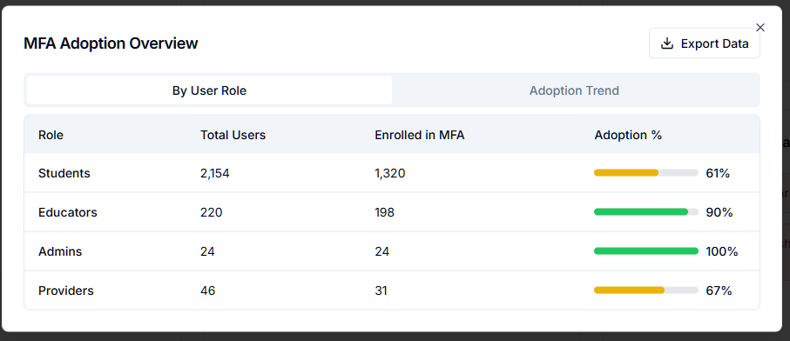
Figure 18: MFA Adoption Overview - By User Role
Field Name | Description | Options | Validations / Messages
By User Role Tab | Tab selection | N/A | None
Adoption Trend Tab | Tab selection | N/A | None
Export Data | Button | N/A | Should download file successfully
Role | User role | Students, Educators, Admins, Providers | None
Total Users | Count | N/A | None
Enrolled in MFA | Count | N/A | None
Adoption % | Percent bar | N/A | None
Trend Range Buttons | 7 Days, 30 Days, 90 Days | N/A | None

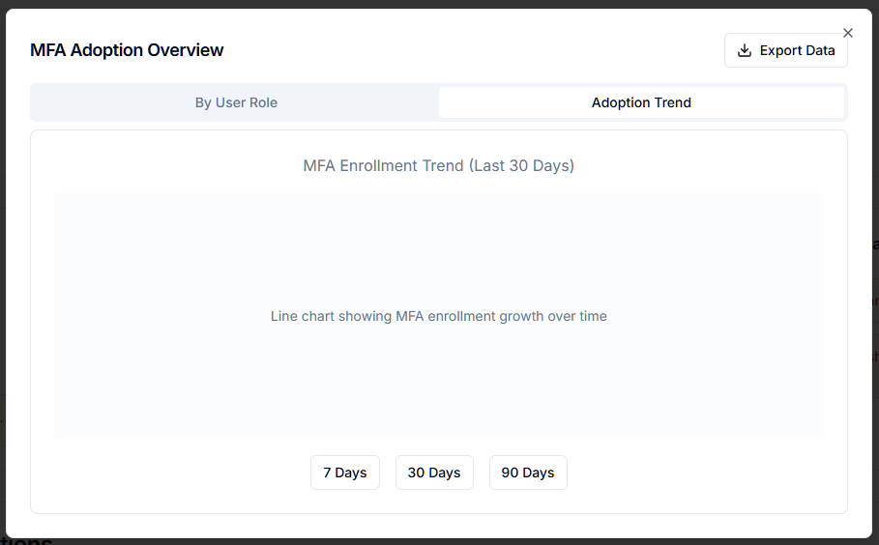
Figure 19: MFA Adoption Overview - By Adoption Trend
If no data is available:
a. If all adoption numbers are empty (new district), display a message as “MFA enrollment has not started yet.”.
b. If no historical adoption trend exists, display a message as “No MFA enrollment trend available.”

Suspicious Login Events
This modal displays suspicious login activity detected by ScholarPath’s security monitoring within the last 24 hours.
Suspicious events include anomalies like:
- Geo Shift (login from unexpected country)
- Device change
- Impossible travel
- Unusual login behavior
- Other anomaly patterns
The modal allows the District Tech Lead to:
- Review suspicious login attempts
- Filter results
- Export suspicious login logs
- View event details
- Clear flags on events
Element | Value
Header Title | “Suspicious Login Events – Last 24 Hours”
Search Bar | “Search by email…”
Filters | All Levels (Risk Levels), All Providers (SSO Providers), All (Time Range)
Export Button | “Export Logs”
Close Button | “X” icon (top-right)

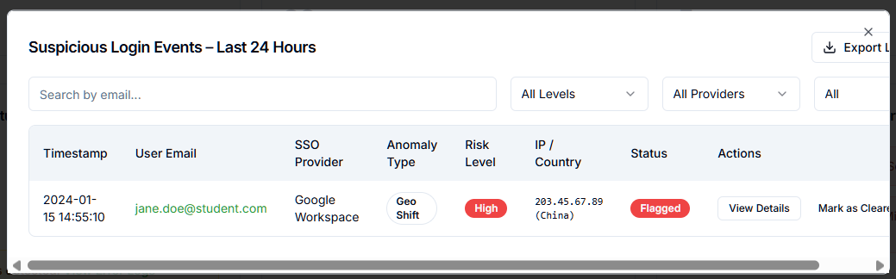
Figure 20: Suspicious Login Events - Last 24 Hours pop-up screen
Field Name | Description | Options (Dropdowns Only) | Validations / Success / Error Messages
Search | Search bar to filter suspicious login entries by user email | N/A | No validations
Risk Level Filter | Filters results by risk severity | All Levels, High, Medium, Low | No validations
SSO Provider Filter | Filters by authentication provider | All Providers, Google Workspace, ClassLink, Clever etc. | No validations
Time Filter | Filters results by time period | All, Last 24 Hours, 7 Days, 30 Days | No validations
Timestamp | Date & time of suspicious login | N/A | None
User Email | Email associated with the suspicious login | N/A | None
SSO Provider | Provider used to authenticate | N/A | None
Anomaly Type | Type of anomaly detected | Examples: Geo Shift, Device Change, Impossible Travel | None
Risk Level | Severity level of the security event | High (red), Medium (yellow), Low (gray) | None
IP / Country | IP address & geolocation | N/A | None
Status | Classification of event | Flagged, Cleared | None
View Details | Opens detailed event modal | N/A | Must open correctly
Mark as Cleared | Clears event from “Flagged” status | N/A | Success: “Event marked as cleared.”

Actions:
1. Export Logs
- Type: Button (top-right)
- Action: Downloads CSV file of all suspicious login events
- Behavior:
  - File contains all visible records after filters applied
  - Always enabled
2. View Details (per row)
- Opens a detailed modal containing:
  - Timestamp
  - User details
  - SSO provider
  - IP & location
  - Anomaly explanation
  - Risk factors
  - Recommended remediation
3. Mark as Cleared
- Action: Removes the “Flagged” status for this suspicious login record
- Changes status from Flagged → Cleared
- Success Message:
“Suspicious login event marked as cleared.”
4. Close (Top-right X)
- Closes the modal
- No validations or warnings
If no suspicious login events exist, display a message inside the modal:
“No suspicious login events detected in the selected period.”

2.3.4 Documents & Compliance Alerts
Shows missing or outdated documents for schools in the district.
Field Name | Description | Options | Validations / Messages
Compliance Alert | Missing document notification | N/A | If the document is missing → “Document name for ‘school name’ is missing.”

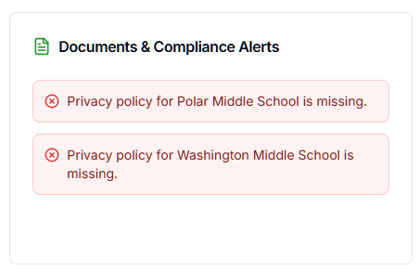
Figure 21: Documents & Compliance Alerts
Clicking an alert:
- Navigates to Compliance Documents
- Auto-selects the Schools tab
- Auto-expands the specific school
- Highlights the missing document type
- No missing or overdue compliance documents, display an empty state box with a message “No compliance alerts at this time.”

Recent Notifications
Displays the latest system notifications.
Field Name | Description | Options | Validations / Messages
Notification Item | One activity item | N/A | None
View All Notifications | Link to Notifications screen | N/A | Must navigate to Notifications & Settings → All Notifications

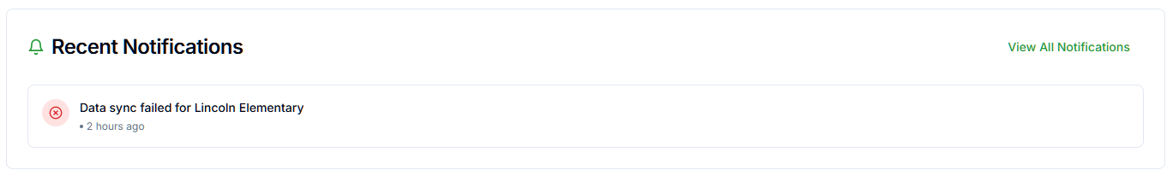
Figure 22: Recent Notifications
If no notifications are available, display a message on the grid as “No recent notifications.”.

Compliance Documents

ScholarPath Reference Documents
This section allows users to manage, review, and track all compliance-related documentation for their district.
Under the ScholarPath tab, users can view and download official reference documents provided by ScholarPath. Each document entry displays the following details:
- Document Name – The title of the reference document.
- Version – The version number of the document.
- Published On – The publication date of the document.
- Actions – Options to View or Download the document.

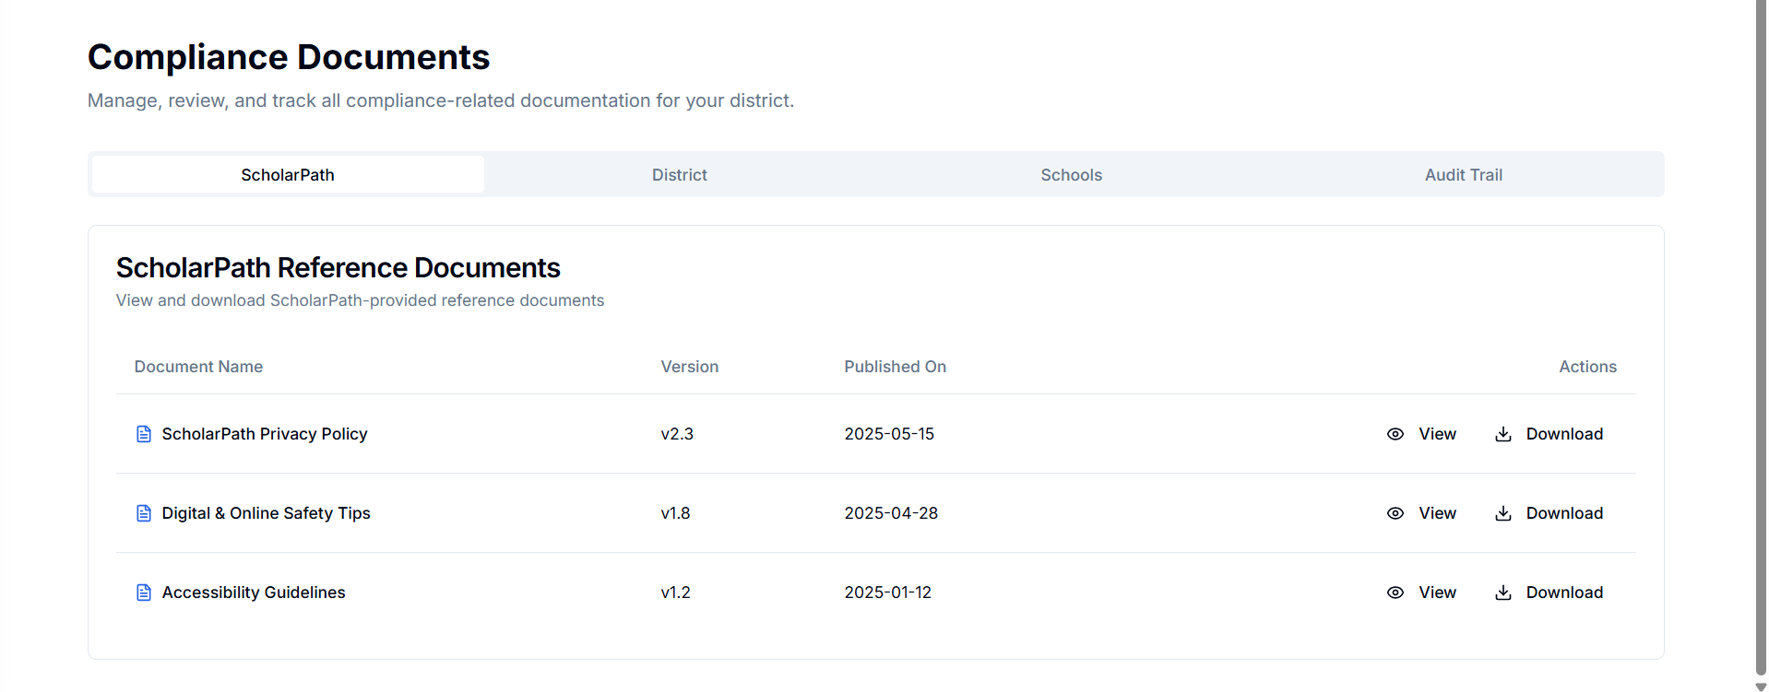
Field Name | Description | Validations | Success / Error Messages
Document Name | Displays the title of each reference document provided by ScholarPath admin. | Must not be empty. Should display text from backend API.
Version | Shows the document version (e.g., v2.3). | Must follow version format v[number].[number]. | Error: “Invalid or missing version number.”
Published On | Displays the publication date of the document. | Must follow date format MM-DD-YYYY. Cannot be a future date. | Error: “Invalid or missing publication date.”
Actions – View (Eye Icon) | Opens the document in a preview mode (new tab). | Must confirm that preview URL exists before opening. | Error: “Unable to preview document. Please try again.”
Actions – Download (Arrow Icon) | Download the selected file directly. | Must confirm file link before download. File should exist on server. | Success: File downloaded successfully Error: “Download failed. Please check your connection or try again.”
Search / Filter Bar (if applicable) | Allows filtering or searching documents by name or version. | Must accept at least 2 characters before triggering search. | Error: “No results found for your search.”

District-Level Compliance Documents
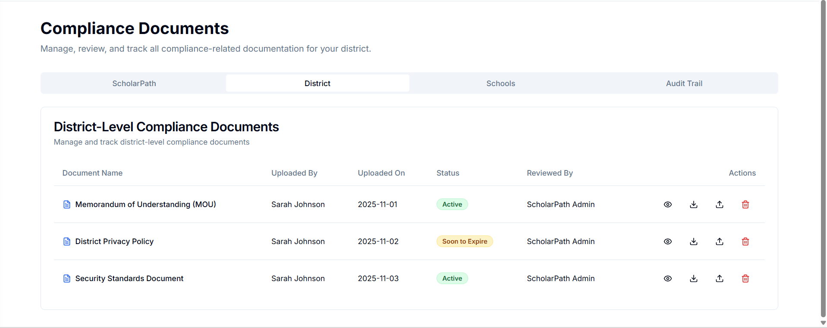
This section allows users to manage, upload, review, and track all district-level compliance documents that are required for maintaining compliance within the district.
Each document record displays key metadata:
- Document Name – The title of the uploaded compliance document.
- Uploaded By – The user who uploaded the document (e.g., District Admin).
- Uploaded On – The date the document was uploaded.
- Status – The current status of the document, such as Active, Soon to Expire, or Expired.
- Reviewed By – The individual or team who reviewed and approved the document (e.g., ScholarPath Admin).
- Actions – Allows users to perform actions such as View, Download, Import (Share), and Delete.
This helps district administrators and compliance officers to ensure all documentation is up-to-date and verified.
Field Name | Description | Validations | Success / Error Messages
Document Name | Displays the name of each uploaded district compliance document (e.g., Memorandum of Understanding, District Privacy Policy, Security Standards Document). | Must not be blank. Should match the backend record name.
Uploaded By | Shows the name of the user who uploaded the document (e.g., District Admin). | Must not be empty. Should display valid user data from backend.
Uploaded On | Displays the upload date of the document. | Must follow the format YYYY-MM-DD. Cannot be a future date.
Status | Displays the document’s compliance state – Active, Soon to Expire, or Expired. | Must be one of the defined values. Should change dynamically based on system rules (e.g., expiration threshold).
Reviewed By | Displays who reviewed or approved the document (e.g., ScholarPath Admin). | Must not be blank. Should reflect the reviewing entity.
Action – View (Eye Icon) | Opens the document in preview mode (new browser tab). | Must verify that a valid preview URL exists.
Action – Download (Arrow Icon) | Downloads the selected file directly from the system. | Must validate file availability and secure access. | Success: “File downloaded successfully.”  Error: “Download failed. Please check your connection or try again.”
Action – Import / Share (Link Icon) | Allows the user to share or import the document to other connected sections (e.g., Schools). | Must ensure at least one valid destination is selected. | Success: “Document successfully shared with the selected schools.”  Error: “Failed to share document. Please check permissions or try again.”
Action – Delete (Trash Icon) | Prompts a confirmation dialog to permanently delete the document. | Must confirm with “Yes” before deletion. Delete should only proceed if user has permission. | Success: “Document deleted successfully.”  Error: “Unable to delete the document. Please check permissions or try again later.”
Delete Confirmation Popup | Displays before deleting a document to prevent accidental deletion. Includes the message: “Are you sure you want to delete this document? This action cannot be undone.” | Buttons must function correctly:  • Yes – Deletes document permanently.  • Cancel – Closes the popup with no changes. | Success: “Document permanently removed from the system.”  Error: “Delete action cancelled.”
Empty State Message | Displays when no district-level documents are available. | Must appear if API returns an empty list. | Message: “No district compliance documents found. Please upload a new document to begin tracking compliance.”

School-Level Compliance Documents
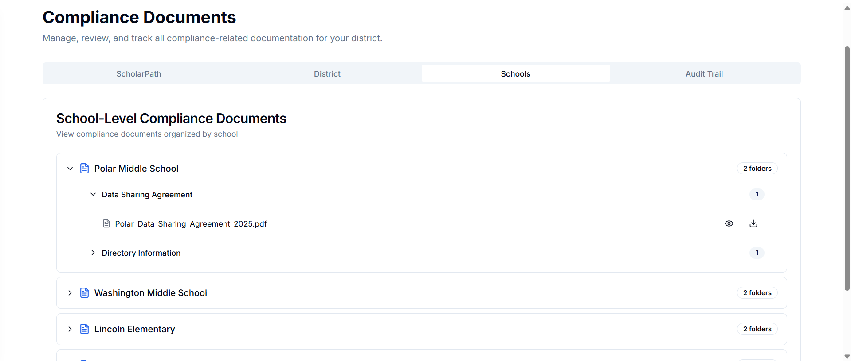
  - This section is designed to manage and view compliance documents organized by individual schools within a district.
  - It provides a hierarchical folder structure displaying schools as top-level entities (e.g., Polar Middle School, Washington Middle School, Lincoln Elementary), and each school’s compliance documents are grouped under relevant categories such as Data Sharing Agreement or Directory Information.
Field Name | Description | Validations | Success / Error Messages
School Name (Expandable Section) | Displays each school’s name (e.g., Polar Middle School, Washington Middle School, Lincoln Elementary). Each can be expanded/collapsed to view its compliance folders. | Must not be empty. Each school must map to at least one folder or a valid placeholder message. | Success: “Folders loaded successfully for [School Name].”  Error: “Unable to load folders for this school.”
Folder Name (e.g., Data Sharing Agreement, Directory Information) | Represents grouped compliance folders under each school. Expanding a folder displays its associated documents. | Must not be blank. Folder must contain at least one valid document entry or placeholder message. | Success: “Folder expanded successfully.”  Error: “No documents found in this folder.”
Document Name | Displays the actual file name (e.g., Polar_Data_Sharing_Agreement_2025.pdf). | Must not be empty; must include valid file extension (e.g., .pdf, .docx). | Error: “Document name unavailable or invalid.”
Action – View (Eye Icon) | Opens the selected document in preview mode in a new browser tab. | Must validate preview URL before opening. | Success: “Document preview opened successfully.”  Error: “Unable to preview document. Please try again.”
Action – Download (Arrow Icon) | Triggers direct download of the selected document. | Must confirm that the file exists in the repository. | Success: “File downloaded successfully.”  Error: “Download failed. Please check file availability or connection.”
Folder/Document Count (e.g., ‘2 folders’, ‘1’) | Displays the number of folders under each school and documents under each folder. | Must display correct count fetched from backend. | Success: Counts reflect the correct number of items.  Error: “Unable to retrieve folder/document count.”
Empty State Message | Displays when no school-level documents are available in the system. | Must appear when API returns an empty dataset. | Message: “No school-level compliance documents found. Please upload or assign documents to schools to begin tracking compliance.”
Page Load / API Fetch | Fetches school-wise compliance data from the ScholarPath backend repository. | Must complete within response timeout; should gracefully handle network errors. | Success: “School-level compliance data retrieved successfully.”  Error: “Failed to fetch data. Please refresh or try again.”

Audit Trail
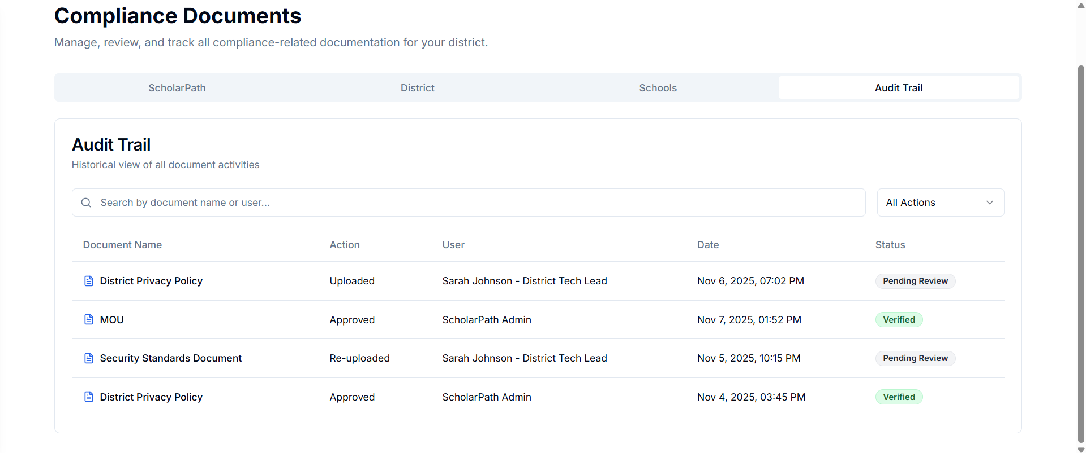
  - The Audit Trail section provides a historical view of all document-related activities across the ScholarPath compliance system.
  - It serves as a compliance monitoring and accountability tool, showing detailed records of who performed what action, when, and on which document.
  - Displayed columns include:
    - Document Name – The title of the document associated with the action.
    - Action – The activity performed (e.g., Uploaded, Approved, Re-uploaded).
    - User – The person who performed the action (e.g., Sarah Johnson – District Tech Lead).
    - Date – The exact date and time of the action.
    - Status – The outcome or current review status (e.g., Pending Review, Verified).
Field Name | Description | Validations | Success / Error Messages
Tab Navigation (ScholarPath / District / Schools / Audit Trail) | Allows switching between document sections. The Audit Trail tab displays historical activity logs for all compliance-related actions. | Must load audit records from the activity logs database. Active tab should be visually highlighted. | Error: “Failed to load Audit Trail data. Please refresh or try again.”
Search Bar | Allows users to search for records by document name or user. | Minimum 2 characters required before triggering search. Should support partial matches for both document names and user names. | Error: “No results found for your search.”
Action Filter (All Actions Dropdown) | Provides filtering options to view specific activity types such as Uploaded, Approved, Deleted, or Re-uploaded. | Must display valid predefined options only; cannot be blank. | Error: “Unable to apply filter. Please try again.”
Document Name | Displays the name of the document on which an action was performed. | Must not be empty; must match an existing compliance document record.
Action | Displays the activity type performed on the document (e.g., Uploaded, Approved, Re-uploaded, Deleted). | Must be one of the predefined valid action types; cannot be blank.
User | Displays the name and role of the person who performed the action (e.g., Sarah Johnson – District Tech Lead). | Must not be empty. Must match a valid user in the system.
Date | Displays the date and time the action occurred. | Must follow standard date and time format (e.g., Nov 6, 2025, 07:02 PM).
Status | Displays the current state of the action result (e.g., Pending Review, Verified). | Must be one of the valid predefined statuses. Should visually differ (color-coded) by status type. | Success: Status displayed correctly.  Error: “Invalid or missing status.”
Empty State Message | Displays when no audit records are available. | Must appear automatically if no activity logs are retrieved. | Message: “No document activity found. Actions like upload, approval, or deletion will appear here once performed.”

Data Integrations
This screen allows districts to configure how their data syncs with ScholarPath.
The user can choose Manual CSV Upload or Nightly Batch Upload (FTP/SFTP).
When Manual Upload is selected, a CSV file must be uploaded manually to update student/staff data.
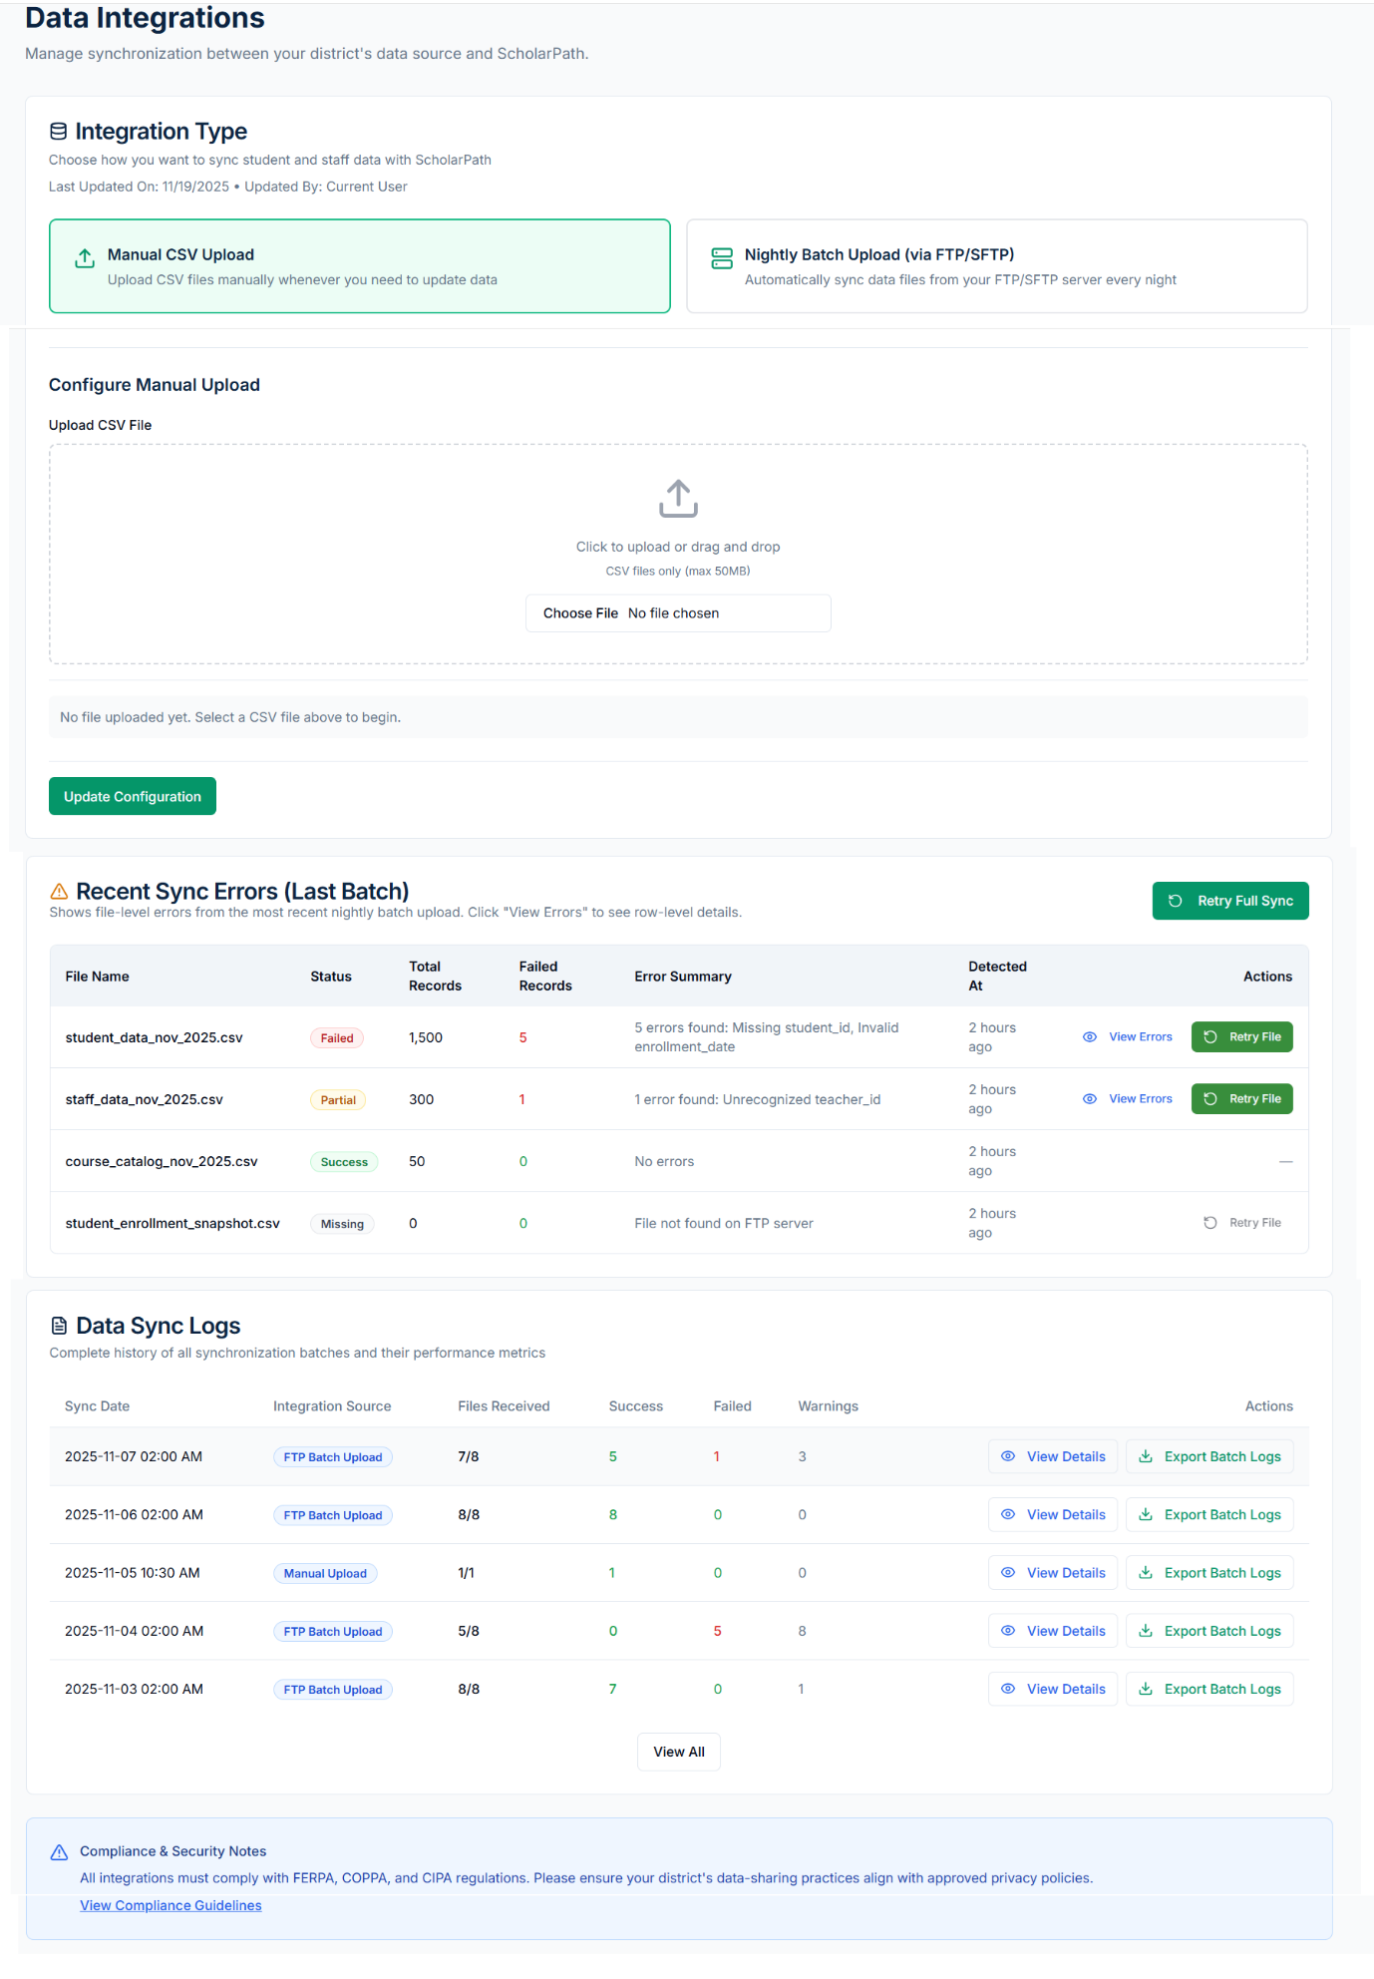

Integration Type
Data Integrations (Manual CSV Upload Page)
This screen allows districts to configure how their data syncs with ScholarPath.
The user can choose Manual CSV Upload or Nightly Batch Upload (FTP/SFTP).
When Manual Upload is selected, a CSV file must be uploaded manually to update student/staff data.
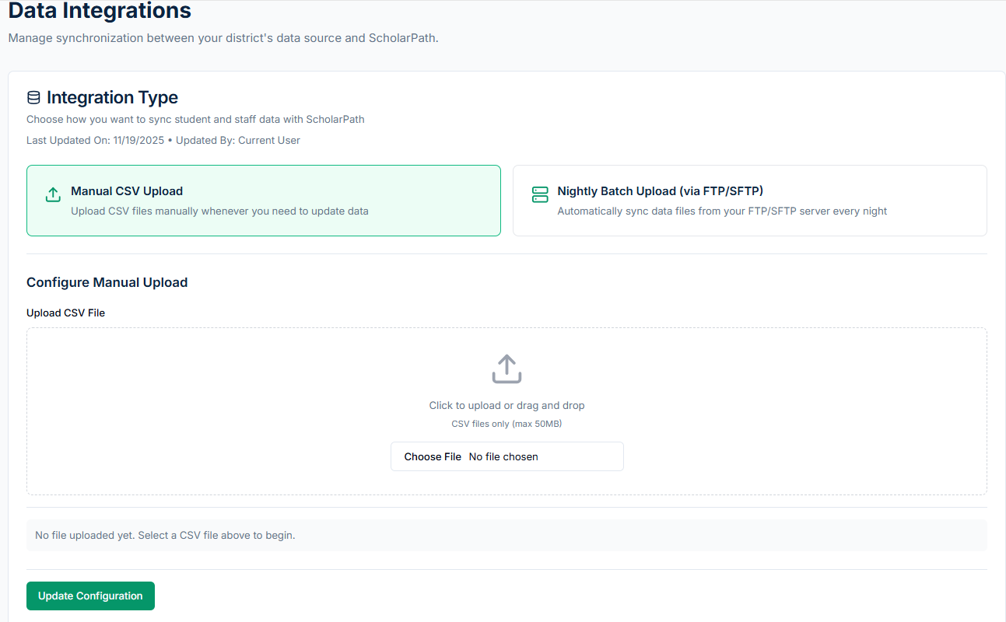
Field Name | Field Description (What the field is / what user does) | Validations / Rules (Very Explicit) | Success Message | Error Message
Integration Type – Manual CSV Upload | A selectable integration mode where the user chooses to manually upload CSV files instead of FTP/SFTP automation. | - User must select one integration type before saving configuration. - Only one integration type can be active at a time. | “Integration type updated successfully.” | “Please select an integration type before continuing.”
Integration Type – Nightly Batch Upload (FTP/SFTP) | A selectable integration mode where nightly sync happens automatically from FTP/SFTP. | - Mutually exclusive with manual upload. - If selected, user must configure FTP settings before saving. | “Integration type updated.” | “FTP/SFTP settings required for nightly batch mode.”
Upload CSV File (Drop Zone) | Drag-and-drop area where user can drop a CSV file to upload. | - Only .csv file types allowed. - Maximum file size: 50 MB. - Only one file can be uploaded at a time. - File name must not contain special characters like / \ * ?. | “CSV file uploaded successfully.” | “Invalid file type. Only CSV allowed.” “File exceeds 50MB limit.”
Choose File (Button) | Opens local file selection dialog to upload a CSV file manually. | - Must select a file before clicking “Update Configuration.” - Must select a valid CSV file (same rules as above). | “File selected successfully.” | “No file selected.”
Update Configuration (Button) | Saves the integration setting and uploaded file selection. | - Requires a valid CSV file to be uploaded. - Integration type must be selected. | “Manual upload configuration saved.” | “Please upload a CSV file before saving.”

Data Integrations (FTP/SFTP Settings Page)
This page appears when Nightly Batch Upload (FTP/SFTP) is selected.
It allows administrators to configure server information for automatic nightly uploads.
Field Name | Field Description | Validations / Rules (Very Explicit) | Success Message | Error Message
Protocol | Dropdown where user selects transfer protocol: FTP or SFTP. | - Field is required. - Must be one of: FTP, SFTP (no other values allowed). | “Protocol saved.” | “Please select a protocol.”
Host / Server URL | Text field where user enters the FTP/SFTP server address or IP. | - Required field. - Must be valid hostname (example: ftp.example.com) OR valid IP address (e.g., 192.168.1.1). - No spaces allowed. - Max length: 255 characters. | “Server URL validated.” | “Invalid server URL. Enter a valid hostname or IP.”
Port | Numeric field for server port. Example: 21 for FTP, 22 for SFTP. | - Required. - Must be numbers only. - Valid range: 1 to 65535. - Cannot be empty or contain characters. | “Port accepted.” | “Invalid port number.”
Username | Username used to connect to the FTP/SFTP server. | - Required. - No spaces allowed. - Max length: 100 characters. | “Username saved.” | “Username is required.”
Password | Password for server authentication (masked). | - Required. - Must contain at least 1 character. | “Password saved.” | “Password cannot be empty.”
Remote Folder Path | Path on server where CSV files are stored. | - Optional when saving settings. - Required before using “Test Connection.” - Cannot contain invalid characters: `? * < > | `. | “Folder path saved.”
Expected File Naming Pattern | Optional naming format for matching specific files. Example: student_*.csv. | - Optional. - If provided, cannot contain disallowed characters: `/ \ ? < > | `. | “Naming pattern saved.”
Test Connection Button | Button that attempts to connect to FTP/SFTP server using provided credentials. | - Requires all required fields: Protocol, Host, Port, Username, Password. - Remote Folder Path also required to complete test. | “Connection successful.” | “Unable to connect. Check server credentials.”
Update Configuration Button | Saves the entire FTP/SFTP configuration. | - All required fields must be valid. | “Configuration updated successfully.” | “Unable to save configuration. Fix highlighted fields.”

3.2 Recent Sync Errors
This table shows the errors detected in the most recent nightly sync across all CSV files.
Each row represents one file with summary-level error info.

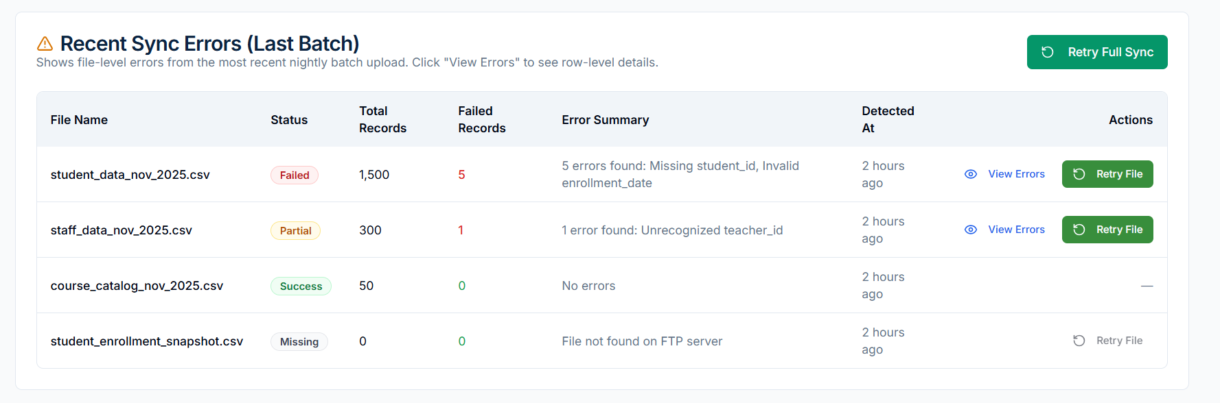
Field Name | Field Description | Validations / Rules | Success Message | Error Message
File Name | Name of CSV file processed in batch sync. | Auto-populated, must match file naming pattern. | — | —
Status | Indicates success or type of failure (Success, Partial, Failed, Missing). | Auto-calculated after validation. | — | —
Total Records | Number of rows in uploaded CSV. | Auto-derived from file. | — | —
Failed Records | Number of records that failed validation. | System-generated. | — | —
Error Summary | High-level description of issue(s). | Auto-generated. | — | —
Detected At | Timestamp of when system detected the error. | Auto. | — | —
View Errors Button | Opens error detail modal for file. | Must have file loaded in system. | “Errors loaded.” | “Unable to load file errors.”
Retry File Button | Reprocesses only that specific file. | File must be present and valid. | “File retry initiated.” | “Retry failed.”
Retry Full Sync Button | Retries the entire batch. | Requires valid FTP/SFTP connection. | “Full sync retry started.” | “Unable to retry sync.”

Error Details Modal
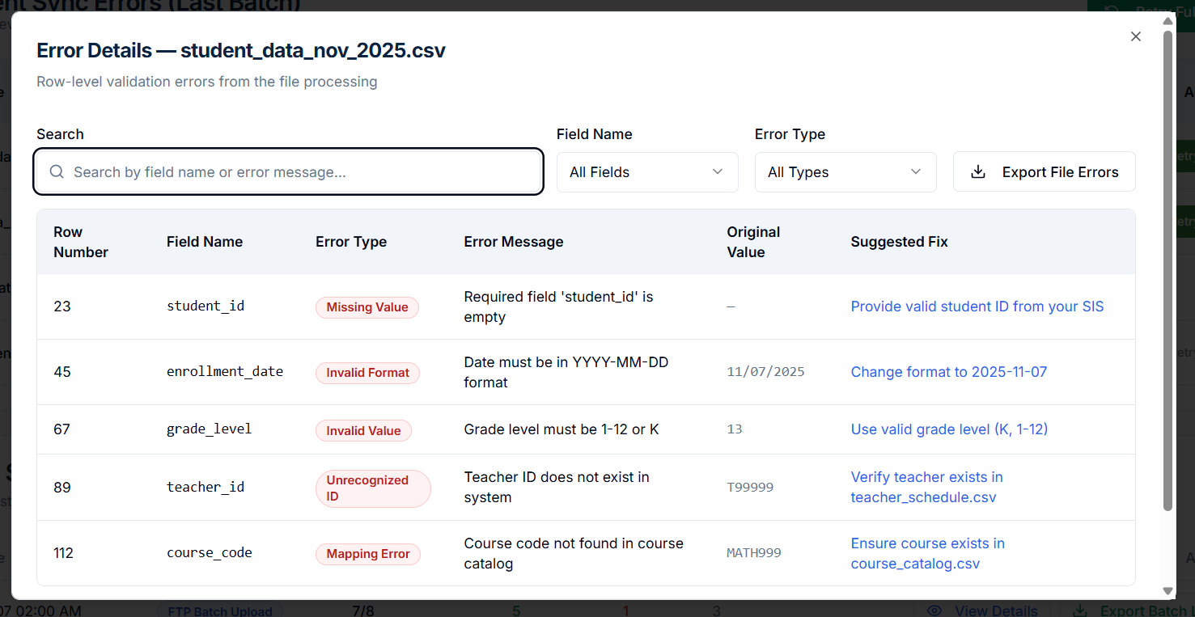
Field Name | Field Description (What the field is / what the user does) | Validations / Rules (Very Explicit) | Success Message | Error Message
Search | A text input where the user can type keywords to filter errors (field name, error message, value). | - Accepts alphanumeric characters. - Filters results dynamically. - No validation restrictions. | “Search results updated.” | —
Field Name Filter Dropdown | Dropdown for selecting a specific CSV column to filter errors (e.g., student_id, enrollment_date). | - Optional filter. - “All Fields” selected by default. | “Field filter applied.” | —
Error Type Filter Dropdown | Dropdown to filter errors by type (Missing Value, Invalid Format, Mapping Error, etc.). | - Optional filter. - “All Types” selected by default. | “Error type filter applied.” | —
Row Number | Row index in the CSV file where the error occurred. | - Auto-generated. - Must be a valid row number from CSV. | — | —
Field Name | Name of the CSV column that caused the error. | - System-detected. - Must match a known header in CSV. | — | —
Error Type | Classification of the error. Examples: Missing Value, Invalid Format, Invalid Value, Unrecognized ID, Mapping Error. | - Auto-determined based on validation engine. | — | —
Error Message | Describes exactly what failed (e.g., “Required field missing”). | - Auto-generated by system. | — | —
Original Value | Shows the exact value from CSV that triggered the error. | - May show “—” if value was empty. | — | —
Suggested Fix | Recommended action with clickable link (e.g., “Provide valid student ID”). | - Link must map to a help page or related file. | “Suggestion link opened.” | “Unable to open suggestion page.”
Export File Errors Button | Exports all row-level errors to a CSV. | - File must contain at least 1 error row. | “File errors exported successfully.” | “Failed to export file errors.”
Close Button | Closes the modal. | - No validation required. | — | —

3.3 Data Sync Logs
Displays a complete history of all sync batches (manual and FTP).
Shows the number of files processed, success/failure counts, warnings, and available actions.
Field Name | Field Description | Validations / Rules (Very Explicit) | Success Message | Error Message
Sync Date | Date & time when the sync batch occurred. | - Auto-generated timestamp. - Format: YYYY-MM-DD HH:MM AM/PM. | — | —
Integration Source | Shows if batch came from Manual Upload or FTP Batch Upload. | - Auto-assigned based on configuration. | — | —
Files Received | Number of files successfully retrieved from source. Example: “7/8”. | - Auto-calculated. - Should not exceed expected file count. | — | —
Success | Count of fully successful files in the batch. | - Auto-calculated. | — | —
Failed | Count of files that failed validation. | - Auto-calculated. | — | —
Warnings | Number of files with non-breaking issues. | - Auto-calculated. | — | —
View Details Button | Opens batch-level details including file-wise error breakdown. | - Must have batch logs available. | “Batch details loaded.” | “Unable to load batch details.”
Export Batch Logs Button | Exports the logs for this batch in CSV/PDF. | - Must have at least 1 processed file. | “Batch logs exported successfully.” | “Failed to export batch logs.”
View All Button | Loads the complete sync log history. | - No validation required. | “Full history loaded.” | “Unable to load sync history.”

Sync Batch Details pop up:
This modal provides full breakdown of a single sync batch, including totals, file-level statuses, and error summaries.
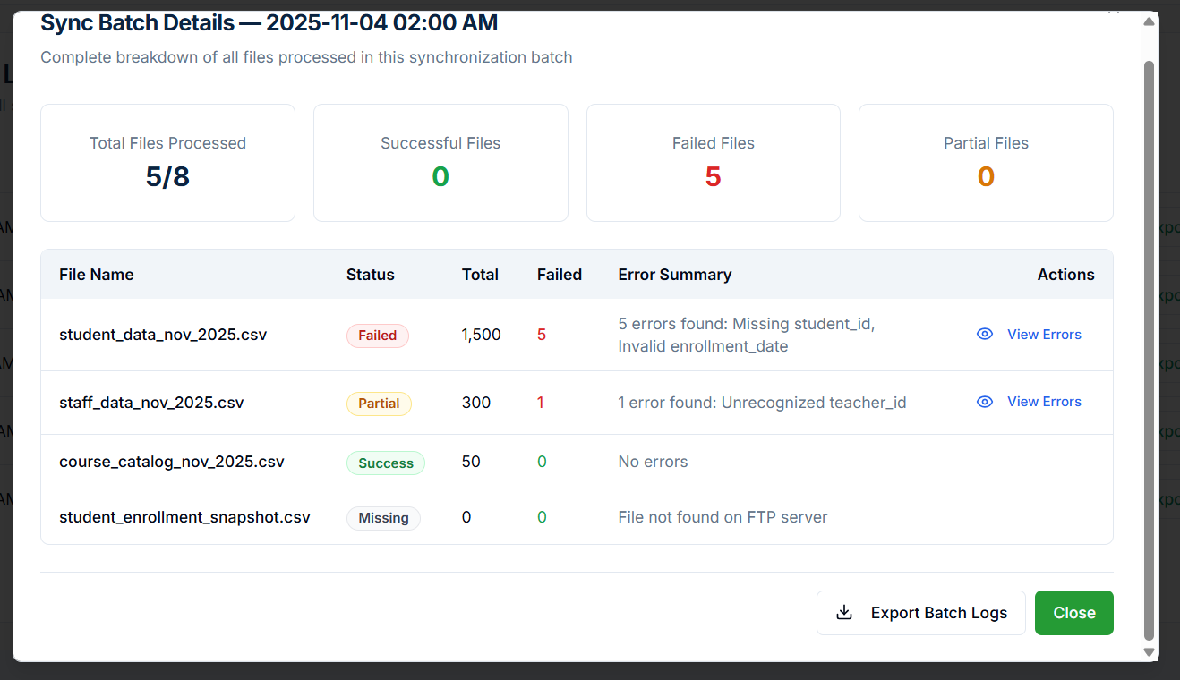
Field Name | Field Description | Validations / Rules (Very Explicit) | Success Message | Error Message
Total Files Processed | Shows the number of files processed in the batch. | - Auto-calculated. - Must equal the number of files received. | — | —
Successful Files | Count of files that completed with no errors. | - Auto-generated. | — | —
Failed Files | Count of files that did not pass validation. | - Auto-generated. | — | —
Partial Files | Files that have some errors but not fully failed. | - Auto-generated. | — | —
File Name | Name of the processed file. | - Must match file naming conventions (if enforced). | — | —
Status | Status of processing the file: Success, Partial, Failed, Missing. | - Auto-determined based on validation. | — | —
Total (Records) | Total rows in the file. | - Auto-determined. | — | —
Failed (Records) | Number of rows that failed validation. | - Auto-determined. | — | —
Error Summary | Short description of what errors occurred. | - Auto-generated. | — | —
View Errors Button | Opens the row-level error modal. | - Only enabled if failed records > 0. | “Error details opened.” | “Unable to load error details.”
Export Batch Logs Button | Exports detailed batch reports. | - Must have at least 1 processed file. | “Batch logs exported successfully.” | “Failed to export logs.”
Close Button | Exits the modal. | - No validation required. | — | —

Security Center
Security Center provides the complete set of security, authentication, audit, alerts, and system-wide controls for the district. It consolidates all critical security operations into one module.

4.1 System Operations
The System Operations tab specifically controls the overall system state, allowing the District Tech Lead to place the district in maintenance mode or resume normal operation while providing real-time status indicators, auto-refreshing, and full audit logging.
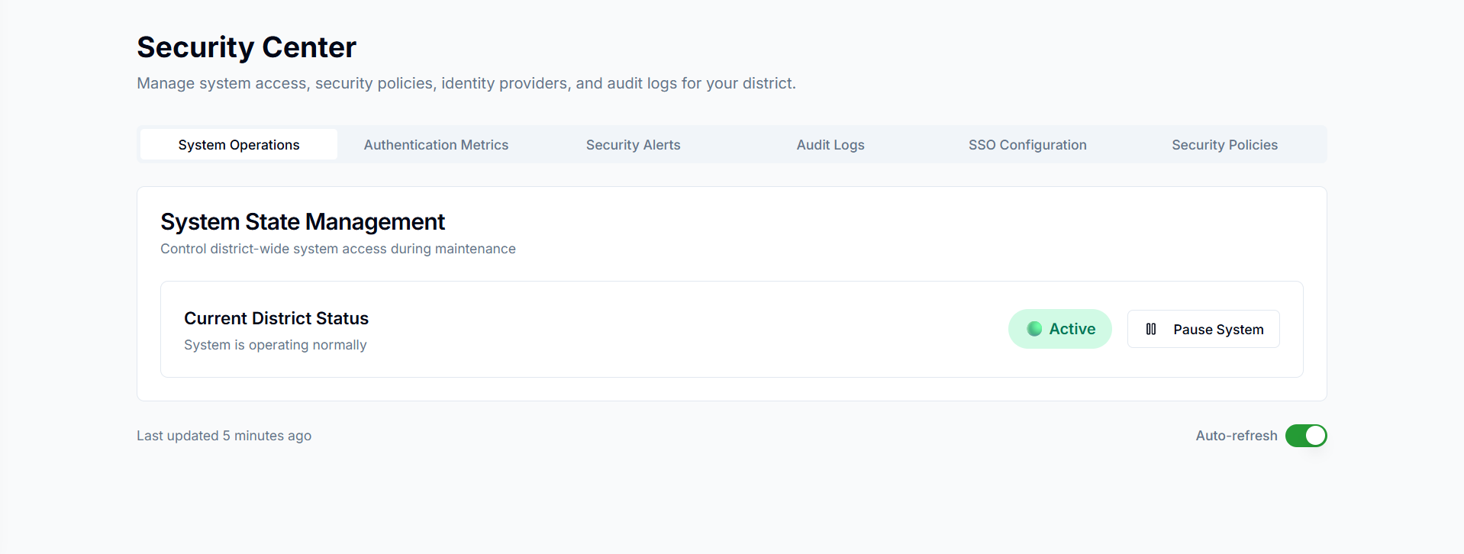

Field Name | Description | Validations | Success / Error Messages
System Operations (Tab) | Navigation tab used to access district-wide system operation settings. | Must be accessible only to users with permission (District Tech Lead / Admin). | Error (Permission Denied): “You do not have access to System Operations.”
System State Management (Section Header) | Title section that groups all settings related to controlling the district system state. | None | None
Current District Status (Label) | Displays the real-time operational status of the district system. | Must always display the latest status from backend. | Active State: “System is operating normally.” Paused State: “System is currently in maintenance mode.”
System is operating normally (Status Text) | Message displayed when the district system is active and functioning normally. | Must match the backend system state flag. | None (informational only)
Status Chip – Active (Green) | Indicates that the district system is fully active. | Must remain green only when system state = Active. | None
Pause System (Button) | Action button used to pause the entire district system, blocking logins and switching to maintenance mode. | Validations: • User must be District Tech Lead or Admin. • System must currently be Active. | Success: “District system has been paused successfully.” Error: “Unable to pause system. Please try again.”
Auto-refresh (Toggle) | Automatically refreshes system status every X seconds. | Valid values: ON / OFF. | Success: No message (silent update). Error: “Auto-refresh failed to update status.”
Last Updated (Timestamp) | Shows the last time the page pulled the latest state from backend. | Must update every auto-refresh cycle. | Error: “Unable to fetch latest system status.”

5.2 Authentication Metrics:

The Authentication Metrics tab in the Security Center provides real-time insight into how users across the district are authenticating into ScholarPath. It helps District Tech Leads monitor login volume, failed authentication attempts, MFA adoption levels, and risky sign-in patterns.
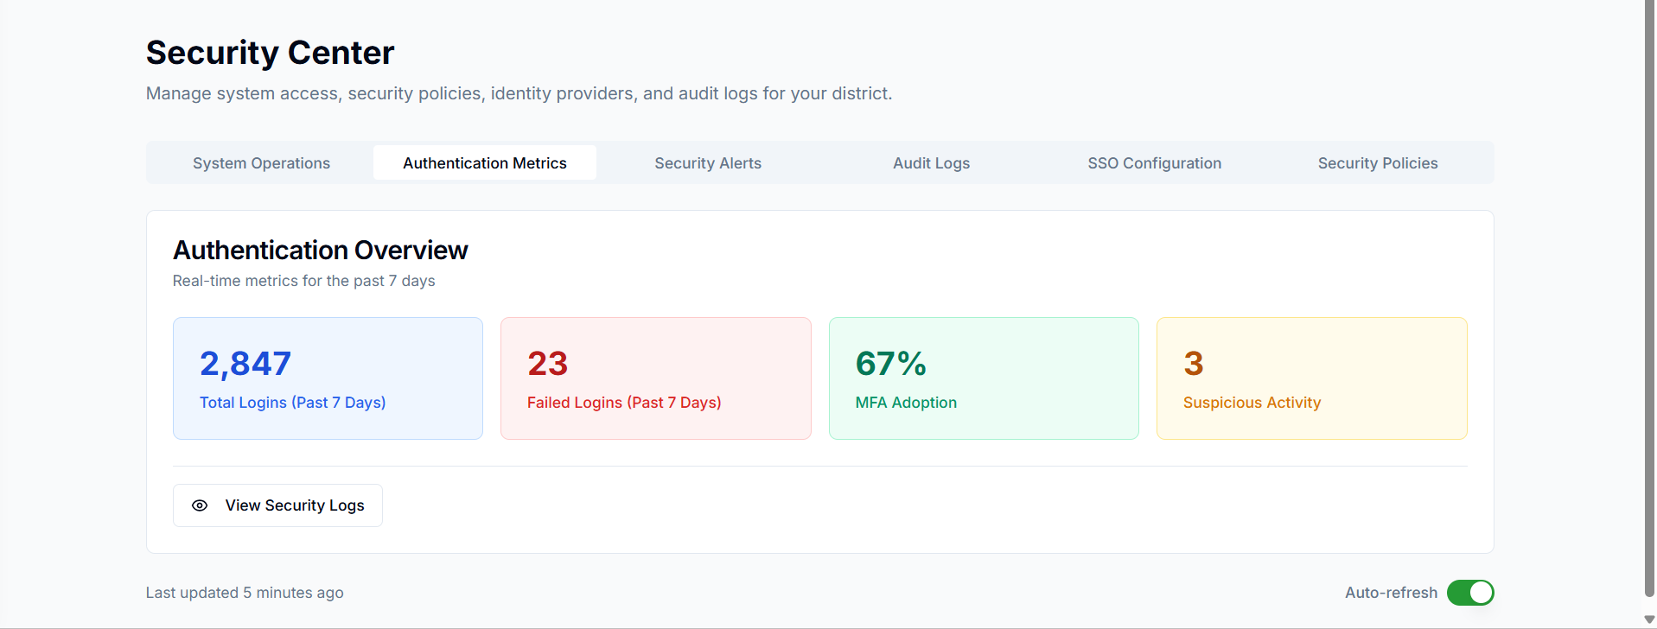
Field Name | Description | Validations / Rules | Success / Error Messages
Total Logins (Past 7 Days) | Displays total number of successful logins over the last 7 days. | Must load from authentication logs; auto-refresh every 5 mins. | If data loads → No message. If fails → “Unable to load login metrics.”
Failed Logins (Past 7 Days) | Shows the count of failed login attempts due to invalid credentials, token issues, or MFA errors. | Should only include failed statuses; must match security logs. | Error loading → “Failed login data unavailable.”
MFA Adoption | Displays the percentage of users enrolled in MFA compared to total eligible accounts. | Must calculate as: (MFA enrolled / total users) * 100. | Error loading → “Unable to retrieve MFA adoption rate.”
Suspicious Activity Count | Shows how many risky logins occurred (geo-change, multiple failures, impossible travel). | Only events tagged with “High” or “Medium” risk should count. | Error loading → “Suspicious login data unavailable.”
View Security Logs Button | Opens Login Activity – Timeline View modal. | Must load past 7 days of logs; sort by timestamp. | Success → modal loads. Error → “Security logs failed to load.”
Login Activity – Timeline View | Shows every authentication event (success + failure), including provider, device, method. | Timestamp required; fields cannot be null; column sorting enabled. | Error → “Unable to load login activity history.”
Failed Login Attempts Modal | Displays only failed logins, including reason (Incorrect Password, Token Expired, MFA Failed). | Failure reason mandatory; IP and device required. | Error → “Failed login records could not be loaded.”
MFA Breakdown (Summary by Role) | Shows MFA enrollment by user role (Students, Educators, Admins, Staff). | Total users and enrolled users must match identity directory counts. | Error → “Unable to load MFA enrollment details.”
MFA Breakdown (Adoption Trend) | Graph showing MFA enrollment growth for 7/30/90 days. | Trend values must match historical security audit logs. | Error → “Unable to load MFA adoption trend graph.”
Suspicious Login Modal | Shows high-risk events with risk scores, geolocation, and reason. | Risk score must be tagged: High (red), Medium (yellow). Location required. | Error → “Suspicious login details unavailable.”
Resolve Button (Suspicious Login) | Opens security workflow to mark login as reviewed. | Must update status in security event log. | Success → “Marked as resolved.” Error → “Unable to resolve event.”
Export Logs Button | Exports login logs (CSV). | Export must include all fields (timestamp, email, provider, status, device). | Success → File downloads. Error → “Export failed. Try again.”
Auto-Refresh Toggle | Refreshes dashboard metrics every 5 minutes. | Toggle must remain persistent per user. | No success message. If fails → “Auto-refresh unavailable.”

Login Activity – Timeline View
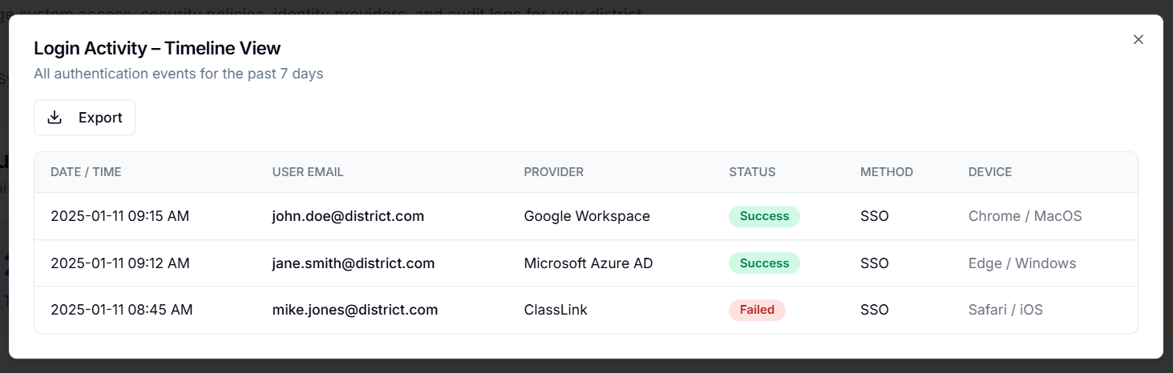
Field Name | Description | Validations | Success / Error Messages
Date / Time | Displays the timestamp of the authentication event in YYYY-MM-DD HH:MM AM/PM format. | Must be a valid timestamp from authentication logs. | - (No direct messages; display-only)
User Email | Email address of the user who attempted login. Helps identify the user performing authentication. | Must be a valid email string stored in login event logs. | - (No direct messages; display-only)
Provider | The SSO or authentication provider used for login. Examples: Google Workspace, Microsoft Azure AD, ClassLink. | Must be present in the identity provider configuration. | - (No direct messages; display-only)
Status | Indicates whether the login attempt was Success (green badge) or Failed (red badge). | Must be one of the valid states: Success, Failed. | - Success: shown with green pill. - Failed: shown with red pill.
Method | Authentication method used: typically SSO for single sign-on. | Must be a valid auth method stored in logs. | - (No direct messages; display-only)
Device | Browser + OS combination used for login attempt, e.g., Chrome/MacOS, Edge/Windows, Safari/iOS. | Must match device metadata captured during login. | - (No direct messages; display-only)
Export Button | Allows exporting the last 7 days of authentication events as a CSV file. | CSV generation must succeed. | Success: File download triggered. Error: “Unable to export login activity. Please try again.”
Modal Close (X) | Closes the Login Activity – Timeline View modal and returns user to Authentication Metrics page. | None. | - (Modal closes without message)

Failed Login Attempts
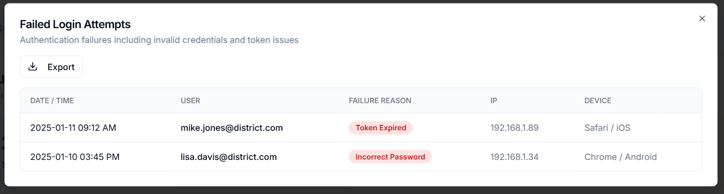
Field Name | Description | Validations | Success / Error Messages
Date / Time | Displays the exact timestamp when the failed authentication attempt occurred. | • Must follow format: YYYY-MM-DD HH:MM AM/PM. • Cannot be empty. | Success: Timestamp displays correctly. Error: “Invalid timestamp format.”
User Email | Email address of the user who attempted to log in. | • Must be a valid email format. • Cannot be empty. | Success: Email displays normally. Error: “Invalid user email format.”
Failure Reason | Shows why the authentication failed (e.g., Token Expired, Incorrect Password). | • Must match one of the defined system failure types. | Success: Failure reason labeled correctly (red badge). Error: “Unknown failure reason.”
IP Address | IP address from which the login attempt was made. | • Must be valid IPv4 or IPv6. • Cannot be empty. | Success: IP address displays correctly. Error: “Invalid IP address.”
Device | Device and operating system used during the login attempt (e.g., Safari / iOS, Chrome / Android). | • Optional field. • If captured, must display as “Browser / OS”. | Success: Device info shown. Error: “Unable to detect device information.”
Export Button | Allows user to export failed login attempts data as CSV. | • Export service must be active. | Success: “Failed login attempts exported successfully.” Error: “Unable to export logs. Try again.”
Close Icon (X) | Closes the modal and returns user to Authentication Metrics screen. | • No validation. | Success: Modal closes smoothly. Error: (None-UI element only).

MFA Breakdown
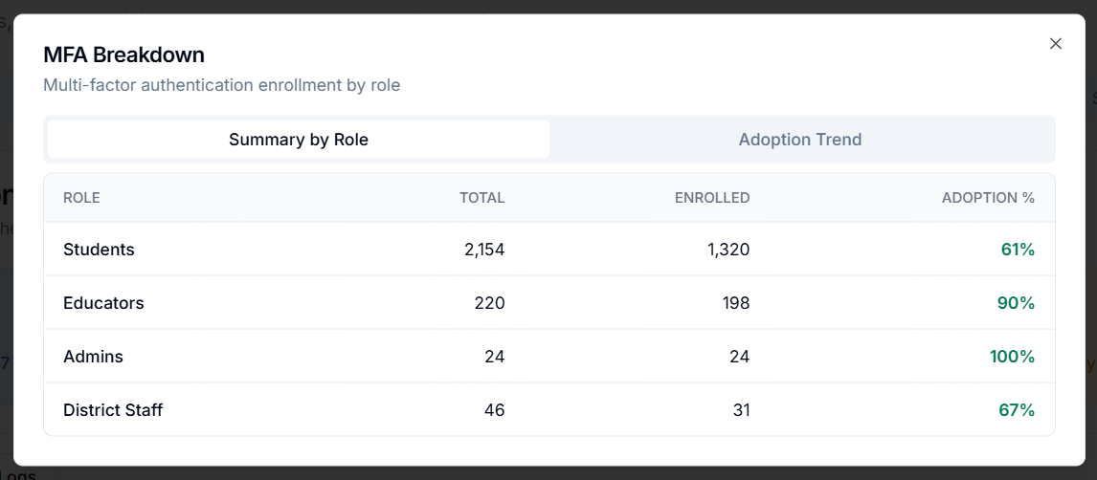
Summary by Role:
Field Name | Description | Validations | Success / Error Messages
Role | User role (Students, Educators, Admins, Staff). | Must match system-defined roles. | -
Total Users | Total number of users in that role. | Must be non-negative integer. | Error: "Invalid user count."
Enrolled | Number of users enrolled in MFA. | Must be ≤ Total Users. | Error: "Enrollment count invalid."
Adoption % | (Enrolled ÷ Total Users) × 100. | Value must auto-calc; valid 0–100%. | -
Adoption Trend:
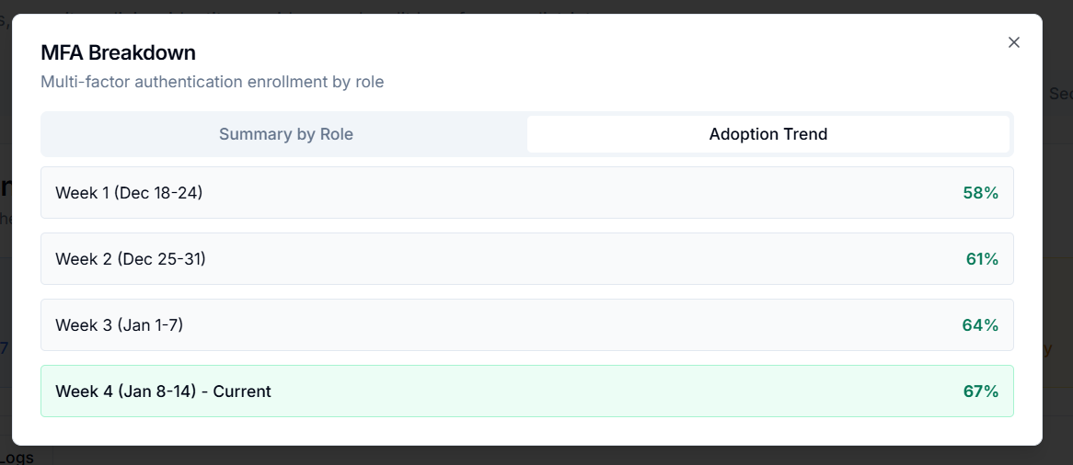
Field Name | Description | Validations | Success / Error Messages
Weekly Range (Week 1, Week 2, Week 3, etc.) | Displays MFA adoption for past weeks. | Requires historic MFA logs. | Error: "Unable to load adoption trend."
Adoption % | MFA enrollment percentage for that week. | Must be a valid integer 0–100%. | -

Suspicious Login Modal
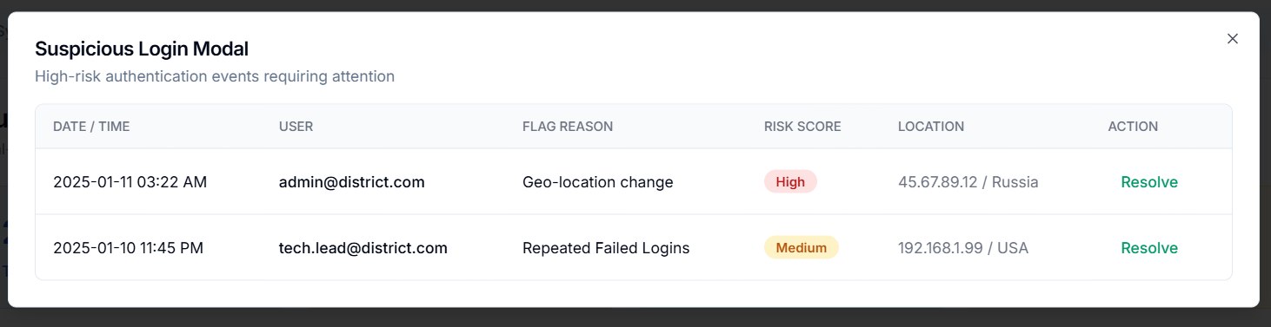

Security Alerts:

The Security Alerts tab inside Security Center provides a real-time view of all security-related events flagged by ScholarPath’s internal monitoring engine for the past 7 days.
Field Name | Description | Validations / Rules | Success / Error Messages
Date Range Dropdown | Allows filtering alerts by time window (7 days, 24 hours, custom). | Must select a valid predefined timeframe. | Success: Alerts refresh based on selected date range. Error: “Unable to load alerts for the selected date range.”
Severity Filter | Filters alerts by severity (Critical, Warning, Info). | Only one severity can be selected at a time. | Success: Table updates with matching alerts.
Status Filter | Filters alerts by Alert Status: Open / Resolved. | Valid statuses only. | Success: Alerts re-filtered by status.
Search Bar | Searches alerts by type, user, IP, or message. | Minimum 2 characters; ignores special characters. | Success: Alerts matching the search appear. Error: “No alerts match your search.”
Alert Type | Name of the detected security event (e.g., Multiple Failed Logins, Geo-Bypass Attempt). | Populated automatically from system logs. | -
Severity Badge | Classification of threat level: Critical, Warning. | Automatically assigned; cannot be edited. | -
User | Email of the user involved in the alert. | Must be a valid existing user in the district. | Error: “User not recognized.” (if user record missing)
IP Address | IP used for the login attempt or suspicious action. | Must be a valid IPv4/IPv6 format. | Error: “Invalid IP format.”
Detected (Date/Time) | Timestamp when the system detected the alert. | Auto-generated; must be valid UTC timestamp. | -
Status Badge | Current alert status: Open / Resolved. | Only system or admin actions can change status. | Success: Status updates when alert is resolved.
View Details (Action) | Opens a modal showing full event details and remediation steps. | Requires valid alert ID. | Error: “Unable to load alert details.”
Auto-Refresh Toggle | Automatically updates the alert list every 30 seconds. | ON/OFF toggle only. | Success: “Auto-refresh enabled.” Success: “Auto-refresh paused.”
Last Updated Timestamp | Shows time of last data refresh. | Auto-updated. | -

Audit Logs tab

The interface shown is a Security Center / Audit Logging System used to monitor authentication events, login attempts, suspicious access, MFA verification, and configuration changes across an organization (e.g., a school district).
It provides:
- Real-time Access Events (success, failed, suspicious, MFA)
- Audit & Logging Controls for system-wide authentication and configuration changes
- Search, filtering, exporting audit logs
- Event details such as user, IP address, action taken, and timestamps

Recent Access Events

Field Name | Description | Validations / Rules | Success / Error Messages
Event Type | Type of access event (Login Success, Login Failed, Suspicious Login, MFA Verified) | Must be one of predefined event categories | Success → “Success”; Failure → “Failed”; Suspicious → “Suspicious”
User | Email address of the user attempting access | Must be a valid email formatCannot be empty | Error → “Invalid user” or “User not found”
IP Address | IP address used during login attempt | Must be valid IPv4 format (e.g., 192.168.1.x) | Error → “Invalid IP address”
Time | Time elapsed since event occurred | Auto-generated timestamp | N/A
Status | Outcome of the event (Success, Failed, Suspicious) | Must match event result logic | Shows color-coded badges (Green = Success, Red = Failed, Yellow = Suspicious)

Audit & Logging Controls
Field Name | Description | Validations / Rules | Success / Error Messages
Total Login Events (7d) | Number of login events in last 7 days | Auto-calculated | N/A
Failed Attempts (7d) | Number of failed login attempts in last 7 days | Auto-calculated | N/A
Security Alerts (7d) | Number of triggered security alerts | Auto-calculated | N/A

Filters & Controls

Field Name | Description | Validations / Rules | Messages
Date Filter (e.g., 7 days) | Filters audit logs by time window | Must be one of predefined ranges (24h, 7d, 30d, custom) | N/A
Event Type Filter | Allows selecting event categories (Login, MFA, Config Change, etc.) | Must match available event types | N/A
Search Bar | Search by user, IP, event keyword | Requires minimum characters (usually 2+) | Error → “No results found”
Export Audit Logs | Downloads logs | File must generate properly | Success → “Audit logs exported”; Error → “Export failed”
View Security Events | Opens security alerts panel | N/A | N/A

Audit Log Table Fields

Field Name | Description | Validations / Rules | Success / Error Messages
Date / Time | Timestamp of the event | Auto-generated | N/A
Event Type | Type of event (Login Success, Config Change, Login Failed, Policy Update) | Must match event definitions | N/A
User | Email of the user who triggered event | Must be valid email format | Error → “Invalid user email”
IP Address | IP from which the event originated | Must be valid IPv4 | Error → “Invalid IP address”
Object Modified | The system object affected (SSO settings, MFA policy, etc.) | Can be empty (for login events) | N/A
Action | Description of what occurred (e.g., updated ID, invalid credentials) | Must correspond to event type | N/A
Details (View) | Button to view full event details | Must open event details page | Error → “Unable to load event details”

SSO Configuration

This screen allows districts to configure Google Workspace as their SSO provider for ScholarPath. Administrators must enter the Google OAuth credentials (Client ID, Client Secret, and Domain) and use the generated Redirect URI to register in Google Console. After configuration, administrators can test the connection and map user attributes from Google to ScholarPath.

Single Sign-On (SSO) Providers – Google Workspace

This screen allows districts to configure Google Workspace as their SSO provider for ScholarPath. Administrators must enter the Google OAuth credentials (Client ID, Client Secret, and Domain) and use the generated Redirect URI to register in Google Console. After configuration, administrators can test the connection and map user attributes from Google to ScholarPath.

Field Name | Description | Validations / Rules | Success / Error Message
Client ID | Google OAuth Client ID used for authentication | Mandatory field; must match Google Console | Error: “Client ID is required.”
Client Secret | Google OAuth Client Secret | Mandatory; hidden input | Error: “Client Secret is required.”
Domain | District’s Google domain (e.g., @district.k12.us) | Must be valid domain format | Error: “Invalid domain.”
Redirect URI | Callback URL to be added in Google Console | Auto-generated; read-only | Success: “Copied to clipboard.”
Test Connection | Button to check SSO connectivity | Requires all fields to be valid | Success: “Connection successful.” / Error: “Connection failed.”
Save Configuration | Saves the SSO settings | All fields must be filled | Success: “Configuration saved successfully.” / Error: “Unable to save configuration.”

Single Sign-On (SSO) Providers - ClassLink

This screen is used to configure ClassLink as the district's SSO provider. Similar to Google, this requires entering ClassLink credentials and registering the Redirect URI in ClassLink's console. Attribute mapping is handled the same way
Field Name | Description | Validations / Rules | Success / Error Message
Client ID | ClassLink issued Client ID | Required | Error: “Client ID is required.”
Client Secret | Secret key used for ClassLink authentication | Required | Error: “Client Secret is required.”
Domain | District domain | Should be in domain format | Error: “Invalid domain.”
Redirect URI | Callback URL to register in ClassLink | Auto-generated; read-only | Success: “Copied to clipboard.”
Test Connection | Tests ClassLink SSO connection | Requires all required fields | Success: “Connection successful.” / Error: “Connection failed.”
Save Configuration | Saves settings | Requires valid inputs | Success: “Configuration saved.” / Error: “Failed to save configuration.”

Single Sign-On (SSO) Providers – Clever

This configuration screen allows districts to set up Clever as their SSO identity provider. Admins enter Clever Client ID and Secret, then register the provided redirect URI with Clever. Attribute mapping ensures correct user provisioning.

Field Name | Description | Validations / Rules | Success / Error Message
Client ID | Clever OAuth Client ID | Required | Error: “Client ID is required.”
Client Secret | Clever OAuth secret key | Required | Error: “Client Secret is required.”
Domain | District domain | Must match valid format | Error: “Invalid domain.”
Redirect URI | Clever callback URL | Auto-generated | Success: “Copied to clipboard.”
Test Connection | Tests Clever connectivity | Requires all inputs valid | Success: “Connection successful.” / Error: “Connection failed.”
Save Configuration | Saves Clever setup | Validations must pass | Success: “Configuration saved.” / Error: “Failed to save configuration.”

Single Sign-On (SSO) Providers – EdLink

This screen is for districts using Edlink as their SSO provider. Similar to others, administrators provide credentials, domain, and use attribute mappings to align user data between Edlink and ScholarPath.

Field Name | Description | Validations / Rules | Success / Error Message
Client ID | Edlink SSO Client ID | Required | Error: “Client ID is required.”
Client Secret | Edlink SSO Secret Key | Required | Error: “Client Secret is required.”
Domain | District domain | Must be valid domain format | Error: “Invalid domain.”
Redirect URI | Edlink callback URL | Auto-generated; read-only | Success: “Copied to clipboard.”
Test Connection | Verifies SSO integration | Requires valid fields | Success: “Connection successful.” / Error: “Connection failed.”
Save Configuration | Saves settings | All inputs validated | Success: “Configuration saved.” / Error: “Unable to save configuration.”

Single Sign-On (SSO) Providers – Generic SAML 2.0

This screen is used for any identity provider that supports SAML 2.0. Administrators must enter the Entity ID, SAML Metadata XML, and use the given Redirect URI as the callback. Attribute mapping ensures user identity synchronization.

Field Name | Description | Validations / Rules | Success / Error Message
Entity ID | Unique SAML provider identifier | Required | Error: “Entity ID is required.”
Metadata XML | SAML provider metadata (XML format) | Must be valid XML | Error: “Invalid SAML metadata.”
Redirect URI | SAML callback URL | Auto-generated; read-only | Success: “Copied to clipboard.”
Test Connection | Checks SAML authentication | Requires valid Entity ID and XML | Success: “Connection successful.” / Error: “SAML connection failed.”
Save Configuration | Saves SAML setup | All validation checks must pass | Success: “Configuration saved.” / Error: “Failed to save configuration.”

5.4 Security Policies - District Security Policies

The Security Center allows district administrators to manage authentication and access-control rules.
It includes password rules, MFA enforcement, session timeout, and geo-restrictions.
The main policies can be configured through the Configure Policies button which opens the settings modal.

Field Name | Description | Validations / Rules | Success Message | Error Message
Password Rules | Shows current password rule settings (8+ chars, upper/lowercase, number) | Read-only indicator on this screen | N/A | N/A
MFA Enforcement | Displays whether MFA is enabled for all admin accounts | Read-only indicator | N/A | N/A
Session Timeout | Current session timeout duration (e.g., 30 minutes) | Read-only indicator | N/A | N/A
Geo-Restriction | Shows if geo-restriction is enabled/disabled | Read-only indicator | N/A | N/A
Edit Button | Opens configuration screen for the selected policy | Must navigate successfully to modal | “Policy loaded successfully” | “Unable to load policy settings”
Configure Policies (Button) | Opens the combined configuration modal | Requires user permission | “Policies loaded” | “Failed to open configuration settings”

Field Name | Description | Validations / Rules | Success Message | Error Message
Enable MFA (Toggle) | Allows enabling/disabling MFA requirement for all admin accounts | Toggles ON/OFF; Requires admin privileges | “MFA has been enabled successfully” | “Failed to update MFA settings”
Auto-logout Timeout (minutes) | Value after which session expires due to inactivity | - Numeric only- Allowed range: 5–120 minutes | “Timeout updated successfully” | “Enter a valid timeout (5–120 minutes)”
Geo-Restriction (Toggle) | Restricts login to specific IP ranges | Must have defined IP ranges when enabled | “Geo-restriction enabled” | “Cannot enable without specifying IP ranges”
Save Policies (Button) | Saves all updated configurations | All validations must pass | “Security policies updated successfully” | “Unable to save changes. Fix highlighted errors.”
Cancel (Button) | Closes modal without saving | No rules | N/A | N/A

5.4 Access Monitoring
    - It displays real-time logs of all user access activities (login attempts, system access, failures, and suspicious logins) to help administrators monitor security events.
    - Lists all recent access attempts in chronological order with key information such as user, IP, time, and status.
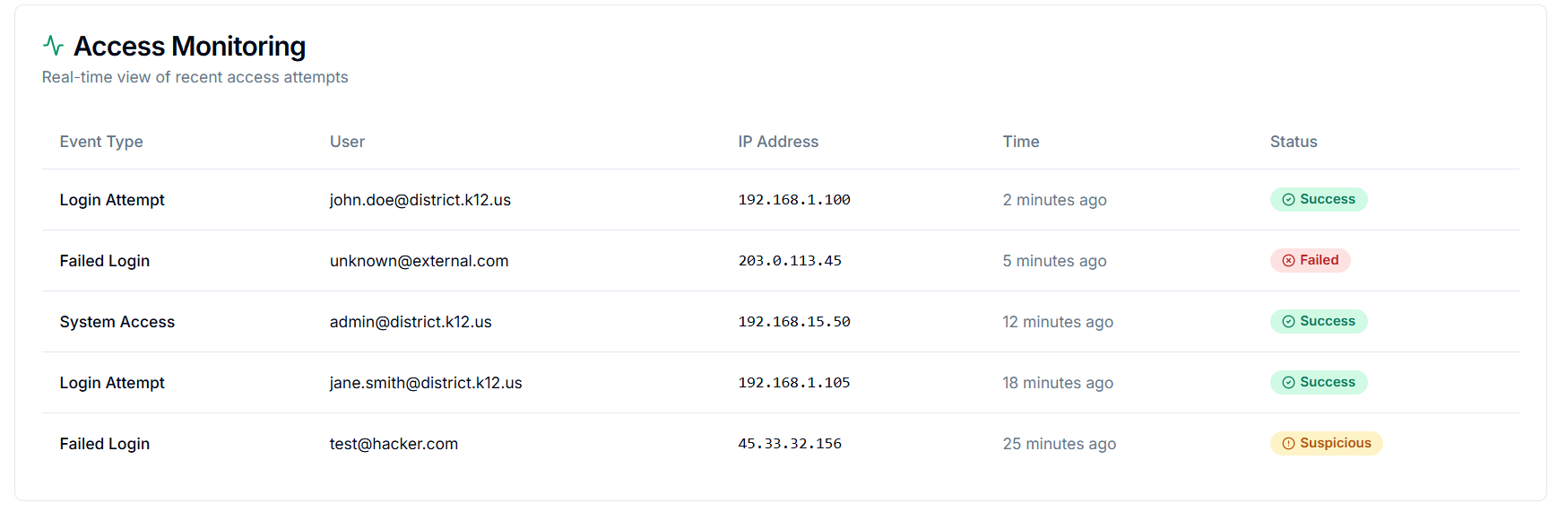
Field / Section | Description / Purpose | Validations / Rules | Error / Success Messages
Section Header – Access Monitoring | Displays a real-time view of recent user access attempts, including successful, failed, and suspicious logins. | - Must fetch the latest 100 entries by default.  - Auto-refresh every 1 minute.- Data must be sorted by time (most recent first).- Only authorized admins can view this section.  -Applied filters must not exclude failed or suspicious events.  - All IPs and timestamps must match the audit database. | Error: “Unable to load access logs. Please refresh.”  Error: “Access denied. You don’t have permission to view logs.”  Empty State: “No access attempts recorded yet. Logs will appear here in real time.”
Event Type (Column) | Displays the type of access event such as Login Attempt, Failed Login, or System Access. | - Must map directly to audit system event types.  - Event type cannot be null or blank.  - Unrecognized types should display as ‘Unknown Event’  .- Each type must have consistent color and icon mapping.  - Filters must correctly group event types. | Error: “Invalid event type received from the server.”  Empty State: “No access events found for the selected time range.”
User (Column) | Displays the email address of the user associated with the access attempt. | - Must display valid email format (name@domain.com).  - If user not found, display “Unknown User”.  - Emails must match registered user records.  - Should not expose masked or temporary IDs.  - No duplicate user records for the same event ID. | Error: “Invalid or missing user identifier.”  Empty State: “User information unavailable.”
IP Address (Column) | Shows the originating IP address of each access attempt. | - Must be a valid IPv4 or IPv6 address.  - Cannot be empty or null.- Internal (192.x / 10.x) IPs marked as “Internal Network.”  - Suspicious IPs flagged through geolocation lookup.  - Display masked format for privacy (e.g., 192.168.x.xxx). | Error: “Invalid IP address format.”  Error: “Unable to resolve IP location.”  Empty State: “No IP data available for this event.”
Time (Column) | Displays when the access event occurred, using a relative timestamp (e.g., 2 minutes ago). | - Time must auto-update dynamically.  - Must use system UTC, adjusted for local time.  - Must handle delayed or future timestamps gracefully.  - Auto-refresh with each new entry  .- Display “Now” for events under 1 minute old. | Error: “Invalid timestamp format.”  Empty State: “Timestamp unavailable.”
Status (Column) | Shows the outcome of each event - Success, Failed, or Suspicious - using color-coded badges. | - Status must come from predefined system list (Success, Failed, Suspicious).  - Color mapping: Green = Success, Red = Failed, Yellow = Suspicious.  - Null/unknown values default to “Pending”.  - Suspicious events must trigger alert notification.  - Failed events must increase failed-login counter. | Error: “Invalid or missing event status.”  Empty State: “No status available.”
Auto-Refresh Functionality | Refreshes the access logs every 1 minute with new entries from the audit log. | - Auto-refresh must not interrupt ongoing filters or sorting.  - API polling every 60 seconds.  - Must maintain scroll position and pagination. | Error: “Auto-refresh failed. Retrying…”  Success: “Access logs updated.”
Backend Synchronization | Connects with the audit database to fetch the latest access events. | - Must validate IP, user, timestamp, and event type consistency.  - Data retrieval in batches of 100.  - API response within 3 seconds. | Error: “Audit log sync failed. Try again later.”
Filtering & Sorting (Implicit Behavior) | Admins can filter events by type, user, or time range (future enhancement). | - Filters must not exclude failed/suspicious records.  - Sorting defaults to descending order by time.  - Combined filters allowed. | Error: “Invalid filter parameters.”

6. Notification & Settings
Allows District Tech Leads to configure alerts, preferences, notification recipients, compliance automation, and team-level access controls within the district’s ScholarPath account.

6.1 System Alerts & Notification Preferences
Allows the District Tech Lead to configure which automated system alerts they want to receive.
This includes:
- SIS Data Sync Alerts
- FTP/SFTP Health Alerts
- Security Alerts
- Compliance Alerts
- Delivery Channel settings (Email, SMS, Push Notifications)
Each alert type is controlled via toggle switches. Critical alerts cannot be fully disabled.
A. SIS Data Sync Alerts
Field Name | Description | Options | Validations / Messages
Nightly Sync Success | Toggle to receive a success alert for the nightly batch | On/Off | None
Nightly Sync Failed | Toggle for complete batch failure alerts | On/Off | Critical Alert → Cannot be disabled
Nightly Sync Completed with Errors | Alerts when some files fail | On/Off | None
courses — File Errors | Toggles alerts for file-level errors | On/Off | None
district_schools — File Errors | Same | On/Off | None
parent_information — File Errors | Same | On/Off | None
student_historic — File Errors | Same | On/Off | None
student_information — File Errors | Same | On/Off | None
student_schedule — File Errors | Same | On/Off | None
teacher_information — File Errors | Same | On/Off | None
teacher_schedule — File Errors | Same | On/Off | None
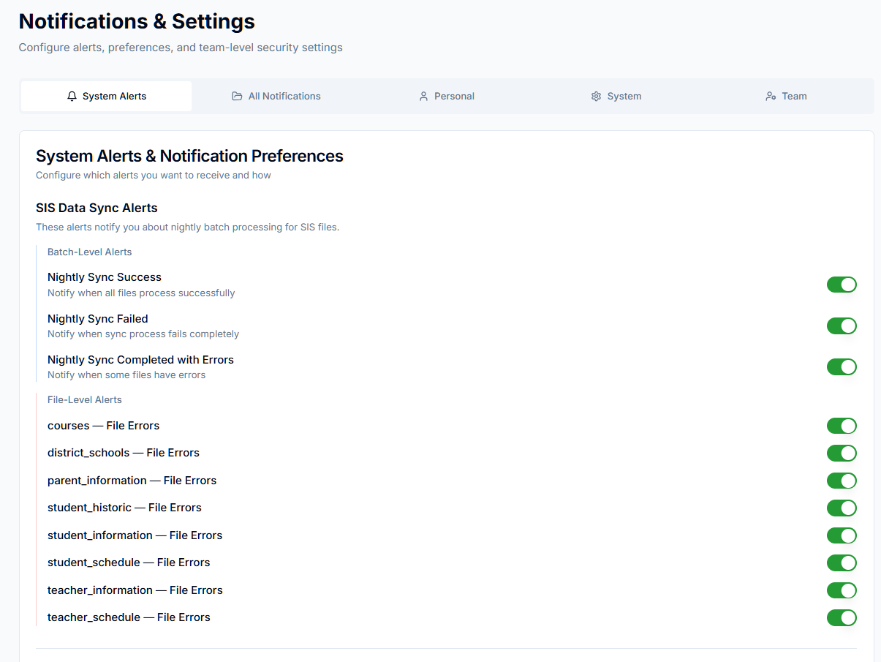
Figure 23: SIS Data Sync Alerts
B. FTP/SFTP Health Alerts
Field Name | Description | Options | Messages
FTP Connection Failure | Alerts when system cannot reach FTP server | On/Off | None
Authentication Error | Invalid credentials or permissions | On/Off | None
File Missing in FTP Directory | Required SIS file missing | On/Off | None
Folder Path Not Found | Configured directory missing | On/Off | None
File Drop Missing During Sync Window | No uploads found | On/Off | None
C. Security Alerts
Field Name | Description | Options | Validations / Messages
Failed Login Attempts | Alerts for repeated failures | On/Off | None
Suspicious Login Activity | Alerts for anomalies | On/Off | Critical Alert → Cannot be disabled
Security Policy Changes | Alerts for MFA/password/policy updates | On/Off | None
System State Changes | Alerts for pauses/resumes in system state | On/Off | None
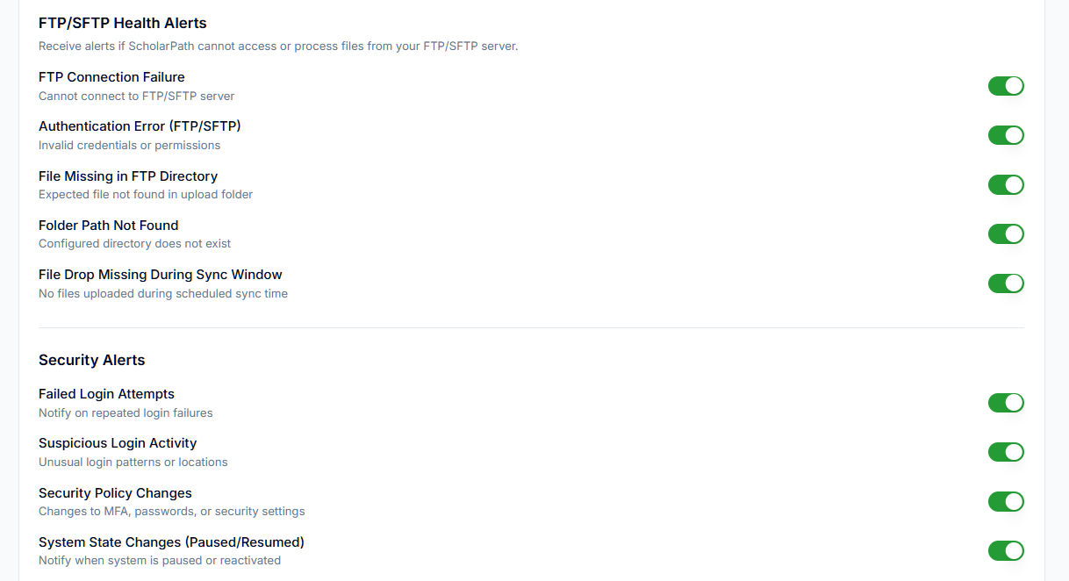
D. Compliance Alerts
Field Name | Description | Options | Messages
Document Expiry Alerts | Warns of upcoming document expirations | On/Off | None
Pending Review Notifications | Alerts for documents awaiting admin approval | On/Off | None
District Compliance Summary (Daily) | Daily digest of compliance state | On/Off | None

E. Delivery Channels
Field Name | Description | Options | Validations
Email | Default delivery channel | Checkbox | Cannot be turned OFF for critical alerts
SMS | Optional channel if phone verified | Checkbox | “Phone number required for SMS.”
Push Notifications | In-app real-time alerts | Checkbox | None
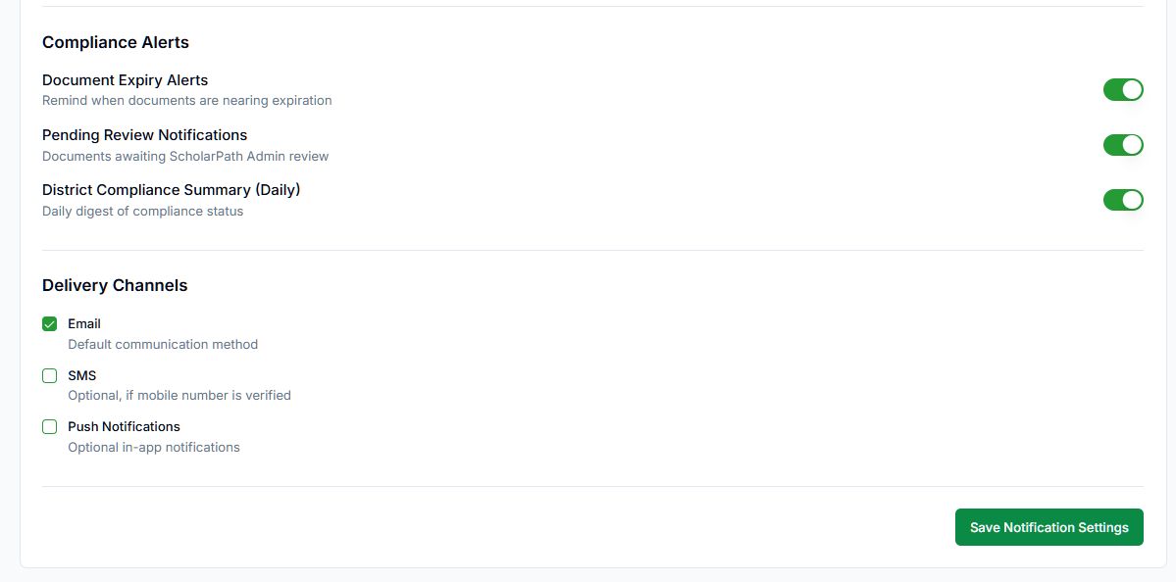
Actions:
Button | Functionality
Save Notification Settings | Saves all toggles and delivery preferences.  Shows Success Toast: “Notification settings updated.”

6.2 All Notifications
Shows a unified timeline of all system alerts triggered for the district.
Includes powerful filtering:
- Category
- Time Range
- Status (Read, Unread, Resolved)
- Keyword Search
Each notification provides actions:
- Mark as Read
- Resolve
- Open Source
Field Name | Description | Options | Validations / Messages
Category Filter | Shows only a selected category | All, File Errors, SIS Sync, FTP/SFTP, Security, Compliance | None
Time Range Filter | Limits timeframe | Last 7, 30, 90 Days | None
Status Filter | Filters by state | All, Unread, Read, Resolved | None
Search | Keyword search (file name, message, type) | N/A | None
Notification Row | Data entry showing date, category, message | N/A | None
Mark as Read | Mark the item as read | N/A | Success: “Notification marked as read”
Resolve | Marks as Resolved | N/A | Success: “Notification resolved”
Open Source | Deep link to source area | N/A | Error if missing: “Source data not available.”
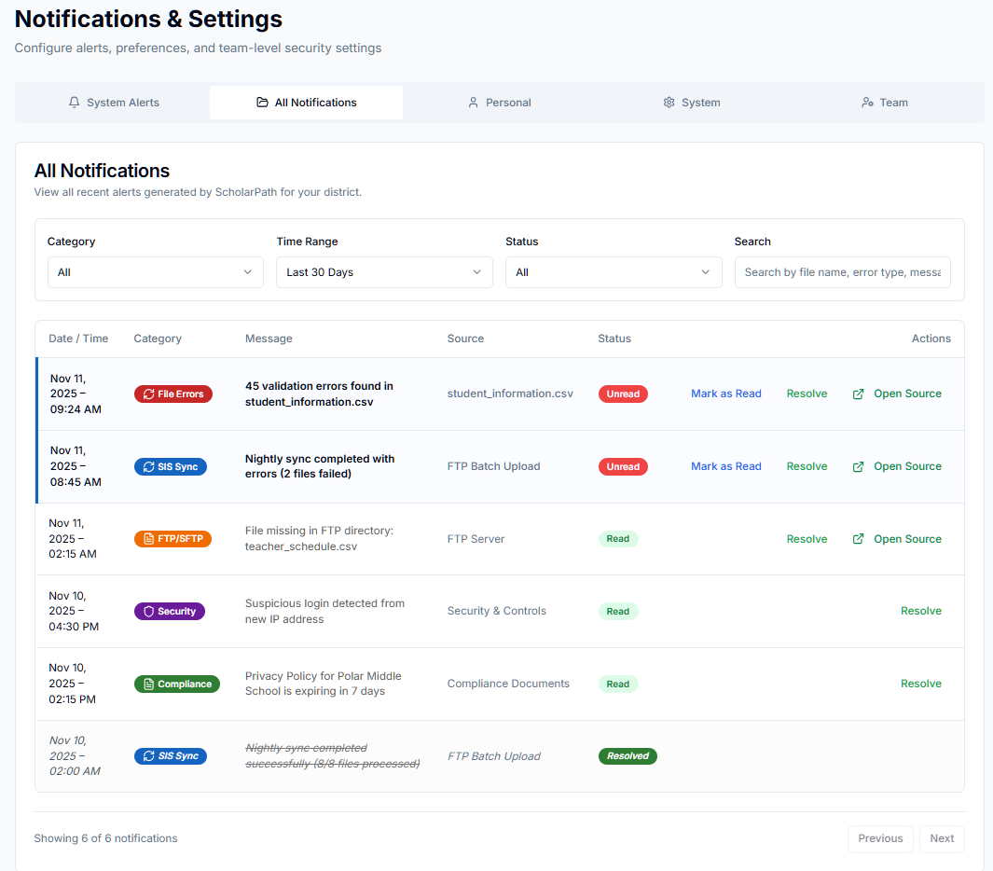
Figure 24: All Notifications
Button | Behavior
Export | Downloads file: District_Notifications_<timestamp>.csv
Mark as Read | Changes item to Read state
Resolve | Sets item state to Resolved (item stays visible)
Open Source | Opens screen + filters + modals automatically

6.3 Personal Settings
Allows the logged-in District Tech Lead to manage their account and security settings.
- Account Information: Displays the user’s Name, Email (with “Verified” badge), and optional phone number.
- Edit Profile – opens editable user info modal.
- Change Password – triggers password update flow.
- Manage MFA Devices – opens MFA management window.
Field / Element | Description / Behavior | Validations / Success / Error Messages
Account Information | Displays the user’s Name, Email (with “Verified” badge), and optional Phone number.
Edit Profile Button | Opens an editable form for Name and Phone. | ✅ “Profile updated successfully.”
Change Password Button | Opens secure password update modal. | ✅ “Password changed successfully.”
Manage MFA Devices Button | Opens MFA management to register, reset, or remove authentication devices. | ✅ “MFA settings updated.”

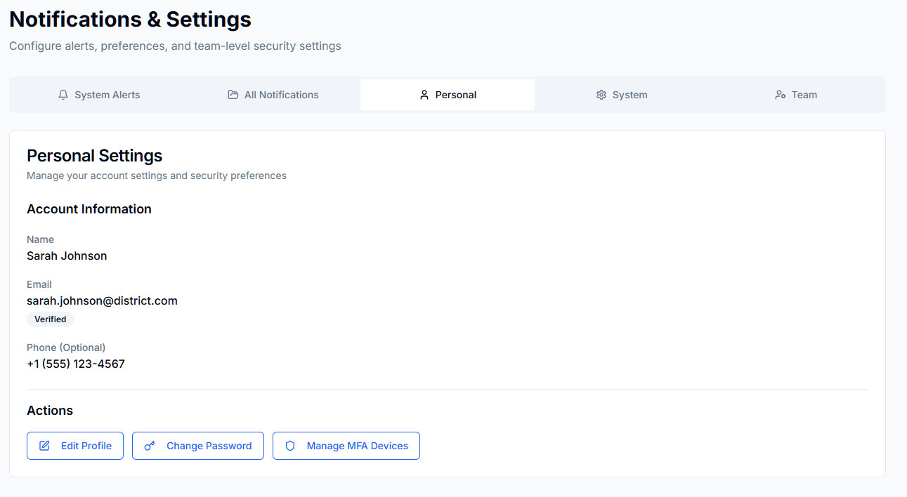

6.4 System Preferences
Allows configuration of district-level operational policies:
- Data Retention
- Auto-Archive
- Daily Sync Summary Emails
- Weekly Audit Log Exports
- FTP Health Monitoring
Field Name | Description | Options | Validations / Messages
Data Retention Policy | How long logs are kept | 1 Year, 3 Years, 5 Years | None
Auto-Archive Logs | Archives logs older than retention | On/Off | None
Daily Sync Summary Email | Daily summary of SIS sync | On/Off | None
Auto-Export Weekly Audit Logs | Exports weekly logs automatically | On/Off | None
FTP Health Monitoring | Tracks FTP/SFTP uptime | On/Off | None

Button | Behavior
Save Preferences | Saves all changes;  Success Toast: “System preferences updated successfully.”

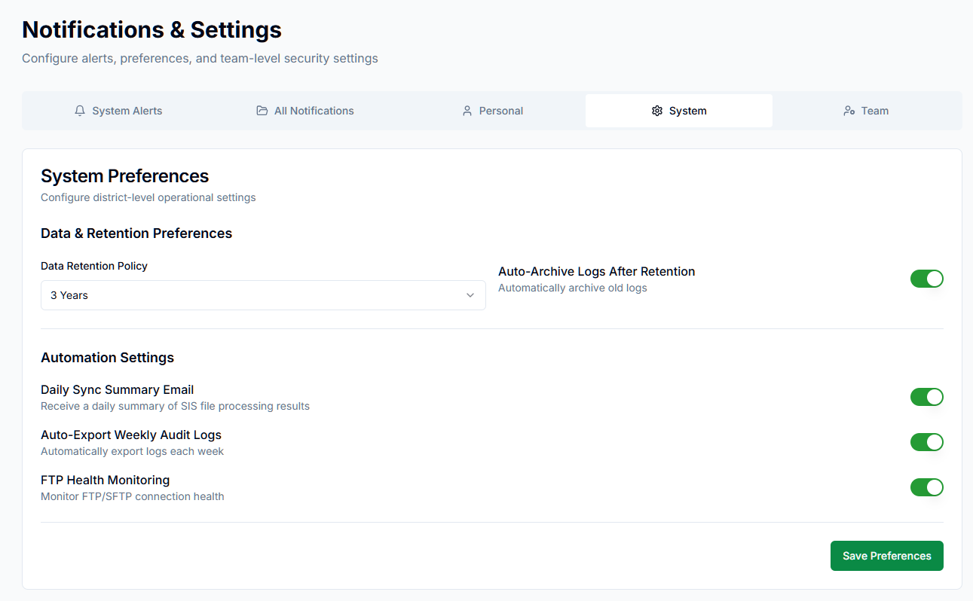
Figure 25: System Preferences

6.5 District Tech Team
- Manage district team members, roles, access levels, and team notification policies.
- Includes:
- Name
- Email
- Role
- Permissions
- Last Login
- Status
- Actions (Deactivate)
Field Name | Description | Options | Validations / Messages
Name | Member name | N/A | None
Email | Team member email | N/A | None
Role | District Tech Lead, Assistant Tech Lead | N/A | None
Permissions | Permission chips | N/A | None
Last Login | Timestamp | N/A | None
Status | Active / Inactive | N/A | None
Deactivate | Deactivate user | N/A | Confirmation: “Deactivate team member?”

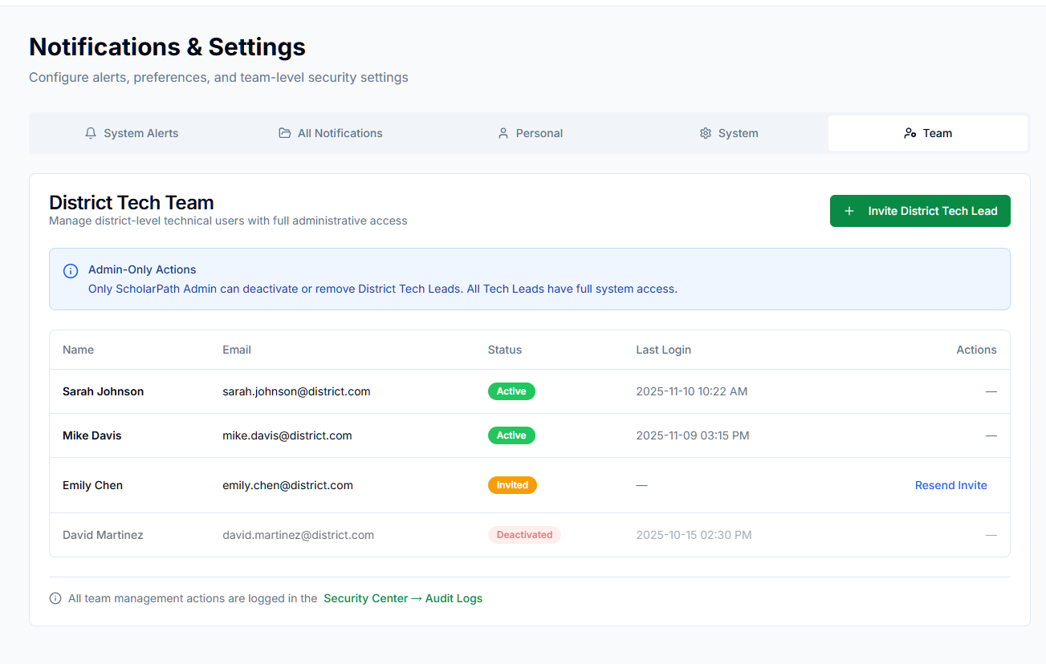
Figure 26: District Tech Team

Invite New Member
Opens Invite New Team Member modal.
Field / Control | Description | Validations / Success / Error Messages
Name | Full name of invitee. | ⚠️ “Name is required.”
Email | Email to send invitation. | ⚠️ “Enter valid email.”
Send Invitation Button | Sends an email with an activation link. | ✅ “Invitation sent successfully.”  ❌ “Unable to send invitation. Try again.”
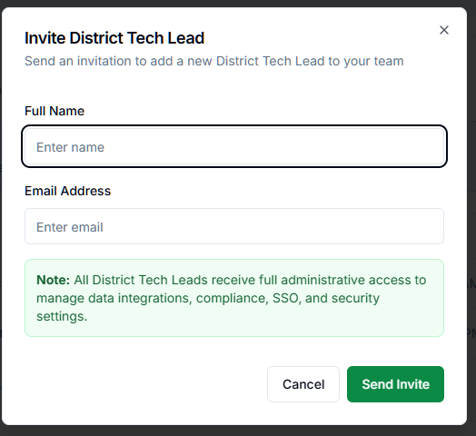
Figure 27: Invite District Tech Lead

Behavior: Sends an invitation email with an account activation link.

