# Sheet1 Ex3

## d)

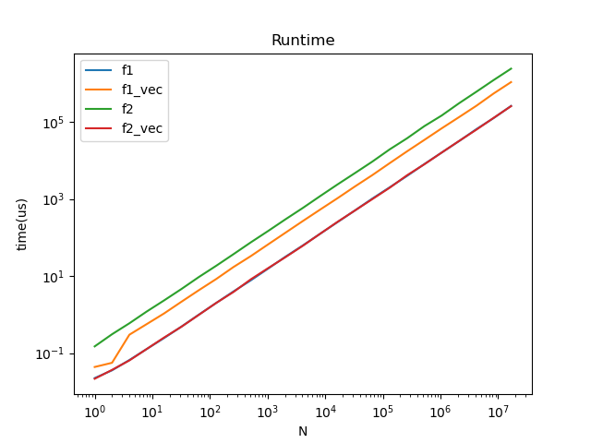

The vectorized version is implemented by using VCL::Vec4d.

F1 in the graph means the first function f(x) = x^3−2x^2+3x-1, f2 means the sum of x^i. The blue line(f1) is almost fully covered by the red line(f2_vec).

For f1, the regular version is faster than the vectorized version. This might because the number of operations per integration is too small, so that the cost of vectorization is higher than the benefit.

For f2, the vectorized version is much faster than the regular version.

## e)

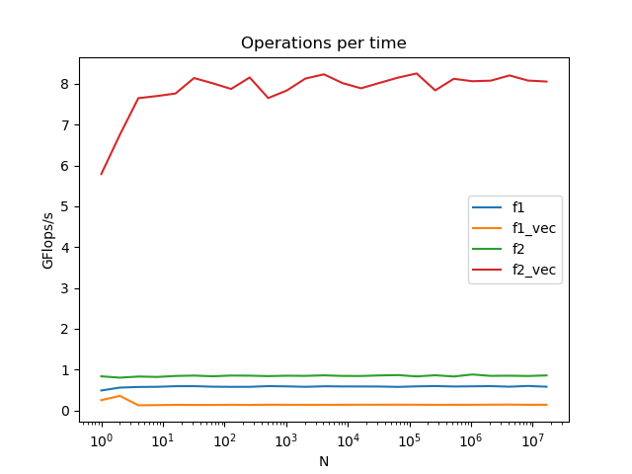

We estimate the number of operations per integration for f1 and f2 by:

ops_f1 = n * 8 + 3 + (n - 1)

ops_f2 = n * 122 + 3 + (n - 1)

The f1 regular version has higher operations per time than the vectorized version.

The f2 vectorized version has significantly higher operations per time than the regular version.

The tricky thing of estimating the number of operations is that we don’t know how many operations it really takes for a vectorized version when doing pow operation. We just estimate that it takes n-1 times of multiplication to calculate x to the power of n.