 **Web and Mobile Application**

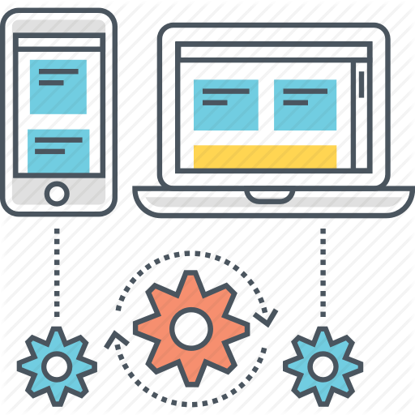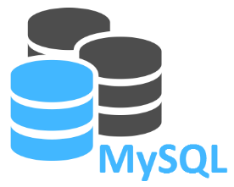

**- Derivation**

**- Load**

**- Replication**

**- Filtering**

**- Data Capture**

**- Cleansing**

**- Profiling**

**- Migration**

**- Merging**

**Calendar Database**

 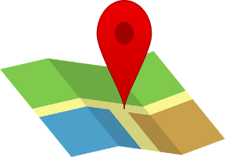

**SMS Geolocation Tracker and**

**Notification Map Route**