**3G Power**

Czarina Bacit

Carla Mabutol

Gleanne Simbanan

**Prototype Web Version**

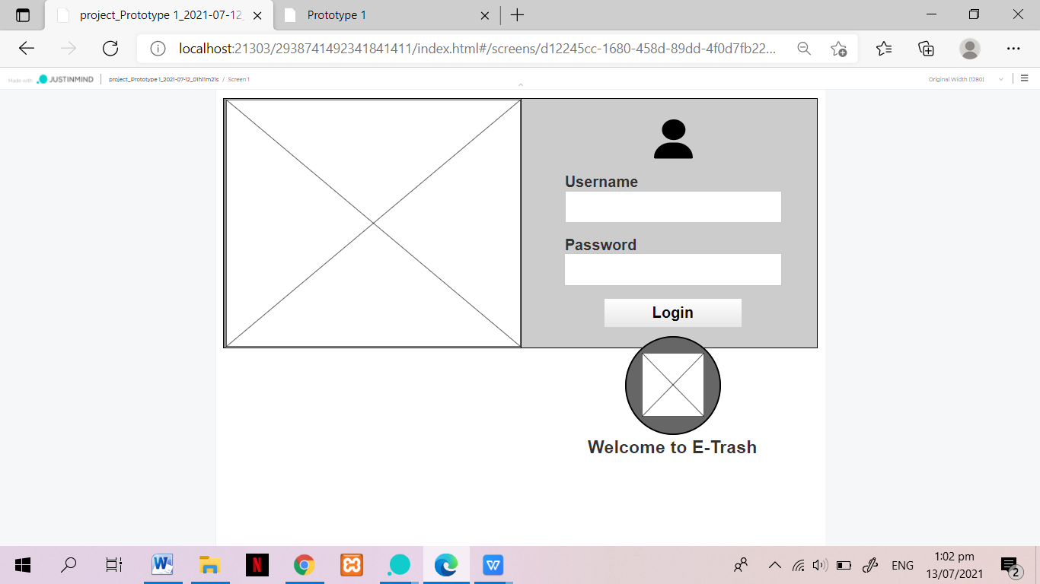

**Fig 1. Admin Login Page**

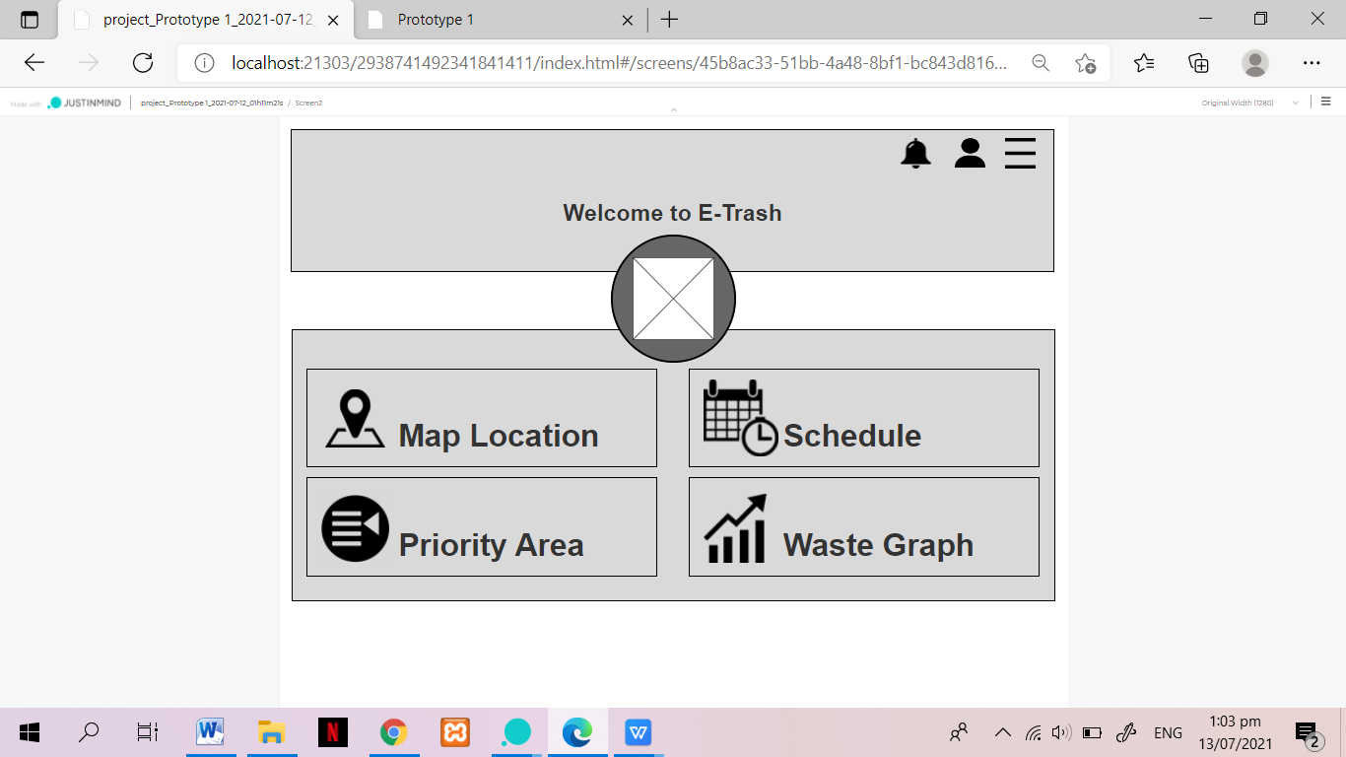

**Fig 2. Admin Main Page**

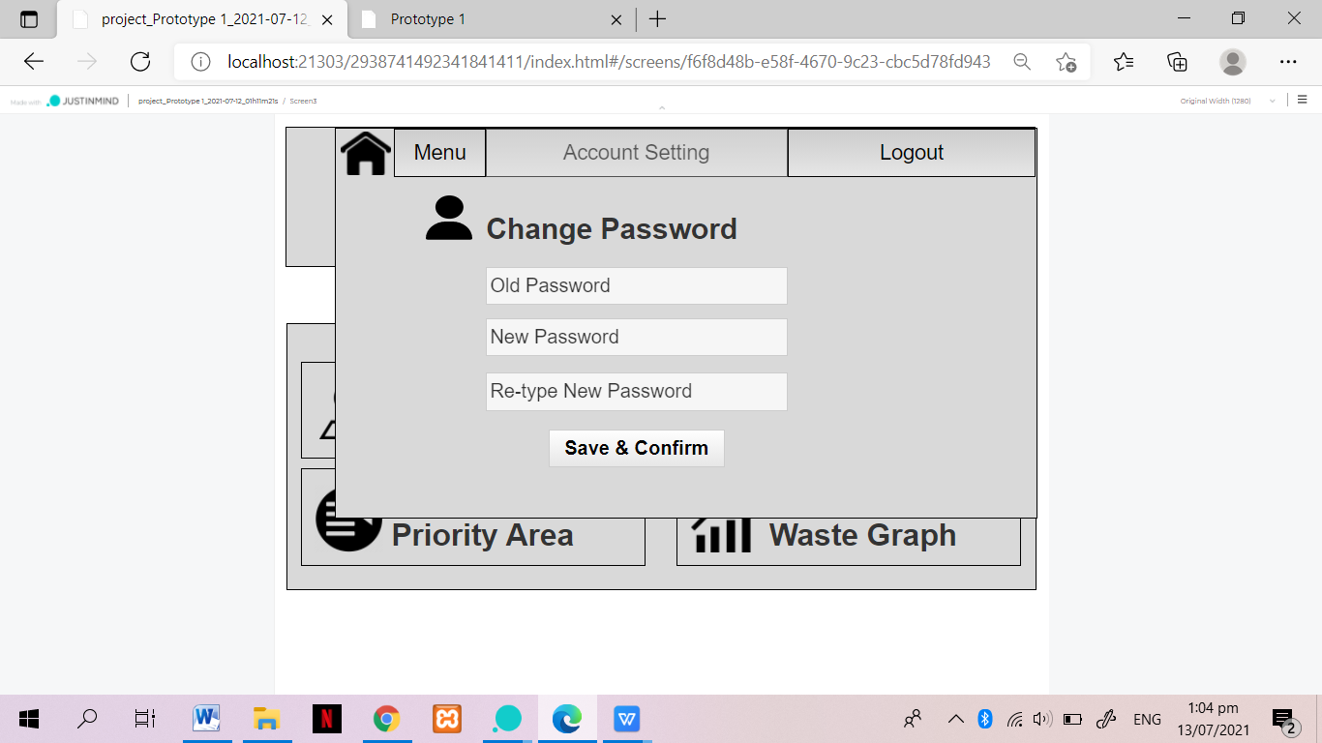

**Fig 3. Admin Menu Account Setting Page**

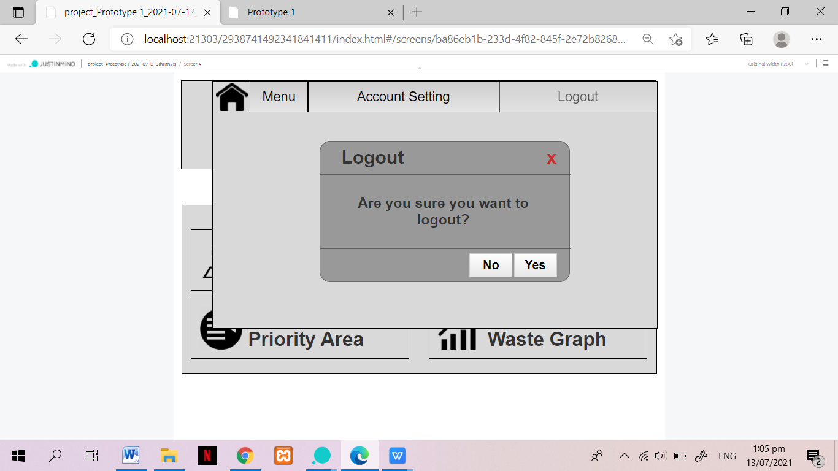

**Fig 4. Admin Menu Logout Page**

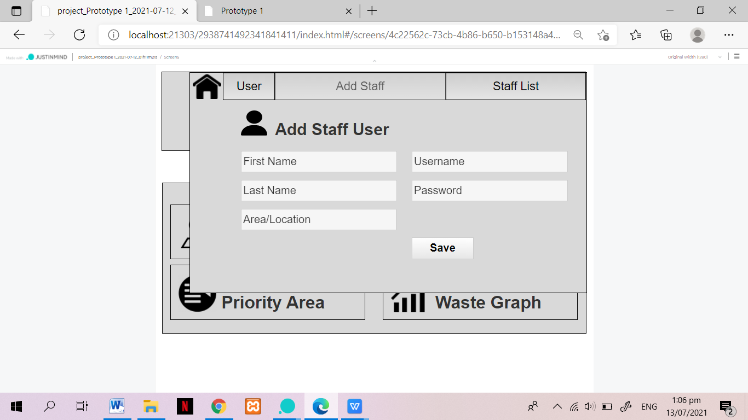

**Fig 5. Admin User Add Staff Page**

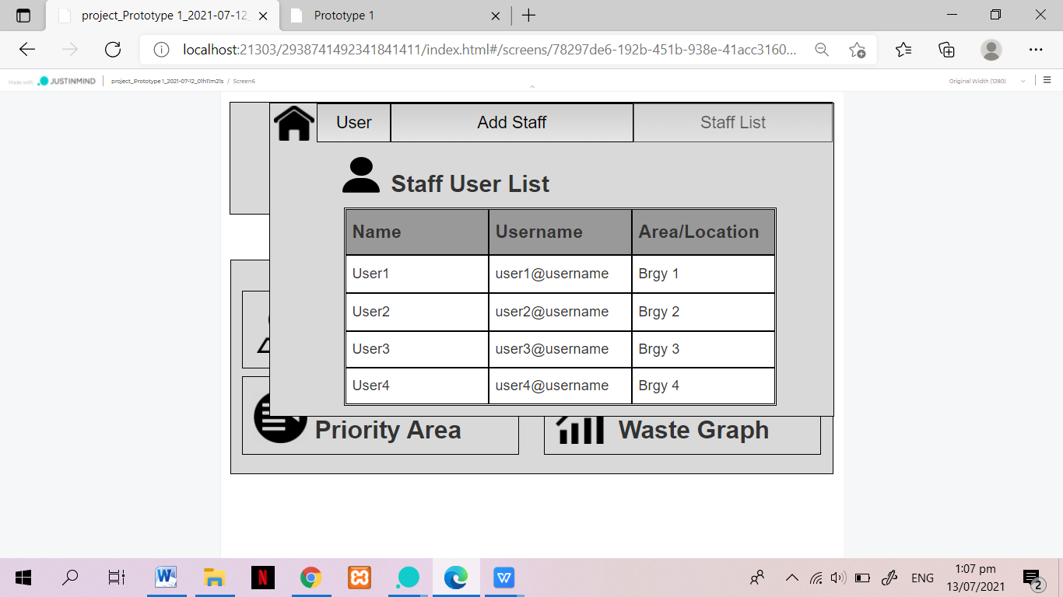

**Fig 6. Admin User Staff List Page**

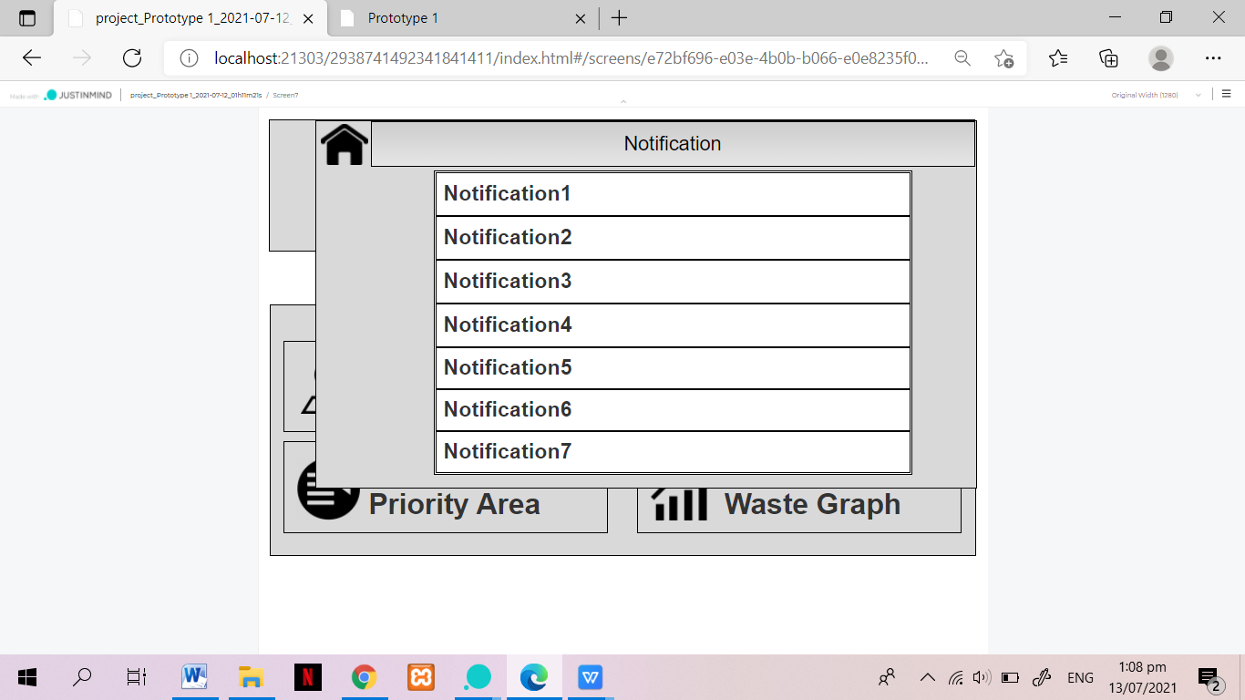

**Fig 7. Admin Notification Page**

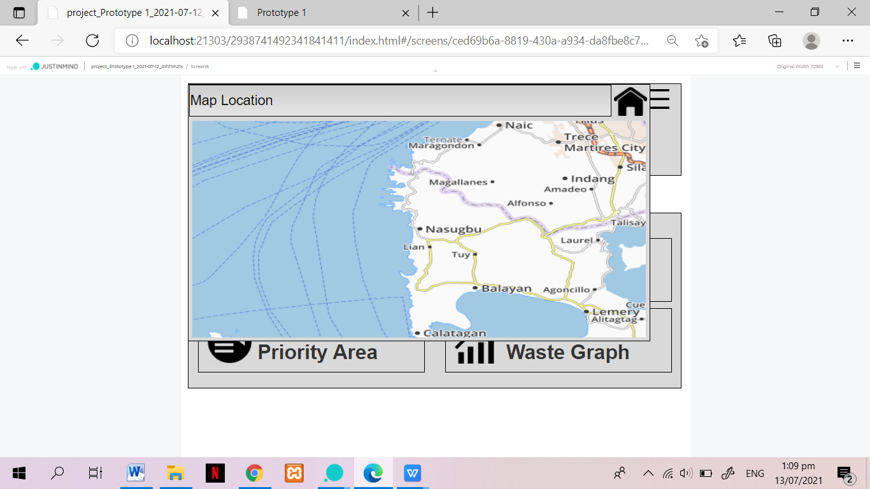

**Fig 8. Admin Map Location Page**

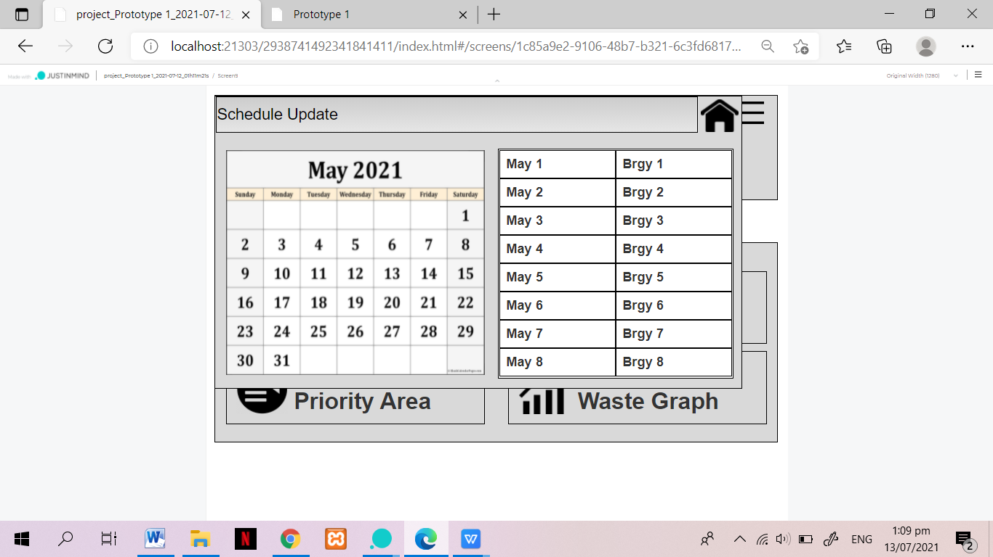

**Fig 9. Admin Schedule Update Page**

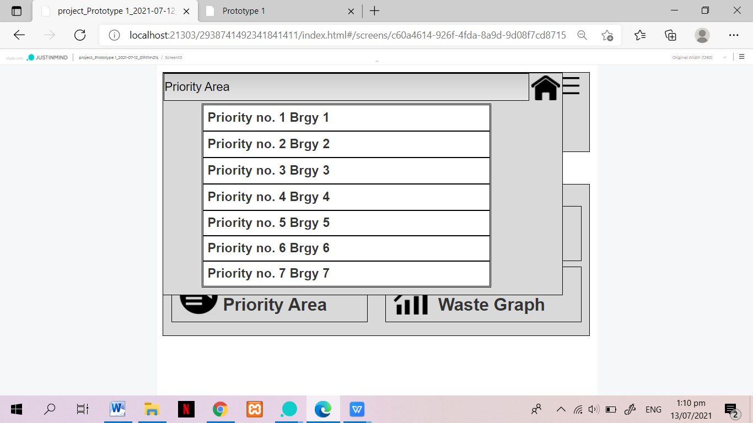

**Fig 10. Admin Priority Area Page**

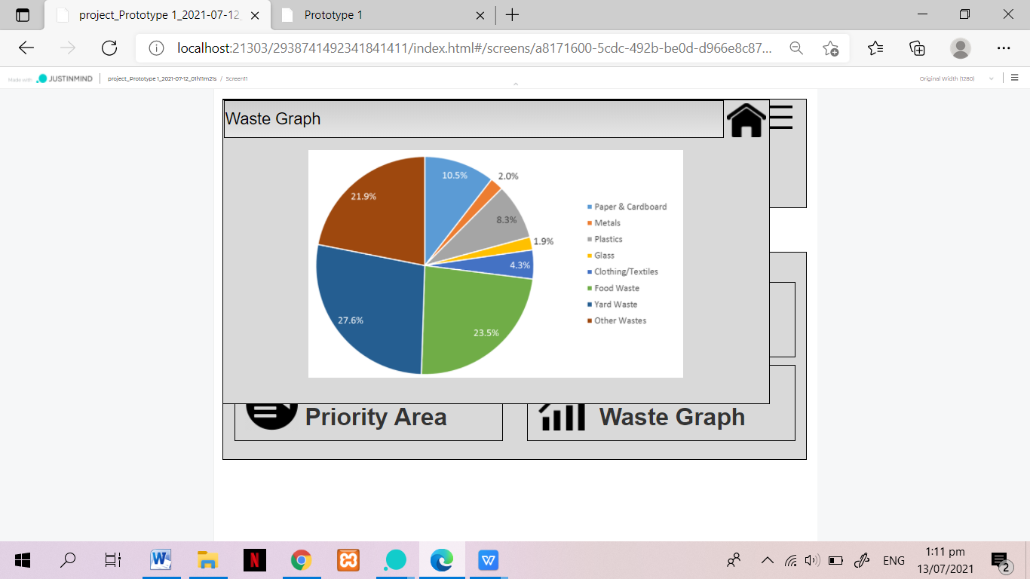

**Fig 11. Admin Waste Graph Page**

**Prototype Mobile Version**

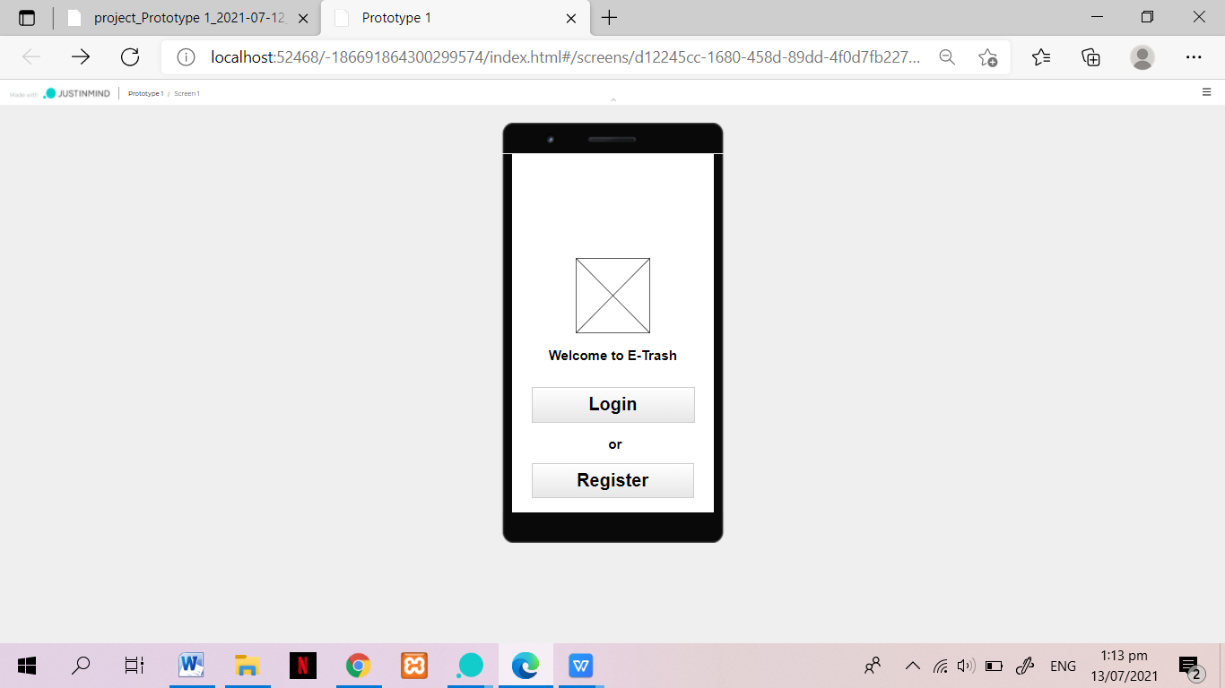

**Fig 12. User Front Page**

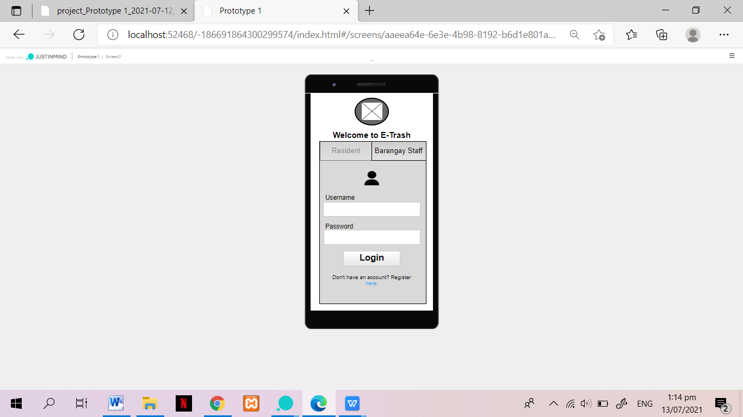

**Fig 13. Resident Login Page**

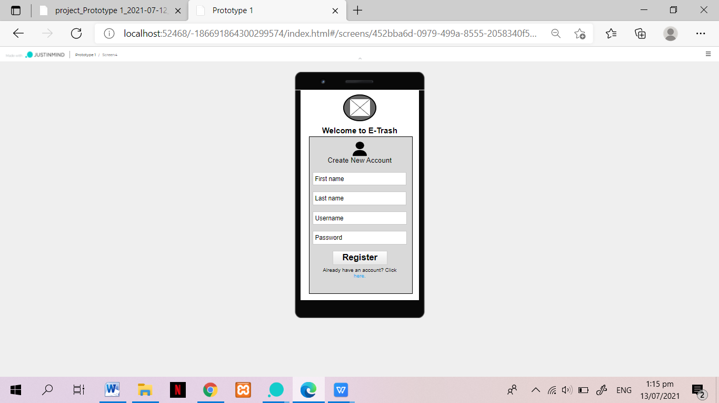

**Fig 14. Resident Register Page**

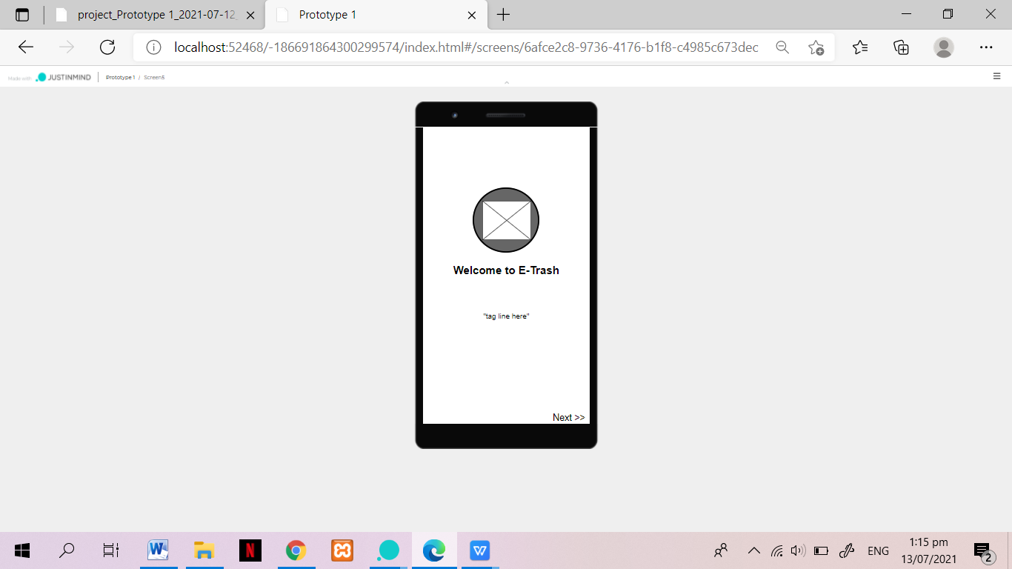

**Fig 15. Resident Welcome Page**

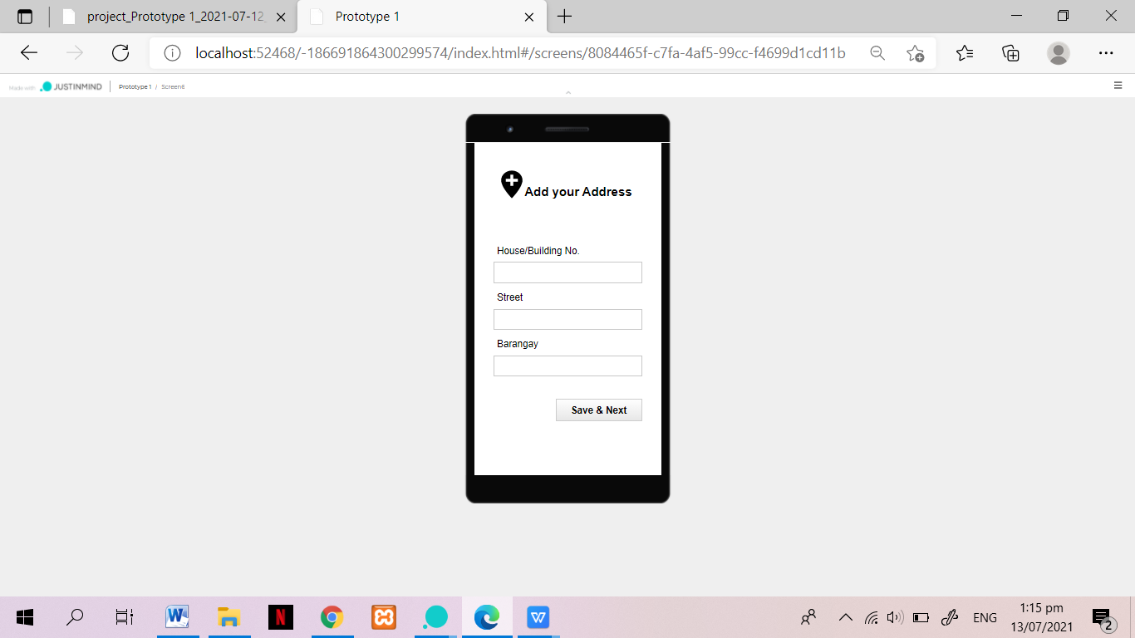

**Fig 16. Resident Input Address Page**

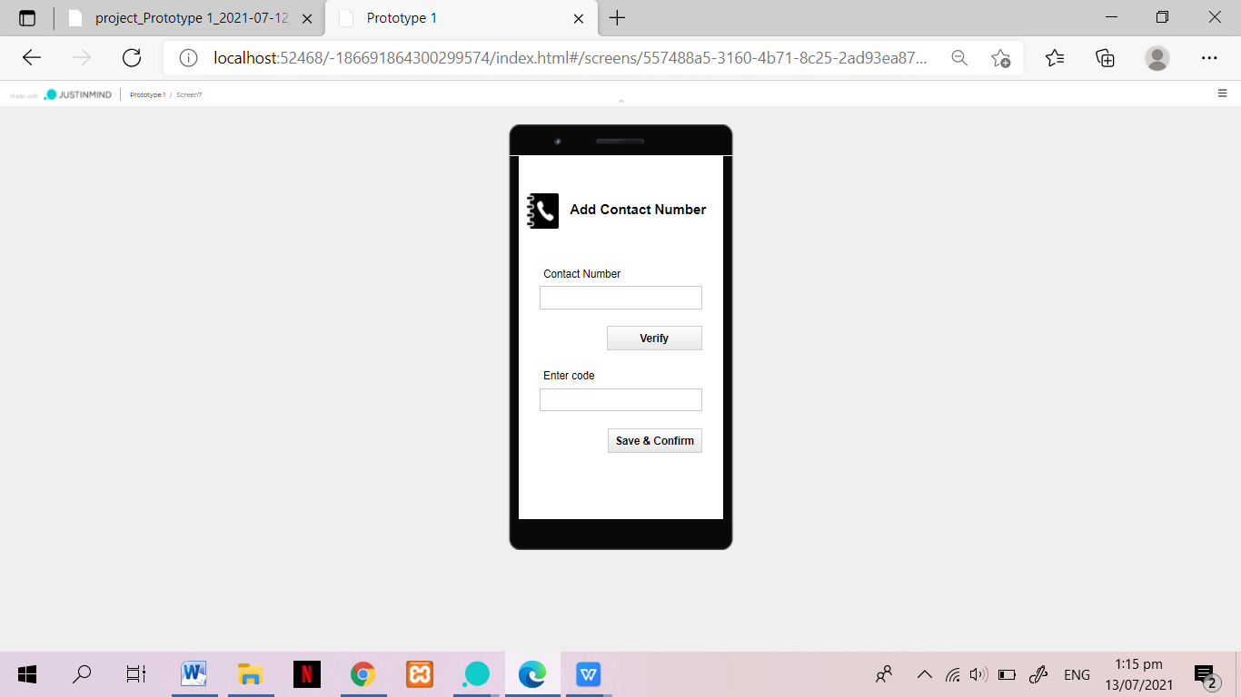

**Fig 17. Resident Input Contact Number Page**

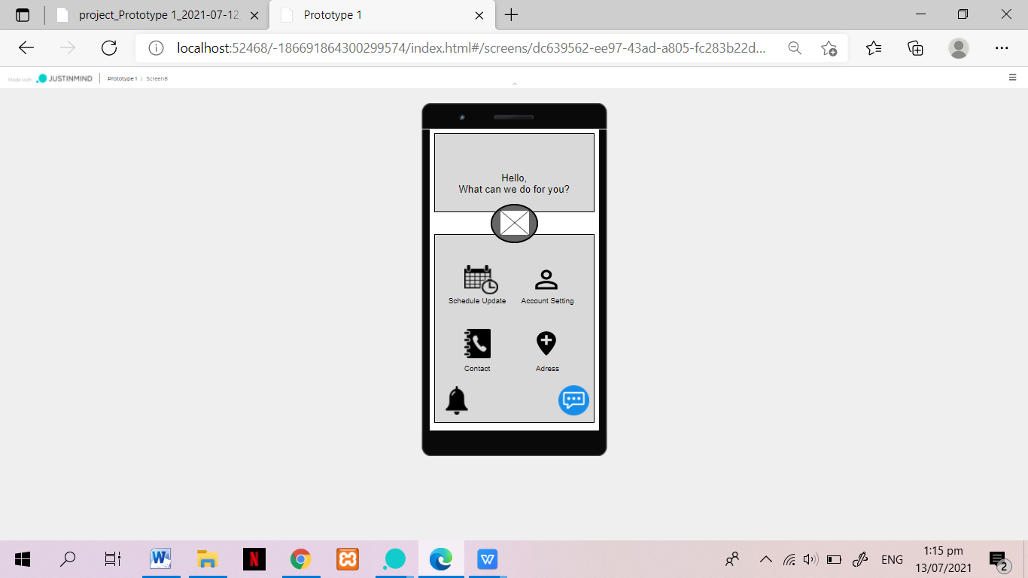

**Fig 18. Resident Main Page**

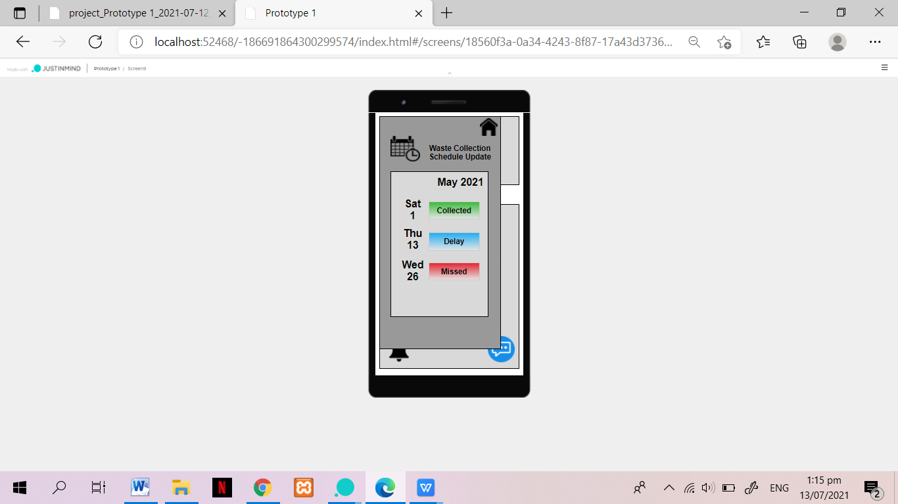

**Fig 19. Resident Schedule Update Page**

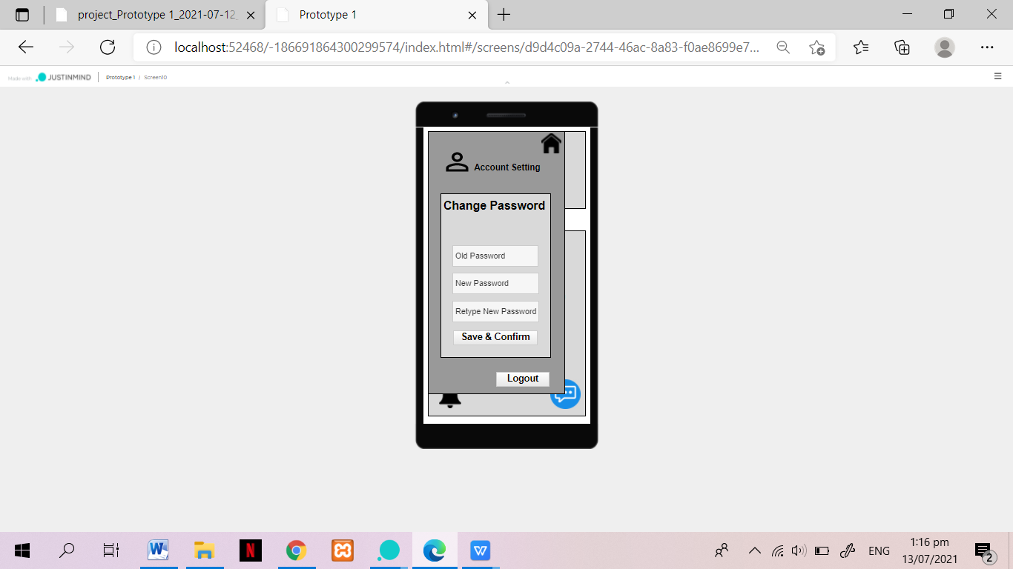

**Fig 20. Resident Account Setting Page**

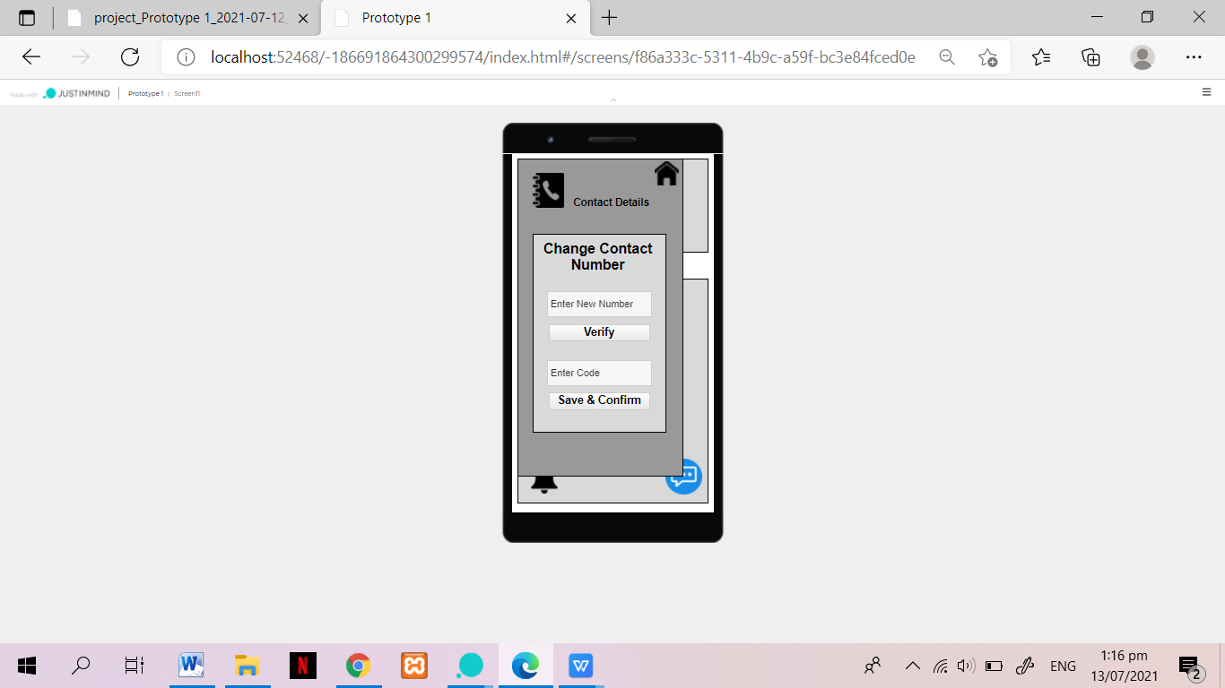

**Fig 21. Resident Change Contact Detail Page**

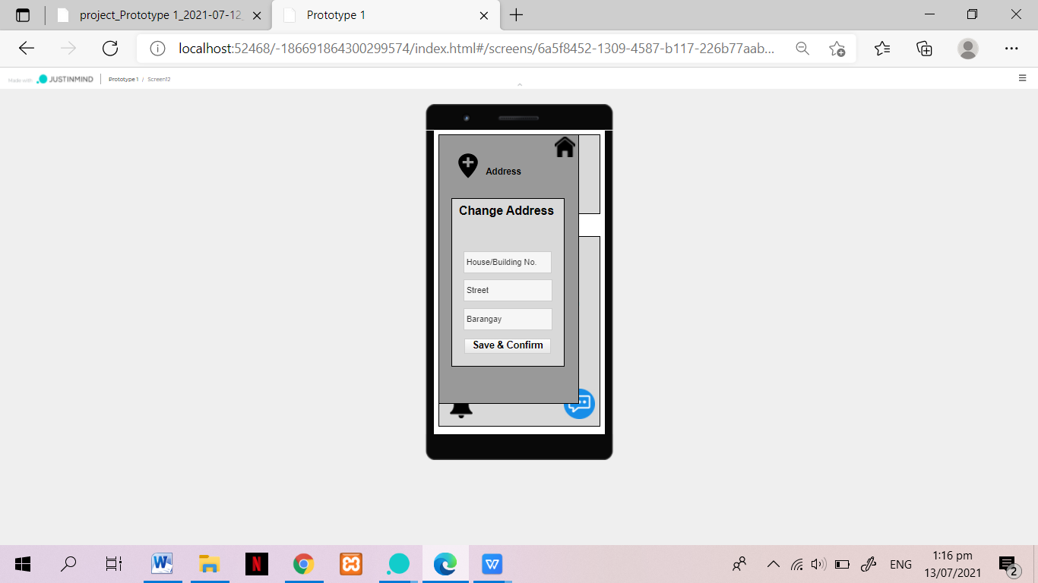

**Fig 22. Resident Change Address Page**

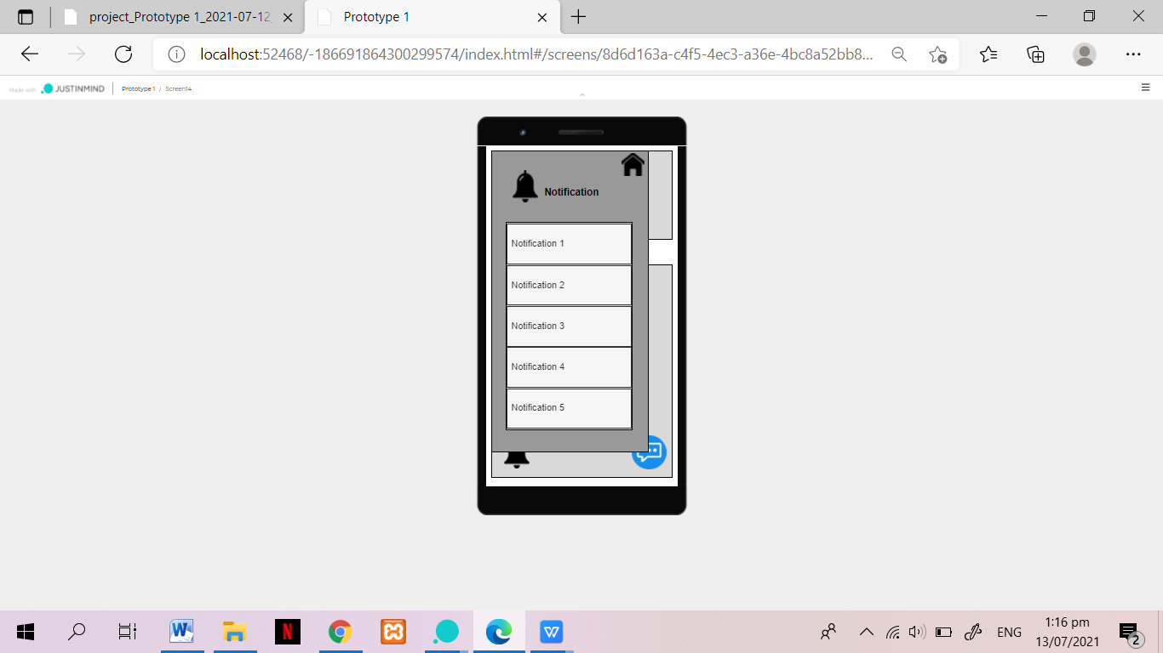

**Fig 23. Resident Notification Page**

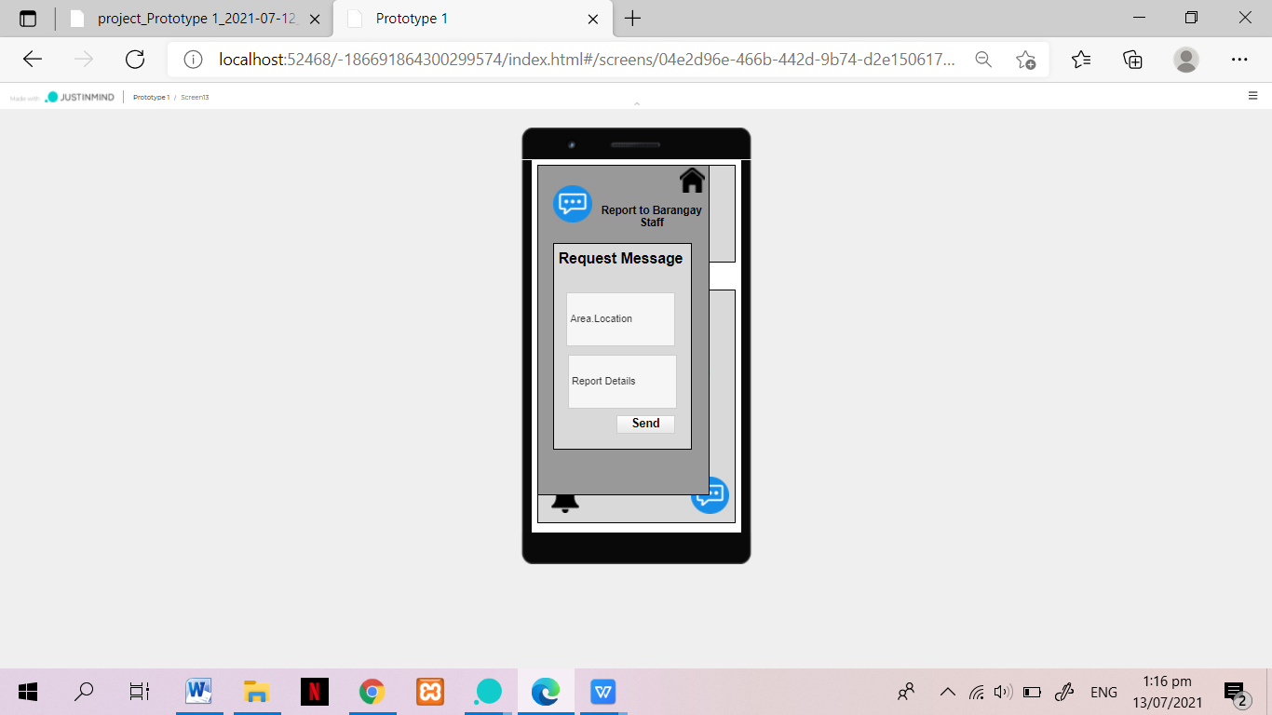

**Fig 24. Resident Report Request Message Page**

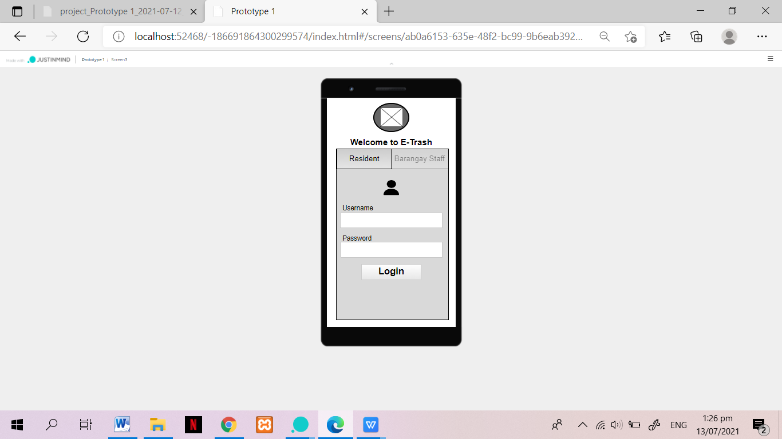

**Fig 25. Staff Login Page**

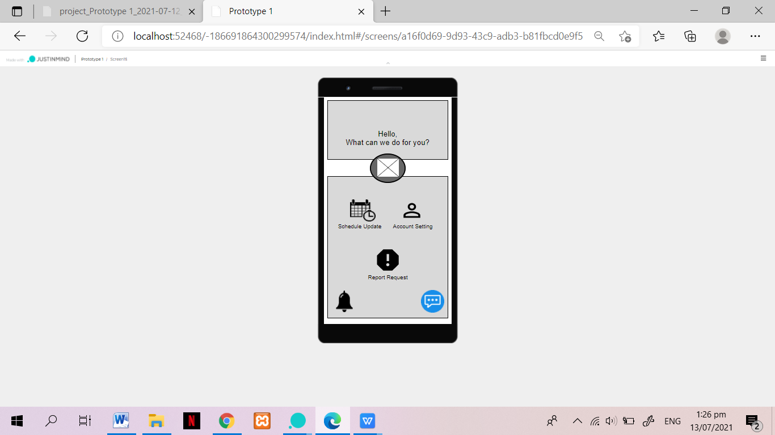

**Fig 26. Staff Main Menu Page**

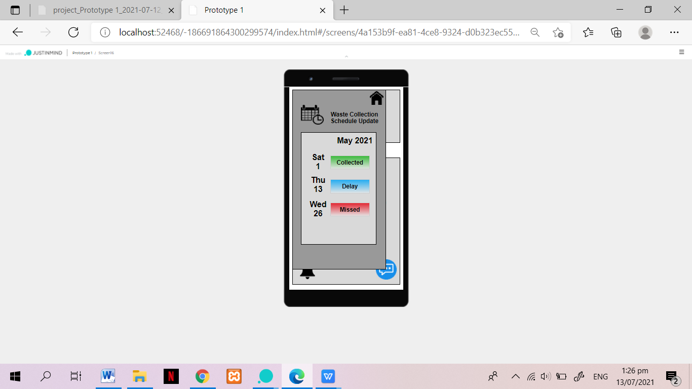

**Fig 27. Staff Schedule Update Page**

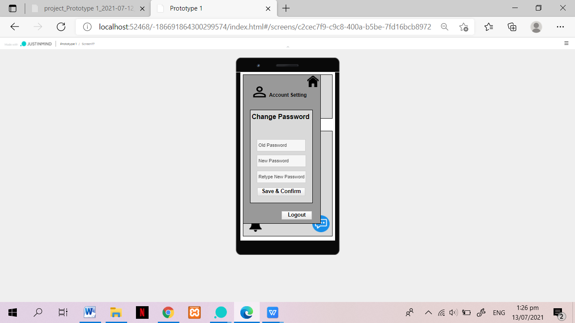

**Fig 28. Staff Account Setting Page**

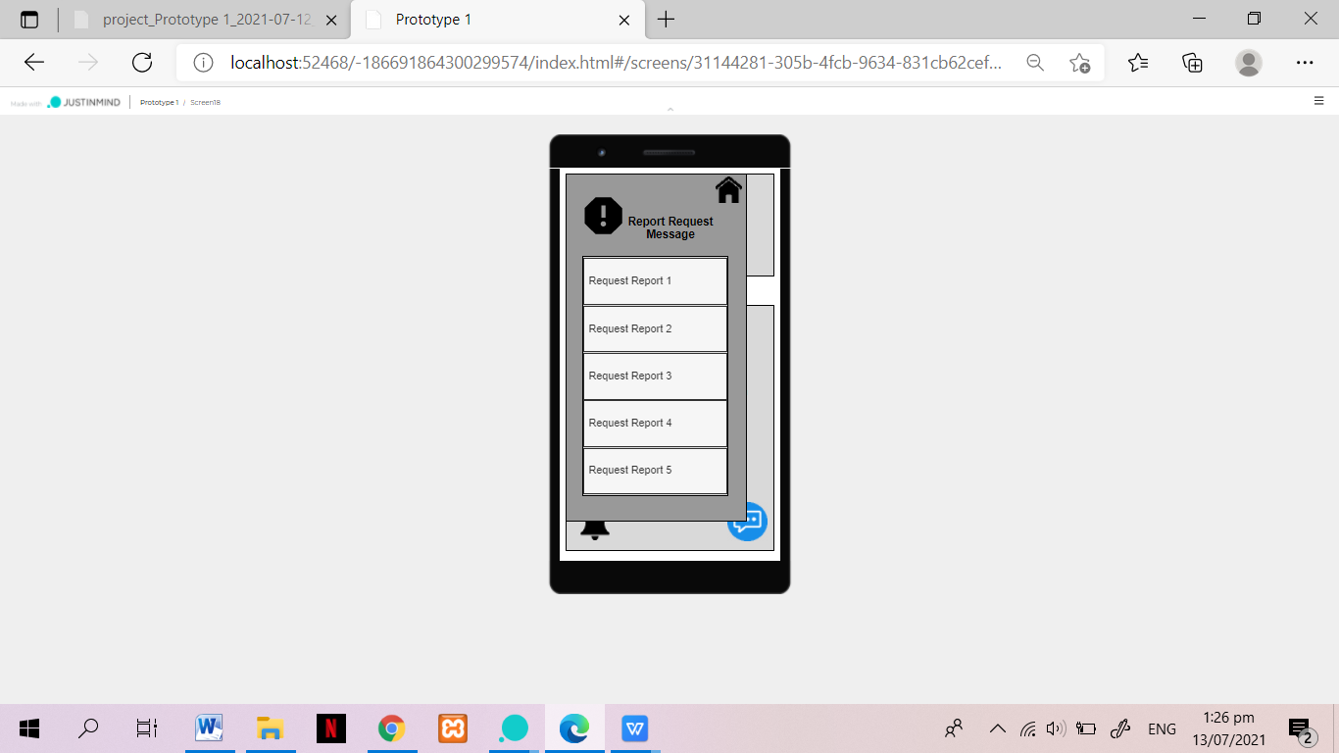

**Fig 29. Staff Report Request Message Page**

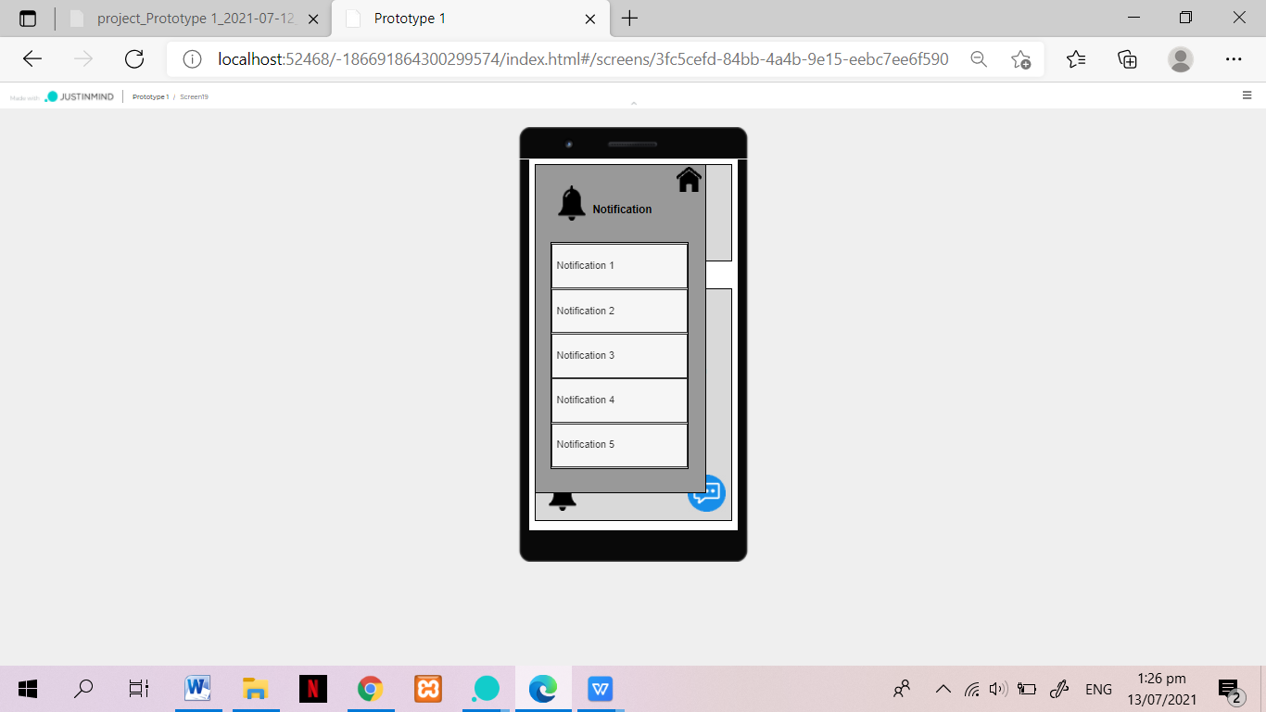

**Fig 30. Staff Notification Page**

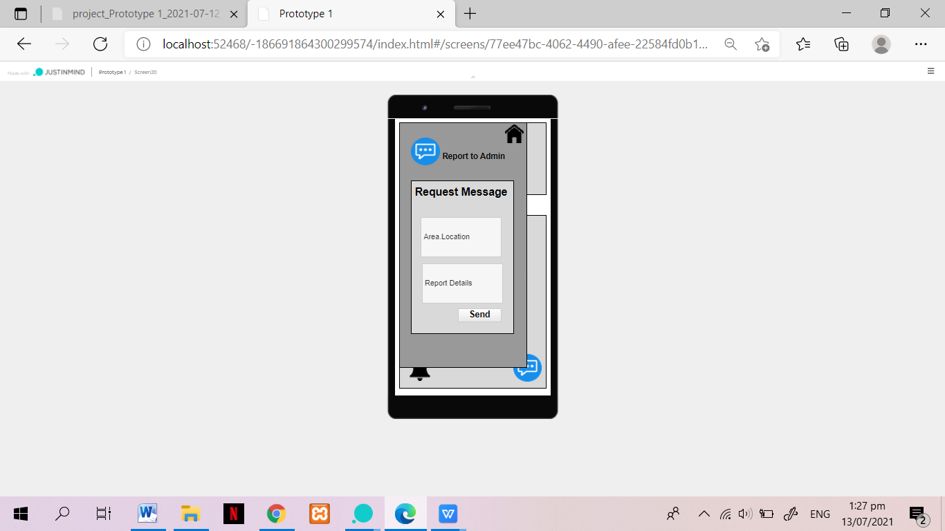

**Fig 31. Staff Request Message Page**