**3G Power**

Czarina Bacit

Carla Mabutol

Gleanne Simbanan

**E-Trash: Online Waste Report Collection and Management System**

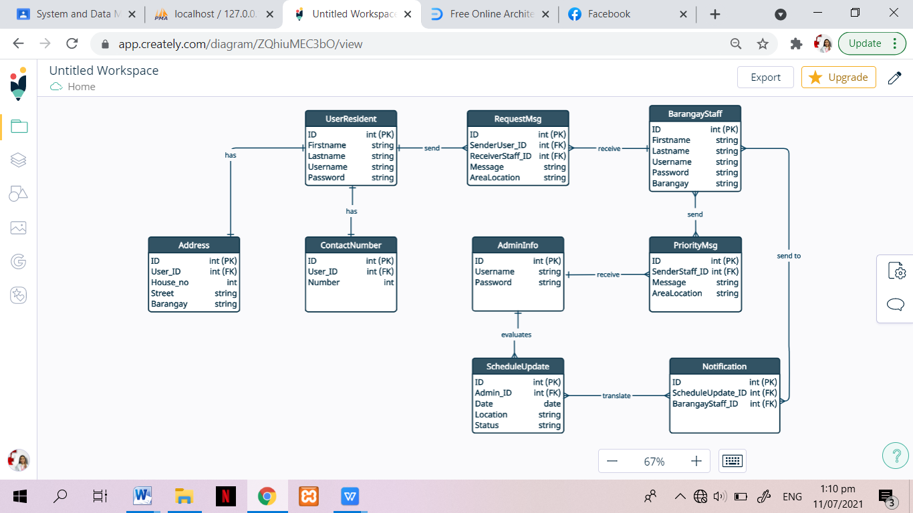

The first table is the UserResident with one to one relationship to Address and ContactNumber table. A resident has one address and one contact number. UserResident sends request message to a barangay staff. One resident can send multiple request message of prioritization to a single staff that depends on its location, therefore there is one to many relationship between table UserResident and RequestMsg then many to one relation from RequestMsg to a BarangayStaff. BarangayStaff will then send a PriorityMsg to admin that eventually evaluated to have a ScheduleUpdate. BarangayStaff table has many to many relationship with PriorityMsg table, then many to one from PriorityMsg to AdminInfo table. AdminInfo has one to many relationship with ScheduleUpdate table. ScheduleUpdate will be translated into Notification that will be sent to BarangayStaff.

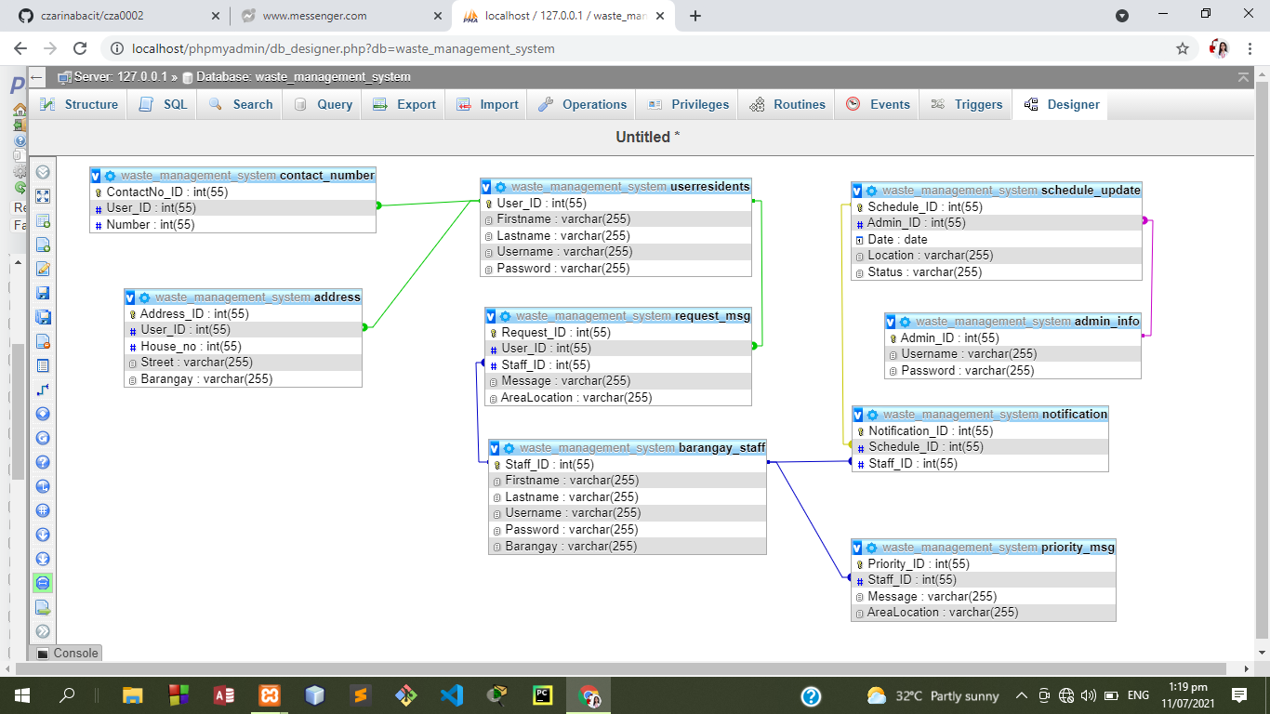

**List of Queries:**

1. List of all UserResident.
2. List of all BarangayStaff.
3. List of all RequestMsg that was sent by a specific UserResident.
4. List of all RequestMsg that was receive by a specific Barangay Staff.
5. List of all RequestMsg that was included in PriorityMsg.
6. List of all ScheduleUpdate with a status of successfully collected waste.
7. List of all ScheduleUpdate with a status of delay collected waste.
8. List of all ScheduleUpdate with a status of uncollected waste.
9. List of all Notification that was sent to a specific BarangayStaff.