Software Requirements Specification

for

E-Trash: Online Waste Report Collection and Management System

**Version 1.0 approved**

**Prepared by Carla Mabutol & Gleanne Simbanan**

**3G Power**

**July 8, 2021**

**Table of Contents**

**Table of Contents ii**

**Revision History ii**

**1. Introduction 1**

1.1 Purpose 1

1.2 Document Conventions 1

1.3 Intended Audience and Reading Suggestions 1

1.4 Project Scope 1

1.5 References 2

**2. Overall Description 2**

2.1 Product Perspective 2

2.2 Product Features 2

2.3 User Classes and Characteristics 2

2.4 Operating Environment 3

2.5 Design and Implementation Constraints 4

2.6 User Documentation 4

2.7 Assumptions and Dependencies 4

**3. System Features** 4

3.1 System Feature 1 4

3.2 System Feature 2 (and so on) 5-7

**4. External Interface Requirements** 8

4.1 User Interfaces 8

4.2 Hardware Interfaces 9

4.3 Software Interfaces 9

4.4 Communications Interfaces 10

**5. Other Nonfunctional Requirements** 10

5.1 Performance Requirements 10

5.2 Safety Requirements 10

5.3 Security Requirements 10

5.4 Software Quality Attributes 10

**6. Other Requirements** 11

**Appendix A: Glossary** 11

**Appendix B: Analysis Models** 12

**Appendix C: Issues List 6**

**Revision History**

|  |  |  |  |
| --- | --- | --- | --- |
| **Name** | **Date** | **Reason For Changes** | **Version** |
|  |  |  |  |
|  |  |  |  |

# Introduction

## Purpose

A project is a platform that aims to provide a better management system of waste collection through reports and schedules with SMS Notification. This includes a request report for the prioritization list of Barangays that needs to prioritize in waste collection. From manual operation of scheduling that encounters faults when there is a delay in collection, E-Trash will help the municipality to distribute notifications when changes happen. This will avoid residents from dumping on street sides and roads especially when the truck of solid waste is not available to collect waste on that specific Barangay. The scope of this project is the municipality of Nasugbu and is specifically concerned with the Barangay that has the most waste and dumps seen on street sides and roads.

## Document Conventions

For a better understanding, this document is created without following specific convention in defining requirements in the project. This will enable the author to tell the intended outcome as it is and doesn’t use any pattern to describe. And also, the function and characteristics that will be analyzed in this document is not implemented yet.

## Intended Audience and Reading Suggestions

This study aims to develop a Mobile Application and Web-Based System which is called E-Trash: Online Waste Report Collection and Management System to help the users limit their waste and manage collection, this study might have importance to the following:

**Municipality of Nasugbu.** This study is an innovation of the existing waste management. The proposed system will help the municipality to have better waste management and take fast actions from the demand of every barangay with regards to waste collection.

**Barangay.** The proposed system will help the barangay to easily notify the waste collector to prioritize their solid waste and the families when there are changes in the schedule.

**Family.** The developed application will help families to receive notification in terms of waste collection schedule.

**To the future researchers.** This study will serve as a reference for the other researchers in future studies related more to waste collection and waste management systems.

## Project Scope

The main purpose of this project is to avoid the massive piling up of trash in the road through this system. This project also aims to notify the household about the waste collection schedule in every barangay of Nasugbu through SMS Notifications. This study aims to develop an E-Trash: Online Waste Report Collection and Management System that is intended to create a mobile application and web-based system to notify waste collectors and prioritize barangays with urgent needs and manage waste collection through the use of digital scheduling system that allow the municipality or the waste collectors to receive request of prioritization and giving back notification to respective Barangay staff regarding modification of schedule of waste collection.

## References

The study conducted by Eisenstein and Ananth Iyer entitled “Garbage Collection in Chicago: A Dynamic Scheduling Model '' that investigates the city of Chicago regarding the scheduling of trucks to collect garbage. Markov decision process is used to show enhancement and its impact on the collection of garbage in Chicago. The model boosts the collection in four ways such as it maintains the current working of the person who manages in the same work day or rules, gives them a combination of route types to be used, it provides a routes that is easy to follow and also allows to try some sequences, and lastly it allows the superintendent of the ward to monitor using control chart the weight being generated by a route. Therefore, the approach decrements the truck capacity to 12-16% compared to their current system that results in $9 million estimated cost reduction. Therefore, a study entitled “Smart Garbage Management System '' by Jajoo et al., proposed a system that monitors the household garbage bin regarding the level filled. It notifies the residents when and where the collection of garbage will be. The system aids both citizens and the BrihanMumbai Municipal Corporation (BMC) which usually fails to gather the waste of some areas.

# Overall Description

## Product Perspective

The E-Trash is an innovative use of digital scheduling that will help waste collectors of the municipality in managing the schedule of waste collection. Specifically, the Municipal Environment and Natural Resources Officer (MENRO) of Nasugbu already has developed an existing manual schedule but when the delay in schedule of waste collection happens, residents tend to dump waste on roads that most of these might get neglected following the definite schedule the next day. With the use of E-Trash, MENRO will be able to manage waste collection while ensuring that residents are notified with regards to the changes in schedule of waste collection. The process of schedule from manual to E-Trash might have similarities but the product itself is self-contained.

## Product Features

The E-Trash: Online waste report collection and management system aims to notify the household about the waste collection in every barangay of Nasugbu. The system project has three (3) actors such as Admin/Waste Collector, Barangay staff, and Residence of Nasugbu. In this system, it is given that every actor must be able to log-in accurately, yet they have different accessibility on the system. The Admin can view and take action on every prioritization request of each barangay. They can also access and produce reports such as user list, barangay list, or request of prioritization list and anything necessary on the system. As admin of the system they can also distribute notifications on certain barangay in case there are changes on waste collection scheduling. Then, barangay staff can receive and distribute the update about the schedule of waste collection to the residents of their barangays and they’re able to view complaints and status of waste collections. Lastly, the residents can receive notification from barangay staff and be able to send complaints regarding their overflowing waste.

## User Classes and Characteristics

The application has three (3) classes that can be accessed as the waste Collector/Admin, barangay staff, and individual. The admin has the power to notify the barangay about the fixed or change in the scheduling of waste collection. This is the main class of the system where it gives all necessary details about the user list for barangay staff and residents and the schedule. Next is the barangay staff that can message the admin about the waste in their area to be prioritized if necessary. Also, the barangay staff can update or notify the individual about the change of waste collection schedule. In the individual or resident class, they are responsible for asking requests for prioritization of their area to the barangay staff. The individual can receive notification about the collection schedule.

## Operating Environment

This part shows information about the hardware and software requirements in developing the E-Trash: Online Waste Report Collection and Management System.

**Software Requirements**

|  |  |
| --- | --- |
| **Particulars** | **Software** |
| Operating System | 64-bit Operating System |
| Database | MySQL |
| Programming Language | Java |
| Integrated Development Environment | Android Studio |
| Web Editor | XAMPP |
| Web Technology | HTML, CSS |
| Mobile Device | Android 8.0 Oreo and Higher |

**Software Needed for the Development**

The table for software needed for the development displays the software requirements in developing E-Trash: Online Waste Report Collection and Management System. The researchers will be using a laptop or personal computer with a 64-bit operating system. For creating databases, researchers will use MySQL using XAMPP web editor. Programming language to be used in developing the system is Java integrated with the IDE, which is the Android Studio, to be used in creating android applications. HTML and CSS for customizing web-based applications and lastly, researchers decided to work with android phone version 8.0 Oreo and higher that is supported by Google.

**Hardware Requirements**

|  |  |
| --- | --- |
| **Particulars** | **Specification** |
| Processor | 2.30 GHz |
| RAM | 4gb RAM |
| Storage | 500gb |
| HDD | 500gb or more |
| Input Devices | Keyboard/Mouse |
| Output Devices | Monitor |

**Hardware Needed for the Development**

The table for hardware needed for the development displays the hardware requirements in developing E-Trash: Online Waste Report Collection and Management System. The researchers will use a 2.30 GHz laptop’s processor, also at least 4gb for RAM and 500gb for the internal storage. To perform the development of the system, keyboard and mouse are needed as input devices and monitor for output devices.

## Design and Implementation Constraints

The following constraints have been identified on the project:

* The project has no defined budget.
* The creation of the project has limited time.
* Resources needed in the project are limited and basic.
* Developers only have basic knowledge in terms of the development of the system in the new IDE.
* Resources for the design and implementation of the system is limited to trial accounts with basic features.

## User Documentation

Before the deployment of the system, developers will provide user assistance that will serve as guide and manual to the admin of the system. End user guide for the residents class as it is in the form of a mobile application is very visible since step by step procedure for this module is presented on the application. Developers will mostly interact with the admin since most of the function of the system is in the admin class.

## Assumptions and Dependencies

This study is purposed to meet the limitations of the paper-based approach of the waste management system. This project is intended to automate the process of requesting waste collection in a certain area and notifying residents along certain barangay. In this system, information is from the users, for that reason, the system must easily accept the appropriate inputs from the users like usernames, passwords, waste collection prioritization requests, and so on. Lastly, the system should generate a list of reports if commanded by the admin.

# System Features

## System Login

3.1.1 Description and Priority

Before entering into the system, the user needs to provide authorized access with the use of username and password respectively. For the admin login, there is only one user with the admin control and the highest class and top priority. For the barangay staff login, only admin have the power to create or add users with staff class and the rest are identified as residents. All login modules are a high priority feature.

3.1.2 Stimulus/Response Sequences

The user needs to provide correct username and password, else, the system will show unauthorized access with a dialog box showing a message for entering incorrect username or password.

3.1.3 Functional Requirements

REQ-1: The system should allow users to login when the correct username and password is provided.

REQ-2: The system should distinguish unauthorized access with incorrect requirements whether it is incorrect username or password.

## Creation of Barangay Staff Account

3.2.1 Description and Priority

The creation of the Barangay staff account can only be done in the admin module. It is also a top priority because without respective staff in each barangay, there is no connection between the admin as a waste collector to its residents.

3.2.2 Stimulus/Response Sequences

The admin needs to input details such as first name, last name, location of the assigned barangay, respective username and password to be used by the staff to login. After adding the staff with its details, the staff user list table will be seen and successfully, staff is added and will be able to login as staff class.

3.3.3 Functional Requirements

REQ-1: The system should allow admin to add unique staff members.

REQ-2: The system should distinguish inputs with the same details available on the user list table.

## Admin Notification Page

3.3.1 Description and Priority

As part of the request that Barangay staff send to admin, all requests are on the list of notifications which is needed in analyzing and modifying the priority schedule of waste collection. It is a top priority for the admin to have a better notification page in order to produce a modified schedule for waste collection.

3.3.2 Stimulus/Response Sequences

Notification bell as the icon should be clicked to get into the notification list.

3.3.3 Functional Requirements

REQ-1: The system should define the structure of the notification list for a better analyzing of priority requests.

REQ-2: TBD

## Schedule Update Page (Admin)

3.4.1 Description and Priority

The schedule update page as a feature for the admin class, this serves as the collection of schedules that identify the date and the location of waste collection respectively wherein admin can modify changes when priority request has been approved in a barangay. It is also one of the top priorities in the system.

3.4.2 Stimulus/Response Sequences

Clicking the schedule update button to proceed on this page is needed. Admin can modify the date of schedule by clicking the Edit button besides each schedule and should provide new information for the schedule update.

3.4.3 Functional Requirements

REQ-1: The system should allow modification of schedule for waste collection.

REQ-2: Other functional requirements are TBD.

## Schedule Update Page (Residents and Staff)

3.5.1 Description and Priority

For residents and staff, this feature only shows the specific schedule of waste collection for a specific month which is relatively connected to the received notification with regards to the changes and schedule from the admin. It is an example of a medium priority feature.

3.5.2 Stimulus/Response Sequences

As part of the description discussed above about this feature, residents and staff should identify whether the collection of waste scheduled on that date is completed, delayed or uncollected.

3.5.3 Functional Requirements

REQ-1: TBD

## Account Setting Feature

3.6.1 Description and Priority

This feature includes the logout button and the capability of the user to change their password. It is part of the medium priority features.

3.6.2 Stimulus/Response Sequences

The user needs to provide the correct current password to change it into a new one. For the log out part, the users are asked if they are sure of logging out.

3.6.3 Functional Requirements

REQ-1: The system should prompt a message once password is confirmed to modify.

REQ-2: The system should ask users if they are sure of logging out.

## Request Message Feature

3.7.1 Description and Priority

For the residents or individual class, this feature allows them to send messages to specific barangay staff in order to request prioritization for the waste collection. This message includes the location or area to be prioritized and the description. For the Barangay staff class, this allows them to send direct prioritization requests to the admin for further modification in the waste collection schedule.

3.7.2 Stimulus/Response Sequences

Both users of different classes from Barangay staff and residents should include location and the description of the prioritization area in the message.

3.7 .3 Functional Requirements

REQ-1: The system should be able to send message requests.

REQ-2: TBD

# External Interface Requirements

## User Interfaces

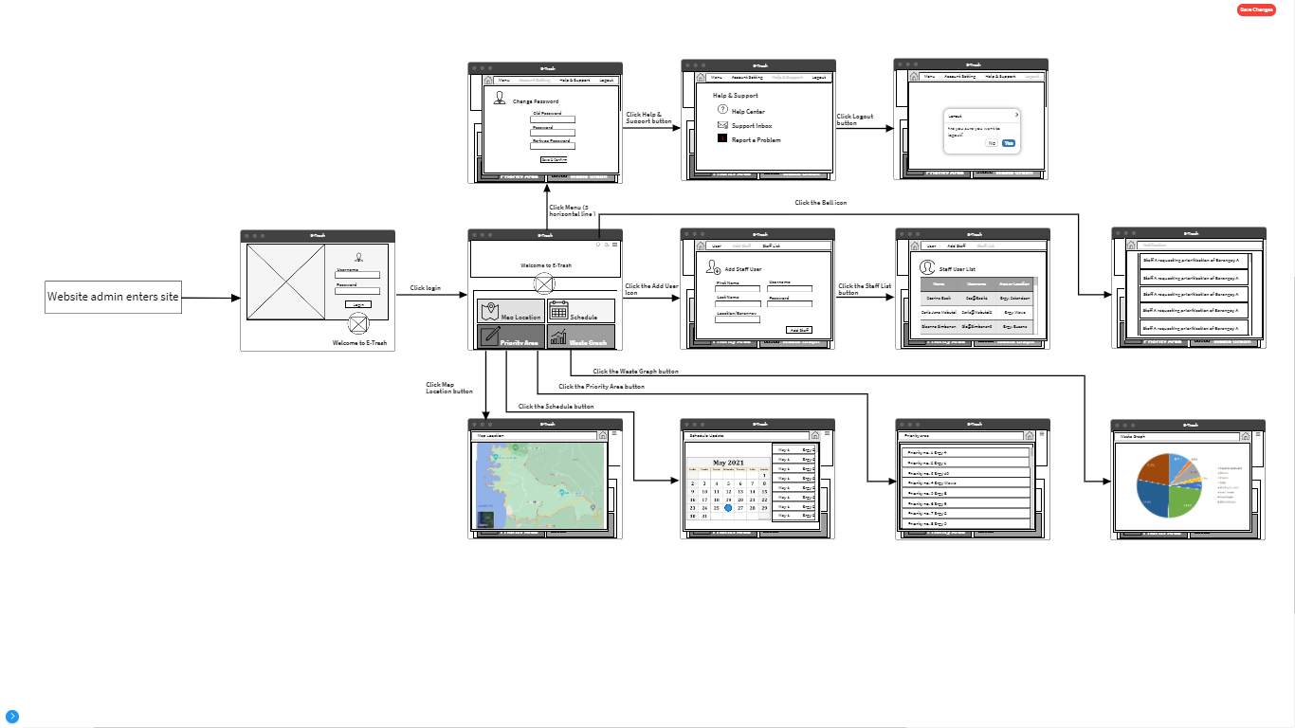

**User Interface for Web Design Wireframe**

In here admin first enter the site for the admin web version module. The first to show the interface is the login, next after entering username and password successfully, it will then show the main page of the admin. It includes main buttons such as Map location, Schedule, Priority Area and Waste Graph button. It also has buttons on the upper right side such as Notification (on bell icon), User (add user icon) and menu (3 horizontal line icon). First let’s discuss the menu button, it has a submenu of Account setting, Help & Support and Logout button. Next part is the User button where it has a submenu of Add staff and Staff list button. Last menu for the upper right side is the Notification. The main part button of this web version wireframe. Where it has four buttons such as Map Location, Schedule, Priority Area and Waste Graph button. All of this wireframe is discuss each above this portion.

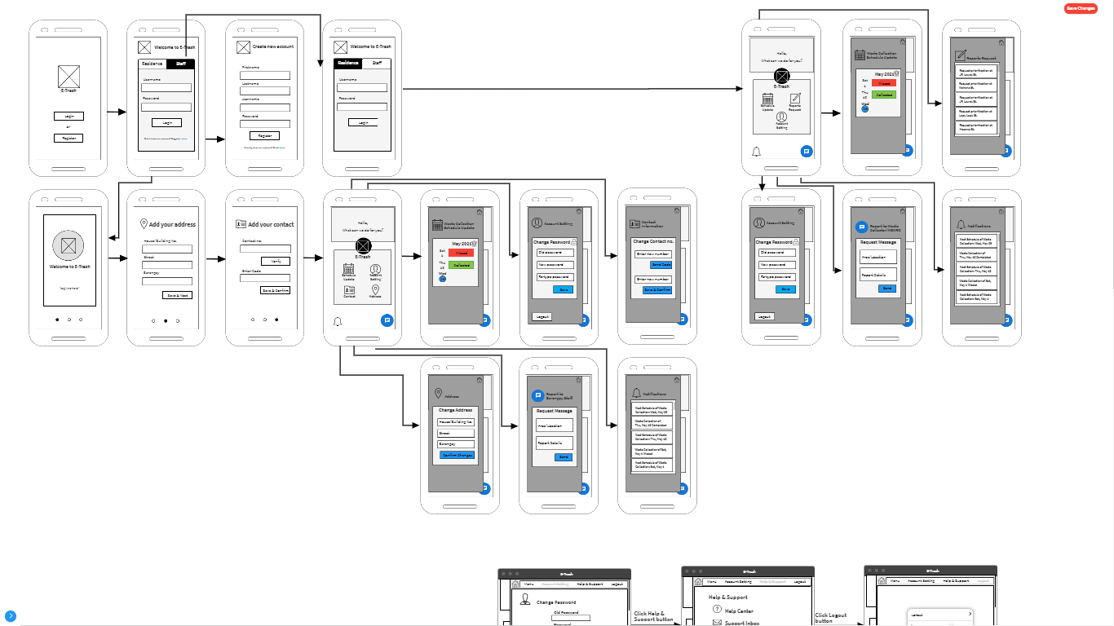

**User Interface for Mobile Design Wireframe**

The mobile application is composed of two modules, residence and staff module. The difference between the residence and the staff module are the following:

1. Residents are the one that reports to staff for prioritization requests. And Staff will summarize its reports to pass to the admin.
2. Residents can register for user accounts while adding staff can only be done by the admin.
3. Residents need to input address and contact information to generate respective staff assigned to their barangay.
4. Staff can notify admin about schedule updates for waste collection and that update comes from the admin report.

## Hardware Interfaces

The researchers will use a 2.30 GHz laptop’s processor, also at least 4gb for RAM and 500gb for the internal storage. To perform the development of the system, keyboard and mouse are needed as input devices and monitor for output devices.

## Software Interfaces

The researchers will be using a laptop or personal computer with a 64-bit operating system. For creating databases, researchers will use MySQL using the XAMPP web editor. Programming language to be used in developing the system is Java integrated with the IDE, which is the Android Studio, to be used in creating android applications. HTML and CSS for customizing web-based applications and lastly, researchers decided to work with android phone version 8.0 Oreo and higher that is supported by Google.

## Communications Interfaces

As part of the distribution of notification, the system will use SMS Notification that will definitely notify and contact residents and staff with regards to the changes of schedule of waste collection. The execution of this communication interface is to be determined in the process of the development of the system.

# Other Nonfunctional Requirements

## Performance Requirements

In order to produce modification within the schedule for the waste collection which is from the evaluated prioritization requests, residents should send a message to a barangay staff and then barangay staff will direct this message to the admin as a form of prioritization requests. One received, the message will undergo evaluation and when it is confirmed, it will be then added to the priority area list giving the location the priority in collecting waste. Notification will be sent to barangay staff for the modified schedule and to the residents as well. Therefore, modification of priorities in the schedule of waste collection will be based on the message requested from the residents and the barangay staff.

## Safety Requirements

In order to prevent any damages and loss especially on the data of every user, the system will go on the process of encrypting any valuable information that can be entered on the system. To avoid damage, the admin is the only authorized to monitor the waste report and prioritization list and send notification to designated barangays.

## Security Requirements

The residents of the Barangay that will use the system will go through the process of verification to provide proof that he/she is resident of the barangay and to make sure that all the information is valid. And to improve security, especially for the passwords and codes, the system will only limit the number of attempts to prevent any access and modification by an unauthorized person.

## Software Quality Attributes

**5.4.1** Reliability

Checked exception handling is highly recommended. Extensive testing is also required.

**5.4.2** *Completeness*

All of the external libraries including their respective licenses should be documented.

**5.4.3** *Consistency, Conciseness, and Efficiency*

The application code will be reviewed regularly to remove redundancy, reduce complexity and increase efficiency.

**5.4.4** *Portability*

Testing across multiple platforms such as OS X, Linux, or Windows and implementations of the Java platform should ensure that code and external libraries are not platform or implementation-dependent.

**5.4.5** *Maintainability*

The application code will be easily recognizable functionality and cohesive. Classes will be abstract enough to facilitate changes in data structures. Function modularity and class should be implemented to avoid the need for major refactoring.

**5.4.6** *Understandability*

The application code and/or comments should be written descriptively. The names of variables, methods, and classes should be self-descriptive. Classes and methods will be

commented to detail their purpose.

**5.4.7** *Security*

See section 5.3.

# Other Requirements

**Appendix A: Glossary**

The key terms in the study are given the following operational definitions.

**Solid Waste**. refers to the range of garbage materials from human and/or animal activities that are discarded as unwanted and useless.

**Waste Management**. refers to the various schemes to dispose and manage of garbage.

**Manual approach**. refers to methods that have existed before automation of processes.

**Appendix B: Analysis Models**

**Context Diagram**

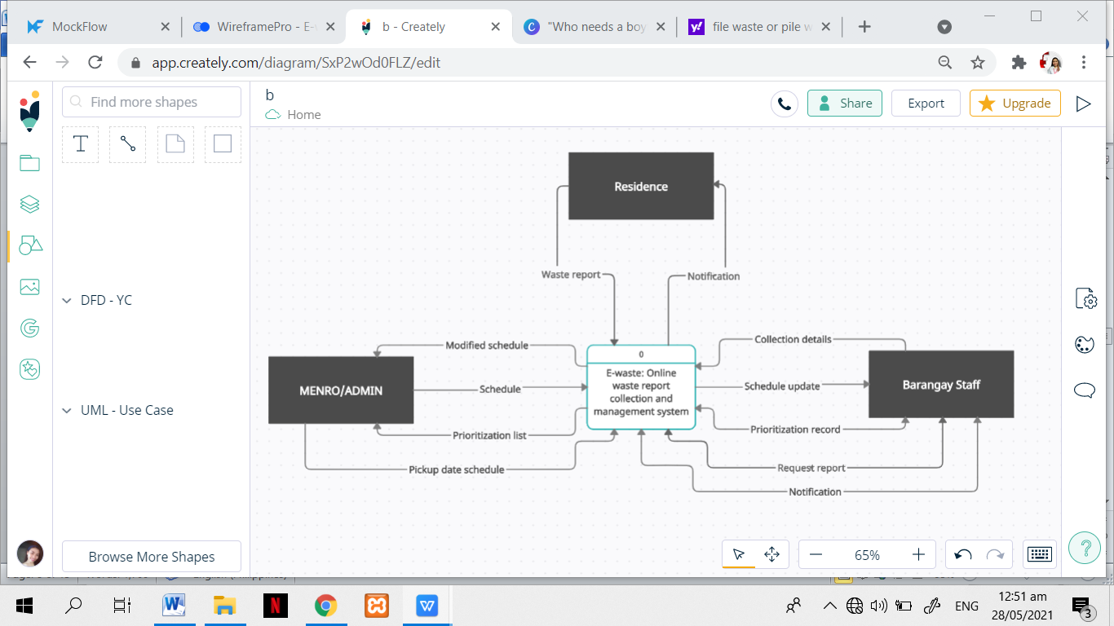

**Context Diagram**

The figure shows the context diagram of the proposed system. The E-waste: Online waste report collection and management system is the process 0 and it is coordinated with three (3) external entities which are Residence, Barangay Staff and the MENRO as the admin. For Residence entities, the needed input is a waste report and a notification shall be received. On the Barangay staff, the needed inputs include collection details, request report and a prioritization record and notification which are both included as an input and output. Together with schedule update as an output flow. And for the last entity which is the MENRO as the admin, pickup date and schedule as the input, modified schedule and prioritization list for the output.

**Data Flow Diagram**

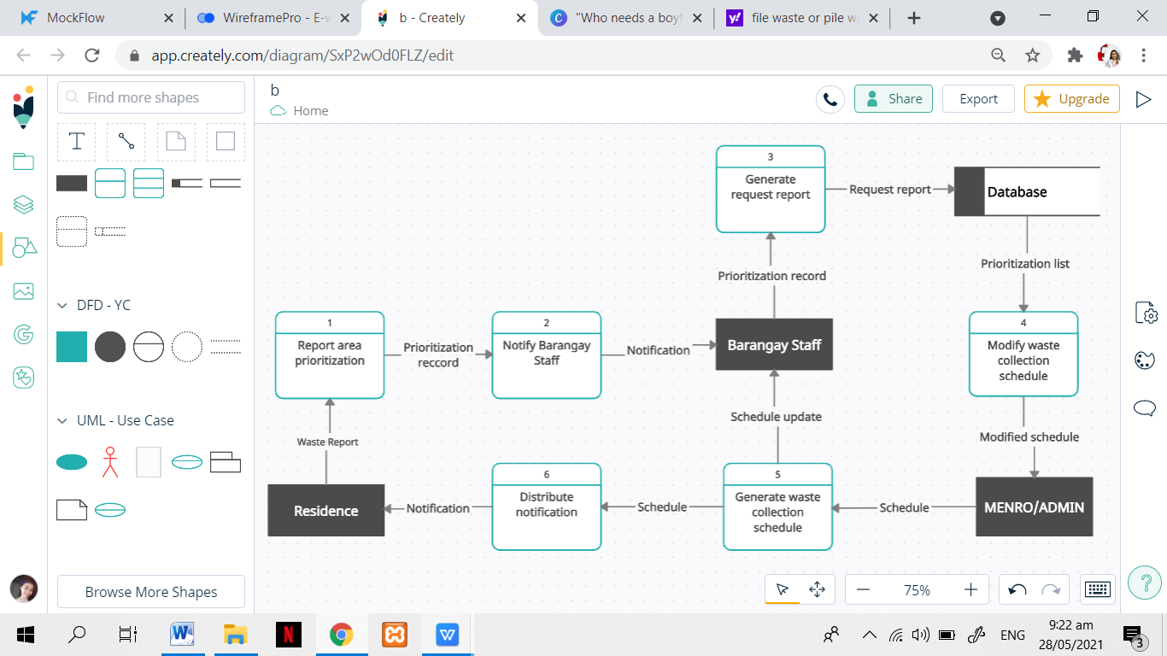

**Data Flow Diagram**

The figure shows the data flow diagram of the proposed system. Residents will report areas for prioritization that will be received by the Barangay staff as notification. The barangay staff will then request a prioritization list to be stored in the database. The record from the database will result in a prioritization list that will be needed as an input to produce output of modified schedule in the process of modified waste collection schedule. This schedule shall be received by the Barangay staff as schedule update and it will undergo a process to distribute notification back to the residence.

**Entity Relationship Diagram**

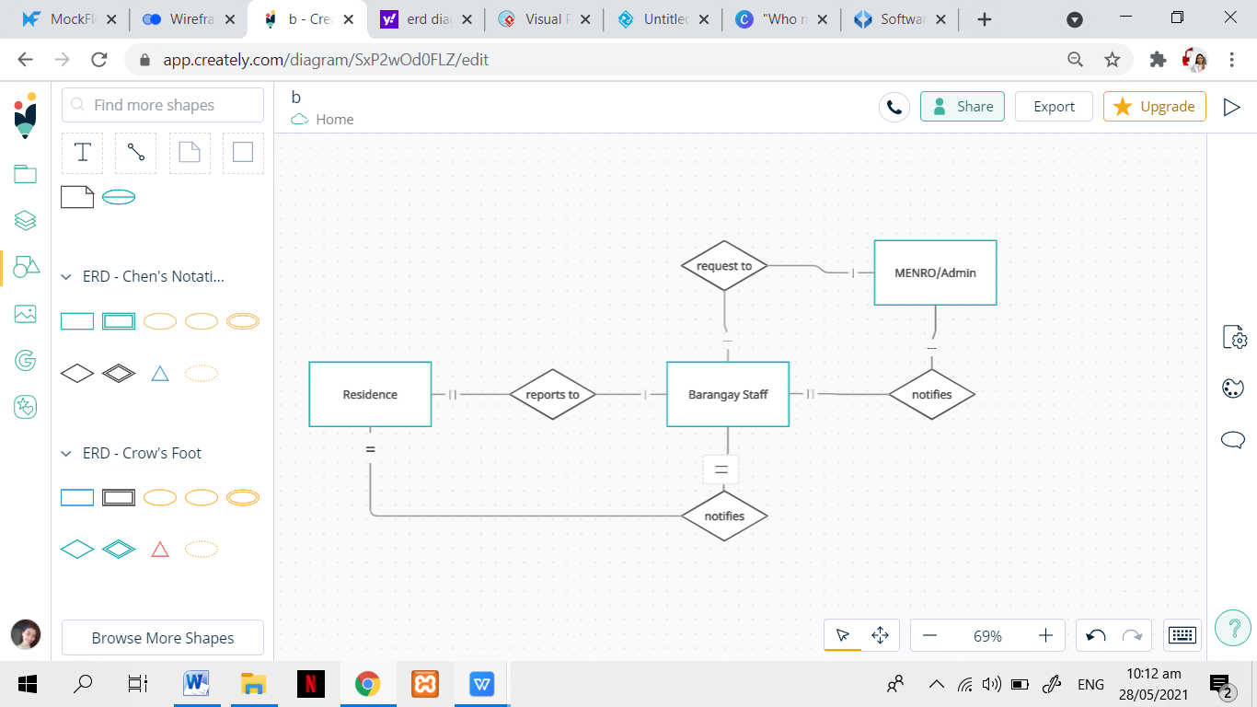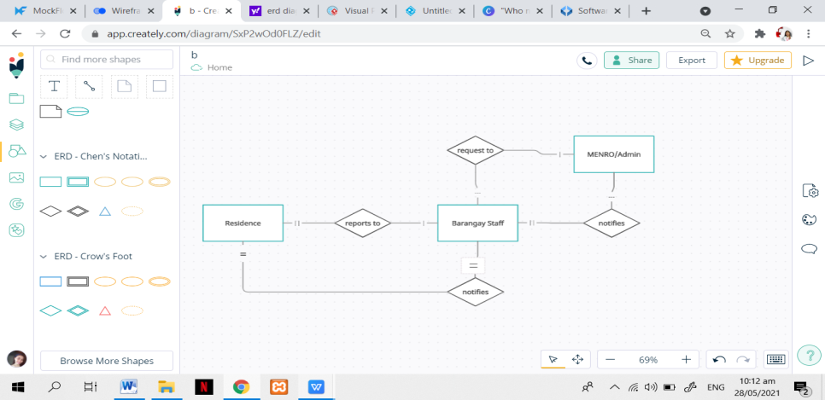

**Entity Relationship Diagram**

The figure shows the entity relationship diagram of the proposed system. Residence reports to Barangay staff with many to one relationship. Barangay staff will make the request to MENRO/Admin which is a one to one relationship. A MENRO/admin will notify one or more Barangay staff regarding the schedule of waste collection. Finally, Barangay staff will notify many residents about the schedule update.

**Appendix C: Issues List**

|  |  |  |
| --- | --- | --- |
| **Issue Name** | **Description** | **Priority** |
| Software license | Maintain a list of all external libraries and their respective licenses. | Middle |
| User interface specification | A study of usability and an evaluation of the user interfaces of other document management systems will be useful. | Middle |
| Performance requirements | Evaluate other document management systems to determine their level of performance and what can be expected of this project. | Low |