**3G Power**

Czarina Bacit

Carla Mabutol

Gleanne Simbanan

**E-TRASH: ONLINE WASTE REPORT COLLECTION AND MANAGEMENT SYSTEM**

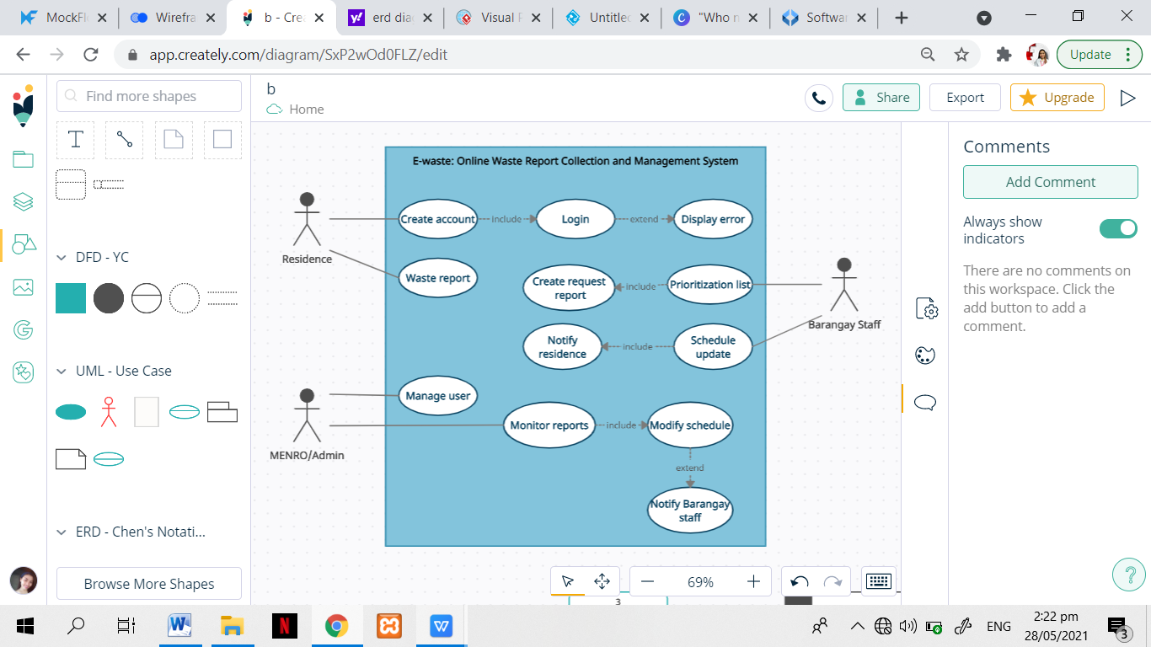

The figure above represents the use case diagram of the propose system “E-Trash: Online waste report collection and management system”. Included here are the three actors which are the residence, barangay staff and MENRO as the admin. The residence needs to create an account that includes login and extended with displaying of errors. The residence is also responsible in creating waste report. For the barangay staff, they needed to provide prioritization list based on the waste reported by the resident of the barangay and proceeds on the creation of request report. Also, staff are responsible to have schedule update to be included in notifying residence. The last actor, which is the MENRO/admin who manages the user. They also monitor reports that includes modifying schedule and extended to notifying barangay staff.