|  |  |  |
| --- | --- | --- |
| СУБД | | |
| Кафедра ЭВМ  Лабораторная работа № 1 | Фамилия студента | Шишкин Г.А. |
| Группа | ИВТ-460 |
| Дата выполнения |  |
| Дата отчета |  |
| Оценка (баллы) |  |
| Подпись преподавателя с расшифровкой |  |

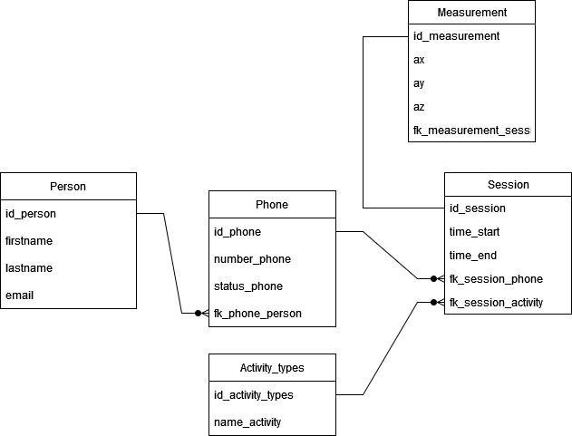

Рисунок 1 – Схема бд

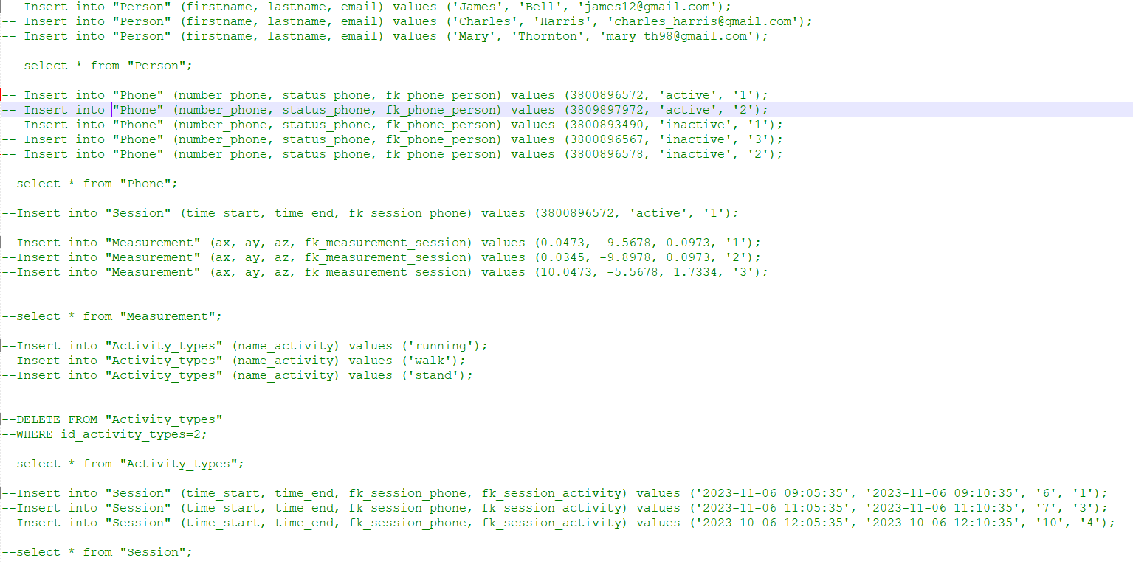

Рисунок 2 – Код sql заполнения бд

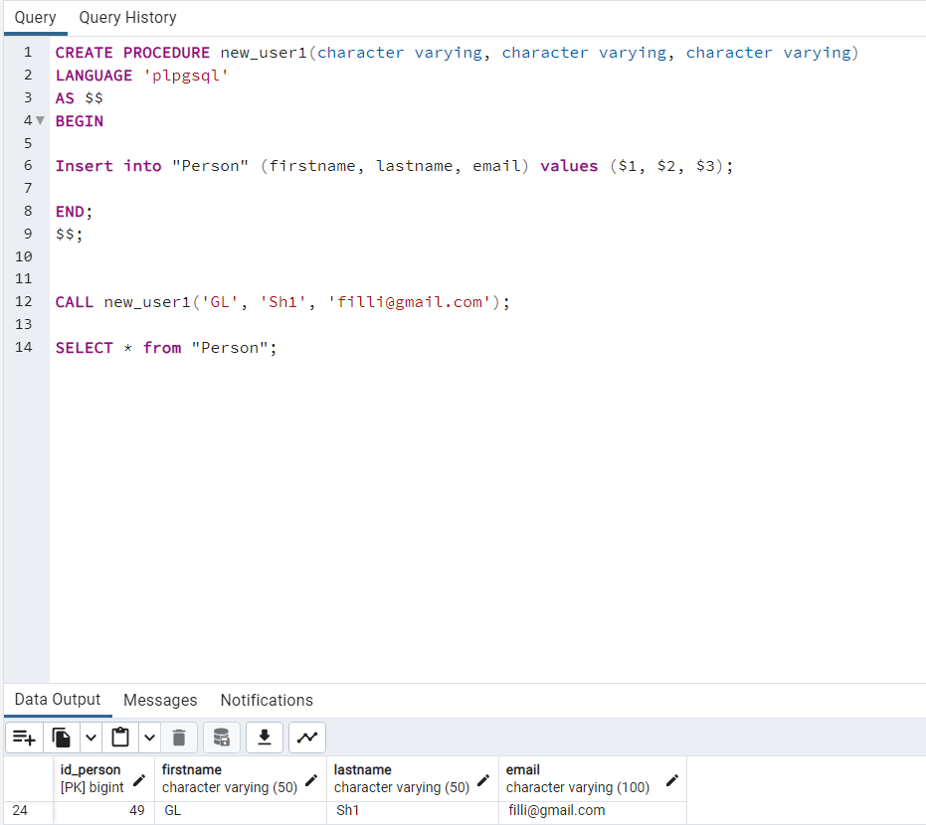

Рисунок 3 – Выполнение процедуры

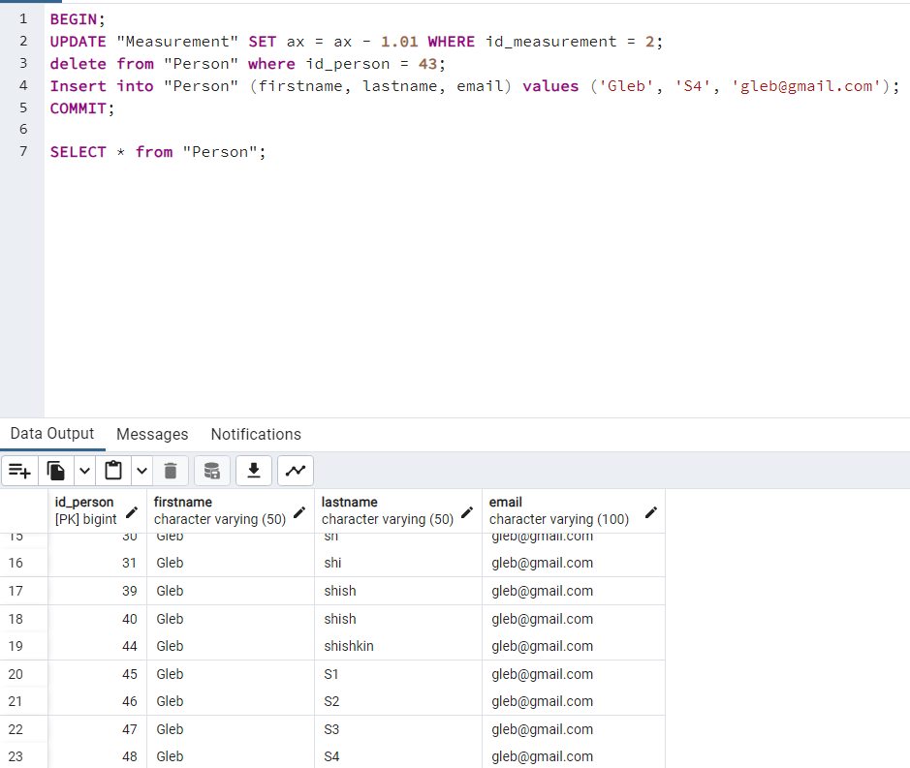

Рисунок 4 – Выполнение транзакции

Приложение 1

CREATE TABLE public."Person" (

id_person bigint NOT NULL primary key,

firstname character varying(50) NOT NULL,

lastname character varying(50) NOT NULL,

email character varying(100) NOT NULL

);

ALTER TABLE public."Person" OWNER TO postgres;

ALTER TABLE public."Person" ALTER COLUMN id_person ADD GENERATED ALWAYS AS IDENTITY (

SEQUENCE NAME public."Person_id_person_seq"

START WITH 1

INCREMENT BY 1

NO MINVALUE

NO MAXVALUE

CACHE 1

);

CREATE TABLE public."Phone" (

id_phone bigint NOT NULL primary key,

number_phone integer NOT NULL,

status_phone character varying(100) NOT NULL,

fk_phone_person bigint REFERENCES "Person"(id_person)

);

ALTER TABLE public."Phone" OWNER TO postgres;

ALTER TABLE public."Phone" ALTER COLUMN id_phone ADD GENERATED ALWAYS AS IDENTITY (

SEQUENCE NAME public."Phone_id_phone_seq"

START WITH 1

INCREMENT BY 1

NO MINVALUE

NO MAXVALUE

CACHE 1

);

CREATE TABLE public."Activity_types" (

id_activity_types bigint NOT NULL primary key,

name_activity character varying(50) NOT NULL

);

ALTER TABLE public."Activity_types" OWNER TO postgres;

ALTER TABLE public."Activity_types" ALTER COLUMN id_activity_types ADD GENERATED ALWAYS AS IDENTITY (

SEQUENCE NAME public."Activity_types_id_activity_types_seq"

START WITH 1

INCREMENT BY 1

NO MINVALUE

NO MAXVALUE

CACHE 1

);

CREATE TABLE public."Session" (

id_session bigint NOT NULL primary key,

time_start timestamp without time zone NOT NULL,

time_end timestamp without time zone NOT NULL,

fk_session_phone bigint REFERENCES "Phone"(id_phone),

fk_session_activity bigint REFERENCES "Activity_types"(id_activity_types)

);

ALTER TABLE public."Session" OWNER TO postgres;

ALTER TABLE public."Session" ALTER COLUMN id_session ADD GENERATED ALWAYS AS IDENTITY (

SEQUENCE NAME public."Session_id_session_seq"

START WITH 1

INCREMENT BY 1

NO MINVALUE

NO MAXVALUE

CACHE 1

);

CREATE TABLE public."Measurement" (

id_measurement bigint NOT NULL,

ax real NOT NULL,

ay real NOT NULL,

az real NOT NULL,

fk_measurement_session bigint REFERENCES "Session"(id_session)

);

ALTER TABLE public."Measurement" OWNER TO postgres;

ALTER TABLE public."Measurement" ALTER COLUMN id_measurement ADD GENERATED ALWAYS AS IDENTITY (

SEQUENCE NAME public."Measurement_id_measurement_seq"

START WITH 1

INCREMENT BY 1

NO MINVALUE

NO MAXVALUE

CACHE 1

);