- Напишите pl/pgsql функцию с именем getStudentHierarchy, которая возвращает результат иерархии из лабораторной работы №8 задания с) (7.3).

CREATE FUNCTION getStudentHierarchy(p_manager_id INTEGER DEFAULT NULL)
RETURNS TABLE (
student text,
role text,
level integer,
path text[]
) AS $$
BEGIN
RETURN QUERY
WITH RECURSIVE _startup AS (
SELECT
s.id,
s.role,
s.manager_id,
s.name,
1 AS level,
array[s.name] AS path
FROM startup AS s
WHERE
(p_manager_id IS NULL AND s.manager_id IS NULL)
OR
(p_manager_id IS NOT NULL AND s.id = p_manager_id)
UNION
SELECT
s1.id,
s1.role,
s1.manager_id,
s1.name,
s2.level + 1 AS level,
s2.path || s1.name AS path
FROM startup AS s1
INNER JOIN _startup AS s2 ON s1.manager_id = s2.id
)
SELECT
s.name::text AS "студент",
r.role::text AS "роль",
s.level::integer AS "уровень",
s.path::text[] AS "путь от лидера"
FROM _startup AS s
INNER JOIN reference AS r ON s.role = r.id;
END;
$$ LANGUAGE plpgsql;

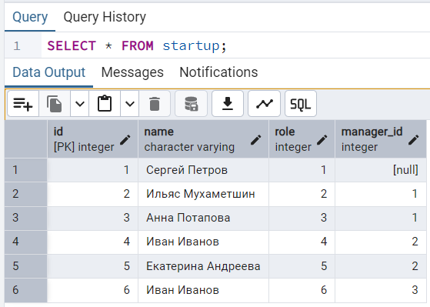
Так выглядит таблица с участниками стартапа
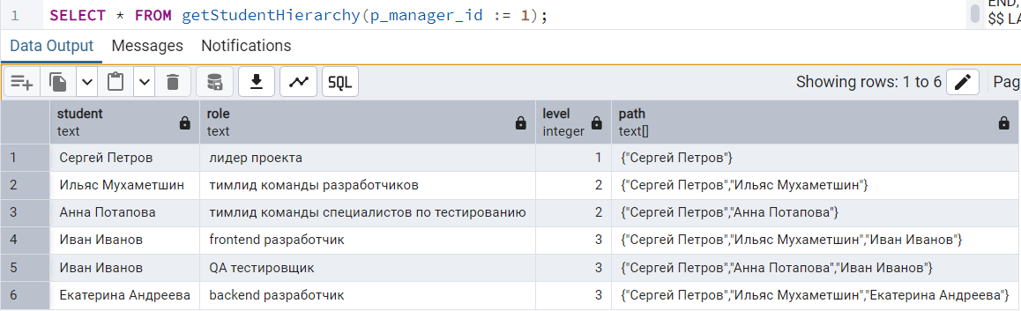

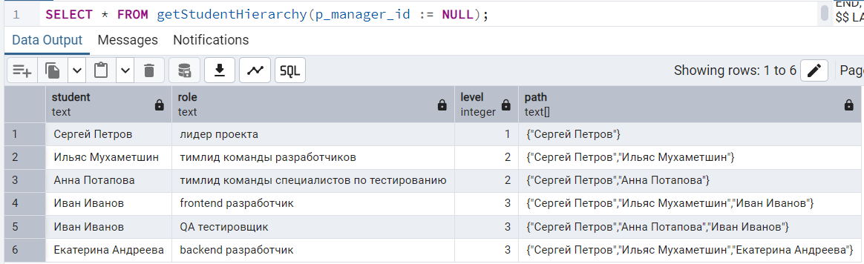

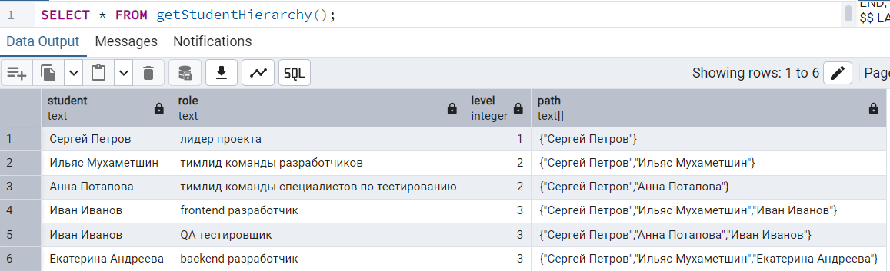

- Напишите pl/pgsql функцию с именем getStudentHierarchyByLevel, которая возвращает результат иерархии с условием дополнительного фильтра по заданному уровню иерархии через входящую переменную p_level.

CREATE FUNCTION getStudentHierarchyByLevel(
p_manager_id INTEGER DEFAULT NULL,
p_level INTEGER DEFAULT NULL
)
RETURNS TABLE (
student text,
role text,
level integer,
path text[]
) AS $$
BEGIN
RETURN QUERY
WITH RECURSIVE _startup AS (
SELECT
s.id,
s.role,
s.manager_id,
s.name,
1 AS level,
ARRAY[s.name] AS path
FROM startup AS s
WHERE
(p_manager_id IS NULL AND s.manager_id IS NULL)
OR
(p_manager_id IS NOT NULL AND s.id = p_manager_id)

UNION

SELECT
s1.id,
s1.role,
s1.manager_id,
s1.name,
s2.level + 1 AS level,
s2.path || s1.name AS path
FROM startup AS s1
INNER JOIN _startup AS s2 ON s1.manager_id = s2.id
WHERE p_level IS NULL OR s2.level + 1 <= p_level
)
SELECT
s.name::text AS student,
r.role::text AS role,
s.level::integer AS level,
s.path::text[] AS path
FROM _startup AS s
INNER JOIN reference AS r ON s.role = r.id
WHERE p_level IS NULL OR s.level = p_level
ORDER BY s.path;
END;
$$ LANGUAGE plpgsql;

