https://api.openweathermap.org/data/3.0/onecall?lat=33.44&lon=-94.04&appid=[{API key}](https://home.openweathermap.org/api_keys)

invalid key 5fc7fbdcb90682df698b36d4b7da1654

key 016f2acc0609536845b270ba738cc674

**401**

**Invalid API key**

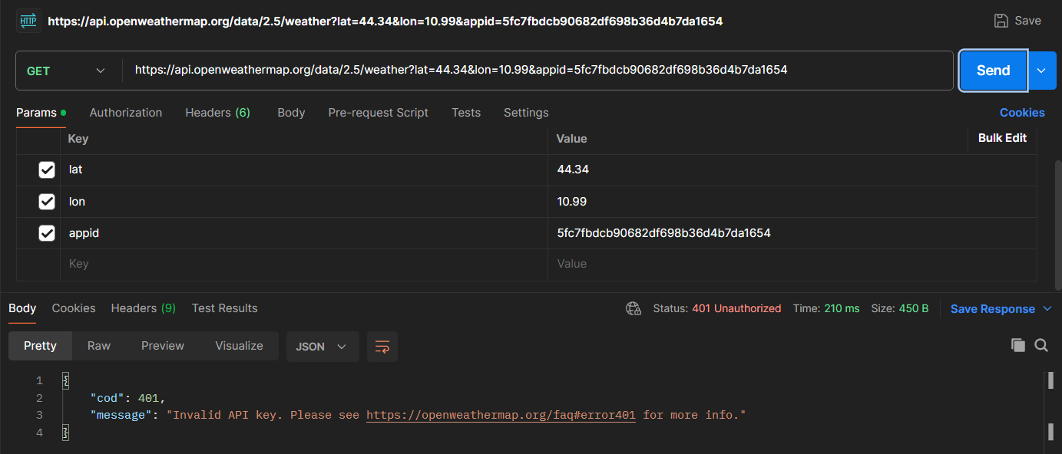

**200**

**Succesful request**

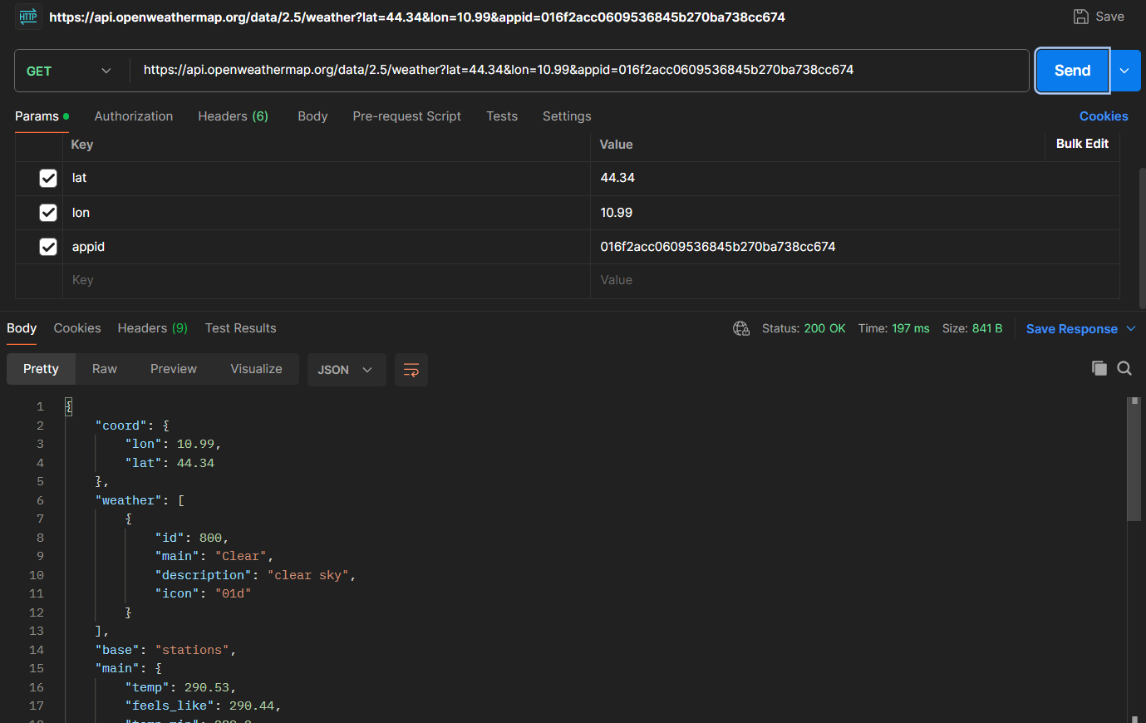

**400**

**Wrong longitude**

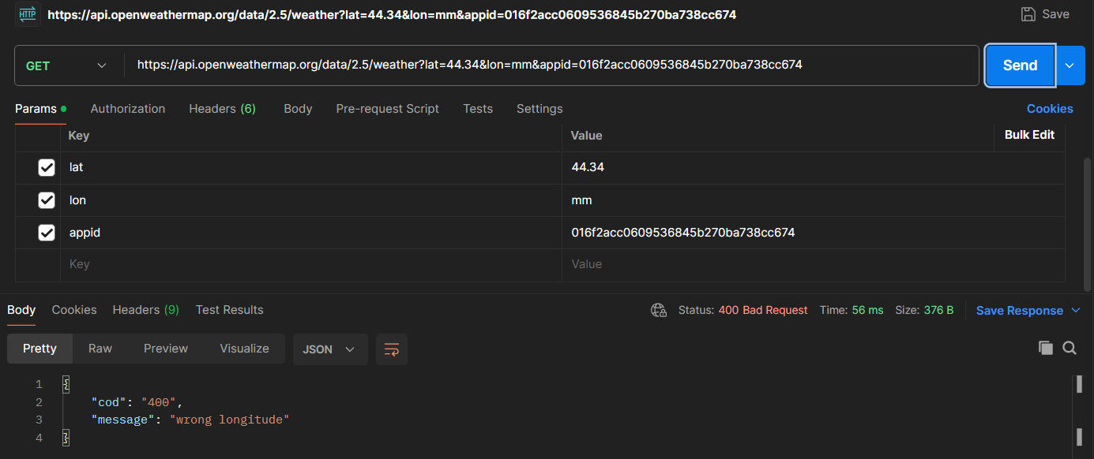

**404**

**Invalid resource**

