1.

a. Google Chrome dev tools Accessibility Audit.

Only 1 error

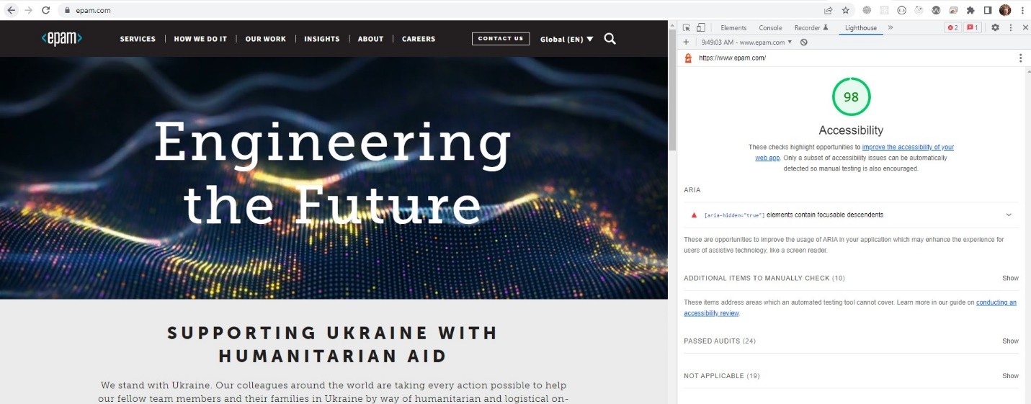

c. Siteimprove Audit

2 errors

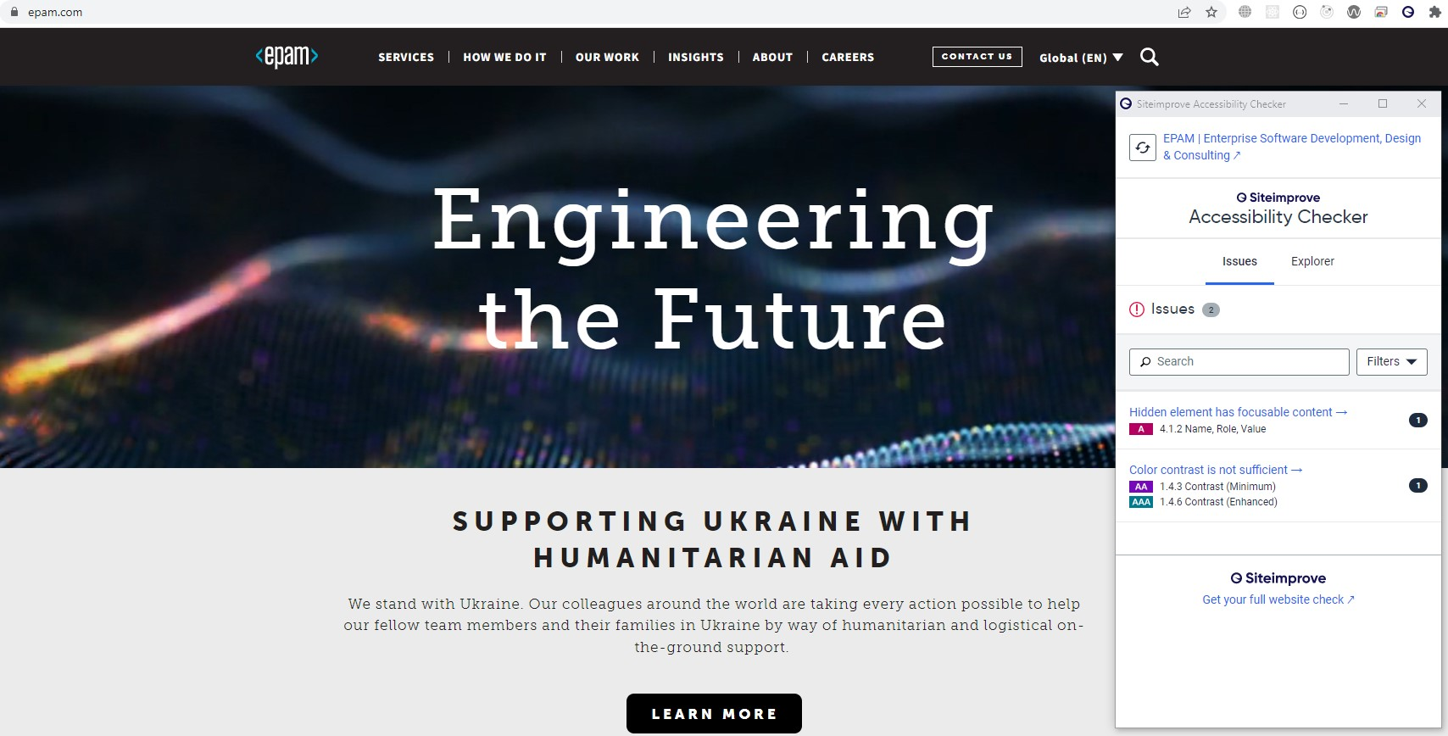

e. Wave audits.

22 errors and a lot of alerts.

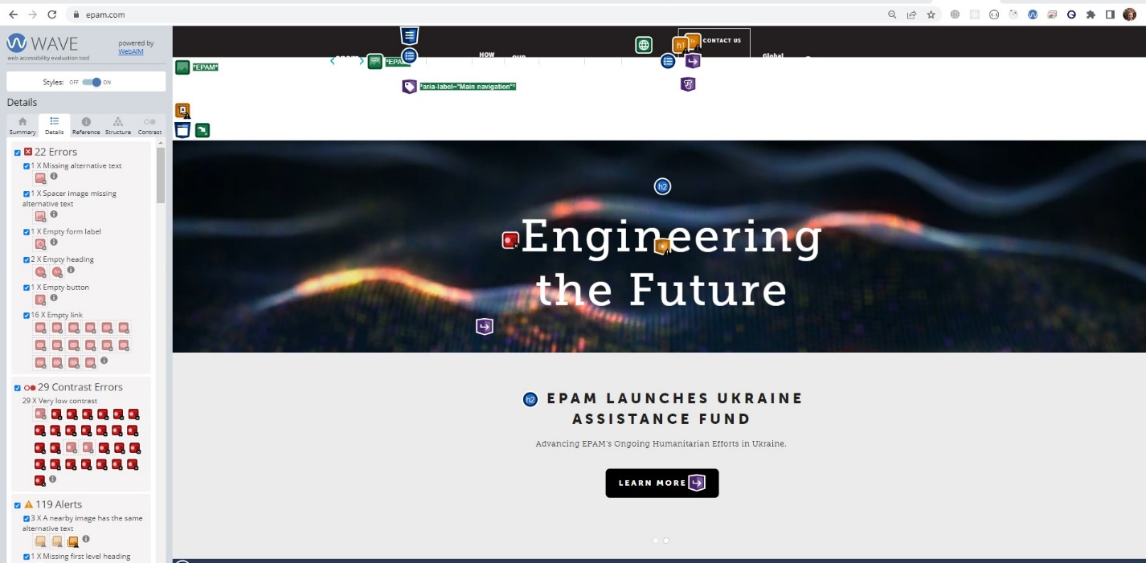

2.

Suggest to use <button/> instead of <a/> for this elements.

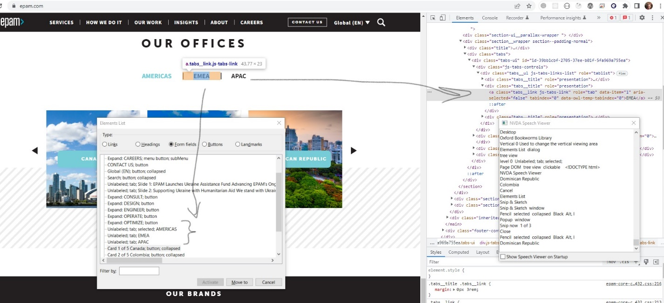

OUR RESULTS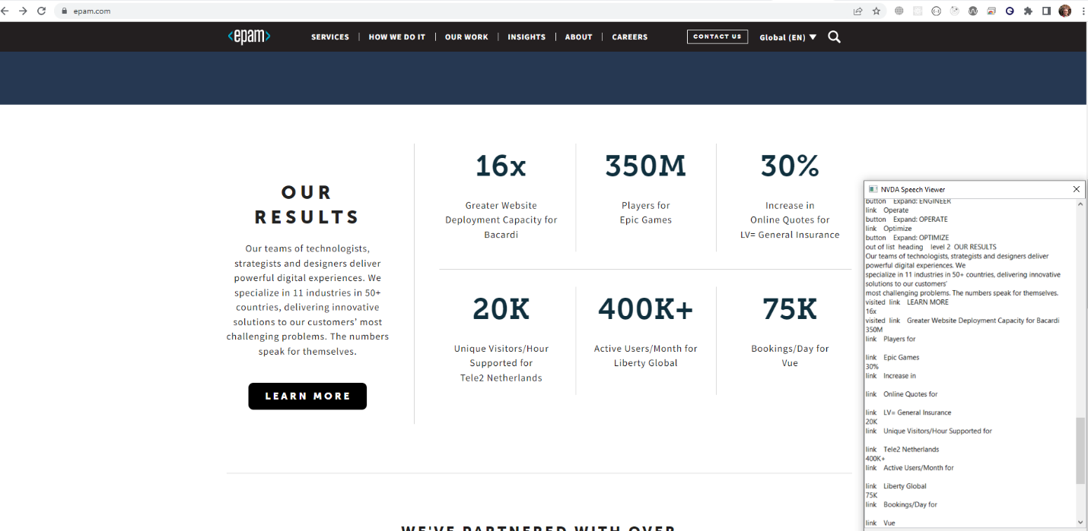

3. Contrast

- Dynamic background reduces contrast



-

 