Балтийский государственный технический университет  
«ВОЕНМЕХ» им. Д. Ф. Устинова

Факультет «О» Естественнонаучный

Кафедра О7 «Информационные системы и программная инженерия»

**Практическая работа №5**по дисциплине «Программирование на ЯВУ»  
на тему «SDL»

Выполнил:  
Студент Костров Г. Ю. Группа О712Б  
Преподаватель: Васюков В.М.

Санкт-Петербург  
2022 г

**Постановка задачи:**

Построить график функции

y = exp(-2) / (x-5)

при x€[-5,3]

Изобразить на экране движение корабля по морю с помощью клавиш управления курсором:

при нажатии на клавишу «>» начинается движение вправо, при нажатии на клавишу «<» – вле-

во, при нажатии на клавишу «^» корабль останавливается.

**Текст программы:**

**// Задание 1**

#include "SDL.h"

#include "stdio.h"

#include "iostream"

#include "math.h"

#include "cmath"

#define SCREEN_WIDTH 1280

#define SCREEN_HEIGHT 720

float map(float minX, float maxX, float minPxX, float maxPxX, float x)

{

return (x - minX) / (maxX - minX) * (maxPxX - minPxX) + minPxX;

}

int main(int argc, char **argv)

{

SDL_Init(SDL_INIT_EVERYTHING);

const auto Width = 1280;

const auto Heigth = 720;

SDL_Window *w = SDL_CreateWindow("Graphs", 63, 126, Width, Heigth, SDL_WINDOW_BORDERLESS);

SDL_Renderer *r = SDL_CreateRenderer(w, -1, SDL_RENDERER_ACCELERATED);

for (auto done = false; !done;)

{

SDL_Event e;

while (SDL_WaitEvent(&e))

{

switch (e.type)

{

case SDL_QUIT:

done = true;

break;

}

SDL_SetRenderDrawColor(r, 0xff, 0xff, 0xff, 0xff);

SDL_RenderClear(r);

SDL_SetRenderDrawColor(r, 0xee, 0xee, 0xee, 0xff);

// Линии, которые делят окно на квадратики)

{

for (float x = -10; x < 10; ++x) {

SDL_RenderDrawLine(r,

map(-10, 10, 0, Width, x), map(-5, 5, Heigth, 0, -5),

map(-10, 10, 0, Width, x), map(-5, 5, Heigth, 0, +5));

}

for (float y = -5; y < 5; ++y) {

SDL_RenderDrawLine(r,

map(-10, 10, 0, Width, -10), map(-5, 5, Heigth, 0, y),

map(-10, 10, 0, Width, 10), map(-5, 5, Heigth, 0, y));

}

}

// Ось абцисс и ординат + функция

{

SDL_SetRenderDrawColor(r, 0xee, 0xc0, 0xc0, 0xff);

SDL_RenderDrawLine(r,

map(-10, 10, 0, Width, -10), map(-5, 5, Heigth, 0, 0),

map(-10, 10, 0, Width, 10), map(-5, 5, Heigth, 0, 0));

SDL_RenderDrawLine(r,

map(-10, 10, 0, Width, 0), map(-5, 5, Heigth, 0, -5),

map(-10, 10, 0, Width, 0), map(-5, 5, Heigth, 0, +5));

SDL_SetRenderDrawColor(r, 0x00, 0x00, 0x00, 0xff);

}

auto oldX = -1;

auto oldY = 0;

for (float x = -5; x <= 3; x += 0.01) // x от -5 до 3 по условию задачи

{

auto y = exp(-2) / (x - 5); // ТУТ МОЖНО ИЗМЕНЯТЬ ФУНКЦИЮ

auto newX = map(-10, 10, 0, Width, x);

auto newY = map(-5, 5, Heigth, 0, y);

if (oldX >= 0)

SDL_RenderDrawLine(r, oldX, oldY, newX, newY);

oldX = newX;

oldY = newY;

}

SDL_RenderPresent(r);

}

SDL_Quit();

}

return 0;

}

**// Задание 2**  
  
//Using SDL, SDL_image, SDL_ttf, standard IO, strings, and string streams  
#include <SDL.h>  
#include <SDL_image.h>  
#include <SDL_ttf.h>  
#include <cstdio>  
#include <string>  
#include <sstream>  
#include <vector>  
  
//Screen dimension constants  
const int SCREEN_WIDTH = 1280;  
const int SCREEN_HEIGHT = 960;  
  
//Texture wrapper class  
class LTexture {  
public:  
 //Initializes variables  
 LTexture();  
  
 //Deallocates memory  
 ~LTexture();  
  
 //Loads image at specified path  
 bool loadFromFile(std::string path);  
  
#if defined(SDL_TTF_MAJOR_VERSION)  
  
 //Creates image from font string  
 bool loadFromRenderedText(std::string textureText, SDL_Color textColor);  
  
#endif  
  
 //Deallocates texture  
 void free();  
  
 //Set color modulation  
 void setColor(Uint8 red, Uint8 green, Uint8 blue);  
  
 //Set blending  
 void setBlendMode(SDL_BlendMode blending);  
  
 //Set alpha modulation  
 void setAlpha(Uint8 alpha);  
  
 //Renders texture at given point  
 void render(int x, int y, SDL_Rect *clip = NULL, double angle = 0.0, SDL_Point *center = NULL,  
 SDL_RendererFlip flip = SDL_FLIP_NONE);  
  
 //Gets image dimensions  
 int getWidth();  
  
 int getHeight();  
  
private:  
 //The actual hardware texture  
 SDL_Texture *mTexture;  
  
 //Image dimensions  
 int mWidth;  
 int mHeight;  
};  
  
//Starts up SDL and creates window  
bool init();  
  
//Loads media  
bool loadMedia();  
  
//Frees media and shuts down SDL  
void close();  
  
//The window we'll be rendering to  
SDL_Window *gWindow = NULL;  
  
//The window renderer  
SDL_Renderer *gRenderer = NULL;  
  
//Globally used font  
TTF_Font *gFont = NULL;  
  
//Scene textures  
LTexture gPromptTextTexture;  
LTexture gInputTextTexture;  
  
std::string nameOfFilesForClock[4] = {"clock.bmp", "hour.bmp", "minute.bmp", "second.bmp"};  
  
std::vector<LTexture> clockTextures(4);  
  
LTexture::LTexture() {  
 //Initialize  
 mTexture = NULL;  
 mWidth = 0;  
 mHeight = 0;  
}  
  
LTexture::~LTexture() {  
 //Deallocate  
 free();  
}  
  
bool LTexture::loadFromFile(std::string path) {  
 //Get rid of preexisting texture  
 free();  
  
 //The final texture  
 SDL_Texture *newTexture = NULL;  
  
 //Load image at specified path  
 SDL_Surface *loadedSurface = IMG_Load(path.c_str());  
 if (loadedSurface == NULL) {  
 printf("Unable to load image %s! SDL_image Error: %s\n", path.c_str(), IMG_GetError());  
 } else {  
 //Color key image  
 SDL_SetColorKey(loadedSurface, SDL_TRUE, SDL_MapRGB(loadedSurface->format, 0, 0xFF, 0xFF));  
  
 //Create texture from surface pixels  
 newTexture = SDL_CreateTextureFromSurface(gRenderer, loadedSurface);  
 if (newTexture == NULL) {  
 printf("Unable to create texture from %s! SDL Error: %s\n", path.c_str(), SDL_GetError());  
 } else {  
 //Get image dimensions  
 mWidth = loadedSurface->w;  
 mHeight = loadedSurface->h;  
 }  
  
 //Get rid of old loaded surface  
 SDL_FreeSurface(loadedSurface);  
 }  
  
 //Return success  
 mTexture = newTexture;  
 return mTexture != NULL;  
}  
  
#if defined(SDL_TTF_MAJOR_VERSION)  
  
bool LTexture::loadFromRenderedText(std::string textureText, SDL_Color textColor) {  
 //Get rid of preexisting texture  
 free();  
  
 //Render text surface  
 SDL_Surface *textSurface = TTF_RenderText_Solid(gFont, textureText.c_str(), textColor);  
 if (textSurface != NULL) {  
 //Create texture from surface pixels  
 mTexture = SDL_CreateTextureFromSurface(gRenderer, textSurface);  
 if (mTexture == NULL) {  
 printf("Unable to create texture from rendered text! SDL Error: %s\n", SDL_GetError());  
 } else {  
 //Get image dimensions  
 mWidth = textSurface->w;  
 mHeight = textSurface->h;  
 }  
  
 //Get rid of old surface  
 SDL_FreeSurface(textSurface);  
 } else {  
 printf("Unable to render text surface! SDL_ttf Error: %s\n", TTF_GetError());  
 }  
  
  
 //Return success  
 return mTexture != NULL;  
}  
  
#endif  
  
void LTexture::free() {  
 //Free texture if it exists  
 if (mTexture != NULL) {  
 SDL_DestroyTexture(mTexture);  
 mTexture = NULL;  
 mWidth = 0;  
 mHeight = 0;  
 }  
}  
  
void LTexture::setColor(Uint8 red, Uint8 green, Uint8 blue) {  
 //Modulate texture rgb  
 SDL_SetTextureColorMod(mTexture, red, green, blue);  
}  
  
void LTexture::setBlendMode(SDL_BlendMode blending) {  
 //Set blending function  
 SDL_SetTextureBlendMode(mTexture, blending);  
}  
  
void LTexture::setAlpha(Uint8 alpha) {  
 //Modulate texture alpha  
 SDL_SetTextureAlphaMod(mTexture, alpha);  
}  
  
void LTexture::render(int x, int y, SDL_Rect *clip, double angle, SDL_Point *center, SDL_RendererFlip flip) {  
 //Set rendering space and render to screen  
 SDL_Rect renderQuad = {x, y, mWidth, mHeight};  
  
 //Set clip rendering dimensions  
 if (clip != NULL) {  
 renderQuad.w = clip->w;  
 renderQuad.h = clip->h;  
 }  
  
 //Render to screen  
 SDL_RenderCopyEx(gRenderer, mTexture, clip, &renderQuad, angle, center, flip);  
}  
  
int LTexture::getWidth() {  
 return mWidth;  
}  
  
int LTexture::getHeight() {  
 return mHeight;  
}  
  
bool init() {  
 //Initialization flag  
 bool success = true;  
  
 //Initialize SDL  
 if (SDL_Init(SDL_INIT_VIDEO) < 0) {  
 printf("SDL could not initialize! SDL Error: %s\n", SDL_GetError());  
 success = false;  
 } else {  
 //Set texture filtering to linear  
 if (!SDL_SetHint(SDL_HINT_RENDER_SCALE_QUALITY, "1")) {  
 printf("Warning: Linear texture filtering not enabled!");  
 }  
  
 //Create window  
 gWindow = SDL_CreateWindow("Time", SDL_WINDOWPOS_UNDEFINED, SDL_WINDOWPOS_UNDEFINED, SCREEN_WIDTH,  
 SCREEN_HEIGHT, SDL_WINDOW_SHOWN);  
 if (gWindow == NULL) {  
 printf("Window could not be created! SDL Error: %s\n", SDL_GetError());  
 success = false;  
 } else {  
 //Create vsynced renderer for window  
 gRenderer = SDL_CreateRenderer(gWindow, -1, SDL_RENDERER_ACCELERATED | SDL_RENDERER_PRESENTVSYNC);  
 if (gRenderer == NULL) {  
 printf("Renderer could not be created! SDL Error: %s\n", SDL_GetError());  
 success = false;  
 } else {  
 //Initialize renderer color  
 SDL_SetRenderDrawColor(gRenderer, 0xFF, 0xFF, 0xFF, 0xFF);  
  
 //Initialize PNG loading  
 int imgFlags = IMG_INIT_PNG;  
 if (!(IMG_Init(imgFlags) & imgFlags)) {  
 printf("SDL_image could not initialize! SDL_image Error: %s\n", IMG_GetError());  
 success = false;  
 }  
  
 //Initialize SDL_ttf  
 if (TTF_Init() == -1) {  
 printf("SDL_ttf could not initialize! SDL_ttf Error: %s\n", TTF_GetError());  
 success = false;  
 }  
 }  
 }  
 }  
  
 return success;  
}  
  
bool loadMedia() {  
 //Loading success flag  
 bool success = true;  
  
 //Open the font  
 gFont = TTF_OpenFont("courier.ttf", 28);  
 if (gFont == NULL) {  
 printf("Failed to load font! SDL_ttf Error: %s\n", TTF_GetError());  
 success = false;  
 } else {  
 //Render the prompt  
 SDL_Color textColor = {0, 0, 0, 0xFF};  
 if (!gPromptTextTexture.loadFromRenderedText("Enter time in format **:** :", textColor)) {  
 printf("Failed to render prompt text!\n");  
 success = false;  
 }  
 }  
 for (int i = 0; i < 4; i++) {  
 if (!clockTextures.at(i).loadFromFile(nameOfFilesForClock[i])) {  
 printf("Failed to load texture!\n");  
 success = false;  
 }  
 }  
 return success;  
}  
  
void close() {  
 //Free loaded images  
 gPromptTextTexture.free();  
 gInputTextTexture.free();  
  
 //Free global font  
 TTF_CloseFont(gFont);  
 gFont = NULL;  
  
 //Destroy window  
 SDL_DestroyRenderer(gRenderer);  
 SDL_DestroyWindow(gWindow);  
 gWindow = NULL;  
 gRenderer = NULL;  
  
 //Quit SDL subsystems  
 TTF_Quit();  
 IMG_Quit();  
 SDL_Quit();  
}  
  
int main(int argc, char *args[]) {  
 //Start up SDL and create window  
 if (!init()) {  
 printf("Failed to initialize!\n");  
 } else {  
 //Load media  
 if (!loadMedia()) {  
 printf("Failed to load media!\n");  
 } else {  
 //Main loop flag  
 bool quit = false;  
  
 //Event handler  
 SDL_Event e;  
  
 //Set text color as black  
 SDL_Color textColor = {0, 0, 0, 0xFF};  
  
 //The current input text.  
 std::string inputText = "text";  
 gInputTextTexture.loadFromRenderedText(inputText.c_str(), textColor);  
  
 //Enable text input  
 SDL_StartTextInput();  
  
 int hour, minute, second;  
 int angleOfSeconds = 0;  
 bool inputTime = false;  
 //While application is running  
 while (!quit) {  
 //The rerender text flag  
 bool renderText = false;  
  
 //Handle events on queue  
 while (SDL_PollEvent(&e) != 0) {  
 //User requests quit  
 if (e.type == SDL_QUIT) {  
 quit = true;  
 }  
 //Special key input  
 else if (e.type == SDL_KEYDOWN) {  
 //Handle backspace  
 if (e.key.keysym.sym == SDLK_BACKSPACE && inputText.length() > 0) {  
 //lop off character  
 inputText.pop_back();  
 renderText = true;  
 }  
 //Handle copy  
 else if (e.key.keysym.sym == SDLK_c && SDL_GetModState() & KMOD_CTRL) {  
 SDL_SetClipboardText(inputText.c_str());  
 }  
 //Handle paste  
 else if (e.key.keysym.sym == SDLK_v && SDL_GetModState() & KMOD_CTRL) {  
 inputText = SDL_GetClipboardText();  
 renderText = true;  
 }  
 }  
 //Special text input event  
 else if (e.type == SDL_TEXTINPUT) {  
 //Not copy or pasting  
 if (!(SDL_GetModState() & KMOD_CTRL &&  
 (e.text.text[0] == 'c' || e.text.text[0] == 'C' || e.text.text[0] == 'v' ||  
 e.text.text[0] == 'V'))) {  
 //Append character  
 inputText += e.text.text;  
 renderText = true;  
 }  
 }  
 if (e.type == SDL_KEYUP && e.key.repeat == 0 && e.key.keysym.sym == SDLK_RETURN &&  
 !inputText.empty() && (inputText.length() == 5)) {  
 if (std::isdigit(inputText[0]) && std::isdigit(inputText[1]) && std::isdigit(inputText[3]) && std::isdigit(inputText[4]) && inputText[2] == ':') {  
 if ((std::stoi(inputText.substr(0, 2)) < 24) && (std::stoi(inputText.substr(3, 2)) < 60)) {  
 hour = std::stoi(inputText.substr(0, 2));  
 minute = std::stoi(inputText.substr(3, 2));  
 if (hour >= 12)  
 hour -= 12;  
 inputTime = true;  
 SDL_StopTextInput();  
 }  
 }  
 }  
 }  
 //Clear screen  
 SDL_SetRenderDrawColor(gRenderer, 0xFF, 0xFF, 0xFF, 0xFF);  
 SDL_RenderClear(gRenderer);  
 if (!inputTime) {  
 //Rerender text if needed  
 if (renderText) {  
 //Text is not empty  
 if (!inputText.empty()) {  
 //Render new text  
 gInputTextTexture.loadFromRenderedText(inputText, textColor);  
 }  
 //Text is empty  
 else {  
 //Render space texture  
 gInputTextTexture.loadFromRenderedText(" ", textColor);  
 }  
 }  
 //Render text textures  
 gPromptTextTexture.render((SCREEN_WIDTH - gPromptTextTexture.getWidth()) / 2, 0);  
 gInputTextTexture.render((SCREEN_WIDTH - gInputTextTexture.getWidth()) / 2,  
 gPromptTextTexture.getHeight());  
 } else {  
 clockTextures.at(0).render((SCREEN_WIDTH - clockTextures.at(0).getWidth()) / 2, (SCREEN_HEIGHT - clockTextures.at(0).getHeight()) / 2);  
 clockTextures.at(3).render((SCREEN_WIDTH - clockTextures.at(0).getWidth()) / 2 + 195, (SCREEN_HEIGHT - clockTextures.at(0).getHeight()) / 2 + 20,  
 nullptr, angleOfSeconds++);  
 if (angleOfSeconds % 360 == 0)  
 minute += 1;  
 clockTextures.at(1).render((SCREEN_WIDTH - clockTextures.at(0).getWidth()) / 2 + 200, (SCREEN_HEIGHT - clockTextures.at(0).getHeight()) / 2 + 120, nullptr, hour * 30);  
 clockTextures.at(2).render((SCREEN_WIDTH - clockTextures.at(0).getWidth()) / 2 + 200, (SCREEN_HEIGHT - clockTextures.at(0).getHeight()) / 2 + 80, nullptr, minute * 6);  
  
 }  
  
 //Update screen  
 SDL_RenderPresent(gRenderer);  
 }  
  
 //Disable text input  
 SDL_StopTextInput();  
 }  
 }  
  
 //Free resources and close SDL  
 close();  
  
 return 0;  
}

**Результат работы программы:**

Рисунок 1:Задание 1.

Рисунок 2: Задание 2.

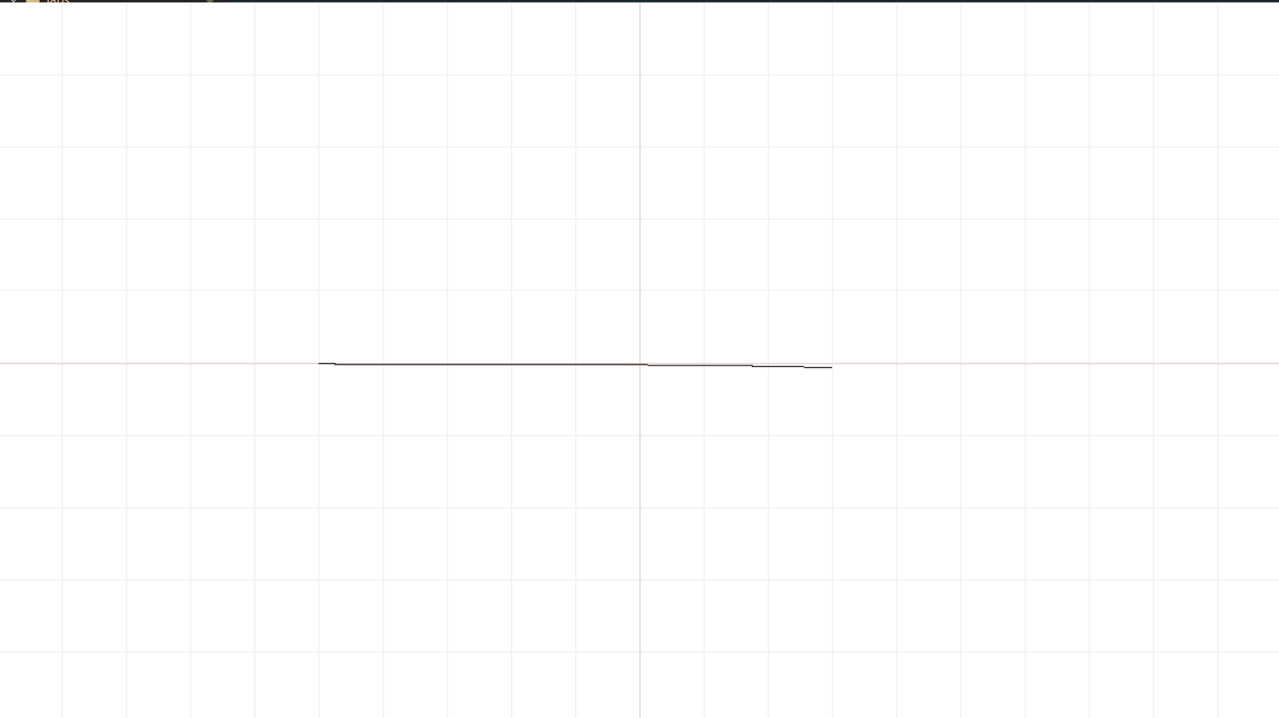

Рисунок 1

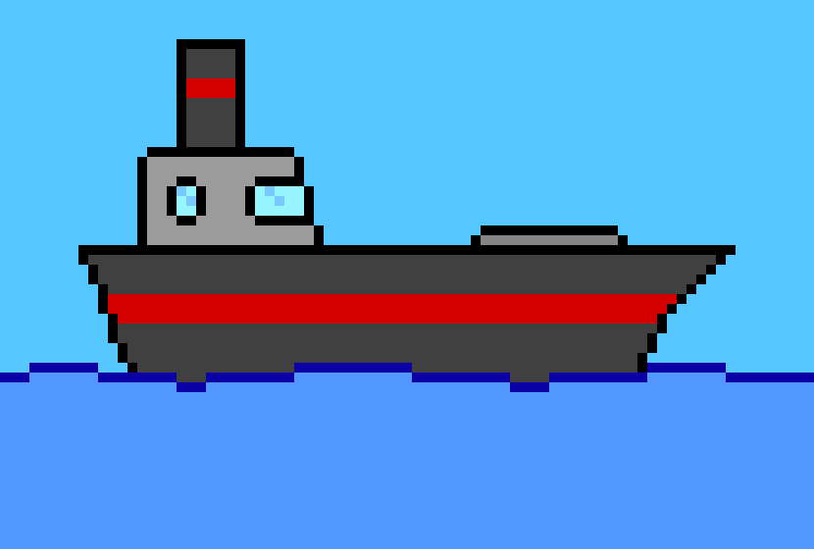

Рисунок 2